Supplementary material for:
A quantitative method for deriving salinity of subglacial water using ground-based transient electromagnetics
S. F. Killingbeck¹, C. F. Dow¹, M. J. Unsworth²
¹Department of Geography and Environmental Management, University of Waterloo, Waterloo, Ontario, Canada
² Department of Physics, University of Alberta, Edmonton, Alberta, Canada
Corresponding author: Siobhan Killingbeck (siobhan.killingbeck@uwaterloo.ca)
Approximate DOI for the Geonics Limited TEM-47 and TEM-67 systems
$h_{TEM-47}=8.94{ L}^{0.4}ρ^{0.25}$ (S1)
$h_{TEM-67}=224{\frac{L}{100}}^{0.4}{\frac{I}{10}}^{0.2}{\frac{ρ}{100}}^{0.24}$ (S2)
where ρ is upper layer resistivity, L is length of transmitter loop size (meters), h is the maximum depth (meters) at which a change in resistivity can be seen above the background noise. I is the current, which is set at 25 A for S2. In Equation S2, the L and I exponents come from the total transmitter moment, and how the resulting field and return response decrease with depth. The ρ exponent and the scale (224) were determined empirically from 2 layer forward modeling (Geonics 1994 and 2012).
Fofonoff and Millard’s 1983 conductivity to salinity conversion
The electrical conductivity (C) of seawater at PSS-78 practical salinity (S), temperature (t) and pressure (p) decibars has a conductivity ratio (R) of
$R=\frac{C\left(S,t,p\right)}{C\left(35,15,0\right)}$ (S3)
Where C(35, 15, 0) is the conductivity of standard seawater of practical salinity 35, at 15ºC and atmospheric pressure. C(35, 15, 0) is equivalent to the conductivity of a reference solution of Potassium Chloride (KCl), with 32.4356 g of KCl per kg of solution, at the same temperature and pressure. The conductivity ratio can be split into three parts
$R= R_{P}.R_{t}.r_{t}$ (S4)
where
$R_{P}\left(S,t,p\right)=\frac{C\left(S,t,p\right)}{C\left(S,t,0\right)}$ (S5)
$R_{t}\left(S,t\right)=\frac{C\left(S,t,0\right)}{C\left(35,t,0\right)}$ (S6)
$r_{t}\left(t\right)=\frac{C\left(35,t,0\right)}{C\left(35,15,0\right)}$ (S7)
The Practical salinity may be computed with the following equation
$S= a_{0}+a_{1}R_{t}^{1/2}+a_{2}R_{t}+a_{3}R_{t}^{3/2}+a_{4}R_{t}^{2}+a_{5}R_{t}^{5/2}+∆S$ (S8)
where
$∆S= \frac{\left(t-15\right)}{1+k\left(t-15\right)}(b_{0}+b_{1}R_{t}^{\frac{1}{2}}+b_{2}R_{t}+b_{3}R_{t}^{\frac{3}{2}}+b_{4}R_{t}^{2}+b_{5}R_{t}^{\frac{5}{2}})$ (S9)
where $k$ = 0.0162 and constants $a$ and $b$ detailed in Table S1. Equations S6 and S7 are calibrated with laboratory measurements over the temperature range -2 to 35⁰C and practical salinity range 2 – 42 (Perkin and Lewis, 1980).
Table S1. Constants $a$ and $b$ used in equations S6 and S7.
Constant | Value | Constant | Value
$$a_{0}$$ | 0.008 | $$b_{0}$$ | 0.0005
$$a_{1}$$ | -0.1692 | $$b_{1}$$ | -0.0056
$$a_{2}$$ | 25.3851 | $$b_{2}$$ | -0.0066
$$a_{3}$$ | 14.0941 | $$b_{3}$$ | -0.0375
$$a_{4}$$ | -7.0261 | $$b_{4}$$ | 0.0636
$$a_{5}$$ | 2.7081 | $$b_{5}$$ | -0.0144

The ratio $r_{t}$ is given by
$r_{t}= c_{o}+ c_{1}t+ c_{2}t^{2}+ c_{3}t^{3}$ + $c_{4}t^{4}$ (S10)
where constants $c$ are detailed in Table S2 and the range of validity is between -2⁰C and 35⁰C.

Table S2. Constants $c$ used in equations S6.
Constant | Value
$$c_{0}$$ | 0.6766097
$$c_{1}$$ | 2.00564 x 10⁻²
$$c_{2}$$ | 1.104259 x 10⁻⁴
$$c_{3}$$ | -6.9698 x 10⁻⁷
$$c_{4}$$ | 1.0031 x 10⁻⁹

The ratio $R_{P}$ is given by
$R_{P}=1+\frac{p(e_{1}+e_{2}p+e_{3}p^{2})}{1+d_{1}t+d_{2}t^{2}+\left(d_{3}+d_{4}t\right)R}$ (S11)
where constants $d$ and$e$ are detailed in Table S3.
Table S3. Constants $d$ and $e$ used in equation S9.
Constant | Value | Constant | Value
$$e_{1}$$ | 2.070 x 10⁻⁵ | $$d_{1}$$ | 3.426 x 10⁻²
$$e_{2}$$ | -6.370 x 10⁻¹⁰ | $$d_{2}$$ | 4.464 x 10⁻⁴
$$e_{3}$$ | 3.989 x 10⁻¹⁵ | $$d_{3}$$ | 4.215 x 10⁻¹
- | - | $$d_{4}$$ | -3.107 x 10⁻³

Given R, t and p the ratio $R_{t}$ is given by
$R_{t}=\frac{R}{(R_{p}.r_{t})}$ (S12)
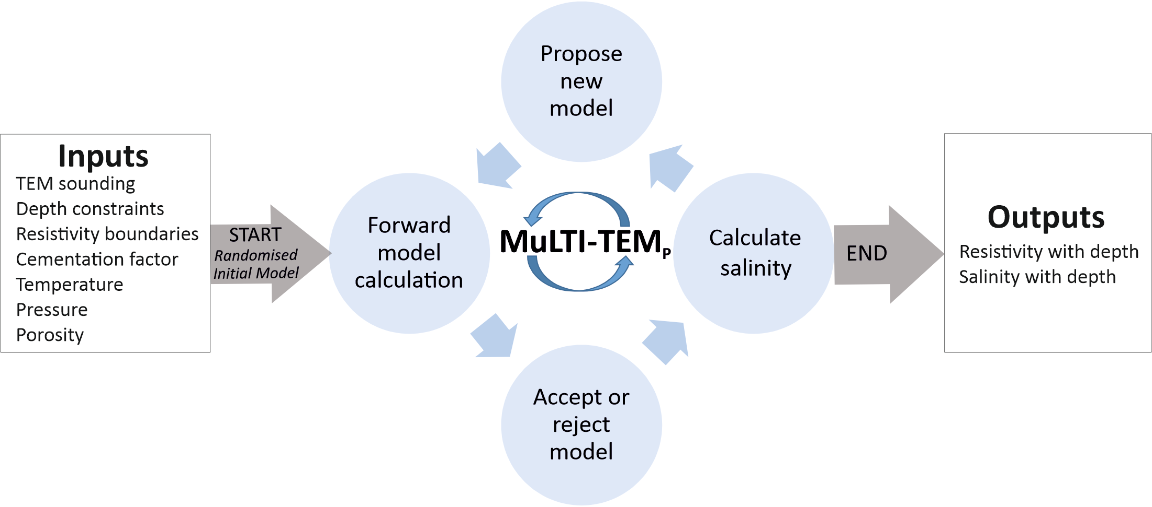
Fig. S1. Schematic illustration of MuLTI-TEM_{P}. The circular workflow represents the iterative inversion processes at the core of MuLTI-TEM_{P}.
Table S4. Inversion parameters and priors used in MuLTI-TEM_{P}. See Killingbeck and others 2018 for a detailed description of each parameter. “Number of layers” is the number of layer boundaries defined by the external constraints available (Fig. 2). K_{min} and K_{max} define the uniformly distributed prior distribution of nuclei (Fig. 2). Maximum depth is the maximum depth of the resistivity-depth model space. Error (σ) is the uncertainty in the observed data. Burn-in period is the amount of iterations to discard, after the burn-in period, the Markov chain is presumed independent of the initial condition. sigma_{changeρ}, sigma_{move} and sigma_{birthρ} define the proposal distribution used to propose a new model during each iteration, that is a function of the current model in the Markov chain (Fig. S1; Killingbeck and others 2018). Layer depth 1 and 2 are the constrained layer depths. ρ boundaries are the resistivity layer boundaries applied to each depth constrained layer (see Fig. 2) and define the resistivity-depth model space. The temperature and pressure is an estimate of the water or saturated sediment temperature and pressure at the target depth, here our target depth is 800 m. The cementation factor (m) represents the combined effect of the pore network, connectivity and permeability used in Archie’s Law (Equation 4).
Inversion Parameters | I. No depth constraints | II. Depth constrained base-ice | III. Depth constrained base-ice and base-lake/base-saturated sediment
Number of Layers | 1 | 2 | 3
Min. number of nuclei (K_{min}) | 1 | 2 | 3
Max. number of nuclei (K_{max}) | 101 | 102 | 103
Maximum depth (m) | 1000 | 1000 | 1000
Error (σ) | ± 7.5 % of the observed data | ± 7.5 % of the observed data | ± 7.5 % of the observed data
Table continued on page 5

Table S4 continued
Burn-in period | 10000 | 10000 | 10000
Number of Iterations (including burn-in) | 500000 | 500000 | 500000
Number of MCMC chains | 1 | 1 | 1
sigma_{changeρ} (log₁₀ Ωm)* | 3 | 3 | 3
sigma_{move} (m)* | 600 | 600 | 600
sigma_{birthρ} (log₁₀ Ωm)* | 3 | 3 | 3

Priors | I) | II) | III)
Base ice (Layer depth (1)) | - | 800 | 800
Base lake/sediment (Layer depth (2)) | - | - | 805
ρ boundaries Layer 1:  (Ωm) Layer 2:  Layer 3: | 0.1 to 50000  -  - | 1000 to 50000  0.1 to 5000  - | 1000 to 50000  0.1 to 100  0.1 to 5000
Temperature (°C) | -14.5 | -14.5 | -14.5
Temperature standard deviation (°C) | ± 4 | ± 4 | ± 4
Pressure (dbars) | 657 | 657 | 657
Pressure standard deviation (dbars) | ± 26 | ± 26 | ± 26
Cementation factor | 1.5 | 1.5 | 1.5
Cementation factor standard deviation | ± 0.15 | ± 0.15 | ± 0.15

Table S5. Normalized misfit for models 1, 2 and 3, inversion method I, II and III, averaged over the last 200000 iterations. The misfit was calculated from Equation 3 and normalized by the number of data points.
Inversion | Normalized data misfit
Model 1 (I) (Fig. 6) | 0.8
Model 1 (II) (Fig. 6) | 0.8
Model 1 (III) (Fig. 6) | 0.75
Model 2 (I) (Fig. 7) | 0.9
Model 2 (II) (Fig. 7) | 0.8
Model 2 (III) (Fig. 7) | 0.8
Model 3 (I) (Fig. 8) | 1.0
Model 3 (II) (Fig. 8) | 0.9
Model 3 (III) (Fig. 8) | 0.7

Fig. S2. 1D inversion results for model A (I) with no depth constraints, (II) depth constrained base-ice and (III) depth constrained base-ice and base-lake. a) Comparison of synthetic data (black dots) and uncertainty tolerance with the posterior distribution of TEM responses for 7.5 Hz base frequency. b) Posterior distribution of resistivity, comparing the medium solution (black line) with the synthetic model (red line). c) Normalized misfit for each iteration, calculated from Equation (3) and normalized by the number of data points, (upper plot) and the posterior distribution of number of nuclei (lower plot).
Fig. S3. 1D inversion results for model B (I) with no depth constraints, (II) depth constrained base-ice and (III) depth constrained base-ice and base-sediment. a) Comparison of synthetic data (black dots) and uncertainty tolerance with the posterior distribution of TEM responses for 3 Hz base frequency. b) Posterior distribution of resistivity, comparing the medium solution (black line) with the synthetic model (red line). c) Normalized misfit for each iteration, calculated from Equation (3) and normalized by the number of data points, (upper plot) and the posterior distribution of number of nuclei (lower plot).
Fig. S4. 1D inversion results for model C (I) with no depth constraints, (II) depth constrained base-ice and (III) depth constrained base-ice and base-lake. a) Comparison of synthetic data (black dots) and uncertainty tolerance with the posterior distribution of TEM responses for 7.5 Hz base frequency. b) Posterior distribution of resistivity, comparing the medium solution (black line) with the synthetic model (red line). c) Normalized misfit for each iteration, calculated from Equation (3) and normalized by the number of data points, (upper plot) and the posterior distribution of number of nuclei (lower plot).

Fig. S5. a) 7.5 Hz TEM responses for the 2D subglacial lake example 1 synthetic model. b) 3 Hz TEM responses for the 2D subglacial lake example 1 synthetic model. Both base frequency TEM responses have random noise added, using a simplified noise model consisting of 7.5% relative Gaussian noise applied to the voltage measured at all time gates.

Fig. S6. a) 7.5 Hz TEM responses for the 2D subglacial lake example 2 synthetic model. b) 3 Hz TEM responses for the 2D subglacial lake example 2 synthetic model. Both base frequency TEM responses have random noise added, using a simplified noise model consisting of 7.5% relative Gaussian noise applied to the voltage measured at all time gates.

