Spatiotemporal supraglacial pond and ice cliff changes in the Bhutan-Tibet border region from 2016-2018.

Caroline Jane Taylor^{1 *}, Joanne Rachel Carr¹, David Robert Rounce²

¹ School of Geography, Politics and Sociology, Newcastle University, Newcastle Upon Tyne, NE1 7RU, UK.
² Carnegie Mellon University, Civil and Environmental Engineering Department Pittsburgh, PA, USA.
*Correspondence: Caroline J. Taylor (C.Taylor11@newcastle.ac.uk)

Supplementary Information
Figure S1: Comparison of PlanetScope and RapidEye imagery for automatic identification of ponds using the same NDWI threshold (0.35).

Figure S2: (a) Operator repeatability assessment from the repeat digitisation of 50 cliffs over the study period and (b) Comparison of NDWI ponded area and manually digitised ponded area.
Figure S3: A 30 m directional buffer used to analyse supraglacial pond and ice cliff coincidence, accounting for an unknown cliff geometry. Any pond within the buffer zone is classed as coincident.

Figure S4: Percentage change in pond area per day for each glacier; G1 (black), G2 (blue) and G3 (yellow) for the period January 2016 to December 2018. Seasonal boundaries are indicated by the vertical dashed lines where W= Winter, M= Monsoon; PO= Post-monsoon and PR=Pre-monsoon. Periods with no data are indicated in grey.

Figure S5: Debris thickness estimates for the three study glaciers. Debris is generally thicker near the terminus and at the glacier margins, and thinner as you move up-glacier towards the headwall. Note ponding generally occurs where there is thinner debris cover (e.g. < 0.4 m) and in areas with thicker debris fewer ponds are found.

Figure S6:: Surface slope estimates for the three study glaciers. Generally, slope is heterogenous across the glacier surface, which is to be expected given the presence of debris cover, supraglacial ponds and ice cliffs.
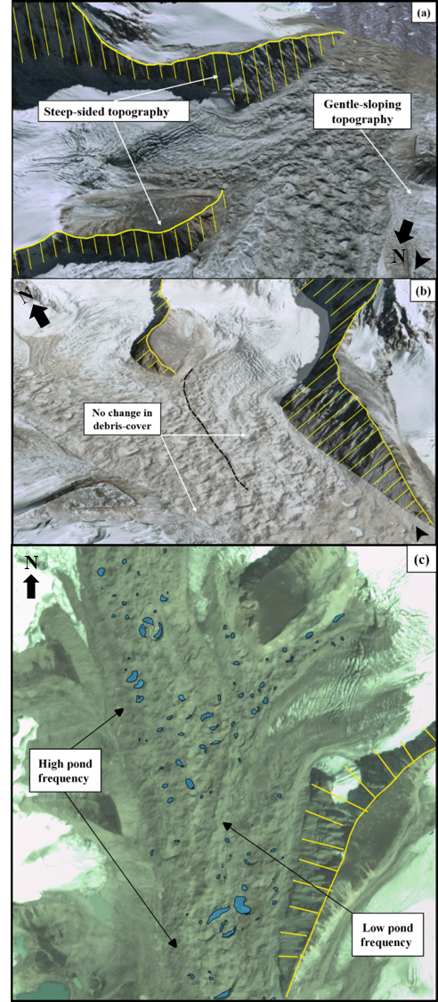
Figure S7: Topography of G1 (a) and (b) shows where the two source tributaries join; the steeper slopes on the eastern margins provide a large shadowing effect onto the glacier surface and (c) shows spatial pattern of ponding on the glacier surface. Background imagery is (a) and (b) GoogleEarth (2018) and (c) PlanetLabs (2018).
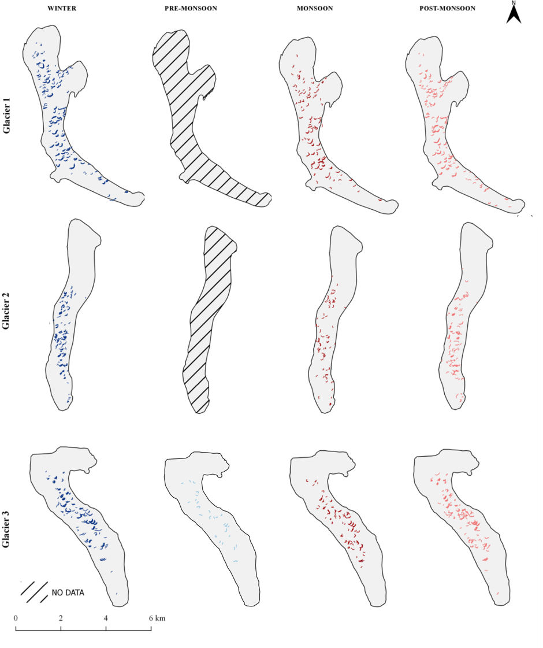
Figure S8: Spatial distribution of ice cliffs across all three study glaciers during the period 2016-2018 for all available seasons.

Image ID/description and spatial resolution | Image date | Image season | Number of scenes in mosaic |  | Glacier
 |  |  |  | G1 | G2 | G3
RapidEye Ortho-tile. 5 m  RapidEye Ortho-tile. 5 m | 07/01/2016  07/02/2016  27/08/2016 | W  W  M | 2  4  1 | *  * | *  * | *  *  *
PlanetScope OS. 3 m  PlanetScope OS. 3 m  PlanetScope OS. 3 m  RapidEye Ortho-tile. 5 m | 23/10/2016  23/11/2016  22/12/2016  07/01/2017 | PO  PO  W  W | 4  3  2  1 | *  *  * | *  *  *  * | *  *  *  *
PlanetScope OS. 3 m | 16/02/2017 | W | 3 | * | * | *
PlanetScope OS. 3 m | 16/06/2017 | M | 1 | * | *
PlanetScope OS. 3 m | 17/06/2017 | M | 2 |  |  | *
PlanetScope OS. 3 m | 05/09/2017 | M | 2 |  |  | *
PlanetScope OS. 3 m  PlanetScope OS. 3m  PlanetScope OS. 3m  PlanetScope OS. 3m  PlanetScope OS. 3m  PlanetScope OS. 3m | 19/10/2017  10/11/2017  04/12/2017  24/01/2018  02/02/2018  22/05/2018 | PO  PO  W  W  W  PR | 7  2  2  2  3  2 | *  *  *  *  * | *  *  *  *  * | *  *  *  *  *
PlanetScope OS. 3 m  PlanetScope OS. 3 m  PlanetScope OS. 3 m | 19/06/2018  06/07/2018  08/09/2018 | M  M  M | 1  1  5 | *  * | *  * | *
PlanetScope OS. 3 m  PlanetScope OS. 3 m  PlanetScope OS. 3 m | 16/10/2018  25/11/2018  06/12/2018 | PO  PO  W | 5  2  2 | *  *  * | *  *  * | *  *  *
High Mountain Asia DEM 8 m | 16/07/2015 | M | 6 | * | * | *
OS = Orthoscene, DEM = Digital Elevation Model, W= Winter, PR= Pre-monsoon, M= Monsoon, PO= Post-monsoon. Image Date: dd/mm/yyyy.
Table S1: Spatial and temporal coverage of imagery used in this study. Image ID (e.g. sensor type) and spatial resolution are given, along with the image date and the number of scenes within each monthly mosaic. The stars (*) indicate glacier coverage. Data in red was discarded from the study.

