Supplementary material of “Annual and seasonal glaciological mass balance of Patsio glacier, western Himalaya (India) from 2010 to 2017”

THUPSTAN ANGCHUK^{1,2}, AL. RAMANATHAN¹, I.M. BAHUGUNA³, ARINDAN MANDAL¹, MOHD SOHEB¹, VIRENDRA BAHADUR SINGH⁴, SOMDUTTA MISHRA¹, SARVAGYA VATSAL¹
¹School of Environmental Sciences, Jawaharlal Nehru University, New Delhi 110067, India
²DST’s Centre of Excellence, Department of Geology, Sikkim University, Sikkim, 737102, India
³Space Applications Centre, Ahmedabad 380015, India
⁴Department of Geology, University of Delhi, Delhi 110007, India
Corresponding author email: alrjnu@gmail.com, thups001@gmail.com

- Data and methodology
During the study period, numerous field works were conducted, maintaining a minimum of three visits in a year. First in May/June, then in August, and the last at the end of the hydrological year (September/October), which enabled us to calculate the sub-seasonal melt rate. The monthly melt rate helped in filling the data gaps and in normalizing the outliers. In 2015, only seven stakes were able to measure due to fresh snowfall during the field campaign. Therefore, stake readings measured on 10 August 2015 were extrapolated until the end of September by applying linear regression. The regression technique is based on the observed melt rate of previous years between August and September. The extrapolated data was compared with measured stakes data of September 2015.
To find a suitable accumulation site was one of the main hindrances of annual mass balance measurements. Also, getting access to the same location every year was not easy due to dense crevasse, harsh weather, etc. Similarly, identification of the last year’s surface (a dirt layer) was not feasible every time. We performed several techniques to measure an accurate annual accumulation. The blue powder was spread on the surface but, failed to trace back in the following years. In 2014, during winter snow core measurement, a polyvinyl chloride (PVC) pipe of a total of five meters (one-meter pipe each connected with connectors) was inserted inside the snow core hole to see the change at the accumulation point (Fig. S1a). During annual accumulation measurement, few pieces of PVC pipes were found broken and exposed on the snow surface. In 2016, two annual snow cores measurements were performed at tributary A between 5375 and 5400 m a.s.l.. The first core was dug until 3.90 m depth and the second till 1.10 m. The last year’s dust layer was prominent at 1.10 m depth. While analysing the first snow core of 2016, several thin frozen layers and high snow densities between 1.0 - 1.20 m depth were observed. Hence it shows that apart from the dirt layer, snow density and stratigraphy were valuable inputs to identify last year’s surface. Simultaneously, snow depths were measured around that location and the average depth was 1.05 m. We thoroughly assessed the annual snow core depth-wise density profiles for all the years. Based on our analysis and understanding, we recalculated the annual snow core depth measurements for the years 2012 and 2013. High-density sections were assumed as last year’s surface for 2012 and 2013 snow accumulation. The estimated result was further correlated with the snow depths, annual precipitation, winter accumulation, and summer ablation.
- Climate setting of Patsio, Chhota Shigri and Stok glaciers
Stok glacier is located ~20 km south of Leh, Union Territory of Ladakh, India (Fig. 1). It is a small debris-free glacier with an area of 0.74 km² (Soheb and others, 2020). Leh-Ladakh region falls in a rain-shadow zone where the annual precipitation is less than 100 mm and the mean annual temperature is around 7.3°C (Soheb and others, 2020). The low precipitation and temperatures make it a cold-arid region. However, Patsio and Chhota Shigri glaciers are located in the Lahaul-Spiti region of Himachal Pradesh, India. Patsio glacier lies on the Greater Himalayan range whereas Chhota Shigri glacier lies on the Pir Panjal range and the distance between these two glaciers is ~55 km (Fig 1). Mean annual precipitation recorded at Chhota Shigri base camp is ~922 mm (Mandal and others, 2020). The mean air temperature recorded at the Patsio glacier for the period August 2015 to September 2017 was -6.3 °C. The automatic weather station (AWS) was installed on the middle moraine of Patsio glacier at an elevation of 5082 m a.s.l.. Whereas the mean air temperature recorded at Chhota Shigri (4863 m a.s.l.) glacier between 2009 to 2019 was -5.4 °C. All these three glaciers (Patsio, Chhota Shigri, and Stok) are monitored by the same working group.

Table S1. Details of the annual and winter mass balance measurements on the Patsio glacier. The number of stakes in the parenthesis of
the year 2015 are extrapolated ones. The probing sites value represents the average of 3-6 probing’s measured almost within the radius of about 5-10 m and the values in the parenthesis are the total number of point measurements.

Year | Annual Mass Balance |  |  |  |  |  |  | Winter Mass Balance
 | Date | Stakes | Elevation range  (m a.s.l.) | Snow Pits/Cores |  | Snow Probing sites | Elevation range  (m a.s.l.) | Date | Snow  Probing sites Pits Cores |  |  | Elevation range  (m a.s.l.)
2011 | 25 Sept | 7 | 4965-5180 | 1 | 5 |  | 5300-5383
2012 | 24 Sept | 7 | 4965-5180 | 1 | 5 |  | 5300-5375 | 15-16 June | 13 (52) | 1 | 1 | 4900-5375
2013 | 29 Sept | 17 | 4965-5313 | 1 | 10 |  | 5300-5415 | 09-11 June | 21 (91) | 1 | 2 | 4900-5375
2014 | 06 Oct | 23 | 4965-5313 | 0 | 15 |  | 5300-5400 | 08-09 June | 9 (38) | 1 | 2 | 4910-5375
2015 | 07 Oct | 13 (6) | 4973-5212 | 1 | 12 |  | 5300-5400 | 05 June | 8 (35) | 1 | 0 | 4905-5250
2016 | 27-28 Sept | 13 | 4965-5305 | 2 | 10 |  | 5300-5450 | 28-29 May | 15 (65) | 1 | 2 | 4925-5470
2017 | 10-11 Oct | 22 | 4965-5366 | 0 | 15 |  | 5300-5450 | 09-10 June | 28 (112) | 1 | 3 | 4900-5460

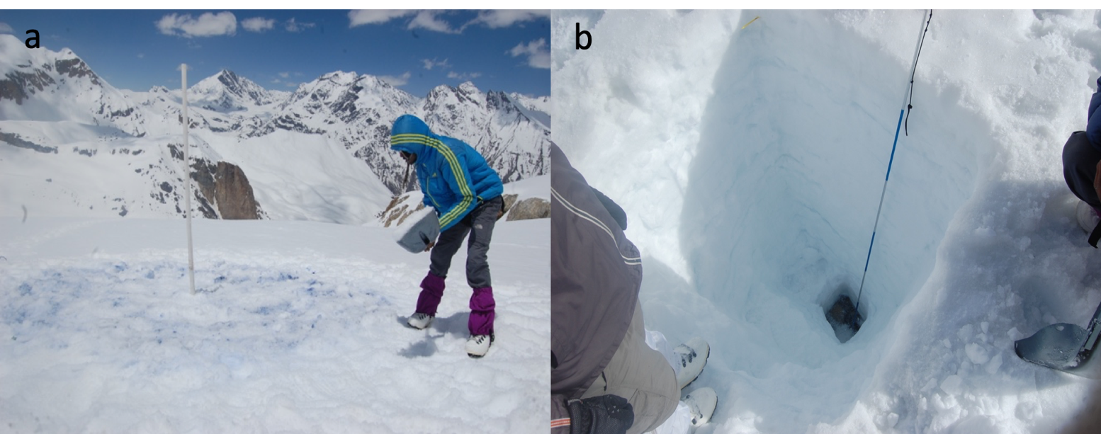
Fig. S1. (a) A polyvinyl chloride (PVC) pipe length of five meters long inserted into the snow core at the accumulation site (~5375m a.s.l.) on 9 June 2014 and (b) Snow pit measured on the Patsio glacier during the winter mass balance. The thin horizontal stratifications are the hard frozen layers.

b
a
Fig. S2. Debris profile measurements at ~4900 (a) and ~5000 (b) m a.s.l.) near the terminus of Patsio glacier. The measurement numbers are the number of point measurements at different profiles. The horizontal measurements start from northwest (1) to northeast (9) direction on the glacier surface.

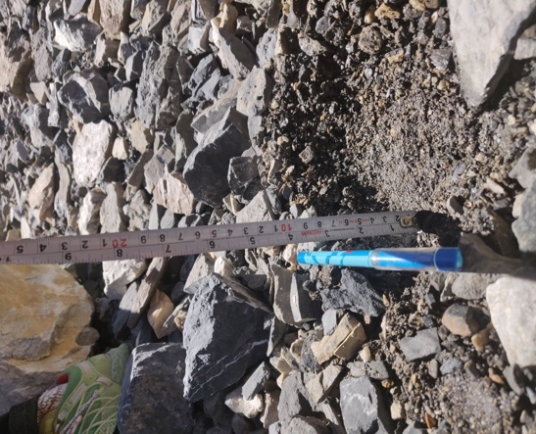
Fig. S3. Debris measurement on Patsio glacier near the stake installed at around 4970 m a.s.l..

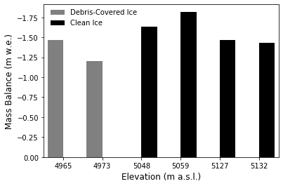
Fig. S4. Point mass balance at similar elevations with same glacier surface morphology except for the debris-covered stakes (grey colour) where debris thickness around stake installed at 4965 m and 4973 m a.s.l. was ~13 cm and ~8 cm respectively.

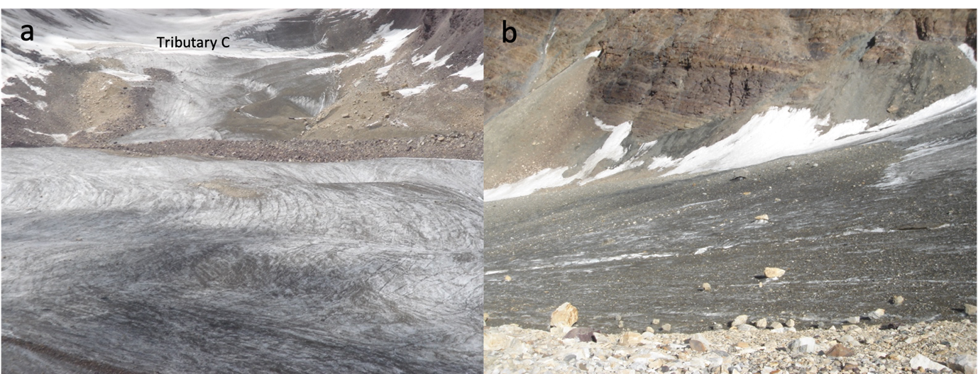
Fig. S5. (a) Fine dust/sediments on the glacier surface at the higher elevation (between 5200-5350 m a.s.l.). The photo was taken from the tributary A. (b) Colour of the debris present on the glacier surface of the Patsio glacier. The photo was taken from the main medial moraine.

Table S2. Glaciological annual and winter mass balance data for Patsio, Chhota Shigri and Stok glacier.
 | Glacier-wide mass balance (m w.e.)
 | 2010/11 | 2011/12 | 2012/13 | 2013/14 | 2014/15 | 2015/16 | 2016/17 | Mean (SD)
Patsio B_{a} | 0.08 | -0.51 | -0.61 | -0.25 | 0.07 | -0.68 | -0.45 | -0.34 (0.32)
Patsio B_{w} |  | 0.88 | 1.07 | 1.28 | 1.34 | 0.9 | 1.16 | 1.11 (19)
Chhota Shigri B_{a} | 0.06 | -0.46 | -0.77 | -0.08 | -0.16 | -0.84 | -0.28 | -0.36 (0.34)
Chhota Shigri B_{w} |  | 1.18 | 0.76 | 1.15 | 1.18 | 0.94 | 1.21 | 1.07 (18)
Stok B_{a} |  |  |  |  | -0.26 | -0.73 | -0.32 | -0.44 (0.26)
 | Air temperature (°C) and Precipitation (mm)
Chhota Shigri Summer T_{air}* | 2.8 | 2.3 | 3.2 | 2.3 | 3.2 | 4.3 | 2.8 | 2.99 (0.69)
Chhota Shigri ΣT_{air}+ | 378 | 352 | 413 | 281 | 428 | 526 | 358 | 396 (82)
Stok Summer T_{air}** |  |  |  |  | 17.5 | 19.8 | 15.5 | 17.60 (2.15)
Lahaul-Spiti Summer P | 176 | 127 | 120 | 94 | 162 | 103 | 138 | 131 (30)
Stok Summer P** |  |  |  |  | 73 | 13 | 13 | 33 (34)
Data source: This study-Patsio, Mandal and others (2020)-Chhota Shigri and Soheb and others (2020)-Stok. IMD Shimla-Lahaul-Spiti Summer P (http://weathershimla.nic.in/). *measured at 4863 m a.s.l.; **measured at 3500 m a.s.l. (Leh station)

Table S3. Correlation coefficients (r) between glacier-wide mass balance (B_{w} and B_{a}) and average precipitation (Annual (P_{a}), Winter (P_{w}), and Summer (P_{s})) of the Lahaul-Spiti recorded by IMD. Significant correlations are shown by * (p < 0.05).
 | B_{a} (m w.e.) | B_{w} (m w.e.)
B_{a} (m w.e.) | -
B_{w} (m w.e.) | 0.82* | -
P_{a} | 0.65 | 0.83*
P_{w} | 0.54 | 0.89*
P_{s} | 0.73 | -

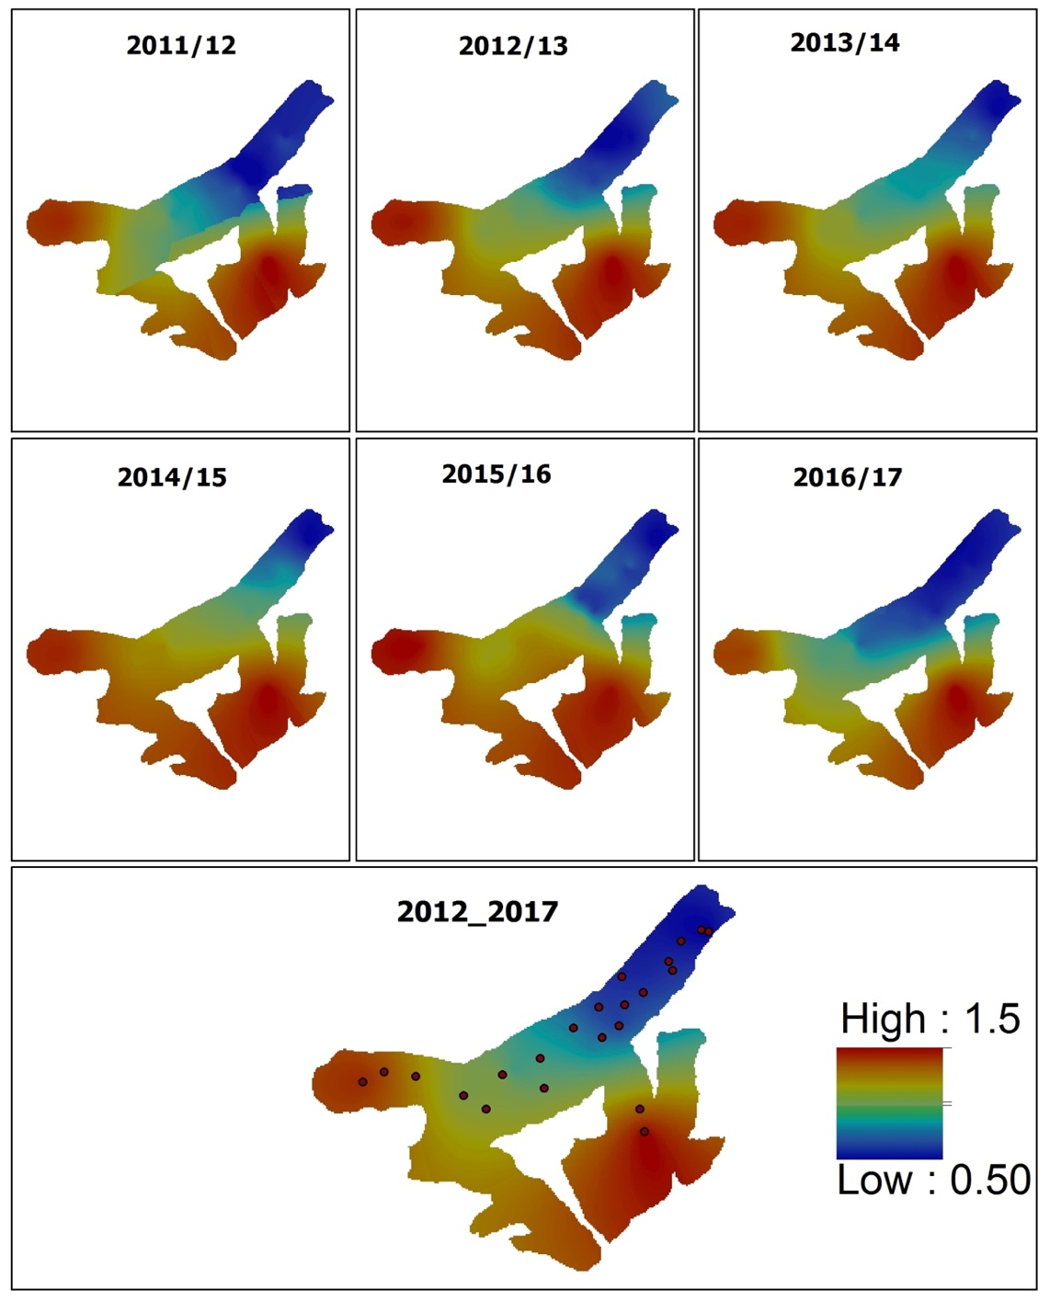
Fig. S6. Year-wise spatial distribution of B_{w} using ordinary kriging method on a 30 m resolution grid for the Patsio glacier. The 2012_2017 is the average value of all the years and the dots are the field measurements data.

References
Mandal A and others (2020) Understanding the interrelationships among mass balance, meteorology, discharge and surface velocity on Chhota Shigri Glacier over 2002–2019 using in situ measurements. Journal of Glaciology 1–21. https://doi.org/10.1017/jog.2020.42
Soheb M, Ramanathan A, Angchuk T, Mandal A, Kumar N, Lotus S (2020). Mass balance observation, reconstruction and sensitivity of Stok glacier, Ladakh region, India, between 1978 and 2019. Journal of Glaciology 1–16. https://doi.org/10.1017/ jog.2020.34

