Supplementary Information: The triggers of the disaggregation of Voyeykov Ice Shelf (2007), Wilkes Land, East Antarctica, and its subsequent evolution
Jennifer F. Arthur¹, Chris R. Stokes¹, Stewart S.R. Jamieson¹, Bertie W.J. Miles¹, J. Rachel Carr², Amber A. Leeson³
¹Department of Geography, Durham University, Durham, DH1 3LE, UK
²School of Geography, Politics and Sociology, Newcastle University, Newcastle-upon-Tyne, NE1 7RU, UK
³Lancaster Environment Centre/Data Science Institute, Lancaster University, Bailrigg, Lancaster, LA1 4YW, UK
Correspondence to: Jennifer F. Arthur (jennifer.arthur@durham.ac.uk)

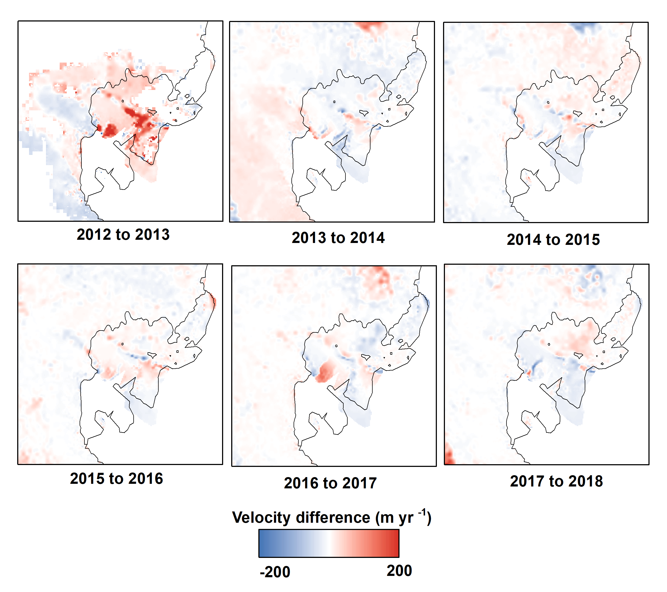

Supplementary Figure S1. Velocity differences between annual ITS_LIVE velocity mosaics on Voyeykov Ice Shelf between 2012 and 2018. Also note the apparent loss of Bell Glacier floating tongue from 2016 onwards represents data scarcity, not a calving event. No velocity data are available covering the eastern portion of the ice shelf fed by Bell Glacier.
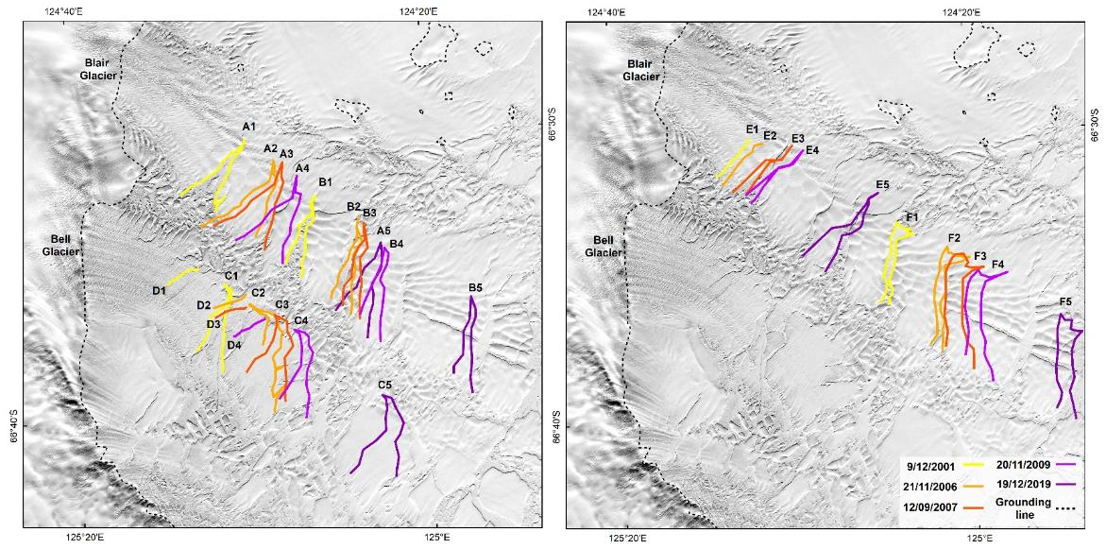
Supplementary Figure S2. Positions of six major rifts (A1-5, B1-5, C1-5, D1-4, E1-5, F1-5) tracked manually between 2001 and 2019 from Landsat-7 scenes on the floating tongues of Blair Glacier and Bell Glacier. Rift position were used to calculate annual rates of rift propagation (the change in rift tip position divided by the time between subsequent satellite images) as an independent check against changes in rates of ice flow speed derived from ITS_LIVE velocity mosaics (Supplementary Table 6).

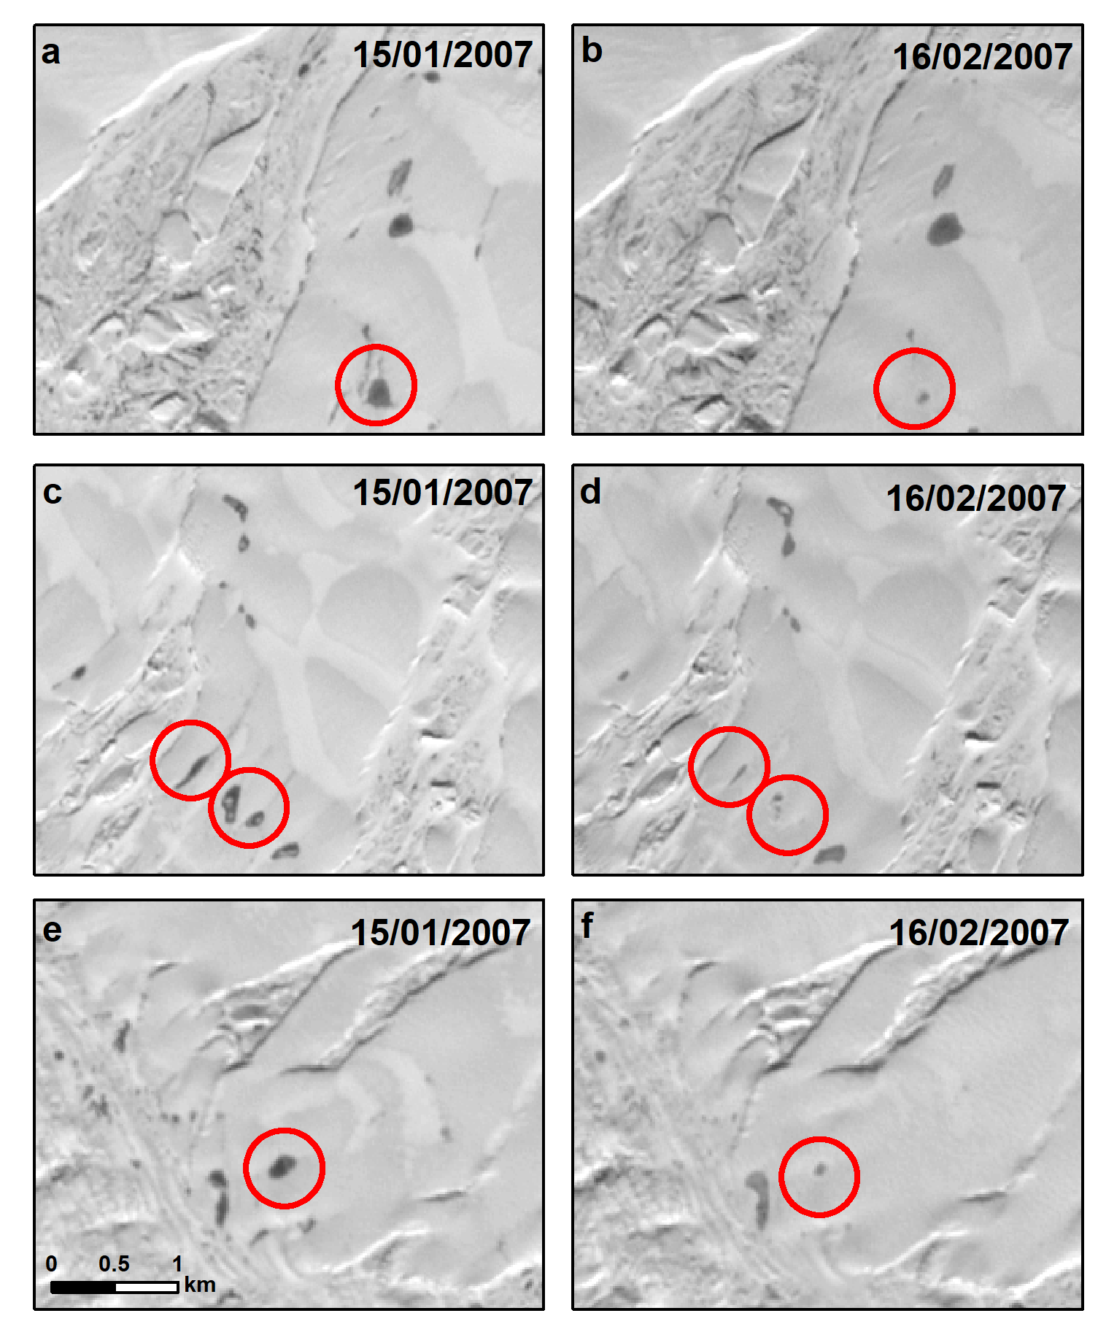
Supplementary Figure S3. Supraglacial lake drainages over a 1-month period on Voyeykov Ice Shelf captured by Landsat-7 imagery.

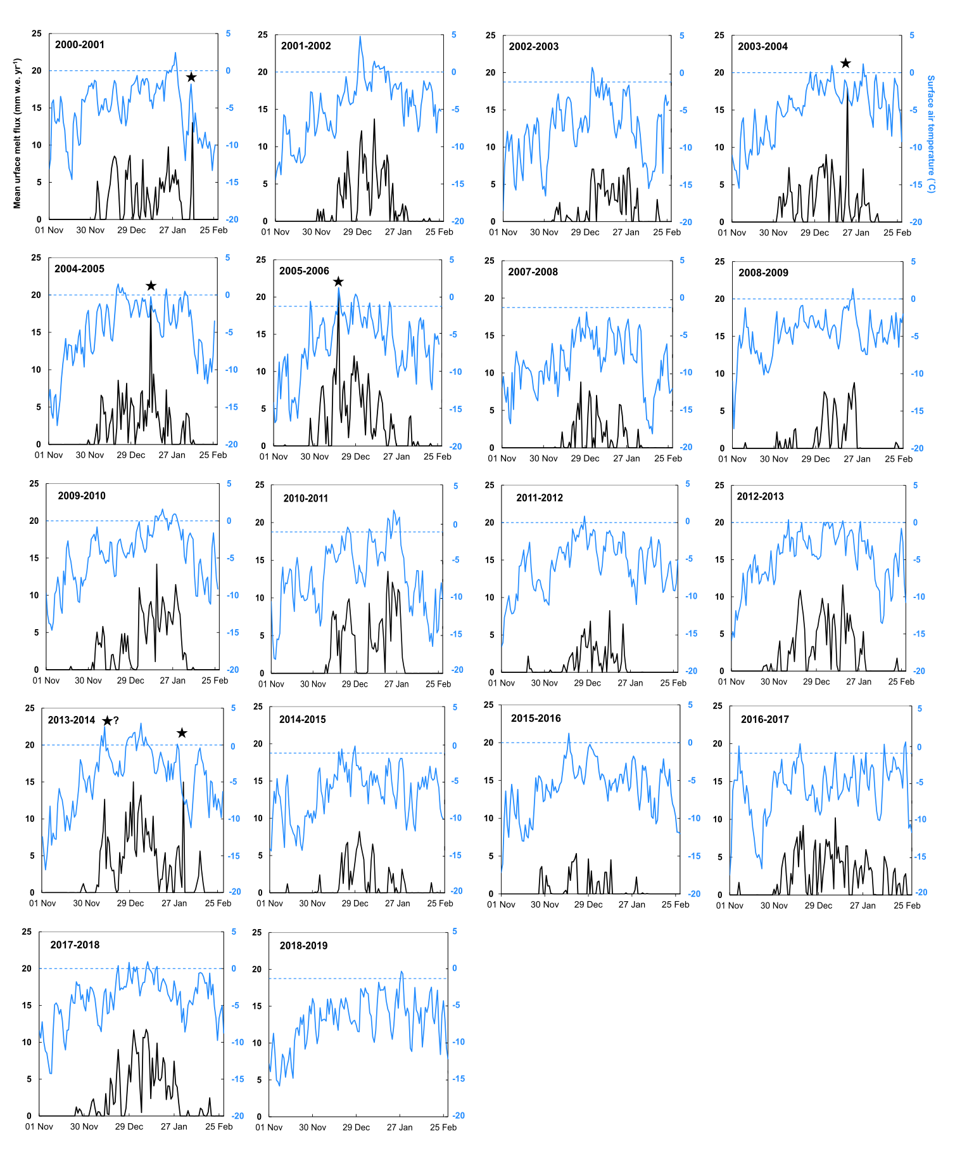
Supplementary Figure S4. Time series of mean average surface melt flux (RACMO2.3) and near surface air temperature (ERA5) for the 2000-2018 summer melt seasons. The 2007 time series is shown in Figure 7 of main paper. Short-lived, intense high magnitude snowmelt events are marked with a black star.

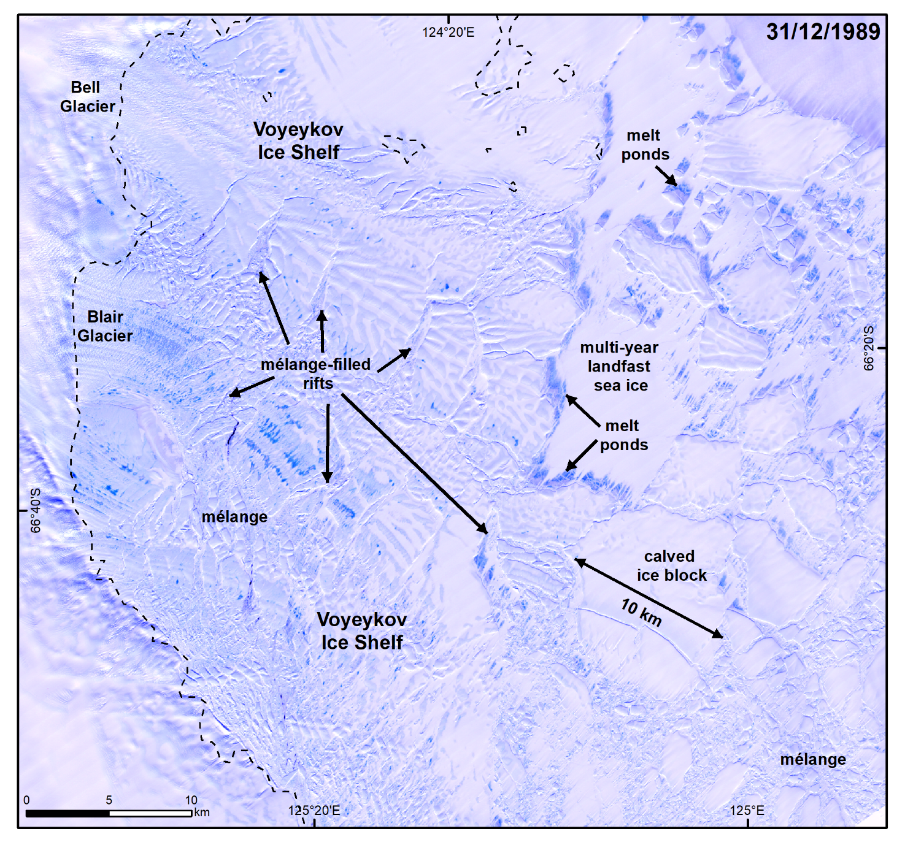

Supplementary Figure S5. Landsat-4 image from 31st December 1989 showing the presence of mélange and large kilometre-scale calved ice blocks bound by multiyear landfast sea ice in front of Voyeykov Ice Shelf, as well as mélange-filled rifts in the heavily fractured main portion of the ice shelf.

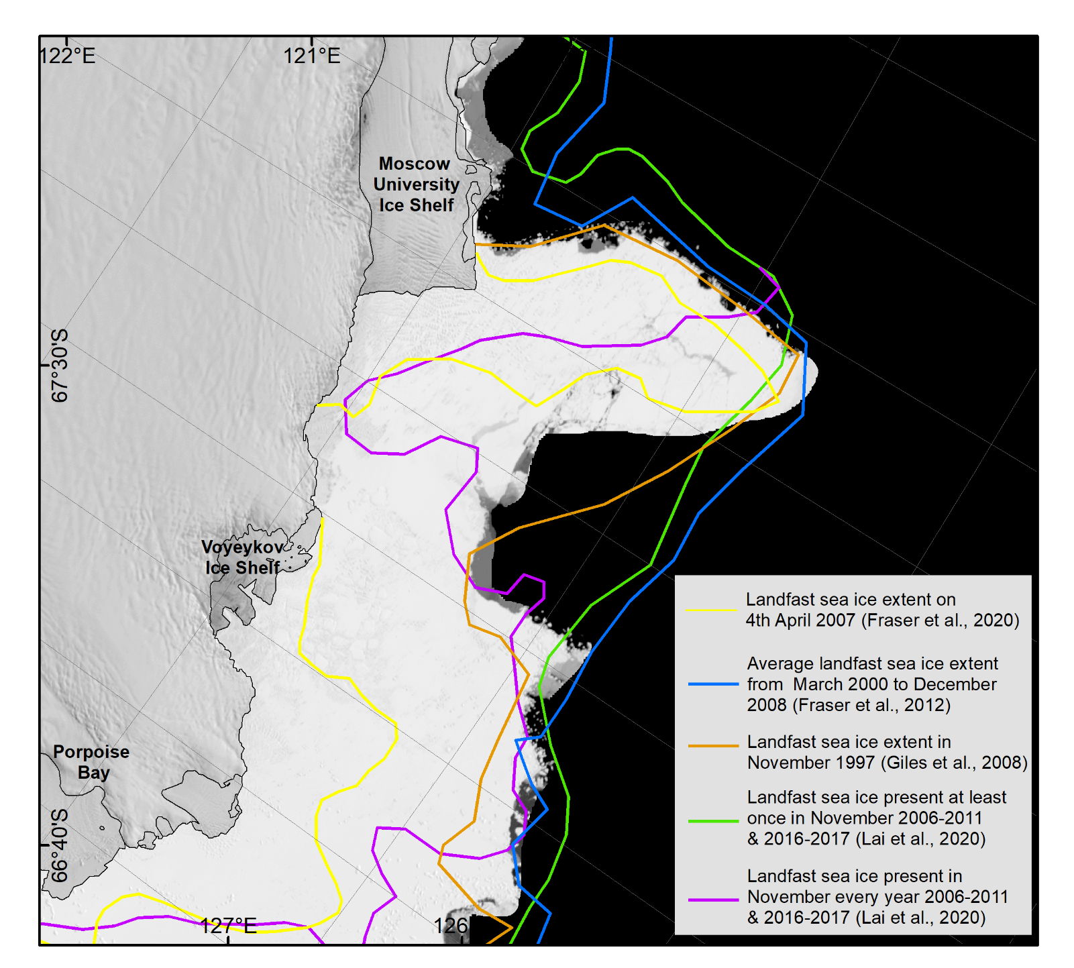
Supplementary Figure S6. Landfast sea ice extents derived from MODIS (Fraser et al., 2012, 2020), RADARSAT ScanSAR (Giles et al., 2008) and ENVISAT and Sentinel-1A/B imagery (Lai et al., 2020), showing extensive persistent landfast sea ice cover around Voyeykov Ice Shelf. The background image is the MODIS mosaic of Antarctica.
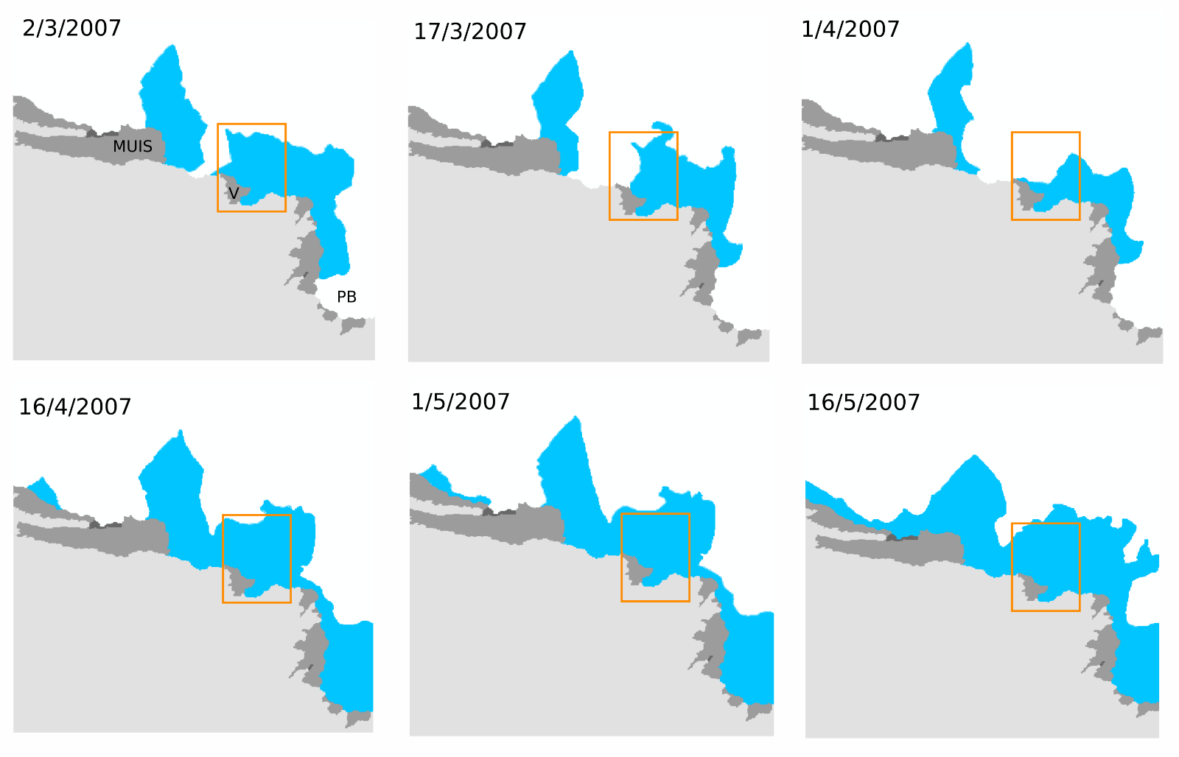
Supplementary Figure S7. Landfast sea ice extents (blue) derived from MODIS (Fraser et al. 2020) confirming the break-out of multiyear sea ice in early April 2007 around Voyeykov Ice Shelf (orange box). MUIS = Moscow University Ice Shelf, V = Voyeykov Ice Shelf, PB = Porpoise Bay.

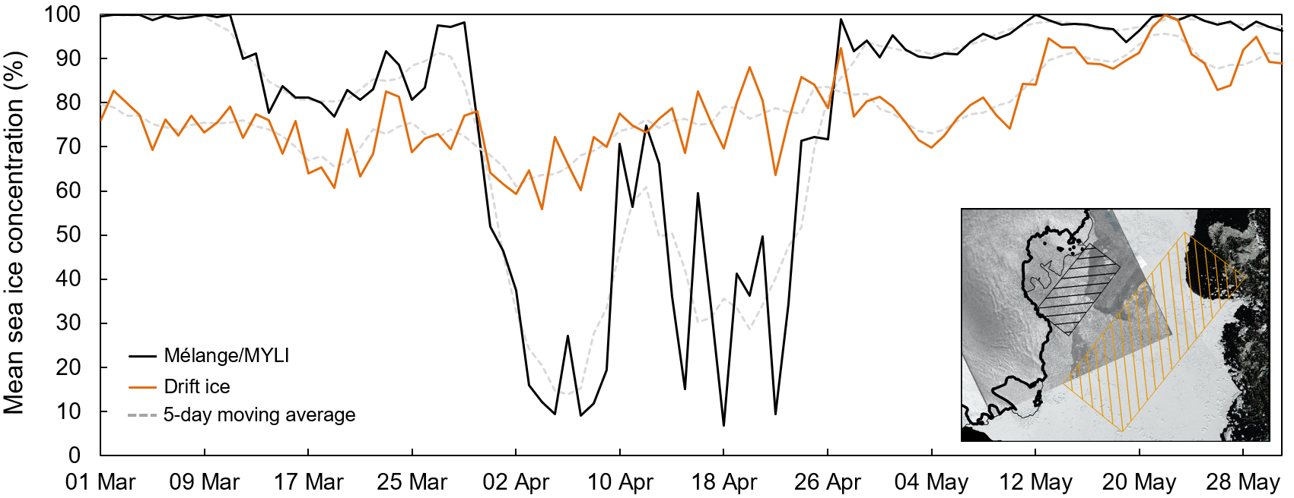

Supplementary Figure S8. Mean daily AMSR-E sea ice concentrations extracted from the region of mélange /MYLI in front of Voyeykov Ice Shelf (black line and hatched black box) and the region of drift ice further offshore (orange line and hatched orange box). Background images in inset are an Envisat ASAR image taken on 23rd April 2007, and the Landsat Image Mosaic of Antarctica (Bindschadler et al., 2008).

Supplementary Table S1: Details of satellite imagery used in this study.

Satellite | Date | Path | Row | Scene Identifier
Landsat-7 | 3/1/2000 | 97 | 107 | LE07_L1GT_097107_20000103_20170215_01_T2
Landsat-7 | 29/2/2000 | 96 | 107 | LE07_L1GT_096107_20000229_20170213_01_T2
Landsat-7 | 21/1/2001 | 97 | 107 | LE07_L1GT_097107_20010121_20170208_01_T2
Landsat-7 | 23/1/2001 | 95 | 107 | LE07_L1GT_095107_20010123_20170208_01_T2
Landsat-7 | 14/11/2001 | 96 | 107 | LE07_L1GT_096107_20011114_20170202_01_T2
Landsat-7 | 9/12/2001 | 95 | 107 | LE07_L1GT_095107_20011209_20170202_01_T2
Landsat-7 | 21/11/2006 | 95 | 107 | LE07_L1GT_095107_20061121_20170107_01_T2
Landsat-7 | 21/12/2006 | 97 | 107 | LE07_L1GT_097107_20061221_20170105_01_T2
Landsat-7 | 15/1/2007 | 96 | 107 | LE07_L1GT_096107_20070115_20170105_01_T2
Landsat-7 | 24/1/2007 | 95 | 107 | LE07_L1GT_095107_20070124_20170105_01_T2
Landsat-7 | 7/2/2007 | 97 | 107 | LE07_L1GT_095107_20070124_20170105_01_T2
Landsat-7 | 16/2/2007 | 96 | 107 | LE07_L1GT_096107_20070216_20170105_01_T2
Landsat-7 | 24/11/2007 | 95 | 107 | LE07_L1GT_095107_20071124_20170101_01_T2
Landsat-7 | 8/12/2007 | 97 | 107 | LE07_L1GT_097107_20071208_20170101_01_T2
Landsat-7 | 10/12/2007 | 95 | 107 | LE07_L1GT_095107_20071210_20161231_01_T2
Landsat-7 | 2/1/2008 | 96 | 107 | LE07_L1GT_096107_20080102_20161231_01_T2
Landsat-7 | 26/11/2008 | 95 | 107 | LE07_L1GT_095107_20081126_20161223_01_T2
Landsat-7 | 3/12/2008 | 96 | 107 | LE07_L1GT_096107_20081203_20161223_01_T2
Landsat-7 | 12/12/2008 | 5 | 107 | LE07_L1GT_095107_20081212_20161224_01_T2
Landsat-7 | 11/1/2009 | 97 | 107 | LE07_L1GT_097107_20090111_20161223_01_T2
Landsat-7 | 13/1/2009 | 95 | 107 | LE07_L1GT_095107_20090113_20161223_01_T2
Landsat-7 | 11/11/2009 | 97 | 107 | LE07_L1GT_097107_20091111_20161219_01_T2
Landsat-7 | 20/11/2009 | 96 | 107 | LE07_L1GT_096107_20091120_20161219_01_T2
Landsat-7 | 27/11/2009 | 97 | 107 | LE07_L1GT_097107_20091127_20161216_01_T2
Landsat-7 | 31/12/2009 | 95 | 107 | LE07_L1GT_095107_20091231_20161218_01_T2
Landsat-7 | 7/1/2010 | 96 | 107 | LE07_L1GT_096107_20100107_20161217_01_T2
Landsat-7 | 3/1/2011 | 95 | 107 | LE07_L1GT_095107_20110103_20161210_01_T2
Landsat-7 | 3/12/2011 | 97 | 107 | LE07_L1GT_097107_20111203_20161204_01_T2
Landsat-7 | 4/1/2012 | 97 | 107 | LE07_L1GT_097107_20120104_20161203_01_T2
Landsat-7 | 6/1/2012 | 95 | 107 | LE07_L1GT_095107_20120106_20161203_01_T2
Landsat-7 | 21/2/2012 | 96 | 107 | LE07_L1GT_097107_20120221_20161203_01_T2
Landsat-8 | 16/11/2013 | 95 | 107 | LC08_L1GT_095107_20131116_20170428_01_T2
Landsat-8 | 23/11/2013 | 96 | 107 | LC08_L1GT_096107_20131123_20170428_01_T2
Landsat-8 | 2/2/2014 | 97 | 107 | LC08_L1GT_097107_20140202_20170426_01_T2
Landsat-8 | 18/2/2014 | 97 | 107 | LC08_L1GT_097107_20140218_20170425_01_T2
Landsat-8 | 27/2/2014 | 96 | 107 | LC08_L1GT_096107_20140227_20170425_01_T2
Landsat-8 | 17/11/2014 | 97 | 107 | LC08_L1GT_097107_20141117_20170417_01_T2
Landsat-8 | 4/1/2015 | 97 | 107 | LC08_L1GT_097107_20150104_20180203_01_T2
Landsat-8 | 6/11/2015 | 95 | 107 | LC08_L1GT_095107_20151106_20170402_01_T2
Landsat-8 | 13/11/2015 | 96 | 107 | LC08_L1GT_096107_20151113_20170402_01_T2
Landsat-8 | 22/11/2015 | 95 | 107 | LC08_L1GT_095107_20151122_20170401_01_T2
Landsat-8 | 29/11/2015 | 96 | 107 | LC08_L1GT_096107_20151129_20170401_01_T2
Landsat-8 | 6/12/2015 | 97 | 107 | LC08_L1GT_097107_20151206_20170401_01_T2
Landsat-8 | 23/1/2016 | 97 | 107 | LC08_L1GT_097107_20160123_20170330_01_T2
Landsat-8 | 17/12/2016 | 96 | 107 | LC08_L1GT_096107_20161217_20170316_01_T2
Landsat-8 | 24/12/2016 | 97 | 107 | LC08_L1GT_097107_20161224_20170315_01_T2
Landsat-8 | 26/2/2017 | 97 | 107 | LC08_L1GT_097107_20170226_20170316_01_T2
Landsat-8 | 18/11/2017 | 96 | 107 | LC08_L1GT_096107_20171118_20171122_01_T2
Landsat-8 | 11/12/2017 | 97 | 107 | LC08_L1GT_097107_20171211_20171223_01_T2
Landsat-8 | 5/1/2018 | 96 | 107 | LC08_L1GT_096107_20180105_20180118_01_T2
Landsat-8 | 23/12/2018 | 96 | 107 | LC08_L1GT_096107_20181223_20181227_01_T2
Landsat-8 | 24/11/2019 | 96 | 107 | LC08_L1GT_096107_20191124_20191203_01_T2
Landsat-8 | 1/12/2019 | 97 | 107 | LC08_L1GT_097107_20191201_20191216_01_T2
Landsat-8 | 19/12/2019 | 95 | 107 | LC08_L1GT_095107_20191219_20191226_01_T2
Landsat-8 | 2/1/2020 | 97 | 107 | LC08_L1GT_097107_20200102_20200113_01_T2
Landsat-8 | 3/2/2020 | 97 | 107 | LC08_L1GT_097107_20200203_20200211_01_T2
Envisat ASAR | 8/1/2007 | - | - | ASA_IMP_1PNESA20070108_234917_000000162054_00302_25406
Envisat ASAR | 12/2/2007 | - | - | ASA_IMP_1PNESA20070212_234917_000000162055_00302_25907
Envisat ASAR | 23/4/2007 | - | - | ASA_IMP_1PNESA20070423_234917_000000162057_00302_26909
Envisat ASAR | 28/5/2007 | - | - | ASA_IMP_1PNESA20070528_234920_000000162058_00302_27410

Supplementary Table S2. Average velocity magnitude errors and counts for ITS_LIVE mosaics extracted from the upper tongue of Blair Glacier (see Figure 4 for location).

Velocity mosaic | Average maximum velocity magnitude error (v_err_max) | Average minimum velocity magnitude error (v_err_min) | Average maximum count (number of velocities used in weighted average) | Average minimum count (number of velocities used in weighted average)
2000 | 40.3 | 24.3 | 4 | 3
2001 | 52.1 | 11.8 | 4 | 1
2002 | 38.9 | 24.4 | 2 | 2
2006 | 149.5 | 73.3 | 10 | 2
2007 | 4.9 | 3.6 | 81 | 55
2008 | 11.6 | 5.2 | 36 | 14
2009 | 21.2 | 10.0 | 33 | 18
2010 | 28.4 | 12.8 | 20 | 7
2011 | 26.6 | 15.3 | 25 | 12
2012 | 26.4 | 12.9 | 8 | 5
2013 | 7.3 | 6.4 | 23 | 19
2014 | 1.7 | 1.5 | 138 | 120
2015 | 2.1 | 1.6 | 262 | 175
2016 | 1.2 | 0.8 | 271 | 177
2017 | 1.1 | 0.8 | 349 | 268
2018 | 1.2 | 0.7 | 458 | 305

Supplementary Table S3. Average velocity magnitude errors and counts for ITS_LIVE mosaics extracted from the lower tongue of Blair Glacier (see Figure 4 for location).

Velocity mosaic | Average maximum velocity magnitude error (v_err_max) | Average minimum velocity magnitude error (v_err_min) | Average maximum count (number of velocities used in weighted average) | Average minimum count (number of velocities used in weighted average)
2000 | 296.8627 | 5.771712 | 4 | 1
2001 | 603.013 | 12.14847 | 3 | 1
2002 | 44.48492 | 1.408237 | 1 | 0
2006 | 379.5804 | 0.620752 | 7 | 1
2007 | 74.123 | 3.305718 | 69 | 7
2008 | 584.5261 | 6.50471 | 26 | 0
2009 | 402.3837 | 0.277142 | 26 | 0
2010 | 464.7792 | 1.315044 | 8 | 0
2011 | 705.516 | 13.80475 | 23 | 0
2012 | 227.7341 | 5.334754 | 4 | 0
2013 | 23.80803 | 5.362753 | 22 | 9
2014 | 9.265244 | 0.902916 | 149 | 128
2015 | 14.4544 | 1.2066 | 243 | 36
2016 | 15.69187 | 0.233736 | 226 | 20
2017 | 13.20853 | 0.054486 | 288 | 60
2018 | 21.32288 | 0.06834 | 458 | 45

Supplementary Table S4. Average velocity magnitude errors and counts for ITS_LIVE mosaics extracted from Voyeykov Ice Shelf grounding line (see Figure 4 for location).

Velocity mosaic | Average maximum velocity magnitude error (v_err_max) | Average minimum velocity magnitude error (v_err_min) | Average maximum count (number of velocities used in weighted average) | Average minimum count (number of velocities used in weighted average)
2000 | 59.24082 | 19.93722 | 4 | 3
2001 | 80.05841 | 6.968855 | 2 | 1
2002 | 35.93208 | 23.81696 | 1 | 1
2006 | 84.58425 | 70.90844 | 13 | 5
2007 | 3.957485 | 3.731326 | 86 | 76
2008 | 8.729736 | 5.016824 | 36 | 15
2009 | 14.75093 | 11.75065 | 27 | 21
2010 | 17.46221 | 13.22388 | 14 | 13
2011 | 18.57222 | 16.12627 | 22 | 17
2012 | 24.13832 | 16.06659 | 6 | 3
2013 | 7.330036 | 6.583596 | 27 | 21
2014 | 1.780097 | 1.507876 | 149 | 127
2015 | 2.447948 | 1.72433 | 256 | 178
2016 | 1.287815 | 0.969103 | 258 | 177
2017 | 1.167656 | 0.942702 | 366 | 278
2018 | 1.134861 | 1.015842 | 395 | 317

Supplementary Table S5. Annual rates of rift advection derived from manual rift tracking.
Date | Sensor | Rift feature | Annual advection rate (m yr⁻¹)
9/12/2001 | Landsat 7 | Rift A | n/a
21/11/2006 | Landsat 7 | Rift A | 599.6
12/09/2007 | Landsat 7 | Rift A | 632.6
20/11/2009 | Landsat 7 | Rift A | 693.9
19/12/2019 | Landsat 7 | Rift A | 270.0
9/12/2001 | Landsat 7 | Rift B | n/a
21/11/2006 | Landsat 7 | Rift B | 786.8
12/9/2007 | Landsat 7 | Rift B | 840.6
20/11/2009 | Landsat 7 | Rift B | 733.6
3/1/2011 | Landsat 7 | Rift B | 768.9
19/12/2019 | Landsat 7 | Rift B | 781.9
9/12/2001 | Landsat 7 | Rift C | n/a
21/11/2006 | Landsat 7 | Rift C | 697.9
12/9/2007 | Landsat 7 | Rift C | 870.4
20/11/2009 | Landsat 7 | Rift C | 859.2
3/1/2011 | Landsat 7 | Rift C | 836.7
19/12/2019 | Landsat 7 | Rift C | 848.4
9/12/2001 | Landsat 7 | Rift D | n/a
21/11/2006 | Landsat 7 | Rift D | 734.7
12/9/2007 | Landsat 7 | Rift D | 875.3
20/11/2009 | Landsat 7 | Rift D | 923.6
21/11/2006 | Landsat 7 | Rift E | n/a
12/9/2007 | Landsat 7 | Rift E | 469.2
20/11/2009 | Landsat 7 | Rift E | 648.3
2/12/2010 | Landsat 7 | Rift E | 613.2
19/12/2019 | Landsat 7 | Rift E | 690.9
9/12/2001 | Landsat 7 | Rift F | n/a
21/11/2006 | Landsat 7 | Rift F | 899.5
12/9/2007 | Landsat 7 | Rift F | 886.5
20/11/2009 | Landsat 7 | Rift F | 834.5
19/12/2019 | Landsat 7 | Rift F | 772.7

