SUPPLEMENTARY INFORMATION FOR:

Complex multi-decadal ice dynamical change inland of marine-terminating glaciers on the Greenland Ice Sheet
Joshua J. Williams¹, Noel Gourmelen¹, Peter Nienow¹
¹School of Geosciences, University of Edinburgh, Edinburgh, EH8 9XP, UK.
*Corresponding author: j.j.williams-4@sms.ed.ac.uk

Contents
Supplementary Text 1: Seasonality
Supplementary Figures S1 – S25
Supplementary References

Supplementary Text 1: Seasonality
GPS data from 1850 m (a.s.l.) in south west Greenland, during the period 2009-2012, reveal a strong seasonal velocity cycle, with summer velocities up to 8.1 % above the winter mean (Doyle and others, 2014). Whilst this sector is land-terminating as opposed to marine-terminating and thus potentially undergoing different dynamic processes, seasonal velocity variability has been observed near the margins of tidewater glaciers on Greenland (Lemos and others, 2018) and up to at least ~70 km inland at Kangiata Nunaata Sermia in southwest Greenland (Sole and others, 2011), although it is not clear how much further inland such variability extends. Given that we include pixels with pair lengths both longer and shorter than 365 days, we calculate the potential impact of such seasonality on our satellite-image-derived velocities, reasoning that any disproportionate sampling of summer vs winter days may result in artificially high or low velocities.
Following previous work (i.e., Hanna and others 2008; 2012; 2013; 2014; 2020; Noël and others, 2015; Hofer and others, 2017; Leeson and others, 2018), we take summer as the months June, July, and August (hereafter JJA), a period spanning 91 days and making up ~25 % of the year, with ‘winter’ spanning 274 days and making up ~75 % of the year. For each GPS site, at each pixel in the 3*3 grid around the site, we use the centre-date and effective pair length to calculate the number of days in the sampling period that fall within JJA, and divide this by the effective pair length to give a percentage of the sampling period that represents summer. We calculate a reference velocity at each pixel by taking the average velocity across the 3*3-pixel window for the period 2014-2018, and then subtracting this from the velocity at that pixel for each year (2014-2018) in turn, giving an ‘adjusted velocity’. As a result, for the pixels within the 3*3 window centred on each GPS site, and for each year in the period 2014-2018, we can plot the percentage summer coverage against the adjusted velocity to assess the impact of any seasonality. To compare across all GPS sites, we normalise the adjusted velocities through the following at each pixel as shown in equation S1.1:
$Adjusted Velocity \left(\%\right)=\frac{({Velocity}_{(i,j)} \left(m {yr}^{-1}\right)-Reference {Velocity}_{(i,j)} \left(m {yr}^{-1}\right))}{Reference {Velocity}_{(i,j)} \left(m {yr}^{-1}\right)}×100$ (S1.1)

We observe that when integrating the data across all GPS sites, for four of the five years (2014, 2015, 2016, 2018), there is a negative correlation between adjusted velocity and the percentage of summer coverage (Figure S1). Considering a larger spatial scale, for an 11*11-pixel window centred around each GPS site, we undertake the same analysis and observe a similar pattern, that is, no correlation (2014, 2015) or a negative correlation (2016, 2018) for four of the five years in our study period (Figure S2). These trends are influenced by outliers, notably when using a small window size (3*3-pixels, Figure S1), which appear to be concentrated at individual GPS sites. There is no consistent pattern with these outliers; with a window size of 3*3-pixels, in four of the five years (2014, 2015, 2016, 2018) we observe strong negative adjusted ice velocity with a summer coverage of 100 % (Figure S1), whereas in 2017 we observe that the apparent positive trend may be driven by strong positive adjusted velocity at a single site with a summer coverage of ~90 %. When more pixels are included with a larger window size (Figure S2), the trends are reduced, which supports our conclusion that we observe no broad seasonal pattern at the PARCA GPS sites during the period 2014-2018.
We also repeat this analysis, but instead of dividing by the reference velocity at each individual pixel within the 3*3-pixel window around the GPS site, we divide by the mean reference velocity across the entire 3*3-pixel window as shown in equation S1.2:
$Adjusted Velocity \left(\%\right)=\frac{({Velocity}_{\left(i,j\right)} \left(m {yr}^{-1}\right)-Reference {Velocity}_{mean} \left(m {yr}^{-1}\right))}{Reference {Velocity}_{mean} \left(m {yr}^{-1}\right)}×100$ (S1.2)
Similarly, for four of the five years (2014, 2015, 2016, 2018) we observe a negative correlation between adjusted velocity and the percentage of summer coverage (Figure S3). With a larger 11*11-pixel window, we observe either a very small negative correlation (2015, 2016, 2018) or no trend (2014, 2017) (Figure S4).
As such, whilst there is variance between GPS sites, there is no coherent pattern showing clear evidence of seasonality in the velocity data at these elevations and so we do not filter the ITS-LIVE data by pair length.
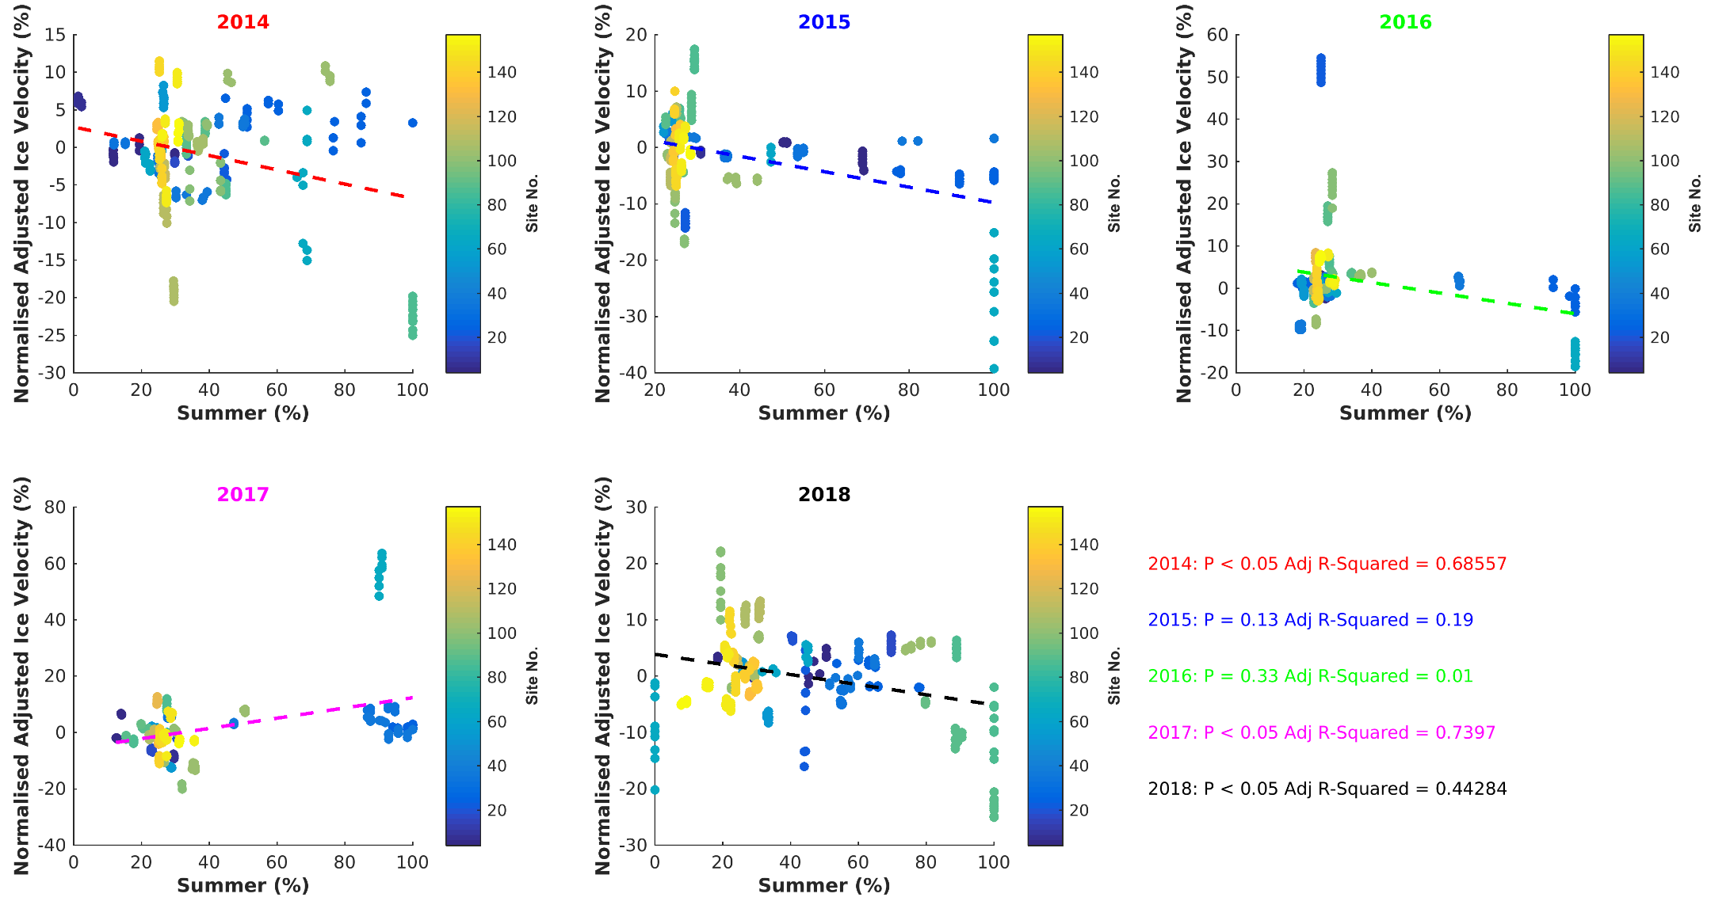
Figure S1: Normalised adjusted ice velocity (%) against summer coverage (%), calculated using equation S1.1, for all pixels in a 3*3-pixel (0.72*0.72 km) window centred around each of the 45 GPS sites included in our analysis for (A) 2014, (B) 2015, (C) 2016, (D) 2017, (E) 2018. The scatter points are coloured by their GPS site number. A linear model is fit to each year of data, with the p- value and adjusted R² displayed in the lower right. The calculation of the adjusted ice velocity and summer coverage are described in Supplementary Text 1.
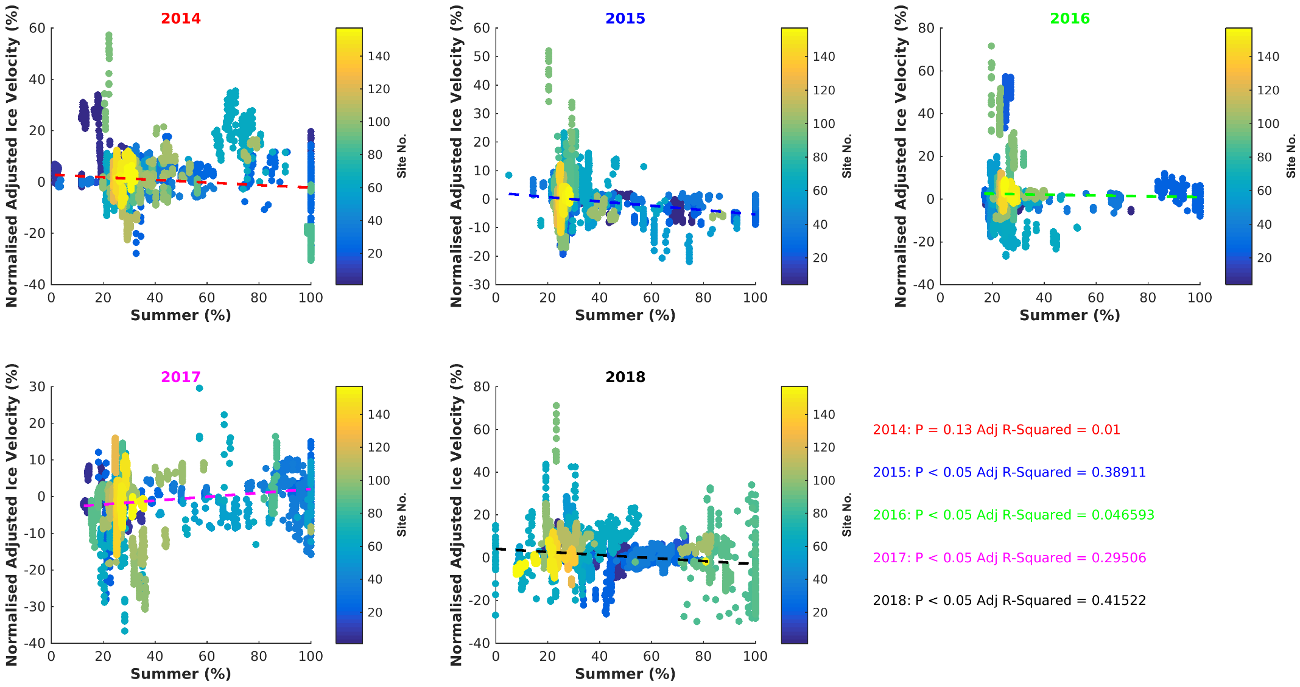
Figure S2: Normalised adjusted ice velocity (%) against summer coverage (%), calculated using equation S1.1, for all pixels in a 11*11-pixel (2.64*2.64 km) window centred around each of the 45 GPS sites included in our analysis for (A) 2014, (B) 2015, (C) 2016, (D) 2017, (E) 2018. The scatter points are coloured by their GPS site number. A linear model is fit to each year of data, with the p-value and adjusted R² displayed in the lower right. The calculation of the adjusted ice velocity and summer coverage are described in the Supplementary Text 1.
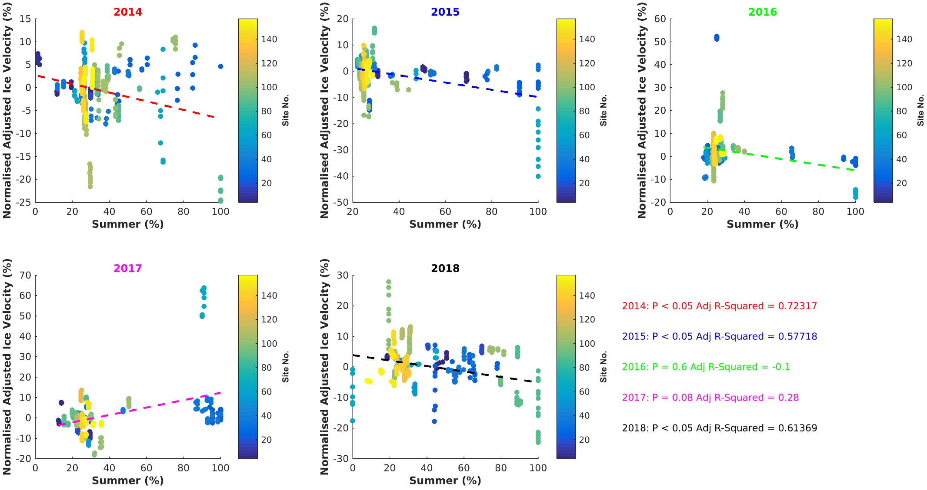
Figure S3: Normalised adjusted ice velocity (%) against summer coverage (%), calculated using equation S1.2, for all pixels in a 3*3-pixel (0.72*0.72 km) window centred around each of the 45 GPS sites included in our analysis for (A) 2014, (B) 2015, (C) 2016, (D) 2017, (E) 2018. The scatter points are coloured by their GPS site number. A linear model is fit to each year of data, with the p- value and adjusted R² displayed in the lower right. The calculation of the adjusted ice velocity and summer coverage are described in Supplementary Text 1.
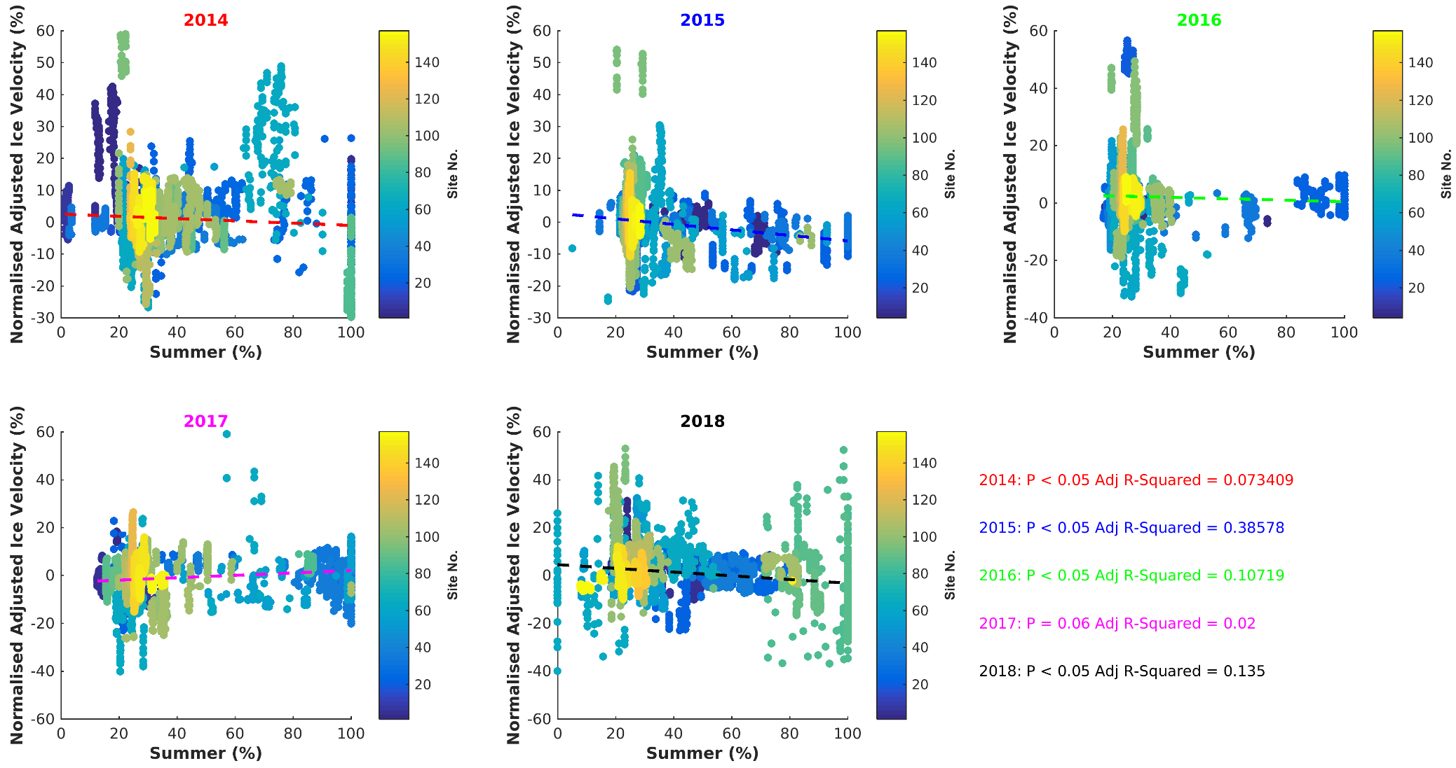
Figure S4: Normalised adjusted ice velocity (%) against summer coverage (%), calculated using equation S1.1, for all pixels in a 11*11-pixel (2.64*2.64 km) window centred around each of the 45 GPS sites included in our analysis for (A) 2014, (B) 2015, (C) 2016, (D) 2017, (E) 2018. The scatter points are coloured by their GPS site number. A linear model is fit to each year of data, with the p-value and adjusted R² displayed in the lower right. The calculation of the adjusted ice velocity and summer coverage are described in the Supplementary Text 1.
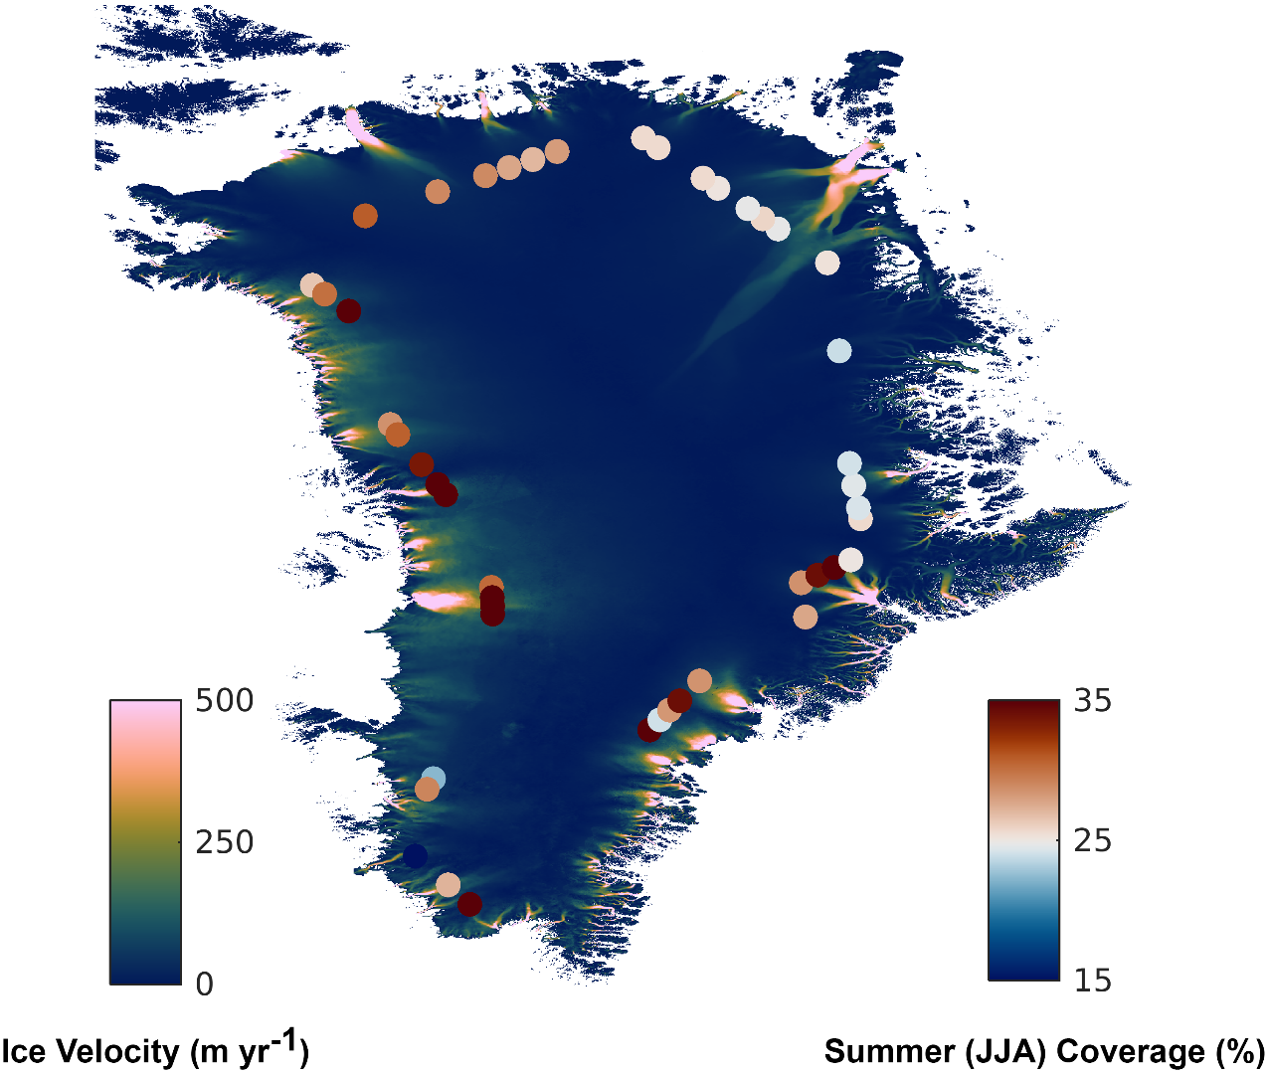

Figure S5: Median 2014-2018 summer coverage (%) within a 3*3-pixel window centred on 45 GPS sites used in our analysis, with summer taken as JJA. The base image is the 2016 velocity field from the NASA ITS-LIVE v0 product (Gardner and others, 2018; 2019).

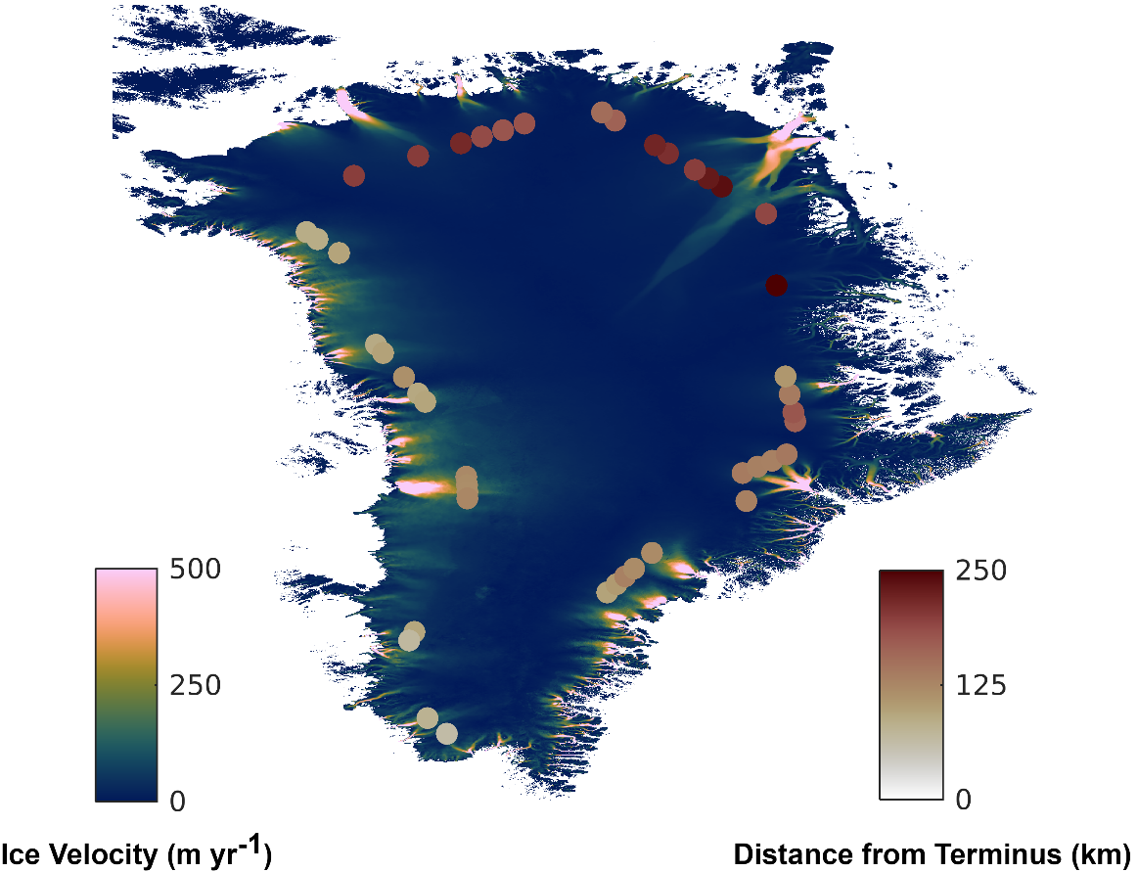
Figure S6: Distance from terminus of the 45 GPS sites inland of tidewater margins used in our analyses. The base image is the 2016 velocity field from the NASA ITS-LIVE v0 product (Gardner and others, 2018; 2019).

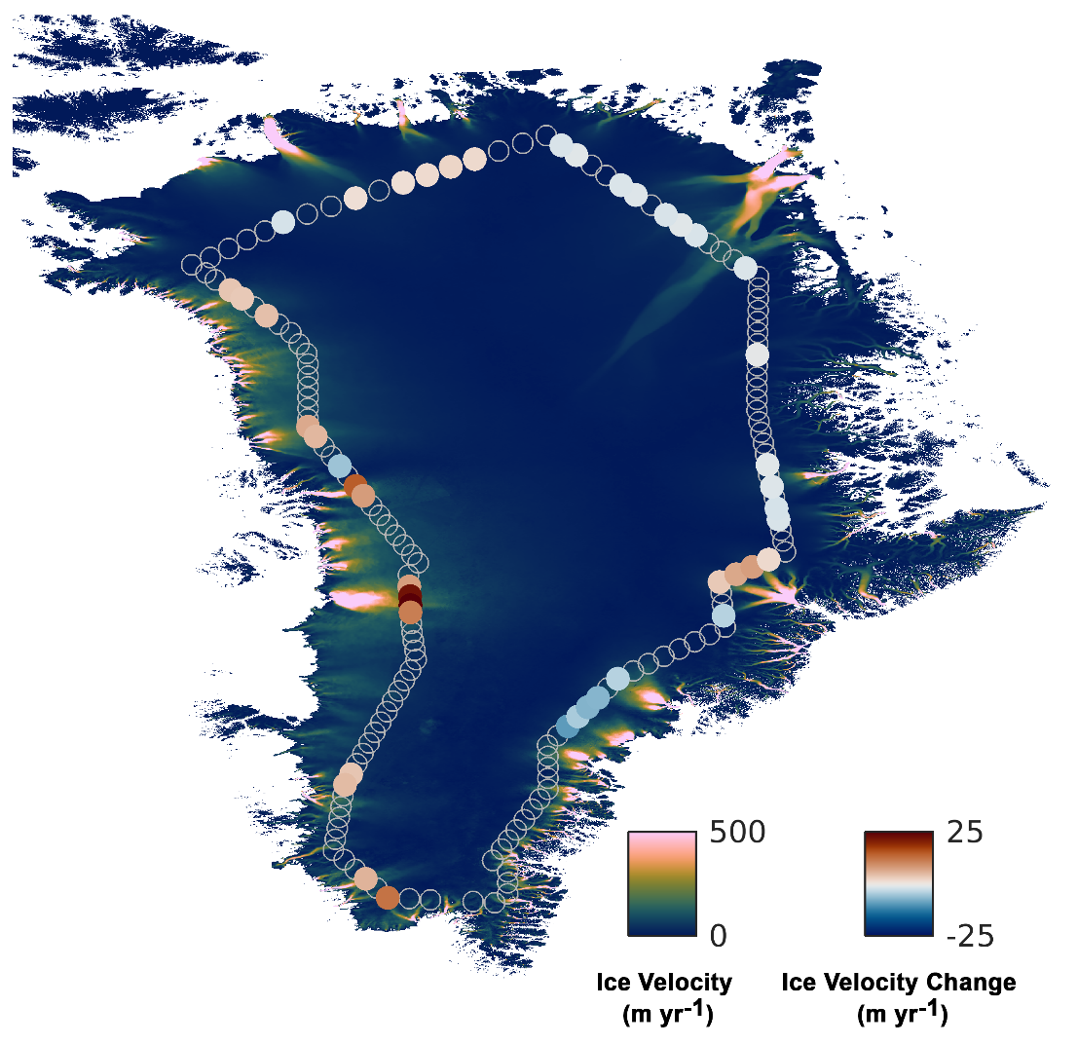

Figure S7: Ice velocity change (m yr⁻¹) at 45 GPS sites inland of tidewater margins between the periods 1993-1997 and 2014-2018. GPS sites that were filtered out of our analysis are shown as empty circles. The base image is the 2016 velocity field from the NASA MEaSUREs ITS-LIVE v0 product (Gardner and others, 2018; 2019).

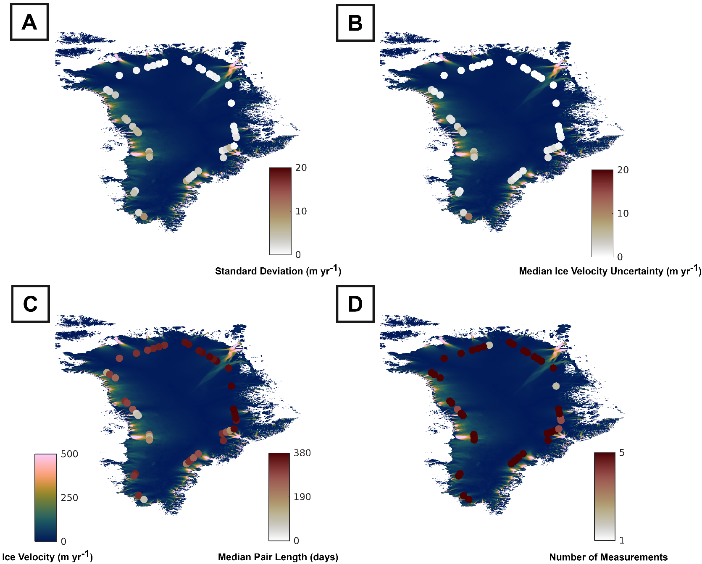
Figure S8: (A) Standard deviation of 2014-2018 ITS-LIVE ice velocity measurements (m yr⁻¹), (B) median ITS-LIVE ice velocity uncertainty (m yr⁻¹), (C) median ITS-LIVE pair length, and (D) the number of ITS-LIVE measurement years at the 45 GPS sites included in our analyses. The base image is the 2016 velocity field from the NASA ITS-LIVE v0 product (Gardner and others, 2018; 2019).

Glacier Name | Centre Latitude (degrees N) | Centre Longitude (degrees E) | Window Size (pixels x) | Window Size (pixels y) | Minimum Velocity (m yr-1) | Error Threshold (m yr-1)
Figure 2
Jakobshavn Isbrae | 69.12 | -49.55 | 51 | 51 | 1500 | 400
Narsap Sermia | 64.66 | -49.88 | 51 | 51 | 1000 | 400
Kangerlugssuaq | 68.64 | -33 | 61 | 61 | 1000 | 400
Upernavik Isstrom | 72.95 | -54.07 | 81 | 41 | 800 | 400
Kong Oscar Glacier | 76.04 | -59.55 | 81 | 41 | 2000 | 400
Petermann Glacier | 80.48 | -59.6 | 81 | 41 | 500 | 40
Rinks Isbrae | 71.77 | -51.44 | 121 | 61 | 2000 | 400
Figure 3
Helheim Glacier | 66.38 | -38.25 | 61 | 61 | 3000 | 400
Daugaard-Jensen Glacier | 71.8 | -28.93 | 161 | 161 | 1000 | 60
79 North Glacier | 79.46 | -22.05 | 151 | 301 | 200 | 400
Zacharie Isstrom | 78.3 | -21 | 101 | 101 | 1000 | 300
Academy Glacier | 81.63 | -32.3 | 31 | 31 | 100 | 60
Umiamako Isbrae | 71.76 | -51.61 | 51 | 51 | 500 | 400
Figure 4
Kangerlugssuaq Branch 1 | 68.8 | -34.01 | 61 | 61 | 50 | 200
Kangerlugssuaq Branch 2 | 68.94 | -33.85 | 61 | 61 | 200 | 100
Kangerlugssuaq Branch 3 | 69.05 | -33.35 | 61 | 61 | 300 | 100
Kangerlugssuaq Branch 4 | 69.05 | -32.92 | 21 | 21 | 200 | 200

Table S1: Input parameters for ITS-LIVE velocity time series extraction at glaciers in Figures 2 through 4.

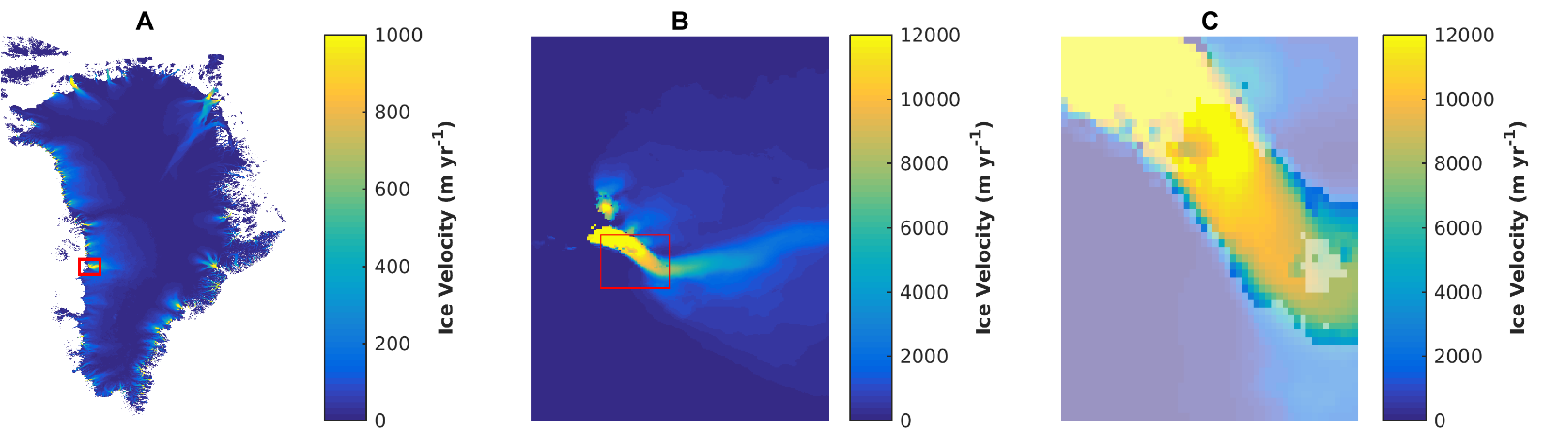
Figure S9: Maps displaying the location of pixels extracted for the velocity time series of Jakobshavn Isbrae. (A) Location of Jakobshavn Isbrae in Greenland. (B) AOI (red rectangle) used for velocity extraction. (C) Pixels common to all years, displayed over a semi-transparent velocity field. In all cases, the velocity data in this figure is the 2016 velocity field from the NASA ITS-LIVE v0 product (Gardner and others, 2018; 2019).
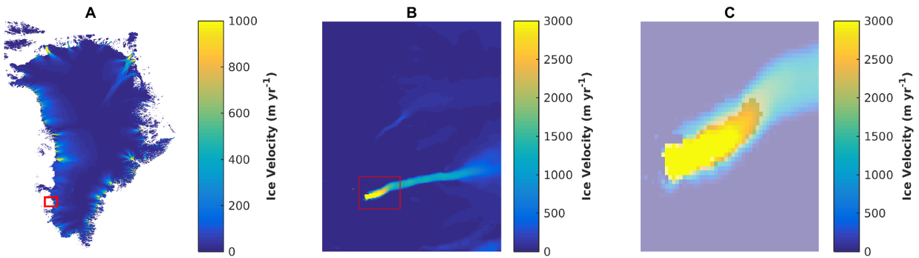

Figure S10: Maps displaying the location of pixels extracted for the velocity time series of Narsap Sermia. (A) Location of Narsap Sermia in Greenland. (B) AOI (red rectangle) used for velocity extraction. (C) Pixels common to all years, displayed over a semi-transparent velocity field. In all cases, the velocity data in this figure is the 2016 velocity field from the NASA ITS-LIVE v0 product (Gardner and others, 2018; 2019).

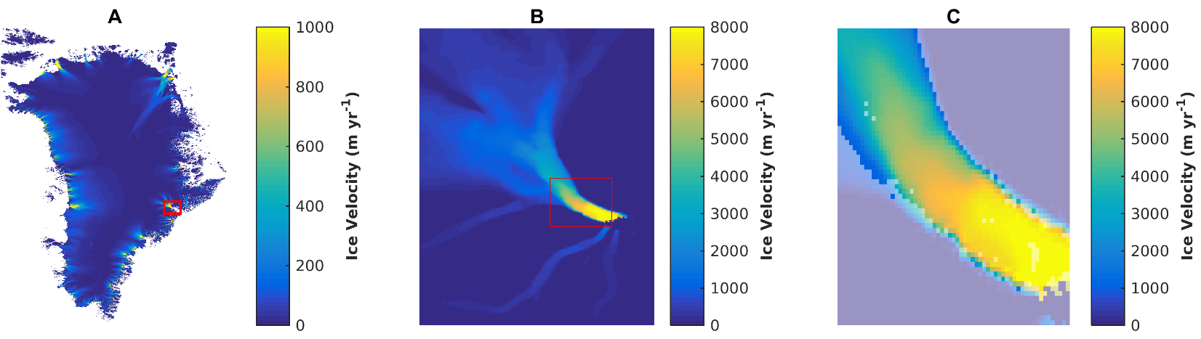
Figure S11: Maps displaying the location of pixels extracted for the velocity time series of Kangerlugssuaq. (A) Location of Kangerlugssuaq in Greenland. (B) AOI (red rectangle) used for velocity extraction. (C) Pixels common to all years, displayed over a semi-transparent velocity field. In all cases, the velocity data in this figure is the 2016 velocity field from the NASA ITS-LIVE v0 product (Gardner and others, 2018; 2019).
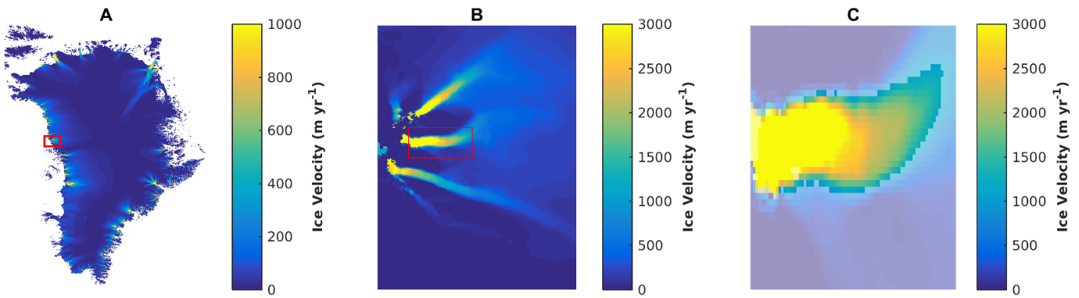

Figure S12: Maps displaying the location of pixels extracted for the velocity time series of Upernavik Isstrom. (A) Location of Upernavik Isstrom in Greenland. (B) AOI (red rectangle) used for velocity extraction. (C) Pixels common to all years, displayed over a semi-transparent velocity field. In all cases, the velocity data in this figure is the 2016 velocity field from the NASA ITS-LIVE v0 product (Gardner and others, 2018; 2019).

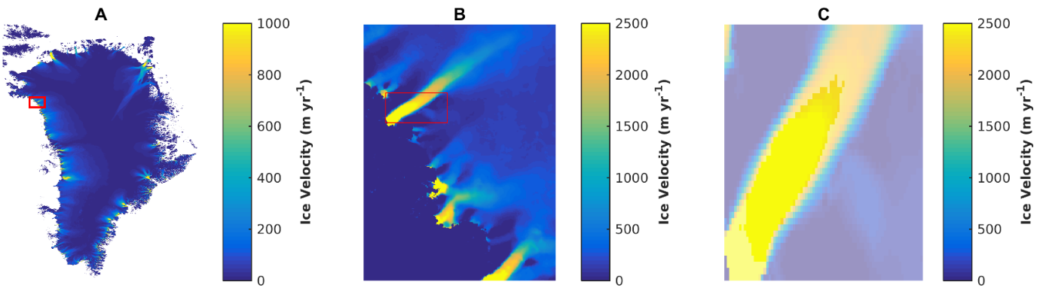
Figure S13: Maps displaying the location of pixels extracted for the velocity time series of Kong Oscar Glacier. (A) Location of Kong Oscar Glacier in Greenland. (B) AOI (red rectangle) used for velocity extraction. (C) Pixels common to all years, displayed over a semi-transparent velocity field. In all cases, the velocity data in this figure is the 2016 velocity field from the NASA ITS-LIVE v0 product (Gardner and others, 2018; 2019).

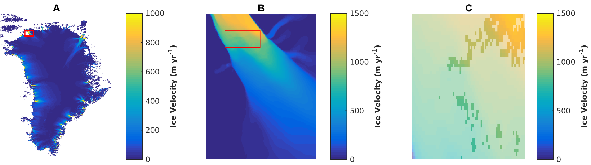

Figure S14: Maps displaying the location of pixels extracted for the velocity time series of Petermann Glacier. (A) Location of Petermann Glacier in Greenland. (B) AOI (red rectangle) used for velocity extraction. (C) Pixels common to all years, displayed over a semi-transparent velocity field. In all cases, the velocity data in this figure is the 2016 velocity field from the NASA ITS-LIVE v0 product (Gardner and others, 2018; 2019).
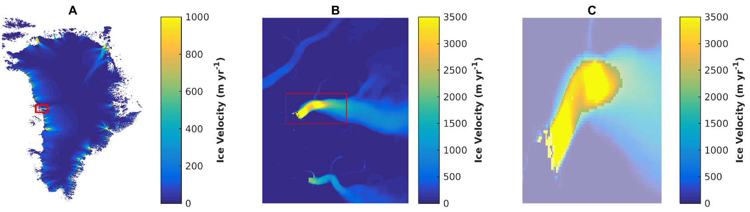
Figure S15: Maps displaying the location of pixels extracted for the velocity time series of Rinks Isbrae. (A) Location of Rinks Isbrae in Greenland. (B) AOI (red rectangle) used for velocity extraction. (C) Pixels common to all years, displayed over a semi-transparent velocity field. In all cases, the velocity data in this figure is the 2016 velocity field from the NASA ITS-LIVE v0 product (Gardner and others, 2018; 2019).

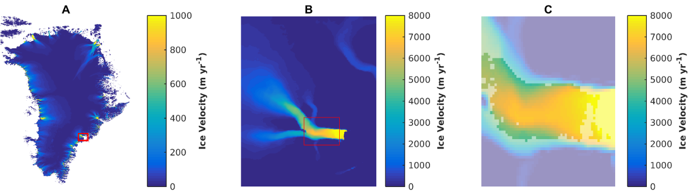
Figure S16: Maps displaying the location of pixels extracted for the velocity time series of Helheim Glacier. (A) Location of Helheim Glacier in Greenland. (B) AOI (red rectangle) used for velocity extraction. (C) Pixels common to all years, displayed over a semi-transparent velocity field. In all cases, the velocity data in this figure is the 2016 velocity field from the NASA ITS-LIVE v0 product (Gardner and others, 2018; 2019).

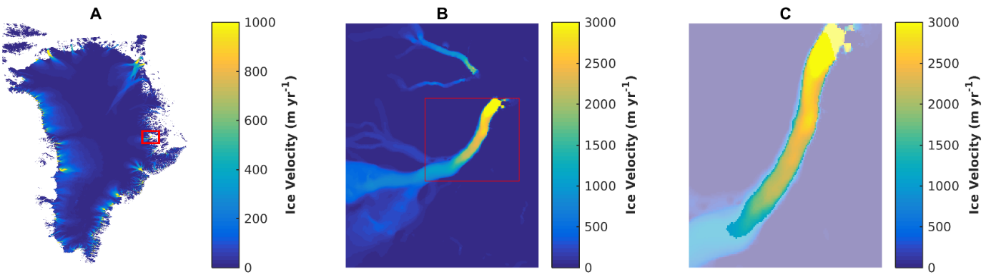
Figure S17: Maps displaying the location of pixels extracted for the velocity time series of Daugaard-Jensen Glacier. (A) Location of Daugaard-Jensen Glacier in Greenland. (B) AOI (red rectangle) used for velocity extraction. (C) Pixels common to all years, displayed over a semi-transparent velocity field. In all cases, the velocity data in this figure is the 2016 velocity field from the NASA ITS-LIVE v0 product (Gardner and others, 2018; 2019).

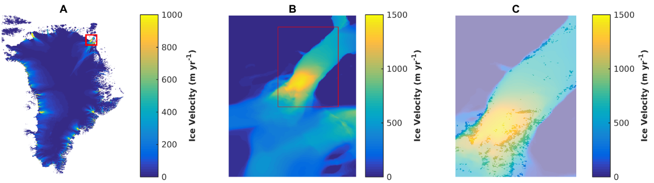
Figure S18: Maps displaying the location of pixels extracted for the velocity time series of 79 North Glacier. (A) Location of 79 North Glacier in Greenland. (B) AOI (red rectangle) used for velocity extraction. (C) Pixels common to all years, displayed over a semi-transparent velocity field. In all cases, the velocity data in this figure is the 2016 velocity field from the NASA ITS-LIVE v0 product (Gardner and others, 2018; 2019).

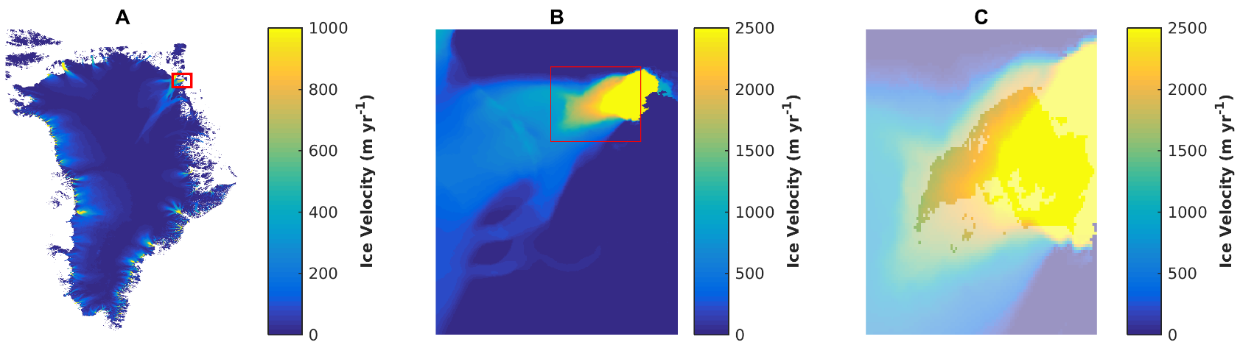
Figure S19: Maps displaying the location of pixels extracted for the velocity time series of Zacharie Isstrom. (A) Location of Zacharie Isstrom in Greenland. (B) AOI (red rectangle) used for velocity extraction. (C) Pixels common to all years, displayed over a semi-transparent velocity field. In all cases, the velocity data in this figure is the 2016 velocity field from the NASA ITS-LIVE v0 product (Gardner and others, 2018; 2019).

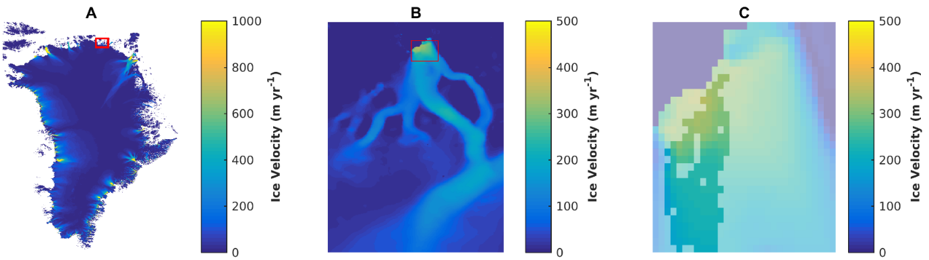
Figure S20: Maps displaying the location of pixels extracted for the velocity time series of Academy Glacier. (A) Location of Academy Glacier in Greenland. (B) AOI (red rectangle) used for velocity extraction. (C) Pixels common to all years, displayed over a semi-transparent velocity field. In all cases, the velocity data in this figure is the 2016 velocity field from the NASA ITS-LIVE v0 product (Gardner and others, 2018; 2019).

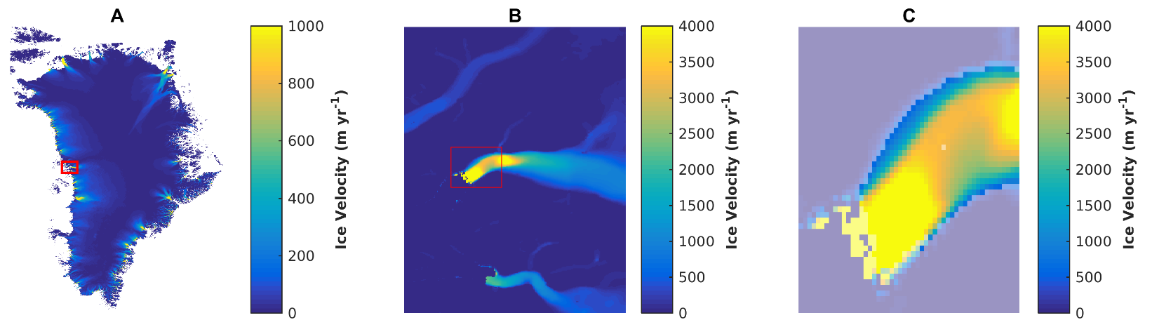
Figure S21: Maps displaying the location of pixels extracted for the velocity time series of Umiamako Isbrae. (A) Location of Umiamako Isbrae in Greenland. (B) AOI (red rectangle) used for velocity extraction. (C) Pixels common to all years, displayed over a semi-transparent velocity field. In all cases, the velocity data in this figure is the 2016 velocity field from the NASA ITS-LIVE v0 product (Gardner and others, 2018; 2019).

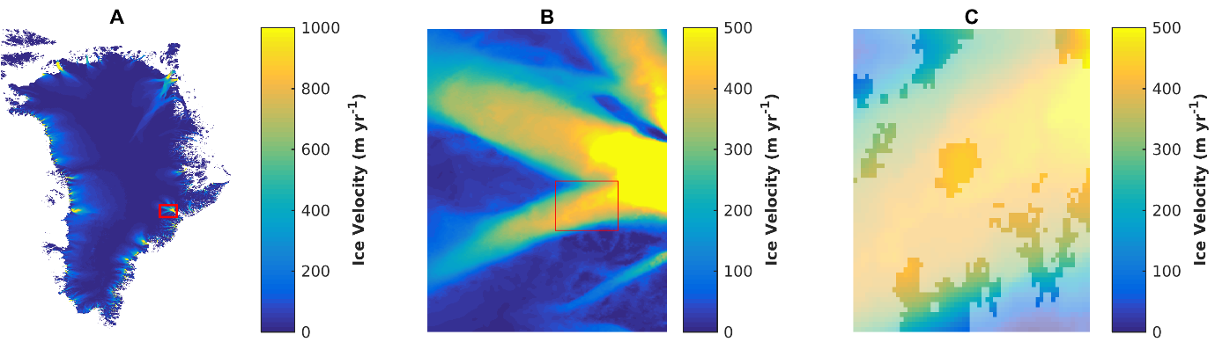
Figure S22: Maps displaying the location of pixels extracted for the velocity time series of Kangerlugssuaq Branch 1. (A) Location of Kangerlugssuaq Branch 1 in Greenland. (B) AOI (red rectangle) used for velocity extraction. (C) Pixels common to all years, displayed over a semi-transparent velocity field. In all cases, the velocity data in this figure is the 2016 velocity field from the NASA ITS-LIVE v0 product (Gardner and others, 2018; 2019).
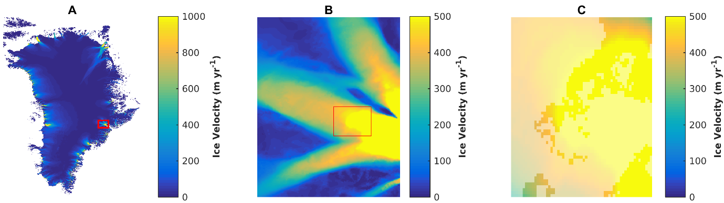
Figure S23: Maps displaying the location of pixels extracted for the velocity time series of Kangerlugssuaq Branch 2. (A) Location of Kangerlugssuaq Branch 2 in Greenland. (B) AOI (red rectangle) used for velocity extraction. (C) Pixels common to all years, displayed over a semi-transparent velocity field. In all cases, the velocity data in this figure is the 2016 velocity field from the NASA ITS-LIVE v0 product (Gardner and others, 2018; 2019).

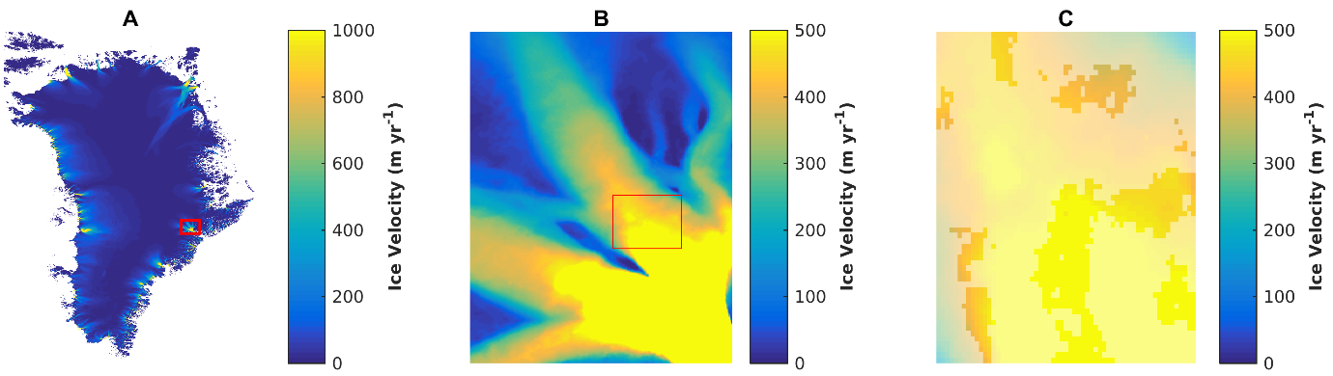
Figure S24: Maps displaying the location of pixels extracted for the velocity time series of Kangerlugssuaq Branch 3. (A) Location of Kangerlugssuaq Branch 3 in Greenland. (B) AOI (red rectangle) used for velocity extraction. (C) Pixels common to all years, displayed over a semi-transparent velocity field. In all cases, the velocity data in this figure is the 2016 velocity field from the NASA ITS-LIVE v0 product (Gardner and others, 2018; 2019).

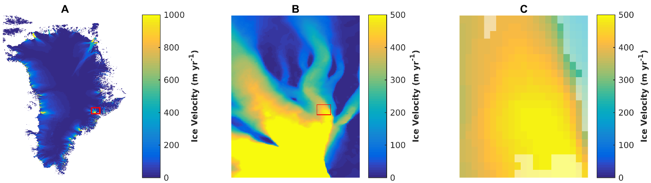

Figure S25: Maps displaying the location of pixels extracted for the velocity time series of Kangerlugssuaq Branch 4. (A) Location of Kangerlugssuaq Branch 4 in Greenland. (B) AOI (red rectangle) used for velocity extraction. (C) Pixels common to all years, displayed over a semi-transparent velocity field. In all cases, the velocity data in this figure is the 2016 velocity field from the NASA ITS-LIVE v0 product (Gardner and others, 2018; 2019).

Supplementary References
Doyle SH and 6 others (2014) Persistent flow acceleration within the interior of the Greenland ice sheet, Geophysical Research Letters, 41(3), 899–905
Gardner AS and 6 others (2018) Increased West Antarctic and unchanged East Antarctic ice discharge over the last 7 years, The Cryosphere, 12(2), 521–547
Gardner AS, Fahnestock MA and Scambos TA (2019) [Data accessed 06/06/2019], ITS_LIVE Regional Glacier and Ice Sheet Surface Velocities, Data archived at National Snow and Ice Data Center, doi:10.5067/6II6VW8LLWJ7
Hanna E and 8 others (2008) Increased runoff from melt from the Greenland Ice Sheet: A response to global warming, Journal of Climate, 21(2), 331-341
Hanna E, Mernild SH, Cappelen J and Steffen K (2012) Recent warming in Greenland in a long-term instrumental (1881-2012) climatic context: 1. Evaluation of surface air temperature records, Environmental Research Letters, 7(4), 045404
Hanna E and 6 others (2013) The influence of North Atlantic atmospheric and oceanic forcing effects on 1900-2010 Greenland summer climate and ice melt/runoff, Int J. Climatol., 33, 862-880
Hanna E and 8 others (2014) Atmospheric and oceanic climate forcing of the exceptional Greenland ice sheet surface melt in summer 2012, Int. J. Climatol., 34, 1022-1037
Hanna E and 8 others (2020) Greenland surface air temperature changes from 1981 to 2019 and implications for ice-sheet melt and mass-balance change, Int. J. Climatol., 41(S1), E1336-E1352
Hofer S, Tedstone AJ, Fettweis X and Bamber JL (2017) Decreasing cloud cover drives the recent mass loss on the Greenland Ice Sheet, Science Advances, 3(6), e1700584
Leeson AA, Eastoe E and Fettweis X (2018) Extreme temperature events on Greenland in observations and the MAR regional climate model, The Cryosphere, 12, 1091-1102
Lemos A, Shepherd A, McMillan M, Hogg AE, Hatton E and Joughin I (2018) Ice velocity of Jakobshavn Isbræ, Petermann Glacier, Nioghalvfjerdsfjorden, and Zachariæ Isstrøm, 2015–2017, from Sentinel 1-a/b SAR imagery, The Cryosphere, 12(6), 2087–2097
Morlighem, M and 31 others (2017) BedMachine v3: Complete bed topography and ocean bathymetry mapping of Greenland from multibeam echo sounding combined with mass conservation, Geophysical Research Letters, 44(21), 11,051-11,061
Noël B, van de Berg WJ, van Meijgaard E, Kuipers Munneke P, van de Wal RSW and van den Broeke MR (2015) Evaluation of the updated regional climate model RACMO2.3: summer snowfall impact on the Greenland Ice Sheet, The Cryosphere, 9, 1831-1844
Sole AJ and 6 others (2011) Seasonal speedup of a Greenland marine-terminating outlet glacier forced by surface melt-induced changes in subglacial hydrology, Journal of Geophysical Research, 116, F03014, http://dx.doi.org/10.1029/2010JF001948

