Supplementary Material

Efficiency of artificial neural networks for glacier ice-thickness estimation: a case study in Western Himalaya, India

Mohd Anul HAQ^{1*}, Mohd. Farooq AZAM², Christian VINCENT³

¹ College of Computer & Information Sciences, Majmaah University, Al-Majmaah,11952, Saudi Arabia
²Discipline of Civil Engineering, Indian Institute of Technology Indore, Simrol 453552, India
³Univ. Grenoble Alpes, CNRS, IRD, IGE, F-38000 Grenoble, France
*Corresponding author email: m.anul@mu.edu.sa

- Digitization of sidewalls and longitudinal profiles:
Five transverse sections were manually digitised on GPR cross sections (1-5) to validate the accuracy of ANN modelled ice-thickness estimates (Fig. 2a). These transverse sections were digitized in a manner such that they contain the glacier surface and 300 m of glacier sidewalls on both sides of glacier boundary (30 points on each side, amounting to a total of 60 points per section) (Fig. 2a), so that sidewall slope can be used for training.
Each transverse section was separated into two parts with an equal number of points. For example, transverse section 1 has 40 points therefore each part had 20 points. The sidewall on the right side had 30 points and was extrapolated for 20 surface points using equation S1. Similarly, the left sidewall had 30 points and was extrapolated using equation (1) for 20 points. Then these extrapolated points on both sides were joined to get the extrapolated elevation EC(Ext) of the transverse section and similarly the extrapolated slope SC(Ext) of transverse section. A similar procedure was applied for all five transverse sections to get the EC(Ext) and SC(Ext).
$f(x,a,b,c)=a^{e^{\left(-bx\right)+c}}$ (S1)
Where a=the coefficient or the initial value of the function (or the y-intercept), b=change factor, exp e is Eulers Number, x is independent variable, and c is constant.
Two longitudinal sections were manually digitized using the approach of Paul and Linsbauer (2012). One longitudinal section (L1) was digitised on the glacier surface between the current snout position at an altitude of 4095 m and 5200 m a.s.l.. A second longitudinal section (L2) was digitised between the current snout position and the assumed previous snout position (around 1400 m from the current snout) (Fig. 2a). Historically, Chhota Shigri Glacier advanced to the Chandra River during the last glacial maximum (Ramanathan and others, 2011), however we only assumed that previous glacier snout may have been 1400 m downwards from the current snout during last glacial maximum (Fig. 2b). The elevation and slope of longitudinal sections and traverse sections were extracted using Cartosat-1DEM developed in current investigation. EL1 and EL2 are the elevation profile of L1 and L2 whereas SL1 and SL2 are slope profile of L1 and L2. L2 was extrapolated using equation (1) to get extrapolated EL (ext) (glacier surface longitudinal sections) and SL (ext) (glacier surface slope of the longitudinal section).

Table S1. Measured altitude, maximum ice depth, and mean ice depth at each GPR cross-section and model output using the ANN method (ABT and AAT).

Cross sections | Altitude  dGPS  (m) | Altitude DEM  (m) | Max. depth GPR  (m) | Avg. depth GPR  (m) | Max. depth ABT  (m) | Avg. depth ABT  (m) | Max. depth AAT  (m) | Avg. depth AAT  (m)
1 | 4402 | 4393 | 124 | 96 | 153 | 87 | 130 | 85
2 | 4668 | 4658 | 240 | 190 | 289 | 176 | 263 | 189
3 | 4742 | 4735 | 245 | 160 | 251 | 145 | 250 | 154
4 | 4897 | 4895 | 270 | 200 | 281 | 178 | 277 | 187
5 | 4869 | 4874 | 175 | 132 | 183 | 127 | 179 | 131

Table S2. Mean surface altitude, ANN (AAT) based maximum ice depth and mean ice depth of the additional 5 transverse cross sections (A-E) for which GPR data was not available. The location of these cross sections is given in Fig. 1.

Cross section | Mean surface Altitude (m.a.s.l.) | Max. Ice Depth  (m) | Mean Ice Depth  (m)
A | 4477 | 167 | 97
B | 4558 | 197 | 111
C | 4788 | 260 | 165
D | 4987 | 290 | 141
E | 5143 | 180 | 94

Table S3. The values of the correlation coefficient for ABT and AAT.
Cross sections |  | ABT (r²) |  | AAT (r²)
1 | 0.86 |  | 0.91
2 | 0.96 |  | 0.99
3 | 0.93 |  | 0.98
4 | 0.92 |  | 0.96
5 | 0.95 |  | 0.99

Table S4. Mean bias error for ice thickness (m) on five GPR transverse cross sections of Chhota Shigri Glacier.
Transverse cross sections | Mean bias error for ice thickness (m)
 | ABT | AAT | GlabTop2 (Ramsankaran and others, 2018) | GlabTop2 (Frey and others, 2014) | GlabTop2 (Frey and others, 2014 on TDX-10m DEM)
Transverse 1 | 8 | 11 | 9 | 70 | -1.42
Transverse 2 | 14 | 1 | 20 | 19 | 36.88
Transverse 3 | 14 | 4 | 19 | 26 | -34.56
Transverse 4 | 21 | 13 | 22 | 53 | 53.06
Transverse 5 | 6 | 1 | 22 | 66 | 19.00

Table S5. RMSE of ice-thickness estimation on five GPR transverse sections of Chhota Shigri Glacier.
Transverse  cross sections | RMSE (in m)
 | ABT | AAT | GlabTop2 (Ramsankaran and others, 2018) | GlabTop2 (Frey and others, 2014) | GlabTop2 (Frey and others, 2014 on TDX-10m DEM)
Transverse 1 | 23 | 20 | 29.52 | 51.06 | 21.00
Transverse 2 | 24 | 6 | 19.40 | 39.49 | 74.00
Transverse 3 | 30 | 14 | 34.17 | 34.93 | 58.00
Transverse 4 | 41 | 26 | 24.14 | 34.73 | 82.00
Transverse 5 | 16 | 6 | 30.72 | 42.23 | 27.00
Overall RMSE | 24 | 13 | 27.37 | 39.61 | 52.40

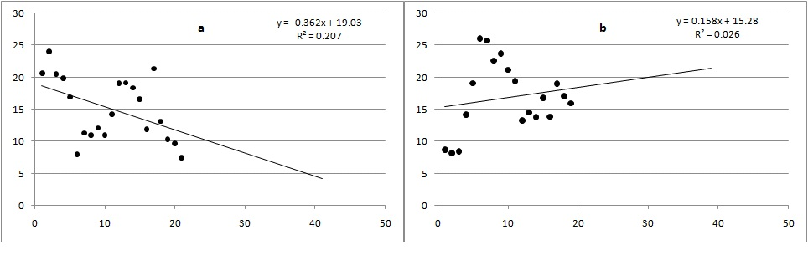
Fig. S1. The simple linear regression was attempted to get the value of subsurface slope with the help of sidewall information (a for left sidewall and b for right sidewall for Profile 1. X-axis represent the local slope of profile 1 and Y-axis represent the dependent slope calculated from regression.

