Future glacial lakes in High Mountain Asia: an inventory and assessment of hazard potential from surrounding slopes – Wilhelm Furian, David Loibl, and Christoph Schneider

Supplementary Material
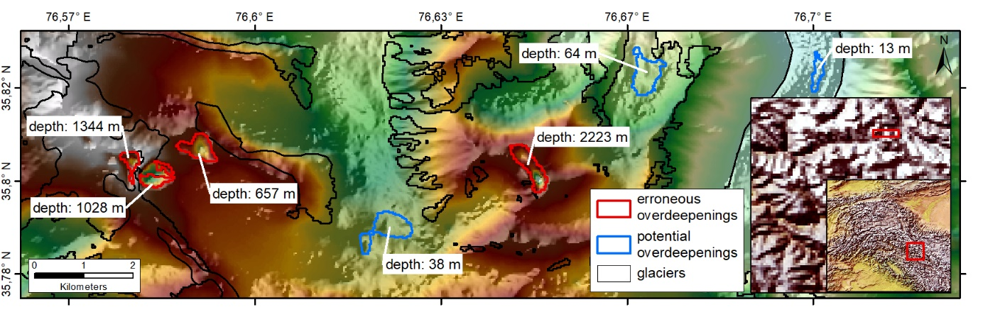
Fig. S1. Computed overdeepenings (red outline) that were excluded due to depth values clearly affected by void-filling artifacts in the AW3D30 DEM. Blue outlines indicate potential glacial lakes with more realistic depths.
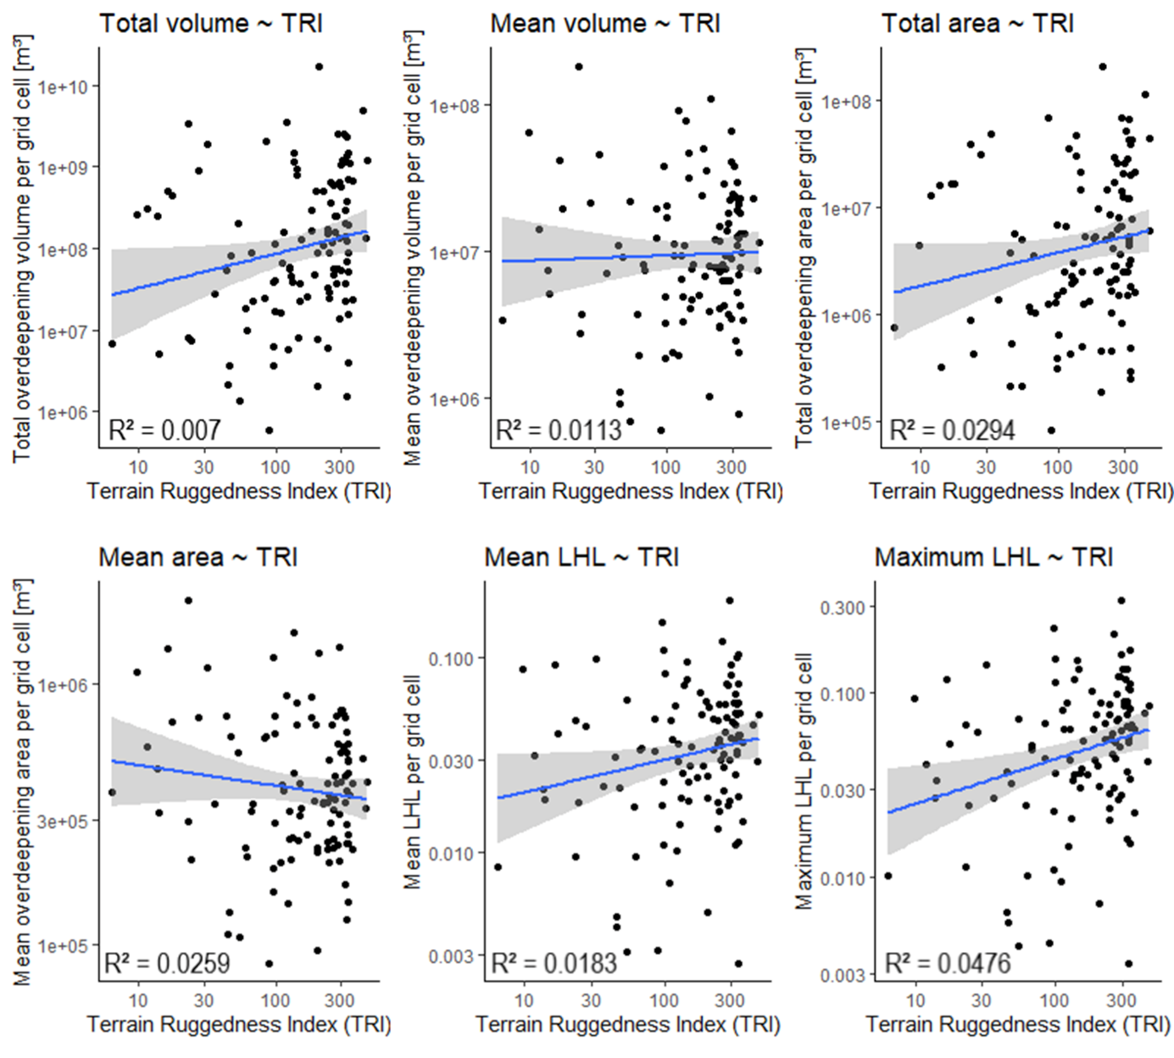
Fig. S2. Further correlations between a grid cell’s ruggedness and its overdeepening volume (total and mean), its overdeepening area (total and mean) as well as its LHL_{mean} and LHL_{max}.
Table S1. TRI-based terrain comparison for selected regions in HMA
Rugged regions | TRI |  | Less rugged regions | TRI
Central Tien Shan | 331 |  | Gangdise | 71
Central Karakoram | 226 |  | Zanskar | 65
Mahalangur | 219 |  | Qilian | 53
Pamir | 170 |  | Hindu Kush W | 49
Nyianqentanglha E | 152 |  | Inner Tibet C | 19

Table S2. Statistics for glaciers and the computed overdeepenings in all regions of HMA with overdeepenings >10⁵ m².
 | Overdeepenings |  |  |  |  |  | Glaciers
 |  | Area  [km²] |  | Volume  [10⁶ m³] |  | Depth  [m] | Area  [km²] | Volume  [km³] | Ratio  [%]
 | Count | Mean | Cumulative | Mean | Cum. | Mean | Cum. | Cum. | Area | Volume
Karakoram C | 653 | 0.8 | 500.8 | 45 | 29464 | 46 | 13432 | 457 | 3.73 | 6.44
Kunlun W | 248 | 0.5 | 126.4 | 14 | 3354 | 31 | 8223 | 436 | 1.54 | 0.77
Pamir N | 221 | 0.6 | 136.4 | 26 | 5773 | 54 | 5732 | 296 | 2.38 | 1.95
Nun Kun | 185 | 0.4 | 73.0 | 11 | 2013 | 45 | 3512 | 238 | 2.08 | 0.85
Tien Shan C | 159 | 0.6 | 94.1 | 25 | 3951 | 45 | 5478 | 203 | 1.72 | 1.95
Karakoram W | 136 | 0.5 | 72.9 | 18 | 2484 | 57 | 3073 | 152 | 2.37 | 1.64
Nyainqentanglha E | 88 | 0.5 | 43.6 | 18 | 1565 | 44 | 3990 | 195 | 1.09 | 0.80
Banderpunch Gangotri | 67 | 0.4 | 26.3 | 12 | 799 | 44 | 1858 | 110 | 1.42 | 0.73
Tangulha | 64 | 1.0 | 66.6 | 39 | 2476 | 60 | 1895 | 140 | 3.52 | 1.77
Kangri Garpo | 62 | 0.8 | 50.1 | 40 | 2495 | 55 | 1989 | 104 | 2.52 | 2.40
Mahalangur | 60 | 0.9 | 54.4 | 47 | 2805 | 46 | 1708 | 103 | 3.18 | 2.73
Hindu Kush N | 58 | 0.4 | 24.7 | 12 | 717 | 70 | 1558 | 104 | 1.58 | 0.69
Dhaulagiri | 54 | 0.3 | 17.8 | 7 | 398 | 39 | 1575 | 87 | 1.13 | 0.46
Kunlun E | 50 | 1.2 | 60.4 | 74 | 3772 | 43 | 1656 | 98 | 3.65 | 3.86
Kunlun C | 47 | 0.7 | 33.4 | 20 | 943 | 61 | 1340 | 86 | 2.49 | 1.09
Bhutan | 47 | 0.9 | 43.1 | 81 | 3813 | 37 | 1258 | 77 | 3.42 | 4.98
Tien Shan W | 42 | 0.4 | 16.6 | 13 | 555 | 39 | 3552 | 175 | 0.47 | 0.32
Borohoro | 42 | 0.3 | 14.6 | 8 | 323 | 43 | 2065 | 107 | 0.71 | 0.30
Karakoram NE | 37 | 0.3 | 10.5 | 5 | 195 | 36 | 1850 | 105 | 0.57 | 0.19
Inner Tibet SE | 34 | 0.5 | 16.0 | 7 | 250 | 28 | 541 | 42 | 2.96 | 0.60
Lahaul Spiti | 33 | 0.3 | 10.1 | 6 | 200 | 47 | 1083 | 61 | 0.93 | 0.33
Pamir Sabykol | 27 | 0.4 | 12.0 | 11 | 297 | 48 | 1632 | 81 | 0.73 | 0.37
Kumaon Chandi | 26 | 0.3 | 6.6 | 7 | 186 | 68 | 1224 | 66 | 0.54 | 0.28
Rolwaling | 26 | 0.8 | 20.8 | 40 | 1053 | 48 | 795 | 51 | 2.61 | 2.08
Hissar Alay | 25 | 0.3 | 8.0 | 7 | 182 | 62 | 1846 | 87 | 0.43 | 0.21
Inner Tibet C | 25 | 0.7 | 17.2 | 18 | 456 | 31 | 531 | 43 | 3.24 | 1.07
Kangchenjunga | 25 | 0.5 | 13.1 | 23 | 568 | 38 | 1215 | 59 | 1.08 | 0.96
Annapurna | 24 | 0.3 | 7.6 | 8 | 194 | 47 | 1240 | 67 | 0.62 | 0.29
Pamir C | 18 | 0.5 | 8.5 | 14 | 254 | 43 | 2511 | 117 | 0.34 | 0.22
Hengduan | 13 | 0.2 | 2.9 | 5 | 66 | 34 | 1335 | 60 | 0.22 | 0.11
Inner Tibet W | 12 | 0.5 | 5.8 | 17 | 207 | 58 | 1344 | 88 | 0.43 | 0.23
Hindu Kush E | 12 | 0.3 | 3.2 | 4 | 51 | 48 | 865 | 42 | 0.37 | 0.12
Nanga Parbat-Haramosh | 12 | 0.4 | 5.0 | 12 | 143 | 29 | 613 | 34 | 0.81 | 0.42
Kangto | 12 | 0.5 | 6.6 | 19 | 231 | 45 | 481 | 27 | 1.37 | 0.86
Karakoram NW | 10 | 0.2 | 1.7 | 4 | 40 | 35 | 2418 | 139 | 0.07 | 0.03
Qilian | 9 | 0.3 | 2.5 | 4 | 38 | 34 | 1637 | 76 | 0.15 | 0.05
Transhimalaya C | 6 | 0.1 | 0.7 | 1 | 5 | 14 | 1216 | 56 | 0.06 | 0.01
Karakoram E | 5 | 0.2 | 1.2 | 3 | 17 | 41 | 1786 | 95 | 0.07 | 0.02
Inner Tibet NE | 4 | 1.1 | 4.4 | 64 | 256 | 36 | 211 | 17 | 2.11 | 1.48
Hindu Kush W | 4 | 0.2 | 0.9 | 6 | 22 | 41 | 632 | 27 | 0.15 | 0.08
Namchabarwa | 4 | 0.1 | 0.6 | 2 | 9 | 62 | 298 | 15 | 0.19 | 0.06
Nyainqentanglha W | 3 | 0.3 | 1.0 | 7 | 22 | 28 | 752 | 34 | 0.14 | 0.07
Himalaya E | 3 | 0.1 | 0.4 | 2 | 6 | 40 | 223 | 9 | 0.19 | 0.06
Bayan Har | 2 | 0.6 | 1.2 | 12 | 24 | 46 | 313 | 15 | 0.40 | 0.16
Zanskar | 2 | 0.3 | 0.5 | 2 | 4 | 17 | 1521 | 63 | 0.03 | 0.01
Pir Panjal | 2 | 0.1 | 0.3 | 2 | 4 | 30 | 341 | 17 | 0.09 | 0.02
Bogda | 1 | 0.6 | 0.6 | 17 | 17 | 101 | 145 | 6 | 0.45 | 0.28
Pamir W | 0
Alatau | 0
Tien Shan N | 0
Karlik | 0
Altun | 0
Transhimalaya E | 0
Transhim. W | 0
Goikarla Rigyu | 0
Ladakh | 0
Pachakshiri | 0

