JOURNAL OF GlACIOLOGY
Supplementary Material for
Investigating the bias of TanDEM-X digital elevation models of glaciers on the Tibetan Plateau: impacting factors and potential effects on geodetic mass-balance measurements
JIA LI^{1, 2}, ZHI-WEI LI^{1*}, JUN HU^{1*}, LI-XIN WU^{1, 2}, XIN LI³, LEI GUO^{1, 2}, ZHUO LIU¹, ZE-LANG MIAO^{1,2}, WEI WANG^{1,2}, JUN-LI CHEN⁴
¹School of Geosciences and Info-Physics, Central South University, Changsha 410083, China.
²Laboratory of GeoHazards Perception, Cognition and Predication, Central South University, Changsha 410083, China.
³Institute of Tibetan Plateau Research, Chinese Academy of Sciences, Beijing 100101, China.
⁴Shanghai Institute of Satellite Engineering, Shanghai 200090, China.
Correspondence: Zhi-wei Li <zwli@csu.edu.cn>; Jun Hu <csuhujun@csu.edu.cn>

Contents of this file

Table S1
Figures S1 and S2
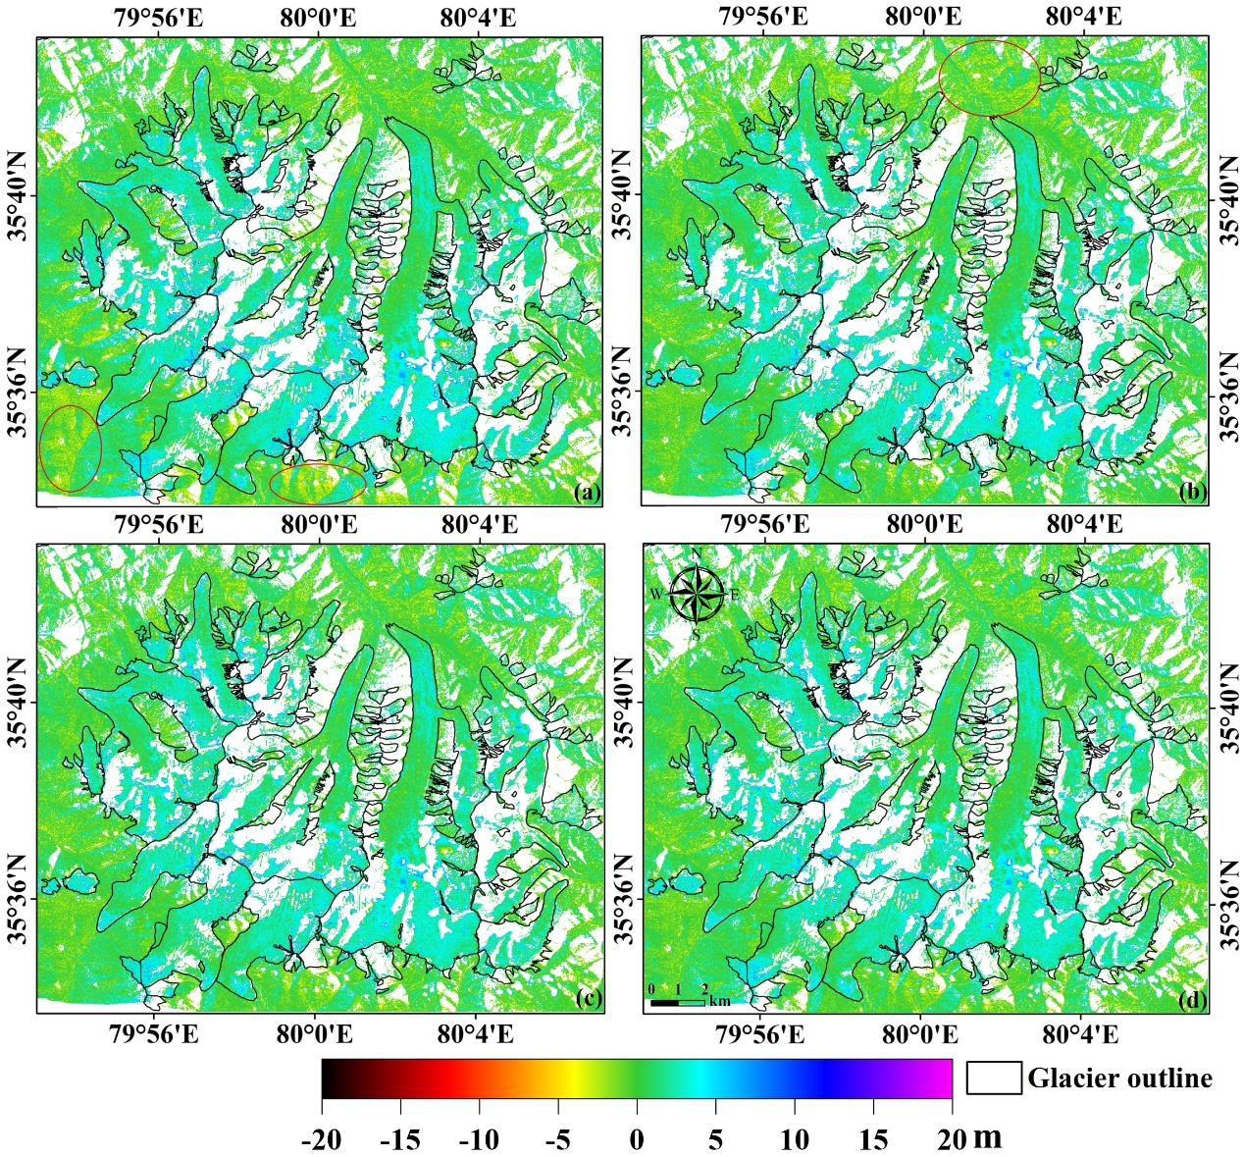
Figure. S1. Improvement of the elevation difference map of Site 1 (SPOT-6 DEM on 10/4/2014 minus the TanDEM-X DEM on 16/4/2014). (a) Raw elevation difference map. (b) Elevation difference map after DEM co-registration. (c) Elevation difference map after planimetric position-related bias correction. (d) Elevation difference map after terrain curvature-related bias correction. White areas present gaps in the data. The red ellipses in (a) and (b) mark the nonglacierised area with bias correction.
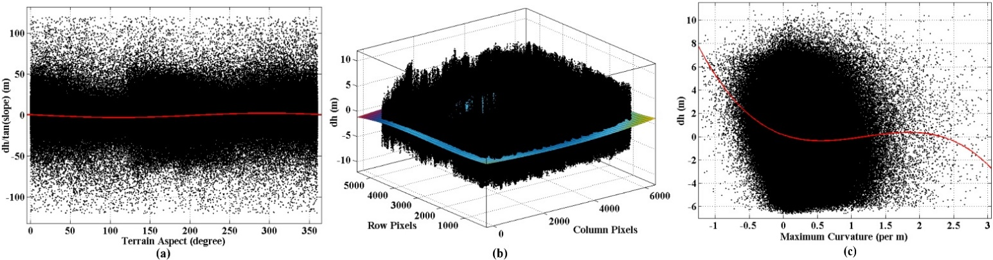
Figure. S2. Universal bias trends fitted for the elevation differences over stable areas in Site 1. (a) Scatterplot between the ratio of the raw elevation difference over the tangent of the slope (dh/tan(slope)) and the terrain aspect. The red curve is the fitted model (cosine function). (b) Three-dimensional view of the scatterplot of the elevation difference (after DEM co-registration) vs. the planimetric positions. The surface is the fitted trend obtained using a quadratic polynomial. (c) Scatterplot of the elevation difference (after DEM co-registration and the correction of planimetric error) vs. the terrain maximum curvature. The red curve is the fitted trend obtained using a third-order polynomial.

Table S1. Statistics of elevation differences over stable areas in Fig. S1.
Elevation differences | Mean (m) | Median (m) | NMAD (m) | NMAD improvement
Raw | 0.01 | -0.13 | 1.86 | -----
After co-registration | -0.01 | -0.11 | 1.71 | 8.1%
After planimetric position-related bias correction | -0.01 | -0.12 | 1.70 | 0.6%
After curvature-related bias correction | 0.00* | -0.12 | 1.68 | 1.2%
*The computed value before rounding is -0.004.

