Supplementary Information

Accelerated glacier mass loss in the largest river and lake source regions of the Tibetan Plateau and its links with local water balance over 1976−2017

Wenfeng Chen^{1,4*}, Tandong Yao^{1,2}, Guoqing Zhang^{1,2}, Shenghai Li¹, Guoxiong Zheng^{3,4}

¹ Key Laboratory of Tibetan Environmental Changes and Land Surface Processes, Institute of Tibetan Plateau Research, Chinese Academy of Sciences (CAS), Beijing, China
² CAS Center for Excellence in Tibetan Plateau Earth Sciences, Beijing 100101, China
³ Xinjiang Institute of Ecology and Geography, Chinese Academy of Sciences, Urumqi 830011, China
⁴ University of Chinese Academy of Sciences, Beijing 100049, China

Table S1 Parameters used to derive glacier surface elevation change. dx, dy, dz means the shift in the x- y- z- directions. The off-glacier range means the area is not covered by glacier.
Usage | Date | dx (m) | dy (m) | dz (m) | Mean dh in off-glacier region (m)
 | 1976 | 58.41 | -14.93 | -74.85 | 0.14
Elevation change over 2000−2011 | 2011/03/08 | 38.09 | -31.93 | 4.80 | -0.23
 | 2011/05/13 | 40.16 | -27.26 | 2.18 | -0.00
 | 2011/06/04 | 31.87 | -23.95 | 1.08 | -0.03
 | 2011/06/04_2 | 40.24 | -23.38 | 5.31 | 0.04
 | 2011/10/03 | 46.89 | -18.07 | 6.51 | -0.07
Elevation change over 2000−2017 | 2014/04/07 | 39.17 | -32.28 | 4.22 | -0.02
 | 2017/01/08 | 40.21 | -27.18 | 2.18 | -0.02
 | 2017/01/30 | 31.86 | -23.97 | 1.08 | -0.01
 | 2017/04/28 | 40.23 | -25.40 | 5.31 | -0.01
Elevation change relative to 2017/01/08 | 2016/09/07 | - | - | - | 0.01
 | 2017/01/30 | - | - | - | 0.01
 | 2017/04/17 | - | - | - | 0.02
 | 2017/05/09 | - | - | - | 0.05
 | 2017/06/11 | - | - | - | 0.06
 | 2017/07/03 | - | - | - | 0.02
 | 2017/09/09 | - | - | - | 0.04
Penetration | SRTM-X | -14.56 | -25.11 | -34.79 | 0.27

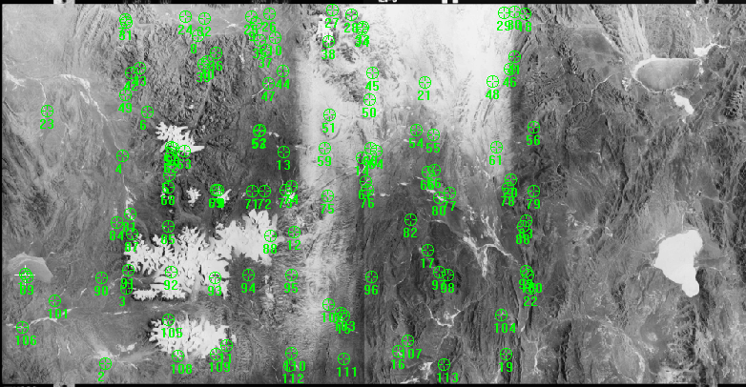
Fig. S1 Location of the ground control and tie points used in the generation of KH-9 DEM.

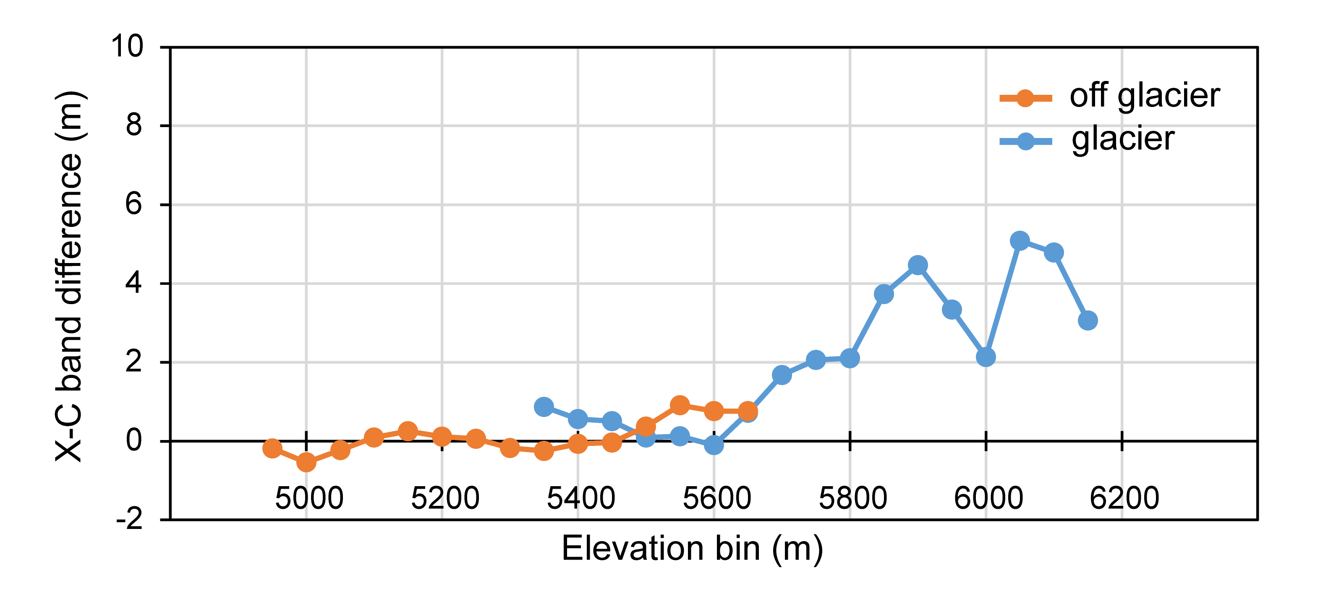
Fig. S2 Penetration correction using SRTM-X and SRTM-C. The orange indicates the elevation difference after error removal in the off-glacier area. The blue is the elevation difference after error removal in the glacier area. The penetration depth between and X- and C- band is calculated based on the blue line.

Fig. S3 Elevation change rate in the glacier and off-glacier area over 1976−2000 (upper), 2000−11 (middle) and 2000−17 (bottom). RGI6.0 glacier outlines are shown.
Fig. S4 Glacier surface elevation change of each glacier with altitude over 1976−2000 (upper), 2000−11 (middle) and 2011−17 (bottom). The median elevation of each glacier is adopted. The black lines are the linear trends.

Fig. S5 Area change of Selin Co (upper) and ChibzhangCo- Dorsodiong Co (bottom) over 1976−2017.

Fig. S6 Snow cover condition change detected by MODIS data in the Geladandong region in the spring of 2017. This could alter the properties of the SAR penetration depth.

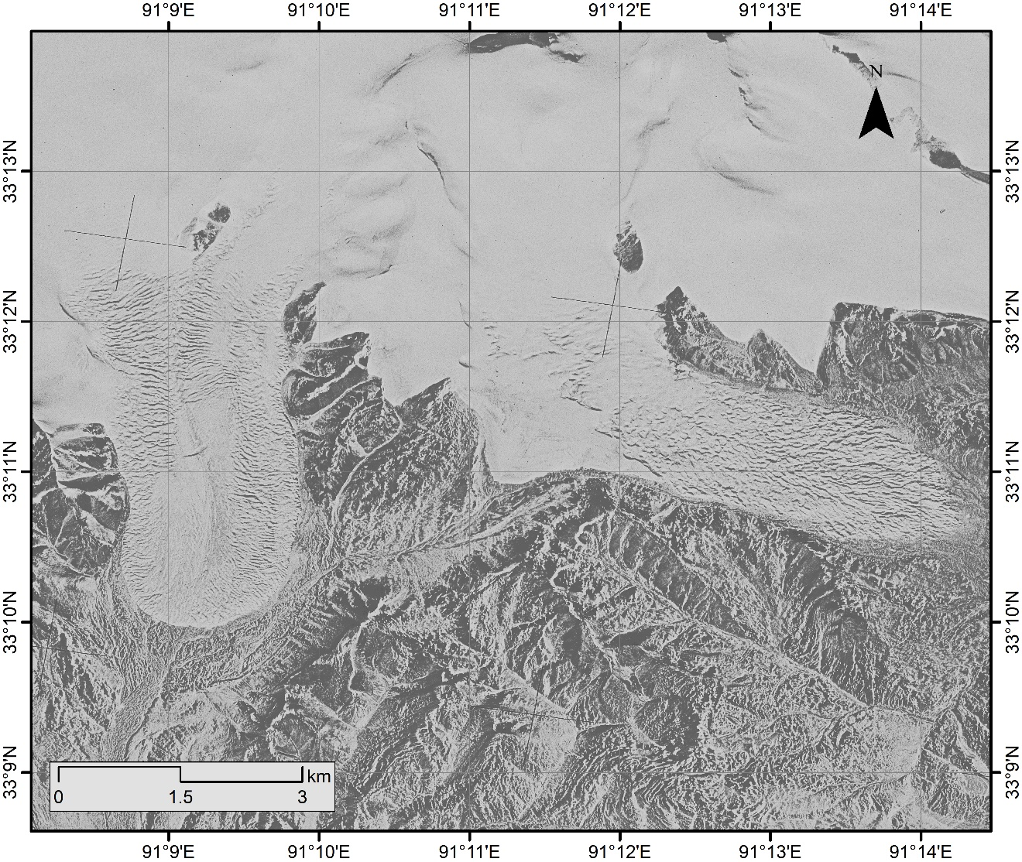
Fig. S7 Example of glaciers with rough surface detected by KH-9 on 7 January 1976.

