Supplementary material for: Determining the evolution of an alpine glacier drainage system by solving inverse problems
Inigo Irarrazaval¹, Mauro A. Werder^{2,3}, Matthias Huss^{2,3,4}, Frederic Herman¹ and Gregoire Mariethoz¹

¹ Institute of Earth Surface Dynamics, University of Lausanne, Lausanne, Switzerland
² Laboratory of Hydraulics, Hydrology and Glaciology (VAW), ETH Zurich, Zurich, Switzerland
³ Swiss Federal Institute for Forest, Snow and Landscape Research (WSL), Birmensdorf, Switzerland
⁴ Department of Geosciences, University of Fribourg, Fribourg, Switzerland

Subglacial channel generator code and movie
Please refer to the file attached separately “Subglacial_channel_generator.gif”. The figure shows how varying the shift parameter (s) translates the Gaussian random field (black box cropping area), influencing the hydraulic potential and consequently the channel network. For simplicity l_{xy} and f are kept constant in the example.
An example Matlab code of the subglacial channel generator can be found at https://github.com/iirarraz/Subglacial_channel_generator.git

Data: Discharge and hydraulic head for each snapshot
Field data used to condition each of the snapshots are summarized in Table S1.
Table S1. Discharge and elevation of the water level in boreholes
 |  | Snapshot 1 | Snapshot 2 | Snapshot 3 | Snapshot 4 | Snapshot 5
 |  | 09-Jun | 08-Jul | 10-Aug | 01-Sep | 26-Sep
Mean discharge (m3s-1) | Gauging station | 6.5 | 10.5 | 9.2 | 13.1 | 4.1
Mean water level elevation  (m a.s.l.) | Bh1 | 2394.55 | 2333.43 | 2468.96 | 2458.30 | 2458.47
 | Bh2 | 2486.75 | 2472.93 | 2471.27 | 2470.72 | 2470.29
 | Bh3 | 2389.35 | 2374.92 | 2362.85 | 2394.95 | 2406.98
 | Bh4 | - | 2334.08 | 2466.23 | 2467.34 | 2466.02
 | Bh5 | - | 2487.11 | 2483.23 | 2482.47 | 2481.07
 | Bh6 | 2464.62 | 2502.42 | 2505.18 | 2493.17 | 2493.30
 | Bh7 | 2405.17 | 2444.14 | 2435.67 | 2434.39 | 2433.73
*Cases with strong diurnal oscillations are underlined

Moulin sensitivity tests
To assess the impact of moulin location on generating subglacial channels we created a set of realizations which randomly sampled moulins and assigned a water recharge contribution proportionally to its Voronoi area. First, a moulin density map was computed from field observations (Loye, 2006). The density map represents the probability of finding a moulin within the model domain (Figure S1).

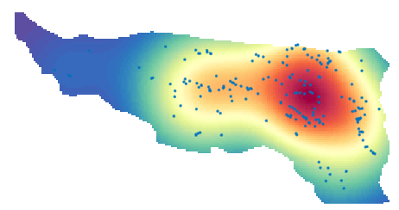
Figure S1. Moulin density map. Blue points correspond to moulins mapped in the survey. Red colours represent a high moulin probability which decreases into low moulin probabilities in blue.
Then, we randomly sampled the moulin density map to inspect the unconditioned subglacial systems created by the subglacial channel generator. In Figure S2 we present a series of cases with different number of moulins and/or location. For comparison, we considered the same Gaussian random field and structural parameters (l_{xy}, s , f).
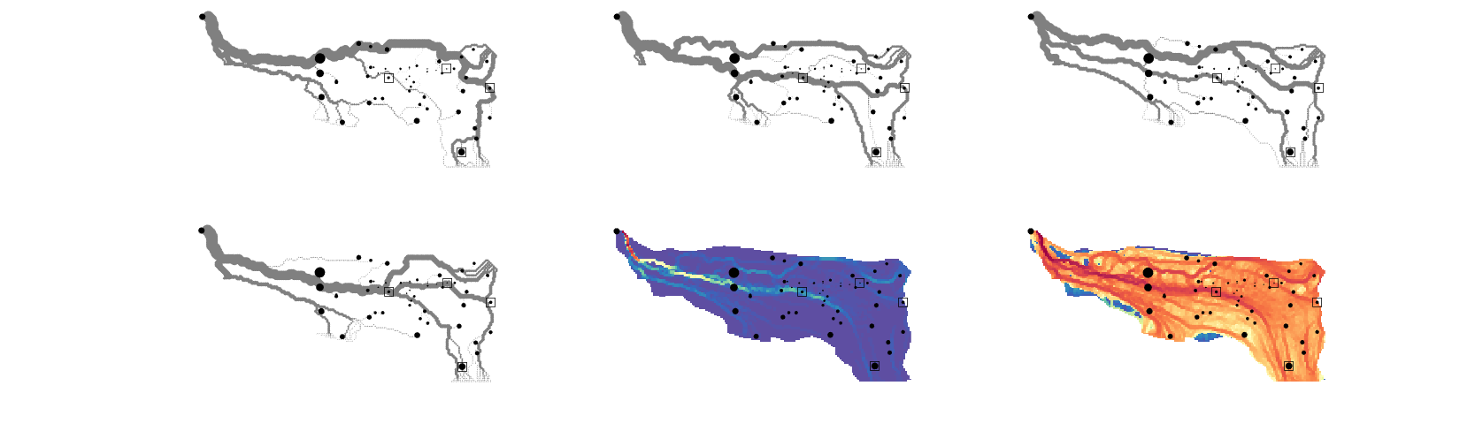
Figure S2. Moulin sensitivity test with 50 randomly sampled moulins. Top and bottom left panels show examples of unconditional subglacial channel networks (grey lines). Black dots indicate moulins with a size is proportional to water recharge. The lower middle panel shows the normalized sum of the accumulated flow for 500 realizations. The bottom right panel shows the log10 of the normalized sum of the accumulated flow for 500 realizations

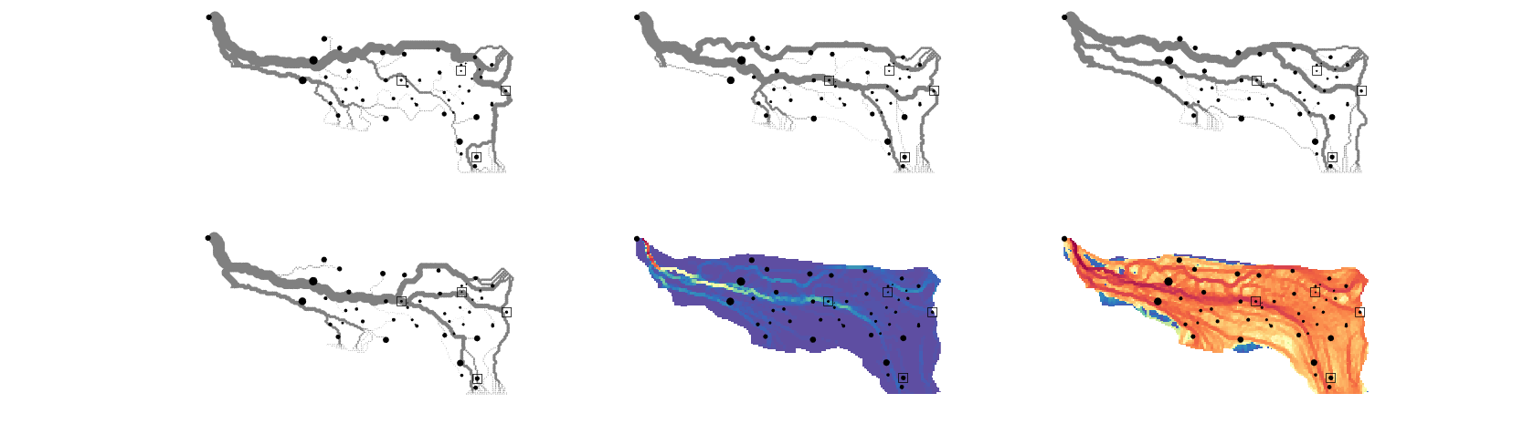
Figure S3. Moulin sensitivity test with 50 randomly sampled moulins (different locations from previous figure) . Top and bottom left panels show examples of unconditional subglacial channel networks (grey lines). Black dots indicate moulins with a size is proportional to water recharge. The lower middle panel shows the normalized sum of the accumulated flow for 500 realizations. The bottom right panel shows the log10 of the normalized sum of the accumulated flow for 500 realizations.

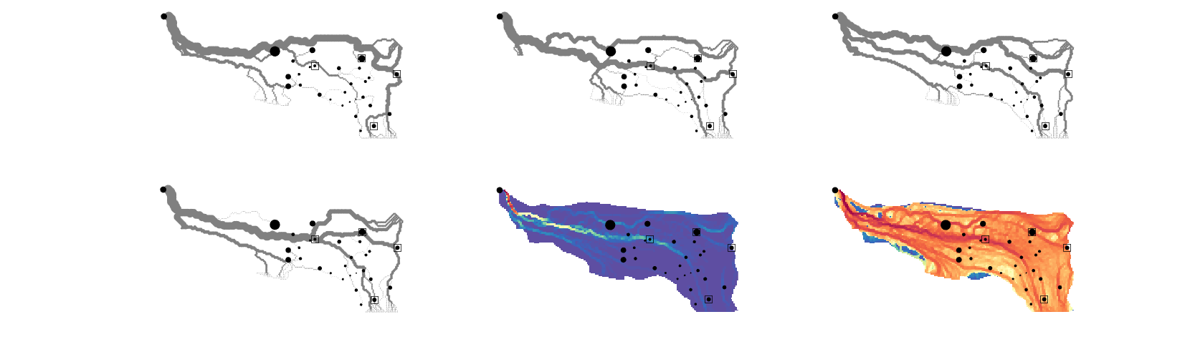
Figure S4. Moulin sensitivity test with 30 randomly sampled moulins. Top and bottom left panels show examples of unconditional subglacial channel networks (grey lines). Black dots indicate moulins with a size is proportional to water recharge. The lower middle panel shows the normalized sum of the accumulated flow for 500 realizations. The bottom right panel shows the log10 of the normalized sum of the accumulated flow for 500 realizations.

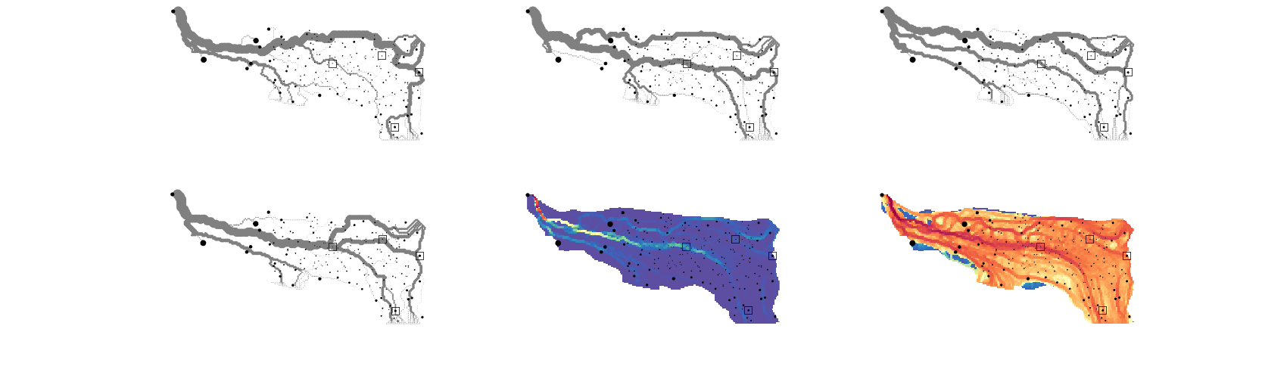
Figure S5. Moulin sensitivity test with 200 randomly sampled moulins. Top and bottom left panels show examples of unconditional subglacial channel networks (grey lines). Black dots indicate moulins with a size is proportional to water recharge. The lower middle panel shows the normalized sum of the accumulated flow for 500 realizations. The bottom right panel shows the log10 of the normalized sum of the accumulated flow for 500 realizations
Last, we carried out a sensitivity test on the number of moulins to determine their influence on the hydraulic potential (equation 1) computed by the steady-state water flow model. For the tests, water forcing of snapshot 3 is considered and borehole observations are used to condition the subglacial channels. In addition, the structural parameters (s, f and l_{xy}) are fixed for all subglacial channel networks to ensure comparability. We sampled 204 moulins from the moulin density map (Figure S1), then subsampled for each of the different tests. Results indicate that main subglacial channel structures are preserved and are located on depressions of the hydraulic potential (Figure S6). Cases with less than 100 moulins, show overall similar patterns of high/low hydraulic potential areas. However, for tests with 100 and 204 moulins, the hydraulic potential is higher in the upper part of the model domain and exhibits steep gradients near subglacial channels (see contour lines in Figure S6). This can be attributed to the fact that moulin recharge is inputted directly to the subglacial system and areas with high moulin density represent a distributed inflow. We consider that a configuration with more than 100 moulins is unlikely as many of those moulins could be connected englacially before reaching the glacier bed.
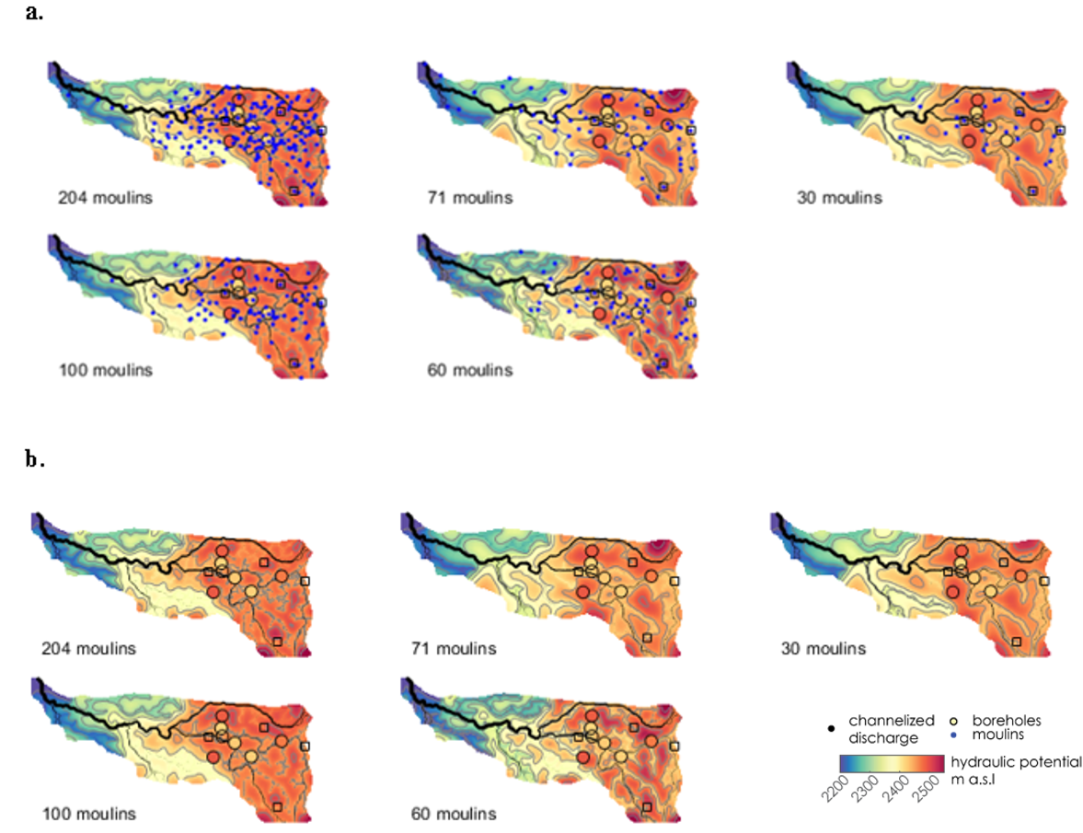
Figure S6. Moulin number sensitivity to a steady-state water flow model under the same forcing conditions (snapshot 3). Colour and contour lines indicate the hydraulic potential, black lines indicate subglacial channel discharge. For each test, the structural parameters are fixed. Panel (a) shows the hydraulic potential and moulins (blue dots). Panel (b) shows the same results as in panel (a) but without moulins for clarity.

Likelihood function form
We present the functional form of equation 11 (Eq. S1) plotted as exp(-S_{ts}) considering, ${d^{ts}}_{min}=0.1$, ${d^{ts}}_{max}=1.2$ and ${σ_{i}}^{ts}=0.25$ms⁻¹ on the y axis. For a range of outputted transit times $0.01≤F_{i}\left(m\right)≤2$ on the x axis,
$S_{ts}=\frac{1}{2}\sum_{i=1}^{n}{{\left(I^{ts}\frac{min⁡(\left|F_{i}\left(m\right){{-d}^{ts}}_{min}\right|,\left|F_{i}\left(m\right)-{d^{ts}}_{max}\right|)}{{σ_{i}}^{ts}}\right)}^{2}} , I^{ts}=\left\{\begin{aligned}0, &{{d^{ts}}_{min}≤F}_{i}\left(m\right)≤{d^{ts}}_{max}, \\ 1, &{{d^{ts}}_{min}>F}_{i}\left(m\right) or {{d^{ts}}_{max}<F}_{i}\left(m\right). &\end{aligned}\right.$ (S1)
Similarly, for comparison we plot equation 8 (Eq. S2) as exp(-S) assuming $d^{ts}=0.5$ ms⁻¹ and ${σ_{i}}^{ts}=0.25$ms⁻¹
$S=\frac{1}{2}\sum_{i=1}^{n}{{\left(\frac{F_{i}\left(m\right)- d^{ts})}{{σ_{i}}^{ts}}\right)}^{2}}$. (S2)
It is observed that for equation 11 (Eq. S1), exp(-S_{ts}) equals one between the range ${d^{ts}}_{min}$ and ${d^{ts}}_{max}$ (Figure S7). In other words, the likelihood is maximum when transit speeds are within the bounds. Outside these bounds the likelihood decreases. This is contrasting with equation 8 (Eq. S2) where the likelihood decreases immediately from the observed value (considered 0.5ms⁻¹ in the example).
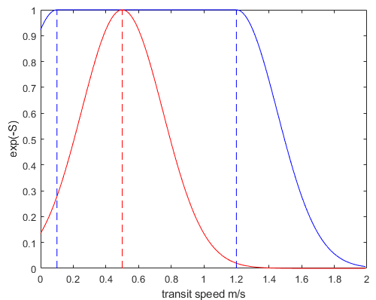
Figure S7. The blue line represents the functional form of equation 11 and the dashed blue lines indicates minimum and maximum constraints. The red line indicates functional form of equation 8.

Conditioned subglacial systems independent inversion (snapshot 3).
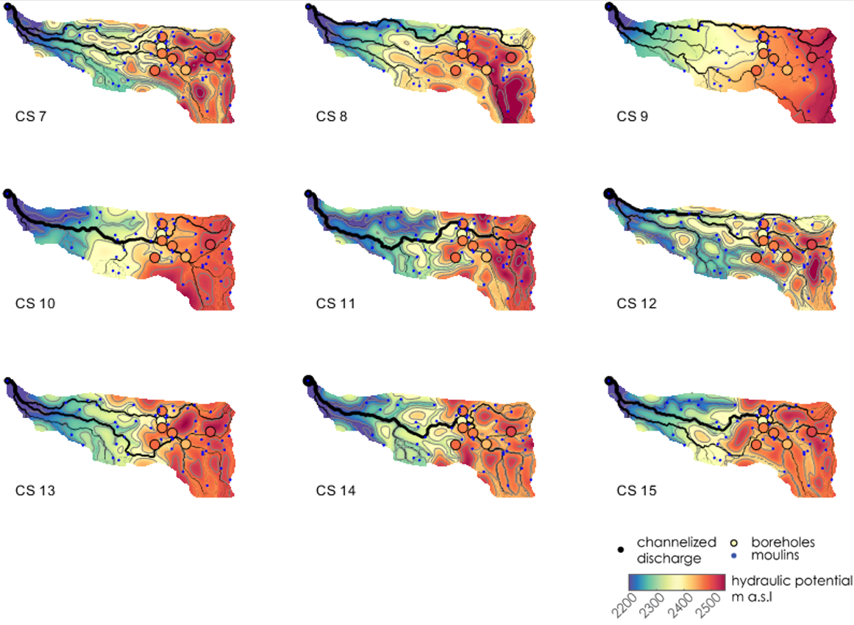Figure S8. Conditioned subglacial systems for nine independent inversions of the reference snapshot (snapshot 3). Each panel shows the maximum likelihood hydraulic potential field and channel discharge.

Snapshots across the melt season for CS 2
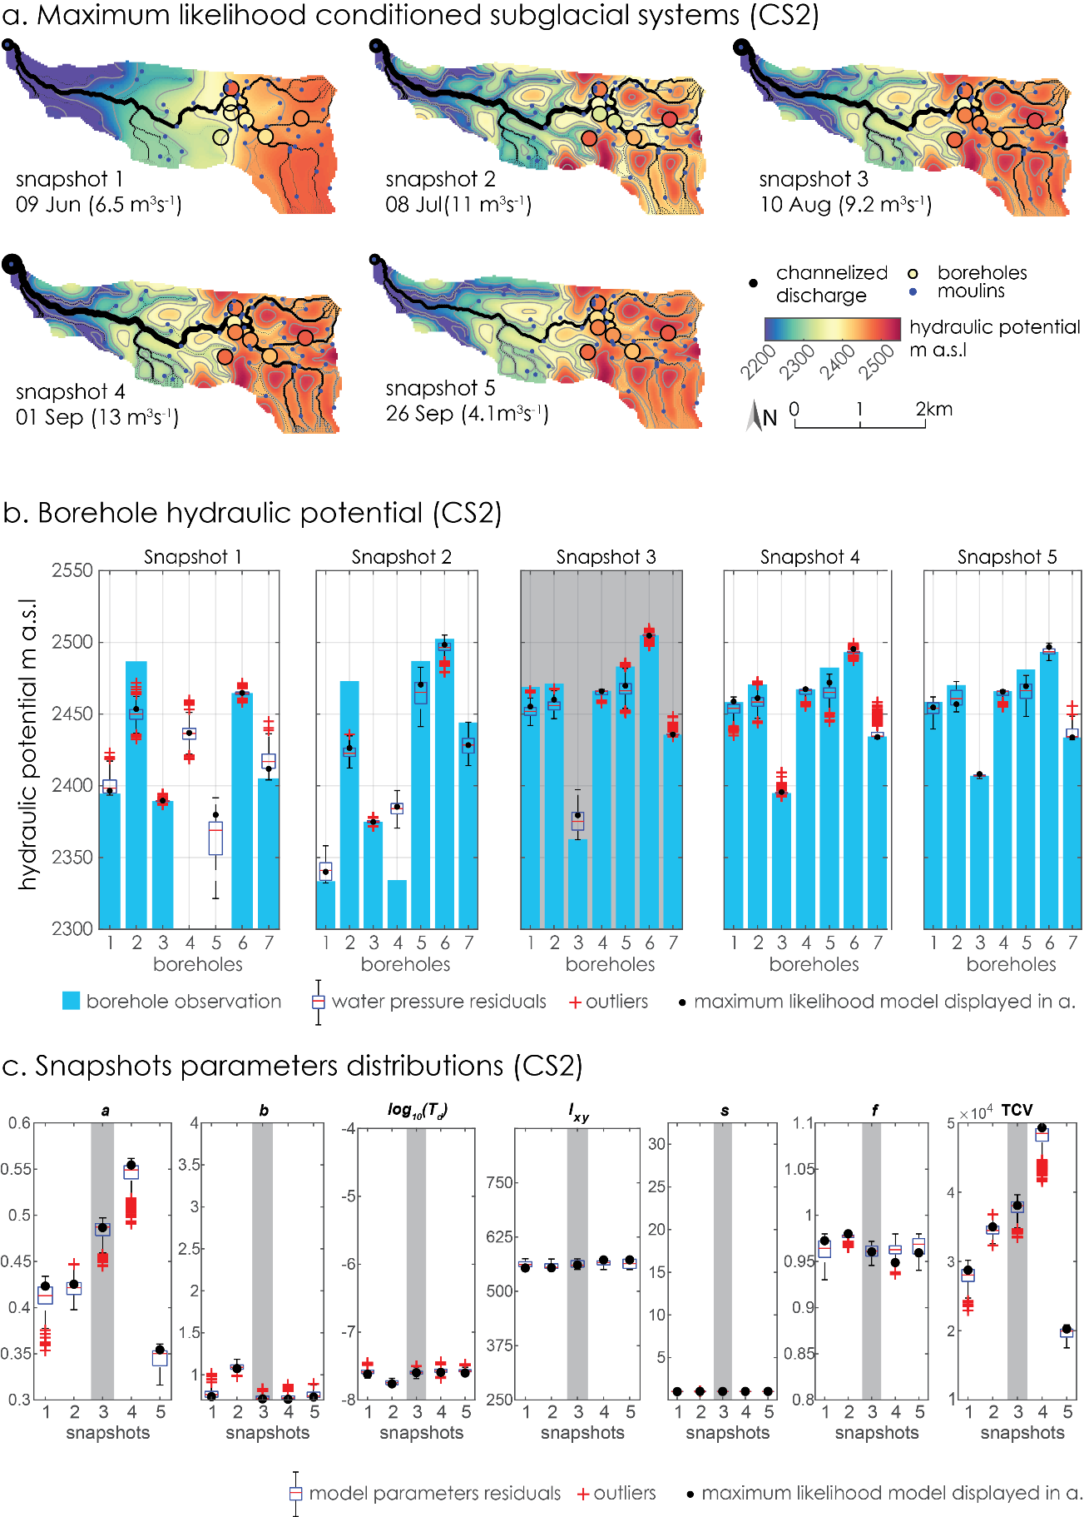
Figure S9. Conditioned subglacial system (CS 2) across the melt season (five snapshots). Grey bands indicate the reference snapshot (snapshot 3) (a) Maximum likelihood hydraulic potential field and channel discharge. Discharge at the outlet is provided in parentheses (b) Borehole water pressure residuals (boreholes in x-axis). In snapshot 1, boreholes 4 and 5 do not have data. Observations are displayed as blue vertical bands, and the black dot indicates the maximum likelihood model displayed in (a). Boxplots indicate the uncertainty with boxes corresponding to the 25th and 75th percentiles, respectively. The whiskers extend to the most extreme data points (~±2.7σ for normal distribution). Outliers are plotted as red crosses. (c) Parameter distributions (CS in x-axis). Black dots indicate the maximum likelihood model displayed in (a), boxplots the parameter residuals. The sum of the total volume of subglacial channels (TCV) is shown on the right-hand side with m³ units.

References
Loye, A. (2006). Evolution of the drainage system during a jökulhlaup as revealed by dye tracer experiments. Diploma thesis, Laboratory of Hydraulics, Hydrology and Glaciology (VAW). ETH Zurich.

