Using climate reanalysis data and multi-temporal satellite thermal imagery to derive supraglacial debris thickness from energy balance modelling
Rebecca Stewart^{1*}, Matthew Westoby¹, Francesca Pellicciotti^{1,2}, Ann Rowan³, Darrel Swift³, Benjamin Brock¹, John Woodward¹
¹Department of Geography and Environmental Sciences, Northumbria University, Newcastle upon Tyne, UK,
²Swiss Federal Institute for Forest, Snow and Landscape Research WSL, Birmensdorf, Switzerland
³Department of Geography, University of Sheffield, Sheffield, UK.

*Corresponding author: Rebecca L Stewart, Department of Geography and Environmental Sciences, Northumbria University, Newcastle upon Tyne, UK (r.l.stewart@northumbria.ac.uk)

Table S1. Landsat 7 image ID and timestamp for all scenes used.
Glacier | Image ID | Date | Timestamp (GMT)
Miage | LE07_L1TP_195028_20010815_20170204_01_T1 | 15 Aug 01 | 10:05:30
 | LE07_L1TP_195028_20020818_20170128_01_T1 | 18 Aug 02 | 10:04:50
 | LE07_L1TP_195028_20040823_20170119_01_T1 | 23 Aug 04 | 10:05:27
 | LE07_L1TP_195028_20050810_20170113_01_T1 | 10 Aug 05 | 10:06:02
 | LE07_L1TP_195028_20071019_20170101_01_T1 | 19 Oct 07 | 10:06:31
 | LE07_L1TP_195028_20080818_20161225_01_T1 | 18 Aug 08 | 10:06:15
 | LE07_L1TP_195028_20120914_20161128_01_T1 | 14 Sept 12 | 10:12:33
 | LE07_L1TP_195028_20150907_20161020_01_T1 | 07 Sept 15 | 10:16:33
 | LE07_L1TP_195028_20160808_20161008_01_T1 | 08 Aug 16 | 10:19:18
 | LE07_L1TP_195028_20160824_20161008_01_T1 | 24 Aug 16 | 10:19:47
 | LE07_L1TP_195028_20160909_20161006_01_T1 | 09 Sept 16 | 10:19:50
 | LE07_L1TP_195028_20170928_20171025_01_T1 | 28 Sept 17 | 10:19:16
 | LE07_L1TP_195028_20180915_20181011_01_T1 | 15 Sept 18 | 10:14:35
 | LE07_L1TP_195028_20190801_20190828_01_T1 | 01 Aug 19 | 10:04:54
Khumbu | LE07_L1TP_140041_20020513_20170130_01_T1 | 13 May 02 | 04:30:41
 | LE07_L1TP_140041_20030516_20170125_01_T1 | 16 May 03 | 04:30:38
 | LE07_L1TP_140041_20040603_20170120_01_T1 | 03 June 04 | 04:31:03
 | LE07_L1TP_140041_20050606_20170114_01_T1 | 06 June 05 | 04:31:27
 | LE07_L1TP_140041_20060508_20170109_01_T1 | 08 May 06 | 04:32:27
 | LE07_L1TP_140041_20070628_20170103_01_T1 | 28 June 07 | 04:32:11
 | LE07_L1TP_140041_20080529_20161229_01_T1 | 29 May 08 | 04:31:50
 | LE07_L1TP_140041_20090430_20161220_01_T1 | 30 April 09 | 04:32:20
 | LE07_L1TP_140041_20090617_20161220_01_T1 | 17 June 09 | 04:32:48
 | LE07_L1TP_140041_20100417_20161215_01_T1 | 17 April 10 | 04:34:09
 | LE07_L1TP_140041_20110826_20161207_01_T1 | 26 Aug 11 | 04:35:19
 | LE07_L1TP_140041_20120609_20161201_01_T1 | 09 June 12 | 04:36:17
 | LE07_L1TP_140041_20130409_20161124_01_T1 | 09 April 13 | 04:37:58
 | LE07_L1TP_140041_20140514_20161115_01_T1 | 14 May 14 | 04:39:15
 | LE07_L1TP_140041_20150602_20161025_01_T1 | 02 June 15 | 04:41:28
 | LE07_L1TP_140041_20160519_20161011_01_T1 | 19 May 16 | 04:44:21
Haut Glacier d’Arolla | LE07_L1TP_195028_20020818_20170128_01_T1 | 18 Aug 02 | 10:04:50
 | LE07_L1TP_195028_20040908_20170119_01_T1 | 08 Sept 04 | 10:05:21
 | LE07_L1TP_195028_20050810_20170113_01_T1 | 10 Aug 05 | 10:06:02
 | LE07_L1TP_195028_20061016_20170106_01_T1 | 16 Oct 06 | 10:06:10
 | LE07_L1TP_195028_20070715_20170103_01_T1 | 15 July 07 | 10:06:53
 | LE07_L1TP_195028_20080818_20161225_01_T1 | 18 Aug 08 | 10:06:15
 | LE07_L1TP_195028_20090906_20161219_01_T1 | 06 Sept 09 | 10:06:51
 | LE07_L1TP_195028_20100707_20161213_01_T1 | 07 July 10 | 10:08:53
 | LE07_L1TP_195028_20110912_20161206_01_T1 | 12 Sept 11 | 10:09:57
 | LE07_L1TP_195028_20120914_20161128_01_T1 | 14 Sept 12 | 10:12:33
 | LE07_L1TP_195028_20130901_20161121_01_T1 | 01 Sept 13 | 10:12:10
 | LE07_L1TP_195028_20140920_20161101_01_T1 | 20 Sept 14 | 10:14:24
 | LE07_L1TP_195028_20150907_20161020_01_T1 | 07 Sept 15 | 10:16:33
 | LE07_L1TP_195028_20160824_20161008_01_T1 | 24 Aug 16 | 10:19:47
 | LE07_L1TP_195028_20180915_20181011_01_T1 | 15 Sept 18 | 10:14:35
 | LE07_L1TP_195028_20190801_20190828_01_T1 | 01 Aug 19 | 10:04:54

1. Comparison of estimated debris thickness using different reanalysis products
Section 5.2.1 shows the estimated debris thickness at Miage Glacier (Fig. 5) and Khumbu Glacier (Fig. 6) using five types of meteorological inputs (Table 6). Therefore, the mean debris thickness varies because of the change in meteorological model input data (Figure S1), as all other model parameters, and surface temperature inputs remain the same. For all variables apart from incoming longwave radiation at Miage Glacier, ERA-5 surface level reanalysis data are the most accurate input data. Despite the model having a high sensitivity to L_{in}, and a low sensitivity to S_{in}, it is likely that the major differences in estimated debris thickness (Table 6) stem from a combination of increasingly inaccurate meteorological input values for a combination of Ts, S_{in}, L_{in} and RH (Figure S1). It is unlikely that L_{in} is the primary cause of these variations as Fig 5c shows good agreement with Fig. 5b (Fig. 5h). Although the model shows high sensitivity to wind speed and surface roughness, we can eliminate these variables as the cause of the variations shown in Fig. 5 and Fig.6 as they remain constant for all model estimations shown in Fig. 5 and Fig. 6.
Fig. S1. A summary of metrological input data used to produce Fig. 5 and Fig. 6 for a. Miage Glacier, and b. Khumbu Glacier.

2. Robustness of debris thickness calculations
A primary variable for the debris thickness estimation method is debris surface temperature (Figure 2), which is derived from Landsat 7 band 6 imagery (NASA, 2019; Rounce and McKinney, 2014). As discussed in the Introduction, energy balance models, by solving the physical equations of the heat transfer between the debris and atmosphere and within the debris, should provide accurate debris thickness for every image and time step they are applied to, if the appropriate meteorological forcing and debris properties contemporary to the thermal image and corresponding conditions are available. Since both meteorological variables and debris properties are estimated with some uncertainty, we test how robust the energy balance model, i.e. how able it is to reproduce the same debris thickness for images that are only a few days apart, when we can assume only minimal changes in debris thickness. This exercise can lend more confidence in our estimates. For this, we retrieved three viable Landsat scenes of Miage Glacier from the 2016 ablation season: 8th August, 24th August and 9th September (Table 8). Because the model is an instantaneous energy balance model, it does not account for the history of heat conduction and storage in the debris layer prior to the image time. We use the appropriate meteorological forcing corresponding to the timestamp of each thermal image and assume constant values for the debris surface properties within the model. We can therefore assess the robustness of the debris thickness estimations under differing energy balance conditions and varying surface temperature inputs. The mean Landsat-derived surface temperature for the three dates (± 1σ) were 281.7 ± 10.3 K, 283.4 ± 10.3 K, and 281.3 ± 9.0 K (Fig. S2a–c). There is no significant change in mean debris thickness in the estimates obtained from the three images (Figure S2d-f); we retrieved mean debris thickness values of 0.08 ± 0.09 m, 0.08 ± 0.08 m, and 0.09 ± 0.10 m for the three dates. Similar results were observed for Khumbu Glacier, where the model predicts mean debris thicknesses of 0.06 ± 0.04 m, and 0.09 ± 0.06 m, for two images from 30th April, and 17th June 2009, characterised by mean surface temperatures of 274.7 ± 9.1 K, and 275.9 ± 10.0 K respectively (Table 8). The model predicts thicker debris in some localised areas for the images with warmer surface temperatures, such as the terminus of Miage Glacier (Fig. S2). These changes in debris thickness, however, are negligible and show that the model physical basis and accuracy of the meteorological variables are robust enough to predicts consistent debris thickness maps.
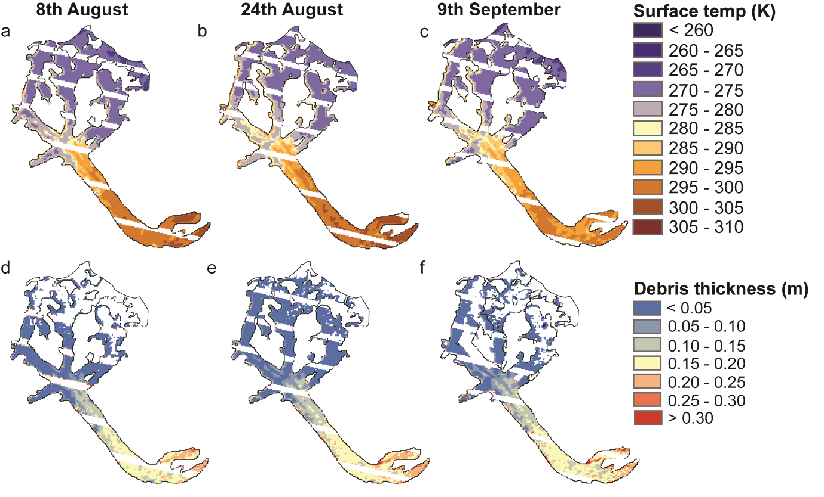
Fig. S2. a–c show debris surface temperature at Miage Glacier derived from Landsat 7 ETM+ band 6 imagery (NASA, 2019). d–f show the corresponding debris thickness maps derived using the thermal imagery and ERA single-level reanalysis data for three dates in 2016.

Table S2. Summary of the mean surface temperatures, and mean debris thickness estimations using ERA-5 single-level data at Miage and Khumbu Glacier for a range of dates over one ablation period.
Glacier | Date | Mean surface temperature (K) | Mean debris thickness (m)
Miage | 08 August 2016 | 281.7 ± 10.3 | 0.08 ± 0.09
 | 24 August 2016 | 283.4 ± 10.3 | 0.08 ± 0.08
 | 09 September 2016 | 281.3 ± 09.0 | 0.09 ± 0.10
Khumbu | 30 April 2009 | 274.7 ± 09.1 | 0.06 ± 0.04
 | 17 June 2009 | 275.9 ± 10.0 | 0.09 ± 0.06

3. Temporal changes in meteorological data
A multiple linear regression was conducted on all input meteorological data, and satellite thermal imagery. This statistical analysis showed no significant relationship between changes in input data and changes in the estimated debris thickness. These input data are shown in Fig. S2.
Fig. S3. Changes in meteorological data and debris thickness over time at a. Miage Glacier, b. Khumbu Glacier, and c. Haut Glacier d’Arolla.

