Journal of Glaciology
Supporting Information for
A doubling of glacier mass loss in the Karlik Range, easternmost Tian Shan, during 1972–2015, in response to regional rapid warming
Zhujun Wan¹, Yetang Wang^{1*}, Shugui Hou², Baojuan Huai¹, Qi Liu¹
- College of Geography and Environment, Shandong Normal University, Jinan 250014, China
- MOE, Key Laboratory for Coast and Island Development, School of Geographic and Oceanographic Sciences, Nanjing University, Nanjing 210093, China
Correspondence: Yetang Wang; yetangwang@sdnu.edu.cn or wangyetang@163.com

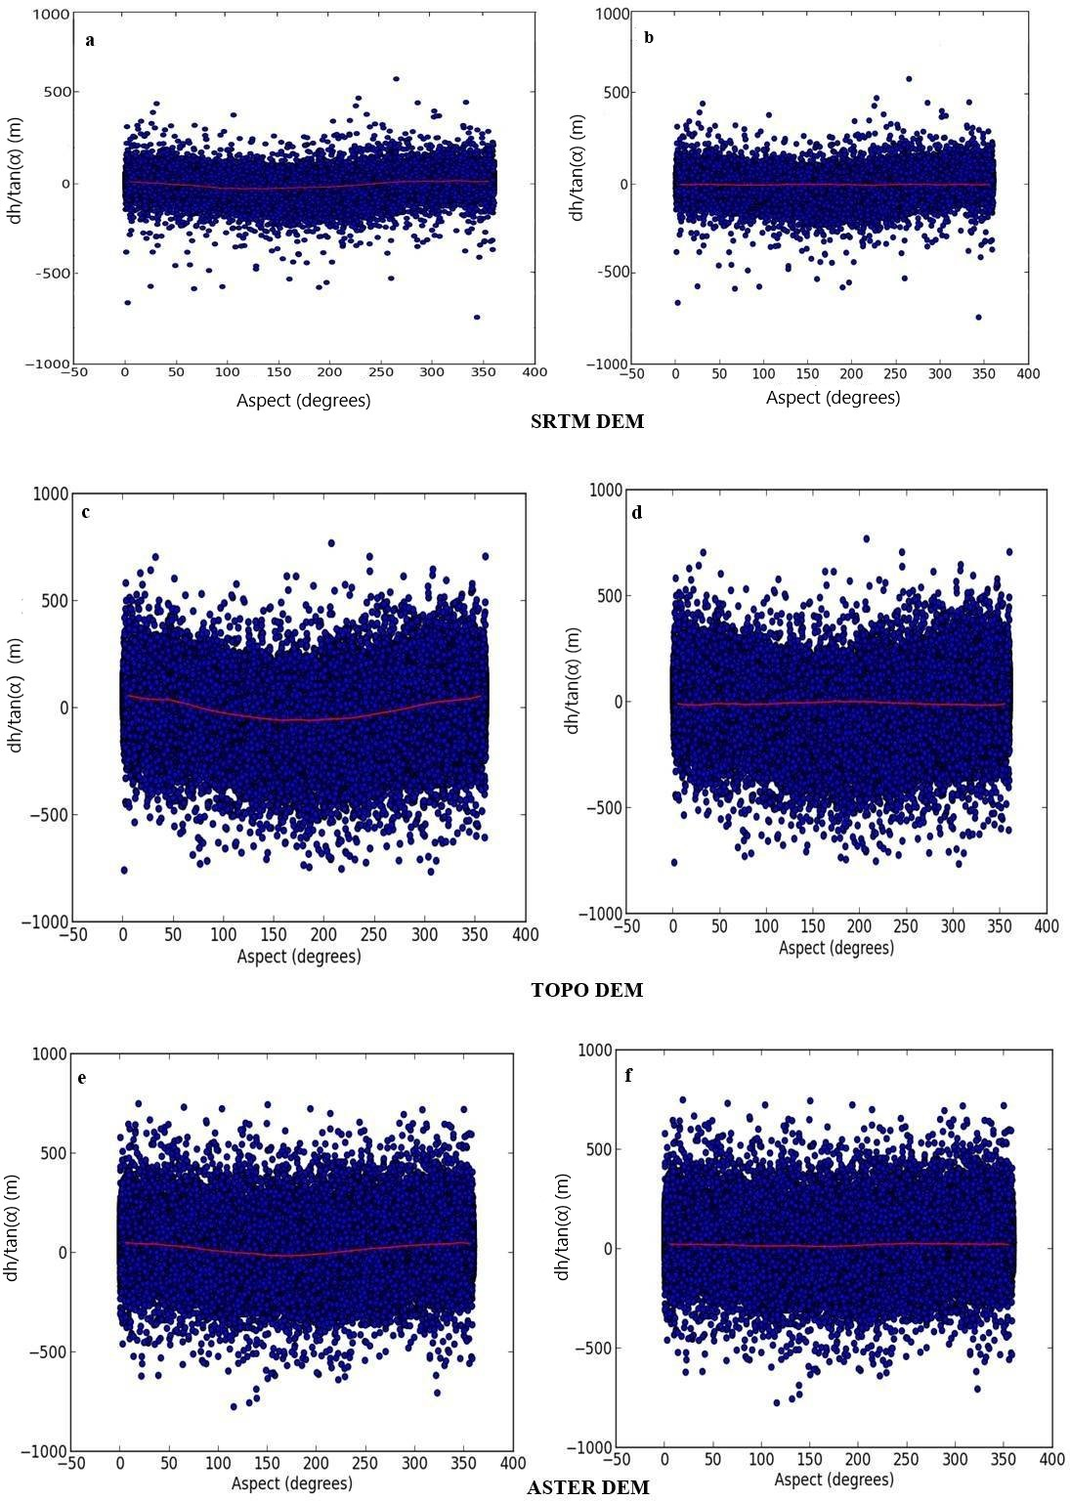

Figure S1. The cosine relationship between elevation difference and aspect before co-registration (a, c and e) and after co-registration(b, d and f)

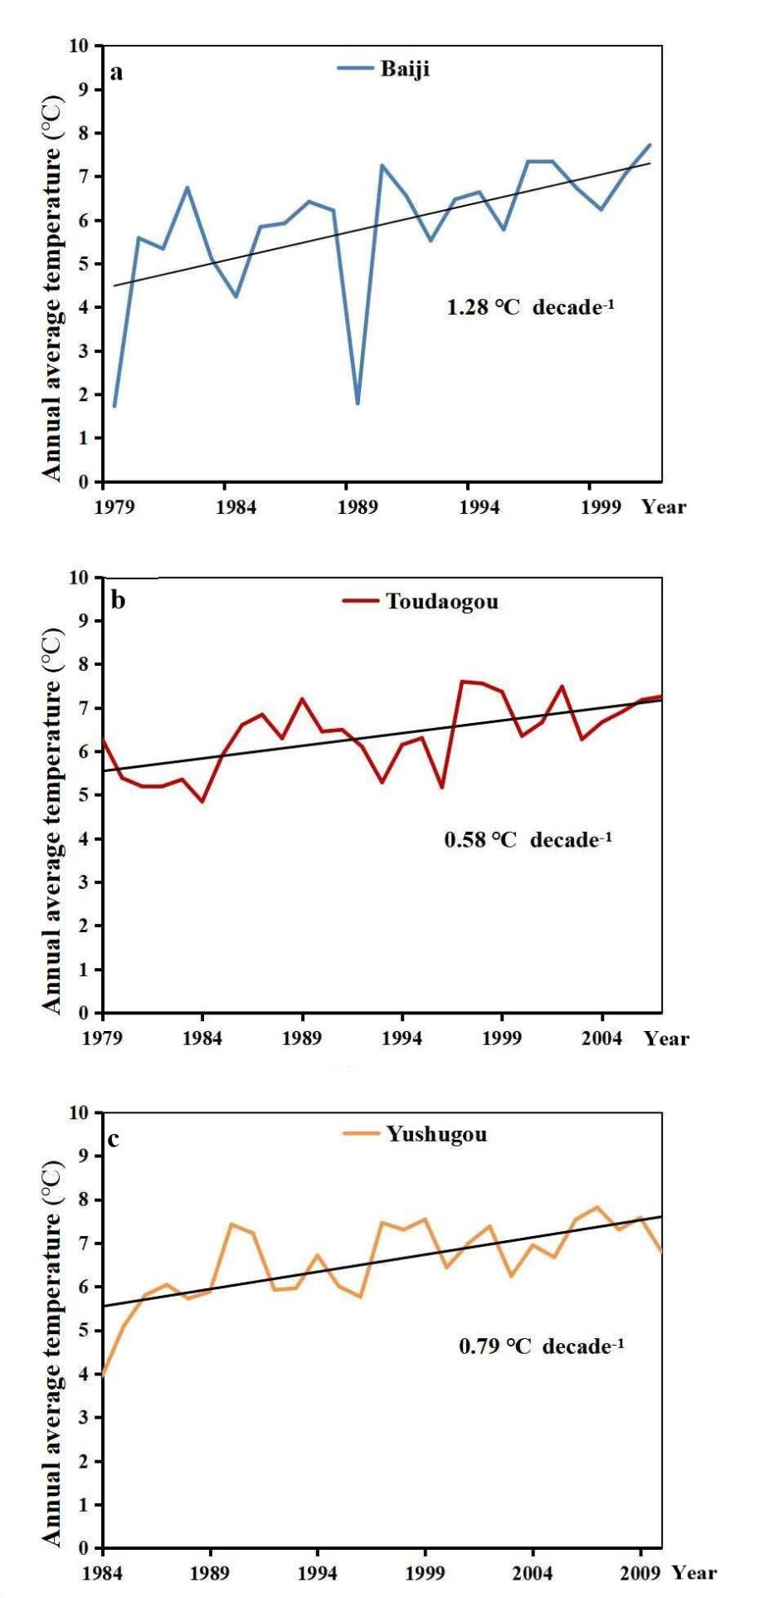
Figure S2. Variations of annual averaged air temperature at the three hydrometric stations (Baiji, Toudaogou and Yushugou Stations) near Karlik Range.

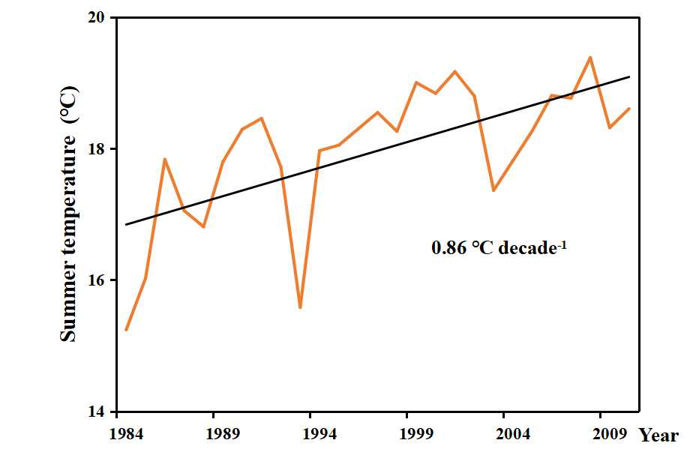
Figure S3. Variations of summer temperature at the Yushugou Stations near Karlik Range.
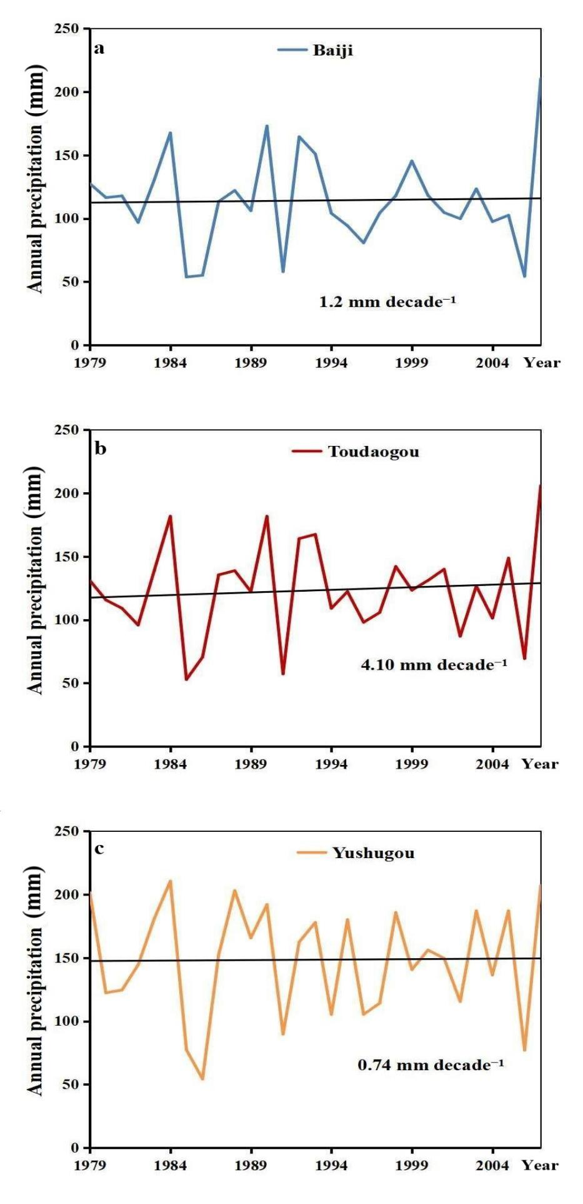
Figure S4. Variations of annual precipitation at the three hydrometric stations (Baiji, Toudaogou and Yushugou Stations) near Karlik Range.

