Slope estimation influences on ice thickness inversion 1
models: a case study for Monte Tronador glaciers, North 2
Patagonian Andes
Valentina ZORZUT¹, Lucas RUIZ¹, Andres RIVERA^{2,3}, Pierre PITTE¹, Ricardo VILLALBA¹, Dorota MEDRZYCKA⁴

¹ Instituto Argentino de Nivología, Glaciología y Ciencias Ambientales,CCT-Mendoza, CONICET, GOb.
Mendoza, UnCuyo, Mendoza, Argentina
² Departamento de Geografía, Universidad de Chile, Santiago de Chile
³ Instituto de Conservación, Biodiversidad y Territorio, Facultad de Ciencias Forestales y Recursos
Naturales, Universidad Austral de Chile, Valdivia, Chile
⁴ Department of Geography, Environment, and Geomatics, University of Ottawa, Ottawa, Canada

Correspondence: Valentina ZORZUT vzorzut@mendoza-conicet.gob.ar

Supplementary materials.

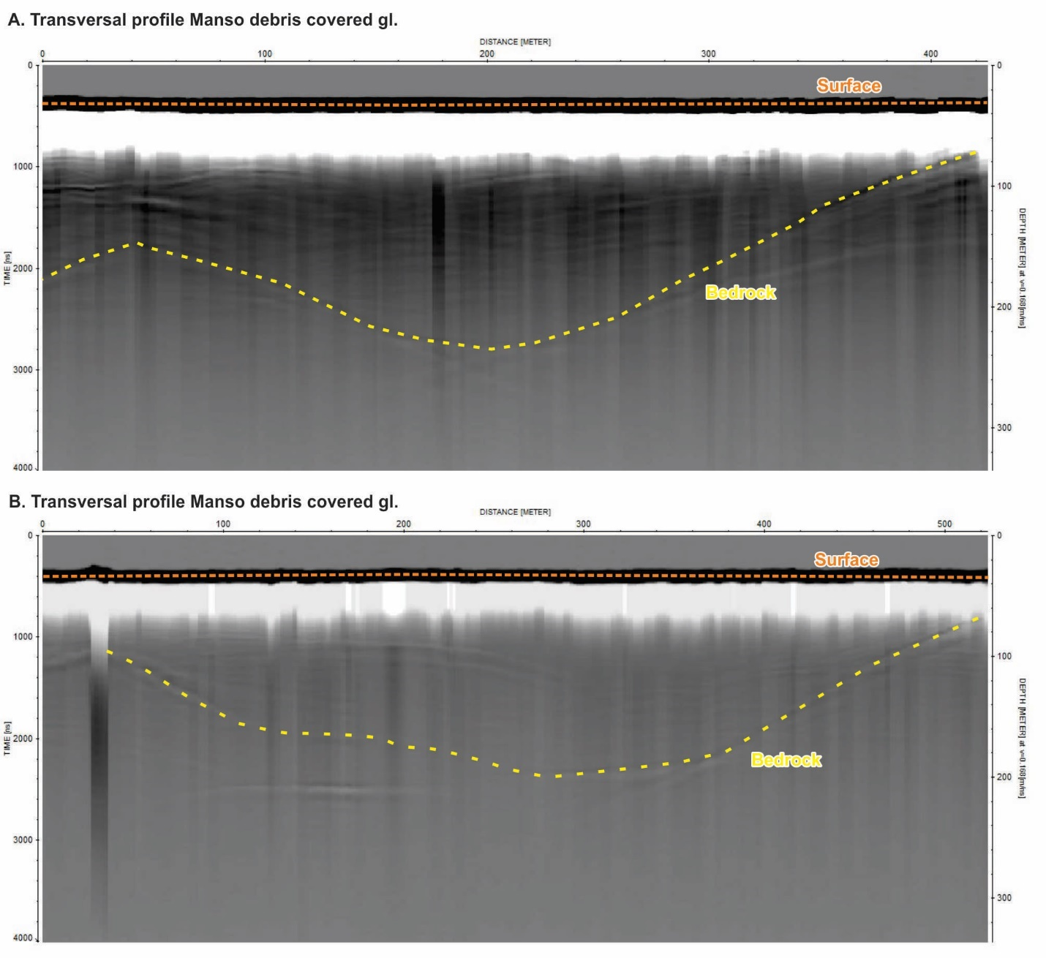
Figure SM1. Example of two transverse GPR profiles from the debris-covered tongue on Manso glacier. See Figure 1 for location of the profiles.

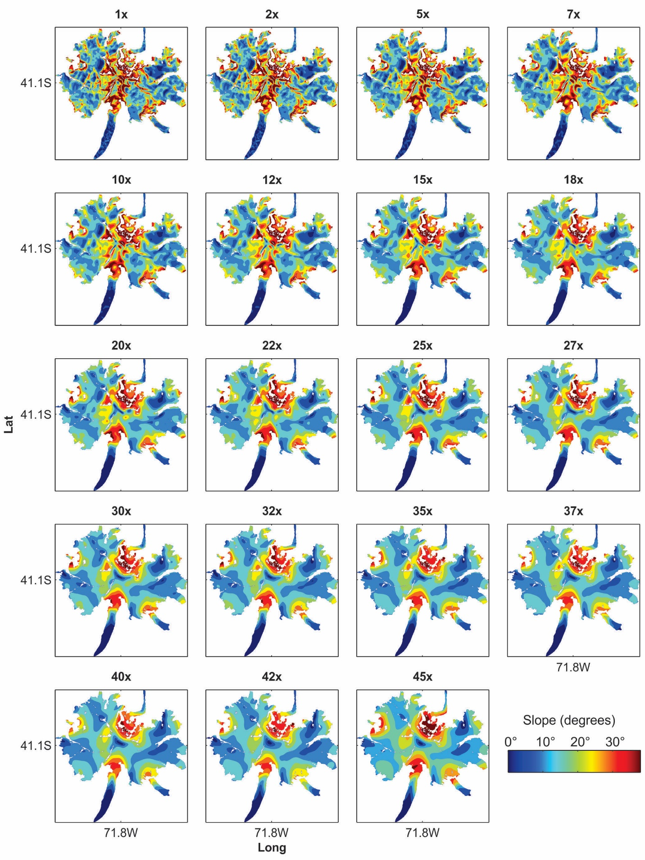Figure SM 2. Surface slope maps resampled at different spatial scales.

Uncertainty analysis

Equation SM 1:
$\frac{σH}{H}=0.25\left[\frac{σU_{s}}{U_{s}}+\frac{σU_{b}}{U_{b}}+\frac{σA}{A}+3\frac{σf}{f}+3\frac{σρ}{ρ}+3\frac{σ\sin{α}}{\sin{α}}\right]$,
where$σH$ is the uncertainty in the ice thickness ($H$) model, $σU_{s}$ is the uncertainty in surface velocity ($U_{s}$), $σU_{b}$ is the uncertainty in basal velocity ($U_{b}$), $σA$ is the uncertainty in the creep parameter ($A$), $σf$ is the uncertainty due to the shape factor ($f$), $σρ$ is the uncertainty due to density of ice ($ρ$), and $σ\sin{α}$ is the uncertainty in the sine of the surface slope ($\sin{α}$).
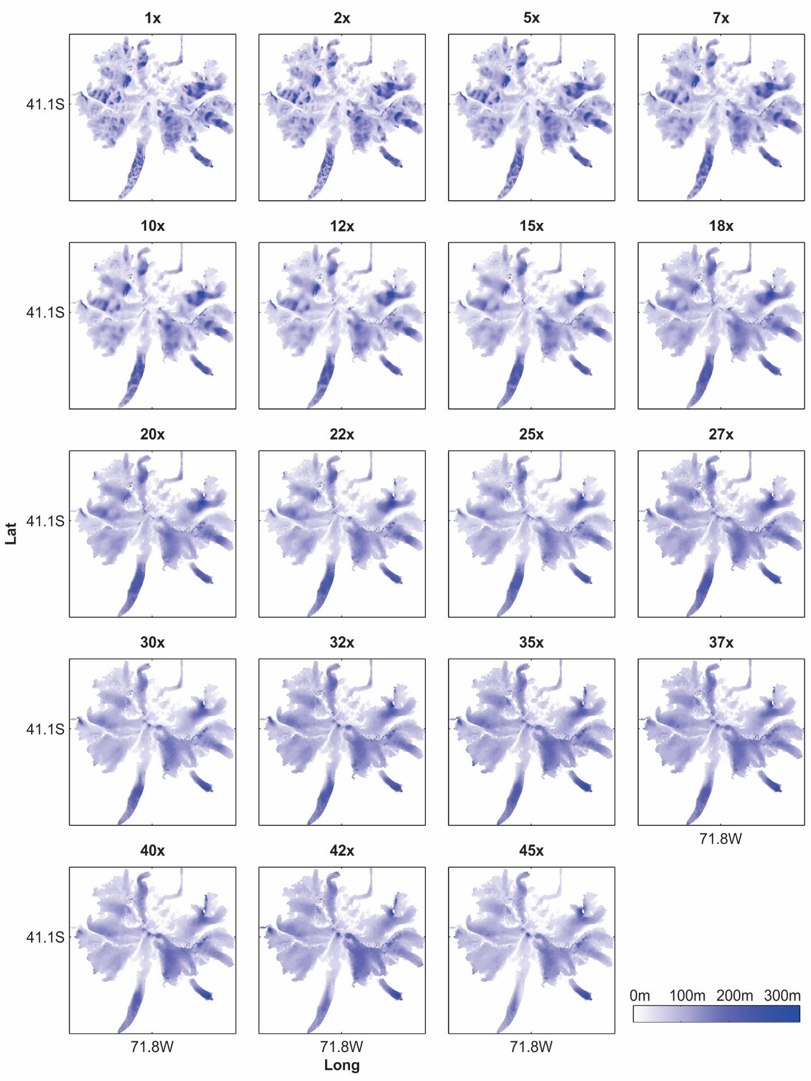Figure SM 3. Ice thickness distribution maps for all SSL filter scales.
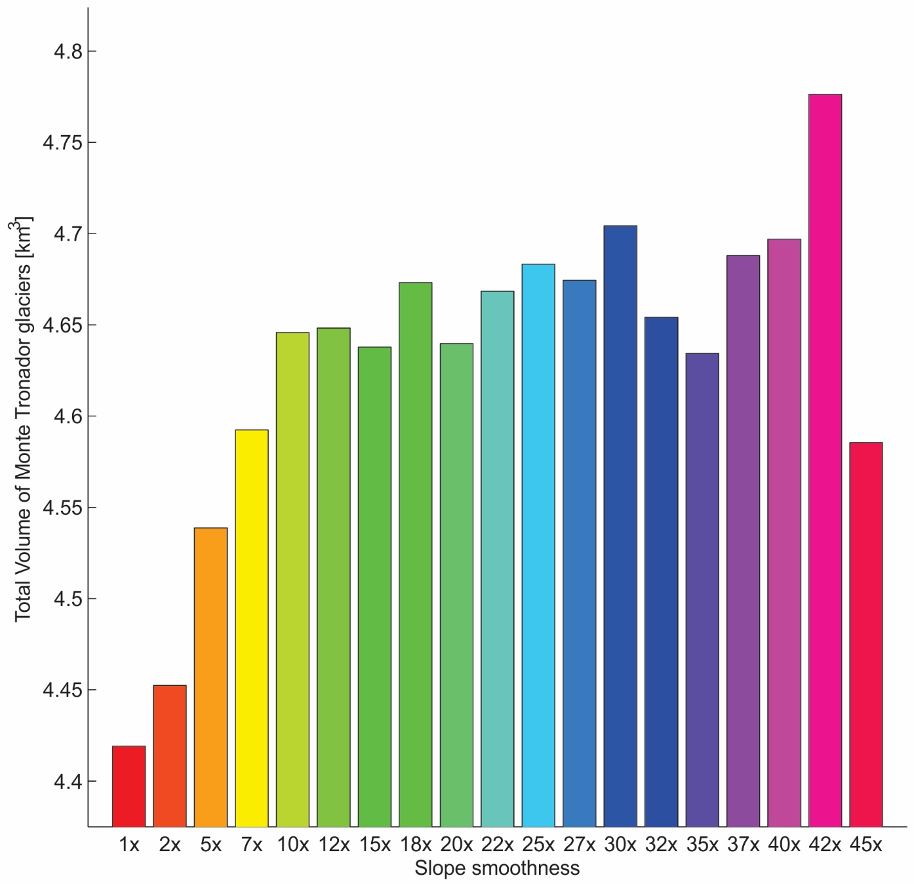
Figure SM4. Total ice volume estimates for all SSL filter scales.

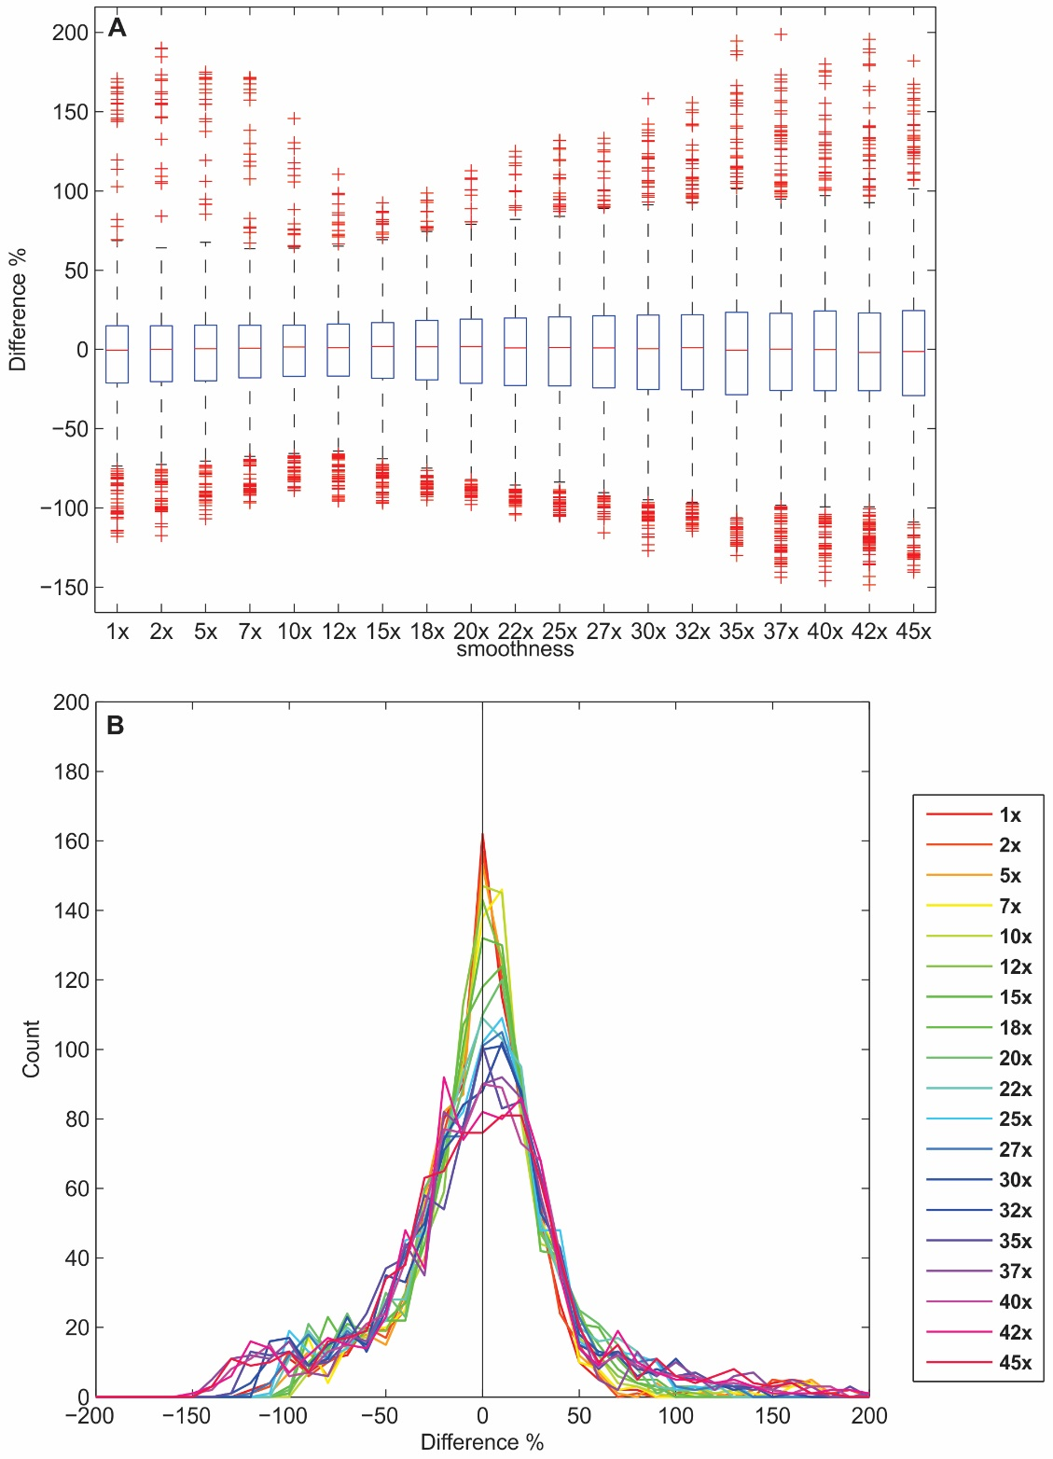
Figure SM5. Difference between ice thickness modeled at different SSL spatial scales, relative to the mean of ice thickness measurements. A) On each box, the central red mark is the median, the edges of the box are the 25th and 75th percentiles, and the whiskers are the 5th and 95th percentiles. B) Histograms of differences for each of the SSL spatial filter scales.

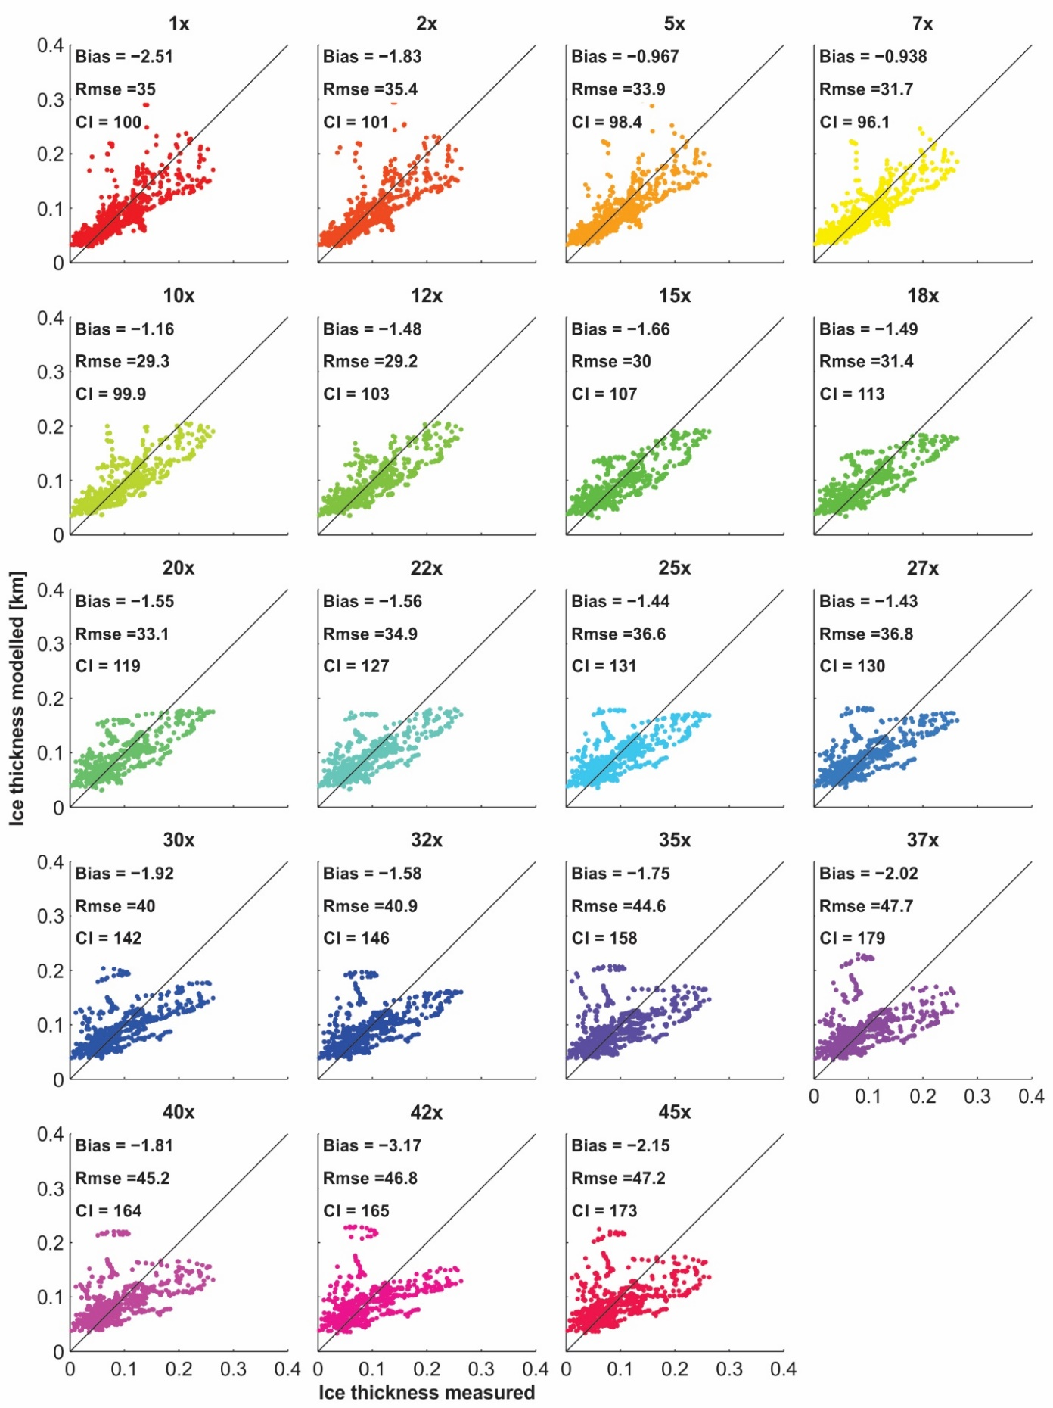
Figure SM6. Accuracy estimates for ice thickness derived from the different SSL filter scales.

