Supplementary Information
A scale-dependent model to represent changing aerodynamic roughness of ablating glacier ice based on repeat topographic surveys

Authors
Thomas Smith¹, Mark W. Smith¹*, Joshua R. Chambers ¹, Rudolf Sailer ², Lindsey Nicholson³, Jordan Mertes⁴, Duncan J. Quincey¹, Jonathan L. Carrivick ¹ and Ivana Stiperski³

Supplementary Tables S1-S2
Supplementary Figures S1-S2
Supplementary Table S1. List of references associated with data points numbered in Figure 1.
Glacier | Reference
1. Taylor Glacier | Hoffman MJ, Fountain AG and Liston GE (2008) Surface energy balance and melt thresholds over 11 years at Taylor Glacier, Antarctica. Journal of Geophysical Research: Earth Surface. 113 (F4), F04014. doi: 10.1029/2008JF001029.
2. Canada Glacier | Lewis KJ, Fountain AG and Dana GL (1998) Surface energy balance and meltwater production for a Dry Valley glacier, Taylor Valley, Antarctica. Annals of Glaciology. 27, 603-609. doi: 10.3189/1998AoG27-1-603-609.
3. Kohnen Station, Polar Plateau | van den Broeke M, Reijmer C, van As D, van de Wal RSW and Oerlemans J (2005) Seasonal cycles of Antarctic surface energy balance from automatic weather stations. Annals of Glaciology. 41, 131-139. doi: 10.3189/172756405781813168.
4. West Dronning Maud Land, Scarffenbergbotnen | van den Broeke M, Reijmer C, van As D, van de Wal RSW and Oerlemans J (2005) Seasonal cycles of Antarctic surface energy balance from automatic weather stations. Annals of Glaciology. 41, 131-139. doi: 10.3189/172756405781813168.
5. West Dronning Maud Land, Nordenskiold | van den Broeke M, Reijmer C, van As D, van de Wal RSW and Oerlemans J (2005) Seasonal cycles of Antarctic surface energy balance from automatic weather stations. Annals of Glaciology. 41, 131-139. doi: 10.3189/172756405781813168.
6. Antarctica Coastal Shelf | van den Broeke M, Reijmer C, van As D, van de Wal RSW and Oerlemans J (2005) Seasonal cycles of Antarctic surface energy balance from automatic weather stations. Annals of Glaciology. 41, 131-139. doi: 10.3189/172756405781813168.
7. McClary Glacier | Schneider C (1999) Energy balance estimates during the summer season of glaciers of the Antarctic Peninsula. Global and Planetary Change. 22(1-4), 117-130. doi: 10.1016/S0921-8181(99)00030-2.
8. D-47 - Adelie Land | Wendler G, Ishikawa N and Kodama Y (1988) The heat balance of the icy slope of Adelie Land, Eastern Antarctica. Journal of Applied Meteorology. 27(1), 52-65. doi: 10.1175/1520-0450(1988)027<0052:THBOTI>2.0.CO;2.
9. King George Island Ice Cap | Braun M and Hock R (2004) Spatially distributed surface energy balance and ablation modelling on the ice cap of King George Island (Antarctica). Global and Planetary Change. 42(1-4) 45-58. doi: 10.1016/j.gloplacha.2003.11.010.
10. Glacier Lengua | Schneider C, Kilian R and Glaser M (2007) Energy balance in the ablation zone during the summer season at the Gran Campo Nevado Ice Cap in the Southern Andes. Global and Planetary Change. 59(1-4), 175-188. doi: 10.1016/j.gloplacha.2006.11.033.
11. Brewster Glacier | Cullen NJ and Conway JP (2015) A 22 month record of surface meteorology and energy balance from the ablation zone of Brewster Glacier, New Zealand. Journal of Glaciology. 61(229), 931-946. doi: 10.3189/2015JoG15J004.
12. Loma Larga Glacier | Corripio JG and Purves RS (2005) Surface energy balance of high altitude glaciers in the central Andes: The effect of snow penitentes. In: de Jong C, Collins DN and Ranzi R eds. Climate and Hydrology of Mountain Areas. Wiley, Chichester, 15-27. doi: 10.1002/0470858249.ch3.
13. Juncal Norte Glacier | Pellicciotti F, Helbing J, Rivera A, Favier V, Corripio J, Araos J, Sicart JE and Carenzo M (2008) A study of the energy balance and melt regime on Juncal Norte Glacier, semi‐arid Andes of central Chile, using melt models of different complexity. Hydrological Processes. 22(19), 3980-3997. doi: 10.1002/hyp.7085.
14. Zongo Glacier | Sicart JE, Hock R and Six D (2008) Glacier melt, air temperature, and energy balance in different climates: The Bolivian Tropics, the French Alps, and northern Sweden. Journal of Geophysical Research: Atmospheres. 113(D24), D24113. doi: 10.1029/2008JD010406.
15. Glacier AX010 | Kayastha RB, Ohata T and Ageta Y (1999) Application of a mass-balance model to a Himalayan glacier. Journal of Glaciology. 45(151), 559-567. doi: 10.3189/S002214300000143X.
16.Parlung No. 4 Glacier | Zhu M, Yao T, Yang W, Xu B, Wu G and Wang X (2018) Differences in mass balance behaviour for three glaciers from different climatic regions on the Tibetan Plateau. Climate dynamics. 50(9-10), 3457-3484. doi: 10.1007/s00382-017-3817-4.
17. Guxiang No.3 Glacier | Wang Z, Deng Y and Zeng X (1982) Water-heat conditions for maritime glaciers developing in Guxiang, Tibetan Region. Memoirs of Lanzhou Institute of Glaciology and Geocryology, Chinese Academy of Sciences. 3, 82-90. [In Chinese]
18. Zhadang Glacier | Zhu M, Yao T, Yang W, Xu B, Wu G and Wang X (2018) Differences in mass balance behavior for three glaciers from different climatic regions on the Tibetan Plateau. Climate dynamics. 50(9-10), 3457-3484. doi: 10.1007/s00382-017-3817-4.
19. Chhota Shigri Glacier | Azam MF, Wagnon P, Vincent C, Ramanathan AL, Favier V, Mandal A and Pottakkal JG (2014) Processes governing the mass balance of Chhota Shigri Glacier (western Himalaya, India) assessed by point-scale surface energy balance measurements. The Cryosphere. 8(6), 2195-2217. doi: 10.5194/tc-8-2195-2014.
20. Xiao Dongkemadi Glacier | Liang L, Cuo L and Liu Q (2018) The energy and mass balance of a continental glacier: Dongkemadi Glacier in central Tibetan Plateau. Scientific reports. 8(1), 12788. doi: 10.1038/s41598-018-31228-5.
21. Qiagntang No.1 Glacier | Li S, Yao T, Yang W, Yu W and Zhu M (2018) Glacier energy and mass balance in the Inland Tibetan Plateau: seasonal and interannual variability in relation to atmospheric changes. Journal of Geophysical Research: Atmospheres. 123(12), 6390-6409. doi: 10.1029/2017JD028120.
22. Chongce Ice Cap | Takahashi S (1989) Characteristics of heat and water fluxes on glacier and ground surfaces in the West Kunlun Mountains. Bulletin of glacier research. 7, 89-98. [In Chinese]
23. MZ15 Glacier | Zhu M, Yao T, Yang W, Xu B, Wu G and Wang X (2018) Differences in mass balance behavior for three glaciers from different climatic regions on the Tibetan Plateau. Climate dynamics. 50(9-10), 3457-3484. doi: 10.1007/s00382-017-3817-4.
24. Bayi Ice Cap | Qing WW, Han CT and Liu JF (2018) Surface energy balance of Bayi Ice Cap in the middle of Qilian Mountains, China. Journal of Mountain Science. 15(6), 1229-1240. doi: 10.1007/s11629-017-4654-y.
25. Laohugou No.12 Glacier | Sun W, Qin X, Wang Y, Chen J, Du W, Zhang T and Huai B (2018) The response of surface mass and energy balance of a continental glacier to climate variability, western Qilian Mountains, China. Climate dynamics. 50(9-10), 3557-3570. doi: 10.1007/s00382-017-3823-6.
26. Qiyi Glacier | Jiang X, Wang NL, Yang SP, He JQ and Song GJ (2010) The surface energy balance on the Qiyi Glacier in Qilian Mountains during the ablation period. Journal of Glaciology and Geocryology, 32(4), 686-695.
27. Keqicar Baxi Glacier | Li J, Liu SY and Zhang Y (2007) Snow surface energy balance over the ablation period on the Keqicar Baxi Glacier in the Tianshan Mountains. Journal of Glaciology and Geocryology. 29(3), 366-373. doi: 10.1657/1938-4246-44.3.296.
28. Urumqi No.1 Glacier | Ersi K and Ohmura A (1994) A parameterized energy balance model of glacier melting on the Tianshan Mountain. Acta Geographica Sinica. 49(5), 467-476. doi: 10.11821/xb199405009.
29. Saint Sorlin Glacier | Sicart JE, Hock R and Six D (2008) Glacier melt, air temperature, and energy balance in different climates: The Bolivian Tropics, the French Alps, and northern Sweden. Journal of Geophysical Research: Atmospheres. 113(D24), D24113. doi: 10.1029/2008JD010406.
30. Vernagtferner | Escher-Vetter H (1985) Energy Balance Calculations for the Ablation Period 1982 at Vernagtferner. Oetztal Alps. Annals of Glaciology. 6, 158-160. doi: 10.3189/1985AoG6-1-158-160.
31. Pasterzenkees | Greuell W and Smeets P (2001) Variations with elevation in the surface energy balance on the Pasterze (Austria). Journal of Geophysical Research: Atmospheres. 106(D23), 31717-31727. doi: 10.1029/2001JD900127.
32. South Cascade Glacier | Anslow FS, Hostetler S, Bidlake WR and Clark PU (2008) Distributed energy balance modeling of South Cascade Glacier, Washington and assessment of model uncertainty. Journal of Geophysical Research: Earth Surface 113(F2), F02019. doi: 10.1029/2007JF000850.
33. Morteratschgletscher | Oerlemans J, Giesen RH and Van den Broeke MR (2009) Retreating alpine glaciers: increased melt rates due to accumulation of dust (Vadret da Morteratsch, Switzerland). Journal of Glaciology. 55(192), 729-736. doi: 10.3189/002214309789470969.
34. Haig Glacier | Ebrahimi S and Marshall SJ (2016) Surface energy balance sensitivity to meteorological variability on Haig Glacier, Canadian Rocky Mountains. The Cryosphere. 10(6), 2799-2819. doi: 10.5194/tc-10-2799-2016.
35. Midtdalsbreen | Giesen RH, van den Broeke MR, Oerlemans J and Andreassen LM (2008) Surface energy balance in the ablation zone of Midtdalsbreen, a glacier in southern Norway: interannual variability and the effect of clouds. Journal of Geophysical Research: Atmospheres. 113 (D21), D21111. doi: 10.1029/2008JD010390.
36. Nordbogletscher | Braithwaite RJ and Olesen OΒ (1990) A simple energy-balance model to calculate ice ablation at the margin of the Greenland ice sheet. Journal of Glaciology. 36(123), 222-228. doi: 10.3189/S0022143000009473.
37. Storbreen | Andreassen LM, Van den Broeke MR, Giesen, RH and Oerlemans J (2008) A 5 year record of surface energy and mass balance from the ablation zone of Storbreen, Norway. Journal of Glaciology 54(185), 245-258. doi: 10.3189/002214308784886199.
38. Vatnajökull | Schmidt LS, Aðalgeirsdóttir G, Guðmundsson S, Langen PL, Pálsson F, Mottram R, Gascoin S and Björnsson H (2017) The importance of accurate glacier albedo for estimates of surface mass balance on Vatnajökull: Evaluating the surface energy budget in a Regional Climate Model with automatic weather station observations. The Cryosphere. 11(4), 1665-1684. doi: 10.5194/tc-11-1665-2017.
39. Qamanârssûp Sermia | Braithwaite RJ and Olesen OΒ (1990) A simple energy-balance model to calculate ice ablation at the margin of the Greenland ice sheet. Journal of Glaciology. 36(123), 222-228. doi: 10.3189/S0022143000009473.
40. West Greenland Ice Sheet, K Transect S5 | van den Broeke MR, Smeets CJPP and van de Wal RSW (2011) The seasonal cycle and interannual variability of surface energy balance and melt in the ablation zone of the west Greenland ice sheet. The Cryosphere. 5(2), 377-390. doi: 10.5194/tc-5-377-2011.
41. Storglaciären | Hock R and Holmgren B (2005) A distributed surface energy-balance model for complex topography and its application to Storglaciären, Sweden. Journal of Glaciology. 51(172), 25-36. doi: 10.3189/172756505781829566.
42. McCall Glacier | Klok EJ, Nolan M and Van den Broeke MR (2005) Analysis of meteorological data and the surface energy balance of McCall Glacier, Alaska, USA. Journal of Glaciology. 51(174), 451-461. doi: 10.3189/172756505781829241.
43. Mid-West Greenland Ice Sheet | Ohmura A, Konzelmann T, Rotach M, Forrer J, Wild M, Abe-Ouchi A and Toritani H (1994) Energy balance for the Greenland ice sheet by observation and model computation. IAHS Publications-Series of Proceedings and Reports-Intern Assoc Hydrological Sciences. 223, 85-94.
44. Langfjordjøkelen | Giesen RH, Andreassen LM, Oerlemans J and van den Broeke MR (2014) Surface energy balance in the ablation zone of Langfjordjøkelen, an arctic, maritime glacier in northern Norway. Journal of glaciology. 60(219), 57-70. doi: 10.3189/2014JoG13J063.
45. Kronpins Christian Land | Konzelmann T and Braithwaite RJ (1995) Variations of ablation, albedo and energy balance at the margin of the Greenland ice sheet, Kronprins Christian Land, eastern north Greenland. Journal of Glaciology. 41(137), 174-182. doi: 10.3189/S002214300001786X.
46. Hans Tausen Ice Cap | Braithwaite RJ, Konzelmann T, Marty C and Olesen OB (1998) Reconnaissance study of glacier energy balance in North Greenland, 1993–94. Journal of Glaciology. 44(147), 239-247. doi: 10.3189/S0022143000002586.

Supplementary Table S2. Mean change in 2D z₀ over 3rd August – 16th August of classified exposure zones. Standard deviation is in square brackets.
Number of days exposed: | Change in 2D z₀ (mm)
< 2 weeks | 1.10 [1.68]
2-3 weeks | 1.06 [1.99]
3-4 weeks | 0.56 [1.91]
4-5 weeks | 0.43 [2.51]
5-6 weeks | 0.32 [2.12]
> 6 weeks | 0.34 [2.51]

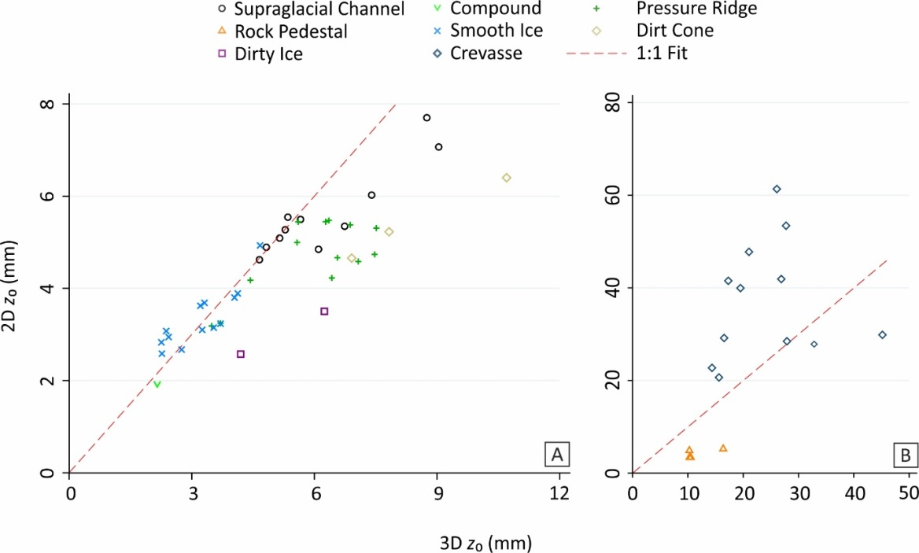
Supplementary Figure S1. Comparison of plot averages for 2D and 3D z₀ estimates for all surveys. 1:1 fit displayed by red dashed line. Note the change in axes scales in (B).

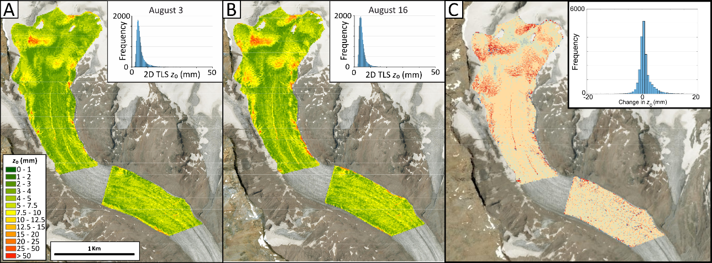
Supplementary Figure S2. Map of estimated 2D z₀ for the 3rd (A) and 16th (B) day of study, and change in z₀ between the two dates (C).

