Examining geodetic glacier mass balance in the eastern Pamir transition zone
Mingyang Lv^{1,2,3}, Duncan J. Quincey³, Huadong Guo^{1,2}, Owen King⁴, Guang Liu², Shiyong Yan⁵, Xiancai Lu¹, and Zhixing Ruan²
¹School of Earth Sciences and Engineering, Nanjing University, Nanjing, China.
²Key Laboratory of Digital Earth Science, Aerospace Information Research Institute, Chinese Academy of Sciences, Beijing, China.
³School of Geography, University of Leeds, Leeds, UK.
⁴School of Geography and Sustainable Development, University of St Andrews, Scotland.
⁵School of Environment Science and Spatial Informatics, China University of Mining and Technology, Xuzhou, China.
Corresponding author: Mingyang Lv (lmynju@163.com)

Contents of this supplementary

Table S1 to S7
Figure S1 to S4

Table S1. Images used for the generation of PRISM DEMs, ice facies identification for SRTM penetration correction, and glacier outline delineation.
Sensor | Scene ID | Date of acquisition | Purpose
ALOS PRISM | ALPSMB191552865 | 2009/08/29 | PRISM DEM (1)
ALOS PRISM | ALPSMN191552810 | 2009/08/29 | PRISM DEM (1)
ALOS PRISM | ALPSMF191552755 | 2009/08/29 | PRISM DEM (1)
ALOS PRISM | ALPSMB189072865 | 2009/08/12 | PRISM DEM (2)
ALOS PRISM | ALPSMN189072810 | 2009/08/12 | PRISM DEM (2)
ALOS PRISM | ALPSMF189072755 | 2009/08/12 | PRISM DEM (2)
ALOS PRISM | ALPSMB186592870 | 2009/07/26 | PRISM DEM (3)
ALOS PRISM | ALPSMN186592815 | 2009/07/26 | PRISM DEM (3)
ALOS PRISM | ALPSMF186592760 | 2009/07/26 | PRISM DEM (3)
ALOS PRISM | ALPSMB189072870 | 2009/08/12 | PRISM DEM (4)
ALOS PRISM | ALPSMN189072815 | 2009/08/12 | PRISM DEM (4)
ALOS PRISM | ALPSMF189072760 | 2009/08/12 | PRISM DEM (4)
ALOS PRISM | ALPSMB186592875 | 2009/07/26 | PRISM DEM (5)
ALOS PRISM | ALPSMN186592820 | 2009/07/26 | PRISM DEM (5)
ALOS PRISM | ALPSMF186592765 | 2009/07/26 | PRISM DEM (5)
ALOS PRISM | ALPSMB193302875 | 2009/09/10 | PRISM DEM (6)
ALOS PRISM | ALPSMN193302820 | 2009/09/10 | PRISM DEM (6)
ALOS PRISM | ALPSMF193302765 | 2009/09/10 | PRISM DEM (6)
ALOS PRISM | ALPSMB186592880 | 2009/07/26 | PRISM DEM (7)
ALOS PRISM | ALPSMN186592825 | 2009/07/26 | PRISM DEM (7)
ALOS PRISM | ALPSMF186592770 | 2009/07/26 | PRISM DEM (7)
ALOS PRISM | ALPSMB193302885 | 2009/09/10 | PRISM DEM (8)
ALOS PRISM | ALPSMN193302830 | 2009/09/10 | PRISM DEM (8)
ALOS PRISM | ALPSMF193302775 | 2009/09/10 | PRISM DEM (8)
Landsat TM | LT51500331992200ISP00 | 1992/07/18 | Glacier surge detection
Landsat TM | LT51500332008276KHC01 | 2008/10/02 | Glacier surge detection
Landsat ETM+ | LE71500331999227EDC00 | 1999/08/15 | Glacier surge detection
Landsat ETM+ | LE71500332000038SGS00 | 2000/02/07 | Ice facies identification
Landsat ETM+ | LE71500332000102SGS00 | 2000/04/11 | Ice facies identification
Landsat ETM+ | LE71500332000246SGS01 | 2000/09/02 | Glacier delineation & Glacier surge detection
Landsat ETM+ | LE71500332002235SGS00 | 2002/08/23 | Glacier surge detection
Landsat ETM+ | LE71500332007233PFS00 | 2007/08/21 | Glacier surge detection
Landsat ETM+ | LE71500332010289SGS00 | 2010/10/16 | Glacier surge detection
Landsat OLI | LC81500332013161LGN00 | 2013/06/10 | Glacier surge detection
Landsat OLI | LC81500332014260LGN00 | 2014/09/17 | Glacier surge detection
Landsat OLI | LC81500332015231LGN00 | 2015/08/19 | Glacier surge detection
Landsat OLI | LC81500332016202LGN01 | 2016/07/20 | Glacier surge detection
Landsat OLI | LC81500332017252LGN00 | 2017/09/09 | Glacier delineation & Glacier surge detection
Landsat OLI | LC81500332020053LGN00 | 2020/02/22 | Glacier surge detection

Table S2. Mean differences and the standard deviation (SD) of each elevation difference map with uncertainty over off-glacier areas before and after correction process.
DEM Product ID | Date | Statistics of stable ground differences (Product vs SRTM) (m)
 |  | Pre-mean | Pre-SD | Post-mean | Post-SD
HMA_DEM8m_AT_20151010_0550_104001001243CD00_1040010011C0F400 | 2015/10/10 | -28.13 | 8.22 | -0.17 | 4.57
HMA_DEM8m_AT_20161011_0552_103001005EB9F600_103001005F46F600 | 2016/10/11 | -28.11 | 9.42 | -1.36 | 4.91
HMA_DEM8m_AT_20150107_0610_1050410012079A00_1050410012079B00 | 2015/01/07 | -28.87 | 9.77 | -0.56 | 4.32
HMA_DEM8m_AT_20151008_0602_1030010048298100_103001004A283A00 | 2015/10/08 | -34.30 | 11.96 | -0.98 | 5.74
HMA_DEM8m_AT_20161023_0626_104001002344F300_1040010024511000 | 2016/10/23 | -27.99 | 9.68 | -1.03 | 5.62
HMA_DEM8m_AT_20150402_0608_1050410012740000_1050410012740200 | 2015/04/02 | -30.70 | 6.79 | -0.55 | 3.92
HMA_DEM8m_AT_20161011_0552_103001005CA93700_103001005D753500 | 2016/10/11 | -26.14 | 10.19 | -1.96 | 3.91
HMA_DEM8m_AT_20150309_0541_10400100083EE600_10400100084AB600 | 2015/03/09 | -27.18 | 9.63 | -1.54 | 3.73
HMA_DEM8m_AT_20150929_0615_1040010012AF9200_10400100112B2C00 | 2015/09/29 | -31.36 | 13.96 | -0.48 | 6.16
HMA_DEM8m_AT_20160829_0539_103001005BD47B00_103001005BCCBA00 | 2016/08/29 | -30.81 | 6.17 | -0.66 | 3.35
HMA_DEM8m_AT_20161003_0547_103001005C3CFA00_103001005D7D4E00 | 2016/10/3 | -29.95 | 13.48 | -0.50 | 5.04
HMA_DEM8m_AT_20150423_0558_1030010042BB7400_1030010040CE3F00 | 2015/04/23 | -30.24 | 5.18 | -0.52 | 3.82
PRISM DEM 1 | 2009/08/29 | 2.09 | 37.47 | 0.50 | 14.07
PRISM DEM 2 | 2009/08/12 | -18.85 | 29.56 | 1.25 | 12.40
PRISM DEM 3 | 2009/07/26 | 0.58 | 24.33 | 1.10 | 11.98
PRISM DEM 4 | 2009/08/12 | 1.94 | 24.32 | 0.30 | 8.22
PRISM DEM 5 | 2009/07/26 | -1.67 | 24.44 | 0.26 | 10.16
PRISM DEM 6 | 2009/09/10 | -18.06 | 42.02 | -1.89 | 19.04
PRISM DEM 7 | 2009/07/26 | 5.71 | 24.21 | -0.82 | 7.22
PRISM DEM 8 | 2009/09/10 | 5.99 | 26.35 | -1.43 | 10.01

Table S3. Attributes of the glaciers in this study. Longitude and latitude represent the center longitude and center latitude. Glacier areas are measured based on 9 September, 2017.
No. | Glacier ID (this study) | Area (km²) | GLIMS ID | Longitude (°E) | Latitude (°N) | Max/min elevation (m asl.) | Median elevation (m asl.) | Mean aspect (°)
1 | Kn1 | 9.01±0.09 | G074258E39293N | 74.258 | 39.293 | 6051/4409 | 4950 | 324
2 | Kn2 | 6.48±0.07 | G074293E39300N | 74.293 | 39.3 | 5699/3898 | 4558 | 6
3 | Kn3 | 20.21±0.21 | G074348E39282N | 74.348 | 39.282 | 5893/3790 | 4685 | 6
4 | Kn4 | 7.7±0.08 | G074419E39295N | 74.419 | 39.295 | 5417/4211 | 4655 | 0
5 | Ayilanama | 27.53±0.28 | G074449E39260N | 74.449 | 39.26 | 5804/3829 | 4542 | 25
6 | Kn5 | 6.38±0.07 | G074525E39252N | 74.525 | 39.252 | 5897/3842 | 4421 | 22
7 | Kn6 | 12.68±0.13 | G074560E39231N | 74.56 | 39.231 | 5655/3716 | 4507 | 9
 |  |  | G074545E39243N | 74.545 | 39.243 | 5469/3938 |  | 53
8 | Kn7 | 14.17±0.14 | G074606E39223N | 74.606 | 39.223 | 5755/3594 | 4486 | 26
9 | Keqiketuoer | 14.56±0.15 | G074652E39213N | 74.652 | 39.213 | 5799/3743 | 4379 | 351
 |  |  | G074688E39236N | 74.688 | 39.236 | 4809/4171 |  | 331
10 | Kn8 | 16.52±0.17 | G074696E39186N | 74.696 | 39.186 | 5892/3665 | 4600 | 42
11 | Kn9 | 9.29±0.09 | G074785E39097N | 74.785 | 39.097 | 5680/4008 | 4721 | 13
12 | Kn10 | 6.95±0.07 | G074826E39097N | 74.826 | 39.097 | 5628/4131 | 4905 | 33
 |  |  | G074813E39103N | 74.813 | 39.103 | 5616/4498 |  | 38
13 | Kn11 | 11.06±0.11 | G074840E38983N | 74.84 | 38.983 | 5535/4404 |  | 30
 |  |  | G074860E38983N | 74.86 | 38.983 | 5626/4242 | 5021 | 358
 |  |  | G074878E38987N | 74.878 | 38.987 | 5606/4196 |  | 340
14 | Kn12 | 7.28±0.07 | G074981E38974N | 74.981 | 38.974 | 5757/3999 | 5063 | 343
15 | Kn13 | 22.15±0.23 | G075050E38938N | 75.05 | 38.938 | 5899/3337 | 4432 | 37
 |  |  | G075011E38949N | 75.011 | 38.949 | 5680/4213 |  | 67
 |  |  | G075016E38961N | 75.016 | 38.961 | 5515/4036 |  | 86
16 | Kn14 | 25.04±0.26 | G075083E38897N | 75.083 | 38.897 | 6090/3138 | 4861 | 31
17 | Kn15 | 23.55±0.24 | G075145E38873N | 75.145 | 38.873 | 6577/2823 | 4874 | 50
18 | Kn16 | 14.69±0.15 | G075160E38813N | 75.16 | 38.813 | 6108/3736 | 4630 | 90
 |  |  | G075150E38828N | 75.15 | 38.828 | 6409/3906 |  | 107
19 | Ks1 | 11.12±0.11 | G074295E39269N | 74.295 | 39.269 | 6058/4524 | 5257 | 200
20 | Ks2 | 15.74±0.16 | G074696E39143N | 74.696 | 39.143 | 6063/4373 | 5376 | 297
21 | Ks3 | 15.41±0.16 | G074800E39007N | 74.8 | 39.007 | 5626/4490 | 5185 | 7
22 | Ks4 | 10.77±0.11 | G074911E38969N | 74.911 | 38.969 | 5617/4244 | 4925 | 88
23 | Ks5 | 16.66±0.17 | G074990E38942N | 74.99 | 38.942 | 5901/4461 | 5259 | 241
24 | Ks6 | 11.18±0.11 | G075022E38910N | 75.022 | 38.91 | 6103/4423 | 5468 | 228
25 | Ks7 | 10.56±0.11 | G075043E38887N | 75.043 | 38.887 | 6068/4588 | 5326 | 256
26 | Ks8 | 14.24±0.15 | G075075E38868N | 75.075 | 38.868 | 6541/4466 | 5506 | 270
27 | Ks9 | 11.36±0.12 | G075097E38848N | 75.097 | 38.848 | 6613/4122 | 5359 | 217
28 | Ks10 | 14.52±0.15 | G075126E38839N | 75.126 | 38.839 | 6428/4267 | 5615 | 237
 |  |  | G075128E38819N | 75.128 | 38.819 | 6111/4576 |  | 279
29 | Kelayayilake | 128.6±1.31 | G075254E38623N | 75.254 | 38.623 | 7566/2812 | 5018 | 11
30 | Ko1 | 15.84±0.16 | G075133E38690N | 75.133 | 38.69 | 6927/3417 | 5363 | 16
31 | Ko2 | 8.83±0.09 | G075087E38696N | 75.087 | 38.696 | 6596/3820 | 5621 | 330
 |  |  | G075073E38691N | 75.073 | 38.691 | 6321/4500 |  | 324
32 | Ko3 | 6.1±0.06 | G075083E38673N | 75.083 | 38.673 | 6768/4260 | 5881 | 259
33 | Ko4 | 5.18±0.05 | G075085E38663N | 75.085 | 38.663 | 6817/4285 | 5911 | 252
34 | Ko5 | 8.72±0.09 | G075102E38655N | 75.102 | 38.655 | 6952/4260 | 6116 | 238
35 | Ko6 | 9.49±0.10 | G075116E38641N | 75.116 | 38.641 | 6936/4274 | 6121 | 220
36 | Ko7 | 10.15±0.10 | G075127E38625N | 75.127 | 38.625 | 7087/4513 | 6036 | 240
37 | Ko8 | 19.45±0.20 | G075146E38607N | 75.146 | 38.607 | 7375/4400 | 5764 | 221
38 | Guerdaoban | 29.85±0.30 | G075191E38590N | 75.191 | 38.59 | 7432/4622 | 5816 | 195
 |  |  | G075211E38573N | 75.211 | 38.573 | 7138/4663 |  | 224
39 | Ko9 | 5.8±0.06 | G075219E38558N | 75.219 | 38.558 | 5933/4838 | 5396 | 220
40 | Ko10 | 47.05±0.48 | G075248E38558N | 75.248 | 38.558 | 7156/4282 | 5548 | 228
41 | Ko11 | 10.87±0.11 | G075262E38523N | 75.262 | 38.523 | 6618/4539 | 5608 | 254
42 | Ko12 | 12.96±0.13 | G075267E38499N | 75.267 | 38.499 | 6485/4584 | 5410 | 240
43 | Ko13 | 10.28±0.10 | G075271E38468N | 75.271 | 38.468 | 6126/4590 | 5328 | 281
44 | Kekesayi | 77.7±0.79 | G075181E38255N | 75.181 | 38.255 | 7520/3910 | 4929 | 83
45 | Mu1 | 13.01±0.13 | G075228E38312N | 75.228 | 38.312 | 6083/4269 | 4926 | 30
46 | Mu2 | 18.92±0.19 | G075161E38311N | 75.161 | 38.311 | 6952/4250 | 5039 | 17
 |  |  | G075143E38318N | 75.143 | 38.318 | 7003/4467 |  | 25
47 | Mu3 | 9.86±0.10 | G075109E38316N | 75.109 | 38.316 | 7136/4504 | 5401 | 333
48 | Kematulejia | 11.23±0.11 | G075086E38293N | 75.086 | 38.293 | 7420/4251 | 6042 | 289
49 | Mu4 | 11.33±0.12 | G075069E38278N | 75.069 | 38.278 | 7485/4405 | 6587 | 271
 |  |  | G075076E38285N | 75.076 | 38.285 | 7519/5106 |  | 294
50 | Kalaxiong | 21.17±0.22 | G075092E38247N | 75.092 | 38.247 | 7240/4418 | 5817 | 267
51 | Mu5 | 10.03±0.10 | G075072E38230N | 75.072 | 38.23 | 6983/4631 | 5676 | 270
 |  |  | G075061E38217N | 75.061 | 38.217 | 6568/5214 |  | 266
52 | Kuosikulake | 18.8±0.19 | G075112E38219N | 75.112 | 38.219 | 6997/4626 | 5962 | 230
53 | Mu6 | 10.53±0.11 | G075110E38190N | 75.11 | 38.19 | 6804/4794 | 5801 | 192
54 | Mu7 | 9.51±0.10 | G075179E38166N | 75.179 | 38.166 | 6287/4604 | 5358 | 251
55 | Mu8 | 6.52±0.07 | G075202E38154N | 75.202 | 38.154 | 6071/4753 | 5314 | 207

Table S4. Mass balances for glaciers in the Muztag Ata during the differing study periods: 2000-2009 and 2000-2015/2016. Note, the available area represents the coverage percentage of DEM data after outlier filtering and before gap filling.
No. | Glacier ID | 2000-2015/16 (m w.e. a⁻¹) | Available area (%) | Acquisition date (yyyy/mm/dd) | 2000-2009 (m w.e. a⁻¹) | Available area (%) | Acquisition date (yyyy/mm/dd) | Surge classification
1 | Kekesayi | -0.01±0.01 | 64.75% | 2016/10/11 | -0.13±0.04 | 70.38% | 2009/09/10 | No evidence
2 | Mu1 | -0.03±0.03 | 83.59% | 2016/10/11 | 0.06±0.08 | 85.75% | 2009/09/10 | No evidence
3 | Mu2 | 0.15±0.02 | 84.72% | 2016/10/11 | No data | - | - | No evidence
4 | Mu3 | 0.10±0.03 | 82.57% | 2016/10/11 | No data | - | - | No evidence
5 | Kematulejia | 0.22±0.05 | 62.01% | 2015/10/10 | No data | - | - | No evidence
6 | Mu4 | 0.31±0.05 | 58.42% | 2015/10/10 | No data | - | - | No evidence
7 | Kalaxiong | 0.27±0.04 | 65.56% | 2015/10/10 | No data | - | - | No evidence
8 | Mu5 | 0.24±0.03 | 81.78% | 2015/03/09 | No data | - | - | No evidence
9 | Kuosikulake | No data | - | - | -0.09±0.19 | 31.66% | 2009/09/10 | Observed
10 | Mu6 | No data | - | - | 0.04±0.12 | 66.52% | 2009/09/10 | No evidence
11 | Mu7 | No data | - | - | -0.09±0.13 | 62.88% | 2009/09/10 | No evidence
12 | Mu8 | No data | - | - | 0.29±0.16 | 64.59% | 2009/09/10 | No evidence
 | Average | 0.16±0.03 |  |  | 0.01±0.12

Table S5. Mass balances for glaciers in the Kongur Tagh during study periods: 2000-2009 and 2000-2015/16. Note, the available area represents the coverage percentage of DEM data after outlier filtering and before gap filling.
No. | Glacier ID | 2000-2015/16 (m w.e. a⁻¹) | Available area (%) | Acquisition date (yyyy/mm/dd) | 2000-2009 (m w.e. a⁻¹) | Available area (%) | Acquisition date (yyyy/mm/dd) | Surge classification
1 | Kelayayilake | -0.04±0.02 | 43.80% | 2016/10/11 | 0.10±0.14 | 49.98% | 2009/09/10 | Observed
2 | Ko1 | 0.08±0.03 | 74.30% | 2016/10/11 | -0.06±0.14 | 77.26% | 2009/07/26 | No evidence
3 | Ko2 | 0.09±0.03 | 98.32% | 2016/10/11 | -0.10±0.15 | 99.80% | 2009/07/26 | No evidence
4 | Ko3 | 0.24±0.04 | 95.88% | 2016/10/11 | 0.16±0.18 | 99.65% | 2009/07/26 | No evidence
5 | Ko4 | 0.37±0.05 | 93.49% | 2016/10/11 | 0.17±0.19 | 99.80% | 2009/07/26 | No evidence
6 | Ko5 | 0.39±0.05 | 82.68% | 2016/10/11 | No data | - | - | No evidence
7 | Ko6 | 0.38±0.04 | 83.99% | 2016/10/11 | -0.02±0.11 | 90.81% | 2009/07/26 | Observed
8 | Ko7 | 0.07±0.04 | 71.52% | 2016/10/11 | 0.15±0.11 | 88.92% | 2009/07/26 | No evidence
9 | Ko8 | 0.32±0.04 | 79.13% | 2016/10/11 | 0.12±0.08 | 87.08% | 2009/07/26 | No evidence
10 | Guerdaoban | 0.14±0.02 | 79.49% | 2016/10/11 | -0.27±0.07 | 83.07% | 2009/07/26 | No evidence
11 | Ko9 | -0.09±0.04 | 86.37% | 2016/10/11 | No data | - | - | No evidence
12 | Ko10 | 0.26±0.03 | 77.73% | 2016/10/11 | 0.09±0.06 | 80.49% | 2009/07/26 | Observed
13 | Ko11 | 0.17±0.05 | 51.22% | 2016/10/11 | No data | - | - | Observed
14 | Ko12 | 0.12±0.03 | 68.80% | 2016/10/11 | No data | - | - | No evidence
15 | Ko13 | 0.09±0.03 | 81.20% | 2016/10/11 | No data | - | - | No evidence
 | Average | 0.17±0.04 |  |  | 0.03±0.12

Table S6. Mass balances for glaciers in the Kingata Mountains during study periods: 2000-2009 and 2000-2015/16. Note, the available area represents the coverage percentage of DEM data after outlier filtering and before gap filling.
No. | Glacier ID | 2000-2015/16 (m w.e. a⁻¹) | Available area (%) | Acquisition date (yyyy/mm/dd) | 2000-2009 (m w.e. a⁻¹) | Available area (%) | Acquisition date (yyyy/mm/dd) | Surge classification
1 | Kn1 | -0.08±0.04 | 93.01% | 2015/09/29 | No data | - | - | No evidence
2 | Kn2 | -0.08±0.05 | 90.11% | 2015/09/29 | No data | - | - | No evidence
3 | Kn3 | -0.04±0.03 | 65.75% | 2016/10/03 | -0.18±0.15 | 88.51% | 2009/08/29 | Observed
4 | Kn4 | 0.02±0.03 | 93.52% | 2016/10/03 | 0.05±0.22 | 96.75% | 2009/08/29 | No evidence
5 | Ayilanama | -0.07±0.02 | 86.73% | 2016/10/03 | -0.15±0.12 | 92.27% | 2009/08/29 | Observed
6 | Kn5 | -0.10±0.06 | 58.36% | 2016/10/03 | -0.38±0.60 | 39.90% | 2009/08/29 | No evidence
7 | Kn6 | -0.11±0.03 | 69.59% | 2015/04/02 | -0.14±0.22 | 75.04% | 2009/08/29 | No evidence
8 | Kn7 | -0.10±0.03 | 59.38% | 2015/04/02 | -0.11±0.21 | 76.44% | 2009/08/29 | Observed
9 | Keqiketuoer | No data | - | - | -0.08±0.18 | 87.82% | 2009/08/29 | Observed
10 | Kn8 | No data | - | - | -0.12±0.19 | 77.07% | 2009/08/29 | Observed
11 | Kn9 | No data | - | - | -0.47±0.19 | 93.90% | 2009/08/12 | Observed
12 | Kn10 | No data | - | - | -0.33±0.21 | 94.83% | 2009/08/12 | Observed
13 | Kn11 | -0.08±0.03 | 96.59% | 2016/10/23 | -0.21±0.12 | 90.16% | 2009/08/12 | No evidence
14 | Kn12 | -0.14±0.03 | 97.75% | 2016/10/11 | -0.11±0.19 | 98.75% | 2009/07/26 | Observed
15 | Kn13 | -0.20±0.03 | 62.80% | 2015/01/07 | 0.01±0.15 | 73.73% | 2009/07/26 | Observed
16 | Kn14 | 0.03±0.03 | 59.31% | 2015/10/08 | 0.05±0.13 | 76.16% | 2009/07/26 | Observed
17 | Kn15 | -0.06±0.06 | 32.98% | 2015/10/08 | -0.29±0.31 | 34.48% | 2009/07/26 | No evidence
18 | Kn16 | -0.01±0.06 | 42.12% | 2015/10/08 | -0.33±0.28 | 42.08% | 2009/07/26 | No evidence
19 | Ks1 | 0.05±0.04 | 77.00% | 2015/09/29 | -0.22±0.18 | 98.13% | 2009/08/29 | No evidence
20 | Ks2 | No data | - | - | -0.10±0.17 | 90.97% | 2009/08/29 | No evidence
21 | Ks3 | -0.05±0.02 | 97.84% | 2015/04/23 | -0.17±0.09 | 99.95% | 2009/08/12 | Probable
22 | Ks4 | -0.17±0.03 | 97.88% | 2016/10/23 | 0.02±0.11 | 99.94% | 2009/08/12 | No evidence
23 | Ks5 | 0.01±0.02 | 94.39% | 2016/10/11 | 0.11±0.09 | 97.87% | 2009/08/12 | Observed
24 | Ks6 | 0.07±0.03 | 95.59% | 2016/10/11 | 0.07±0.11 | 95.85% | 2009/08/12 | Observed
25 | Ks7 | 0.09±0.03 | 83.14% | 2016/10/11 | 0.08±0.13 | 83.95% | 2009/08/12 | No evidence
26 | Ks8 | 0.06±0.03 | 67.37% | 2016/10/11 | 0.00±0.13 | 70.22% | 2009/08/12 | No evidence
27 | Ks9 | 0.03±0.07 | 31.84% | 2016/10/11 | -0.19±0.32 | 32.36% | 2009/08/12 | Observed
28 | Ks10 | 0.06±0.04 | 71.58% | 2015/10/08 | 0.06±0.13 | 71.58% | 2009/08/12 | Observed
 | Average | -0.04±0.04 |  |  | -0.12±0.19
 | Average on the south | 0.02±0.03 |  |  | -0.03±0.15
 | Average on the north | -0.07±0.04 |  |  | -0.17±0.22

Table S7. Mass changes and active phase periods of surge-type glaciers in the eastern Pamir sorted according to the initiation time of surges.
No. | Glacier ID | HMA DEM-SRTM DEM |  |  | PRISM DEM-SRTM DEM |  |  | Evidence for surging
 |  | Mass changes (m w.e.) | Annual changes (m w.e. a⁻¹) | Acquisition date of HMA DEM | Mass changes (m w.e.) | Annual changes (m w.e. a⁻¹) | Acquisition date of PRISM images
1 | Ks3 | -0.69±0.30 | -0.05±0.02 | 2015/04/23 | -1.66±0.85 | -0.17±0.09 | 2009/08/12 | Probably surged between 1977 and 1989; Recorded in Lv and others (2019).
2 | Ks5 | 0.13±0.33 | 0.01±0.02 | 2016/10/11 | 1.07±0.85 | 0.11±0.09 | 2009/08/12 | Surged from 1993 to 2002; Recorded in Lv and others (2019).
3 | Ko6 | 6.41±0.67 | 0.38±0.04 | 2016/10/11 | -0.14±1.04 | -0.02±0.11 | 2009/07/26 | Surged from 1999 to 2000; The upper glacier tongue thickened and the lower part thinned between 2000 and 2009; A surge bulge propagated to the downstream in 1999; heavy surface crevassing.
4 | Kn12 | -2.37±0.50 | -0.14±0.03 | 2016/10/11 | -1.01±1.79 | -0.11±0.19 | 2009/07/26 | Two surge events (1999-2002 and 2013-2016); Recorded in Lv and others (2019).
5 | Kn3 | -0.69±0.50 | -0.04±0.03 | 2016/10/03 | -1.68±1.43 | -0.18±0.15 | 2009/08/29 | Two surge events (1999-2003 and 2013-2016); Recorded in Lv and others (2019).
6 | Kn7 | -1.59±0.45 | -0.10±0.03 | 2015/04/02 | -1.05±2.00 | -0.11±0.21 | 2009/08/29 | Surged from 2000 to 2007; Ice discharged from the reservoir zone to the receiving zone between 2000 and 2009; Some debris-cover feature twisted and advanced ~400 m from 2000 to 2007.
7 | Ks9 | 0.52±1.17 | 0.03±0.07 | 2016/10/11 | -1.78±3.04 | -0.19±0.32 | 2009/08/12 | Surged from 2001 to 2007; Recorded in Lv and others (2019).
8 | Kn8 | No data | - | - | -1.11±1.81 | -0.12±0.19 | 2009/08/29 | Surged between 2002 and 2008; Ice discharged from the reservoir zone to the receiving zone between 2000 and 2009; Twisted debris cover could be detected in 2014.
9 | Kn14 | 0.48±0.47 | 0.03±0.03 | 2015/10/08 | 0.50±1.23 | 0.05±0.13 | 2009/07/26 | Surged from 2005 to 2007; Recorded in Lv and others (2019).
10 | Ks6 | 1.12±0.50 | 0.07±0.03 | 2016/10/11 | 0.62±1.04 | 0.07±0.11 | 2009/08/12 | Surged from 2007 to 2008; Recorded in Lv and others (2019).
11 | Ko11 | 2.89±0.83 | 0.17±0.05 | 2016/10/11 | No data | - | - | Surged from 2007 to 2014; Ice discharged from the reservoir zone to the receiving zone between 2000 and 2016; The terminus advanced 628 m from 2007 to 2014; heavy surface crevassing.
12 | Kn9 | No data | - | - | -4.42±1.80 | -0.47±0.19 | 2009/08/12 | Surged from 2007 to 2016; Recorded in Lv and others (2019).
13 | Kn10 | No data | - | - | -3.14±1.99 | -0.33±0.21 | 2009/08/12 | Surged from 2007 to 2016; Recorded in Lv and others (2019).
14 | Kn13 | -2.92±0.45 | -0.20±0.03 | 2015/01/07 | 0.15±1.42 | 0.01±0.15 | 2009/07/26 | Surged from 2007 to 2016; Recorded in Lv and others (2019).
15 | Ks10 | 1.00±0.63 | 0.06±0.04 | 2015/10/08 | 0.61±1.23 | 0.06±0.13 | 2009/08/12 | Surged from 2008 to 2010; Recorded in Lv and others (2019).
16 | Kuosikulake | No data | - | - | -0.88±1.82 | -0.09±0.19 | 2009/09/10 | Surged from 2010 to 2015; The middle part of its glacier tongue thickened and the terminus part thinned between 2000 and 2009; A surge bulge propagated to the downstream; Some surface features advanced 772 m since 2010; Heavy surface crevassing; Reported in Holzer and others (2015) as a possible surging glacier.
17 | Keqiketuoer | No data | - | - | -0.73±1.72 | -0.08±0.18 | 2009/08/29 | Surged from 2013 to 2016; Recorded in Lv and others (2019).
18 | Ayilanama | -1.12±0.33 | -0.07±0.02 | 2016/10/03 | -1.47±1.14 | -0.15±0.12 | 2009/08/29 | Surged since 2014; The upper part of the west branch thickened and the lower part thinned between 2000 and 2016; A surge bulge could be detected in the upper part of the west branch since 2014 and advanced 308 m from 2014 to 2020; The lower glacier tongue remained stagnant.
19 | Kelayayilake | -0.72±0.33 | -0.04±0.02 | 2016/10/11 | 0.91±1.34 | 0.10±0.14 | 2009/09/10 | Surged from 2015 to 2016; Recorded in Shangguan and others (2016).
20 | Ko10 | 5.37±0.47 | 0.34±0.03 | 2015/10/08 | No data | - | - | Surged from 2015 to 2017; The upper glacier tongue thickened and the lower glacier tongue thinned between 2000 and 2015; Heavy surface crevassing; Twisted and folded debris-cover feature; Part of the surface feature advanced 753 m from 2015 to 2017.
 |  | 4.32±0.83 | 0.26±0.05 | 2016/08/29 | No data | - | -
 |  | 4.28±0.50 | 0.26±0.03 | 2016/10/11 | No data | - | -

Figure S1. The elevation changes before and after co-registration for PRISM DEM (4) and SRTM DEM with plots showing aspect-dependent distribution of shift direction and magnitude on stable ground.
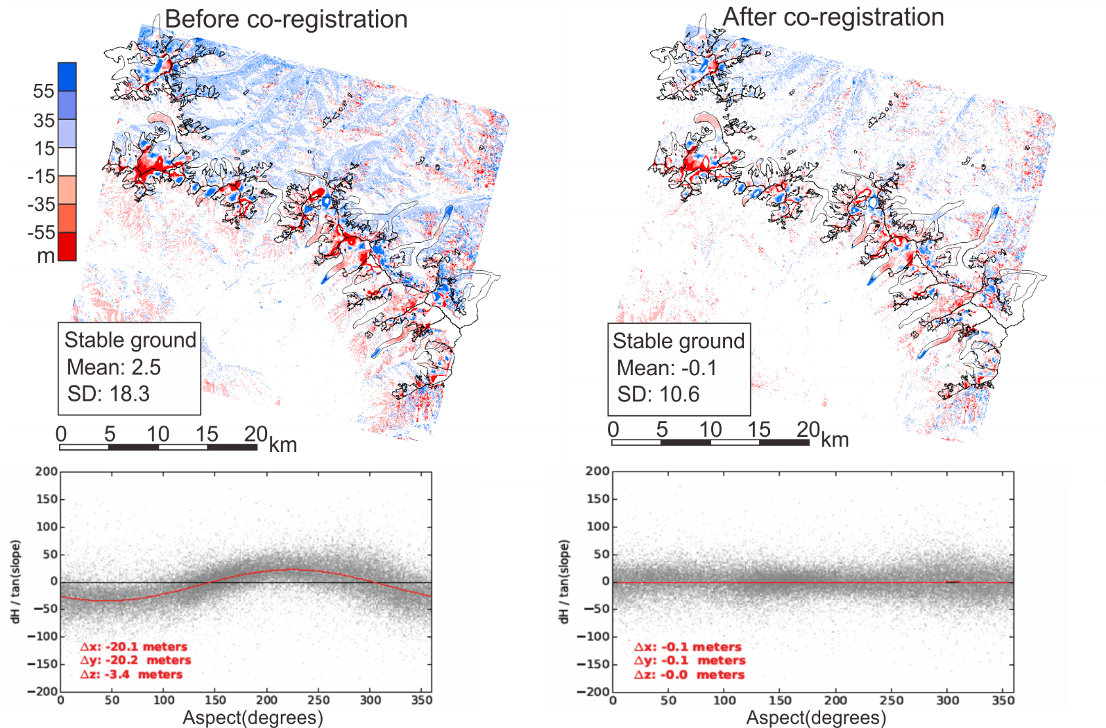

Figure S2. The elevation changes before and after co-registration for PRISM DEM (7) and SRTM DEM with plots showing aspect-dependent distribution of shift direction and magnitude on stable ground.
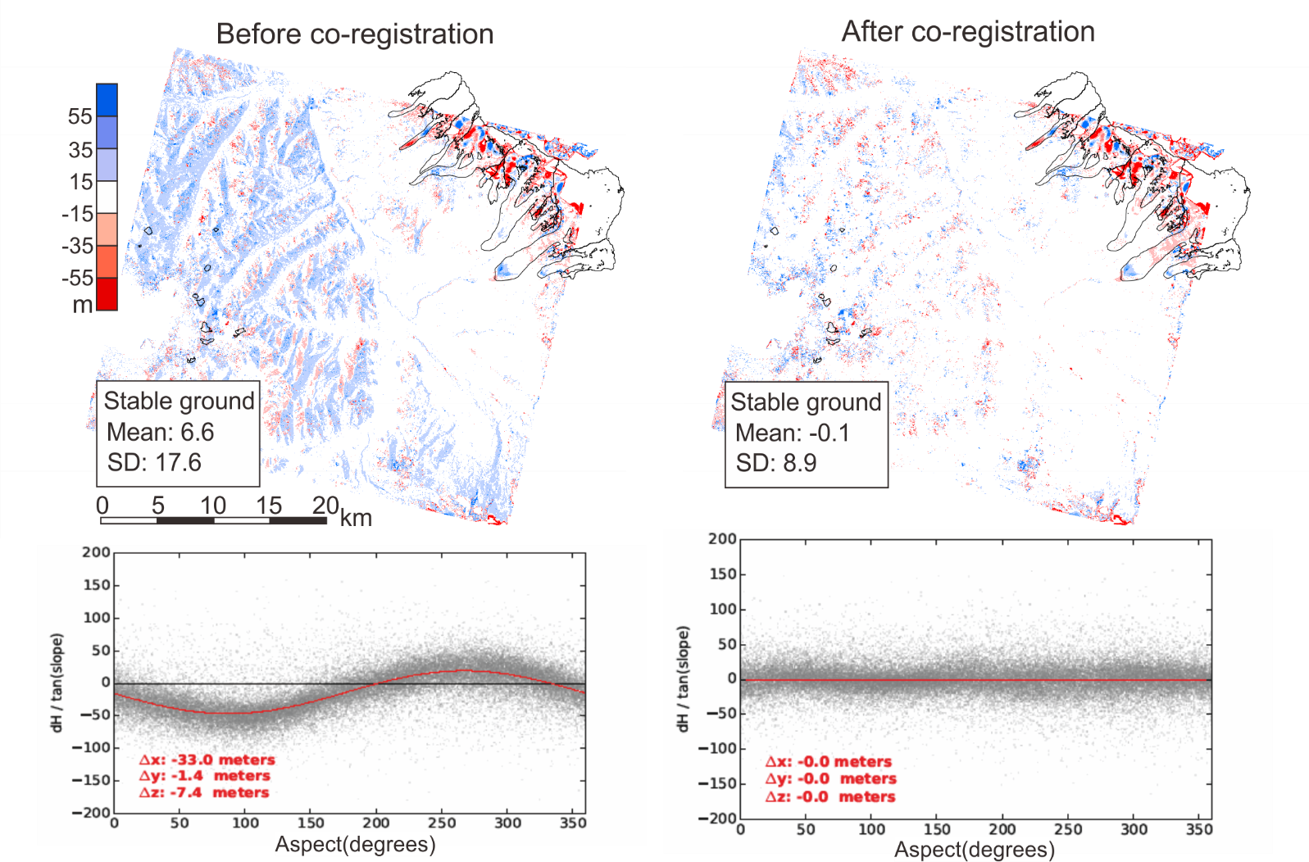

Figure S3. The elevation changes before and after co-registration for HMA DEM (HMA_DEM8m_AT_20151008_0602_1030010048298100_103001004A283A00) and SRTM DEM with plots showing aspect-dependent distribution of shift direction and magnitude on stable ground.
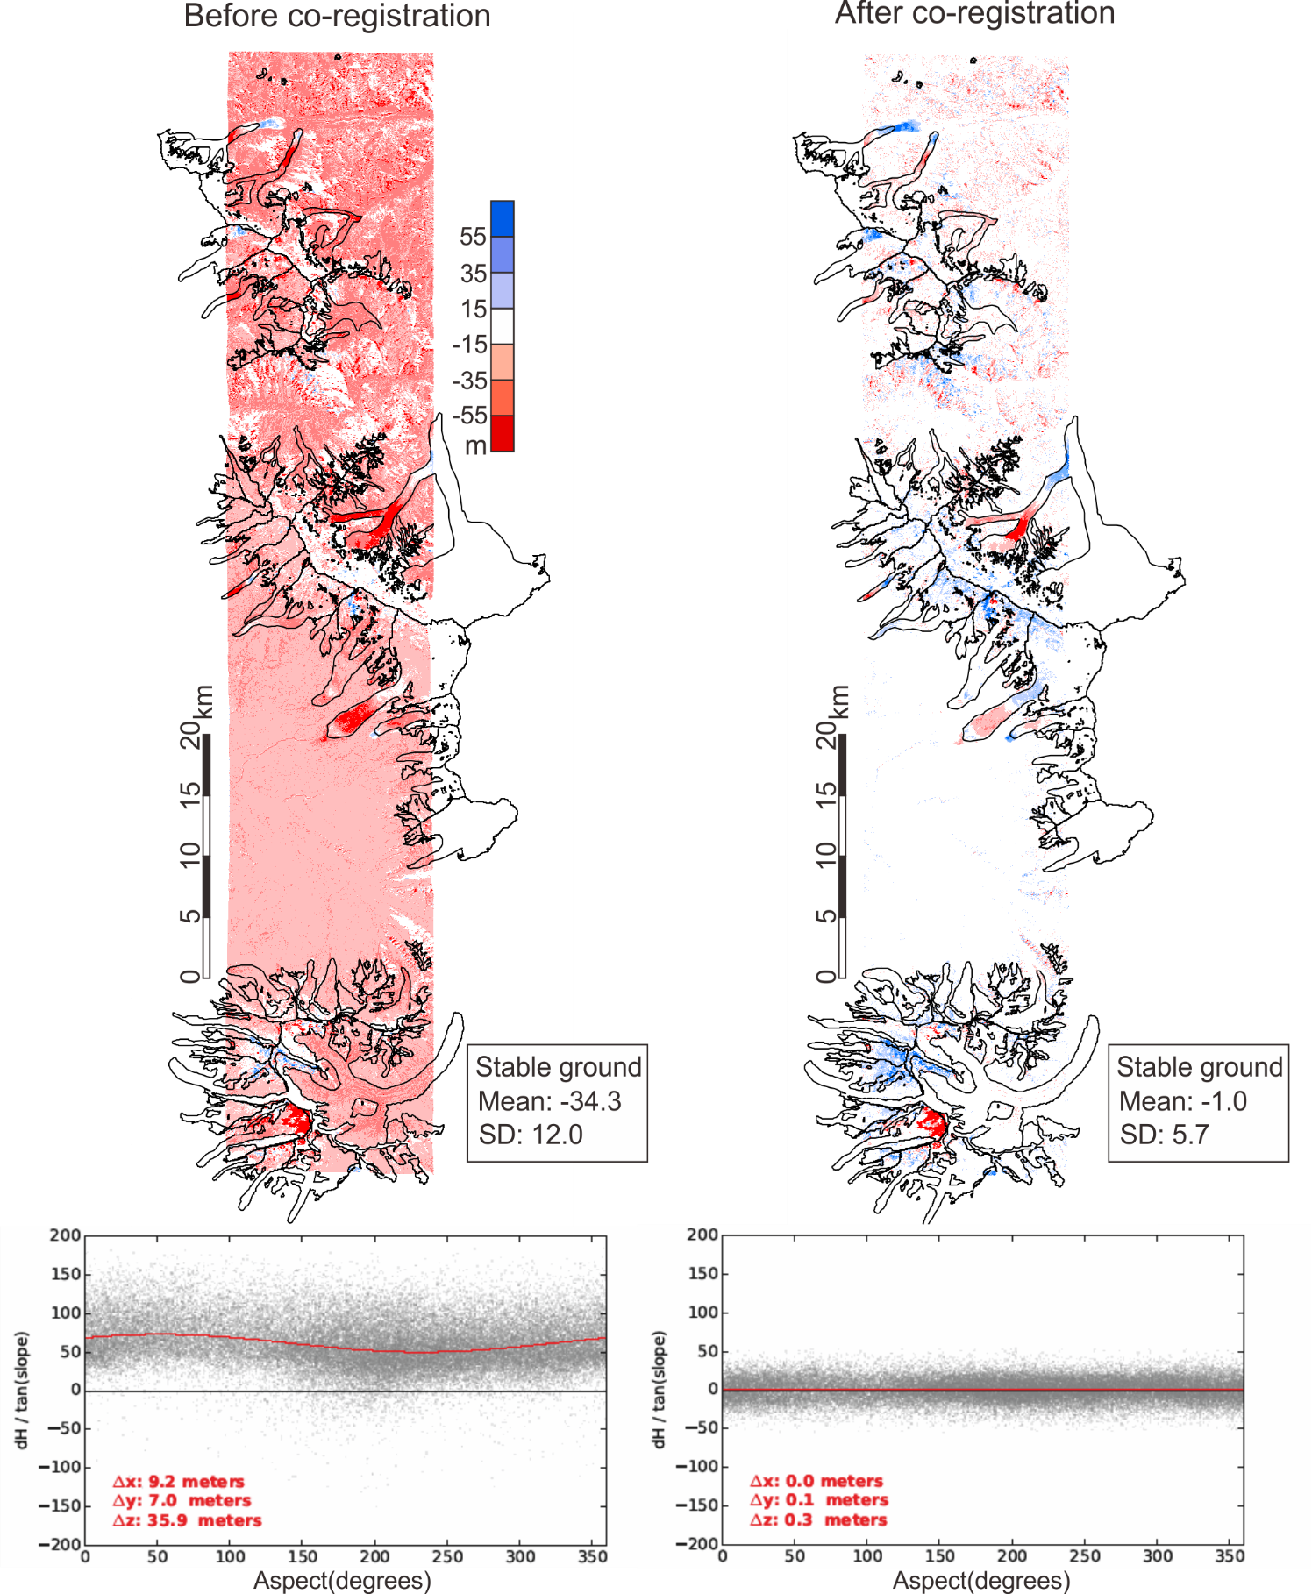

Figure S4. The elevation changes before and after co-registration for HMA DEM (HMA_DEM8m_AT_20150402_0608_1050410012740000_1050410012740200) and SRTM DEM with plots showing aspect-dependent distribution of shift direction and magnitude on stable ground.
