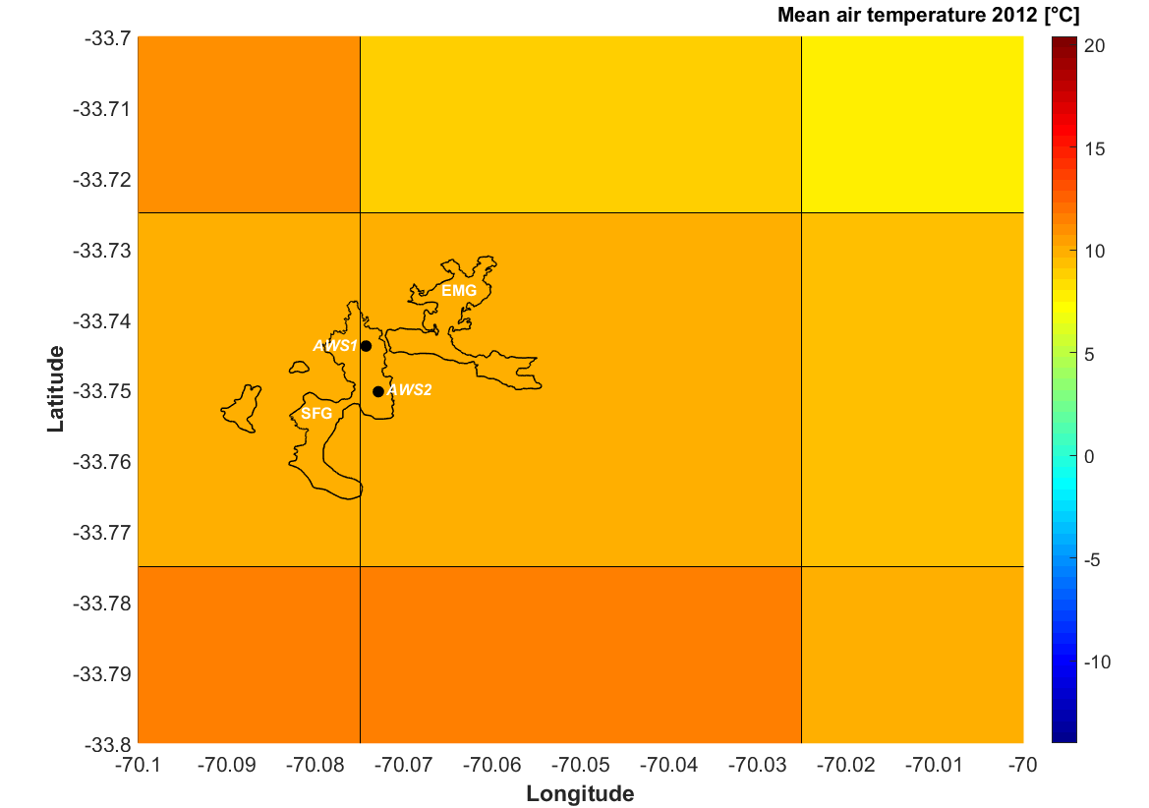

Figure S1. CR2MET air temperature grid and glacier outlines of the San Francisco Glacier (SFG) and El Morado Glacier (EMG). The Automatic Weather Station 1 (AWS1) and 2 (AWS) are both located over the SFG.

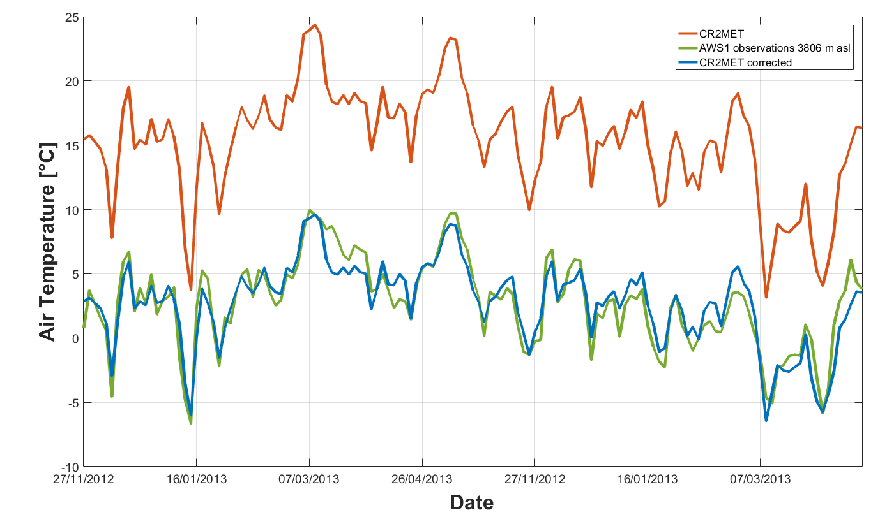
Figure S2. Time series of the observed (AWS1), estimated (CR2MET) and corrected daily air temperature at the location of the AWS1.

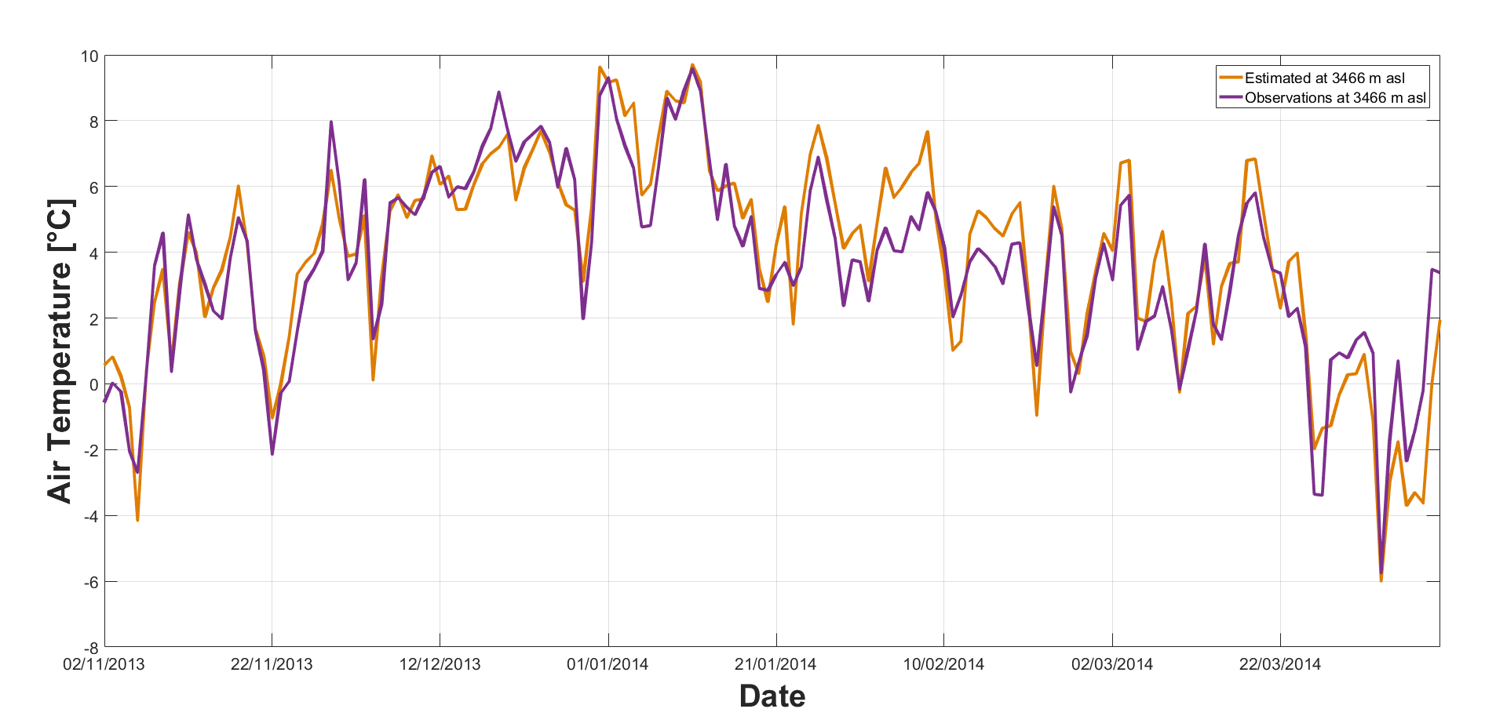
Figure S3. Daily air temperature time series from observations at AWS2 and estimation after correction using CR2MET data at the same location.

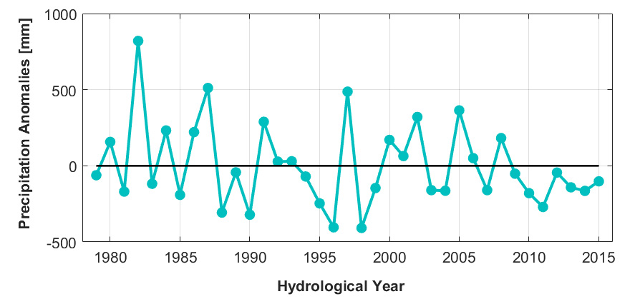
Figure S4. CR2MET annual precipitation anomalies during the 1979-2015 period at the location of the El Morado Glacier (EMG)

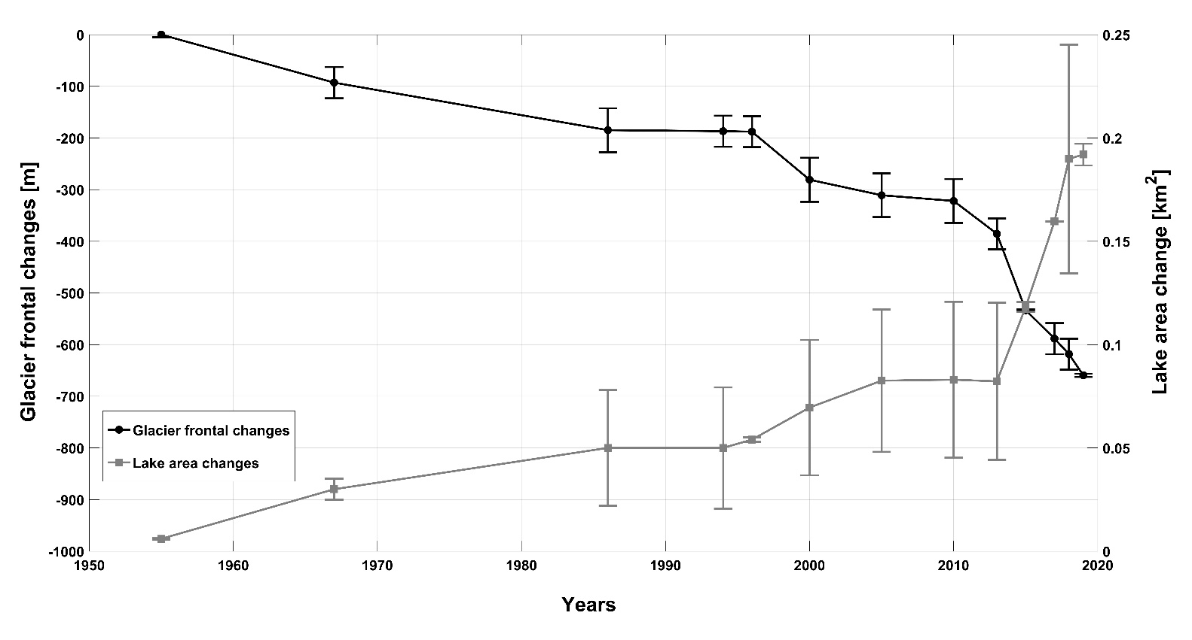

Figure S5. Comparison between glacier frontal changes and proglacial lake changes.

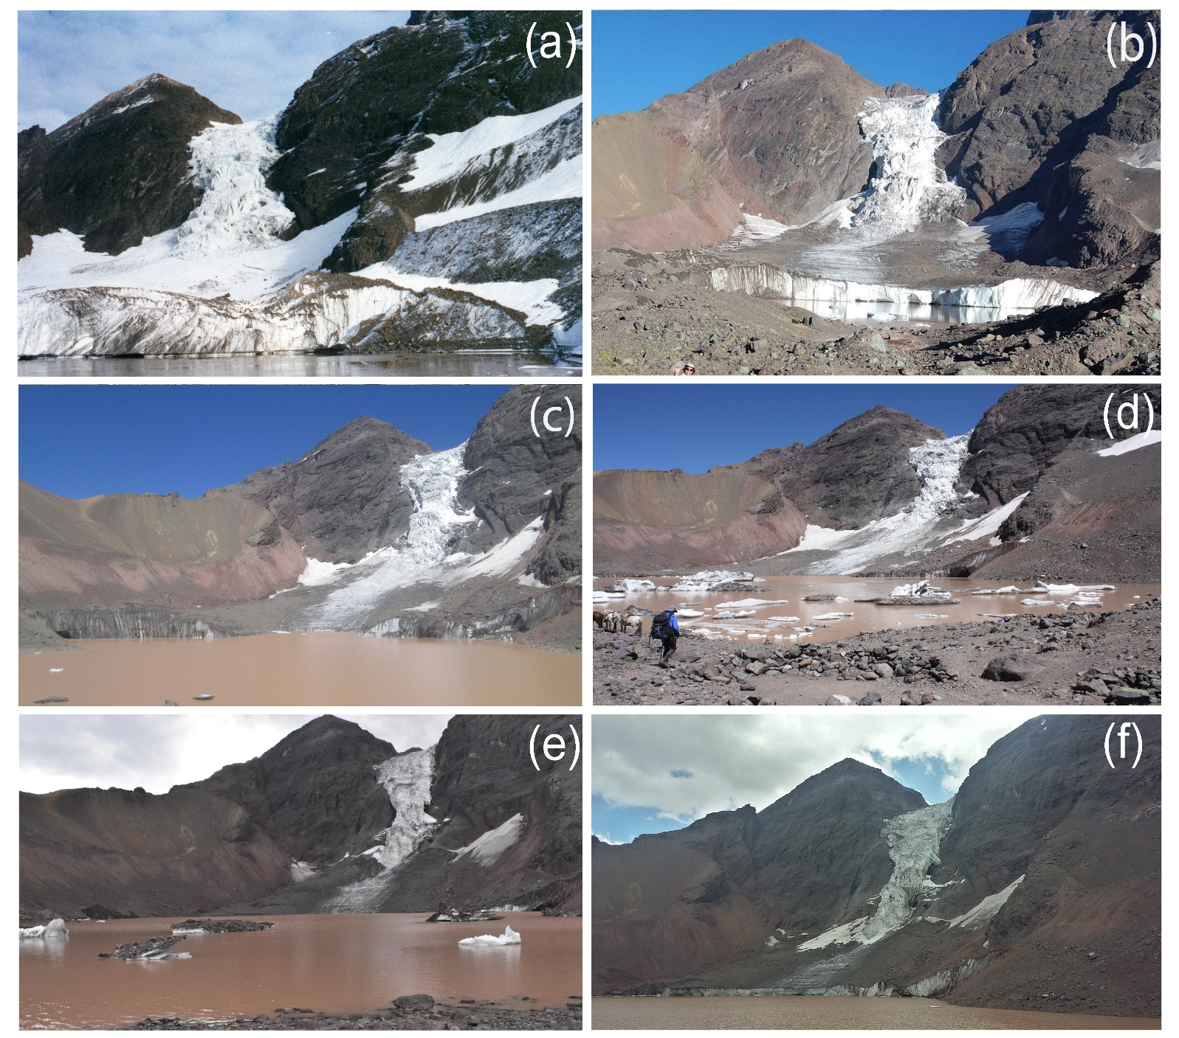
Figure S6. Photographs of El Morado Glacier front and proglacial lake between 2003 and 2009. (a) Corresponds 2003, (b) 2009 (Photo: Guillermo Azocar), (c) 2015, (d) 2017, (e) 2018, (f) 2019.

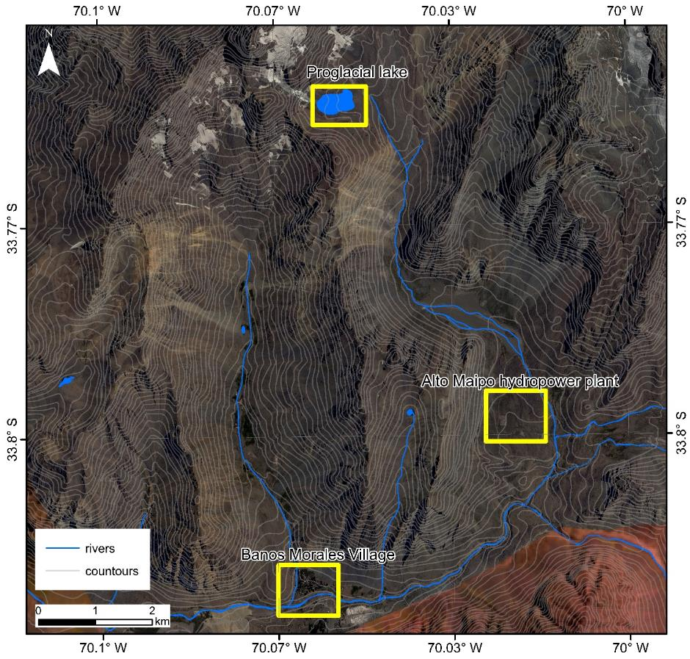

Figure S7. Location of the study area (Proglacial lake), Baños Morales village and hydropower infrastructure. Background: SPOT 6 satellite image (2015).

