SUPPLEMENTARY MATERIALS
Understanding the interrelationships among mass balance, meteorology, discharge and surface velocity on Chhota Shigri Glacier over 2002-2019 using in-situ measurements
Arindan MANDAL¹, AL. RAMANATHAN^{1*}, Mohd. Farooq AZAM², Thupstan ANGCHUK¹, Mohd. SOHEB¹, Naveen KUMAR¹, Jose George POTTAKKAL³, Sarvagya VATSAL¹, Somdutta MISHRA¹, Virendra Bahadur SINGH^{1,4}
¹School of Environmental Sciences, Jawaharlal Nehru University, New Delhi 110067, India
²Discipline of Civil Engineering, Indian Institute of Technology Indore, Simrol 453552, India.
³Western Himalayan Regional Centre, National Institute of Hydrology, Jammu, India.
⁴Department of Geology, University of Delhi, Delhi 110007, India
Email: <alrjnu@gmail.com> / <arindan.141@gmail.com>

Supplementary information:

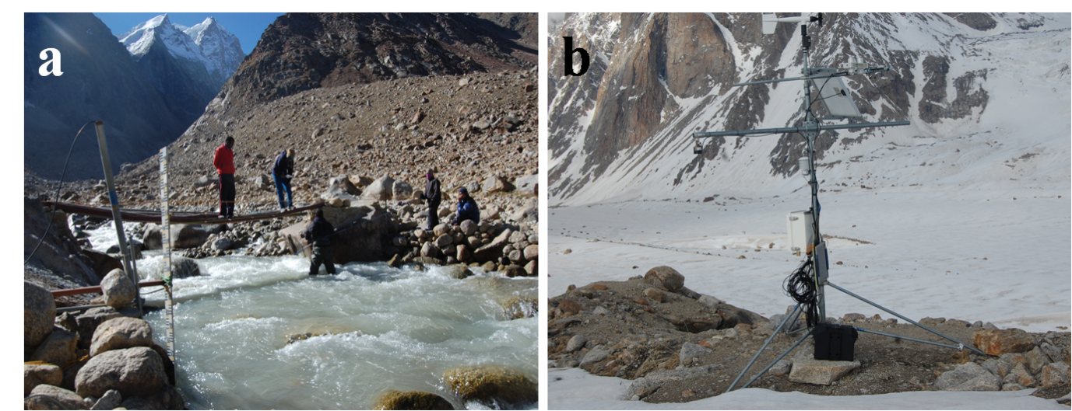
Fig. S1. Photographs of (a) the discharge measurement site (~3840m a.s.l.) and (b) AWS-M (4863 m a.s.l.) at the Chhota Shigri Glacier catchment.

Table S1. Mean seasonal values of T_{air} and ∑T_{air}⁺(°C), RH (%), u (m s⁻¹), S_{in} and L_{in} (W m⁻²) at AWS-M (4863 m a.s.l.) for 2009/10 to 2018/19 hydrological years. T, RH, u and S_{in} are the mean seasonal values of 10 hydrological years between 1 October 2009 and 28 September 2019 while L_{in} is the mean seasonal values between 1 June 2010 and 28 September 2019. P is the sum (in mm) of seasonal precipitation for between 1 October 2012 and 30 September 2018 (with a gap from October 2013 to September 2014) at the glacier base camp (3850 m a.s.l.) collected by the Geonor precipitation gauge. P of 2018/19 is the area-weighted average of Lahaul-Spiti district (hence not used in the long-term calculation of seasonal and annual P of Chhota Shigri Glacier) which was obtained from IMD, Shimla (http://weathershimla.nic.in/en-IN/rainfallmonthly.html; last accessed on 10 October 2019).
Seasons | Variables | 2009/10 | 2010/11 | 2011/12 | 2012/13 | 2013/14 | 2014/15 | 2015/16 | 2016/17 | 2017/18 | 2018/19 | Mean
Post-monsoon (ON) | T_{air} | -8.8 | -7.2 | -6.1 | -9.1 | -6.9 | -7.4 | -5.0 | -5.8 | -6.7 | -9.2 | -7.2
 | ∑T_{air}⁺ | 0.0 | 0.0 | 2.5 | 0.0 | 17.1 | 3.4 | 9.5 | 11.0 | 0.7 | 0.0 | 4.4
 | RH | 48 | 35 | 33 | 39 | 39 | 37 | 33 | 33 | 35 | 39 | 37
 | u | 5.1 | 4.2 | 4.1 | 4.2 | 4.0 | 4.4 | 4.2 | 4.0 | 4.2 | 4.5 | 4.3
 | S_{in} | 150 | 192 | 186 | 178 | 181 | 184 | 490 | 194 | 184 | 181 | 212
 | L_{in} |  | 178 | 191 | 195 | 200 | 195 | 221 | 193 | 198 | 197 | 196
 | P |  |  |  | 32 | 30 | 64 | 46 | 6 | 38 | 57 | 39
Winter (DJFM) | T_{air} | -12.5 | -13.7 | -14.5 | -13.1 | -14.0 | -12.4 | -10.8 | -12.2 | -11.9 | -14.3 | -12.9
 | ∑T_{air}⁺ | 0.0 | 0.0 | 0.0 | 0.0 | 0.0 | 0.0 | 0.0 | 0.0 | 0.0 | 0.0 | 0.0
 | RH | 43 | 41 | 43 | 38 | 43 | 37 | 34 | 41 | 35 | 45 | 40
 | u | 5.1 | 5.5 | 6.3 | 5.0 | 5.6 | 5.0 | 5.0 | 5.6 | 5.1 | 5.5 | 5.4
 | S_{in} | 144 | 168 | 163 | 168 | 158 | 247 | 461 | 192 | 174 | 164 | 204
 | L_{in} |  | 191 | 195 | 193 | 199 | 200 | 208 | 204 | 194 | 204 | 199
 | P |  |  |  | 679 | 452 | 708 | 256 | 401 | 209 | 473 | 454
Pre-monsoon (AM) | T_{air} | -4.5 | -4.9 | -6.2 | -5.5 | -6.2 | -3.4 | -2.7 | -4.6 | -4.9 | -4.9 | -4.8
 | ∑T_{air}⁺ | 0.3 | 3.1 | 0.3 | 4.8 | 0.0 | 3.6 | 20.1 | 0.0 | 0.6 | 0.0 | 3.3
 | RH | 52 | 50 | 54 | 50 | 49 | 44 | 45 | 50 | 51 | 48 | 49
 | u | 3.9 | 3.4 | 3.4 | 3.5 | 3.6 | 3.1 | 3.4 | 3.6 | 3.6 | 3.3 | 3.5
 | S_{in} | 256 | 323 | 311 | 314 | 313 | 661 | 648 | 302 | 299 | 317 | 374
 | L_{in} |  | 230 | 233 | 230 | 230 | 241 | 250 | 241 | 234 | 228 | 235
 | P |  |  |  | 148 | 192 | 310 | 187 | 153 | 160 | 171 | 189
Summer-monsoon (JJAS) | T_{air} | 1.9 | 2.8 | 2.3 | 3.2 | 2.3 | 3.2 | 4.3 | 2.8 | 2.8 | 2.5 | 2.8
 | ∑T_{air}⁺ | 318.0 | 378.2 | 351.7 | 412.8 | 281.3 | 428.2 | 526.1 | 358.4 | 387.9 | 340.4 | 378.3
 | RH | 69 | 67 | 69 | 68 | 64 | 59 | 65 | 69 | 72 | 68 | 67
 | u | 2.9 | 2.7 | 2.9 | 2.7 | 2.7 | 3.2 | 2.9 | 2.7 | 2.7 | 2.6 | 2.8
 | S_{in} | 260 | 276 | 263 | 265 | 278 | 572 | 539 | 257 | 247 | 278 | 324
 | L_{in} | 280 | 276 | 283 | 284 | 272 | 294 | 298 | 275 | 281 | 274 | 282
 | P |  |  |  | 117 | 265 | 220 | 129 | 194 | 360 | 395 | 240
Annual | T_{air} | -5.8 | -5.7 | -6.1 | -5.7 | -6.1 | -4.9 | -3.4 | -4.9 | -5.0 | -6.3 | -5.4
 | ∑T_{air}⁺ | 318.3 | 381.3 | 354.6 | 417.6 | 298.4 | 435.2 | 555.7 | 369.4 | 389.2 | 340.4 | 386.0
 | RH | 54 | 50 | 52 | 50 | 50 | 46 | 46 | 50 | 50 | 52 | 50
 | u | 4.2 | 4.0 | 4.3 | 3.8 | 4.0 | 4.0 | 3.9 | 4.0 | 3.9 | 4.0 | 4.0
 | S_{in} | 202 | 234 | 225 | 226 | 228 | 414 | 523 | 233 | 221 | 230 | 274
 | L_{in} |  | 224 | 230 | 230 | 229 | 237 | 247 | 232 | 230 | 230 | 232
 | P |  |  |  | 976 | 939 | 1302 | 617 | 755 | 767 | 1096 | 922

Temperature Lapse Rate (TLR)
To calculate the temperature lapse rate (TLR) in the Chhota Shigri catchment, another T_{air} sensor (accuracy of ±0.2 °C) was installed at the base camp (3850 m a.s.l.) since the summer of 2016 which logged data into a Sutron XLite 8210 data logger at 1-hour intervals. TLR was calculated between AWS-BC and AWS-M to understand altitude dependency of the slope lapse rate values of T_{air} for the period 1 October 2016 to 28 September 2019. The altitude difference between these two locations is 1019 m with ~7 km horizontal distance. Daily TLRs are plotted in Fig. S2. There is a noticeable seasonal and inter-annual cycle in TLRs, with the highest mean monthly TLR (7.37 °Ckm⁻¹) in June during summer and the lowest (4.46 °C km⁻¹) in January during winter (Fig. S2). The lower TLRs during winter months can be supported by the presence of katabatic/down-valley winds, which are common over Chhota Shigri Glacier during winter (Azam and others, 2014a). Katabatic winds mix the near-surface atmosphere and probably control the lower TLRs during winter. The lower TLRs during winters have also been observed over Sutri Dhaka Glacier, which is located in the same catchment about 15 km northward from Chhota Shigri (Pratap and others, 2019). TLR between Askole and Urdukas in the Baltoro glacier catchment also has shown a similar monthly pattern with slightly higher values in summer (Bashir and Rasul, 2010). The mean monthly TLR curve estimated in this study is different than previously estimated between AWS-M and Bhuntar station for the period 2009-2012, where monthly temperature TLRs were the lowest in summer and the highest in winter (Azam and others, 2014b). This is because Bhuntar station lies on the windward side, where the influence of the summer-monsoon (ISM) is higher than in the Chhota Shigri catchment, and strong monsoonal convectional currents mix the atmosphere (Shea and others, 2015). Similar TLR patterns were also noted for Kasol-Manali and Bhuntar-Manali in the Sutlej-Beas catchment (Thayyen and Dimri, 2018).
The annual TLR between AWS-BC and AWS-M were found to be 6.16 °C km⁻¹, close to the environmental lapse rate (6.5 °C km⁻¹). TLR observed on Chhota Shigri Glacier fairly matches with the previously estimated TLR between AWS-M and Bhuntar station (6.4 °C km⁻¹; Azam and others, 2014b), Sutlej-Beas catchment (5.99 °C km⁻¹ between Kasol and Manali; Thayyen and Dimri, 2018) and Dokriani Glacier catchment (6.4 °C km⁻¹ between base camp and advance base camp; Yadav and others, 2019). Whereas, TLR is significantly different compared to Sutri Dhaka Glacier (4.2 °C km⁻¹) and Baltoro Glacier catchments (7.52 °C km⁻¹). We stress the point that TLRs discussed here are estimated between two points only. Indeed for robust estimation of TLRs requires more than two stations in a valley.
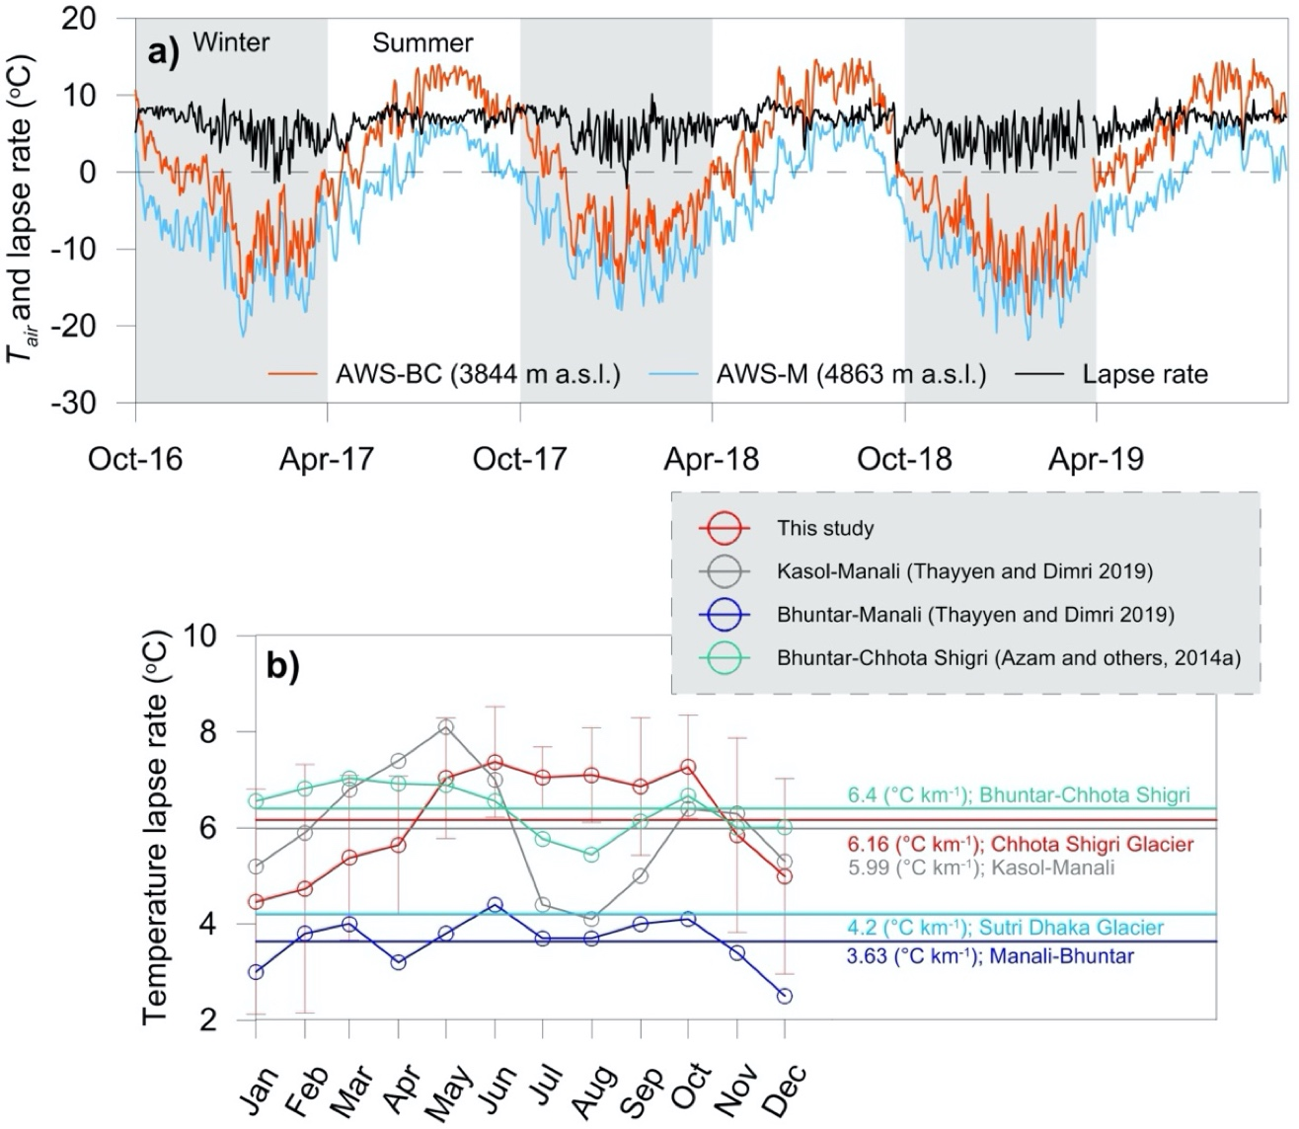
Fig. S2. (a) Daily T_{air} difference between AWS-BC and AWS-M (1019 m altitude difference) with TLRs between 1 October 2016 to 28 September 2019, and (b) Monthly TLR variations with SD.
Comparison of annual mass balance gradients
The db/dz is an important quantity to describe the climatic setting of a glacier and is usually steeper for glaciers with a large mass turnover typical of wet climates, and gentler for glaciers in drier and colder regions (Oerlemans, 2001). Oerlemans and Hoogendoorn (1989) showed that the db/dz is mainly controlled by the decrease of air temperature with altitude and the vertical gradient of accumulation (depending on the precipitation gradient and phase) and hence the vertical changes in surface albedo. Here, we compared the db/dz from a few Himalayan glaciers to understand the control of db/dz on B_{a} (Table S2). Figure S11 depicts the B_{a} as a function of db/dz. All db/dz are calculated over debris-free areas since debris cover has a large impact on db/dz (Banerjee, 2017). Mean B_{a} of the Chhota Shigri Glacier was negative at -0.46 m w.e. a⁻¹ with a mean db/dz of 0.68 m w.e. (100 m)⁻¹ a⁻¹ over 2002-2019, while the Pokalde and ChangriNup glaciers in Nepal had a mean B_{a} of -0.69 m w.e. a⁻¹ (2010-2015) and -1.24 m w.e. a⁻¹ (2009-2015) corresponding to a db/dz of 1.37 and 1.47 m w.e. (100 m)⁻¹ a⁻¹, respectively (Sherpa and others, 2017) which are much steeper than Chhota Shigri. The db/dz of Mera Glacier (30 km apart from Changri Nup) is comparatively flat 0.46 m w.e. (100 m)⁻¹ a⁻¹, which yields a near-positive B_{a} of -0.03 m w.e. a⁻¹ over 2007-2015. Similarly, in the Trambau Glacier (near the Mera) a less negative B_{a} was recorded in comparison with Pokalde and Changri Nup, where db/dz was less steep (2017 and 2018: 0.59 and 0.73 m w.e. (100 m)⁻¹ a⁻¹) corresponding to a B_{a} of -0.66 and -0.82 m w.e. (Sunako and others, 2019). Our analysis demonstrates that the less negative B_{a} of Mera, Chhota Shigri and Trambau glaciers are possibly driven by flat or moderately steep db/dz. Nonetheless, the difference in db/dz may be due to either increased accumulation or decreased ablation depending on the local setting of the individual glaciers; therefore, such an analysis would require more in-situ measurements in the future covering different parts of the Himalayan region to develop a coherent picture.
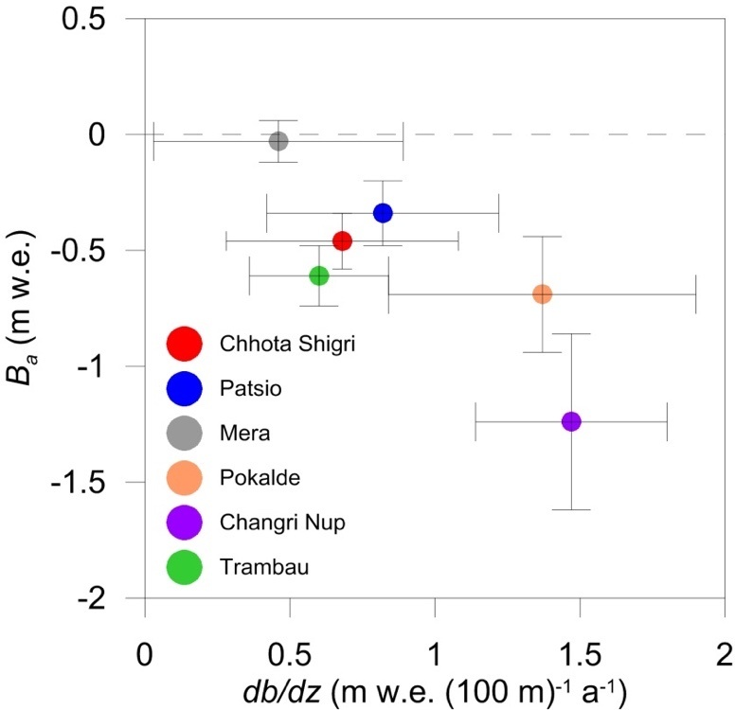
Fig. S3. B_{a} as a function of db/dz in measured Himalayan glaciers. Additional details about the glaciers are listed in Table S2. Error bars are the SDs.
Table S2. Compilation of vertical mass balance gradients (db/dz) of Himalayan glaciers. All db/dz are calculated over debris-free areas.

Glacier, region (Country) | db/dz (SD)  (m w.e. (100 m)⁻¹ a⁻¹) | Elevation range of db/dz  (m a.s.l.) | Glacier area (km²) | Mean B_{a}  (m w.e.) | Period | Source
Chhota Shigri, Lahaul-Spiti (India) | 0.68 (0.12) | 4400-5200 | 15.5 | -0.46 | 2002-2019 | This study
Patsio, Lahaul-Spiti (India) | 0.82 (0.14) | 5100-5400 | 2.25 | -0.34 | 2010-2017 | Angchuk and others, in prep.
Mera, Everest region (Nepal) | 0.46 (0.09) | 4940-6420 | 5.1 | -0.03 | 2007-2015 | Sherpa and others, 2017
Pokalde, Khumbu valley (Nepal) | 1.37 (0.25) | 5430-5690 | 0.1 | -0.69 | 2009-2015 | Sherpa and others, 2017
ChangriNup, Khumbu valley (Nepal) | 1.47 (0.38) | 5330-5690 | 0.9 | -1.24 | 2010-2015 | Sherpa and others, 2017
Trambau, Rolwaling region (Nepal) | 0.60 (0.13) | 4450-6690 | 31.70 | -0.61 | 2016-2018 | Sunako and others, 2019

Table S3. Dates of the annual and winter mass balance measurements on the Chhota Shigri Glacier and the respective number of stakes, snow/firn cores, and snow probings for the period 2013/14-2018/19. Each probing value represents the average of 3-5 probing measurements. In 2014/15 and 2017/18, annual snow cores/drills are based on previous years measured values; discussed in Sec. 3.2.1. Stakes/cores/probings on the eastern and western flanks are shown in parentheses. Annual mass balance measurements were performed on 4 October 2002, 4 October 2003, 22 September 2004, 3 October 2005, 30 September 2006, 1 October 2007, 6 October 2008, 9 October 2009, 10 October 2010, 9 October 2011, 10 October 2012, 6 October 2013 and 4 October 2014 (±10 days), respectively (Azam and others, 2016).
Year | Annual mass balance |  |  | Winter mass balance
 | Date | Stakes | Snow core/drill | Date | Stakes | Probings/snow depths | Snow core/drill
2013/14 | - | - | - | 18 June 2014 | 0 | 20 (16, 4) | 5 (3, 2)
2014/15 | 11 October 2015 | 18 (12, 6) | 5 (3, 0) | 9 June 2015 | 2 (2, 0) | 10 (10, 0) | 5 (2, 3)
2015/16 | 4 October 2016 | 17 (11, 6) | 3 (2, 1) | 5 June 2016 | 8 (8, 0) | 17 (13, 4) | 6 (4, 2)
2016/17 | 4 October 2017 | 16 (11, 5) | 6 (4, 2) | 31 May 2017 | 7 (7, 0) | 19 (19, 0) | 5 (2, 3)
2017/18 | 15 September 2018 | 16 (10, 6) | 5 (2, 3) | 8 June 2018 | 0 | 33 (18, 15) | 4 (2, 2)
2018/19 | 28 September 2019 | 15 (12, 3) | 5 (3, 2) | 26 June 2019 | 0 | 9 (9, 0) | 2 (2, 0)

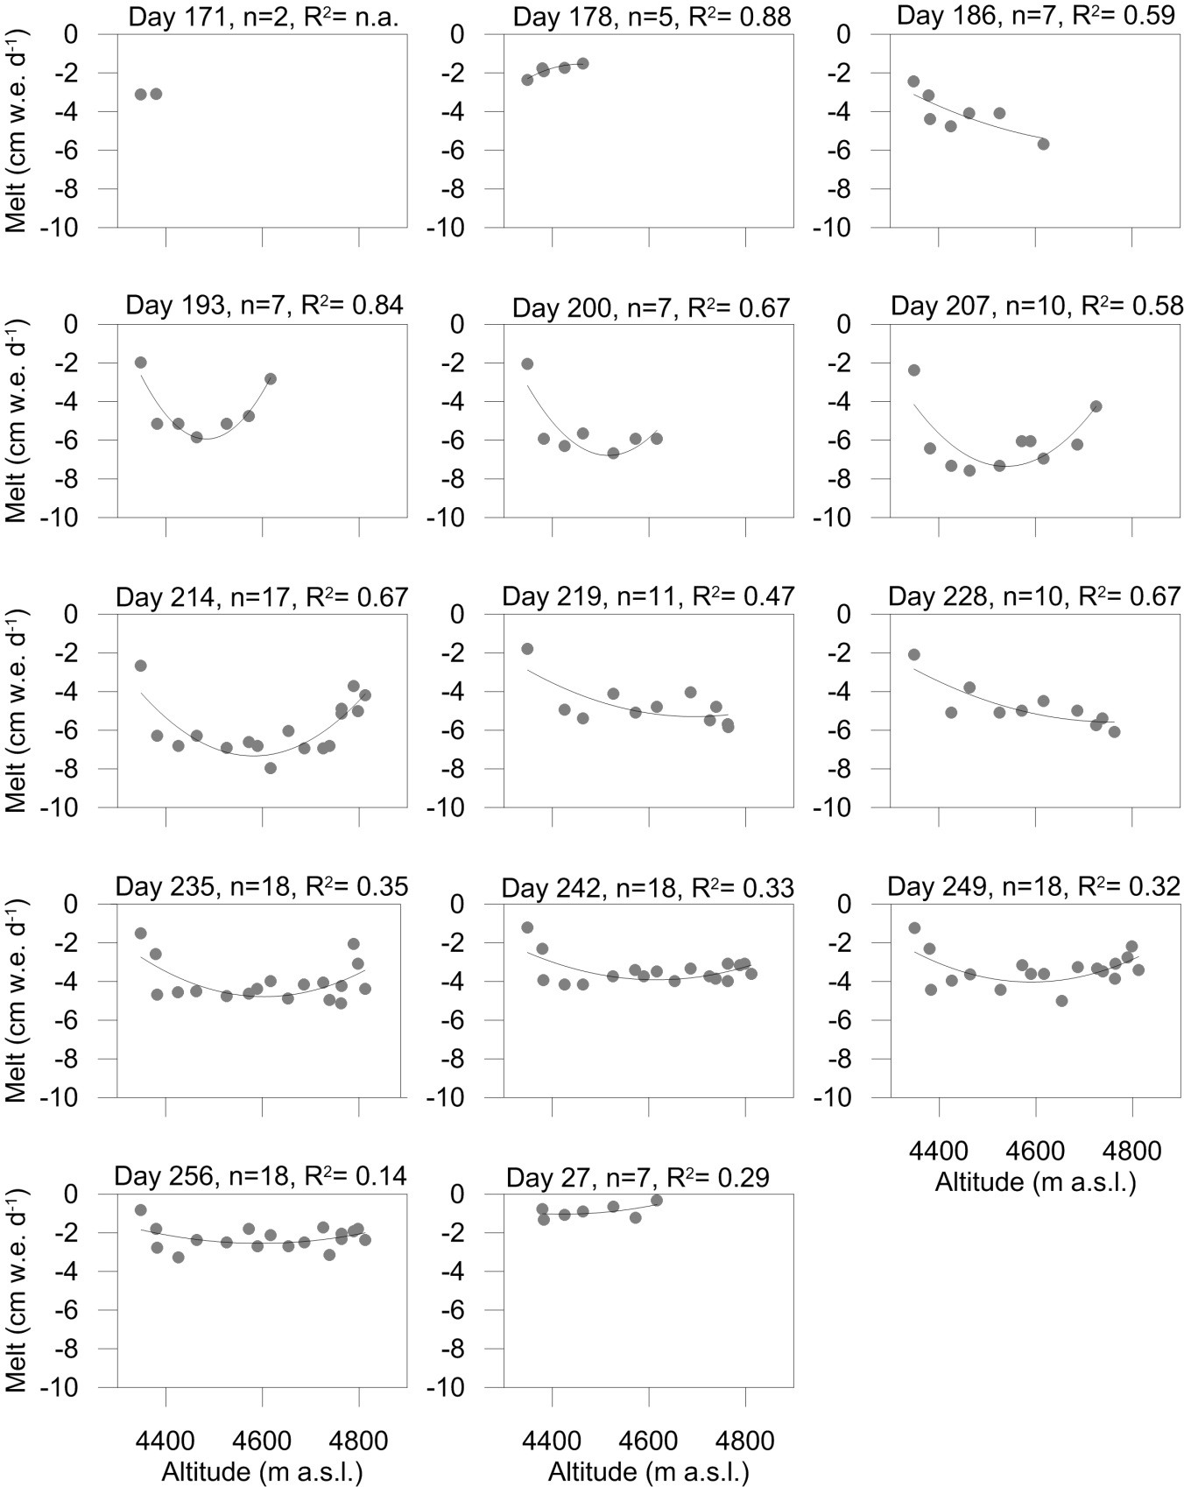
Fig. S4. The fitted sub-seasonal ablation rate from the ablation zone in 2015 for each of the observation periods. The polynomial fit (2nd order) parameters are given on top of each plot.

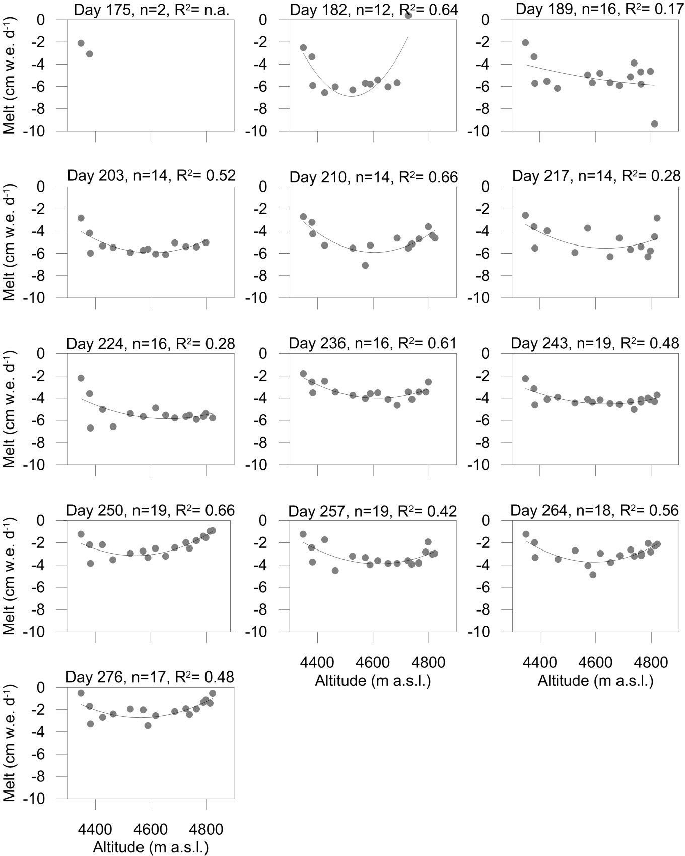
Fig. S5. The fitted sub-seasonal ablation rate from the ablation zone in 2016 for each of the observation periods. The polynomial fit (2nd order) parameters are given on top of each plot.
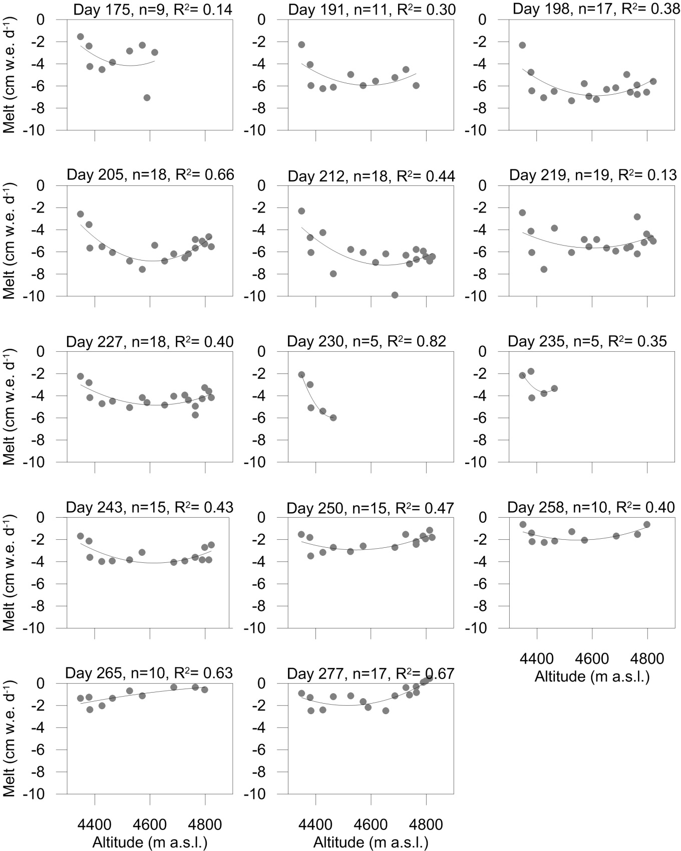
Fig. S6. The fitted sub-seasonal ablation rate from the ablation zone in 2017 for each of the observation periods. The polynomial fit (2nd order) parameters are given on top of each plot.
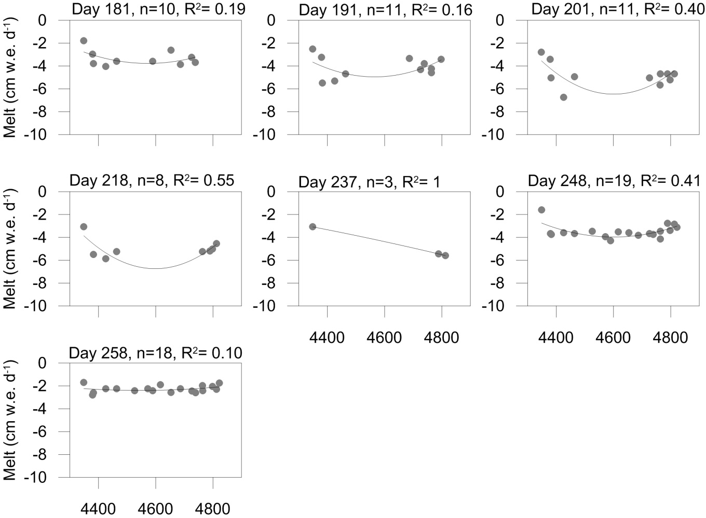
Fig. S7. The fitted sub-seasonal ablation rate from the ablation zone in 2018 for each of the observation periods. The polynomial fit (2nd order) parameters are given on top of each plot.

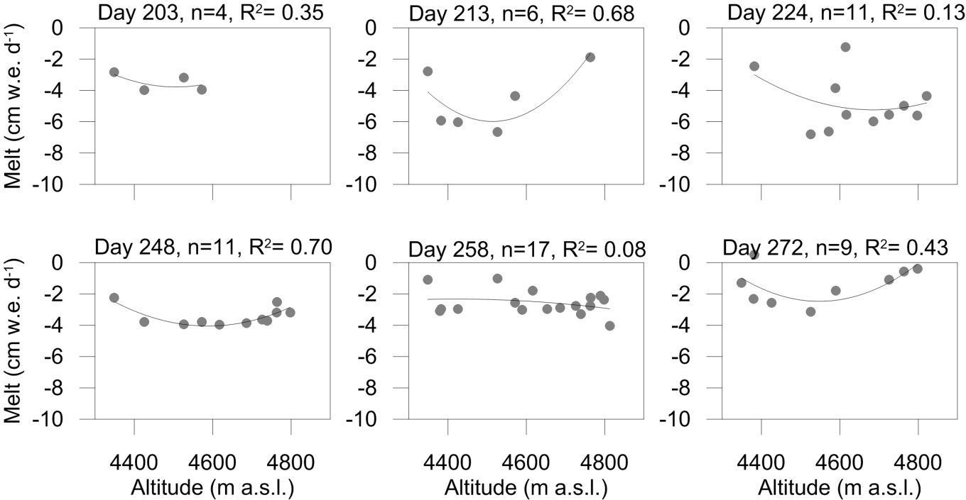
Fig. S8. The fitted sub-seasonal ablation rate from the ablation zone in 2019 for each of the observation periods. The polynomial fit (2nd order) parameters are given on top of each plot.

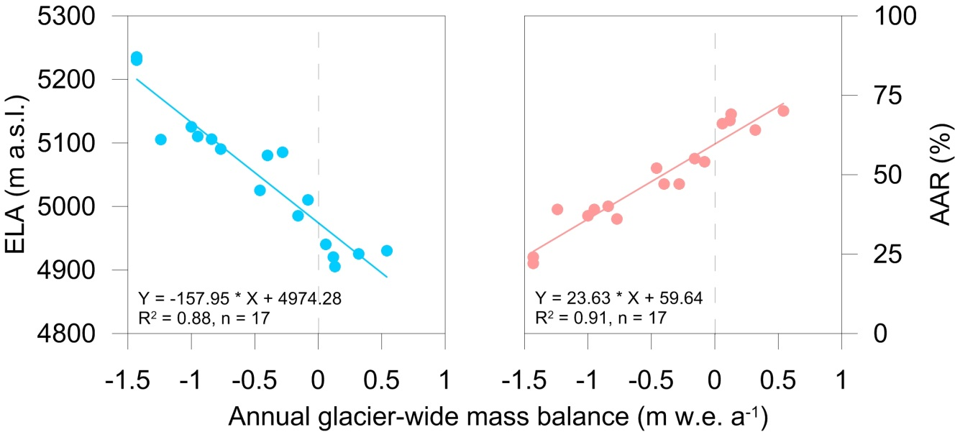
Fig. S9. Relationship between annual glacier-wide mass balance and Equilibrium Line Altitude (ELA), Accumulation Area Ratio (AAR) for the period 2002-2019.
Table S4. Correlation coefficients (R²) between annual and seasonal glacier-wide mass balance and meteorological variables recorded at the AWS-M (4863 m a.s.l.) except precipitation measured at base camp (3850 m a.s.l.) over the 6-year studied period (2014-2019).Significant correlations are shown by * (p < 0.05) and ** (p < 0.01).
ON | B_{a} (m w.e.) | B_{w} (m w.e.) | B_{s} (m w.e.) | T_{air} | ∑T_{air}⁺ | RH | u | S_{in} | L_{in} | P
B_{a} (m w.e.) | 1
B_{w} (m w.e.) | **0.93 | 1
B_{s} (m w.e.) | *0.84 | 0.62 | 1
T_{air} | -0.94 | -0.88 | -0.74 | 1
∑T_{air}⁺ | -0.31 | -0.44 | 0.10 | 0.54 | 1
RH | 0.80 | 0.62 | *0.86 | -0.85 | -0.12 | 1
u | 0.42 | 0.58 | 0.06 | -0.64 | -0.86 | 0.36 | 1
S_{in} | -0.70 | -0.47 | -0.75 | 0.64 | 0.19 | -0.54 | 0.02 | 1
L_{in} | -0.62 | -0.43 | -0.65 | 0.53 | 0.21 | -0.35 | 0.03 | **0.96 | 1
P | 0.25 | 0.28 | 0.14 | -0.52 | -0.59 | 0.53 | *0.84 | 0.10 | 0.20 | 1
DJFM | B_{a} (m w.e.) | B_{w} (m w.e.) | B_{s} (m w.e.) | T_{air} | ∑T_{air}⁺ | RH | u | S_{in} | L_{in} | P
B_{a} (m w.e.) | 1
B_{w} (m w.e.) | **0.93 | 1
B_{s} (m w.e.) | *0.84 | 0.62 | 1
T_{air} | -0.92 | -0.76 | -0.92 | 1
∑T_{air}⁺ |  |  |  |  | 1
RH | *0.86 | 0.80 | *0.82 | -0.91 |  | 1
u | 0.55 | 0.48 | 0.59 | -0.70 |  | *0.87 | 1
S_{in} | -0.72 | -0.51 | -0.72 | 0.76 |  | -0.64 | -0.61 | 1
L_{in} | -0.13 | 0.14 | -0.24 | 0.23 |  | 0.09 | 0.04 | 0.65 | 1
P | 0.51 | 0.36 | 0.73 | -0.44 |  | 0.38 | 0.07 | -0.25 | 0.05 | 1
AM | B_{a} (m w.e.) | B_{w} (m w.e.) | B_{s} (m w.e.) | T_{air} | ∑T_{air}⁺ | RH | u | S_{in} | L_{in} | P
B_{a} (m w.e.) | 1
B_{w} (m w.e.) | **0.93 | 1
B_{s} (m w.e.) | *0.84 | 0.62 | 1
T_{air} | -0.53 | -0.31 | -0.63 | 1
∑T_{air}⁺ | -0.71 | -0.49 | -0.72 | 0.78 | 1
RH | 0.15 | 0.06 | 0.07 | -0.78 | -0.60 | 1
u | -0.31 | -0.34 | -0.27 | -0.53 | -0.13 | *0.84 | 1
S_{in} | -0.47 | -0.39 | -0.34 | *0.86 | 0.74 | -0.94 | -0.66 | 1
L_{in} | -0.83 | -0.66 | -0.75 | *0.85 | 0.81 | -0.52 | -0.08 | 0.73 | 1
P | 0.01 | -0.12 | 0.29 | 0.41 | 0.09 | -0.78 | -0.81 | 0.73 | 0.21 | 1
JJAS | B_{a} (m w.e.) | B_{w} (m w.e.) | B_{s} (m w.e.) | T_{air} | ∑T_{air}⁺ | RH | u | S_{in} | L_{in} | P
B_{a} (m w.e.) | 1
B_{w} (m w.e.) | **0.93 | 1
B_{s} (m w.e.) | *0.84 | 0.62 | 1
T_{air} | -0.75 | -0.53 | -0.79 | 1
∑T_{air}⁺ | -0.70 | -0.47 | -0.80 | **0.98 | 1
RH | 0.05 | 0.16 | -0.32 | -0.28 | -0.22 | 1
u | -0.42 | -0.47 | -0.17 | 0.59 | 0.63 | -0.79 | 1
S_{in} | -0.43 | -0.36 | -0.27 | 0.78 | 0.77 | -0.78 | **0.92 | 1
L_{in} | -0.64 | -0.52 | -0.59 | *0.91 | **0.93 | -0.51 | *0.85 | **0.92 | 1
P | 0.73 | 0.67 | 0.45 | -0.70 | -0.58 | 0.50 | -0.52 | -0.63 | -0.59 | 1
ANNUAL | B_{a} (m w.e.) | B_{w} (m w.e.) | B_{s} (m w.e.) | T_{air} | ∑T_{air}⁺ | RH | u | S_{in} | L_{in} | P
B_{a} (m w.e.) | 1
B_{w} (m w.e.) | **0.93 | 1
B_{s} (m w.e.) | *0.84 | 0.62 | 1
T_{air} | -0.90 | -0.72 | -0.88 | 1
∑T_{air}⁺ | -0.74 | -0.52 | -0.80 | **0.93 | 1
RH | 0.68 | 0.66 | 0.45 | -0.78 | -0.81 | 1
u | 0.63 | 0.51 | 0.79 | -0.71 | -0.75 | 0.58 | 1
S_{in} | -0.61 | -0.46 | -0.52 | 0.79 | **0.92 | -0.89 | -0.54 | 1
L_{in} | -0.68 | -0.47 | -0.68 | *0.87 | **0.97 | -0.82 | -0.58 | **0.97 | 1
P | 0.67 | 0.52 | 0.77 | -0.54 | -0.35 | -0.04 | 0.30 | -0.09 | -0.28 | 1

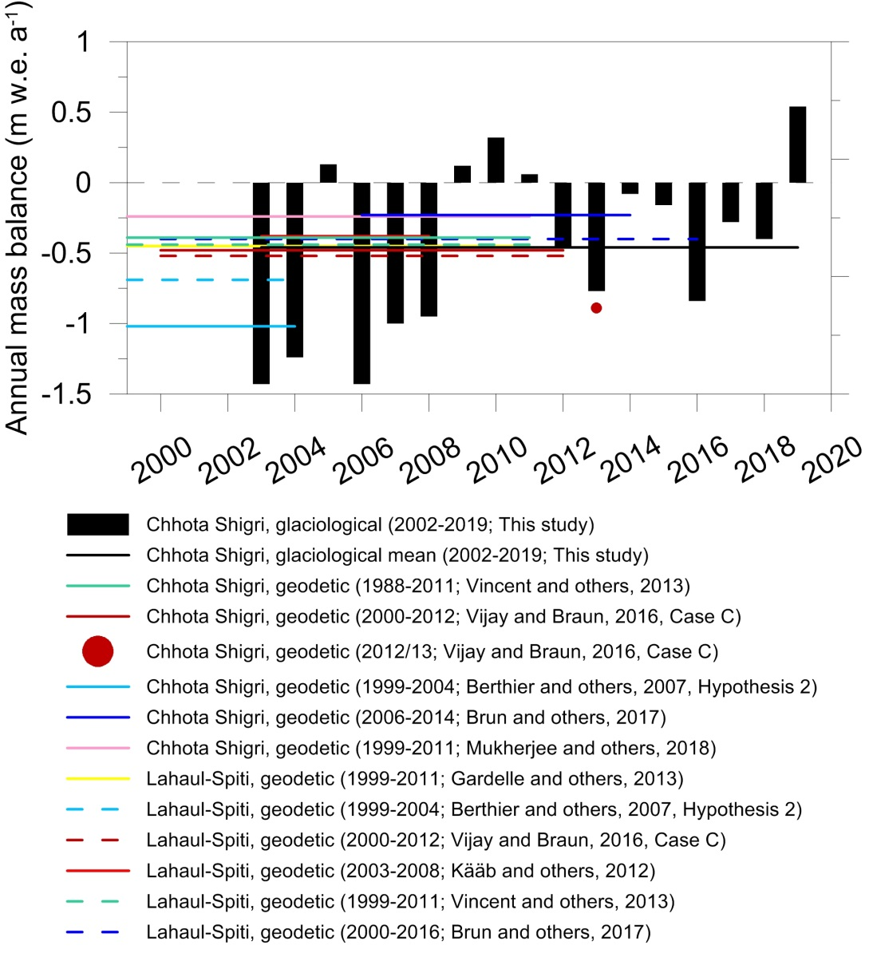
Fig. S10. Compilation of all available mass balance records on the Chhota Shigri Glacier performed using glaciological and geodetic approaches. Corresponding references/sources are also mentioned in the legend.
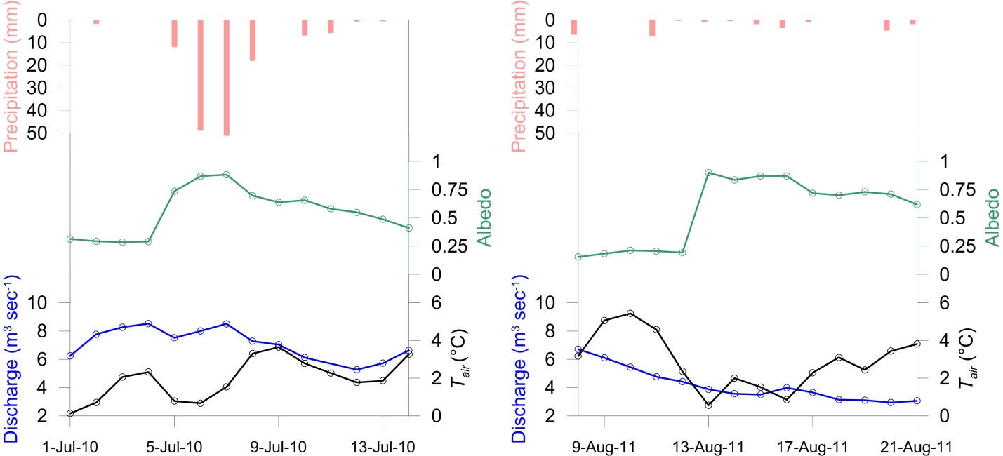
Fig. S11. Role of snowfalls on daily discharge. Daily mean air temperature (black) and albedo (green) recorded at AWS-M.

References
Angchuk T and others (in preparation) Glaciological mass balance (seasonal and annual) of Patsio glacier, western Himalaya (India) since 2010.
Azam MF, Wagnon P, Vincent C, Ramanathan Al, Favier V, Mandal A and Pottakkal JG (2014a) Processes governing the mass balance of Chhota Shigri Glacier (western Himalaya, India) assessed by point-scale surface energy balance measurements. The Cryosphere 8(6), 2195–2217 (doi:10.5194/tc-8-2195-2014)
Azam MF, Wagnon P, Vincent C, Ramanathan A, Linda A and Singh VB (2014b) Reconstruction of the annual mass balance of Chhota Shigri glacier, Western Himalaya, India, since 1969. Annals of Glaciology 55(66), 69–80 (doi:10.3189/2014AoG66A104)
Azam MF, Ramanathan A, Wagnon P, Vincent C, Linda A, Berthier E, Sharma P, Mandal A, Angchuk T, Singh VB and Pottakkal JG (2016) Meteorological conditions, seasonal and annual mass balances of Chhota Shigri Glacier, western Himalaya, India. Annals of Glaciology 57(71), 328–338 (doi:10.3189/2016AoG71A570)
Banerjee A (2017) Brief communication: Thinning of debris-covered and debris-free glaciers in a warming climate. The Cryosphere 11(1), 133–138 (doi:https://doi.org/10.5194/tc-11-133-2017)
Bashir F and Rasul DG (2010) Estimation of Water Discharge from Gilgit Basin using Remote Sensing, GIS and Runoff Modeling. Pakistan Journal of Meteorology 6(12), 17
Berthier E, Arnaud Y, Kumar R, Ahmad S, Wagnon P and Chevallier P (2007) Remote sensing estimates of glacier mass balances in the Himachal Pradesh (Western Himalaya, India). Remote Sens. Environ., 108(3), 327–338
Brun F, Berthier E, Wagnon P, Kääb A and Treichler D (2017) A spatially resolved estimate of High Mountain Asia glacier mass balances from 2000 to 2016. Nature Geoscience 10(9), 668 (doi:10.1038/ngeo2999)
Gardelle J, Berthier E, Arnaud Y and Kääb A (2013) Region-wide glacier mass balances over the Pamir-Karakoram-Himalaya during 1999&ndash;2011. The Cryosphere 7(4), 1263–1286 (doi:10.5194/tc-7-1263-2013)
Kääb A, Berthier E, Nuth C, Gardelle J and Arnaud Y (2012) Contrasting patterns of early twenty-first-century glacier mass change in the Himalayas. Nature 488(7412), 495–498 (doi:10.1038/nature11324)
Mukherjee K, Bhattacharya A, Pieczonka T, Ghosh S and Bolch T (2018) Glacier mass budget and climate reanalysis data indicate a climatic shift around 2000 in Lahaul-Spiti, western Himalaya. Climatic Change, 1–15 (doi:10.1007/s10584-018-2185-
Oerlemans J (2001) Glaciers and climate change. A.A Balkema Publ., Brookfield, VT
Oerlemans J and Hoogendoorn NC (1989) Mass-Balance Gradients and Climatic Change. Journal of Glaciology 35(121), 399–405 (doi:10.3189/S0022143000009333)
Pratap B, Sharma P, Patel L, Singh AT, Gaddam VK, Oulkar S and Thamban M (2019) Reconciling High Glacier Surface Melting in Summer with Air Temperature in the Semi-Arid Zone of Western Himalaya. Water 11(8), 1561 (doi:10.3390/w11081561)
Shea JM, Wagnon P, Immerzeel WW, Biron R, Brun F and Pellicciotti F (2015) A comparative high-altitude meteorological analysis from three catchments in the Nepalese Himalaya. International Journal of Water Resources Development 31(2), 174–200 (doi:10.1080/07900627.2015.1020417)
Sherpa SF, Wagnon P, Brun F, Berthier E, Vincent C, Lejeune Y, Arnaud Y, Kayastha RB and Sinisalo A (2017) Contrasted surface mass balances of debris-free glaciers observed between the southern and the inner parts of the Everest region (2007–15). Journal of Glaciology 63(240), 637–651 (doi:10.1017/jog.2017.30)
Sunako S, Fujita K, Sakai A and Kayastha RB (2019) Mass balance of Trambau Glacier, Rolwaling region, Nepal Himalaya: in-situ observations, long-term reconstruction and mass-balance sensitivity. Journal of Glaciology, 1–12 (doi:10.1017/jog.2019.37)
Thayyen RJ and Dimri AP (2018) Slope Environmental Lapse Rate (SELR) of Temperature in the Monsoon Regime of the Western Himalaya. Front. Environ. Sci. 6 (doi:10.3389/fenvs.2018.00042)
Vijay S and Braun M (2016) Elevation Change Rates of Glaciers in the Lahaul-Spiti (Western Himalaya, India) during 2000–2012 and 2012–2013. Remote Sensing 8(12), 1038 (doi:10.3390/rs8121038)
Vincent C, Ramanathan Al, Wagnon P, Dobhal DP, Linda A, Berthier E, Sharma P, Arnaud Y, Azam MF, Jose PG and Gardelle J (2013) Balanced conditions or slight mass gain of glaciers in the Lahaul and Spiti region (northern India, Himalaya) during the nineties preceded recent mass loss. The Cryosphere 7(2), 569–582 (doi:10.5194/tc-7-569-2013)
Yadav JS, Pratap B, Gupta AK, Dobhal DP, Yadav RBS and Tiwari SK (2019) Spatio-temporal variability of near-surface air temperature in the Dokriani glacier catchment (DGC), central Himalaya. Theor. Appl. Climatol. 136(3), 1513–1532 (doi:10.1007/s00704-018-2544-z)

