Seismic Characterization of a Rapidly-Rising Jökulhlaup Cycle at the A.P. Olsen Ice Cap, NE-Greenland
Michael Behm¹, Jacob I. Walter², Daniel Binder^{3,4,12}, Feng Cheng⁵, Michele Citterio⁴, Bernd Kulessa⁶, Kirsty Langley⁷, Phillipe Limpach⁸, Stefan Mertl⁹, Wolfgang Schöner^{10,12}, Mikkel Tamstorf¹¹, Gernot Weyss^{3,12}
(1) School of Geosciences, University of Oklahoma (Norman, US)
(2) Oklahoma Geological Survey, University of Oklahoma (Norman, US)
(3) Climate Section, ZAMG - Central Institute for Meteorology and Geodynamics (Vienna, A)
(4) Glaciology and Climate Department, GEUS - Geological Survey of Denmark and Greenland (Copenhagen, DK)
(5) Lawrence Berkeley National Laboratory (Berkeley, US)
(6) Glaciology Group, Swansea University (GB)
(7) Greenland Survey, ASIAQ (Nuuk, Greenland)
(8) Institute of Geodesy and Photogrammetry, ETH Zurich (CH)
(9) Mertl Research GmbH (Vienna, A)
(10) Institute of Geography and Regional Research, Graz University (A)
(11) Department of Bioscience, Aarhus University (DK)
(12) Austrian Polar Research Institute (APRI)

Supplementary material:

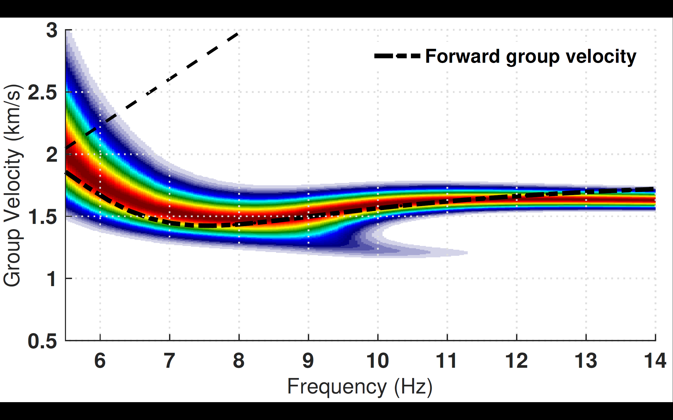
Fig. S1: Measured group velocity dispersion images of the station pair APO3-APO2 (causal part).The dashed line indicates the forward computed group velocity dispersion curve from the velocity model shown in Figure 10d.

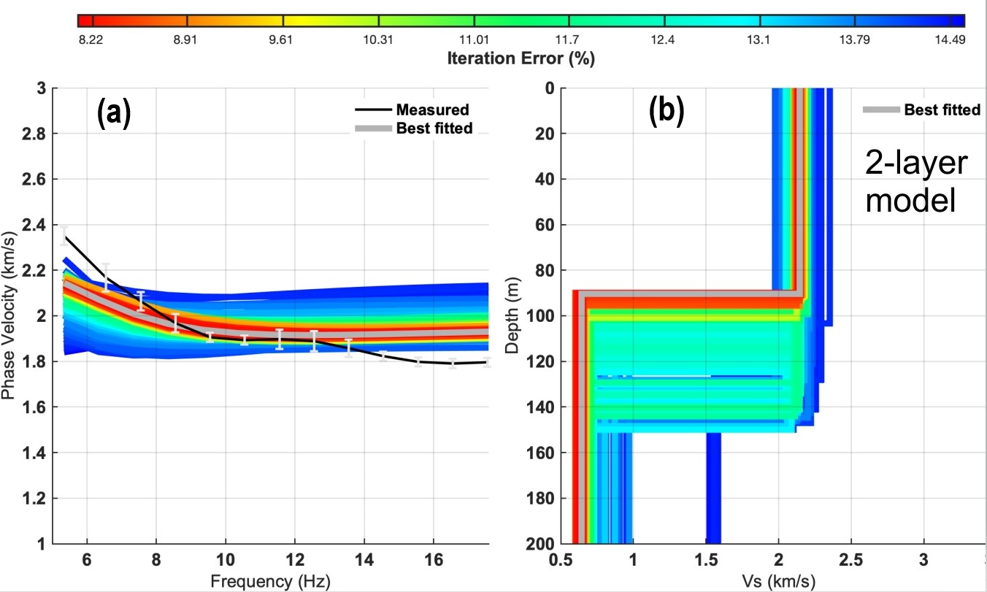
Fig. S2: Inversion result of the dispersion curve (Fig. 10b) for a 2-layer model. (a) shows measured (black lines) and inverted phase velocity dispersion curves, respectively. Colors are representing the data misfit expressed as relative RMS error. (b) shows the corresponding shear-wave velocity models for the dispersion curves. The grey curve is the model with the smallest RMS error. Compared to the 3-layer model (Fig. 10), the error is significantly larger, and the obtained models result in an unrealistic thick low-velocity basal zone.

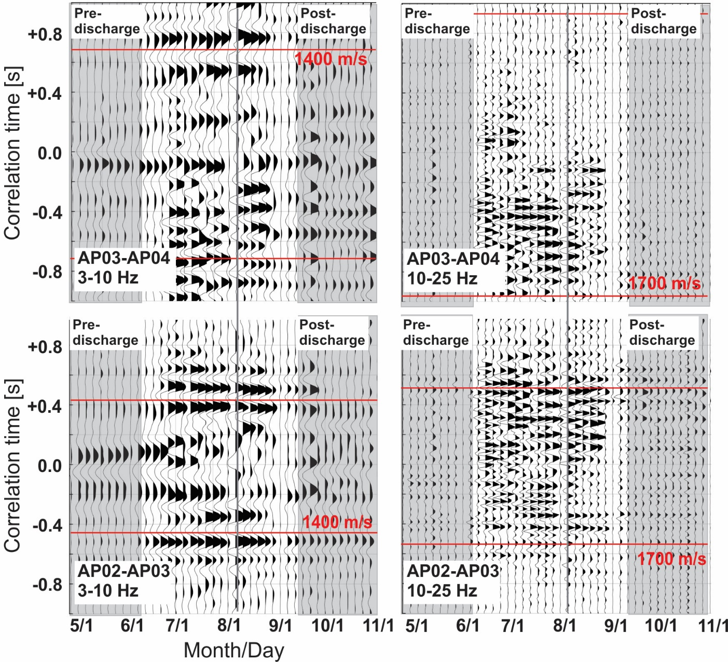
Figure S3: Time-lapse interferogram sections for the station pairs AP03-AP04 and AP02-AP03 in two different frequency bands. Traces are scaled to the maximum amplitude within each section. Red lines: Move-out velocities of 1400 m/s and 1700 m/s, respectively. Vertical grey line indicates the occurrence of the jökulhlaup at 8/6/2012. Pre- and post-discharge periods correspond to measured discharge rates < 1.75 m³/s. See text for details.

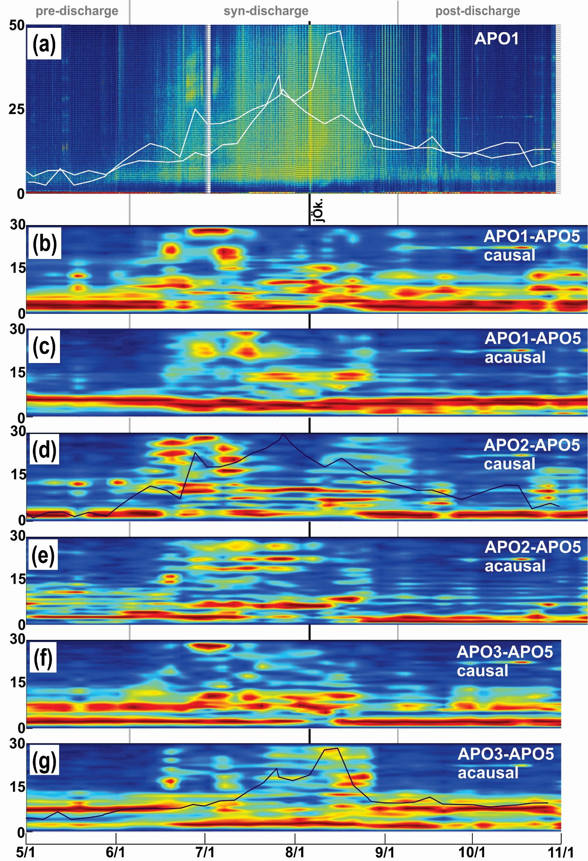
Fig. S4
Amplitude spectra vs. deployment time for vertical component data. Vertical axis: Frequency (Hz). Horizontal axis: deployment time (month/day). (a) Spectrogram of raw data recorded at station APO1. This station has been chosen since it is located in the center of the deployment. White lines are the apparent velocity changes at the station pairs APO2-APO5 and APO3-APO5 (Fig. 13). (b – g): Amplitude spectra of the station pairs shown in Fig. 12. Black lines are the corresponding apparent velocity changes.
The gradual increase of the apparent velocities prior to the jökulhlaup does not find an according expression in the spectral domain. The local velocity peak at the end of June at station pair APO2-APO5 (d) does however correlate with the emergence of an additional noise source in the band 30 – 40 Hz, which lasts for ca. 2 weeks.

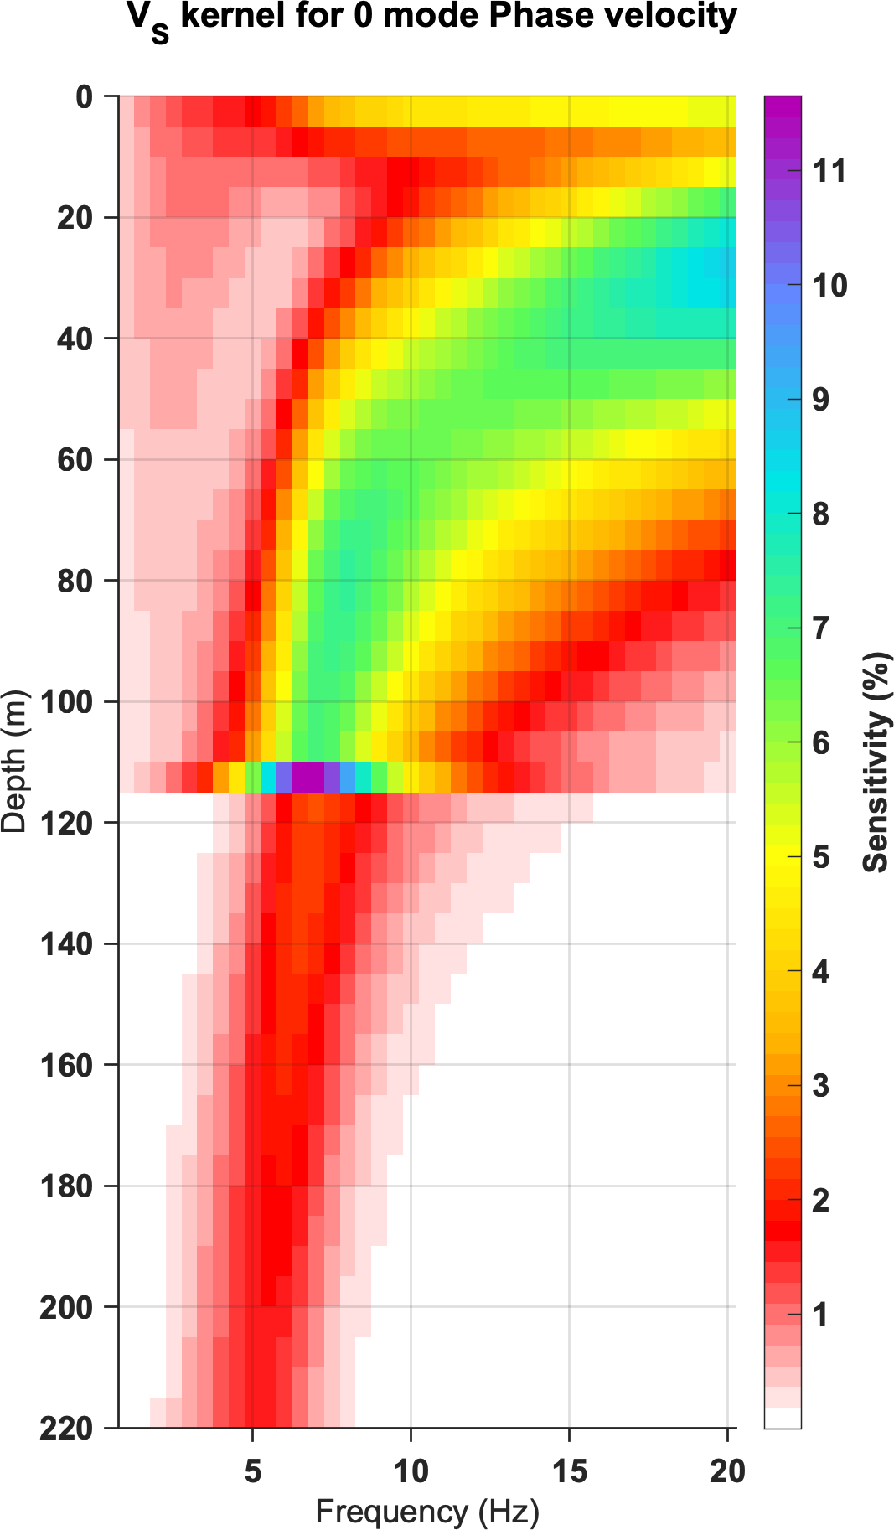
Fig. S5: Sensitivity kernel for the fundamental mode phase velocity based on the best fitted inversion model in (Fig. 10d).

