Supplementary material for
Black carbon and mineral dust on two glaciers on the central Tibetan Plateau: Sources and implications
Xiaofei LI, ^{1,2,3} Shichang KANG, ^{4,5} Michael Sprenger, ⁶ Yulan Zhang, ⁴ Xiaobo HE, ⁴ Guoshuai Zhang, ⁷ Lekhendra Tripathee, ⁴ Chaoliu LI, ^{5,7} Junji CAO ^{1,2,3*}
¹ Key Laboratory of Aerosol Chemistry and Physics, Institute of Earth Environment, Chinese Academy of Sciences, Xi’an, 710061, China
² State Key Lab of Loess and Quaternary Geology, Institute of Earth Environment, Chinese Academy of Sciences, Xi’an, 710061, China
³ CAS Center for Excellence in Quaternary Science and Global Change, Xi’an, 710061, China
⁴ State Key Laboratory of Cryospheric Sciences, Northwest Institute of Eco-Environment and Resources, Chinese Academy of Sciences, Lanzhou, 730000, China
⁵ CAS Center for Excellence in Tibetan Plateau Earth Sciences, Beijing, 100101, China
⁶ Institute for Atmospheric and Climate Science, ETH Zurich, CH-8092 Zurich, Switzerland
⁷ Key Laboratory of Tibetan Environment Changes and Land Surface Processes, Institute of Tibetan Plateau Research, Chinese Academy of Sciences, Beijing, 100101, China
Corresponding author:
Prof. Dr. Junji Cao. E-mail: jjcao@ieecas.cn

This supplementary material consists of 19 pages, including eleven figures, six tables and literatures cited.
Figures
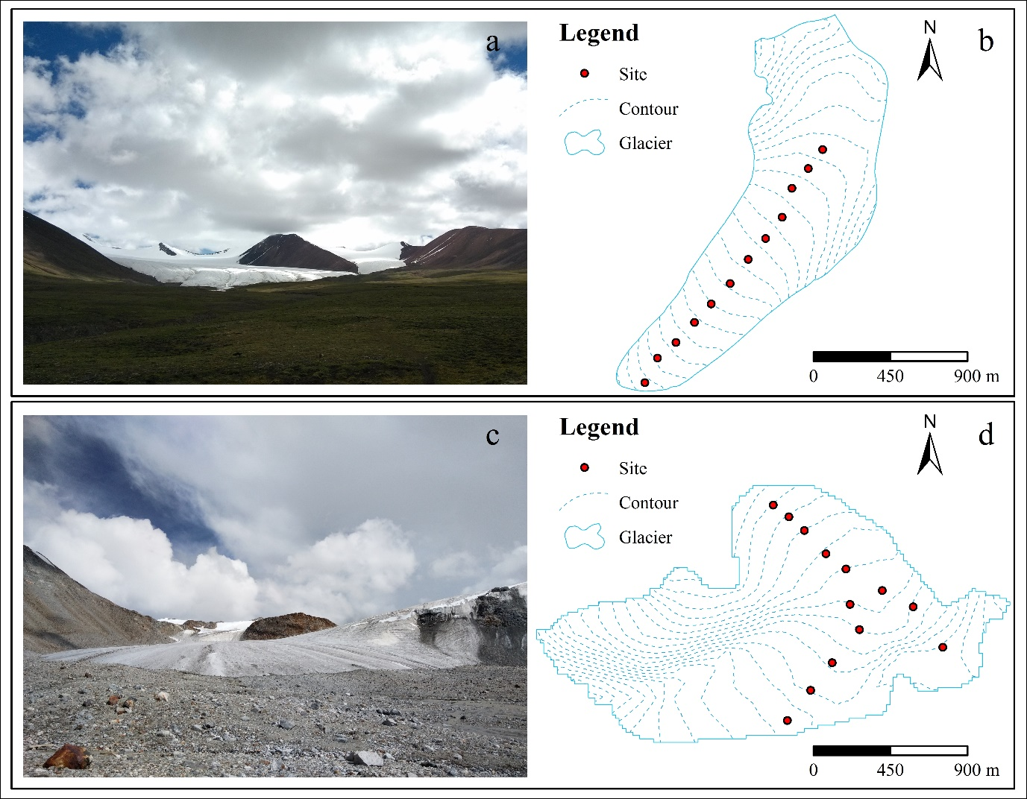
Fig. S1. The Xiao Dongkemadi Glacier and Zhadang Glacier. (a) Photo of the Xiao Dongkemadi Glacier, (b) sampling sites on the Xiao Dongkemadi Glacier, (c) photo of the Zhadang Glacier and (d) sampling sites on the Zhadang Glacier.
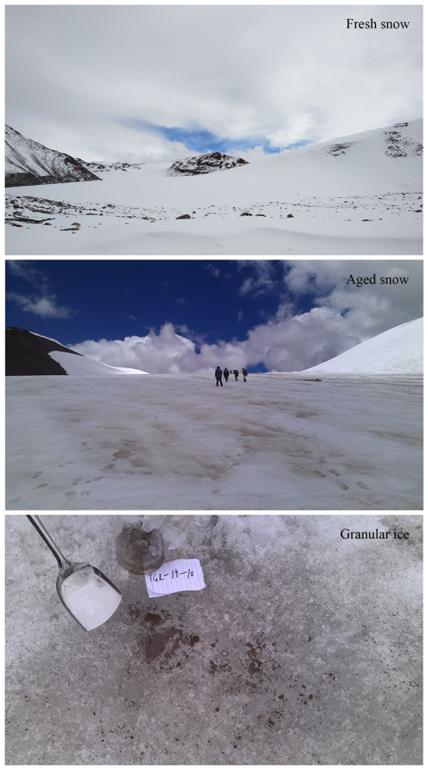
Fig. S2. Different sample type collected from the central Tibetan Plateau glaciers.
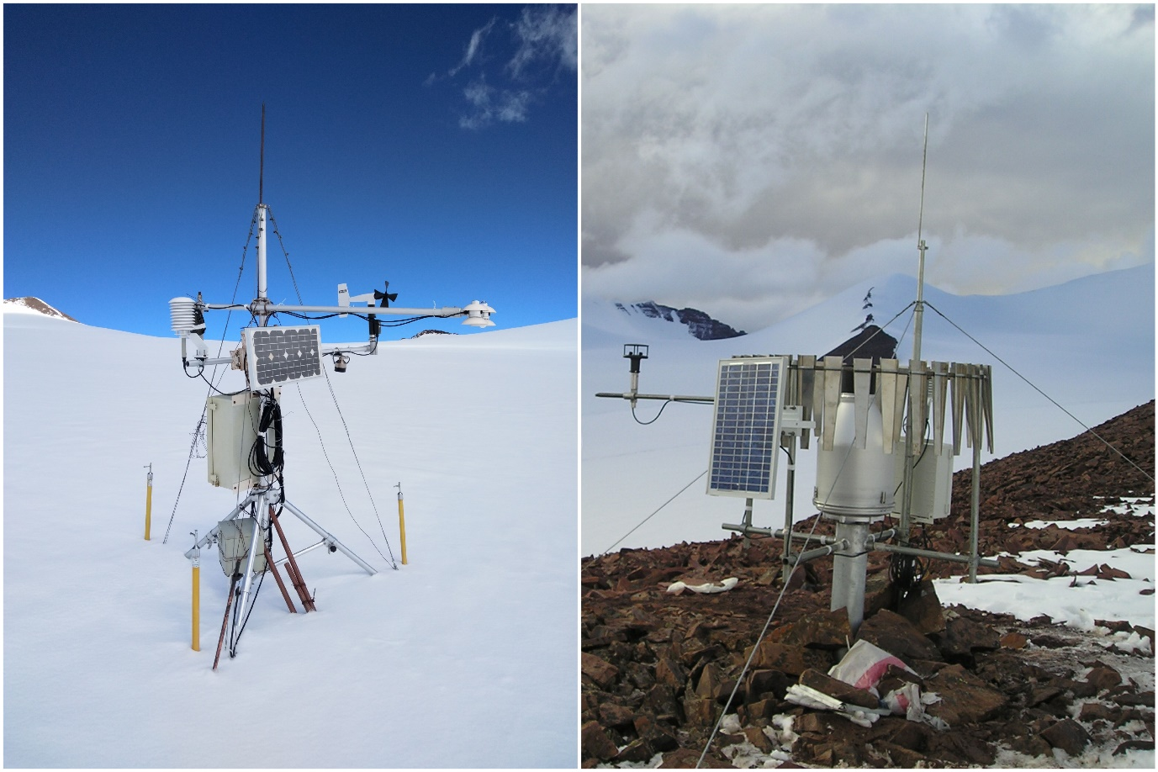
Fig. S3. Photos of the automatic weather station (AWS) set up on the central Tibetan plateau glaciers.

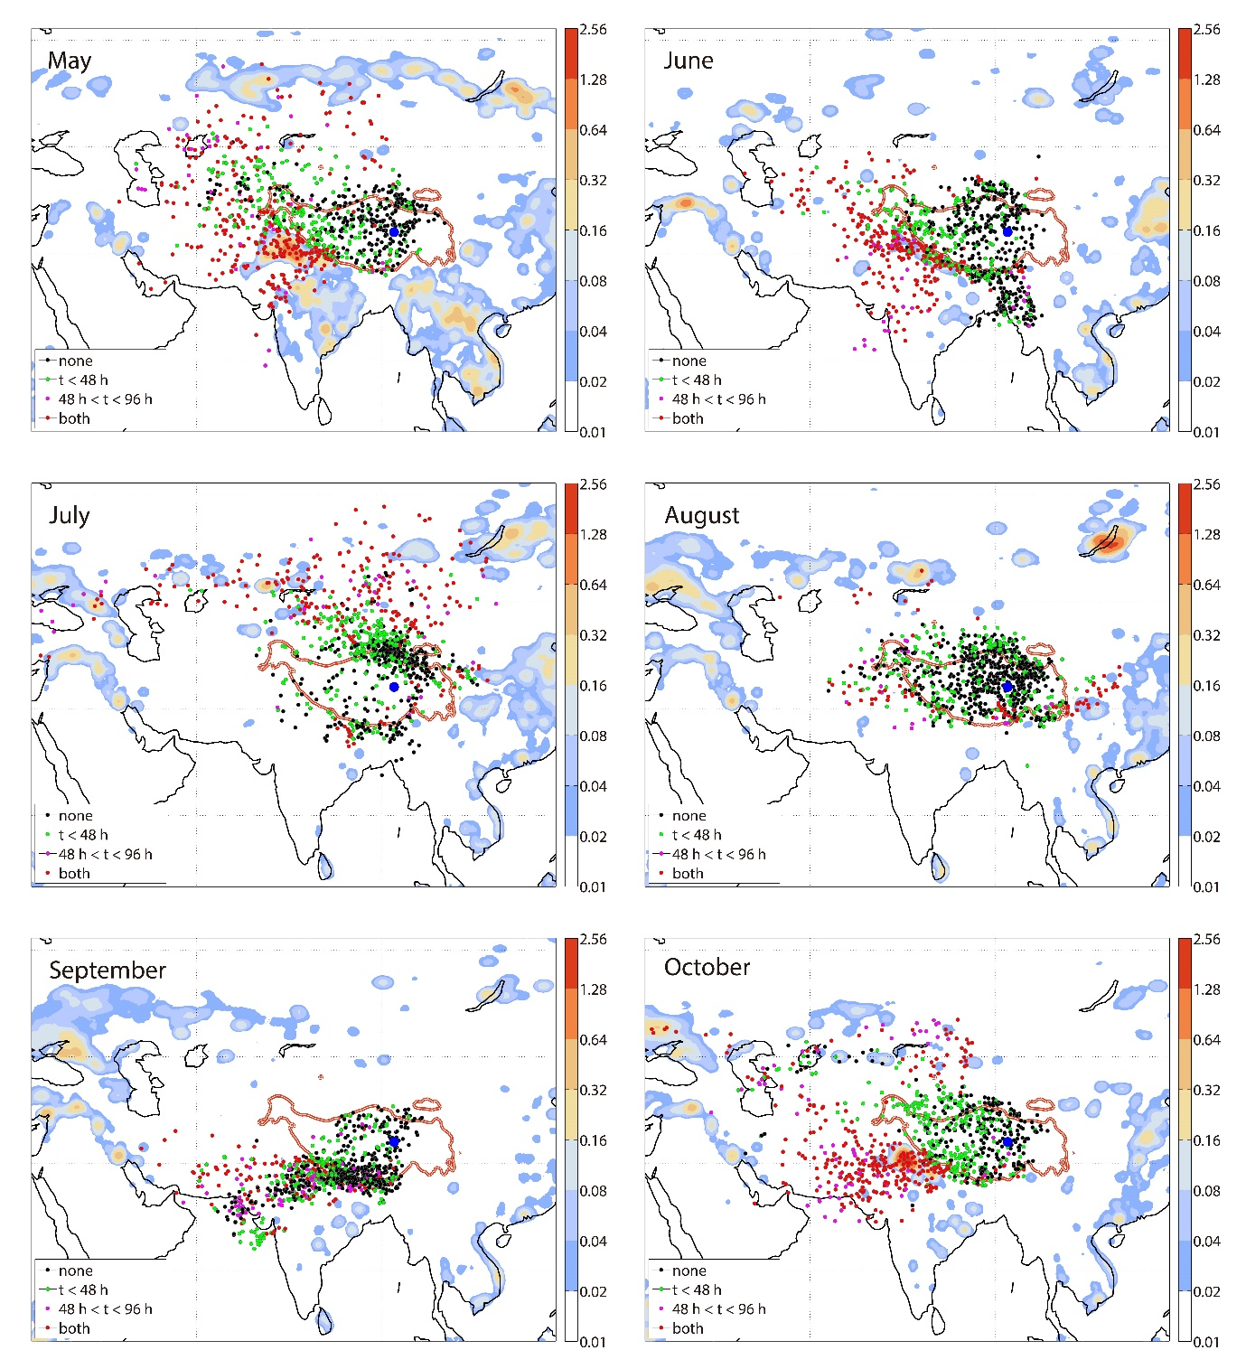
Fig. S4. Backward trajectories starting at below 500 hPa launched over Xiao Dongkemadi Glacier (Blue dots) and fire counts from May to October 2015. Black dots: the air parcels had 'no contact' to a fire within 96 h before arriving at the study glaciers; Green dots: a fire will be passed in the 48 h before arriving at the study glaciers; Magenta dots: the air parcel had a fire contact between 48-96 h before arriving at the study glaciers, but not during the 48 h immediately before arrival; Red dots: air parcels having fire contact in the earlier and later time period; The color code gives the mean number of FINN 1.5 fire counts within a 0.25° × 0.25° grid box, averaged over the period May–Oct 2015 and spatially smoothed with a 100 km filter radius (FINN 1.5 fire spots km⁻²).
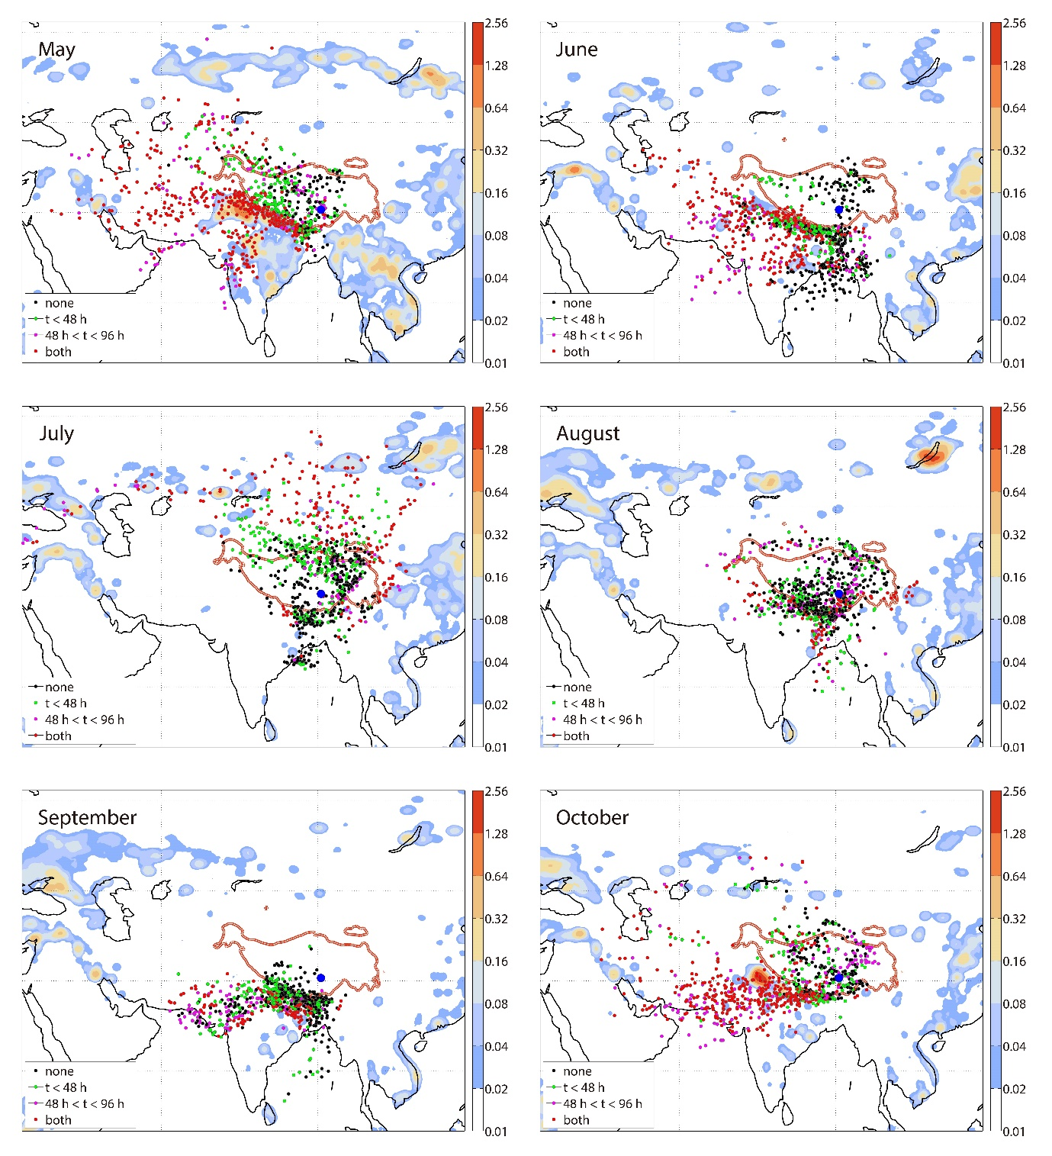
Fig. S5. Backward trajectories starting at below 500 hPa launched over Zhadang Glacier (Blue dots) and fire counts from May to October 2015. Black dots: the air parcels had 'no contact' to a fire within 96 h before arriving at the study glaciers; Green dots: a fire will be passed in the 48 h before arriving at the study glaciers; Magenta dots: the air parcel had a fire contact between 48-96 h before arriving at the study glaciers, but not during the 48 h immediately before arrival; Red dots: air parcels having fire contact in the earlier and later time period; The color code gives the mean number of FINN 1.5 fire counts within a 0.25° × 0.25° grid box, averaged over the period May–Oct 2015 and spatially smoothed with a 100 km filter radius (FINN 1.5 fire spots km⁻²).
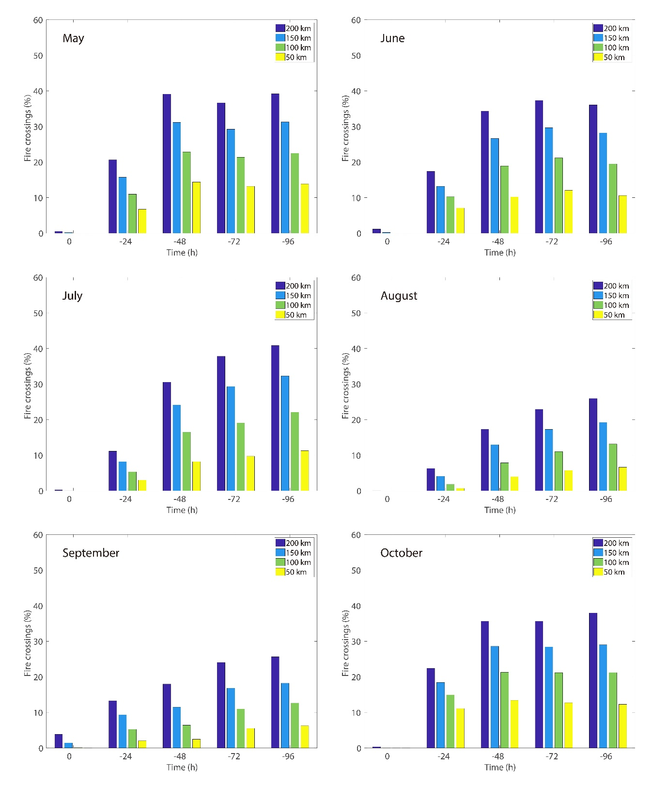
Fig. S6. Contributions of fire spots sourced BC emissions deposited at Xiao Dongkemadi Glacier from May to October 2015. The different times correspond to the time in hours before the air parcels arrive at the measurement site, and the differently colored bars to the distance in km below which the fire has to be relative to the trajectory position. Fire crossing (%) represented the percentage of parcel trajectories that crossing at least one fire spot over a certain time period.
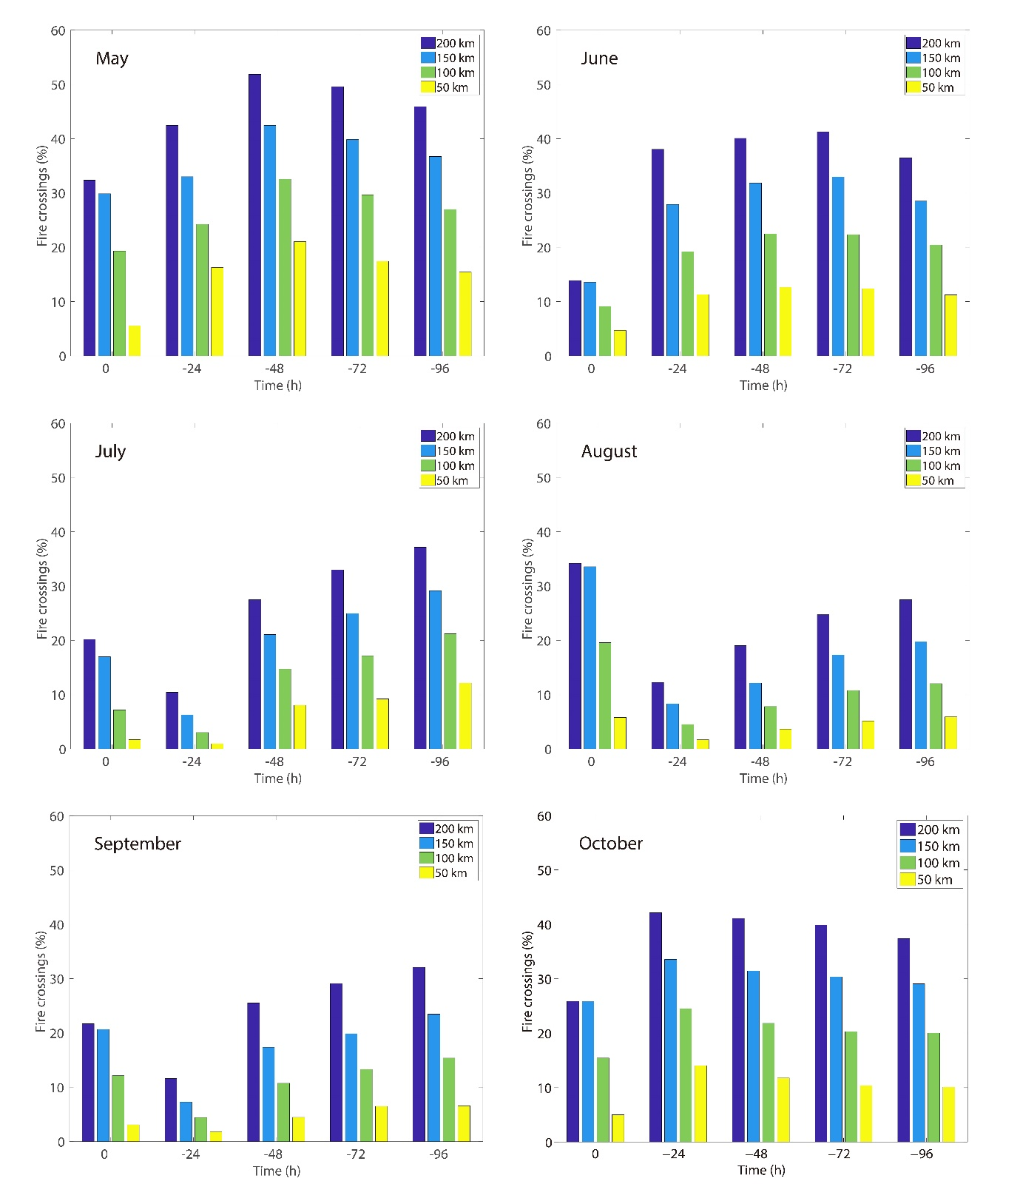
Fig. S7. Contributions of fire spots sourced BC emissions deposited at Zhadang Glacier from May to October 2015. The different times correspond to the time in hours before the air parcels arrive at the measurement site, and the differently colored bars to the distance in km below which the fire has to be relative to the trajectory position. Fire crossing (%) represented the percentage of parcel trajectories that crossing at least one fire spot over a certain time period.
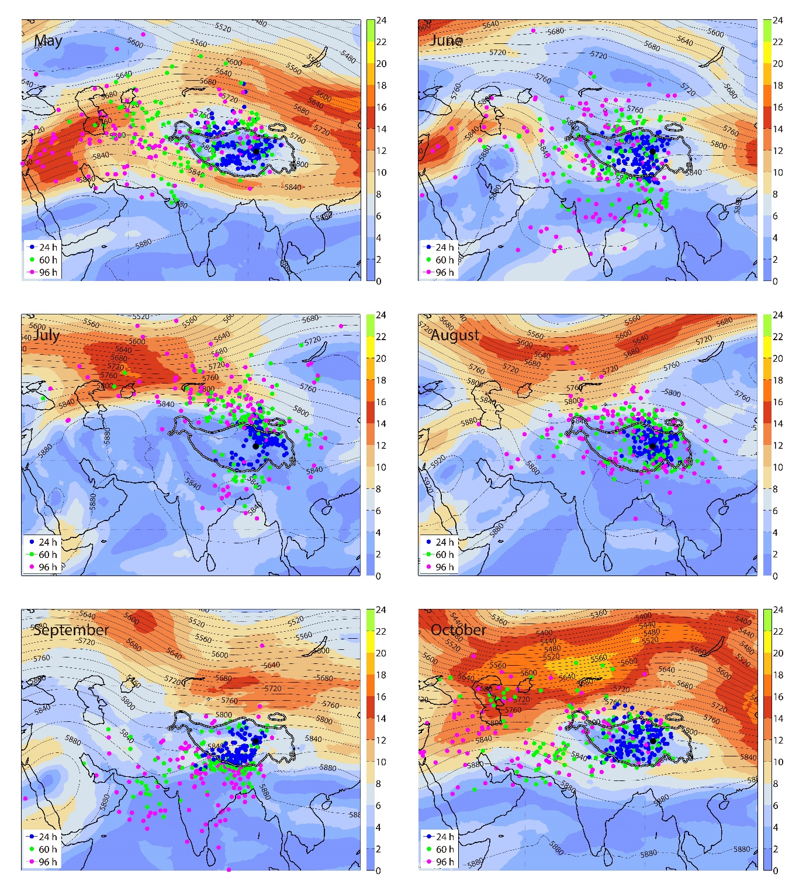
Fig. S8. Maps of wind speed, and the geopotential heights in the study region based on ECMWF analysis data from May to October 2015. The dots mark the position of the air parcels at 24, 60, and 96 h before arrival at the measurement site. Only air parcels arriving at 500 hPa at the Xiao Dongkemadi Glacier site (Black dots) are included. Color bar represented the wind speed (m s⁻¹), contour lines represented the geopotential heights (m² s⁻²).
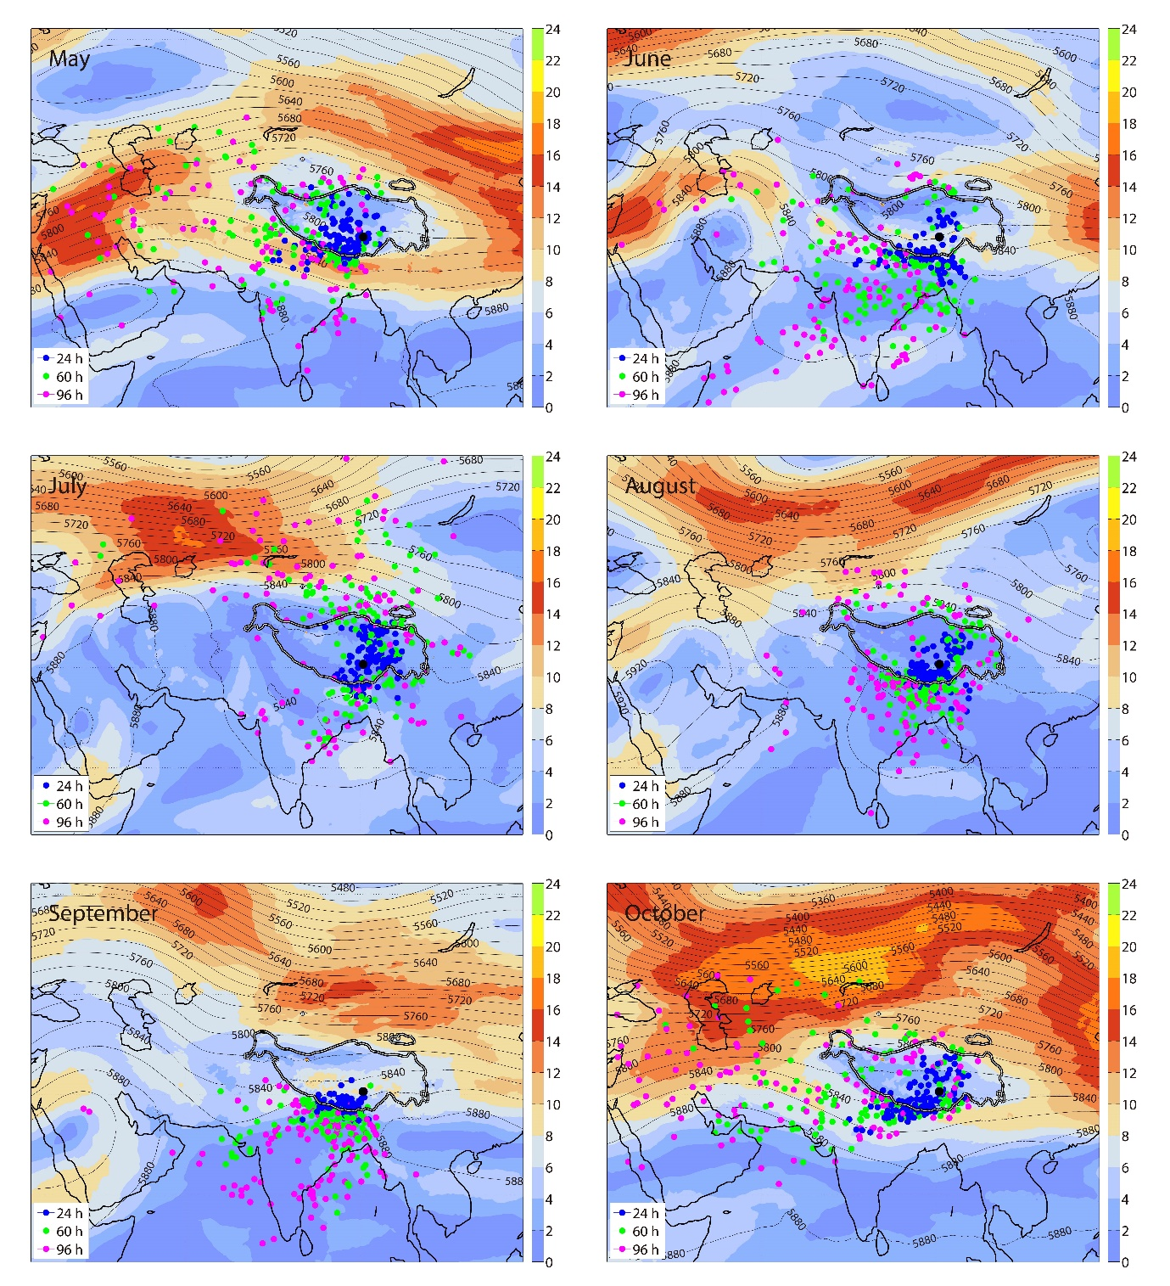
Fig. S9. Maps of wind speed, and the geopotential heights in the study region based on ECMWF analysis data from May to October 2015. The dots mark the position of the air parcels at 24, 60, and 96 h before arrival at the measurement site. Only air parcels arriving at 500 hPa at the Zhadang Glacier site (Black dots) are included. Color bar represented the wind speed (m s⁻¹), contour lines represented the geopotential heights (m² s⁻²).
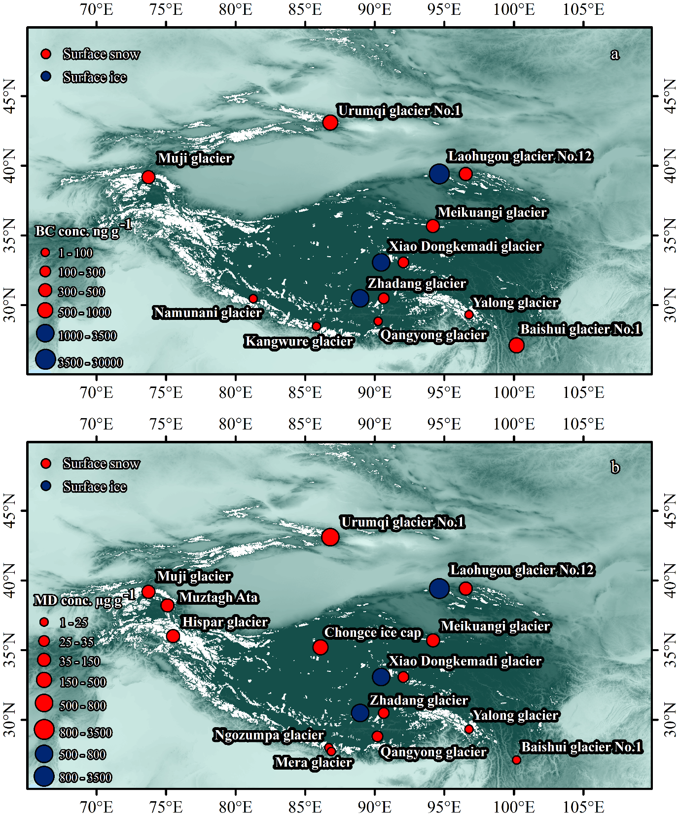
Fig. S10. Distributions of BC and MD concentrations in snow/ice on the Tibetan plateau and its surroundings.

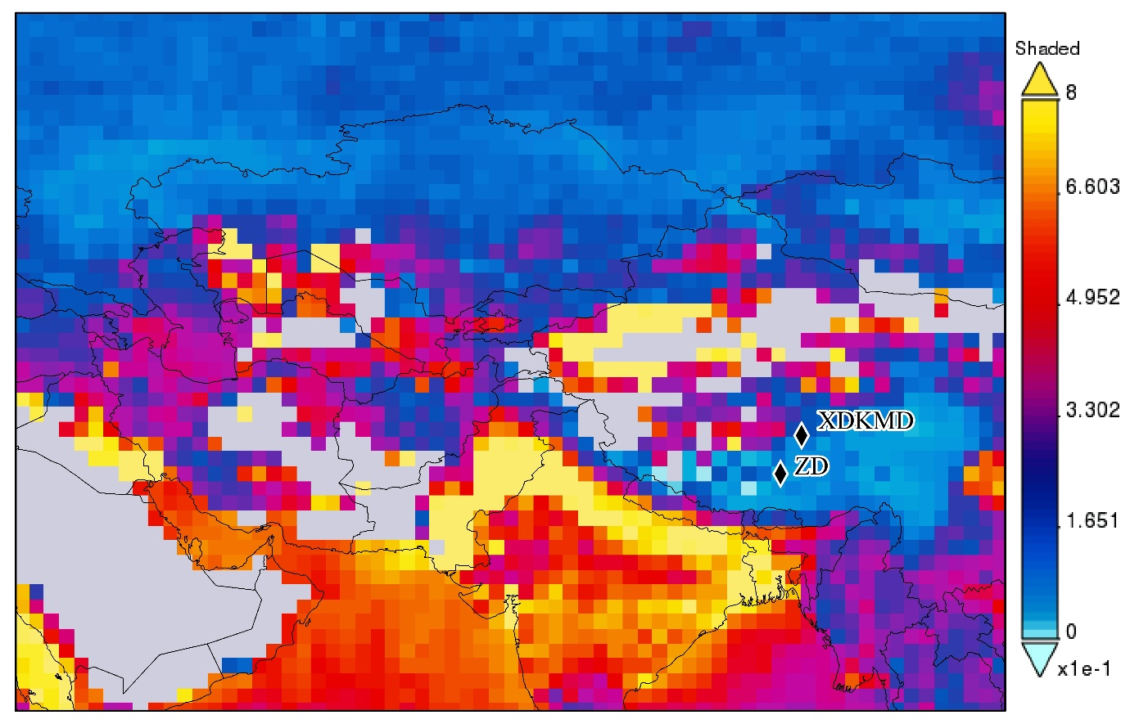
Fig. S11. MODIS (MODIS-Terra MOD08_M3 v6) atmospheric optical depth (AOD) fields at 550 nm from May and October 2015 derived using Dark Target algorithm over the Tibetan Plateau and its surroundings. (http://giovanni.sci.gsfc.nasa.gov).
Tables
Table S1. Location information of the surface snow/ice sampling on the Xiao Dongkemadi Glacier and Zhadang Glacier.
Site | Longitude (°) | Latitude (°) | Altitude (m a.s.l.)
XDKMD-1 | 92.07388 | 33.06268 | 5454
XDKMD-2 | 92.07466 | 33.06398 | 5483
XDKMD-3 | 92.07581 | 33.06482 | 5508
XDKMD-4 | 92.07695 | 33.06587 | 5534
XDKMD-5 | 92.07799 | 33.06686 | 5559
XDKMD-6 | 92.07916 | 33.06794 | 5585
XDKMD-7 | 92.08027 | 33.06922 | 5607
XDKMD-8 | 92.08136 | 33.07033 | 5627
XDKMD-9 | 92.08238 | 33.07146 | 5649
XDKMD-10 | 92.08297 | 33.07299 | 5670
XDKMD-11 | 92.08399 | 33.07404 | 5691
XDKMD-12 | 92.08487 | 33.07504 | 5707
ZD-1 | 90.640150 | 30.475283 | 5570
ZD-2 | 90.641117 | 30.474683 | 5595
ZD-3 | 90.642083 | 30.473983 | 5615
ZD-4 | 90.643417 | 30.472783 | 5635
ZD-5 | 90.644650 | 30.472000 | 5655
ZD-6 | 90.646883 | 30.470900 | 5670
ZD-7 | 90.644950 | 30.470133 | 5675
ZD-8 | 90.645550 | 30.468817 | 5695
ZD-9 | 90.648783 | 30.470077 | 5690
ZD-10 | 90.643933 | 30.467050 | 5735
ZD-11 | 90.642668 | 30.465573 | 5755
ZD-12 | 90.650633 | 30.467983 | 5770
ZD-13 | 90.641283 | 30.463950 | 5790
Table S2. BC concentrations (ng g⁻¹) in the surface snow/ice of the Xiao Dongkemadi Glacier and Zhadang Glacier.
Site | May 2015 | Jun 2015 | Jul 2015 | Aug 2015 | Sep 2015 | Oct 2015
XDKMD-1 | 398.50 | 288.45 | 1307.18 | 10073.69 | 1891.11 | 2598.69
XDKMD-2 | 298.63 | 230.88 | 4109.95 | 8362.78 | 2216.76 | 479.97
XDKMD-3 | 135.94 | 258.71 | 422.47 | 676.26 | 4773.66 | 2086.41
XDKMD-4 | 161.66 | 283.08 | 9884.74 | 526.40 | 5577.45 | 951.12
XDKMD-5 | 38.55 | 128.46 | 489.71 | 3459.54 | 2995.51 | 223.97
XDKMD-6 | 30.54 | 286.74 | 1656.58 | 10522.05 | 8562.70 | 1418.60
XDKMD-7 | 34.57 | 256.88 | 382.11 | 134.11 | 4106.09 | 1011.17
XDKMD-8 | 47.79 | 263.60 | 354.50 | 129.29 | 2188.21 | 994.38
XDKMD-9 | 42.70 | 207.98 | 330.12 | 110.77 | 4919.50 | 997.06
XDKMD-10 | 47.53 | 246.60 | 146.34 | 57.25 | 2514.42 | 541.31
XDKMD-11 | 51.46 | 178.72 | 376.31 | 35.70 | 7494.85 | 229.24
XDKMD-12 | 42.36 | 119.92 | 213.42 | 31.63 | 1341.11 | 332.77
ZD-1 | 673.70 | - | - | 52.35 | 2508.68 | -
ZD-2 | 709.31 | - | - | 51.63 | 1164.29 | -
ZD-3 | 688.10 | - | - | 52.82 | 2550.48 | -
ZD-4 | 848.40 | - | - | 56.74 | 2610.85 | -
ZD-5 | 839.19 | - | - | 51.93 | 533.47 | -
ZD-6 | 751.81 | - | - | 53.28 | 2128.78 | -
ZD-7 | 716.81 | - | - | 53.52 | 818.13 | -
ZD-8 | 733.75 | - | - | 54.68 | 131.65 | -
ZD-9 | 607.67 | - | - | 57.23 | 123.97 | -
ZD-10 | 578.46 | - | - | 56.45 | 129.08 | -
ZD-11 | 529.66 | - | - | 57.41 | 127.62 | -
ZD-12 | 290.47 | - | - | 51.30 | 119.71 | -
ZD-13 | 188.66 | - | - | 52.81 | 113.29 | -
- denotes no samples.
Table S3. MD concentrations (μg g⁻¹) in the surface snow/ice of the Xiao Dongkemadi Glacier and Zhadang Glacier.
Site | May 2015 | Jun 2015 | Jul 2015 | Aug 2015 | Sep 2015 | Oct 2015
XDKMD-1 | 37.01 | 43.02 | 424.41 | 2564.55 | 718.09 | 584.96
XDKMD-2 | 38.18 | 32.02 | 1244.46 | 3462.90 | 661.26 | 120.76
XDKMD-3 | 19.87 | 27.59 | 112.50 | 140.95 | 951.57 | 92.49
XDKMD-4 | 19.24 | 45.23 | 1913.88 | 123.51 | 980.84 | 305.50
XDKMD-5 | 1.31 | 22.64 | 103.89 | 1093.31 | 710.43 | 45.35
XDKMD-6 | 0.44 | 40.01 | 387.79 | 3103.61 | 1860.20 | 395.59
XDKMD-7 | 0.55 | 31.98 | 77.65 | 36.66 | 1049.07 | 276.67
XDKMD-8 | 1.32 | 35.47 | 98.83 | 28.32 | 661.91 | 215.07
XDKMD-9 | 2.50 | 27.02 | 71.59 | 19.63 | 1114.64 | 239.15
XDKMD-10 | 2.15 | 31.97 | 12.83 | 2.98 | 386.10 | 82.07
XDKMD-11 | 3.16 | 16.00 | 82.12 | 2.22 | 1781.31 | 25.54
XDKMD-12 | 2.22 | 12.58 | 46.07 | 2.45 | 277.90 | 51.90
ZD-1 | 77.54 | - | - | 2.05 | 759.60 | -
ZD-2 | 78.32 | - | - | 1.76 | 438.93 | -
ZD-3 | 73.73 | - | - | 2.02 | 875.00 | -
ZD-4 | 78.26 | - | - | 1.58 | 863.53 | -
ZD-5 | 90.72 | - | - | 2.23 | 123.32 | -
ZD-6 | 86.67 | - | - | 2.57 | 585.82 | -
ZD-7 | 72.48 | - | - | 2.28 | 227.32 | -
ZD-8 | 77.85 | - | - | 2.41 | 19.81 | -
ZD-9 | 70.54 | - | - | 1.82 | 17.40 | -
ZD-10 | 61.96 | - | - | 1.60 | 19.47 | -
ZD-11 | 57.84 | - | - | 1.55 | 17.41 | -
ZD-12 | 26.72 | - | - | 1.19 | 19.46 | -
ZD-13 | 29.17 | - | - | 1.02 | 17.75 | -
- denotes no samples.
Table S4. BC concentrations (ng g⁻¹) in glaciers from the Tibetan Plateau and its surroundings.
Glaciers | Longitude (°) | Latitude (°) | Altitude  (m a.s.l.) | Types | BC | References
Xiao Dongkemadi glacier | 92.0667 | 33.0667 | 5420-5760 | surface snow | 190 | This study
Xiao Dongkemadi glacier | 90.4667 | 33.0667 | 5420-5760 | surface ice | 3018 | This study
Zhadang glacier | 90.6500 | 30.4833 | 5570-5790 | surface snow | 300 | This study
Zhadang glacier | 88.9600 | 30.4833 | 5570-5790 | surface ice | 1759 | This study
Urumqi glacier No.1 | 86.8167 | 43.1000 | 3845-4050 | surface snow | 882 | (Ming and others, 2016)
Laohugou glacier No.12 | 96.5500 | 39.4167 | 4400-5000 | surface snow | 315 | (Li and others, 2016)
Laohugou glacier No.12 | 94.6500 | 39.4167 | 4400-5000 | surface ice | 26778 | (Li and others, 2016)
Muji glacier | 73.7333 | 39.1833 | 4700-5500 | surface snow | 378 | (Yang and others, 2015)
Meikuang glacier | 94.1833 | 35.6667 | 5200 | surface snow | 446 | (Xu and others, 2006)
Namunani glacier | 81.2667 | 30.4500 | 5780-6080 | surface snow | 4 | (Xu and others, 2006)
Yarlong glacier | 96.7736 | 29.3074 | 4030-4124 | surface snow | 80 | Unpublished
Qiangyong glacier | 90.2500 | 28.8333 | 5400 | surface snow | 43 | (Xu and others, 2006)
Kangwure glacier | 85.8167 | 28.4667 | 6000 | surface snow | 22 | (Xu and others, 2006)
Baishui glacier No.1 | 100.1964 | 27.1044 | 4660-4740 | surface snow | 520 | (Niu and others, 2017)
Table S5. MD concentrations (μg g⁻¹) in glaciers from the Tibetan Plateau and its surroundings.
Glaciers | Longitude (°) | Latitude  (°) | Altitude  (m a.s.l.) | Types | MD | References
Xiao Dongkemadi glacier | 90.4667 | 33.0667 | 5420-5760 | surface ice | 760 | This study
Xiao Dongkemadi glacier | 92.0667 | 33.0667 | 5420-5760 | surface snow | 32 | This study
Zhadang glacier | 88.9600 | 30.4833 | 5570-5790 | surface ice | 553 | This study
Zhadang glacier | 90.6500 | 30.4833 | 5570-5790 | surface snow | 32 | This study
Urumqi glacier No.1 | 86.8167 | 43.1000 | 3845-4050 | surface snow | 762 | (Ming and others, 2016)
Laohugou glacier No.12 | 94.6500 | 39.4167 | 4400-5000 | surface ice | 3151 | (Li and others, 2016)
Laohugou glacier No.12 | 96.5500 | 39.4167 | 4400-5000 | surface snow | 37 | (Li and others, 2016)
Muji glacier | 73.7333 | 39.1833 | 4700-5500 | surface snow | 61 | (Yang and others, 2015)
Muztagh Ata | 75.1000 | 38.2000 | 5910 | surface snow | 109 | (Wake and others, 1994)
Hispar glacier | 75.5000 | 36.0000 | 5150 | surface snow | 137 | (Wake and others, 1994)
Meikuang glacier | 94.2000 | 35.7000 | 5480 | surface snow | 78 | (Wake and others, 1994)
Chongce ice cap | 86.1000 | 35.2000 | 6237 | surface snow | 226 | (Wake and others, 1994)
Yarlong glacier | 96.7736 | 29.3074 | 4030-4124 | surface snow | 8 | Unpublished
Qiangyong glacier | 90.2000 | 28.8000 | 5850 | surface snow | 33 | (Wake and others, 1994)
Ngozumpa glacier | 86.7000 | 28.0000 | 5700 | surface snow | 7 | (Wake and others, 1994)
Mera glacier | 86.8833 | 27.7167 | 5400 | surface snow | 9 | (Kaspari and others, 2014)
Baishui glacier No.1 | 100.1964 | 27.1044 | 4660-4740 | surface snow | 11 | (Niu and others, 2017)

Table S6. Contributions of BC and MD to the glacier melt during May-October in fresh snow, aged snow and granular ice at different scenarios on the central Tibetan Plateau glaciers.
Glaciers | Types | Scenarios | Melt without impurities  (mm w.e.) | Melt with MD  (mm w.e.) | Melt with BC  (mm w.e.) | Melt with MD and BC  (mm w.e.) | MD  (%) | BC  (%) | MD&BC  (%)
Xiao Dongkemadi | Fresh snow | Low | -188 ± 92 | -189 ± 92 | -199 ± 92 | -199 ± 92 | 1 ± 1 | 7 ± 4 | 7 ± 4
 |  | Medium | -271 ± 145 | -272 ± 144 | -283 ± 143 | -284 ± 142 | 1 ± 1 | 6 ± 4 | 6 ± 4
 |  | High | -422 ± 240 | -423 ± 239 | -436 ± 235 | -437 ± 235 | 0 ± 0 | 5 ± 4 | 5 ± 4
 | Aged snow | Low | -325 ± 85 | -354 ± 96 | -395 ± 108 | -412 ± 116 | 9 ± 4 | 21 ±10 | 26 ± 11
 |  | Medium | -455 ± 111 | -487 ± 117 | -535 ± 118 | -555 ± 126 | 7 ± 4 | 18 ± 10 | 23 ± 11
 |  | High | -618 ± 181 | -651 ± 186 | -706 ± 193 | -725 ± 201 | 6 ± 4 | 15 ± 11 | 19 ± 13
 | Granular ice | Low | -475 ± 177 | -540 ± 215 | -599 ± 254 | -623 ± 270 | 12 ± 11 | 24 ± 17 | 28 ± 19
 |  | Medium | -627 ± 234 | -671 ± 259 | -732 ± 297 | -743 ± 305 | 6 ± 5 | 15 ± 11 | 17 ± 11
 |  | High | -706 ± 263 | -737 ± 280 | -798 ± 319 | -801 ± 321 | 4 ± 3 | 12 ± 8 | 12 ± 8
Zhadang | Fresh snow | Low | -151 ± 13 | -152 ± 13 | -160 ± 12 | -160 ± 12 | 0 ± 0 | 5 ± 2 | 6 ± 2
 |  | Medium | -222 ± 25 | -222 ± 24 | -230 ± 22 | -231 ± 22 | 0 ± 0 | 4 ± 2 | 4 ± 2
 |  | High | -358 ± 42 | -359 ± 42 | -367 ± 39 | -367 ± 39 | 0 ± 0 | 2 ± 1 | 3 ± 1
 | Aged snow | Low | -652 ± 425 | -798 ± 600 | -1014 ± 853 | -1059 ± 897 | 18 ± 15 | 44 ± 37 | 50 ± 40
 |  | Medium | -848 ± 519 | -1042 ± 758 | -1319 ± 1089 | -1373 ± 1142 | 18 ± 17 | 43 ± 41 | 49 ± 44
 |  | High | -1087 ± 609 | -1348 ± 943 | -1677 ± 1342 | -1737 ± 1403 | 18 ± 20 | 42 ± 44 | 47 ± 47
 | Granular ice | Low | -986 ± 46 | -1087 ± 41 | -1156 ± 62 | -1216 ± 78 | 10 ± 5 | 17 ± 8 | 24 ± 10
 |  | Medium | -1294 ± 48 | -1360 ± 36 | -1433 ± 49 | -1469 ± 54 | 5 ± 2 | 11 ± 5 | 14 ± 6
 |  | High | -1448 ± 46 | -1494 ± 36 | -1568 ± 43 | -1589 ± 44 | 3 ± 2 | 8 ± 4 | 10 ± 4
Note: Different scenarios depend on the albedo reduction relative to Xiao Dongkemadi Glacier and Zhadang Glacier. MD (%), BC (%), MD&BC (%) are the concentrations of MD, BC, MD and BC combined to the melt increase on the glaciers.
References
Kaspari S, Painter TH, Gysel M, Skiles SM and Schwikowski M (2014) Seasonal and elevational variations of black carbon and dust in snow and ice in the Solu-Khumbu, Nepal and estimated radiative forcings. Atmos. Chem. Phys., 14(15), 8089-8103 (doi: 10.5194/acp-14-8089-2014).
Li Y and 10 others (2016b) Impacts of black carbon and mineral dust on radiative forcing and glacier melting during summer in the Qilian Mountains, northeastern Tibetan Plateau. Cryosphere Discuss., 2016, 1-14 (doi: 10.5194/tc-2016-32).
Ming J, Xiao C, Wang F, Li Z and Li Y (2016) Grey Tienshan Urumqi Glacier No.1 and light-absorbing impurities. Environ. Sci. Pollut. Res., 23(10), 9549-9558 (doi: 10.1007/s11356-016-6182-7).
Niu H and 8 others (2017) In-situ measurements of light-absorbing impurities in snow of glacier on Mt. Yulong and implications for radiative forcing estimates. Sci. Total Environ., 581–582, 848-856 (doi: 10.1016/j.scitotenv.2017.01.032).
Wake CP, Mayewski PA, Li Z, Han J and Qin D (1994) Modern eolian dust deposition in central Asia. Tellus, 46(3), 220-233 (doi: 10.3402/tellusb.v46i3.15793).
Xu B, Yao T, Liu X and Wang N (2006) Elemental and organic carbon measurements with a two-step heating–gas chromatography system in snow samples from the Tibetan Plateau. Ann. Glaciol., 43(1), 257-262 (doi: 10.3189/172756406781812122).
Yang S, Xu B, Cao J, Zender CS and Wang M (2015) Climate effect of black carbon aerosol in a Tibetan Plateau glacier. Atmos. Environ., 111, 71-78 (doi: 10.1016/j.atmosenv.2015.03.016).

