Figures
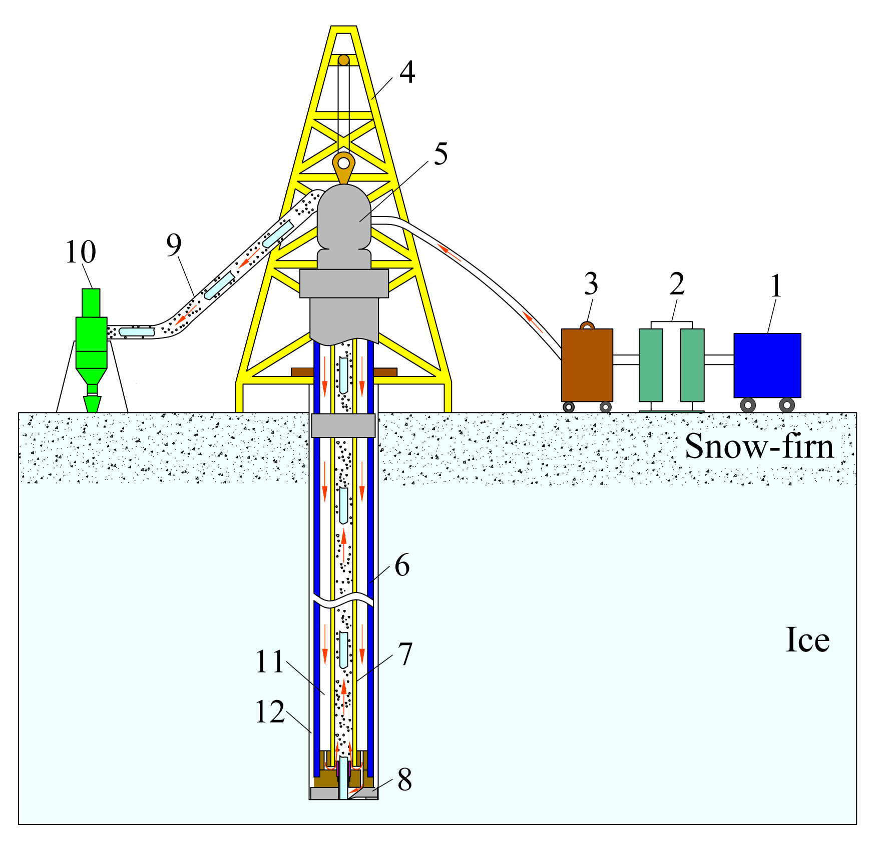
Fig.1 Schematic diagram of air reverse circulation drilling: 1-air compressor; 2-cooler; 3-dryer; 4-drill tower; 5-swivel with dual wall; 6-outer pipe of drill pipe; 7-inner pipe of drill pipe; 8-drill bit; 9-discharge pipe; 10-cyclone; 11-annulus of the drill pipe; 12-annular space between drill pipe and borehole wall.

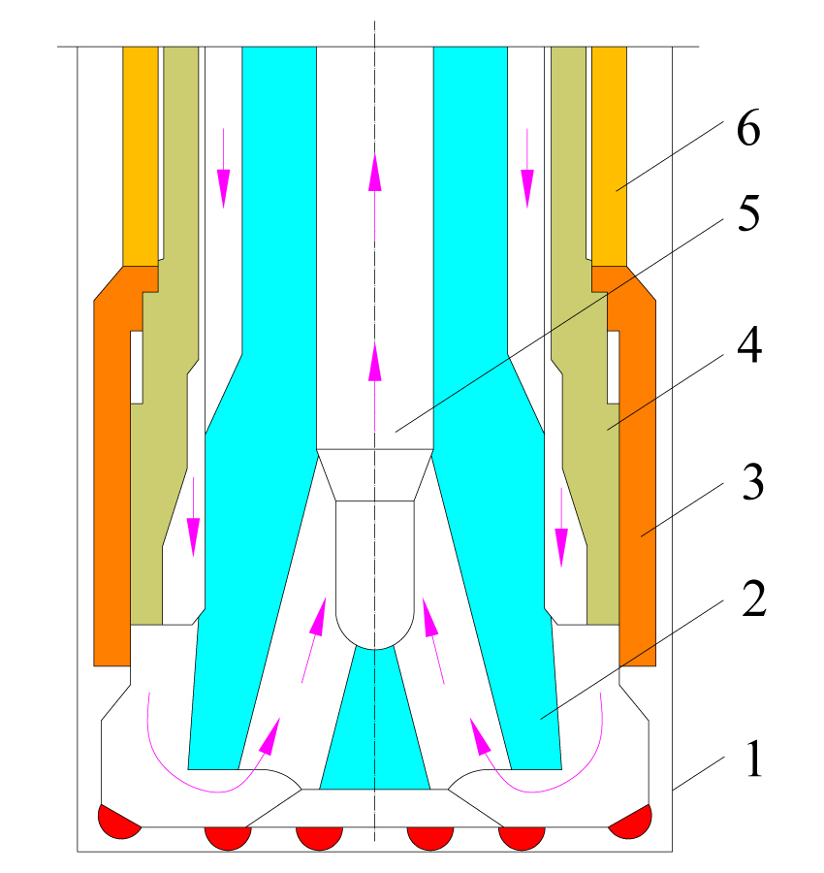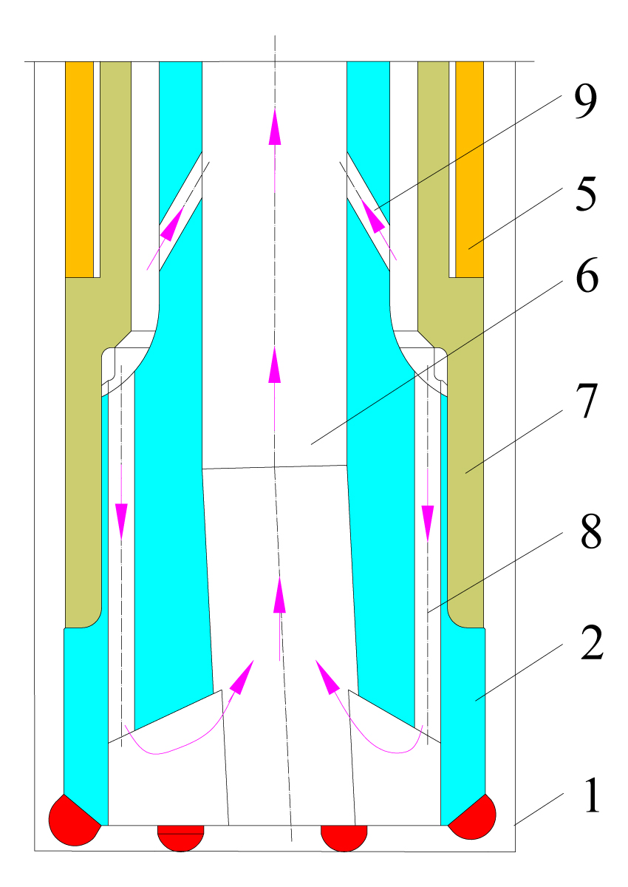
(a) drill bit with a shroud (b) ejector type of drill
Fig.2 Air reverse circulation drill bit in rock drilling: 1-borehole wall; 2-drill bit; 3-shroud; 4-drive sub; 5-hammer casing; 6-central passage; 7-connector; 8-flushing nozzles; 9- inner nozzles.

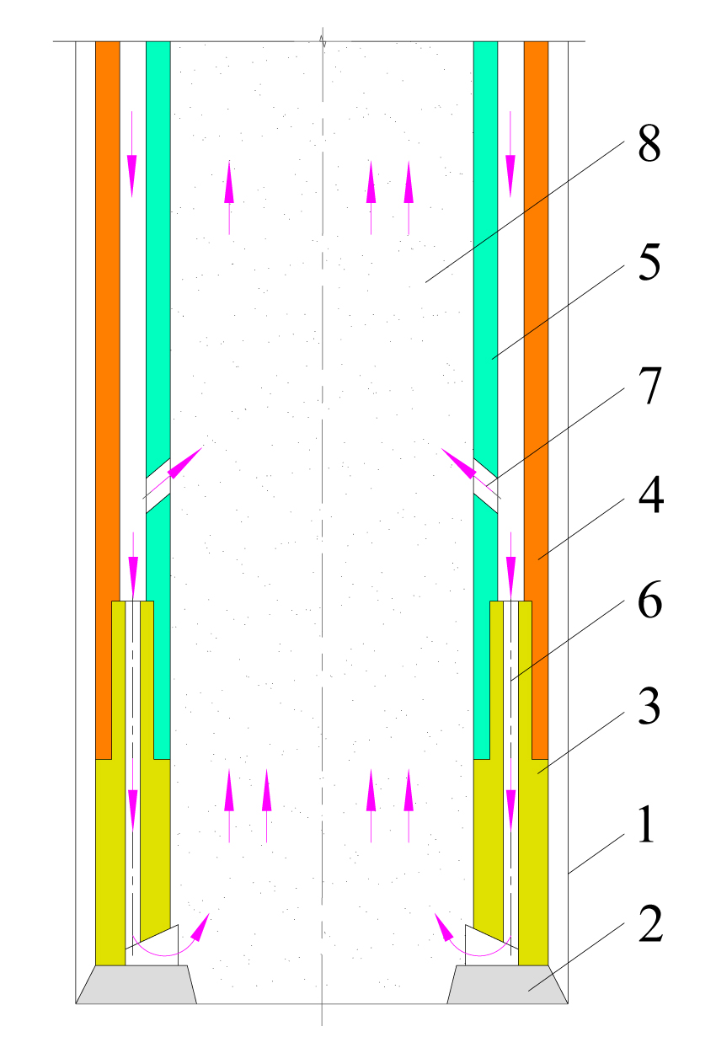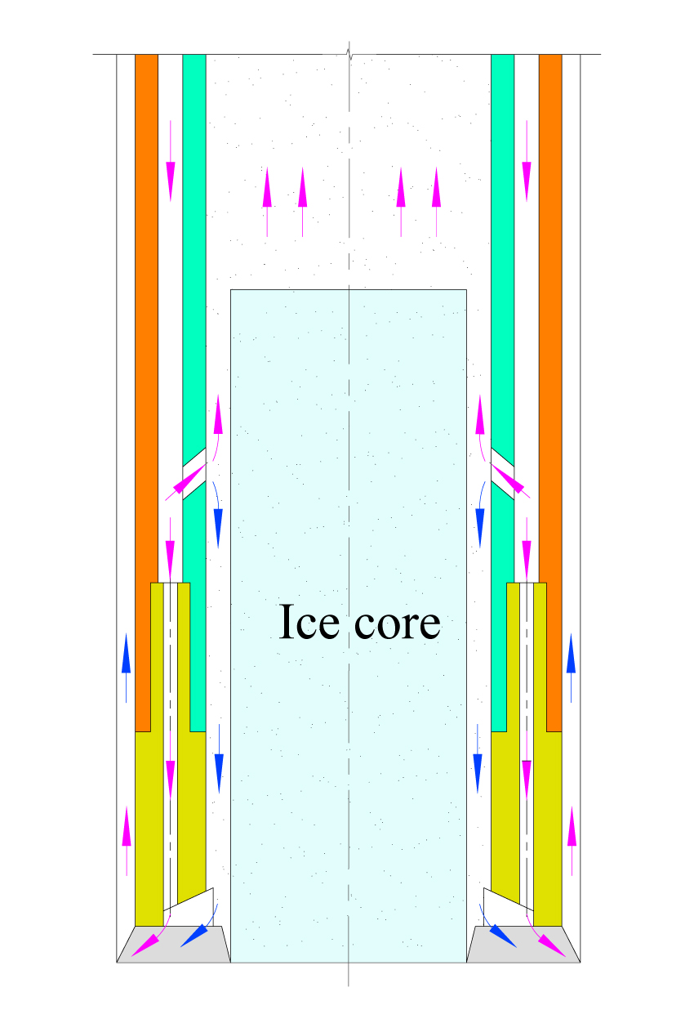
(a) without ice core (b) with ice core
Fig.3 Air reverse circulation in drill bit: 1-borehole wall; 2-cutter; 3-drill bit; 4-outer tube; 5-inner tube; 6-flushing nozzles; 7-inner nozzles; 8-central passage.

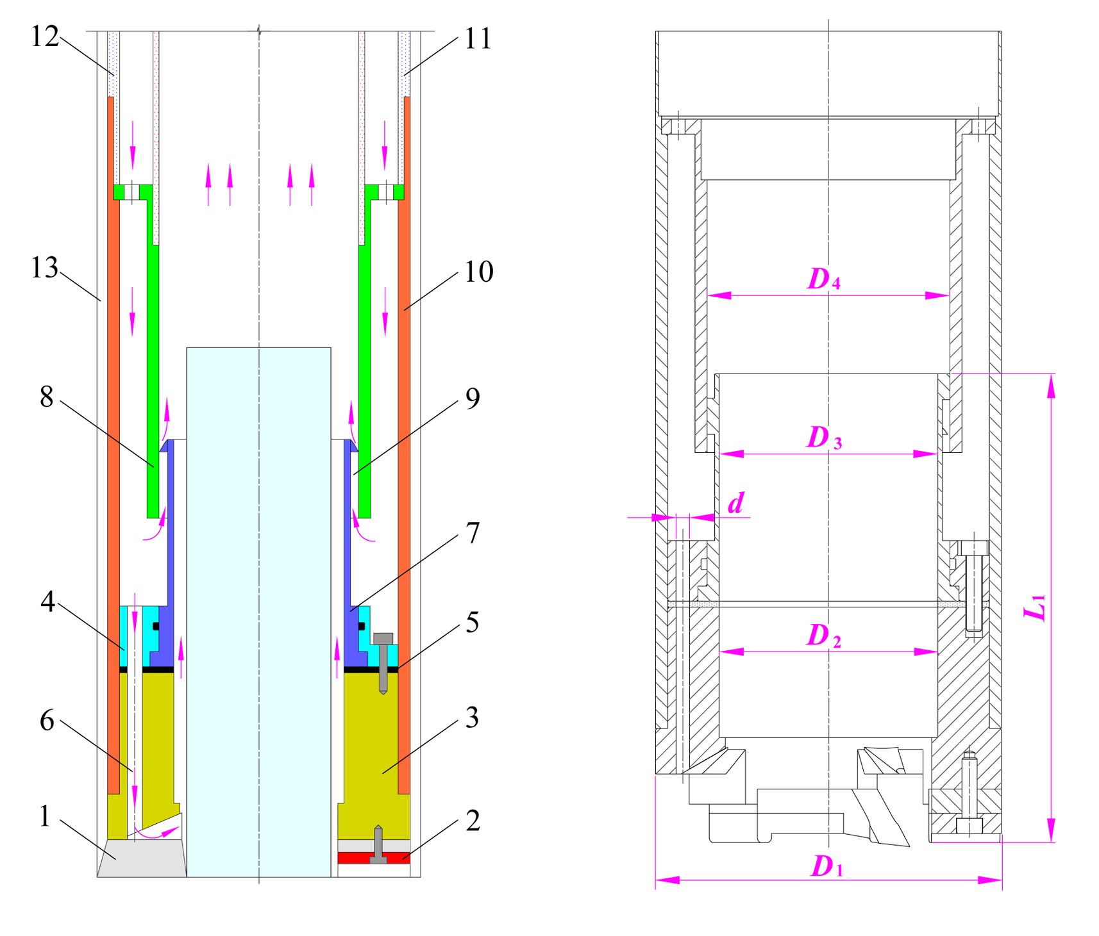
(a)working principle of swirling drill bit
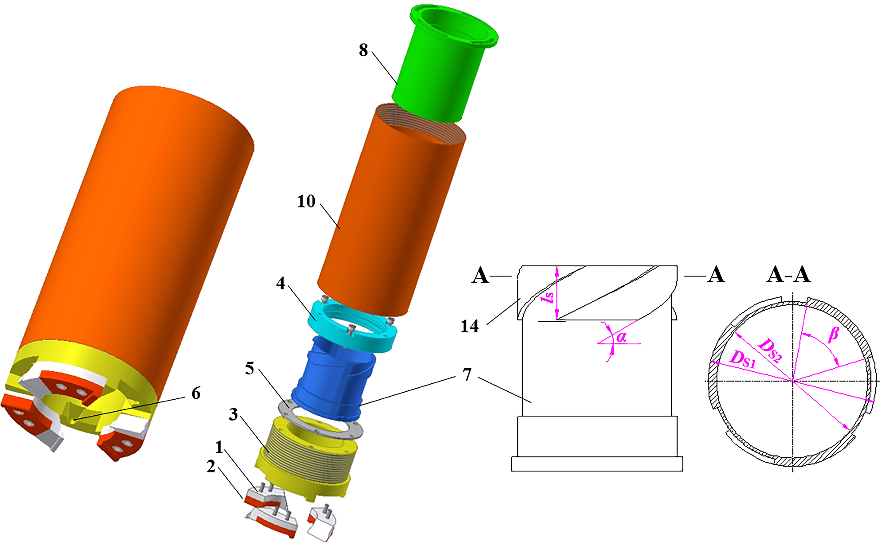
(b) 3D models and van swirler
Fig.4 Swirling ice core drill bit: 1-cutters; 2-shoes; 3-lower drill bit body; 4-upper drill bit body; 5-gasket sealer; 6-flushing nozzles; 7-vane swirler; 8-inner tube of drill bit; 9-swirling slot; 10-outer tube of drill bit; 11-outer tube of connector; 12-.inner tube of connector; 13-borehole wall; 14-spiral blade.

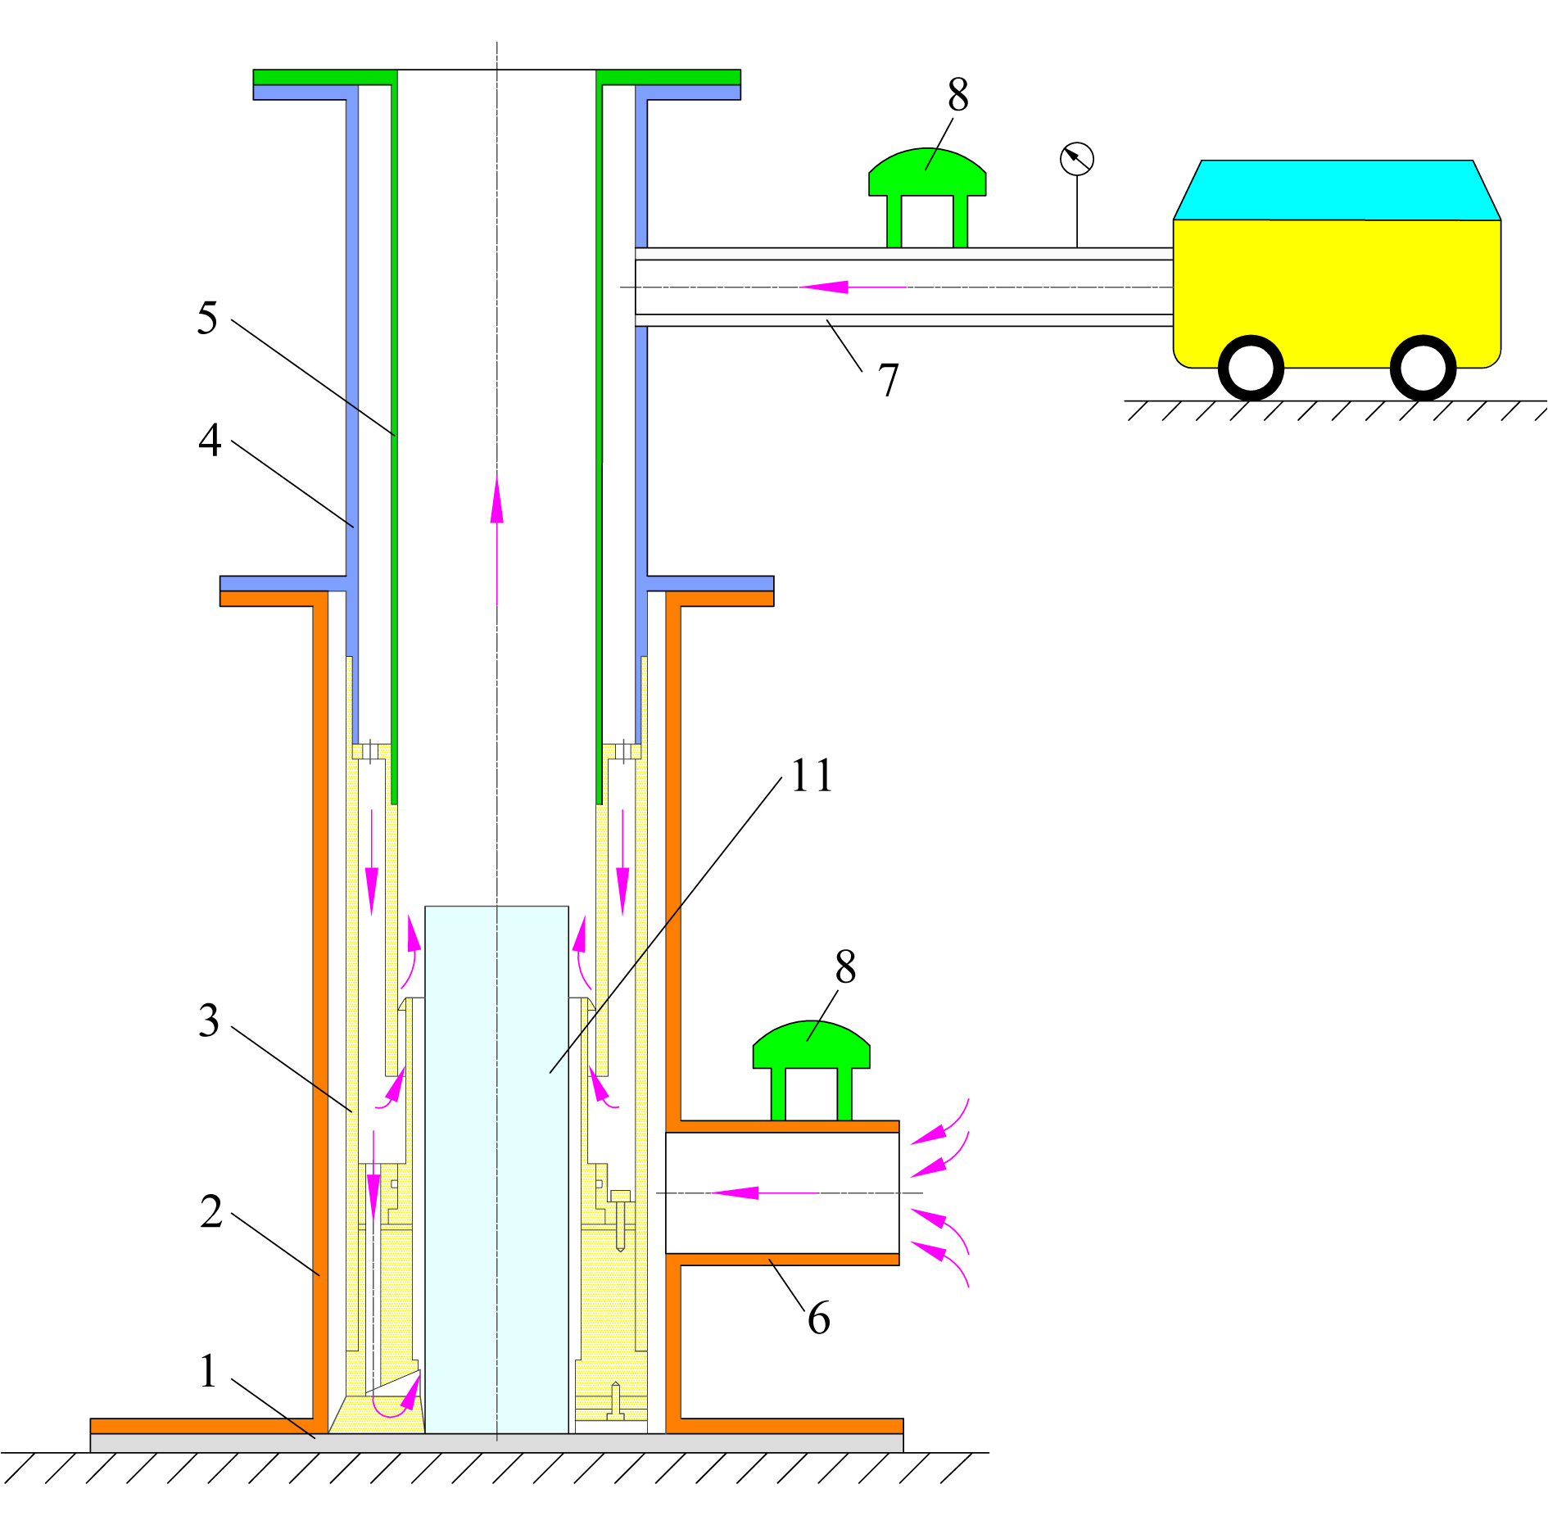
Fig.5 Experimental apparatus: 1-base frame; 2-casing; 3-swirling ice drill bit; 4-outer tube; 5-inner tube; 6-connector pipe; 7-air inlet pipe; 8-flow rate sensor; 9-pressure sensor; 10-air compressor; 11-steel pipe.

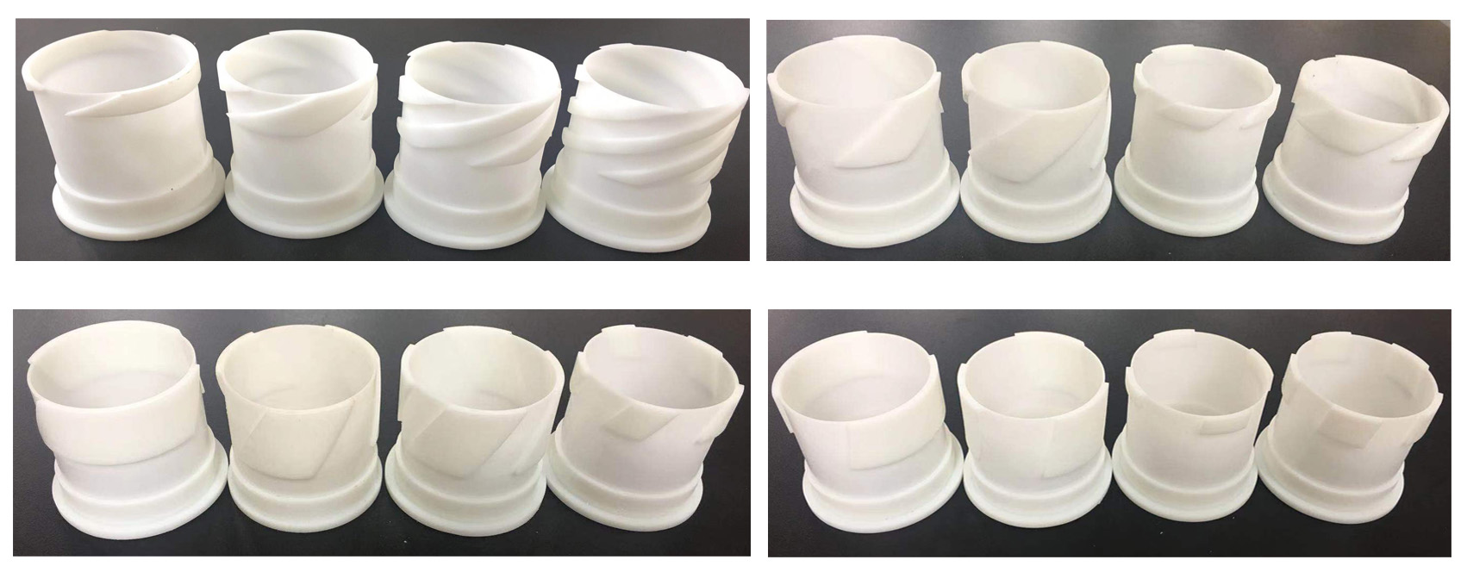
Fig.6 Swirlers produced by 3D print technology.

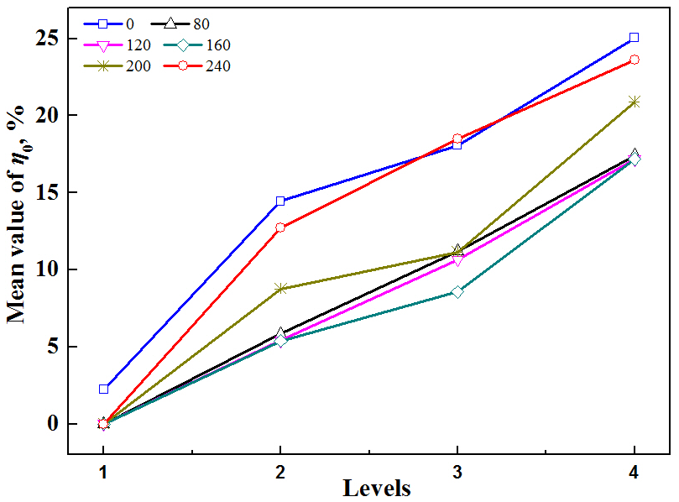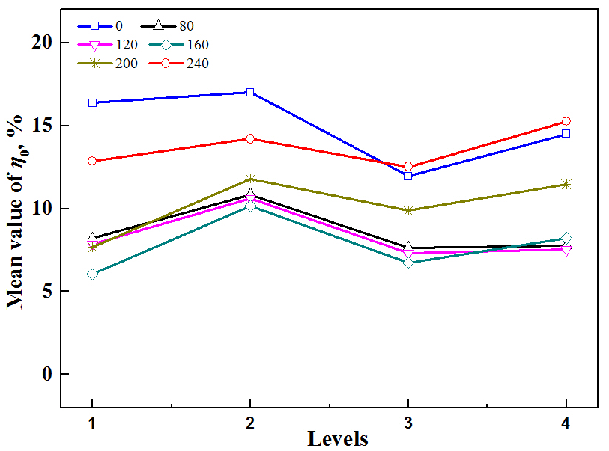
(a) Factor A (helical angle) (b) Factor B (number of blades)
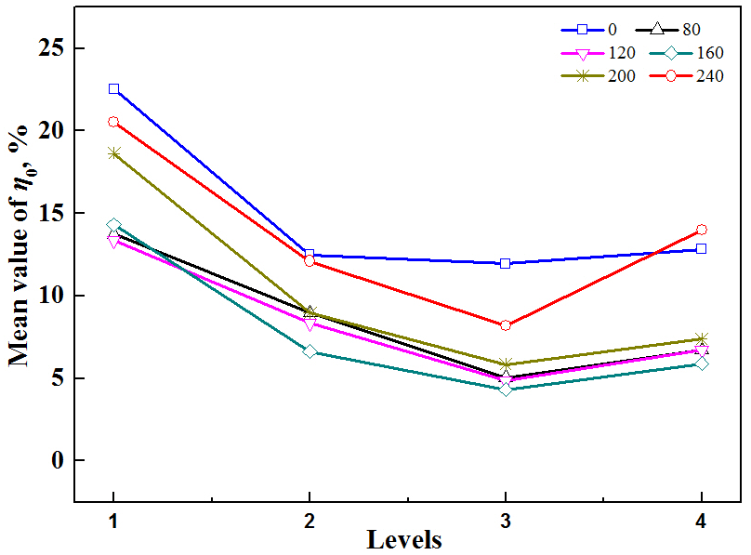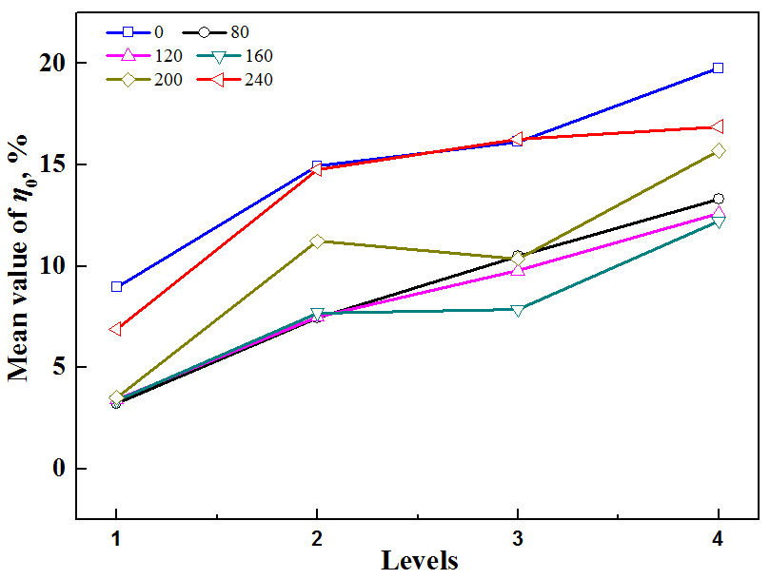
(c) Factor C (blade length) (d) Factor D (area ratio)
Fig.7 Relationship between mean values of entrainment ration and factor levels for the drill bit Ⅰ.

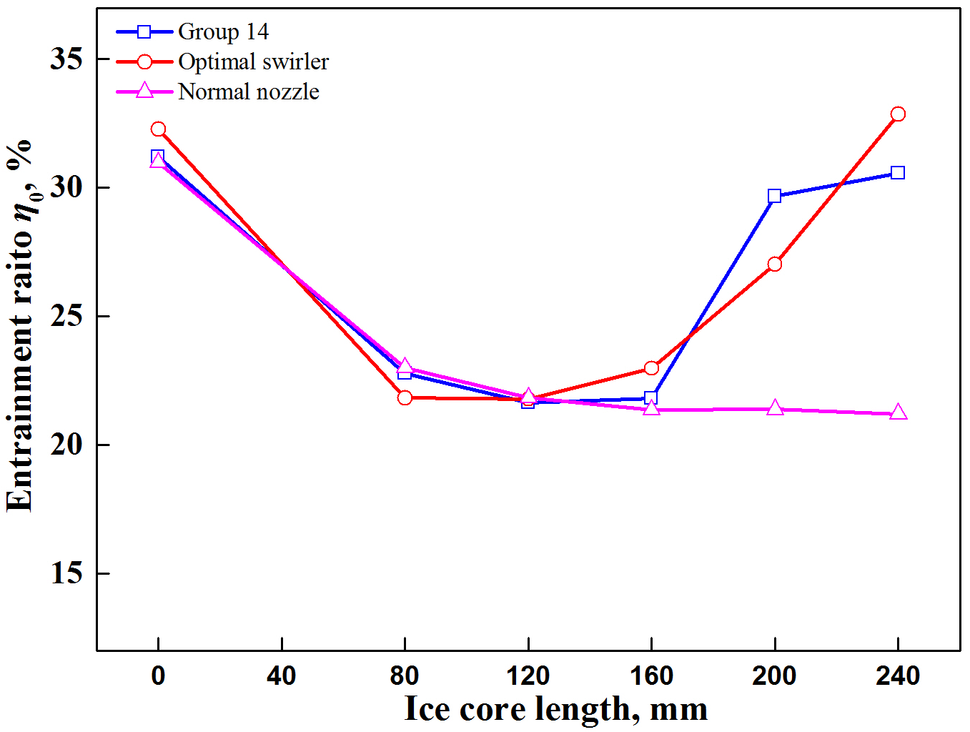
Fig.8 Comparison between testing group 14 and the optimal group for drill bit Ⅰ.

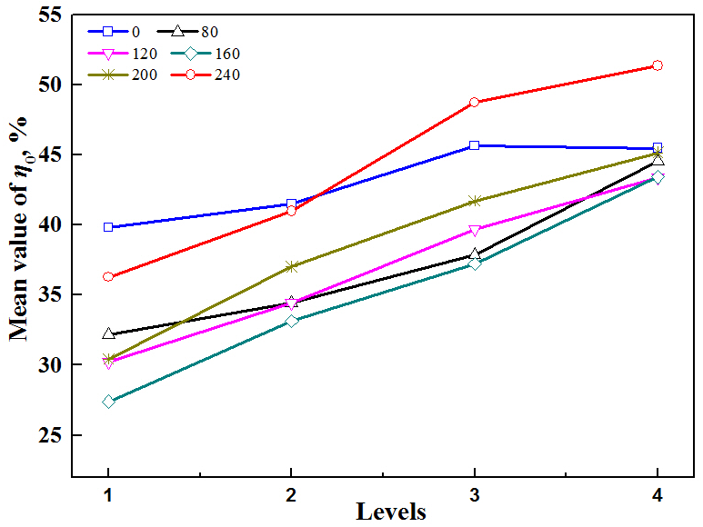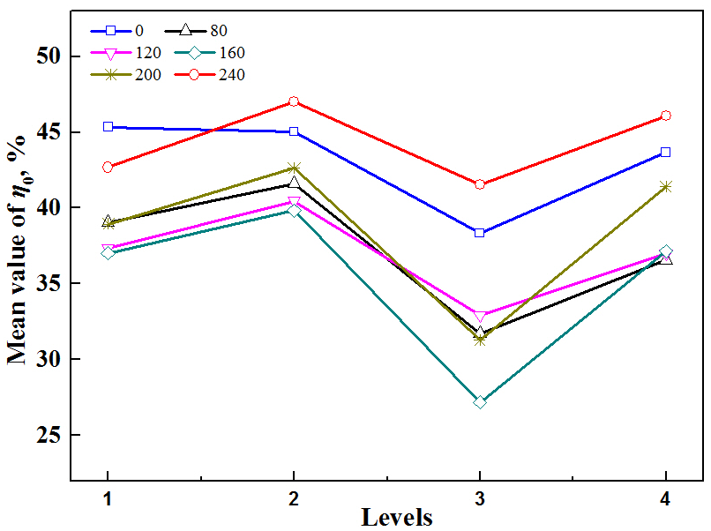
(a) Factor A (helical angles) (b) Factor B (number of blades)
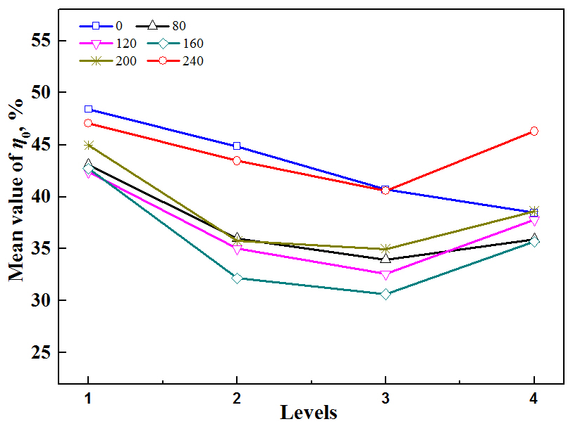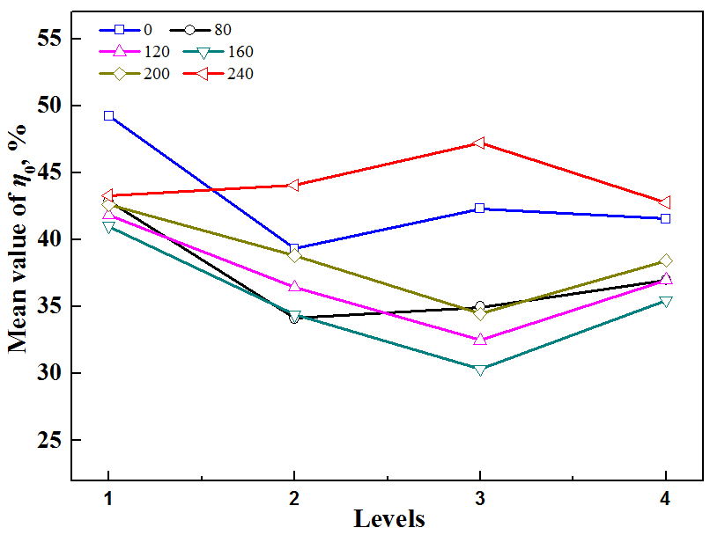
(c) Factor C (blade length) (d) Factor D (area ratio)
Fig.9 Relationship between mean values of entrainment ratio and factor levels for the drill bit Ⅱ.

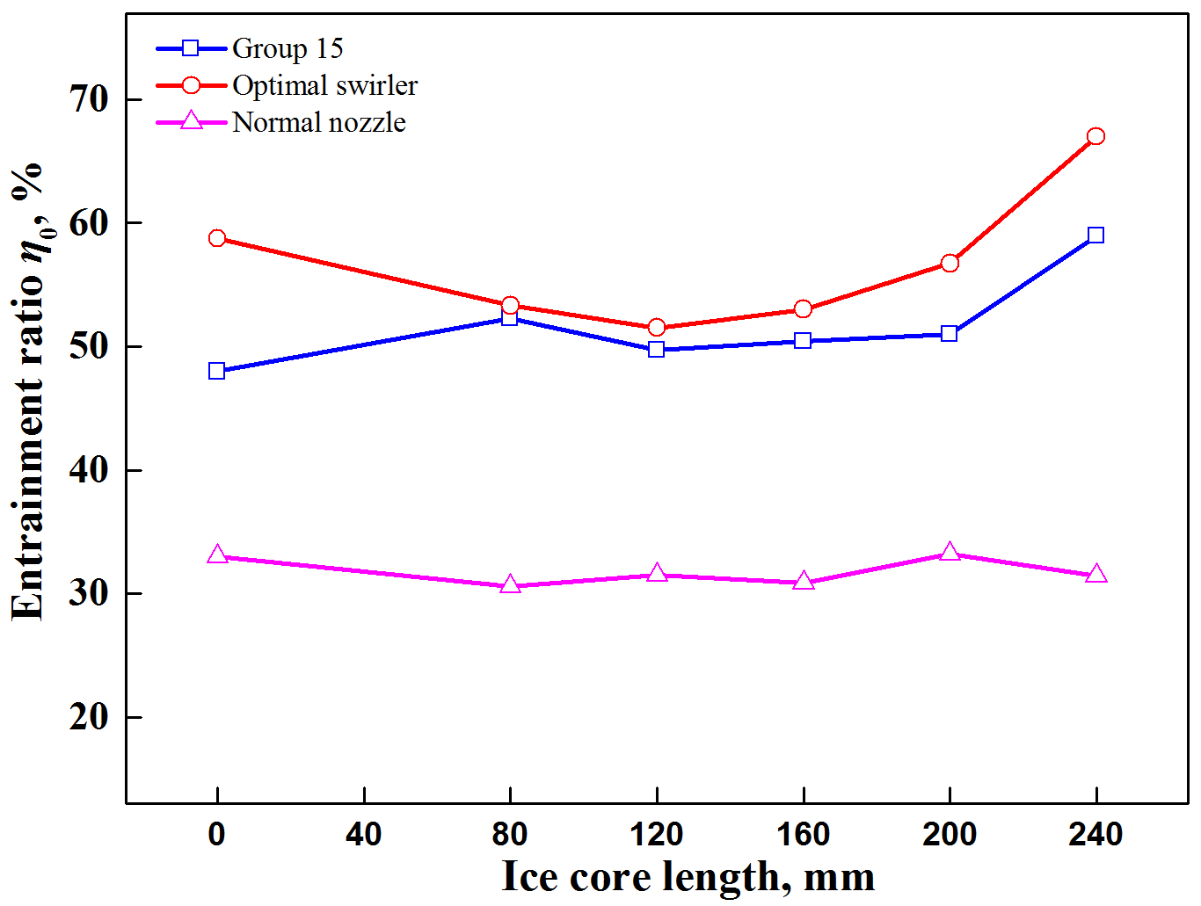
Fig.10 Comparison between testing group 15 and the optimal group for drill bit Ⅱ.

