SUPPLEMENTARY INFORMATION
Section 1 Landsat Imagery
Supp Fig. 1 shows a range of imagery from across three Antarctic summer seasons. The pattern of snow / snow free areas is consistent across all images, though the extent of the snow free areas changes a small amount from image to image. There is no pattern of less snow towards the end of the season, however, which suggests the distribution is a function of snowfall events rather than atmospheric ablation. The snow free extent is least in the January 2018 image (Supp Fig. 1g), it is likely that there has been a recent snow fall event, and the snow drift pattern is not as advanced as in the other images.
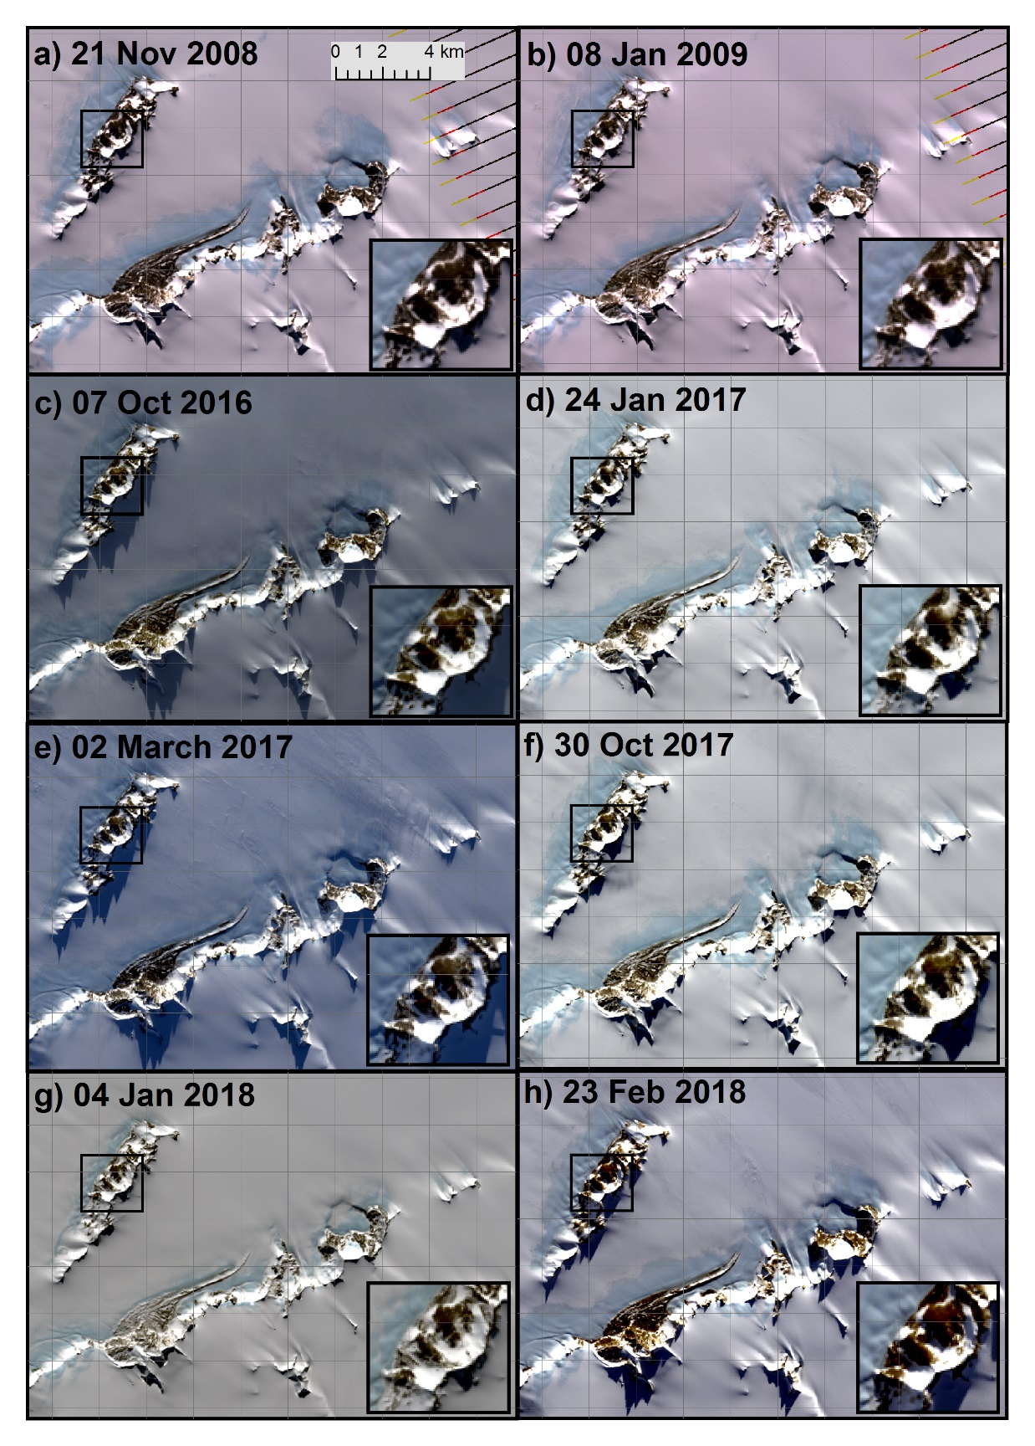
Supplementary Figure 1. Landsat true colour composite for seasons a-b) 2008-2009 (Landsat 7), c-e) 2016-2017 (Landsat 8) and f-h) 2017-2018 (Landsat 8).
Section 2 Representative windspeed

Supplementary Figure 2. Windspeed (m s⁻¹) recorded at Patriot Hills weather station (Fig.1) for the days 01/12/2008-07/01/2009.
Section 3 Further details of the shelter index calculation
Supplementary Figure 3. Further details of the calculations of Expt. 1, a) Slope, b) Aspect, c) Slope Index (S_{i}) d) Aspect Index (A_{i}), e-f) Shelter Index (T_{i}), g) Modified Windspeed (F_{m}) and h) Modified Wind Direction (contours show topographic elevation). Note Aspect is relative to the model grid rather than compass orientations.

Section 4 Inclusion of curvature into the shelter index
Supp Fig. 4a&b shows that areas with a low curvature index generally correspond to areas where there is no snow present in the Landsat image. However, there are some areas with a low curvature in areas where the 2009 image does have snow present, but other images show snow free conditions (see Supp Fig. 1). One area in particular is highlighted with a red circle on Fig. 4b, which has snow in the 2009 image, but is snow free in the other images. This helps to support the inclusion of the curvature index into the shelter index.
Supplementary Figure 4. Details of the calculation of the curvature index for Expt 5, a) positive plan curvature values (negative values not shown), b) Curvature Index (C_{i}), c) Shelter Index for Expt 4. and d) Shelter Index for Expt 5.

Section 5 Quantitative assessment
Supp Fig. 5 shows more details of the quantitative assessment process. Supp Fig. 5c in particular shows the choice of threshold of reflectance value of 120 in the blue band of the January 2009 Landsat Image. The test extent shown in Fig. 5d was chosen to provide an almost equal number of snow / no snow cells so not to bias the assessment towards one or the other state. The test extent contains 1222 ‘snow’ cells and 1226 ‘no snow’ cells. Supp Fig. 5e&f shows an example of the two grids that are compared to one another, using the Purves original setup (Expt. 1) as an example.
Supplementary Figure 5. Details of the quantitative assessment methodology, a) 21/11/2009 Landsat true colour composite, b) 21/11/2009 Landsat blue band, c) showing the reflectance threshold at a value of 120 (8 bit pixel depth), d) test extent for the quantitative assessment, e) observed snow / no snow grid, d) modelled snow / no snow grid for Expt. 1.

Section 6 Chosen parameter set & extreme parameter sets
Supp Fig. 6 shows the end member parameter sets from Table 2 in the main text; Expt. 6 (Supp Table 1) provides the most snow accumulation in the test area, whereas Expt. 7 provides the least. Expt. 5 is shown for reference from the main text.
Supp Table 1. Parameter sets for experiment results shown in Supp. Fig. 6.
Expt. | md | mxd | F | F_{t} | S_{max} | C_{max}
5 | 150 | 690 | 15 | 5 | 20 | 0.5
6 | 150 | 690 | 6.25 | 5 | 20 | -
7 | 150 | 690 | 15 | 5 | S_{max} in grid (69.2) | 0.5

Supplementary Figure 6. a) 21/11/2009 Landsat true colour composite for test area, b-d) Illustration of snow depth index at 8 iterations for Expts. in Supplementary Table 1.

