Reanalysis of the U.S. Geological Survey Benchmark Glaciers: Long-term insight into climate forcing of glacier mass balance

Shad O’Neel¹, Chris McNeil¹, Louis Sass¹, Caitlyn Florentine², Emily Baker¹, Erich Peitzsch², Daniel McGrath³, Andrew Fountain⁴, Dan Fagre²
Supplementary Material

S-1 Point mass balance data

S-1.1 Assembling point balances from Lemon Creek Glacier
The Juneau Icefield Research Program (JIRP) assembled the majority of the LCG record, which is characterized by a single set of observations annually (Pelto and others, 2013; McNeil, 2016). After about a decade of research focus, JIRP evolved into an effort focused on education and outreach, where logistics constrain observations to the middle of the ablation season (Miller and Pelto, 1999; Pelto and others, 2013; McNeil, 2016). Accumulation dominates the observations, with snow pits forming the core of the record. Seasonal ablation observations were made only early in the record, although short time interval ablation observations (few days) have been incorporated into the field program throughout the record. Recently, McNeil (2016) substantiated earlier results, motivating consistent processing with the other USGS benchmark glaciers, and filling an essential spatial gap in the observation suite. Transient-snow line observations (Pelto, 2011; Mernild and others, 2013) help to constrain the record by giving sub-seasonal point balances (b=0), which facilitate comparison with the other glaciers presented here. Traditional stake networks operated since 2013 provide additional support that the early record is valid, especially with respect to interannual variability (McNeil, 2016). The detailed reanalysis spans the interval 1998–present, and is spliced into earlier solutions presented previously (e.g. Pelto and others, 2013).
S-1.2 Assembling point balances from South Cascade Glacier
The primary challenge at SCG is variable field methods, inconsistent number and location of observation sites related to evolving concepts, fluctuating staff and budgets. As a result, the reanalysis extends back to 1986, with earlier glacier-wide mass balances retrieved from the WGMS data archive. In 1988, only site (P1) was measured. Following Krimmel, (1989), we developed a regression between the point balance measured at site P1 and the glacier-wide mass balance to fill a data gap in the time series. As shown in Figure S1, glacier-wide balance is well described by the regression, with R²=0.91.
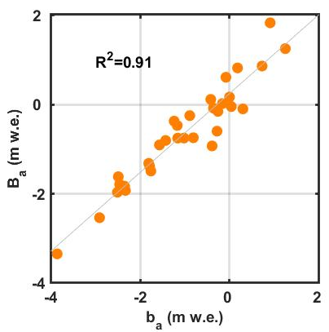
Fig. S1. Regression-derived SCG glacier-wide mass balance, which was used to solve the 1988 annual balance when only site P1 was measured. Point balances measured at P1 are plotted on the x-axis, glacier-wide mass balances on the y-axis.

S-2. Meteorological data
Weather stations were installed in each benchmark glacier basin early in the period of record, but changes to instrumentation, particularly the analog-to-digital transition, as well as lapses in maintenance, result in data gaps. Temperature and precipitation are used in the mass balance analysis. Intermittent observations of wind, humidity and solar radiation also exist (Fig. S2). Although secondary weather stations were recently installed at GG and WG, these data are not used in the analysis. They are included here only to present a complete picture of observables from the project. Further detail is provided in the accompanying data release (Baker and others, 2018).

Fig. S2. Sensor operation history for weather stations maintained as part of the USGS Benchmark Glacier Project. In each panel the y-axis is labeled with the basin name and elevation (m) of the station. Bars, as keyed to the legend, specify the operation interval for each sensor.

S-2.1 Temperature
Before ca. 1995 at GG and WG, analog data were recorded to strip charts. Daily average temperatures were computed by researchers (Mayo and others, 1992), but the slow-response thermometers performed poorly at capturing maximum and minimum temperatures. Since ca. 1995, data loggers have stored digital temperature observations at 15–minute intervals. Daily averages are computed directly from these higher frequency data. The digital thermometers have a faster response time, and a 1°C bias between the analog and digital sensors was detected. An adjustment was made to the early record to produce a consistent temperature time series (March and O’Neel, 2011). During 2010, aspirated temperature sensor shields were installed to better resolve temperatures in low-wind conditions when non-aspirated shields heat up above ambient levels. Following WMO guidance, we default to aspirated-shield observations when available and when consistent with other sensors. In the case when aspirated sensors malfunction, all other observations (generally ranging between one and three) are averaged if they meet a 0.5–degree similarity criteria (World Meteorological Organization, 2008). No correction is made between aspirated and non-aspirated shielding. Differences tend to occur in low wind conditions when the ground is snow covered (spring time).
Temperature measurement quality control involves several sequential steps. First, outliers resulting from intermittent sensor noise are removed using a seven-sample Hampel filter with a 3–median absolute deviation threshold. Next, we linearly interpolate through any short (~hourly) data gaps that may exist. Next, to provide a single value for the site, we average values when multiple sensors exist, given that they meet WMO guidance for similarity. Finally, we compute a daily-average temperature, as the average of all daily observations, requiring 90% data completeness. This step diverts from standard climatological analyses for average temperature, which is generally estimated as (T_{max} + T_{min} /2) (World Meteorological Organization, 2008), but allows a consistent and continuous record through the analog-to-digital transition. Through the digital era, the mean difference in daily average methods is −0.27 °C for GG and −0.08 °C for WG (i.e. WMO yields a higher daily average) and the USGS approach is less sensitive to outliers and sensor malfunctions. Averaging occurs in the local time zone to appropriately capture diurnal processes. Finally, we fill long data gaps in the daily record from alternative, low-elevation stations, using the closest station with a continuous record (c.f. van Beusekom and others, 2010). Table S1 provides the completeness of each station’s record.

Table S1. Completeness histories for primary temperature (T) and precipitation (P) data used in the reanalysis. For Gulkana and Wolverine glaciers, data gaps are filled with weather data from nearby locations as specified. URL’s for LCG: ncdc.noaa.gov, Station ID: USW00025309; SCG: https://wrcc.dri.edu/cgi-bin/cliMAIN.pl?wadiabSG: https://wcc.sc.egov.usda.gov/nwcc/site?sitenum=482

Glacier | Missing T  # days | Missing T  % |  | Missing P  # days | Missing P  % | Gap Filling station
Gulkana | 932 |  | 5 | 1296 | 7 | Gulkana Airport (40 km)
Wolverine | 1264 |  | 7 | 1326 | 7 | Seward (40 km)
Lemon Creek, i.e.  Juneau Airport (20 km) | 4 |  | 0 | 5 | 0 | n/a
South Cascade, i.e.  Diablo Dam (40 km) | 401 |  | 2 | 272 | 1 | n/a
Sperry, i.e. Flattop Snotel (25 km) | 338 |  | 6 | 9 | < 1 | n/a

S-2.2 Precipitation
An antifreeze, storage-tank-style precipitation gage recorded precipitation catch at GG, WG and LCG in the early years of the program. A float in the storage tank recorded stage, but was highly sensitive to thermal expansion of the ever-changing fluid properties of the liquid in the tank(Mayo, 1972; Kennedy, 1995). Strong winds are common at all five sites, and impact snow-catch ratios substantially, even with modified-Nipher shields (Yang and others, 1999) protecting the orifices. In 2015, weighing-style precipitation gages were installed at WG and GG, and operated simultaneously with stage gages for approximately one year. Both types of gages record cumulative precipitation, which must be numerically differentiated to obtain daily totals. Thermal noise often produces negative precipitation totals, which must be smoothed. All daily values before 1996 represent the work of team members that are no longer with the program; descriptions of analog processing are described in existing publications (Mayo and others, 1992; Kennedy, 1995; Kennedy and others, 1997).
Weighing gages improve catch and reduce thermal expansion problems. A single-factor adjustment coefficient was determined for each pair of gages through the period of overlap to merge the records (Yang and others, 1999; Harpold and others, 2017).
We performed a three-step procedure to remove noise (thermal, wind, service visits, etc.) from the records (Nayak and others, 2008). First, we correct for addition or removal of gage fluids during service visits. At these times, apparent changes exceed natural precipitation rates and can be removed with a threshold filter. Next, we apply a Hampel filter to remove spurious outliers in the time series. We use a six-sample window, and replace values exceeding two median absolute deviations from the window median with the window-median value. The final step removes variations related to thermal expansion and wind. We used a bi-directional smoothing process designed specifically for precipitation gage data. This filter exhibits two important characteristics: It preserves total volume, while ensuring a monotonically increasing time series, i.e. it removes negative precipitation events that result from thermal properties of the measurement approach. Following smoothing, we differentiated the time series numerically, then summed precipitation amounts over daily intervals in the local time zone. For a day to be included in the time series, we required at least 90% observation completeness.

S-3 Geospatial Data
We use 33 DEMs in our analyses. DEMs were produced using propetairy software packages (e.g., Socet Set, Agisoft Photoscan, Ames Stereo Pipeline), and rasterization from point clouds was performed using the built-in functionality of the software packages. Tables S2-S6 characterize the DEM construction process by specifying acquisition, resolution, processing and uncertainty properties for each product. More detail can be found in the accompanying data release (Baker and others, 2018).

Table S2. Geospatial data used for Gulkana Glacier. Coordinate system used is WGS84, projected into UTM Zone 6N, (EPSG: 26906). For the geodetic calibration, we prescribed breakpoints at 1979 and 2005. Platform refers to whether the imagery was acquired from air or space, and resolution is the native or digitized pixel size. Approach specifies the photogrammetric method where SfM is Structure from Motion, Conv refers to conventional photogrammetry, ASP refers to the NASA Ames Stereo Pipeline processor (Shean and others, 2016). Uncertainty is given by Equation 7 in the main text, and represents the geodetic mass balance computed between the date of the indicated DEM and the reference (most modern) DEM. Hence no uncertainty is listed for the reference DEM. Glacier coverage describes the fraction of the glacier area imaged. The adjustment interval is the number of days between the image acquisition and the glacier-wide mass minimum date. The adjustment magnitude is the mass balance adjustment from running the mass balance model over the adjustment interval.

Acquisition Date | Platform | Resolution (m) | Approach | Uncertainty (m) | Glacier Coverage (%) | Adjustment interval (days) | Adjustment  magnitude  (m w.e.)
31 Aug 1967 | aerial | 2.89 | SfM | 2.80 | 65 | 4 | -0.06
4 Sep 1974 | aerial | 3.95 | SfM | 2.49 | 77 | 17 | -0.22
25 Aug 1979 | aerial | 2.88 | SfM | 1.86 | 100 | 20 | -0.10
11 Jul 1993 | aerial | 1.38 | SfM | 2.52 | 96 | 52 | -0.66
8 Aug 2005 | aerial | 2.76 | SfM | 1.28 | 97 | 12 | -0.25
11 Aug 2007 | aerial | 1.80 | SfM | 0.60 | 99 | 32 | -0.34
30 Aug 2016 | satellite | 2.00 | ASP | – | 94 | 5 | -0.10

Table S3. Similar to Table S2, except for Wolverine Glacier. Prescribed geodetic calibration breakpoints are in 1979 and 2005.

Acquisition Date | Platform | Resolution (m) | Approach | Uncertainty (m) | Glacier Coverage (%) | Adjustment interval (days) | Adjustment magnitude  (m w.e.)
25 Aug 1969 | aerial | 1.10 | SfM | 2.86 | 46 | 32 | -0.37
13 Sep 1972 | aerial | 1.08 | SfM | 2.24 | 70 | 12 | -0.02
3 Aug 1979 | aerial | 5.83 | SfM | 3.43 | 67 | 51 | -1.64
27 Sep 1995 | aerial | 4.82 | SfM | 1.72 | 95 | 0 | 0.00
8 Aug 2006 | aerial | 2.94 | SfM | 2.14 | 51 | 43 | -0.71
10 Sep 2016 | lidar | 0.50 | available | 0.24 | 99 | 35 | -0.22
12 Sep 2018 | satellite | 2 | ASP | – | 97 | 20 | -0.35

Table S4. Similar to Table S2, but for Lemon Creek Glacier, and the UTM projection is Zone 8N, (EPSG: 26908), and geodetic calibration breakpoint is in 2000. The DEM for 11 Feb. 2000 (*) was generated from Shuttle Radar Topography Mission (SRTM) data which penetrates several meters into seasonal snow (Rignot and others, 2001). We therefore assume that this DEM represents the mass minimum 22 September 1999 glacier surface.

Acquisition Date | Platform | Resolution (m) | Approach | Uncertainty (m) | Glacier Coverage (%) | Adjustment interval (days) | Adjustment magnitude  (m w.e.)
5 Jul 1948 | aerial | 0.86 | SfM | 11.82 | 100 | 72 | -1.89
18 Sep 1957 | aerial | 0.33 | SfM | 2.89 | 100 | 12 | -0.22
11 Aug 1979 | aerial | 0.40 | SfM | 3.06 | 66 | 44 | -1.26
28 Aug 1989 | aerial | 0.41 | SfM | 2.64 | 76 | 38 | -0.67
11 Feb 2000* | satellite | n/a | available | 2.30 | 99 | n/a | n/a
4 Sep 2013 | satellite | n/a | available | 1.79 | 100 | 28 | -0.45
28 Aug 2016 | satellite | 0.34 | ASP | 1.11 | 100 | 41 | -0.60
2 Sep 2018 | satellite | 2 | ASP | – | 100 | 0 | -0.00

Table S5. Similar to Table S2, but for South Cascade Glacier, and the UTM projection is Zone 10N, (EPSG: 26910) and the defined geodetic calibration breakpoints include 1985 and 2004. The 2004 DEM was constructed using classified imagery unavailable for release.

Acquisition Date | Platform | Resolution (m) | Approach | Uncertainty (m) | Glacier Coverage (%) | Adjustment interval (days) | Adjustment magnitude (m w.e.)
13 Aug 1958 | aerial | 1.24 | SfM | 3.50 | 98 | 54 | -2.00
29 Sep 1970 | aerial | 0.32 | SfM | 1.90 | 100 | 5 | -0.12
6 Oct 1979 | aerial | 0.23 | SfM | 1.90 | 100 | 10 | -0.23
5 Sep 1986 | aerial | 0.40 | SfM | 2.06 | 74 | 49 | -0.29
6 Oct 1992 | aerial | 0.15 | SfM | 1.23 | 92 | 6 | -0.04
20 Sep 2001 | aerial | 0.14 | SfM | 1.01 | 96 | 16 | -0.25
26 Sep 2004 | satellite | classified | Conv | 1.06 | 99 | 12 | -0.22
1 Oct 2008 | satellite | 0.51 | ASP | 0.41 | 99 | 3 | -0.06
14 Oct 2015 | satellite | 0.55 | ASP | – | 99 | 9 | -0.08

Table S6. Similar to Table S2, except for Sperry Glacier, and the UTM projection is Zone 12N, (EPSG: 26912).

Acquisition Date | Platform | Resolution (m) | Approach | Uncertainty (m) |  |  | Glacier Coverage (%) | Adjustment interval (days) | Adjustment magnitude (m w.e.)
2 Sep 2005 | aerial | Classified | Conv |  | 1.59 | 100 |  | 28 | -0.32
7 Sep 2014 | satellite | 0.5 | Conv |  | – | 100 |  | 46 | -0.69

S-4 Processing Approach
We describe a consistent, transparent and adaptable approach to produce and evaluate time series of glacier-wide seasonal and annual surface mass balance in a variety of time systems and/or reference frames with the period of record and reanalysis intervals given in Table S7. We developed a reanalysis code with a graphical user interface (GUI) and batch processing capacity. The code is written in the Matlab® computing environment. It was designed to accommodate any data that can be re-formatted in the style of the input files provided and described in the accompanying data release (Baker and others, 2018). Users can explore time systems and parameter space using the GUI.
Time systems: The most basic time system is measurement date, where mass balance estimates are given on the day an observation or suite of observations was collected. Point balance estimates can be solved for in a stratigraphic (floating date) time system, where the mass balance model is used to determine the mass extrema and simultaneous balances by running the model around the acquisition dates and using derivative tests to determine the extrema. Output includes annual, summer and winter point mass balances along with the timing of the seasonal mass extrema to daily resolution.
Table S7. Period of mass balance record and period of detailed reanalysis.

Glacier | Period of record | Reanalysis interval
Gulkana | 1966-2018 | 1966-2018
Woverine | 1966-2018 | 1966-2018
Lemon Creek | 1948-2018 | 1998-2018
South Cascade | 1958-2018 | 1986-2018
Sperry | 2005-2018 | 2005-2018

Besides the floating date ‘stratigraphic’ solution, fixed date (water-year) time system solutions are also available, where balances are modeled from the acquisition date to a specified date — usually the end of the water year. Output is provided as glacier-wide values.
The user can also specify estimates in the conventional reference frame (variable hypsometry) or as reference-surface mass balances (balances projected onto a fixed hypsometry) following Elsberg and others (2001).
Other specified or tunable parameters include subset site (stake and pit) networks, air temperature lapse rates, precipitation scale factors, transient snow lines, missing data handling, extrapolation method and calibration approach. Subroutines to ingest weather data and empirically resolve model coefficients accompany the processing tool.
On occasion, less than three sites were measured in a measurement campaign, requiring infilling to construct a balance profile, or an alternative approach. If two measurements were made, we used the glacier’s time-averaged balance profile (Fig. 3) to predict the missing observation from its average relationship with other observations. When only one site was measured, as was the case for SCG in 1988, the glacier-wide balance was estimated from a regression (Fig. S1). Resolving seasonal and annual balances requires these conditions were met in both seasons. As a last resort, the mass balance model was used to model the mass balance from the closest observation in time, such as if bad weather delayed complete measurement of the observation network in the same period. Flags are given in output files for cases when infilling occurred.

S-4.1 Mass-balance model parameterization
Lack of direct lapse-rate observations at the glacier elevations and/or through time prompted us to use a constant lapse across the study glaciers and interval. Snow and ice coefficients are solved empirically, and resolved values are similar to those suggested by Braithwaite (1995). Precipitation scale factors are somewhat influenced by the length of the direct record relative to the date of the switch between the analog and digital precipitation gauge because of the higher catch efficiency of the modern gauge. These values are likely to undergo evolution as the record-length increases.
Table S8. Ablation coefficients used in the temperature-index model vary for snow (k_{s}) and ice (k_{i}) but are held constant across each glacier.

Glacier | Lapse Rate (°C km⁻¹) | k_{s} (mm w.e. °C⁻¹) | k_{i} (mm w.e. °C⁻¹)
Gullkana | 6.5 | −2.5 | −6.0
Wolverine | 6.5 | −3.8 | −4.7
Lemon Creek | 6.5 | −5.1 | −5.2
South Cascade | 6.5 | −3.6 | −5.6
Sperry | 6.5 | −4.1 | −5.1

Table S9. Dimensionless precipitation scale factors for each glacier, with sites linked to Figure 1 in main text.

 | Gulkana | Wolverine | Lemon Cr. | S. Cascade | Sperry
LA | 1.01 | 0.89
A | 0.84 | 0.89 | 1.41 | 1.92 | 1.77
AU | 0.79 | 0.89
AB | 0.81
B | 1.95 | 1.26 | 2.39 | 2.19 | 0.88
C | 1.40 | 1.94 | 3.23 | 1.98 | 2.05
D | 1.37 |  | 3.15 |  | 2.05
E |  |  | 4.05 | 1.01 | 2.35
F |  |  | 2.38 | 0.62 | 2.06
G |  |  | 3.15 | 0.65 | 1.80
H |  |  | 3.15 | 0.09
J |  |  |  | 0.66
K |  |  |  | 1.01
L |  |  |  | 0.84
N |  | 1.37
P1 |  | 1.37 |  | 1.73
S |  | 2.91
T | 1.67 | 2.79
V | 1.31
W | 1.30
X | 1.39
Y |  | 2.57
Z |  |  |  |  | 2.05

S-4.2 Resolve timing: Adjust to mass maxima
An important component of our analysis is using the mass-balance model to estimate the timing of the glacier-wide mass extrema. Figure S3 shows the relationship between observations, model-determined site extrema and model-determined glacier-wide extrema. The example shows only the three traditional index-sites for clarity. The approach allows us to resolve the stratigraphic balance timing.
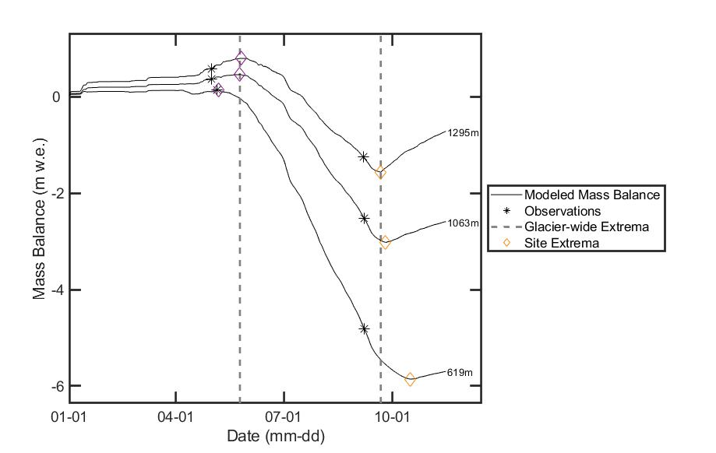
Fig. S3. Example from Wolverine Glacier of the relationship between a point balance observation, mass-balance modeling around the observation, and the timing of the balance extrema for each site. Only primary stakes are shown for clarity, reference Figure S4 for hypsometry.

S-4.3 Extrapolation methods
S-4.3.1 The USGS site-index method
The site-index method was used in most prior USGS Alaska Benchmark Glacier mass balance efforts (March and Trabant, 1996; van Beusekom and others, 2010; March and O’Neel, 2011; O’Neel and others, 2014; WGMS and others, 2017), but was not adopted widely by the community. The approach relied on intuitive site selection to capture average processes over broad regions of the glaciers, with area-weighted averaging used to compute glacier-wide values. In concept, the sparse approach of the site-index method was supposed to be calibrated approximately every ten years by larger-scale efforts, but this was not implemented. At GG, expanded efforts were undertaken at the onset of the program, but never again. At WG, only two intensive campaigns exist (1968 and 2016–17). We used the measurements from the recent intensive campaign directly in the reanalysis. Data from the early campaigns consist of large-format paper maps with unknown ‘georeferencing’ techniques leading us to use the data only implicitly. We extracted 35 annual balances from a 1968 map (Tangborn and others, 1977), a year know to be exceptionally warm. Balances were noted as stake, pit or probe, but elevations were contoured at 100 m, which allowed us to produce only a crude balance profile (Fig. S4). These intensive campaign profiles suggest non-stationarity, or transience in the shape and intercept of the profiles. Changes are strongest in the ablation zone, with a much steeper slope to the modern profile, in accordance with warmer temperatures and longer melt seasons. In the accumulation zone, neither data set suggests as steep of a slope as the average profile that contains fewer high elevation observations (Fig. S4). This highlights an inherent problem with the ‘site-index’ method, where sites low in the accumulation zones were selected (in the 1960s) to represent regions higher on the glacier.

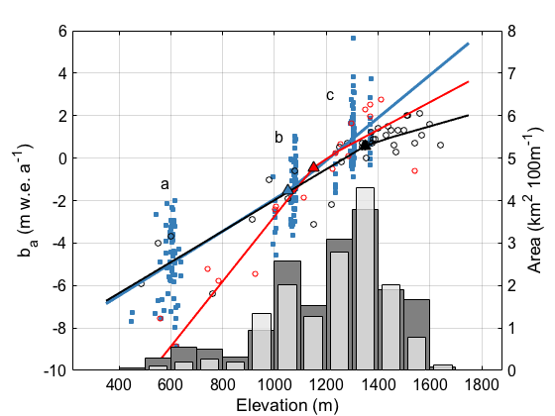
b
c
a
Fig. S4. Balance profiles through all used WG point data (blue) as in Figure 3b, but also showing alternative profiles for years of intensive campaigns (1968, 2016–18). Long-term index sites a, b and c are annotated. Points and the fitted profile from 2016–18 are shown in red. Points and the fitted profile from 1968 are plotted in black. Glacier hypsometry for 1967 and 2018 are shown on the right-hand y-axis.

S-4.3.2 Balance profile fitting
The sparse networks characterizing GG and WG markedly limits flexibility in applying other approaches in determining glacier-wide mass balance. Several stakes were added to the GG and WG networks beginning in 2010 to inform spatial variability of mass balance, and to better facilitate the profile method for these glaciers. We used the expanded data sets to explore several fitting approaches (linear, piecewise-linear and kernel-smoothed (Bowman and Azzalini, 1997)), and applied these methods to the other glaciers as well (Fig. S5). We sought to increase goodness of fit for seasonal and annual profiles, without introducing additional biases with the method. Our analyses revealed that the kernel smoothing approach worked well with ample observations, but for most of the benchmark glaciers and most years, data was overly sparse for this method. Profiles are poorly constrained above the highest-elevation index-sites, which are admittedly low on GG and WG (Fig. S4, site c). We gained insight into seasonal and annual patterns of mass balance in the accumulation zone from supplemental direct and GPR observations (McGrath and others, 2018). As discussed in the main text, we opted to use piece-wise linear spline fits (Fig. S5; free-knot spline; https://www.mathworks.com/matlabcentral/fileexchange/13812-splinefit).

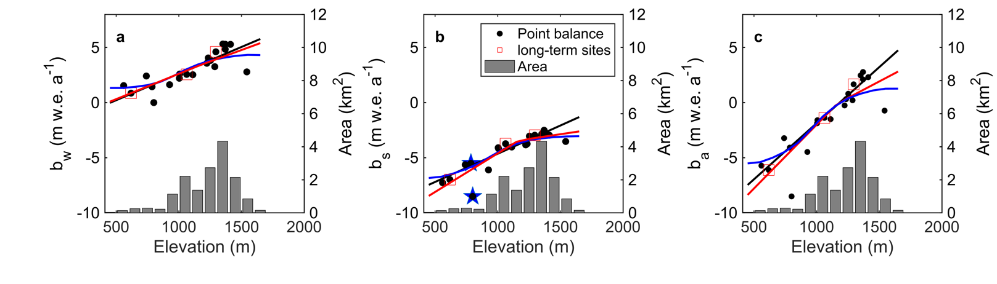
Fig. S5. Example of balance profile fitting from Wolverine Glacier 2016. (a) winter balance; (b) summer balance; (c) annual balance. Long term index sites are boxed in red. The linear profile is displayed as a black line, the piecewise-spline in red and the kernel-smoothed profile in blue. In (b), stars mark stakes with 15 m elevation difference but 3m difference in balance rate (as discussed in main text). Glacier hypsometry is shown with grey bars.

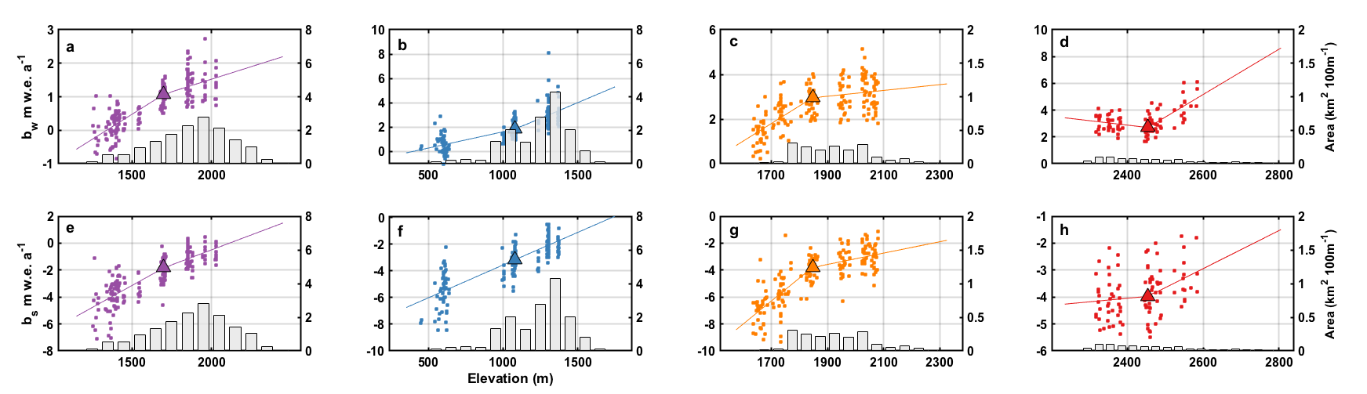
Fig. S6. Average seasonal mass balance profiles using piece-wise linear, single-breakpoint fits to all available point-balance data from each glacier. (a, e) Gulkana, (b, f) Wolverine, (c, g) South Cascade and (g, h) Sperry glaciers. Lemon Creek has only annual balance estimates. The top row (a–d) shows winter balance, the bottom row (e–h) shows summer balance. Present-day area-altitude distributions are shown as bar plots below the profiles, emphasizing the relationship between glacier hypsometry and data collection.

S 4.4 Geodetic calibration coefficients
Our three geodetic calibration approaches are illustrated schematically in Figure S7. The breakpoint method introduces small changes to recently published values (Pelto and others, 2013; O’Neel and others, 2014; Le Bris and Paul, 2015; WGMS and others, 2017; Clark and others, 2017; Florentine and others, 2018). Even without further method development, we expect continued time series evolution as additional geodetic (impacting the current epoch of the breakpoint calibration) and weather (refined degree-day calibrations) data continue to accumulate. These changes should be small (on the order of 0.1 m w.e. a⁻¹), and will not significantly influence interpretations of the records. Table S9 provides breakpoint geodetic calibration intervals and values.

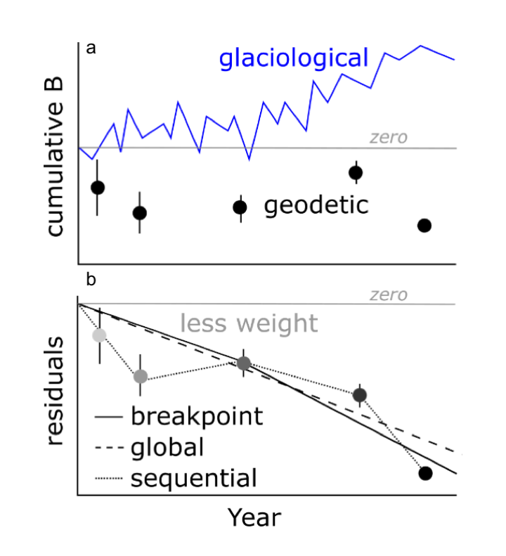

Figure S7: Schematic of geodetic calibration methods. (a) uncalibrated direct glaciological solution and geodetic mass balance. (b) Three calibration approaches showing differences among them as indicated in the legend.

Table S10. Geodetic calibration intervals and values (m w.e.) for each glacier. The 1998-2000 LCG calibration value, marked with *, does not align with the geodetic calibration breakpoint (2000), but relates to splicing WGMS data (1953-1997) with the reanalysis results.

Glacier | Calibration Interval | Calibration value (m w.e. a⁻¹)
Gulkana | 1966–1979 | -0.66
 | 1980–2005 | -1.21
 | 2006–2018 | -0.49
Wolverine | 1966–1979 | -0.50
 | 1980–2006 | -0.98
 | 2006–2018 | -0.69
Lemon Creek | 1953-1997 | +0.08
 | 1998-2000* | 0.00
 | 2001-2018 | -0.43
S. Cascade | 1959–1985 | +0.03
 | 1986–2004 | -0.27
 | 2005–2018 | +0.14
Sperry | 2005–2017 | -0.22

S-5 Trend detection
Following Medwedeff and Roe (2017), we removed a linear trend from each annual and seasonal balance time series. Residuals for all annual and summer balance series passed the Jarque-Bera test for normality at field significance ($α$ = 0.10) and all but Wolverine’s annual balance time series passed at $α$ = 0.05. All summer balance residuals exhibit normality. WG and GG exhibit non-normal winter balance distributions at $α$ = 0.05; GG fails by less than 1%. LCG demonstrated persistence as evaluated using autocorrelation, but the result is statistically marginal. All other seasonal and annual balances exhibit no memory (autocorrelation) suggesting that parametric analyses (e.g. t-test) can be used with confidence. There was no significant correlation between seasonal balances at any of the glaciers (LCG cannot be evaluated). Trend significance was evaluated by calculated signal-to-noise ratios for each time series, normalized by record length, then performing a two-sided t-test. Results (Table S10) indicate significant trends for values $α$ < 0.05.
Table S11. Results from the 2-sided t-test for seasonal (B_{w}, B_{s}) and annual mass balance trends. Bold values indicate significance at the $α$ = 0.05 level.

Glacier | B_{a} | B_{w} | B_{s} | B_{amp}
Gulkana | 0.02 | 0.68 | 0.01 | 0.61
Wolverine | 0.07 | 0.66 | <0.01 | 0.72
Lemon Cr. | <0.01 | N/A | N/A | N/A
S. Cascade | 0.10 | 0.92 | <0.01 | 0.77
Sperry | 0.68 | 0.87 | 0.30 | 0.55

Table S12. Correlation coefficients for annual to winter (B_{a}:B_{w}) and annual to summer (B_{a}:B_{s}) mass balances for each glacier.

Glacier | B_{a}:B_{w} | B_{a}:B_{s}
Gulkana | 0.47 | 0.85
Wolverine | 0.84 | 0.63
Lemon Cr. | 0.66 | 0.89
S. Cascade | 0.66 | 0.74
Sperry | 0.61 | 0.66

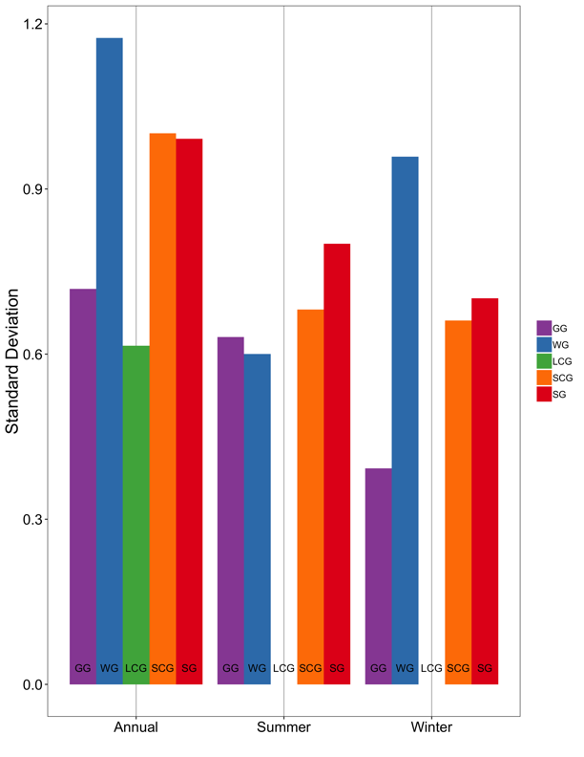
Fig. S8. Standard deviation of seasonal and annual balances for each glacier.

S-6 Sensitivity and uncertainty
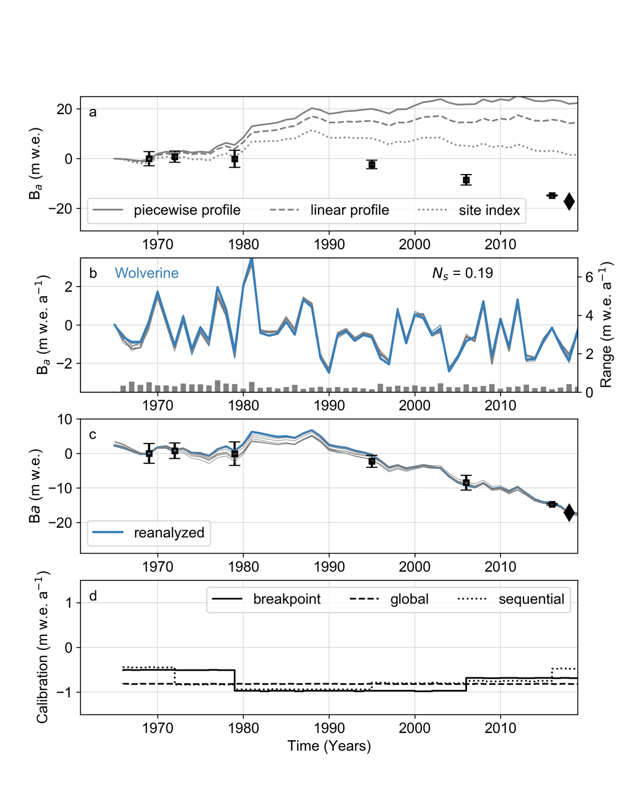

Figure S9: WG sensitivity test results. (a) Uncalibrated cumulative mass balance solutions according to different balance profile fitting methods. Geodetic mass balance results (black squares, black error bars) plotted with the year of the reference DEM indicated (black diamond). (b) Preferred annual balance solution (colored line) compared to other calibrated solution variants (gray lines). The range between these nine solutions for every year in the reanalysis time series is shown as gray bars keyed to the secondary y-axis. (c) Cumulative mass balance for the reanalyzed and other calibrated solutions. The reanalyzed solution reflects the breakpoint geodetic calibration (colored line). Geodetic mass balance results as in (a) that guided calibration fitting are also plotted. (d) Geodetic calibration coefficients for the breakpoint (solid black line), global (dashed black line), and sequential (dotted black line) methods.
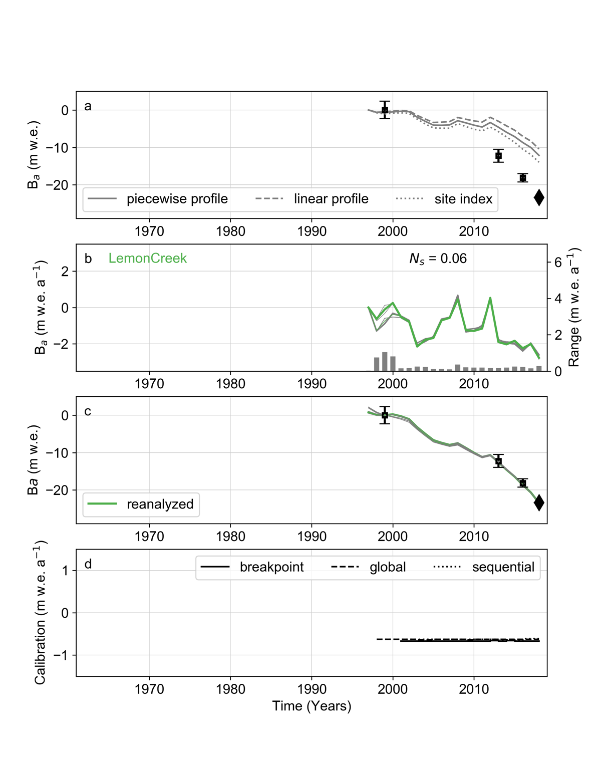
Figure S10: Similar to Figure S9, except for LCG.
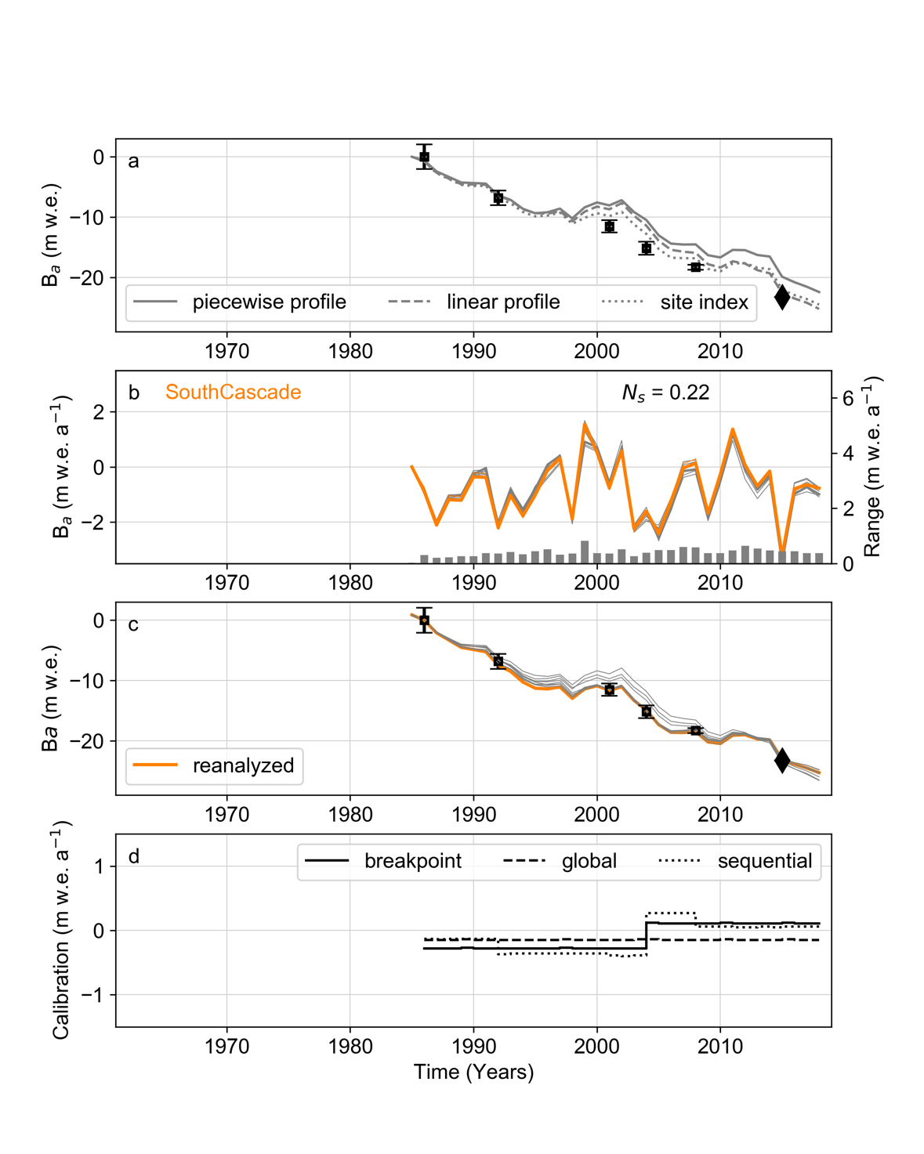
Figure S11: Similar to Figure S9, except for SCG.
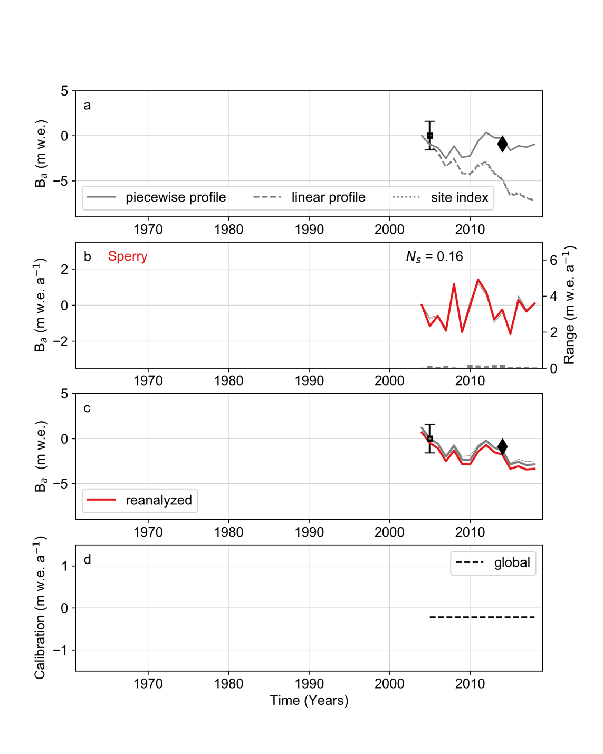
Figure S12: Similar to Figure S9, except for SG.

REFERENCES
Baker EH and 9 others (2018) USGS Benchmark Glacier mass balance and project data: U.S. Geological Survey data release. https://doi.org/10.5066/F7BG2N8R
van Beusekom AE, O’Neel S, March RS, Sass LC and Cox LH (2010) Re-analysis of Alaskan benchmark glacier mass-balance data using the index method. US Geol. Surv. Sci. Investig. Rep. 2010(5247), 16
Bowman AW and Azzalini A (1997) Applied smoothing techniques for data analysis: The kernel approach with S-Plus illustrations. Oxford
Braithwaite RJ (1995) Positive degree-day factors for ablation on the Greenland ice sheet studied by energy-balance modelling. J. Glaciol. 41(137), 153–160 (doi:10.3189/S0022143000017846)
Clark AM, Fagre DB, Peitzsch EH, Reardon BA and Harper JT (2017) Glaciological measurements and mass balances from Sperry Glacier, Montana, USA, years 2005–2015. Earth Syst. Sci. Data 9(1), 47–61 (doi:10.5194/essd-9-47-2017)
Elsberg DH, Harrison WD, Echelmeyer KA and Krimmel RM (2001) Quantifying the effects of climate and surface change on glacier mass balance. J. Glaciol. 47(159), 649–658 (doi:10.3189/172756501781831783)
Florentine C, Harper J, Fagre D, Moore J and Peitzsch E (2018) Local topography increasingly influences the mass balance of a retreating cirque glacier. Cryosphere 12(6), 2109–2122 (doi:10.5194/tc-12-2109-2018)
Harpold AA and 7 others (2017) Rain or snow: hydrologic processes, observations, prediction, and research needs. Hydrol. Earth Syst. Sci. 21(1), 1–22 (doi:10.5194/hess-21-1-2017)
Kennedy BW (1995) Air temperature and precipitation data, Wolverine Glacier basin, Alaska, 1967-94. Report 95–444.
Kennedy BW, Mayo LR, Trabant DC and March RS (1997) Air temperature and precipitation data, Gulkana Glacier, Alaska, 1968-96. Report 97–358.
Krimmel RM (1989) Mass balance and volume of South Cascade Glacier, Washington 1958–1985. Oerlemans J ed. Glacier Fluctuations and Climatic Change. Springer Netherlands, Dordrecht, 193–206
Le Bris R and Paul F (2015) Glacier-specific elevation changes in parts of western Alaska. Ann. Glaciol. 56(70), 184–192 (doi:10.3189/2015AoG70A227)
March RS and O’Neel S (2011) Gulkana Glacier, Alaska – mass balance, meteorology, and water measurements, 1997-2001. US Geol. Surv. Sci. Investig. Rep. 2011(5046), 84
March RS and Trabant DC (1996) Mass balance, meteorological, ice motion, surface altitude, and runoff data at Gulkana Glacier, Alaska, 1992 balance year. 95–4277 http://pubs.er.usgs.gov/publication/wri954277
Mayo LR (1972) Self-mixing antifreeze solution for precipitation gages. J. Appl. Meteorol. 11(2), 400–404 (doi:10.1175/1520-0450(1972)011<0400:SMASFP>2.0.CO;2)
Mayo LR, March R and Trabant D (1992) Air temperature and precipitation data, 1967-88, Wolverine Glacier basin, Alaska. Report 91–246.
McGrath D and 6 others (2018) Interannual snow accumulation variability on glaciers derived from repeat, spatially extensive ground-penetrating radar surveys. Cryosphere 12(11), 3617–3633 (doi:10.5194/tc-12-3617-2018)
McNeil C (2016) Surface mass balance reanalysis of Taku amd Lemon Creek glaciers, Alaska: 1946–2015. MS, Alaska Pacific University.
Mernild SH, Pelto M, Malmros JK, Yde JC, Knudsen NT and Hanna E (2013) Identification of snow ablation rate, ELA, AAR and net mass balance using transient snowline variations on two Arctic glaciers. J. Glaciol. 59(216), 649–659 (doi:10.3189/2013JoG12J221)
Miller MM and Pelto MS (1999) Mass balance measurements on the Lemon Creek Glacier, Juneau Icefield, Alaska 1953-1998. Geogr. Ann. Ser. Phys. Geogr. 81(4), 671–681
Nayak A, Chandler DG, Marks D, McNamara JP and Seyfried M (2008) Correction of electronic record for weighing bucket precipitation gauge measurements. Water Resour. Res. 44(4) (doi:10.1029/2008WR006875)
O’Neel S, Hood E, Arendt A and Sass L (2014) Assessing streamflow sensitivity to variations in glacier mass balance. Clim. Change 123(2), 1–13 (doi:10.1007/s10584-013-1042-7)
Pelto M (2011) Utility of late summer transient snowline migration rate on Taku Glacier, Alaska. Cryosphere 5(4), 1127–1133 (doi:10.5194/tc-5-1127-2011)
Pelto M, Kavanaugh J and McNeil C (2013) Juneau Icefield mass balance program 1946–2011. Earth Syst. Sci. Data 5(2), 319–330 (doi:10.5194/essd-5-319-2013)
Rignot E, Echelmeyer K and Krabill W (2001) Penetration depth of interferometric synthetic-aperture radar signals in snow and ice. Geophys. Res. Lett. 28(18), 3501–3504 (doi:10.1029/2000GL012484)
Shean DE and 6 others (2016) An automated, open-source pipeline for mass production of digital elevation models (DEMs) from very-high-resolution commercial stereo satellite imagery. ISPRS J. Photogramm. Remote Sens. 116, 101–117 (doi:10.1016/j.isprsjprs.2016.03.012)
Tangborn W, Mayo LR, Scully DR and Krimmel RM (1977) Combined ice and water balances of Maclure Glacier, California, South Cascade Glacier, Washington, and Wolverine and Gulkana glaciers, Alaska—1967 hydrologic year. US Geol. Surv. Prof. Pap. (715-B), 20
WGMS (2017) Global Glacier Change Bulletin No. 2 (2014–2015). World Glacier Monitoring Service, Zurich, Switzerland doi:10.5904/wgms-fog-2017-10
World Meteorological Organization (2008) Guide to meteorological instruments and methods of observation. World Meteorological Organization, Geneva, Switzerland
Yang D and 12 others (1999) Quantification of precipitation measurement discontinuity induced by wind shields on national gauges. Water Resour. Res. 35(2), 491–508 (doi:10.1029/1998WR900042)

