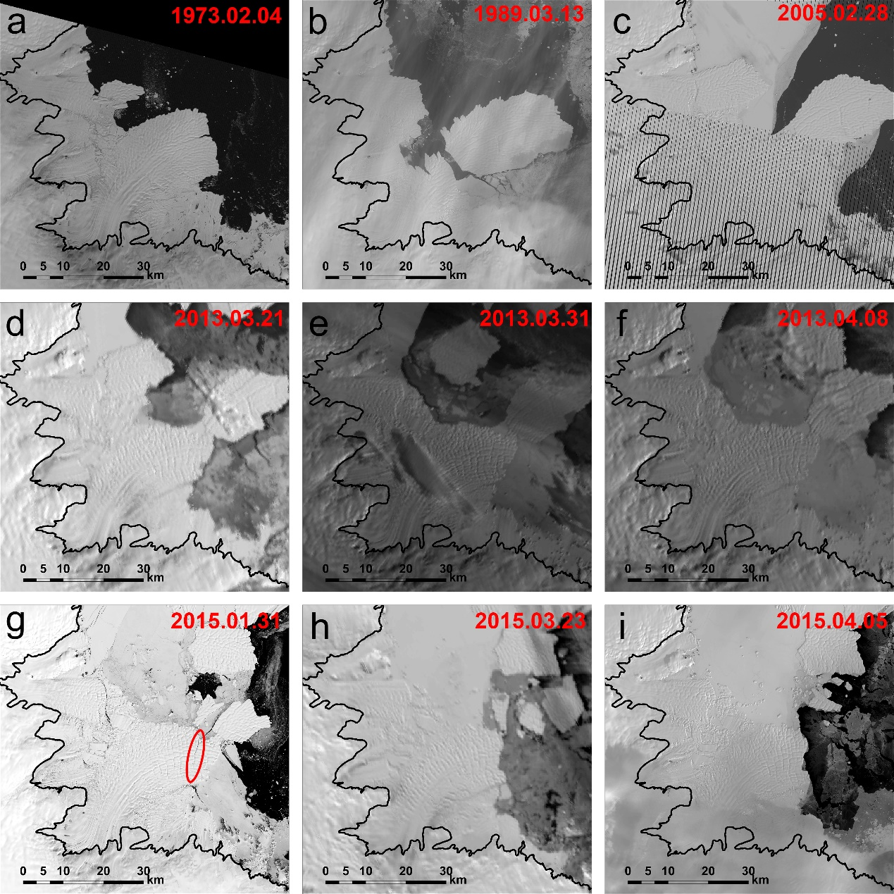
Fig. S1. Images of the Polar Record Glacier between 1973 and 2015. (a) - (c), (g) and (i) are the Landsat panchromatic-band images. (d) - (f) and (h) are the MODIS images with 250 m spatial resolutions. Figures g-i demonstrates a calving event occurred in 2015. The red ellipse in (g) indicates the rift discussed in the text.

