Supplementary information for
Glacier changes between 1971 and 2016 in the Jankar Chhu Watershed, Lahaul Himalaya, India
Suresh Das and Milap Chand Sharma
Centre for the Study of Regional Development (CSRD), Jawaharlal Nehru University (JNU), New Delhi 110067, India
Correspondence to: Suresh Das (suresh41_ssf@jnu.ac.in)

Table S1: Comparison between glacier areas derived from Google earth and Sentinel 2A images in 2016 based on manual delineation techniques. For location see Supplementary Figure S1 below.
Sl. no | Glacier ID | GLIMS ID | Google Earth (km²) | Sentinel (km²) | Deviation (km²) | Deviation (%)
1 | 2 | 3 | 4 | 5 | 6 | 7
1 | G12 | G077065E32681N | 6.8829 | 6.9061 | -0.0232 | -0.3369
2 | G17 | G077120E32704N | 0.8859 | 0.8946 | -0.0087 | -0.9820
3 | G18 | G077095E32703N | 2.0353 | 1.9824 | 0.0529 | 2.6001
4 | G19 | G077076E32706N | 2.9192 | 2.9031 | 0.0161 | 0.5519
5 | G20 | G077079E32731N | 8.0504 | 8.1785 | -0.1281 | -1.5915
6 | G24 | G077078E32759N | 3.5520 | 3.6103 | -0.0583 | -1.6416
7 | G32 | G077057E32772N | 2.7550 | 2.7445 | 0.0105 | 0.3811
8 | G34 | G077027E32775N | 21.3632 | 21.7433 | -0.3801 | -1.7792
9 | G38 | G076999E32802N | 6.4537 | 6.4663 | -0.0126 | -0.1957
10 | G47 | G077019E32842N | 5.6627 | 5.6364 | 0.0263 | 0.4644
11 | G54 | G076984E32862N | 14.7855 | 14.9094 | -0.1239 | -0.8380
12 | G55 | G076974E32876N | 2.0688 | 2.0950 | -0.0262 | -1.2689
13 | G56 | G076984E32920N | 9.2451 | 9.3282 | -0.0832 | -0.8995
14 | G56a | G077000E32929N | 1.2858 | 1.2852 | 0.0005 | 0.0420
15 | G56b | G076986E32894N | 2.7439 | 2.7800 | -0.0361 | -1.3160
16 | G68 | G077050E32943N | 13.3475 | 13.3684 | -0.0209 | -0.1566
17 | G72 | G077041E32979N | 6.5682 | 6.6657 | -0.0975 | -1.4844
18 | G74 | G077059E32981N | 1.0214 | 1.0259 | -0.0045 | -0.4406
19 | G78 | G077085E32958N | 1.7625 | 1.7573 | 0.0052 | 0.2928
20 | G84 | G077097E32951N | 1.4084 | 1.3895 | 0.0189 | 1.3448
21 | G85 | G077102E32962N | 1.4335 | 1.4465 | -0.0129 | -0.9006
22 | G86 | G077110E32968N | 0.8084 | 0.8316 | -0.0232 | -2.8690
23 | G87 | G077116E32952N | 7.9750 | 7.9760 | -0.0010 | -0.0122
24 | G95 | G077153E32945N | 1.2682 | 1.2715 | -0.0033 | -0.2602
25 | G96 | G077157E32922N | 1.5379 | 1.5348 | 0.0030 | 0.1964
26 | G114 | G077129E32873N | 4.8472 | 4.9168 | -0.0696 | -1.4355
27 | G120 | G077154E32901N | 3.6297 | 3.6205 | 0.0092 | 0.2526
28 | G129 | G077228E32860N | 2.6966 | 2.7080 | -0.0115 | -0.4254
29 | G136 | G077213E32816N | 3.2930 | 3.2668 | 0.0261 | 0.7935
30 | G141 | G077187E32795N | 2.5018 | 2.4760 | 0.0258 | 1.0313
 | Total |  | 144.7885 | 145.7187 | -0.9302 | -0.6425

Table S2: Details of glaciers area change for analyzed 127 glaciers in the JCW, Lahaul Himalaya derived from Corona, Landsat, Sentinel 2A images, and ASTER GDEM V2. For location see Supplementary Figure S1 below.
Glacier ID | 1971-2000 |  | 2000-2016 |  | 1971-2016 |  | Topographical parameters |  |  |  |  |  |  | Glacier type | DC Change 1971 - 2016 (%)$
 |  |  |  |  |  |  | Mean Slope (°) | Aspect# | Elevation (m a.s.l)
 | ΔA  (%) | ΔU  (%) | ΔA  (%) | ΔU  (%) | ΔA  (%) | ΔU  (%) |  |  | Min | Max | ER (m) | Mean | Median
1 | 2 | 3 | 4 | 5 | 6 | 7 | 8 | 9 | 10 | 11 | 12 | 13 | 14 | 15 | 16
G01 | 13.3 | 4.2 | 23.5 | 4.9 | 33.7 | 1.8 | 21 | E | 4997 | 5265 | 268 | 5111 | 5110 | 2
G02 | 4.4 | 8.6 | 4.7 | 9.1 | 8.9 | 2.2 | 31 | E | 5212 | 5552 | 340 | 5382 | 5373 | 3
G03 | 5.3 | 5.0 | 8.5 | 5.5 | 13.4 | 2.1 | 23 | NE | 4774 | 5099 | 325 | 4919 | 4919 | 2 | 24.6
G04 | 4.5 | 7.1 | 1.8 | 7.6 | 6.2 | 2.2 | 26 | NW | 4857 | 5279 | 422 | 5036 | 5036 | 2 | 100.0
G05 | 4.4 | 10.1 | 1.0 | 10.7 | 5.4 | 2.2 | 26 | NW | 4740 | 4956 | 216 | 4843 | 4844 | 3 | 56.5
G06 | 4.3 | 7.1 | 2.2 | 7.6 | 6.4 | 2.2 | 29 | NW | 4813 | 5224 | 411 | 5039 | 5070 | 2 | 1.7
G07 | 14.2 | 7.1 | 3.5 | 8.4 | 17.2 | 2.0 | 25 | NW | 4746 | 5107 | 361 | 4943 | 4942 | 2 | 100.0
G08 | 2.4 | 4.0 | 7.1 | 4.3 | 9.3 | 2.2 | 22 | NW | 4829 | 5471 | 642 | 5136 | 5120 | 2 | 48.1
G09 | 11.0 | 3.7 | 7.8 | 4.4 | 17.9 | 2.0 | 18 | NE | 4925 | 5269 | 344 | 5071 | 5070 | 5 | 7.1
G10 | 12.2 | 6.5 | 9.1 | 7.6 | 20.2 | 2.0 | 22 | NE | 5105 | 5274 | 169 | 5194 | 5196 | 5
G11 | 11.8 | 4.8 | 36.4 | 5.4 | 43.8 | 1.6 | 25 | NE | 5027 | 5389 | 362 | 5214 | 5218 | 5
G12 | 1.8 | 2.6 | 5.4 | 3.0 | 7.1 | 2.2 | 18 | SE | 4718 | 5999 | 1281 | 5314 | 5279 | 1 | 48.3
G13 | 4.8 | 14.0 | 5.8 | 14.8 | 10.3 | 2.1 | 28 | W | 5348 | 5454 | 106 | 5402 | 5406 | 3
G14 | 2.4 | 3.8 | 2.7 | 4.2 | 5.0 | 2.2 | 17 | E | 5120 | 5430 | 310 | 5249 | 5241 | 2
G15 | 10.1 | 5.2 | 2.9 | 5.9 | 12.7 | 2.1 | 21 | E | 5124 | 5502 | 378 | 5313 | 5311 | 5 | 5.5
G16 | 7.8 | 8.0 | 16.8 | 8.8 | 23.3 | 1.9 | 21 | NE | 5246 | 5422 | 176 | 5340 | 5347 | 5
G17 | 10.1 | 3.5 | 13.7 | 4.1 | 22.4 | 1.9 | 16 | NE | 4980 | 5400 | 420 | 5184 | 5185 | 5
G18 | 5.6 | 3.0 | 1.5 | 3.5 | 7.0 | 2.2 | 17 | NE | 4804 | 5415 | 611 | 5089 | 5097 | 5 | 36.6
G19 | 4.8 | 2.6 | 7.2 | 3.1 | 11.6 | 2.1 | 18 | NE | 4986 | 5815 | 829 | 5349 | 5340 | 5
G20 | 2.0 | 2.4 | 2.6 | 2.9 | 4.5 | 2.2 | 18 | NE | 4667 | 5790 | 1123 | 5264 | 5305 | 6 | 75.7
G21 | 10.8 | 6.6 | 7.2 | 7.6 | 17.2 | 2.0 | 22 | NE | 4950 | 5178 | 228 | 5049 | 5044 | 5
G22 | 10.7 | 11.5 | 8.8 | 12.9 | 18.6 | 2.0 | 23 | E | 4958 | 5073 | 115 | 5027 | 5031 | 5
G23 | 4.9 | 5.4 | 2.1 | 5.8 | 6.8 | 2.2 | 23 | NE | 5199 | 5663 | 464 | 5450 | 5453 | 5 | 100.0
G24 | 2.4 | 2.3 | 1.5 | 2.8 | 3.9 | 2.2 | 16 | NE | 4908 | 5614 | 706 | 5259 | 5247 | 5 | 19.8
G25 | 9.4 | 7.1 | 10.5 | 8.0 | 18.9 | 2.0 | 30 | NE | 4797 | 5133 | 336 | 4969 | 4965 | 3
G26 | 4.6 | 4.7 | 4.5 | 5.1 | 8.9 | 2.2 | 18 | NE | 5018 | 5393 | 375 | 5203 | 5206 | 5 | 31.4
G27 | 16.0 | 6.2 | 6.0 | 7.5 | 21.1 | 2.0 | 19 | NW | 4890 | 5048 | 158 | 4961 | 4957 | 5
G28 | 5.2 | 4.8 | 6.1 | 5.3 | 11.0 | 2.1 | 20 | NW | 5023 | 5463 | 440 | 5231 | 5223 | 5 | 100.0
G29 | 7.1 | 4.2 | 7.3 | 4.7 | 13.9 | 2.1 | 17 | NW | 5114 | 5471 | 357 | 5300 | 5306 | 5
G30 | 7.9 | 5.9 | 10.3 | 6.5 | 17.4 | 2.0 | 21 | NW | 4963 | 5295 | 332 | 5115 | 5123 | 5 | 4.0
Table S2 contd.
G31 | 4.9 | 5.6 | 4.7 | 6.1 | 9.4 | 2.1 | 21 | NW | 4933 | 5375 | 442 | 5102 | 5087 | 5
G32 | 4.1 | 2.3 | 3.6 | 2.9 | 7.5 | 2.2 | 18 | NW | 5061 | 5754 | 693 | 5359 | 5334 | 2
G33 | 12.5 | 5.9 | 11.7 | 6.9 | 22.7 | 1.9 | 20 | NW | 4991 | 5192 | 201 | 5095 | 5102 | 3 | 72.9
G34 | 0.3 | 1.9 | 1.0 | 2.5 | 1.3 | 2.3 | 17 | SE | 4363 | 6081 | 1718 | 5169 | 5205 | 1 | 35.4
G35 | 14.1 | 7.7 | 4.8 | 9.0 | 18.2 | 2.0 | 28 | SE | 5171 | 5304 | 133 | 5236 | 5238 | 3 | 100.0
G36 | 23.3 | 3.5 | 5.8 | 4.8 | 27.8 | 1.9 | 23 | E | 5136 | 5560 | 424 | 5309 | 5307 | 5 | 4.4
G37 | 11.1 | 4.4 | 1.7 | 5.2 | 12.6 | 2.1 | 25 | NE | 5062 | 5629 | 567 | 5330 | 5325 | 5
G38 | 2.2 | 2.2 | 3.3 | 2.7 | 5.4 | 2.2 | 17 | E | 4689 | 6146 | 1457 | 5314 | 5332 | 5 | 90.8
G39 | 14.9 | 11.8 | 15.9 | 13.9 | 28.5 | 1.8 | 37 | E | 5814 | 5952 | 138 | 5886 | 5879 | 3
G40 | 4.3 | 4.1 | 4.2 | 4.5 | 8.3 | 2.2 | 20 | NE | 5125 | 5548 | 423 | 5338 | 5357 | 5 | 100.0
G41 | 5.3 | 9.9 | 15.7 | 10.5 | 20.1 | 2.0 | 25 | E | 5221 | 5373 | 152 | 5291 | 5290 | 5 | 100.0
G42 | 14.0 | 13.4 | 9.7 | 15.6 | 22.4 | 1.9 | 22 | NE | 5313 | 5404 | 91 | 5356 | 5355 | 5
G43 | 5.6 | 3.9 | 6.7 | 4.4 | 11.9 | 2.1 | 18 | NE | 5078 | 5611 | 533 | 5310 | 5325 | 5 | 100.0
G44 | 12.0 | 9.9 | 8.1 | 11.3 | 19.2 | 2.0 | 31 | NE | 5167 | 5458 | 291 | 5307 | 5310 | 5 | 100.0
G45 | 13.2 | 9.3 | 7.6 | 10.8 | 19.8 | 2.0 | 31 | N | 4975 | 5199 | 224 | 5073 | 5071 | 5 | 26.7
G46 | 11.4 | 11.4 | 13.7 | 12.9 | 23.5 | 1.9 | 36 | E | 4967 | 5200 | 233 | 5058 | 5045 | 5 | 11.2
G47 | 1.3 | 3.0 | 0.6 | 3.5 | 1.9 | 2.3 | 16 | E | 4769 | 5991 | 1222 | 5315 | 5300 | 6
G48 | 3.2 | 4.6 | 3.8 | 5.0 | 6.9 | 2.2 | 18 | SW | 5284 | 5699 | 415 | 5452 | 5444 | 5
G49 | 21.0 | 12.9 | 14.8 | 16.4 | 32.7 | 1.8 | 26 | NE | 5599 | 5701 | 102 | 5649 | 5645 | 4
G50 | 11.7 | 5.8 | 6.2 | 6.7 | 17.2 | 2.0 | 26 | N | 5237 | 5564 | 327 | 5369 | 5359 | 5 | 58.5
G52 | 17.2 | 6.7 | 7.1 | 8.2 | 23.1 | 1.9 | 25 | NW | 4857 | 5125 | 268 | 4962 | 4947 | 5 | 16.3
G53 | 2.4 | 3.5 | 0.8 | 4.0 | 3.2 | 2.3 | 21 | NE | 4905 | 5611 | 706 | 5283 | 5283 | 2 | 92.7
G54 | 1.2 | 2.4 | 1.5 | 2.9 | 2.7 | 2.3 | 17 | SE | 4630 | 5974 | 1344 | 5333 | 5357 | 1 | 37.1
G55 | 6.4 | 2.8 | 4.2 | 3.3 | 10.3 | 2.1 | 16 | E | 5214 | 5655 | 441 | 5423 | 5421 | 2 | 100.0
G56 | 5.3 | 2.5 | 5.7 | 3.0 | 10.7 | 2.1 | 17 | S | 4857 | 5967 | 1110 | 5305 | 5316 | 1 | 58.5
G57 | 10.2 | 7.3 | 4.1 | 8.3 | 13.9 | 2.1 | 34 | E | 5493 | 5955 | 462 | 5685 | 5675 | 4
G58 | 15.7 | 10.1 | 0.0 | 12.0 | 15.7 | 2.0 | 26 | S | 5630 | 5820 | 190 | 5764 | 5773 | 4
G59 | 24.0 | 4.1 | 20.1 | 5.4 | 39.3 | 1.7 | 20 | S | 5328 | 5586 | 258 | 5427 | 5419 | 2 | 100.0
G61 | 30.9 | 5.2 | 15.5 | 7.5 | 41.6 | 1.6 | 17 | S | 5322 | 5493 | 171 | 5417 | 5429 | 4
G62 | 15.9 | 4.9 | 6.8 | 6.0 | 21.6 | 1.9 | 15 | SE | 5222 | 5403 | 181 | 5309 | 5312 | 2
G64 | 16.4 | 4.5 | 15.0 | 5.5 | 28.9 | 1.8 | 17 | N | 5190 | 5396 | 206 | 5299 | 5301 | 5 | 100.0
G65 | 3.8 | 9.3 | 16.0 | 9.7 | 19.2 | 2.0 | 37 | NE | 4980 | 5250 | 270 | 5120 | 5125 | 5
G66 | 12.0 | 6.8 | 4.8 | 7.8 | 16.2 | 2.0 | 27 | NE | 4899 | 5198 | 299 | 5077 | 5077 | 5 | 57.8
G67 | 17.0 | 5.6 | 8.1 | 6.8 | 23.7 | 1.9 | 27 | E | 5052 | 5372 | 320 | 5181 | 5180 | 5 | 100.0
G68 | 2.2 | 2.4 | 3.0 | 2.9 | 5.2 | 2.2 | 17 | S | 4653 | 6031 | 1378 | 5286 | 5299 | 1 | 13.5
G69 | 3.7 | 11.3 | 3.1 | 11.8 | 6.7 | 2.2 | 38 | NE | 5544 | 5955 | 411 | 5818 | 5832 | 3
G70 | 16.7 | 9.4 | 8.7 | 11.4 | 24.0 | 1.9 | 25 | E | 5586 | 5707 | 121 | 5646 | 5645 | 3
G71 | 8.0 | 10.6 | 4.4 | 11.6 | 12.1 | 2.1 | 25 | S | 5192 | 5329 | 137 | 5259 | 5260 | 5 | 17.2
G72 | 2.8 | 2.6 | 1.7 | 3.1 | 4.4 | 2.2 | 15 | E | 4881 | 6000 | 1119 | 5317 | 5336 | 1 | 48.8
Table S2 contd.
G73 | 17.8 | 14.0 | 12.2 | 17.1 | 27.9 | 1.9 | 28 | SW | 5469 | 5572 | 103 | 5520 | 5517 | 3
G74 | 3.8 | 3.2 | 2.8 | 3.6 | 6.4 | 2.2 | 17 | S | 5219 | 5543 | 324 | 5381 | 5386 | 2 | 100.0
G75 | 26.6 | 6.4 | 33.7 | 8.7 | 51.3 | 1.5 | 22 | SE | 5356 | 5620 | 264 | 5470 | 5451 | 5 | 100.0
G76 | 8.7 | 10.5 | 13.1 | 11.5 | 20.6 | 2.0 | 41 | SW | 5717 | 6064 | 347 | 5879 | 5867 | 4
G77 | 3.8 | 4.7 | 1.6 | 5.1 | 5.3 | 2.2 | 19 | NW | 5168 | 5646 | 478 | 5406 | 5411 | 2 | 49.3
G78 | 4.7 | 3.8 | 1.9 | 4.3 | 6.5 | 2.2 | 18 | NW | 5107 | 5790 | 683 | 5418 | 5434 | 2 | 25.9
G79 | 4.9 | 4.9 | 3.2 | 5.3 | 7.9 | 2.2 | 23 | W | 5204 | 5671 | 467 | 5439 | 5429 | 5
G80 | 4.3 | 5.5 | 1.7 | 5.9 | 6.0 | 2.2 | 25 | SW | 5099 | 5686 | 587 | 5371 | 5365 | 2 | 59.4
G81 | 14.1 | 5.4 | 12.5 | 6.4 | 24.9 | 1.9 | 32 | E | 5305 | 6089 | 784 | 5692 | 5685 | 3
G82 | 3.3 | 4.2 | 3.9 | 4.6 | 7.0 | 2.2 | 18 | SE | 4900 | 5245 | 345 | 5093 | 5094 | 2 | 72.3
G84 | 4.8 | 3.1 | 1.8 | 3.6 | 6.5 | 2.2 | 17 | SE | 5061 | 5531 | 470 | 5336 | 5355 | 2 | 30.3
G85 | 4.8 | 3.0 | 5.5 | 3.5 | 10.0 | 2.1 | 14 | E | 5228 | 5625 | 397 | 5427 | 5435 | 2
G86 | 6.4 | 3.4 | 5.6 | 3.9 | 11.6 | 2.1 | 16 | NW | 5343 | 5628 | 285 | 5496 | 5490 | 2
G87 | 4.3 | 2.3 | 2.7 | 2.8 | 6.8 | 2.2 | 19 | SE | 4984 | 6019 | 1035 | 5512 | 5504 | 1 | 34.2
G88 | 14.4 | 13.0 | -0.8 | 15.3 | 13.8 | 2.1 | 36 | SW | 5681 | 5874 | 193 | 5760 | 5757 | 4
G89 | 0.8 | 13.9 | 12.1 | 14.0 | 12.8 | 2.1 | 32 | W | 5821 | 5979 | 158 | 5898 | 5896 | 3
G90 | -1.3 | 12.9 | 18.0 | 12.8 | 16.9 | 2.0 | 27 | W | 5540 | 5690 | 150 | 5633 | 5628 | 3
G91 | 5.8 | 5.4 | 11.8 | 5.8 | 16.9 | 2.0 | 29 | SW | 5383 | 5879 | 496 | 5672 | 5700 | 3
G92 | 17.5 | 9.9 | 22.5 | 12.0 | 36.1 | 1.7 | 33 | S | 5612 | 5793 | 181 | 5713 | 5714 | 5
G93 | 18.7 | 14.8 | 41.1 | 18.2 | 52.1 | 1.5 | 20 | SE | 5487 | 5603 | 116 | 5530 | 5524 | 3
G94 | 30.0 | 6.1 | 25.8 | 8.7 | 48.1 | 1.6 | 32 | SE | 5466 | 5992 | 526 | 5732 | 5753 | 3
G95 | 3.5 | 3.2 | 13.8 | 3.5 | 16.9 | 2.0 | 15 | NW | 5417 | 5928 | 511 | 5597 | 5588 | 2
G96 | 1.5 | 3.0 | 5.3 | 3.4 | 6.7 | 2.2 | 17 | NW | 5247 | 5834 | 587 | 5511 | 5501 | 5
G97 | 8.8 | 4.5 | 8.2 | 5.1 | 16.3 | 2.0 | 21 | NW | 5184 | 5675 | 491 | 5381 | 5354 | 5
G98 | 9.1 | 11.9 | 17.1 | 13.2 | 24.7 | 1.9 | 27 | NW | 5435 | 5630 | 195 | 5556 | 5567 | 3
G99 | 6.5 | 3.6 | 3.3 | 4.1 | 9.5 | 2.1 | 17 | NW | 5009 | 5587 | 578 | 5283 | 5306 | 5
G100 | 7.6 | 6.4 | 15.2 | 7.0 | 21.7 | 1.9 | 31 | NW | 5105 | 5375 | 270 | 5226 | 5226 | 2 | 42.1
G101 | 9.9 | 5.6 | 4.6 | 6.4 | 14.0 | 2.1 | 24 | E | 5069 | 5516 | 447 | 5233 | 5224 | 2 | 35.1
G104 | 5.7 | 9.1 | 5.9 | 9.8 | 11.2 | 2.1 | 30 | W | 5609 | 5811 | 202 | 5735 | 5747 | 3
G105 | 9.4 | 5.3 | 6.2 | 6.0 | 15.0 | 2.1 | 21 | E | 5163 | 5517 | 354 | 5303 | 5287 | 2 | 23.4
G112 | 8.6 | 9.6 | 46.2 | 10.4 | 50.8 | 1.5 | 26 | NE | 5247 | 5606 | 359 | 5426 | 5424 | 3
G113 | 6.7 | 4.9 | 1.1 | 5.5 | 7.7 | 2.2 | 20 | NW | 5043 | 5318 | 275 | 5167 | 5156 | 3 | 63.3
G114 | 1.5 | 2.6 | 0.9 | 3.1 | 2.4 | 2.3 | 18 | NE | 4812 | 5878 | 1066 | 5212 | 5213 | 6 | 38.2
G115 | 8.6 | 4.9 | 3.7 | 5.5 | 11.9 | 2.1 | 21 | NE | 5071 | 5427 | 356 | 5275 | 5287 | 2 | 24.8
G116 | 11.3 | 6.1 | 8.4 | 7.0 | 18.7 | 2.0 | 20 | S | 5300 | 5562 | 262 | 5433 | 5426 | 2
G117 | 13.1 | 12.6 | 37.8 | 14.4 | 46.0 | 1.6 | 12 | S | 5375 | 5415 | 40 | 5399 | 5403 | 2 | 100.0
G118 | 1.6 | 7.4 | 6.8 | 7.7 | 8.2 | 2.2 | 35 | NE | 5648 | 6032 | 384 | 5836 | 5832 | 3
G119 | 3.9 | 3.6 | 1.6 | 4.1 | 5.5 | 2.2 | 18 | SW | 5033 | 5668 | 635 | 5329 | 5334 | 5 | 61.6
G120 | 1.7 | 3.0 | 2.6 | 3.4 | 4.2 | 2.2 | 19 | SE | 5194 | 6080 | 886 | 5555 | 5544 | 5
Table S2 contd.
G121 | 7.5 | 9.4 | 26.0 | 10.1 | 31.6 | 1.8 | 21 | S | 5248 | 5429 | 181 | 5342 | 5343 | 2 | 100.0
G122 | 26.2 | 7.6 | 3.8 | 10.3 | 29.0 | 1.8 | 34 | E | 5468 | 5750 | 282 | 5616 | 5608 | 3
G123 | 31.0 | 10.5 | 12.9 | 15.2 | 39.9 | 1.7 | 33 | NW | 5523 | 5732 | 209 | 5621 | 5627 | 3
G124 | 6.6 | 4.2 | 3.5 | 4.7 | 9.8 | 2.1 | 18 | NW | 4931 | 5418 | 487 | 5090 | 5040 | 2 | 23.4
G128 | 1.5 | 6.8 | 2.1 | 7.1 | 3.6 | 2.2 | 28 | NW | 5163 | 5825 | 662 | 5424 | 5376 | 2 | 100.0
G129 | 1.5 | 3.0 | 1.8 | 3.4 | 3.2 | 2.3 | 16 | S | 4948 | 5761 | 813 | 5222 | 5220 | 5 | 75.5
G130 | 1.7 | 5.1 | 7.3 | 5.4 | 8.9 | 2.2 | 20 | N | 5103 | 5577 | 474 | 5283 | 5262 | 5 | 100.0
G132 | 15.5 | 6.3 | 12.8 | 7.5 | 26.3 | 1.9 | 21 | NW | 5094 | 5393 | 299 | 5232 | 5218 | 5 | 100.0
G134 | 1.8 | 4.0 | 3.8 | 4.4 | 5.5 | 2.2 | 22 | NE | 5201 | 5672 | 471 | 5394 | 5361 | 5 | 23.1
G135 | 8.4 | 4.0 | 11.2 | 4.5 | 18.7 | 2.0 | 19 | NE | 5180 | 5751 | 571 | 5402 | 5391 | 5 | 60.4
G136 | 1.1 | 2.4 | 3.9 | 2.9 | 5.0 | 2.2 | 19 | NW | 4960 | 5922 | 962 | 5388 | 5384 | 5 | 100.0
G137 | 19.8 | 7.1 | 17.8 | 8.9 | 34.1 | 1.8 | 33 | NE | 5307 | 5652 | 345 | 5481 | 5483 | 3
G138 | 1.1 | 3.6 | 0.6 | 4.0 | 1.7 | 2.3 | 26 | NW | 4928 | 5734 | 806 | 5338 | 5312 | 2
G141 | 3.2 | 2.7 | 3.5 | 3.1 | 6.6 | 2.2 | 18 | N | 4897 | 5614 | 717 | 5205 | 5206 | 2 | 100.0
G142 | 18.1 | 5.2 | 10.1 | 6.4 | 26.4 | 1.9 | 18 | S | 5224 | 5390 | 166 | 5312 | 5305 | 2
G144 | 0.3 | 4.6 | 6.9 | 4.8 | 7.1 | 2.2 | 28 | NW | 4839 | 5492 | 653 | 5191 | 5206 | 2 | 30.5
G145 | 2.0 | 9.2 | 17.4 | 9.5 | 19.1 | 2.0 | 23 | W | 5048 | 5238 | 190 | 5143 | 5142 | 5 | 100.0
G146 | 6.6 | 7.2 | 8.4 | 7.8 | 14.5 | 2.1 | 27 | NW | 5012 | 5290 | 278 | 5131 | 5123 | 5 | 69.6
G147 | 3.1 | 10.3 | 5.4 | 10.7 | 8.3 | 2.2 | 29 | N | 5029 | 5293 | 264 | 5156 | 5160 | 5 | 76.7
Notes:
ΔA = Area change, ΔU = Uncertainty, Min = Minimum, Max = Maximum, ER = Elevation range. Glacier type: 1 = Valley, 2 = Cirque, 3 = plateau, 4 = hanging, 5 = Simple basin (mountain), 6 = Compound basin (valley).
# Aspect has been calculated by taking the majority value of classified aspect for each glaciers polygon.
$ 100% debris-covered change denotes that those glaciers were debris free in 1971.

Table S3. Temperature trends for the period 1948–2017 for 32.5° N and 77.5° E grid, based on the Mann–Kendall non-parametric test at 95% significant level. Data derived from US National Center for Environmental Prediction/ National Center for Atmospheric Research (NCEP/NCAR) reanalysis I at 2.5° x 2.5° grid.
Parameters | Correlation coefficient | P - value | Mann-Kendall results
 |  |  | ΔT (°C)
1 | 2 | 3 | 4
Annual mean temperature | 0.152 | 0.064 | 0.008
DJF mean temperature | 0.284 | 0.001 | 0.019
MAM mean temperature | -0.036 | 0.663 | -0.003
JJA mean temperature | 0.017 | 0.835 | 0.001
SON mean temperature | 0.152 | 0.064 | 0.016
Data source: NCEP Reanalysis data provided by the NOAA/OAR/ESRL PSD, Boulder, Colorado, USA, and downloaded from their Web site (https://www.esrl.noaa.gov/psd/). Note: DJF: December, January, February; MAM: March, April, May; JJA: June, July, August; SON: September, October, November.

Table S4. Comparison of glacier inventory of the Jankar Chhu watershed, Lahaul Himalaya.
Sl. no | Inventory | Numbers of glaciers | Area (km²) | Minimum glacier size (km²) | Data used (year) | References
1 | 2 | 3 | 4 | 5 | 6 | 7
A. Previously reported glacier inventory records for the JCW.
1 | ICIMOD (2011) | 145 | 177.26 | 0.02 | Landsat ETM+ (2005 ± 3) | (Bajracharya and Shrestha, 2011)
2 | Glob Glacier, (2002) (part of RGI v4) | 197 | 205.08 | 0.02 | Landsat ETM+ (2002) and ALOS Palsar (2007) | (Frey and others, 2012)  (Pfeffer and others, 2014)
3 | Glob Glacier, (2002) (part of RGI v5/v6)/GAMDAM Inventory | 142 | 192.24 | 0.02 | Landsat ETM+ (2002) and ALOS Palsar (2007) | (Arendt and others, 2015)  (Pfeffer and others, 2014)  (Nuimura and others, 2015)
4 | Present study (2016) | 153 | 185.62 ± 3.84 | 0.02 | Sentinel 2A (2016) and ASTER GDEM v2(2011) | Present study
B. Previously reported glacier inventory records for the Bhaga basin. @
5 | ISPRS Technical Commission VIII Symposium, 09 – 12 December 2014, Hyderabad, India | 231 | 385.17 ± 3.71 | 0.03 | IRS P6 LISS III data, ASTER DEM and other ancillary data (2011) | (Birajdar and others, 2014)
C. Previously reported glacier inventory records for the Chenab basin. #
6 | Glacier atlas of India | 1278 | 2300 | Not mentioned | Survey of India topographic maps, vertical aerial photographs and satellite imagery. | (Raina and Srivastava, 2008)
@ Birajdar and others (2014) has been generated an inventory for the Bhaga basin for 2011 as suggested by United Nations Temporary Technical Secretariat (UNESCO/TTS) and later modified with few additional parameters. Shape file of glacier outlines are not available from the authors. There is no separate watershed wise classification (e.g. JCW, Milang valley) of glaciers.
# For glacier inventory, Raina and Srivastava (2008) demarcated the glacier outlines from Survey of India topographical maps on 1:50000 scale with a contour interval of 40 m. In addition, vertical aerial photographs and satellite imagery has also been used in the compilation of inventory. Glaciers were categorized based on the large scale river basins for the Indian Himalaya. They have classified glaciers number and area for Chenab basin whereas JCW is a small watershed within Chenab basin.
Table S5. Assessment of glacier area change across the Himalaya.
Region/ Basin/ Sub-basin | Glaciers | Period | Change in surface area (%) | Change rate  (% aˉ¹) | Data used | References
1 | 2 | 3 | 4 | 5 | 6 | 7
Western Himalaya
Ravi basin |  | 1971‒2010/2013 | 4.6 ± 4.1 | 0.1 ± 0.1 | Corona, Landsat, Worldview, Aster | (Chand and Sharma, 2015)
Saraswati/Alaknanda |  | 1968‒2006 | 4.6 ± 2.8 | 0.12 ± 0.07 | Corona, Landsat, ASTER, LISS IV, Cartosat | (Bhambri and others, 2011)
Bhagirathi |  | 1968‒2006 | 5.7 ± 2.7 | 0.15 ± 0.7
Kang Yatze |  | 1969‒2010 | 14.3 | 0.3 | Corona, Landsat, Spot, Worldview | (Schmidt and Nüsser, 2012)
Massif, Ladakh
Central Ladakh Range | Phutse | 1969‒2016 | 6 | 0.4 | Corona, Landsat, and field campaigns | (Schmidt and Nüsser, 2017)
 | Nangtse |  | 7 | 0.5
Stok Range |  |  | 22.4 | 0.5
Kang Yatze Range |  |  | 21.4 | 0.5
Lungser Range |  |  | 17.7 | 0.4
Ladakh range |  | 1991‒2014 | 12.8 | 0.6 | Landsat TM, ETM+, OLI | (Chudley and others, 2017)
Chenab basin |  | 1962‒2001/2004 | 21 | 0.5 | SOI Maps, LISS III, LISS IV | (Kulkarni and others, 2007)
Parbati basin |  |  | 22 | 0.52
Baspa basin |  |  | 19 | 0.45
Goriganga basin |  | 1962‒2001/2004 | 19 | 0.45 | SOI Maps, LISS III, LISS IV | (Kulkarni and others, 2011)
Bhagirathi basin |  |  | 14 | 0.33
Chandra basin |  |  | 20 | 0.48
Bhaga basin |  |  | 30 | 0.71
Miyar basin |  |  | 8 | 0.19
Bhut basin |  |  | 10 | 0.24
Warwan basin |  |  | 21 | 0.5
Zanskar basin |  |  | 9 | 0.21
Bhaga basin | Baralacha La | 1971‒2011 | 16.37 ± 3.74 | 0.41 ± 0.09 | Corona, Landsat, LISS IV, Cartosat 1 | (Negi and others, 2013)
Zanskar range | Parkachik | 1971‒2015 | 1.5 ± 0.09 | 0.03 ± 0.002 | Corona, Landsat, GE | (Mir and Majeed, 2016)
Zansar  range | Pensilungpa | 1977‒2013 | 14.47 | 0.40 | Landsat | (Shukla and Qadir, 2016)
 | Durung-drung |  | 12.67 | 0.35
 | Haskira |  | 20.74 | 0.58
 | Kange |  | 13.61 | 0.38
 | Hagshu |  | 15.55 | 0.43
Chandrabhaga basin |  | 1980‒2010 | 2.5 | 0.08 | Landsat, LISS III, AWiFS | (Pandey and Venkataraman, 2013)
Alaknanda basin | Tipra | 1962‒2008 | ~18 | 0.39 | SOI Maps, LISS III, Field observation | (Mehta and others, 2011)
Kashmir Himalaya | Kolahai | 1962‒2014 | 22.99 ± 2.3 | 0.44 ± 0.04 | SoI Maps, Landsat, Aster, LISS IV | (Shukla and others, 2017)
Upper Tons basin |  | 1962‒2010 | 5.4 | 0.11 | SOI Maps, Landsat, LISS III, Field observation | (Mehta and others, 2012)
Chandra basin | Samudra Tapu | 1962‒2000 | 10.96 | 0.30 | SoI Maps, IRS PAN and LISS III | (Kulkarni and others, 2006)
Kashmir Himalaya |  | 1980‒2013 | 17.92 | 0.54 | Landsat and Aster GDEM | (Murtaza and Romshoo, 2016)
Upper Chandra  basin | Sakchum | 1993‒2014 | 3.7 | 0.18 | Landsat, Terra ASTER, SRTM, Worldview | (Garg and others, 2017a)
 | Chhota Shigri |  | 1.26 | 0.06
 | Bara Shigri |  | 0.92 | 0.04
Chenab basin (Warwan-Bhut region) |  | 1962‒2001/02 | 11 | 0.28 | SoI maps, LISS III, AWiFS | (Brahmbhatt and others, 2017)
Miyar basin |  | 1989‒2014 | 9 ± 0.7 | 0.36 ± 0.01 | Landsat and Aster GDEM | (Patel and others, 2018)
Jankar Chhu  Watershed |  | 1971‒2016 | 7.48 ± 2.17 | 0.17 ± 0.05 | Corona, Landsat, Sentinel 2A, ASTER GDEM v2 | Present Study
Central Himalaya
Kumbhu Himalaya |  | 1962‒2005 | 5.2 | 0.12 | Corona KH- 4, Landsat, Aster | (Bolch and others, 2008)
Sagarmanthan |  | 1950‒1990 | 4.9 | 0.12 | Based on topographic maps | (Salerno and others, 2008)
National Park
Mt. Everest region |  | 1974‒2008 | 10.4 | 0.3 | Landsat MSS/TM, ASTER, ALOS/AVNIR2 | (Ye and others, 2009)
Kanchenjunga–Sikkim area |  | 1962‒2000 | 19 ± 7 | 0.5 ± 0.18 | Corona KH- 4, Landsat, ASTER, Quick bird, Worldview | (Racoviteanu and others, 2015)
Imja valley, Nepal | Nuptse | 1980‒2010 | 27.3 | 0.91 | Landsat | (Bajracharya and others, 2015)
 | West Lhotse |  | 54.9 | 1.83
 | Lhotse |  | 30.6 | 1.02
 | Imja |  | 16.2 | 0.54
 | East Amadablam |  | 17.4 | 0.58
 | Amadablam |  | 13 | 0.43
 | Duwo |  | 5.3 | 0.18
Eastern Himalaya
Sikkim Himalaya |  | 1989/90‒2010 | 3.3 ± 0.8 | 0.2 ± 0.1 | Landsat, LISS III | (Basnett and others, 2013)
Bhutan Himalaya |  | 1980‒2010 | 23.3 ± 0.9 | 0.8 ± 0.03 | Landsat | (Bajracharya and others, 2014)
Lunana area, Bhutan | Bechung | 1980‒2010 | 18.6 | 0.62 | Landsat | (Bajracharya and others, 2015)
 | Raphstreng |  | 29.3 | 0.98
 | Thorthormi |  | 14.5 | 0.48
 | Lugge |  | 21.2 | 0.71
 | Drukchang |  | 8.2 | 0.27

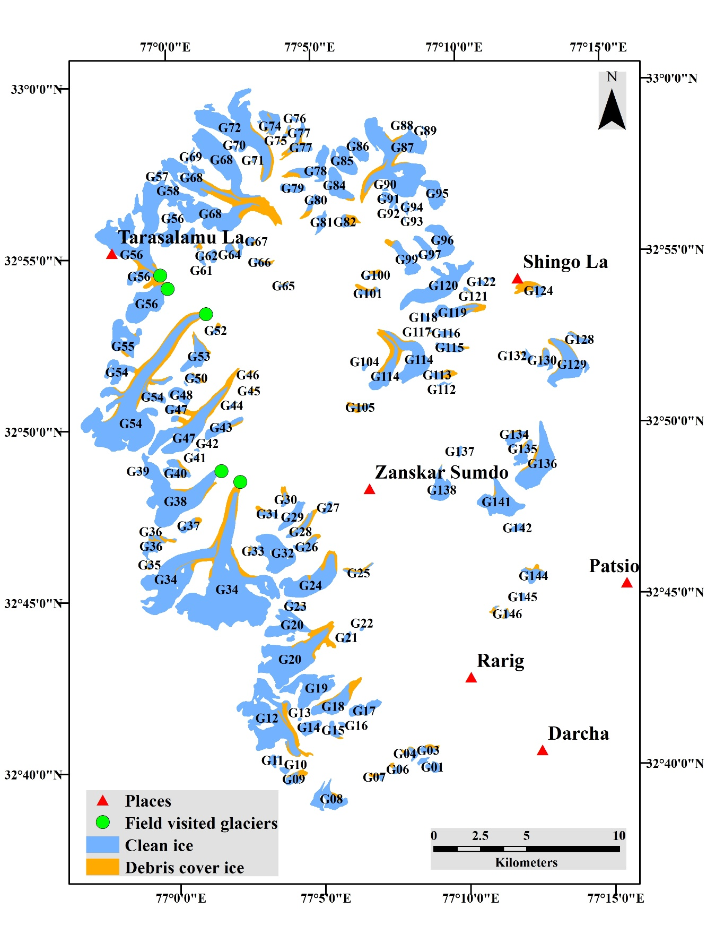
Figure S1: Distribution of clean ice and debris-covered ice with glaciers id in the Jankar Chhu watershed, Lahaul Himalaya in 2016.
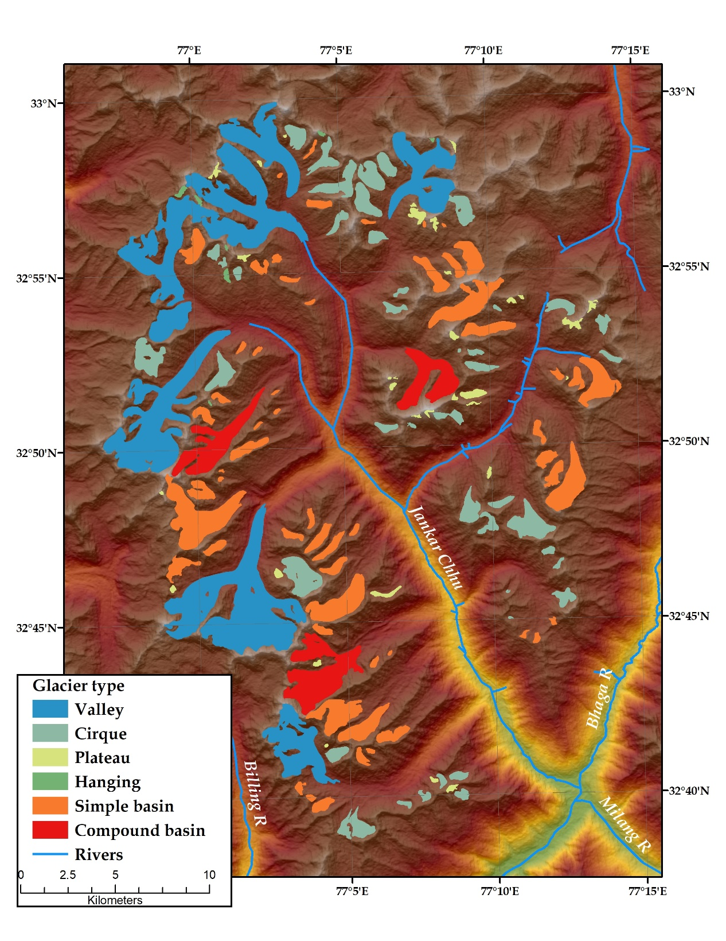
Figure S2. Distribution of glaciers according to morphological types in the JCW. Glacier outlines derived from Sentinel 2A (2016) and ASTER GDEM v2. Glaciers classification is based on Bajracharya and Shrestha (2011) and Schmidt and Nusser (2012).
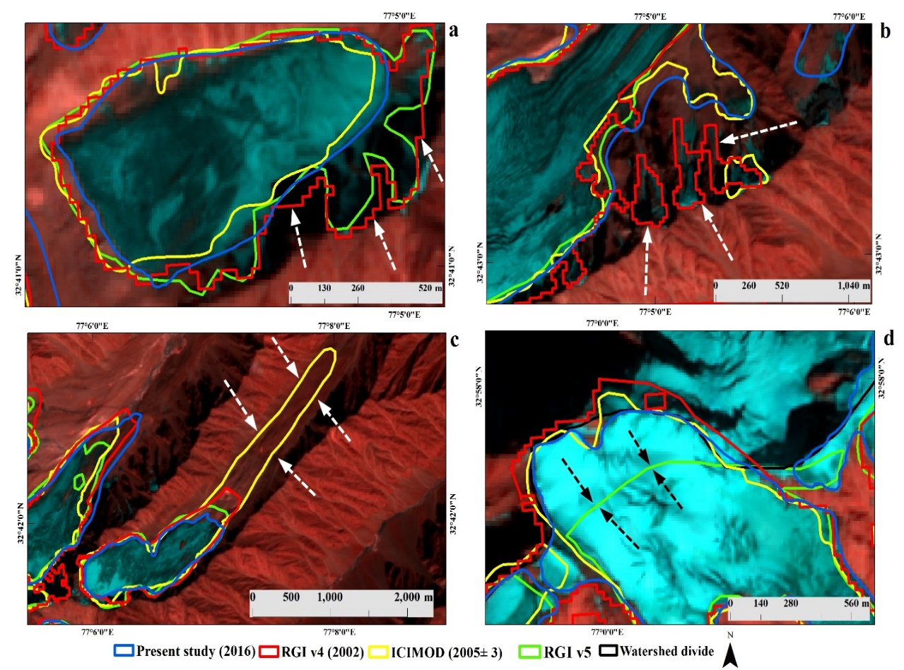
Figure S3. Comparison of glacier inventory, (a) misinterpretation of the shadowy area, (b) misinterpretation of seasonally snow cover patches, (c) misinterpretation of debris- cover ice, and (d) misclassified ice divides. Sentinel 2A image is used as background. The White and black arrow is showing the misinterpreted glaciers boundary in different inventories.

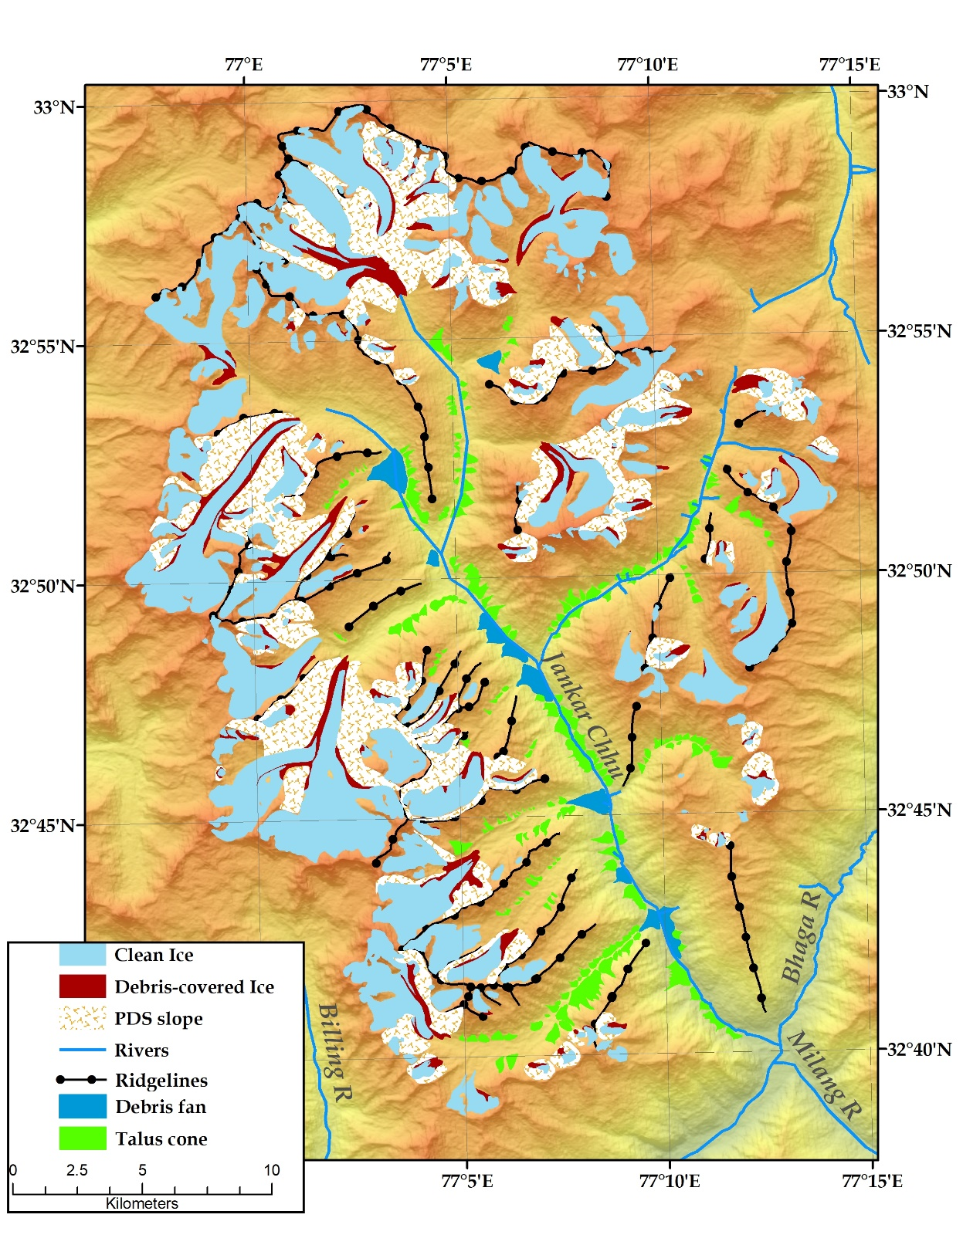
Figure S4. Distribution of potential debris supply (PDS) slopes for selected glaciers (>10% of debris-cover area to the total area) in the JCW. PDS slope were mapped using Sentinel 2A (bands 12-4-3) and Google Earth (GE) in 2016.

References
Arendt A, Bliss A, Bolch T, Cogley J, Gardner A, Hagen J, Hick R, Huss M, Kaser G, Kienhilz C, Pfeffer W, Moholdt G, Paul F, Radic V, Andreassen L, Bajracharya S, Barrand N, Beddle M, Bertheir E, Bhambri R, Brown I, Burgess E, Burgess D, Cawkwell F, Chinn T, Copland L, Davies R, Angelis H, Dolgova E, Earl L, Filbert K, Forester R, Fountain A, Frey H, Giffen B, Glasser N, Guo W, Gurney S, Hagg W, Hall D, Haritashya U, Hartman G, Helm C, Herried S, Howat I, Kapustin G, Khromova T, Konig M, Kohler J, Kreigel D, Kutuzov S, Lavrentiev I, LeBris R, Liu S, Lund J, Manley W, Marti R, Mayar C, Miles E, Li X, Menounos B, Mercer A, Molg N, Mool P, Nosenko G, Negrete G, Nuimara T, Nuth C, Petterson R, Racoviteanu A, Ranzi R, Rastner P, Rau F, Raup B, Rich J, Rott H, Sakai A, Schneider C, Seliverstov Y, Sharp M, Sigurosson O, Stokes C, Way R, Wheate R, Winsvold S, Wolken G, Wyatt F and Zheltyhina N (2015) Randolf Glacier Inventory - A dataset of global glacier outlines: Version 5.0. GLIMS Tech. Rep. (July), 63
Bajracharya B and Shrestha SR (2011) The Status of Glaciers in the Hindu Kush–Himalayan Region. Kathmandu http://dx.doi.org/10.1659/mrd.mm113
Birajdar FS, Venkataraman G, Bahuguna IM and Samant HP (2014) A Revised glaciers inventory of Bhaga basin Himachal Pradesh , India : Current status and recent glacier variation. ISPRS Ann. Photogramm. Remote Sens. Spat. Inf. Sci. II(December), 9–12 (doi:10.5194/isprsannals-II-8-37-2014)
Frey H, Paul F and Strozzi T (2012) Compilation of a glacier inventory for the western Himalayas from satellite data: Methods, challenges, and results. Remote Sens. Environ. 124, 832–843 (doi:10.1016/j.rse.2012.06.020)
Nuimura T, Sakai A, Taniguchi K, Nagai H, Lamsal D, Tsutaki S, Kozawa A, Hoshina Y, Takenaka S, Omiya S, Tsunematsu K, Tshering P and Fujita K (2015) The GAMDAM glacier inventory: A quality-controlled inventory of Asian glaciers. Cryosphere 9(3), 849–864 (doi:10.5194/tc-9-849-2015)
Pfeffer WT, Arendt AA, Bliss A, Bolch T, Cogley JG, Gardner AS, Hagen JO, Hock R, Kaser G, Kienholz C, Miles ES, Moholdt G, Molg N, Paul F, Radic V, Rastner P, Raup BH, Rich J, Sharp MJ, Andreassen LM, Bajracharya S, Barrand NE, Beedle MJ, Berthier E, Bhambri R, Brown I, Burgess DO, Burgess EW, Cawkwell F, Chinn T, Copland L, Cullen NJ, Davies B, De Angelis H, Fountain AG, Frey H, Giffen BA, Glasser NF, Gurney SD, Hagg W, Hall DK, Haritashya UK, Hartmann G, Herreid S, Howat I, Jiskoot H, Khromova TE, Klein A, Kohler J, Konig M, Kriegel D, Kutuzov S, Lavrentiev I, Le Bris R, Li X, Manley WF, Mayer C, Menounos B, Mercer A, Mool P, Negrete A, Nosenko G, Nuth C, Osmonov A, Pettersson R, Racoviteanu A, Ranzi R, Sarikaya MA, Schneider C, Sigurdsson O, Sirguey P, Stokes CR, Wheate R, Wolken GJ, Wu LZ and Wyatt FR (2014) The randolph glacier inventory: A globally complete inventory of glaciers. J. Glaciol. 60(221), 537–552 (doi:10.3189/2014JoG13J176)
Raina VK and Srivastava D (2008) Glaviers atlas of India., First ed. Geological society of India, Bangalore

