A two-dimensional glacier-fjord coupled model applied to estimate submarine melt rates and front position changes of Hansbreen, Svalbard
E. De Andrés¹, J. Otero¹, F. Navarro¹, A. Promińska², J. Lapazaran¹ and W. Walczowski²
¹Department of Applied Mathematics, Universidad Politécnica de Madrid, Madrid, Spain.
²Institute of Oceanology, Polish Academy of Sciences, Sopot, Poland.

Corresponding author: Eva De Andrés (eva.deandres@upm.es)

Content
1. Mooring data
2. Sensitivity of fjord properties to subglacial discharge
3. Sensitivity of the fjord model to grid resolution
4. Results of the fjord-circulation model
5. Subglacial discharge and surface meltwater production
  - 1 Mooring Data
Temperature and salinity were measured during spring-summer of 2010. The observations comprise the period between 2nd of April to 9th of August of 2010. From 9th of April to 12th of July there is a long time gap in CTD data that we filled by interpolation. In Figure S1 we show the evolution of temperature observations inside the fjord, measured with both, CTD and mooring, at 55 to 59 m depth. We observe that temperature rapidly increases from ~1.9°C in April up to ~9°C in August, and thereafter, starts a decreasing overall trend. The corresponding simulation period for August 9th is week 17. We extrapolate temperature and salinity profiles up to week 20 (end of August), simply considering the same conditions as those observed in week 17.

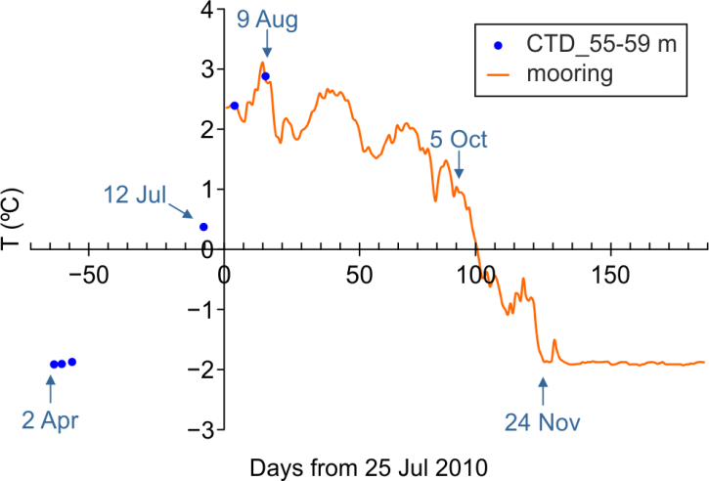
Figure S1. Time evolution of temperature at 57 m depth from mooring (line) and the mean of all CTD data inside Hansbukta, averaged between 55 to 59 m depth (dots).

  - 2 Sensitivity of fjord properties to subglacial discharge
Subglacial discharge flows (Q_{sg}) are difficult to quantify, due to the difficulty and risk of taking measurements in the vicinity of a glacial front in summer, when iceberg calving can occur. For this reason, glacier mass balance models are used to estimate surface melting (due to atmospheric forcing), which are easily convertible to catchment runoff. They are usually considered in the literature as ipso facto subglacial discharges. However, there is much uncertainty about the number and extent of the different catchments that collect this surface melting, the time that takes the meltwater to reach the waters of the fjord, how much of meltwater flows on the surface or subglacially, how is the network of discharge channels that is formed under the glacier body, or how many subglacial discharge channels, and of what size, inject the meltwater into the fjord. For all the above reasons, and given that we are using a 2D model (which has horizontal spreading and diffusive limitations when the fresh water is introduced into the domain, making both salinity and temperature susceptible of sensitivity to Q_{sg}), we decided to adjust the subglacial discharge inputs based on two principles: 1) during each period, Q_{sg} cannot be greater than those estimated from the cumulative surface meltwater derived from the mass balance model until the start of the period considered; 2) the vertical average of temperature modeled inside the fjord (excluding the first 5 m of the top layer, since we do not contemplate atmospheric forcing or melting of floating ice) should adjust as much as possible to the observed one, without excessively compromising the vertical average of salinity. In this way, we obtain temperatures and velocities near the glacier front that are more consistent with reality. This ensures better estimates of submarine melting. Between April and August of 2010, the range of total freshwater runoff was between 3 and 9 m³s ⁻¹ (Finkelnburg, 2013). Considering a continuous and uniformly distributed subglacial discharge along the 1.5 km active front of Hansbreen, the discharge velocity trough a modeled conduit of 1 m² area would range from 2·10⁻³ to 6·10⁻³ m s ⁻¹. If, instead, we assume all SMW discharging through one main conduit of 30 m², the flow velocities would vary between 0.1 and 0.3 m s ⁻¹. Therefore, since we have no data about size or number of discharging channels, we tested discharge velocities in the range from 0 to 0.3 m s ⁻¹ to assess the various possibilities in between both situations along the modelled period (Fig. S2). Finally, best-fit Q_{sg} fluxes (velocities implemented through a 1 m²-grid cell) ranged from 10⁻³ in early April to 5·10⁻² m³ s⁻¹ in August.

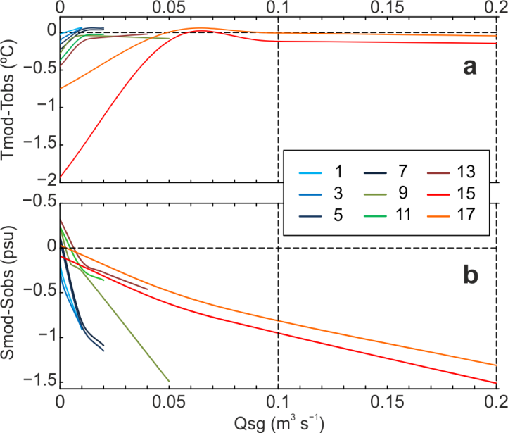
Figure S2. Sensitivity of the model to subglacial discharge fluxes in terms of a) temperature and b) salinity.

  - 3 Sensitivity of the fjord model to grid resolution
Sensitivity of submarine melt rates to spatial grid resolution was tested for the best-fit subglacial discharge scenario (i.e. scenario 1). The experiment was carried out during the first week of August, which is one of the periods of maximum melting. Horizontal size of the grid cells embedded into the high resolution zone of the domain were varied (while maintaining the same order of magnitude) from 0.9 to 4 m, so no variation in viscous or diffusive coefficients were needed. Submarine melt rates were calculated and compared, and results are shown in Fig. S3. In order to resolve phenomena that occur on a small scale near the glacier front, our model presents a high resolution grid cell of 1 m x 1 m in the two dimensions (horizontal-x and vertical-z) in this zone (the first 100 m closest to the glacier front). An analysis of sensitivity to horizontal resolution was made in terms of vertical velocity (tangential to the front face) and temperature. The temporal averages of both variables were calculated over the simulation period, and the maximum values ​​of both variables were identified along the water column, in the cell immediately adjacent to the glacier front. The same calculations were made for the submarine melt rates estimated by the model. The minimum cell size that allowed the stability of the model without changing the size of the time step was 0.9 m. The maximum cell size that allows us to use the same coefficients (viscosity and diffusion without involving a change of their order of magnitude, is 4 m. For the sensitivity study, simulations of the period between weeks 15 and 17 were carried out, with fixed subglacial discharges of 0.1 m³s⁻¹. From Figure S3, it is inferred that the temperature in the cell contiguous to the front varies slightly (<9% across the range of cell sizes), which indicates that the plume-environment mixing processes are well resolved. However, the maximum speeds reached in these cells vary enormously (~ 50%) with decreasing grid-cell resolution. This suggests that the kinematic viscosity coefficients used in our model are valid only for cell sizes of 1 m or less, taking into account that the time step should be adjusted for cell sizes smaller than 0.9 m. For cell sizes greater than 1 m, the value of the viscous coefficients should be adjusted, in order to account for the (probably turbulent) unresolved processes and to reach the expected speeds. This sensitivity of velocity to spatial resolution also translates into sensitivity in terms of submarine melting estimates. Thus, the maximum melting rates are produced for cell sizes of 0.9 and 1 m, with almost zero variation between both (~ 0.1%). Therefore, we can state that our model is adequately solving the velocity and temperature fields in the vicinity of the front, assuring the optimum values ​​of submarine melting.

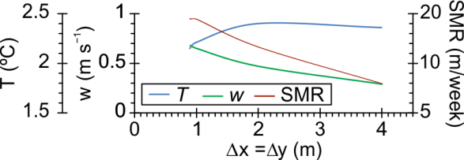
Figure S3. Sensitivity of the modeled variables to spatial resolution. Temperature (T) in blue, vertical velocity (w) in green and submarine melt rates (SMR) in red. Kinematic viscosity and diffusive coefficients set to 0.014 and 0.0014 m² s⁻¹, respectively, and time step fixed to 0.5 s.
  - 4 Results of the fjord-circulation model
Results of temperature and salinity along the fjord domain, obtained from the best-fit subglacial discharge model, are shown in Fig. S4. Only those modeled weeks with corresponding-in-time CTD data are presented for comparison with observations, which are: weeks 1, 13, 15 and 17 (April 9, July 12, July 28 and August 9, respectively). Temperature ranges from -1.9 to ~3.2 ºC and salinity from ~31.5 to 34.5 psu over the entire simulated period.
The results of week 1 (Fig. S4a, e) show quite homogeneous distribution in both vertical and horizontal directions and for both variables, temperature and salinity. The modeled temperature values vary between -1.89 and -1.83 ºC and maximum deviation from observations is of ~0.1 ºC at the uppermost 20 m below sea level. In the case of modeled salinity at the end of week 1, the ranges of variation are from 34.25 psu at the surface to 34.55 psu at the bottom, differing up to 0.2 psu from observations mainly at the bottom layer (i.e. 20 m depth to the bottom).
At the end of week 13 (Fig. S4b, f), salinity shows a vertical stratification pattern, with values of 32 to 32.5 psu at the top layer and 33.15 at the very bottom. Observed salinity profiles show a top layer of ~32 psu, but confined to a thinner top layer of 10 m-thick, and constant values of ~33 psu from below to the bottom. Vertical distribution of temperature remains practically invariant (0.28 to 0.35 ºC) along the fjord. However, at the sill region, temperature follows strong horizontal stratification from the inner to the outer part (0.4 to 0.8 ºC), probably due to the effects of the boundary forcing. Deviations from observed temperature profiles are maxima of 0.25 ºC, at ~10 m depth.
Modeled salinity at the end of weeks 15 and 17 follow the same distribution pattern. There is a stratified top layer of 20-30 m-thick, with salinity values ranging from 30.4 to 32.5 psu. The observations show also a stratified top layer, but confined to the uppermost 15 m, and a narrower salinity range of 32 to 32.5 psu. Therefore, our fjord model at the end of July and beginning of August experiments an over-freshening trend, which we attribute to the lack of the 3rd dimension. Our 2D model is unable to reproduce lateral mixing in the y-direction, so the buoyant plume formed by subglacial discharge inputs at the grounding point results in a vertical over mixing. Since subglacial discharges come from meltwater, salinity of the input fluxes is zero, provoking a strong impact of freshening on fjord salinity (up to ~2 psu of departure from observations). Modeled temperature at the end of week 15 (2 to 2.5 ºC) is lower than that of week 17 (2.6 to 3.1 ºC), both showing stratification and agreeing with observations. However, modeled temperature of week 17 better match observations (deviations < 0.2 ºC) than that of week 15 (see Fig. 5c in the main text).
The influence of the buoyant plume is evident from week 13 onwards and can be inferred from the shape of the isohaline and isothermal curves.

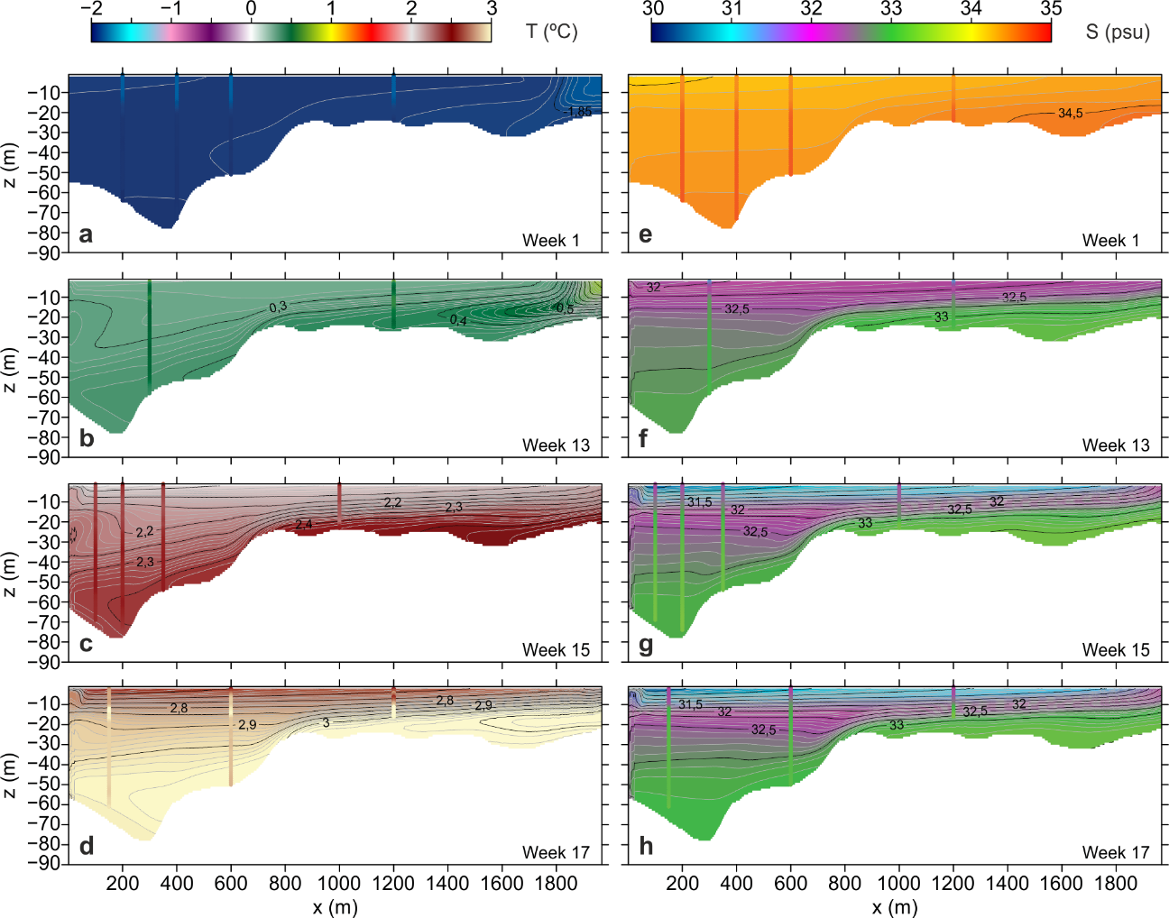
Figure S4. Results of the best-fit u_{sg}-model (Model 2 in the main manuscript) at the end of those weeks with available CTD measurements (weeks 1, 13, 15 and 17) and comparison with the corresponding observations at different locations. Ice front is located to the left and fjord mouth to the right bound. Snapshots of properties distribution along the fjord domain: a)-d) temperature; e)-h) salinity. For comparison, the observations are shown as vertical profiles with the same color scales as those used for model results.

As described above, the distribution patter of the fjord properties is fairly well represented by our 2D model. Despite that salinity departure from observations during latest weeks, temperature closely resembles observations under the best-fit u_{sg} model. The main variables controlling submarine melting are temperature and vertical velocities next to the glacier front. Therefore, if our modeled temperature results are in agreement with observations for a given subglacial discharge velocity, our estimations of submarine melt rates could be feasible, which is one of the key points to study the effect that submarine melting might exert on calving rates and front position changes.
Taking into account all the information given in this section, we think that a vertical average of the properties at the deepest point of the fjord can be considered as a good and simple strategy to compare the results obtained with different u_{sg} models.
  - 5 Subglacial discharge and surface melwater production
Subglacial discharge velocities, u_{sg}, were calibrating by searching for the best-fit temperature distribution in the fjord while maintaining a fair agreement with the salinity. In this way, we ensure a compromise by which both processes fjord circulation and buoyant plume are represented by our 2D model. Therefore, estimations of submarine melt rates under the best-fit scenario might be feasible. After calibration, we observe that subglacial discharge velocities lag 4 to 5 weeks surface meltwater production (Fig. S5). Although it is a collateral finding with potential sources of errors and it is not considered in our main aims, we think it deserves to be mentioned as a basis for further studies in the subglacial hydrology field.

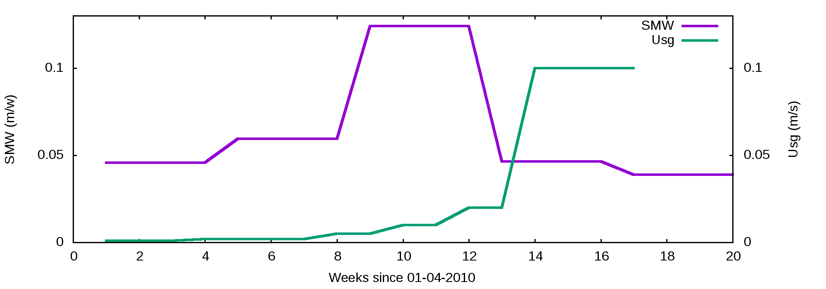
Figure S5. Time evolution of surface melt water production (purple) and subglacial discharge velocities (green) used in the best-fit u_{sg}-model.

  - References
Finkelnburg R (2013) Climate variability of Svalbard in the first decade of the 21st century and its impact on Vestfonna ice cap, Nordaustlandet. Technische Universität Berlin. (doi:10.14279/depositonce-3598)

