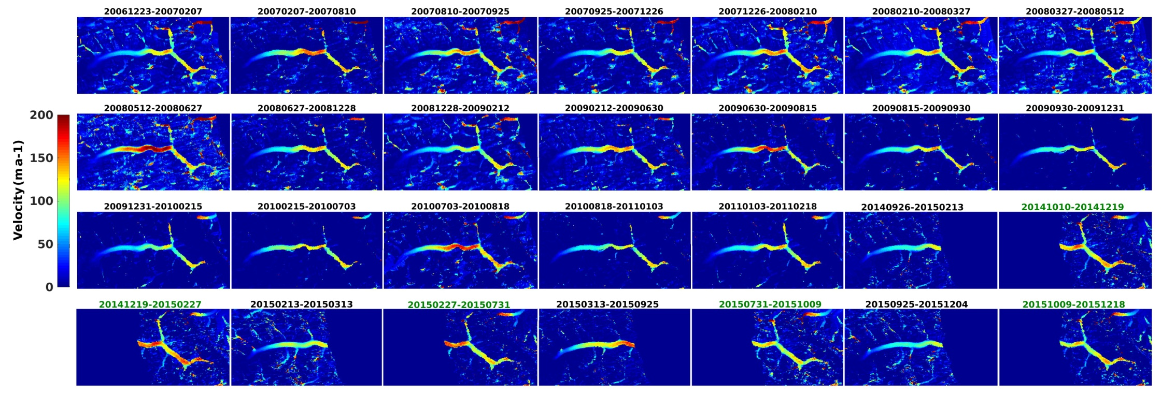
Figure S1. Surface velocity field of Baltoro Glacier from 2007 to 2015. Green color numbers indicate the temporal baseline for the Right Looking Fine beam mode (with an incident angle of 31.4°).

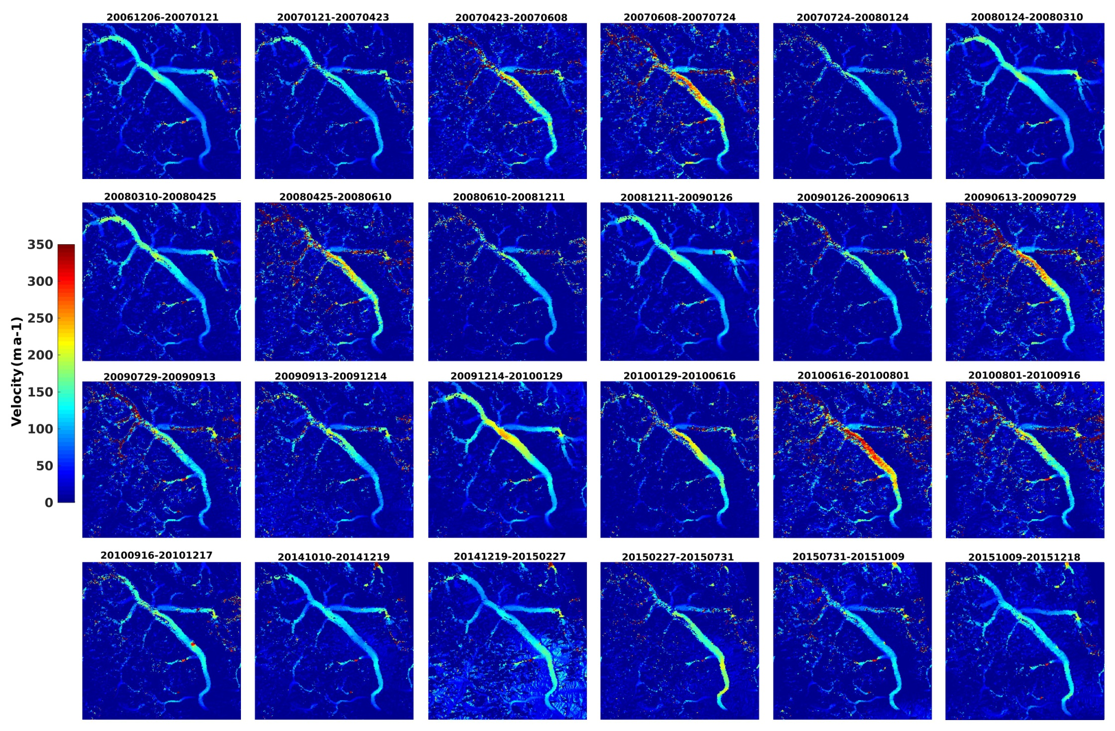
Figure S2. Surface velocity field of Siachen Glacier from 2007 to 2015.
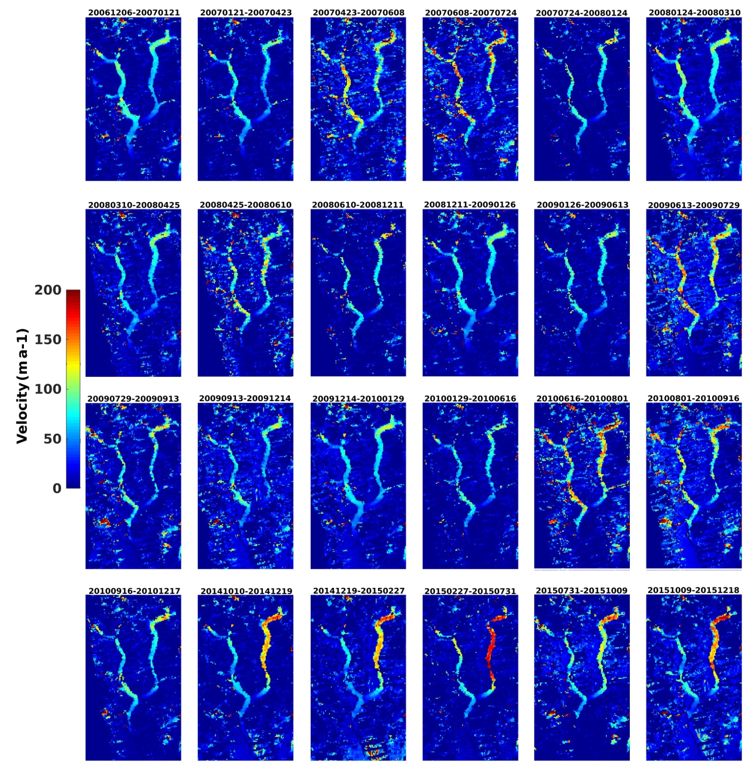
Figure S3. Surface velocity field of Kundos Glacier from 2007 to 2015.

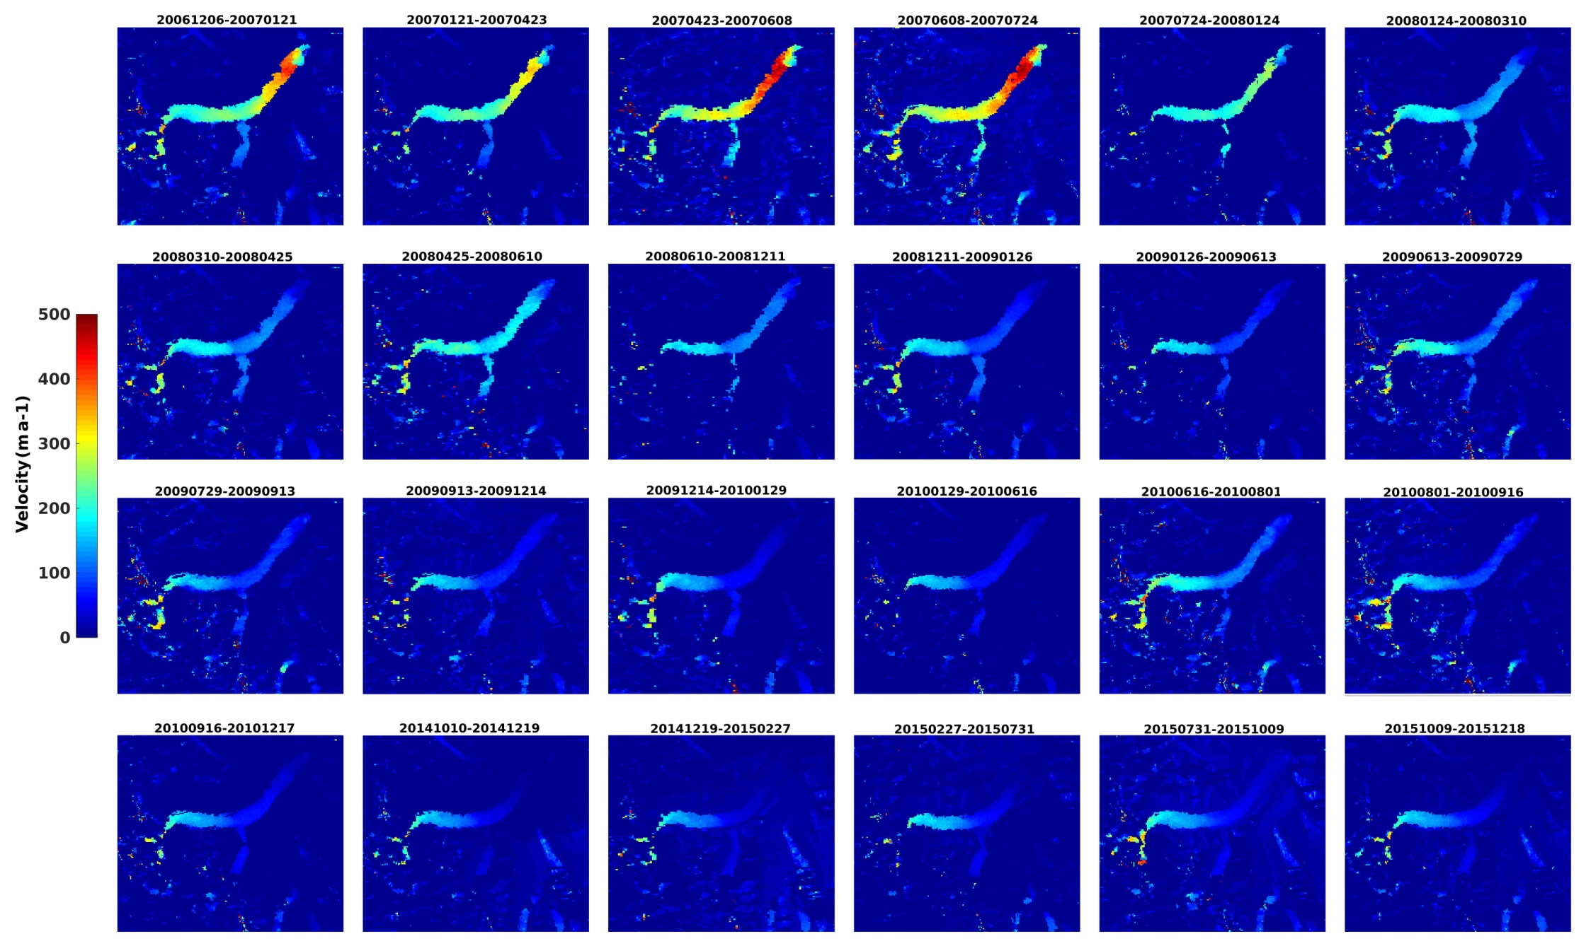
Figure S4. Surface velocity field of Gasherbrum Glacier from 2007 to 2015.

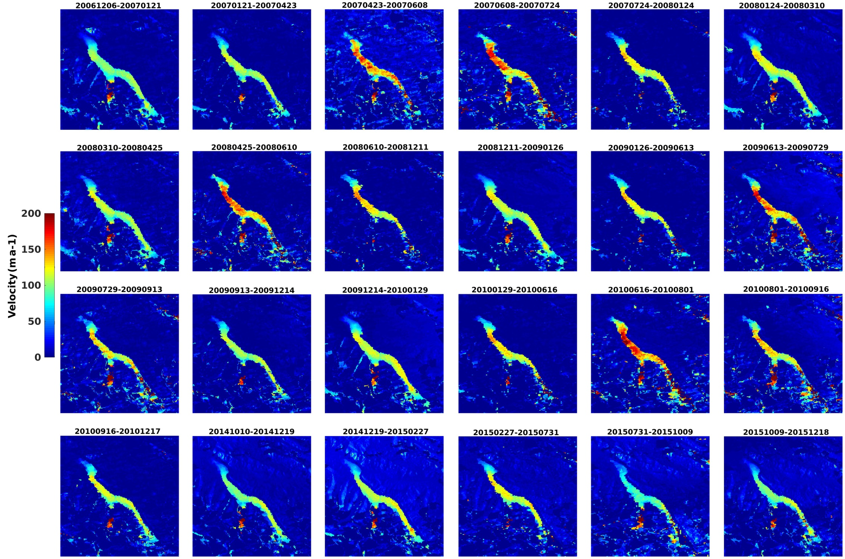
Figure S5. Surface velocity field of Singkhu Glacier from 2007 to 2015.

