Supplementary Material
Importance of longwave emissions from adjacent terrain on patterns of tropical glacier melt and recession

Caroline Aubry-Wake*, Department of Earth and Planetary Sciences, McGill University, Montréal, Québec, Canada ⁽¹⁾ and Centre for Hydrology, University of Saskatchewan,
Saskatoon, Saskatchewan, Canada ⁽²⁾

Dorian Zéphir, Département de génie de la construction, École de Technologie Supérieure, Montréal, Québec, Canada

Michel Baraer, Département de génie de la construction, École de Technologie Supérieure, Montréal, Québec, Canada

Jeffrey M. McKenzie, Department of Earth and Planetary Sciences, McGill University, Montréal, Québec, Canada

Bryan G. Mark, Department of Geography, The Ohio State University, Columbus, Ohio, USA

*Corresponding author: C. Aubry-Wake, Centre for Hydrology, University of Saskatchewan,
101-121 Research Drive, Saskatoon, Saskatchewan, Canada, S7N 1K2
(caroline.aubrywake@usask.ca)

The supplementary material consists of one figure and three tables.
Fig. S1 is the measurements at the automated weather station.
Table S1 is the instrumentation details of the automated weather station.
Table S2 is the driving equations of the melt model used in this study
Table S3 is the parameters used in the melt model.

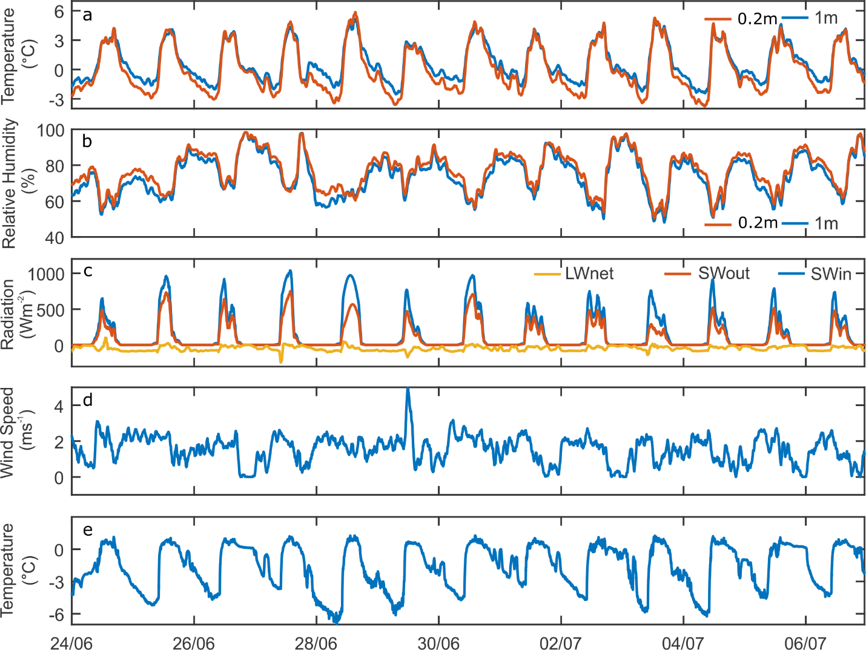
Fig. S1: Measurements at automatic weather station (AWS) on Cuchillacocha glacier for the period June 24, 2014 to July 7. (a) Air temperature at 0.3 meter (orange) and 1.0 m above the ice surface (blue), (b) relative humidity, (c) radiation components with net longwave radiation (yellow), reflected shortwave radiation (orange) and incoming shortwave (blue), (d) wind speed, (e) surface temperature.

Table S1: Instruments deployed at Cuchillacocha Glacier.
Location | Measurement Period | Time Interval | Variable Measured | Manufacturer | Model | Precision | Range
IR Camera | June 23 6:00 PM-June 24, 6:00 AM  June 24, 5:30 PM – June 25 3:00 PM | 10 min | Picture | Jenoptik | VarioCam HD | ±1.5 °C | 7.5-14 um
 |  |  | T | Onset | HOBO S-THB-M008 | ± 0.21°C | -40- 75°C
 |  |  | RH |  |  | ± 2.5% | 0-100%
AWS | June 23, 6:00 PM- July 10, 11:00 AM | 1 min | SW | APOGEE | SP-230 | 0,20 mV/ W/m2 | 360-1120 nm
 |  |  | Net R | KIPP & ZONEN | NR-Lite2 | 10 mV/W/m2 | 200-100 000 nm
 |  |  | T | Campbell Scientific | CS215 | ±0.4°C | -40-70°C
 |  |  | RH |  |  | ±2% | 0- 100%
 |  |  | Tsurface | Campbell Scientific | IRTS-P | ±0.3°C | -10-55°C
Glacier Edge | June 23, 3:30 PM – July 7, 12:00 PM | 10 min | T | Maxim | DS1922L (iButton) | ±0.5°C (0° to 50°C) | -40-85°C

Table S2: Melt model driving equations
 | Equations | Reference
SW | $${SW}_{in}=\frac{I_{AWS}}{I_{\begin{aligned}AWS,calculated \end{aligned}}}*I_{c}$$ | Hock (2005)
 | $$I_{c} = I_{0}*{\left(\frac{R_{m}}{R}\right)}^{2}ψ_{a}^{\frac{P}{P_{0cos}\left(z\right)}}\cos\left(θ\right)$$ | Hock (2005)
 | $$\cos\left(θ\right)=\cos\left(β\right)\cos\left(Z\right)+\sin\left(β\right)\sin\left(Z\right)\cos\left(φ_{sun}-φ_{slope}\right)$$ | Hock (2005)
LW | $${LW}_{in}= ϵ_{c} σ T_{air}^{4}$$ | Hock (2005)
 | $$ϵ_{c}=1.24*{\left(\frac{e_{a}}{T_{up}}\right)}^{1/7}$$ | Brutsaert (1975)
 | $${LW}_{out}= ϵ_{s} σ T_{low}^{4}+\left(1-ϵ_{s}\right)* {LW}_{in}$$ | Hock (2005)
H | $$H=ρ C_{p}k^{2}*Stab*V*\frac{\left(T_{up}-T_{low}\right)}{{\left(\log\left(\frac{z_{up}}{z_{low}}\right)\right)}^{2}}$$ | Rigaudière (1995)
LE | $$LE=ρ L_{v} k^{2}*\frac{Stab}{2}*\frac{{(V}_{up}-V_{low})*\left(e_{up}-e_{low}\right)}{{\left(\log\left(\frac{z_{up}}{z_{low}}\right)\right)}^{2}}$$ | Rigaudière (1995)
Stability coefficient  « Stab » | $$Si R_{i}>0 :Stab={\left(1+7*R_{i}\right)}^{-0,1} \\ Si R_{i}<0 :Stab={\left(1-58*R_{i}\right)}^{0,25}$$ | Kustas and others (1994)
Richardson’s Number | $$R_{i}=\frac{{g\left(T_{haut}-T_{bas}\right)*z}_{haut}-z_{bas}}{T_{haut}*{\left(V_{haut}-V_{bas}\right)}^{2}}$$ | Mahong and others. (1992)

Table S3: Parameters used in melt model
Symbol | Name | Value | Unit | Source
$$ρ$$ | Air density | 1.29 | kgm-3
$$C_{p}$$ | Specific heat capacity | 1005 | J kg-1 K-1
$$k$$ | Von Karman constant | 0.350 | SU
$$I_{0}$$ | Solar constant | 1368 | W m-2 | Fröhlich (1993)
$$ψ_{a}$$ | Clear sky atmospheric transmissivity | 0.75 |  | Oke (1987)
$$β$$ | Cell slope |  | degree
$$Z$$ | Zenith |  | degree
$$φ_{slope}$$ | Cell aspect |  | degree
$$φ_{sun}$$ | Sun orientation |  | degree
z | Height of measurement | Up : 1.0 m  Down : 0.20 m | m
T | Air temperature |  | °C
V | Wind speed |  | m s-1

