SUPPLEMENTARY INFORMATION

Quantifying ice cliff evolution with multi-temporal point clouds on the debris-covered Khumbu Glacier, Nepal
C. Scott Watson¹, Duncan J. Quincey¹, Mark W. Smith¹, Jonathan L. Carrivick¹, Ann V. Rowan², Mike James³
1. School of Geography and water@leeds, University of Leeds, Leeds, LS2 9JT, UK
2. Department of Geography, University of Sheffield, Sheffield, S10 2TN, UK
3. Lancaster Environment Centre, Lancaster University, Lancaster, LA1 4YQ, U.K.
Correspondence to: C. S. Watson (scott@rockyglaciers.co.uk)

Interactive 3D models of several ice cliffs featured in this study are available to view at:
https://sketchfab.com/rocky_glaciers
These model were processed using low density point clouds to reduce processing time, and were subsequently meshed in CloudCompare.
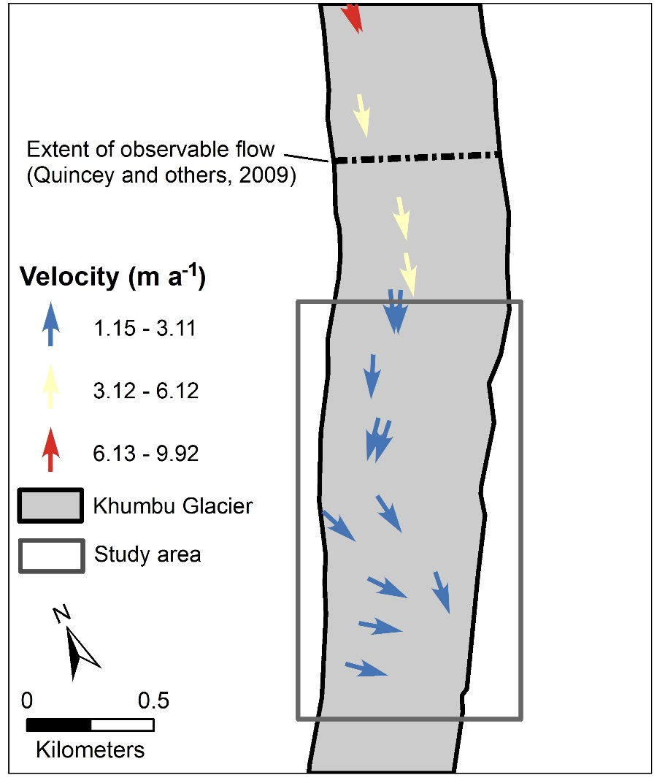
Fig. S1. The location of tagged boulders surveyed with a dGPS October 2015 to October 2016 at the expected transition from active to inactive ice on Khumbu Glacier.
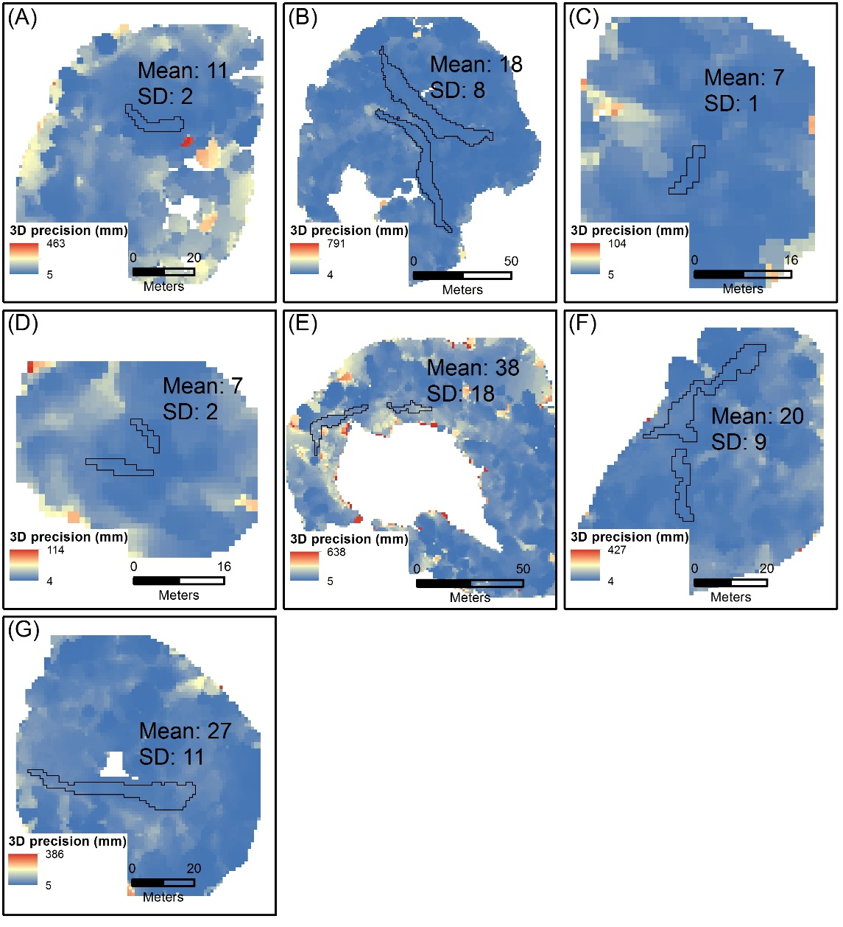
Fig. S2. Example precision maps derived for the May 2016 ice cliffs (black polygons). Point cloud precision estimates were interpolated onto a 1 m raster grid following James and others (2017). The mean and standard deviation of the precision estimates for each ice cliff polygon are shown in units of millimetres. Ground control point and tie point RMSE (units of pixels) used to generate the precision maps were: Cliff A 2.93 and 0.75, Cliff B 2.24 and 0.98, Cliff C 1.29 and 0.87, Cliff D 1.72 and 0.80, Cliff E 5.09 and 0.84, Cliff F 1.76 and 1.05, and Cliff G 2.41 and 0.91.

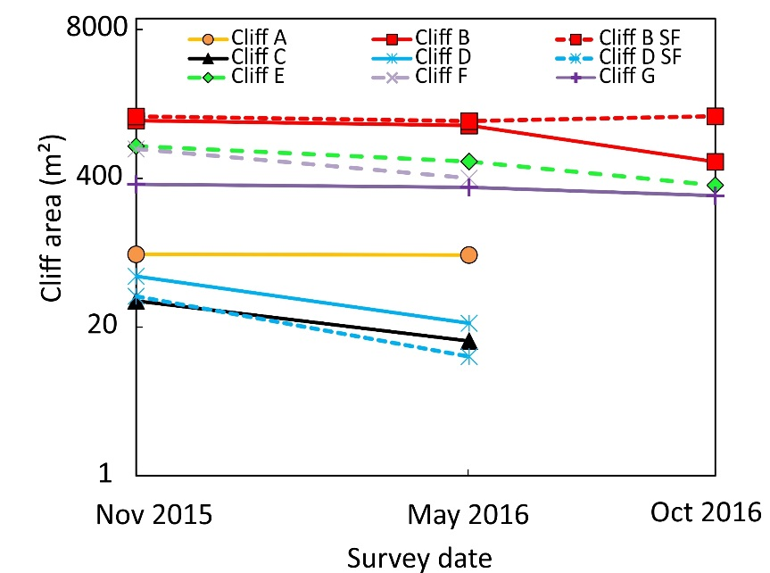
Fig. S3. Absolute cliff area change plotted on a logarithmic scale. Zero values are not shown for cliffs that degraded over the study period.
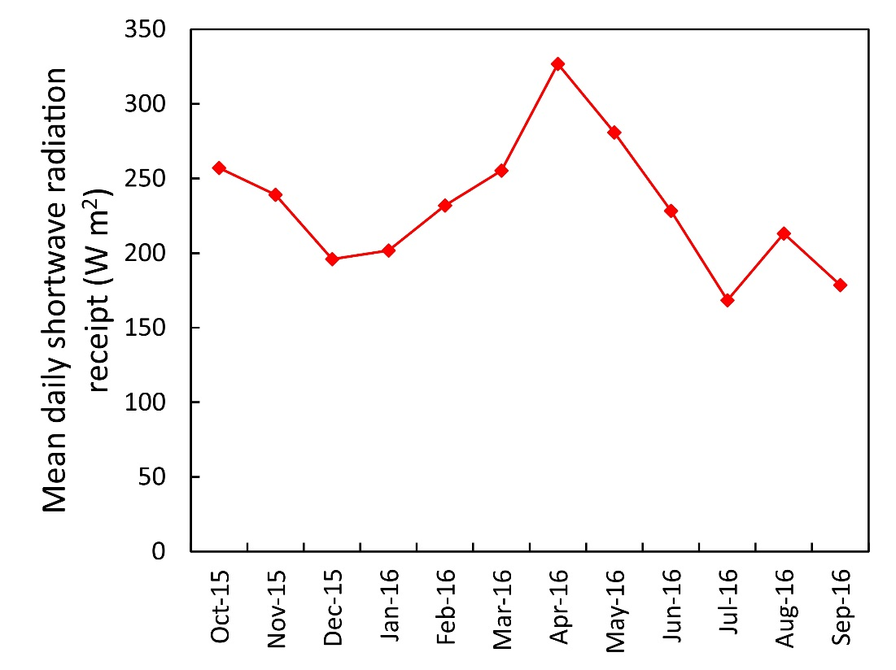
Fig. S4. Mean daily shortwave radiation receipt for the months October 2015 to September 2016 measured at an automatic weather station installed on Changri Nup Glacier (UTM North, Zone 45: Easting: 478293 m; Northing: 3095381 m; altitude: 5360 m), ~5.5 km from our study ice cliffs. Instrument: Kipp&Zonen CNR4 0.305<λ<2.8μm.

Supplementary Table 1. Percentage of ice cliff normals at time one intersecting an ice cliff at time two, from M3C2 distance calculations.
Cliff ID | Cliff-to-cliff normals (%)
 | Nov 2015 to May 2016 | May 2016 to Oct 2016
A | 86 | 0
B | 45 | 28
B – SF | 75 | 84
C | 22 | 0
D | 44 | 0
D - SF | 19 | 0
E | 54 | 53
F | 29 | 0
G | 86 | 34

