**Supplementary material: Sherpa and others**

1. **Correlation between monthly precipitation recorded by Geonor sensor and EvK2CNR tipping bucket at Pyramid**



**Fig. S1.** Monthly precipitation recorded at Geonor T-200 sensor as a function of monthly precipitation recorded by the tipping bucket of EvK2CNR (in mm w.e.) between December 2012 and April 2015 at 5035 m a.s.l. at Pyramid (22 months in total given that there are gaps in the EvK2CNR record). Also shown is the 1:1 line (dashed line). This figure illustrates the 30 to 40% underestimation of precipitation by classical tipping bucket.

1. **Geodetic mass balances**

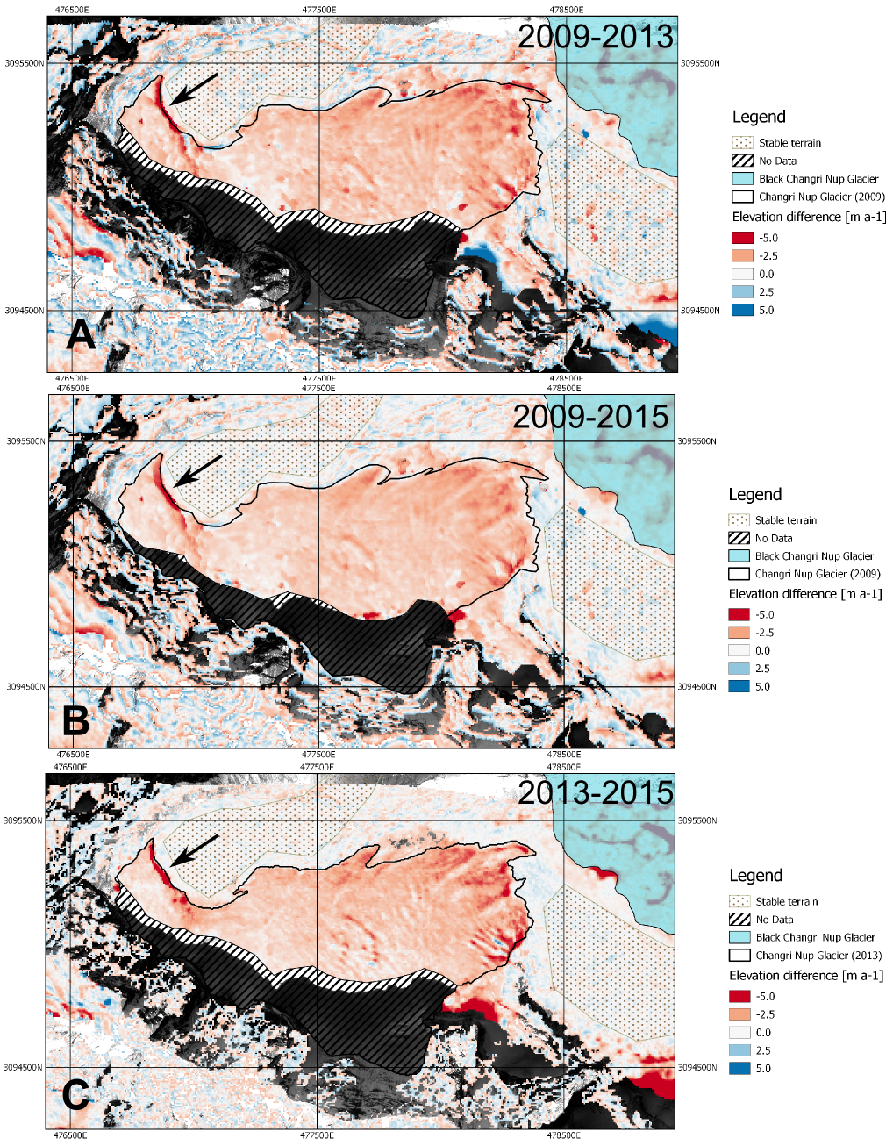

**Fig. S2.** Map of the rate of elevation change (m a-1) for the periods 2009-2013 (A), 2009-2015 (B) and 2013-2015 (C). The background image is an orthoimage derived from the Pléiades nadir image of November 2015. Coordinates in WGS84, UTM North zone 45. The black arrows point to the ice cliff at ~5570 m a.s.l.

**Table S1.** Horizontal shifts (in m) between the different satellite DEMs of white Changri Nup Glacier. dX is the shift in the easting direction and is counted positive towards east, dY is the shift in the northing direction, positive towards north. The values in parenthesis are the shifts between the 2013 and the 2009 DEMs expected from their respective shifts with 2015 DEM.

|  |  |  |
| --- | --- | --- |
| **Ref. DEM**  **Sec. DEM** | **2015 DEM** | **2013 DEM** |
| **2009 DEM** | dX = -3.3  dY = - 22.1 | dX = -3.8 (-2.7)  dY = -18.3 (-20.1) |
| **2013 DEM** | dX = -0.6  dY = -2.0 | - |

**Table S2.** Summary of the geodetic mass balance estimates and their formal uncertainties (MB1) for the three periods.

|  |  |  |  |  |  |
| --- | --- | --- | --- | --- | --- |
|  | **data voids [%]** | **mean dh**  **[m]** | **Mass balance [m w.e. a-1]** | **std stable**  **[m]** | MB1  **[m w.e. a-1]** |
| **2009 - 2015** | 23 | -7.90 | -1.10 | 3.16 | 0.12 |
| **2009 - 2013** | 33 | -6.23 | -1.30 | 3.10 | 0.11 |
| **2013 - 2015** | 33 | -3.07 | -1.32 | 1.11 | 0.08 |

**Supplementary text: internal consistency of geodetic mass balance for three time periods**

To check for internal consistency of our geodetic mass balances, we derived a DEM from three Pléiades images acquired on 29 November 2013. The 6-m DEM was extracted without GCPs.

We calculated the 2013-2015 geodetic mass balance and found again a good agreement with the glaciological mass balance over this short two-year period (-1.32 ± 0.11 *vs*. -1.31 ± 0.27 m w.e. a-1).

As described in the main text, triangulation between the maps of elevation difference for the three periods (2009-2013, 2013-2015 and 2009-2015) reveal a residual elevation difference of 1.42 m. This difference is partly explained by the different sampling between the three DEMs: the 2013 DEM has more data voids than the two others because a larger part of the glacier was in the shade when the images were acquired (Fig. S1 and Table S2). If we sample the 2009-2015 elevation difference map only over the area common with the two other elevation difference map, we find a residual elevation difference reduced to 0.92 m (corresponding to 0.13 m w.e. a-1).

1. **Climatic conditions**

**Table S3.** Annual (1 December to 30 November) and seasonal values of air temperature (Tair), precipitation, relative humidity (RH), incoming short- and long-wave radiation (SWin and LWin, respectively), wind speed (u) and sum of positive daily air temperature (∑Tair+) from 2010 to 2015. The 5-year mean and standard deviation of every variable are also displayed. Treatment of data gaps: annual values are missing when already one seasonal value is missing; seasonal values are missing when more than one monthly mean is missing; monthly mean is missing when more than 15 days of data are missing.

|  |  |  |  |  |  |  |  |
| --- | --- | --- | --- | --- | --- | --- | --- |
| **Meteorological conditions (from AWS at 5360 m a.s.l. except precipitation at 5035 m a.s.l.)** | | | | | | | |
|  | **2010-11** | **2011-12** | **2012-13** | **2013-14** | **2014-15** | **Mean** | **SD** |
| **Tair (◦C)** | -4.1 | -3.8 | -3.4 | -- | -4.5 | **-3.9** | **0.5** |
| **Precip (mm)** | 678 | 549 | 619 | 594 | 585 | **605** | **48** |
| **RH (%)** | 54 | 50 | 52 | -- | 54 | **53** | **2** |
| **SWin (W m-2)** | -- | 236 | 232 | -- | 256 | **241** | **13** |
| **LWin (W m-2)** | -- | 233 | 236 | -- | 231 | **233** | **2** |
| **u (m s-1)** | -- | 2.1 | -- | -- | 2.6 | **2.3** | **0.3** |
| **∑Tair+ (°C)** | 255.1 | 327.7 | 435.4 | 213.0 | 242.4 | **294.7** | **89.3** |
|  | **Winter (DJF)** | | | | | | |
| **Tair (◦C)** | -10.1 | -9.8 | -9.9 | -- | -10.9 | **-10.2** | **0.5** |
| **Precip (mm)** | 0 | 4 | 49 | 29 | 61 | **29** | **27** |
| **RH (%)** | 21 | 24 | 25 | -- | 28 | **24** | **3** |
| **SWin (W m-2)** | 209 | 210 | 201 | -- | 210 | **208** | **4** |
| **LWin (W m-2)** | 165 | 171 | 178 | -- | 178 | **173** | **6** |
| **u (m s-1)** | 2.6 | 3.0 | -- | -- | 3.6 | **3.1** | **0.5** |
| **∑Tair+ (°C)** | 0.0 | 0.5 | 0.0 | 0.0 | 0.0 | **0.1** | **0.2** |
|  | **Pre-monsoon (MAM)** | | | | | | |
| **Tair (◦C)** | -5.2 | -4.8 | -4.4 | -4.7 | -6.5 | **-5.1** | **0.8** |
| **Precip (mm)** | 53 | 42 | 82 | 120 | 167 | **93** | **51** |
| **RH (%)** | 53 | 47 | 49 | 58 | 52 | **52** | **4** |
| **SWin (W m-2)** | 282 | 301 | 303 | 312 | 319 | **304** | **14** |
| **LWin (W m-2)** | 226 | 218 | 223 | 228 | 219 | **223** | **5** |
| **u (m s-1)** | 1.9 | 2.1 | 2.0 | 2.1 | 2.8 | **2.2** | **0.3** |
| **∑Tair+ (°C)** | 5.0 | 23.0 | 58.0 | -- | 3.6 | **22.4** | **25.3** |
|  | **Monsoon (JJAS)** | | | | | | |
| **Tair (◦C)** | 2.0 | 1.2 | 3.1 | 1.6 | 1.9 | **2.0** | **0.7** |
| **Precip (mm)** | 621 | 502 | 387 | 396 | 332 | **447** | **115** |
| **RH (%)** | 86 | 80 | 82 | 87 | 83 | **84** | **3** |
| **SWin (W m-2)** | -- | 209 | 213 | 216 | 248 | **221** | **18** |
| **LWin (W m-2)** | -- | 283 | 306 | 303 | 295 | **296** | **10** |
| **u (m s-1)** | -- | 1.5 | 1.4 | 1.3 | 1.5 | **1.4** | **0.1** |
| **∑Tair+ (°C)** | 249.2 | 301.6 | 375.1 | 211.4 | 238.1 | **275.1** | **64.8** |
|  | **Post-monsoon (ON)** | | | | | | |
| **Tair (◦C)** | -5.5 | -5.6 | -4.9 | -5.7 | -4.9 | **-5.3** | **0.4** |
| **Precip (mm)** | 3 | 1 | 101 | 49 | 25 | **36** | **41** |
| **RH (%)** | 43 | 29 | 38 | 39 | 40 | **38** | **5** |
| **SWin (W m-2)** | 217 | 230 | 207 | 213 | 248 | **223** | **16** |
| **LWin (W m-2)** | 182 | 195 | 200 | 193 | 203 | **195** | **8** |
| **u (m s-1)** | 2.3 | 2.3 | 2.5 | 2.6 | 2.4 | **2.4** | **0.1** |
| **∑Tair+ (°C)** | 0.9 | 2.7 | 2.4 | 0.0 | 0.8 | **1.3** | **1.1** |

1. **Glaciological mass balances**

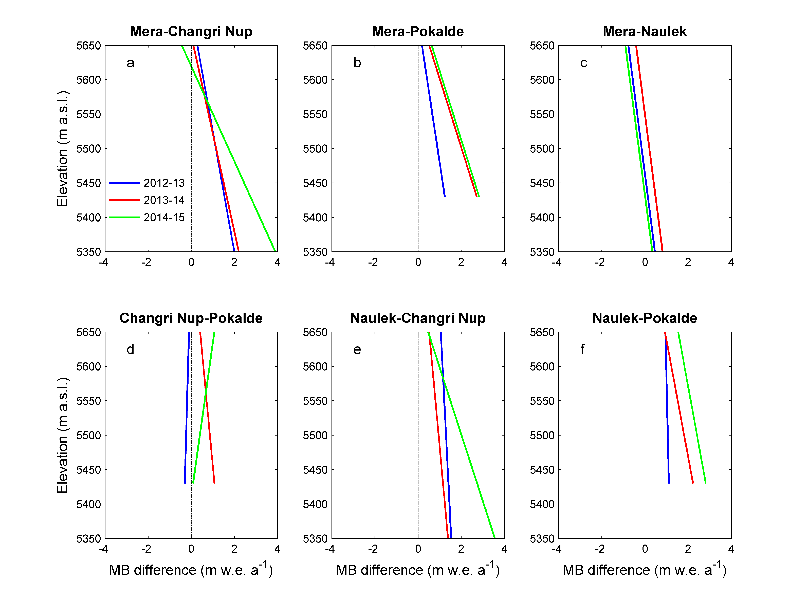

**Fig. S3.** Difference of annual mass balance from one glacier to another according to elevation (between 5350/5430 and 5650 m a.s.l., covering roughly the altitudinal range of Changri Nup/Pokalde Glacier) for the period 2012-2015. The comparison was made only for three years because the annual point MB measurements were not available for 2010-2011 and 2011-2012. The title of every panel gives the names of the glaciers i.e. Mera – Changri Nup stands for the annual MB (Mera) – annual MB (Changri Nup), with Mera and Naulek referring to Mera and Naulek branches of Mera Glacier (Wagnon and others, 2013). These annual MB differences are obtained from the linear regression lines derived from the *ba* field measurements (Fig. 4).

Figure S3 shows the difference of the annual point MB as a function of altitude between each glacier over the 5350-5650 m a.s.l. altitudinal range covering the ablation zones of the 3 glaciers studied. Since the elevations of stake measurements often do not match from one glacier to another (i.e. stakes on Pokalde Glacier are located between 5505 and 5635 m a.s.l., an elevation range where there is often no stake on Mera and Naulek branches), we calculated these differences based on the regressions derived from point annual mass balances (Fig. 4).

Measurements were performed on 14 December 2010, 12 December 2012, 4 December 2013, 20 November 2014, and 1 December 2015 on Pokalde Glacier; on 30 October 2010, 5 December 2012, 2 December 2013, 24 November 2014, and 26 November 2015 on Changri Nup Glacier; and on 11 November 2010, 10 November 2011, 23 November 2012, 22 November 2013, 8 December 2014, and 8 December 2015 on Mera Glacier.

1. **Correlation between annual glacier-wide mass balances and meteorological records**

**Table S3.** Correlation coefficients (r) between annual glacier-wide mass balance of the three monitored glaciers (*Ba*-M, *Ba*-P and *Ba*-CN for Mera, Pokalde and Changri Nup glaciers, respectively) and meteorological variables recorded at the Changri Nup AWS (5360 m a.s.l.) except precipitation measured at Pyramid (5035 m a.s.l.) over the 5-year studied period (2010-2015).

|  |  |  |  |  |  |  |  |  |  |  |
| --- | --- | --- | --- | --- | --- | --- | --- | --- | --- | --- |
|  | **Annual glacier-wide MB** | | | **Annual means of meteorological variables** | | | | | | |
| **r** | ***Ba*-M** | ***Ba*-P** | ***Ba*-CN** | **Tair** | **Precip** | **RH** | **SWin** | **LWin** | **u** | **∑Tair+** |
| ***Ba*-M** | 1 | *0.91* | *0.99* | 0.10 | 0.89 | 0.70 | -0.04 | 0.50 | -- | 0.22 |
| ***Ba*-P** |  | 1 | 0.87 | 0.25 | 0.81 | 0.58 | -0.27 | 0.68 | -- | 0.45 |
| ***Ba*-CN** |  |  | 1 | 0.15 | 0.87 | 0.66 | -0.09 | 0.54 | -- | 0.23 |
| **Tair** |  |  |  | 1 | -0.01 | -0.64 | -0.98 | 0.96 | -- | *0.95* |
| **Precip** |  |  |  |  | 1 | 0.67 | -0.14 | 0.58 | -- | -0.05 |
| **RH** |  |  |  |  |  | 1 | 0.78 | -0.40 | -- | -0.57 |
| **SWin** |  |  |  |  |  |  | 1 | -0.89 | -- | -0.91 |
| **LWin** |  |  |  |  |  |  |  | 1 | -- | -- |
| **u** |  |  |  |  |  |  |  |  | 1 | -1.00 |
| **∑Tair+** |  |  |  |  |  |  |  |  |  | 1 |
|  | **Annual glacier-wide MB** | | | **Monsoonal means of meteorological variables** | | | | | | |
| **r** | ***Ba*-M** | ***Ba*-P** | ***Ba*-CN** | **Tair** | **Precip** | **RH** | **SWin** | **LWin** | **u** | **∑Tair+** |
| ***Ba*-M** | 1 | *0.91* | *0.99* | 0.81 | 0.14 | 0.40 | 0.22 | 0.85 | -0.29 | 0.21 |
| ***Ba*-P** |  | 1 | 0.87 | 0.78 | 0.32 | 0.06 | 0.10 | 0.52 | 0.12 | 0.46 |
| ***Ba*-CN** |  |  | 1 | 0.84 | 0.09 | 0.44 | 0.16 | 0.90 | -0.38 | 0.22 |
| **Tair** |  |  |  | 1 | -0.24 | -0.02 | 0.00 | 0.75 | -0.19 | 0.64 |
| **Precip** |  |  |  |  | 1 | 0.16 | -0.77 | -0.65 | 0.17 | -0.05 |
| **RH** |  |  |  |  |  | 1 | 0.15 | 0.63 | -0.83 | -0.69 |
| **SWin** |  |  |  |  |  |  | 1 | 0.02 | 0.38 | -0.46 |
| **LWin** |  |  |  |  |  |  |  | 1 | -0.74 | 0.10 |
| **u** |  |  |  |  |  |  |  |  | 1 | 0.22 |
| **∑Tair+** |  |  |  |  |  |  |  |  |  | 1 |

Significant correlations at p < 0.05 are shown in italics.