Supplementary Material 1
Main article: ¹⁰Be in the Akademii Nauk ice core – first results for CE 1590–1950 and implications for future chronology validation by Luisa von Albedyll, Thomas Opel, Diedrich Fritzsche, Silke Merchel, Thomas Laepple, Georg Rugel

THEORETICAL CONSIDERATIONS
Aliasing can arise due to sampling with a frequency lower than the Nyquist frequency f_{ny}=2f₀ where f₀ corresponds to the largest dominant frequency. The relevance of this effect for ¹⁰Be records was proven by McCracken (2003, 2004) who showed that up to 35% of the variations in ¹⁰Be concentrations could be addressed to pseudo-random variability as a consequence of the unresolved 11-year cycle (see also Beer and others, 2012; McCracken and others, 2004). Since the amplitude of the 11-year solar cycle exceeds the amplitudes of the lower, truly depicted frequencies of the long-term variations, the long-term production signal might be significantly masked complicating a good match.
Aliasing effects are reduced by using running means that work as a low-pass filter and attenuate the signals, which were generated accidentally. Besides, Beer and others (2012) described that taking longer samples whose lengths correspond to multiples of the most dominant period of the data (e.g. 11 years) are likely to suppress most of the aliasing effects. This can be deduced from the roots of the sine cardinal (sinc) function that can be used to describe the influence of aliasing effects of the different sample lengths for a given periods (Beer and others, 2012). Consequently, the present data set was averaged over time periods of 22 years each, aiming to reduce climate- and sampling-induced errors. However, one has to consider that the 11-year solar cycle does not have a fixed period, but can vary between 7-18 years (Beer, 2000). Thus, theoretical considerations of the impact of aliasing and other effects related to sample length and frequency are limited and their influence was analysed further by means of a computer model, which is described below.

SAMPLING FUNCTION
In general sampling can be described mathematically as

$Z\left(i,j\right)=D_{z}\left(i,j\right)*S\left(m\right)$ with $S\left(m\right)= \left\{\begin{aligned}1, m=nT_{s} \\ 0, other \end{aligned}\right.$ (1)

where the variables represent the following
- an output data set Z(i,j), which hold the results of the sampling, consisting of age X(i,j) and ¹⁰Be concentrations Y(i,j).
- an input data set D that is sampled, likewise consisting of age D_{x} and ¹⁰Be concentrations D_{y}
- a sampling function S where m and n are integers and T_{s} the sampling period.
The output data sets (X(i,j), Y(i,j)), the input data sets (D_{x,} D_{y}) and the sampling function S are {nx11} matrices. This is due to the fact that one complete sampling of a record is reproduced for 11 different starting points (p). These starting points are 10 data points (1 year) apart from each other. This procedure was applied to rule out biases due to interference phenomena between the sampling period and the natural periodicity in the data set.

The entries of the sampling function S matrix refer to the indices i of the input matrices to indicate where to sample. The entries of S are found recursively by summing up the following three parts:
- the endpoint of the last interval
- the sampling period
- a random number expressing the age-model uncertainty
The random number is an integer between -10 and 10 that has been created based on the uniform random number function of MATLAB®. By adding or subtracting those random numbers to the sampling period, varying sampling intervals are simulated as they occur in reality when the age model is uncertain.

SAMPLING MODES
Two different sampling modes were tested (see figure S1). In the discrete sampling mode (single-point sampling) samples are treated as data points with the length of the smallest unit that is present in the data, i.e. 0.1 years. As starting point, the first entry of S, p = {10, 20, .... , 110} has been defined. So, each entry of S_{single} is expressed by the sum of the endpoint of the last interval, the sampling period s, and the age-model uncertainty r.
$S_{single}= \left(\begin{matrix}10 & 20 & ⋯ & 110 \\ 10+s+r_{1} & 20+s+r_{1} & ⋯ & 110+s+r_{1} \\ 10+2s+r_{1}+r_{2} & 20+2s+r_{1}+r_{2} & ⋯ & 110+2s+r_{1}+r_{2} \\ ⋯ & ⋯ & ⋯ & ⋯\end{matrix}\right)$ (2)
Finally, sampling is performed by picking out the values form the input matrices whose indices correspond to the entries of S_{single}. This is expressed by
$X_{single}\left(i,j\right)=D_{x}\left(S_{single}\right)$ $Y_{single}\left(i,j\right)=D_{y}\left(S_{single}\right)$ (3)

Multi-year sampling was designed to be continuous sampling with samples of a specific length of l={20, 30, ..., 110, 220}. When applying multi-year sampling the average of one sample is assigned to its centre point (see figure S1). These centre points are saved in the output matrix X_{multi} (i,j). The centre points are calculated using the same three components of S as mentioned above:
In a first step, the proceeding sampling interval (i+1) is calculated by summing sample length l and age-model uncertainty r_{i+1}. Then, the half of the last sampling interval $\frac{l+r_{i}}{2}$ and the half of the next sampling interval $\frac{l+r_{i+1}}{2}$ are added to the centre point of the last interval to find the new centre point. Consequently, S_{multi} x is given by:
$S_{multi x}= \left(\begin{matrix}10+\frac{l+r_{1}}{2} & 20+\frac{l+r_{1}}{2} & ⋯ & 110+\frac{l+r_{1}}{2} \\ 10+l+r_{1}+\frac{l+r_{2}}{2} & 20+l+r_{1}+\frac{l+r_{2}}{2} & ⋯ & 20+l+r_{1}+\frac{l+r_{2}}{2} \\ ⋯ & ⋯ & ⋯ & ⋯\end{matrix}\right)$ (4)
In a next step, X_{multi} (i,j) is calculated by
$$X_{multi}\left(i,j\right)=D_{x}\left(S_{multi x}\right)$$

Furthermore, a modification of the multi-year sampling process has been developed to simulate missing parts in the ice core. This has been achieved by shifting each end point of a sampling interval by adding an integer g resulting in a gap in the continuous sampling. The parameter g consists of two pieces. The first one ($h*{rand}_{1}$) describes the length of the missing part by multiplying the maximum gap h with a random number from a uniform distribution bounded by 0 and 1. This results in a randomly variable gap length. The second piece (gg) when a part is missing. This is realized by defining a rectangular function gg. This function is equal to 1 when a second random number from a uniform distribution on the interval [0,1] is greater than 0.5. In all other cases it is 0. By changing 0.5 to another value, the ice core quality is introduced to the model. In short, g is defined as:

$g= \left\lceil (h*{rand}_{1}*g\right.\left.g\right\rfloor$ with $gg= \left\{\begin{aligned}1, {rand}_{2}>0.5 \\ 0, other \end{aligned}\right.$ (6)

with rand_{i} $=$random number taken from a uniform distribution on the interval [0,1], i=1,2 and the ceiling and floor operation $\left\lceil x\left. \right\rfloor \right.$ express rounding towards the nearest integer. The maximum gap h has been set to 20 data points (=2 years).

To sum up, the results of the sampling process are the two matrices: X (i,j) (information about age) and Y (i,j) (information about ¹⁰Be concentrations). They represent the sampling protocol of the computer sampling.

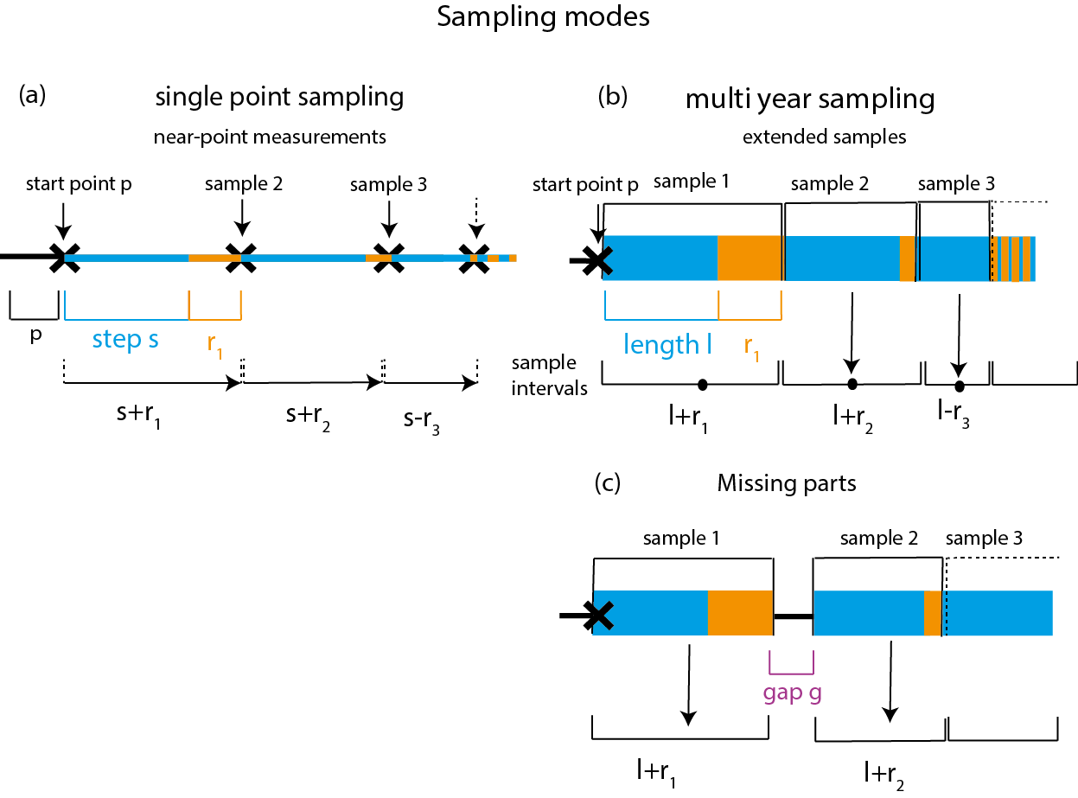
Figure S1: Schematic representation of the sampling modes. (a) Single-point sampling: At starting point p the first sample is taken as a single-point measurement (black crosses). The next sample is taken after one sampling interval, composed of the sampling step s and the uncertainty r₁. (b) Multi-year sampling: A sample that has the length of one sampling interval, is taken. The average concentration of this whole sample is assigned to the centre point of the sample (indicated by point). (c) Sampling with “missing parts” (subtype of multi-year sampling) simulates a gap g after one sampling interval. In all modes, the sampling intervals are not constant because the age-model uncertainty r_{n} varies between -10 and 10. Shortened sampling intervals due to a negative r are indicated by dashed lines.

REFERENCES
Beer J (2000): Long-Term Indirect Indices of Solar Variability. In Space Sci Rev., 94, 53–66 (doi: 10.1007/978-94-010-0888-4_5)
Beer J, McCracken KG and Steiger R von (2012): Cosmogenic radionuclides. Theory and applications in the terrestrial and space environments, Springer. Heidelberg and New York, 260-262
McCracken KG (2003): The Accuracy of Cosmogenic ¹⁰Be as a Quantitative Measurement of the GCR. In Kajita T, Asaoka Y, Kawachi A, Matsubara Y and Sasaki M eds. Proceedings of the 28th International Cosmic Ray Conference. July 31-August 7, 2003. Tsukuba, Japan. Frontiers Science Series. Tokyo, Japan, 4127–4130
McCracken KG (2004) Geomagnetic and atmospheric effects upon the cosmogenic ¹⁰Be observed in polar ice. J. Geophys. Res., 109(A4), A04101 (doi: 10.1029/2003JA010060)
McCracken KG, McDonald FB, Beer J, Raisbeck GM and Yiou F (2004): A phenomenological study of the long-term cosmic ray modulation, 850–1958 AD. In J. Geophys. Res., 109, A12103 (doi: 10.1029/2004JA010685)

