Two glaciers collapse in western Tibet
Lide Tian, Tandong Yao, Yang Gao, Lonnie Thompson, Ellen Mosley-Thompson, Sher Muhammad, Jibiao Zong, Chen Wang, Shengqiang Jin, Zhiguo Li

Supplementary Material

Data and method:

- Landsat satellite data
The extent of glacier cover areas was mapped for the region as shown in Figure S1, using Landsat TM (Thematic Mapper), ETM+ (Enhanced Thematic Mapper) and Landsat 8 data for the years 1994, 2005, 2010, 2013, and 2015. For the purpose, cloud free images of the late ablation season (August - October) during the study period were used, as shown in Table S1. This study used supervised classification to map and estimate glacier cover area. Method of “maximum likelihood classifier” was used to obtain manually selected, well distributed, uncounted clusters of different land cover classes including ice. The input training sites were selected in the false colour composite (FCC) 7-4-2 image. The results of glacier cover area estimation were improved by performing the classification several times, after editing and evaluating the signatures each time, by improving the output classes. The derived classification results were further enhanced for the imprecise areas by manual digitization.

- Sentinel-2 satellite data
The Sentinel-2 is an optical mission, part of Europe’s Copernicus programme, planning five constellations of satellites. The purpose of these satellites is to provide free access to images with more frequent coverage. The first Sentinel-2 satellite has been in orbit since April 2015; the second one is scheduled to launch in 2017. The two satellites will fly at a height of 786 km and 180° degrees apart, and will provide a revisit time of five days at the Equator and more frequent in higher latitudes. Each satellite provides 13 bands in the visible, near infra-red, and short wave infra-red, at different ground resolution, with the highest resolution of 10 m in the visible and near infra-red bands. The satellite provides data with high resolution and more frequent temporal coverage, but they require strong computational power due to large data size. Moreover, the data are provided in different levels of processing. We used Level-1C data of pre and post glacier slide event. Fortunately the satellite passed over the study site on the first sunny day (derived from MODIS images) after the event happened on 17th July. The images were co-registered and the detached ice and the lake surface ice were mapped using the visible and NIR bands with 10 meter resolution.
- Gaofen -2 satellite data

Launched in September 2014, the GF-2 satellite employs the CAST-CS-L3000A bus and two PAN/MS cameras, capable of collecting images with a GSD (Ground Sampling Distance) of 0.81 m in panchromatic and 3.24 m in the multispectral bands on a swath of 45 km. Figure 1 is the Gaofen-2 satellite multispectral data with 4 meter in resolution and Fusion data with 1m resolution.

- dGPS measurement
A Starfire 3040 RTK GPS was used to measure the fallen ice depth. The precision of the dGPS measurement is within 10cm vertically. The survey is only carried out in the southern edge of the debris ice area on 13 August 2016. The interior of the ice area is still inaccessible. The left glacier is unsafe to visit because there are many crevasses in the lower part of the glacier.

- Automatic weather station
Meteorological instruments at Nagri station (33.39ºN, 79.70ºE, 4260 m a.s.l.) were installed in the end of 2009, measuring air temperature at two levels, wind speed and wind direction, upward and downward longwave and short wave radiation, air pressure, precipitation, soil water content and soil temperature at different depths. Here we used the rain gauge data and air temperature data. The precipitation was measured by T-200B precipitation gauge, with a sensitivity of 0.1mm and capacity of 600mm, manufactured by Geonor Company, USA. Air temperature is measured by HMP45C sensor by VAISALA Oyj, Finland. Here we used the air temperature at 2.8m height.

Figure S1. Glacier cover areas were mapped for the whole region as of 10 September 2015.

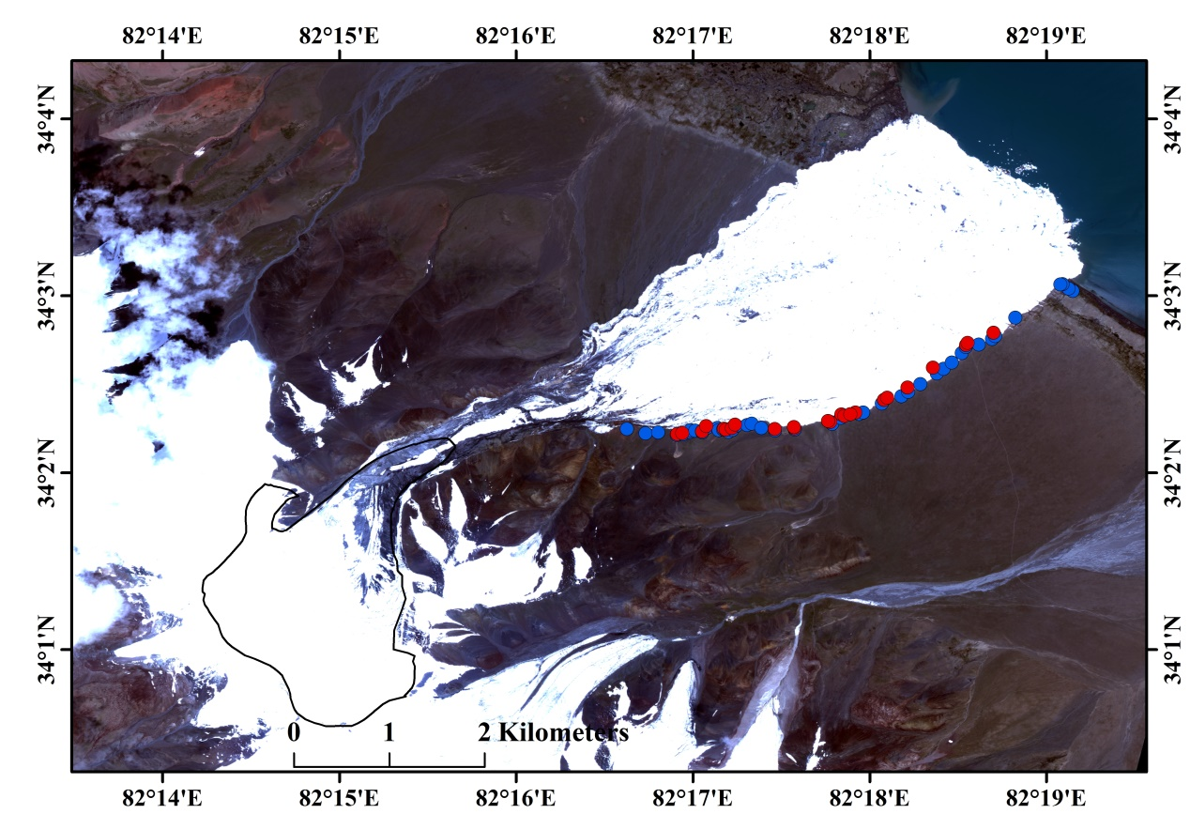

Figure S2. Location of the differential GPS measurement along the margin of the collapsed ice to estimate the depth of fallen ice in August 13. The elevations on the ice are compared with the neighboring points on the bare land to calculate the ice depth. Inside ice is as yet inaccessible because of its unstable rugged surface. The blue dots show the dGPS measured points on the exposed land surface, while red dots show the points on the ice mass.

Table S1: Glacier area change in past decades for the whole glacier region (Fig. S1) from Landsat images. TM, ETM+ and OLI indicate Thematic Mapper, Enhanced Thematic Mapper and Operational Land Imager respectively.
No | Sensor | Path/ Row | Acquisition date | Glacier-cover area (Sq. Km.)
1 | TM | 144/036 | 10/16/1994 | 25.04
2 | ETM+ | 144/036 | 09/06/2005 | 28.36
3 | TM | 144/036 | 09/28/2010 | 27.58
4 | OLI | 144/036 | 08/03/2013 | 27.02
5 | OLI | 144/036 | 09/10/2015 | 27.43

Table S2 Collapsed ice depth from Differential GPS measurement along the southern edge of the collapse glacier ice area.

Glacier edge |  |  | ice |  |  | Depth
Lat | Lon | elevation | Lat | Lon | elevation
34.02389 | 82.27641 | 5071.353
34.02346 | 82.27816 | 5065.076
34.02357 | 82.27934 | 5056.637
34.02332 | 82.2811 | 5046.173 | 34.0234 | 82.28114 | 5049.234 | 3.061
34.02338 | 82.28166 | 5043.759 | 34.02348 | 82.2816 | 5047.608 | 3.849
34.0236 | 82.28231 | 5036.542
34.02377 | 82.28242 | 5032.137
34.02373 | 82.28285 | 5028.664
34.02356 | 82.28351 | 5021.758 | 34.02365 | 82.28348 | 5026.416 | 4.658
34.02402 | 82.28399 | 5010.801 | 34.02415 | 82.28388 | 5016.388 | 5.587
34.02397 | 82.28492 | 5003.227
34.02377 | 82.28506 | 5004.200
34.02383 | 82.28546 | 5001.893 | 34.02391 | 82.28555 | 5008.025 | 6.132
34.02359 | 82.28596 | 5001.991 | 34.02381 | 82.28572 | 5009.029 | 7.038
34.02379 | 82.28633 | 4998.414 | 34.02397 | 82.28628 | 5005.413 | 6.999
34.02417 | 82.28671 | 4993.251 | 34.02429 | 82.28658 | 5000.629 | 7.378
34.02424 | 82.28773 | 4987.838
34.02439 | 82.28817 | 4985.992
34.02397 | 82.28908 | 4982.135
34.02375 | 82.29036 | 4977.024 | 34.02387 | 82.29034 | 4983.465 | 6.441
34.02383 | 82.29223 | 4975.129 | 34.02395 | 82.29219 | 4978.868 | 3.739
34.02437 | 82.29575 | 4976.098 | 34.02455 | 82.29556 | 4986.295 | 10.197
34.02492 | 82.29655 | 4973.553 | 34.02525 | 82.29661 | 4984.191 | 10.638
34.0253 | 82.29829 | 4972.287 | 34.02543 | 82.29794 | 4983.867 | 11.58
34.02542 | 82.29867 | 4971.516
34.02628 | 82.30042 | 4966.645 | 34.02663 | 82.30062 | 4975.705 | 9.06
34.02696 | 82.30227 | 4962.418
34.02738 | 82.30291 | 4960.315 | 34.02778 | 82.30285 | 4968.894 | 8.579
34.0281 | 82.30405 | 4955.719
34.02912 | 82.30562 | 4950.136 | 34.02965 | 82.30523 | 4963.759 | 13.623
34.02953 | 82.30625 | 4947.708
34.03013 | 82.30703 | 4944.443
34.03102 | 82.30796 | 4939.848
34.0316 | 82.30835 | 4937.182 | 34.03178 | 82.30837 | 4943.338 | 6.156
34.03182 | 82.30955 | 4935.130
34.03235 | 82.3108 | 4931.520
34.03263 | 82.31111 | 4930.304 | 34.03293 | 82.31095 | 4940.652 | 10.348
34.03437 | 82.31301 | 4923.272
34.03686 | 82.3184 | 4907.726
34.03711 | 82.31804 | 4907.497
34.03751 | 82.31746 | 4907.688
34.03748 | 82.31724 | 4908.027

