Supplementary Material
A comparative study of changes in the Lambert Glacier-Amery Ice Shelf System, East Antarctica, during 2004-2008 using gravity and surface elevation observations

Huan Xie^{1, 2}, *Rongxing Li^{1, 2}, Xiaohua Tong^{1, 2}, Xiaolei Ju^{1, 2}, Jun Liu^{1, 2}, Yunzhong Shen^{1, 2}, Lei Chen^{1, 2}，Shijie Liu^{1, 2}, Bo Sun³, Xiangbin Cui³, Yixiang Tian^{1, 2}, Wenkai Ye^{1, 2}

¹ Center for Spatial Information Science and Sustainable Development, Tongji University, 1239 Siping Road, Shanghai, China, 200092
² College of Surveying and Geo-Informatics, Tongji University, 1239 Siping Road, Shanghai, China, 200092
³ Polar Research Institute of China, 451 Jinqiao Road, Shanghai, China, 200136

*Rongxing Li, corresponding author, email: RonLi_282@hotmail.com

S1. Recent Mass Balance Studies in the LAS

This is the supplementary material for review and analysis of the recent mass balance in the Lambert Glacier and Amery-Ice Shelf system presented in Table 1.
All research results listed in Table 1 are based on the mass balance of the entire AIS, except Ren and others (2002) and Yu and others (2010) which were performed specifically for the LAS. The basin boundaries are defined in Zwally and others (2012). In Fig. S1 the basins that are completely or partially inside the study area (red wedge) are drawn in blue lines and numbered Basins 7 - 12 (white) as in Zwally and others (2012). The same complete or partial basins (purple lines) inside the study area are named Basins 1 – 6 (black) in this paper.
The “Trend/Mass I” column of in Table S1 presents the original trend values of the greater LAS basins, which were summed from all basins in blue lines (Fig. S1) for all AIS based results. The uncertainties were estimated as the root mean square of the uncertainties of the basins involved. The boundaries of the LAS study areas of Ren and others (2002) and Yu and others (2010) are different. Both trends and the uncertainty of Yu and others (2010) were estimated directly. The uncertainty of the trend in Ren and others (2002) is not given.

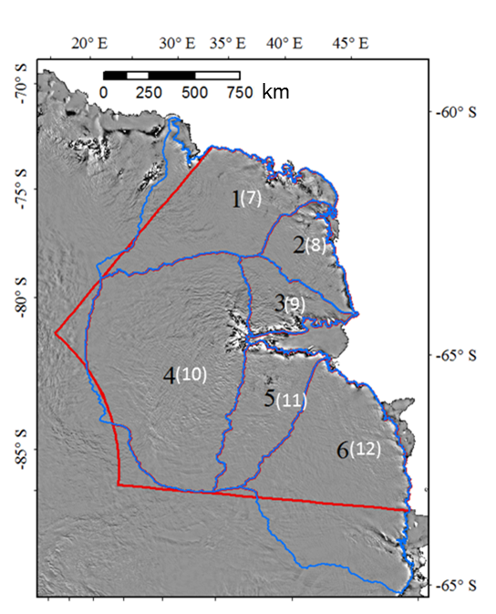
Fig. S1. The LAS basin boundaries (purple) in our study area (red) and drainage basin boundaries (blue) defined by Zwally and others (2012).
Author | Method/sensor | Period | Trend
 |  |  | Mass I  Gt a⁻¹ | Mass II  Gt a⁻¹
Zwally and others (2005) | ERS-1&-2 | Apr 1992- Apr 2001 | -14±8 | -13±7
Wingham and others (2006b) | ERS-1&-2 | Oct 1992-Feb 2003 | 14±1 | 14±1
Ren and others (2002) | In-situ measurements | 1994-1999 | 5.7 | 17
Rignot and others (2008) | InSAR, Snow accumulation data | 2000 | -16±28 | -14±25
Yu and others (2010) | InSAR, Snow accumulation data | 2000 | 22.9±4.4 | 42±8
King and others (2012) | GRACE RL04 GIA(W12a) | Aug 2002-Dec 2010 | 40±12 | 36±11
Sasgen and others (2012) | GRACE( GFZ RL05 & CSR RL05) GIA(AGE1) | Jan 2003-Sep 2012 | 38±9 | 35±8
McMillan and others (2014) | CryoSat-2 | Oct 2010-Sep 2013 | 2±20 | 2±18

The “Trend/Mass II” column of in Table S1 lists the adjusted trend of the study area inside in the red wedge. The adjustment is based on the present study area and the areas covered by each result. Thus the values in the “Trend/Mass I” column were scaled down or up to those in The “Trend/Mass II” column according to the areal ratio. For example, the LAS study area in Yu and others (2010) has an area of 1318.915×10³ km² which smaller than the area of the present study, 2427.82×10³ km². Thus, the original trend of 22.9±4.4 Gt yr⁻¹ in their paper was adjusted up to 42±8 Gt a⁻¹. The uncertainty was also adjusted up accordingly.

Table S1. Trend estimates of mass changes in the LAS from 1992 to 2013 from the results published by different authors

The following areas were adopted from the corresponding publications. If not, we calculated the area using the boundaries from Zwally and others (2005).

Present study Area: 2427.82×10³ km²
Zwally and others (2005) Area: 2666.2×10³ km²
Wingham and others (2006) Area: 2410×10³ km²
Rignot and others (2008) Area: 2679×10³ km²
Ren and others (2002) Area: 804×10³ km²
Yu and others (2010) Area: 1318.915×10³ km²
King and others (2012) Area: the same as Zwally et al. (2005)
Sasgen and others (2012) Area: 2643×10³ km²
McMillan and others (2014) Area: 2627.675×10³ km²

The time listed for Rignot and others (2008) and Yu and others (2010) are the time of INSAR data.

S2. Uncertainty Estimation for the ICESat change rates
Within each 500 m by 500 m box a simplified spatial-temporal polynomial model (Eqn (3)) is applied to characterize the ice surface topography and elevation change trend. The uncertainty of the estimated trend is calculated through an error propagation that is embedded in the least squares process. Then an intermediate level a grid with a cell size of 30 km by 30 km is produced. We calculate the elevation change rate of each cell by averaging the trends of all boxes inside the cell. The corresponding uncertainty is first calculated by a scaled median absolute deviation (MAD) which does not require a normal distribution of the sample (Ewert and others, 2012). The MAD is defined as the median of the absolute deviations from the data’s median:
MAD = median (|X − median(X)|) (S1)
where X denotes the sample vector. In the case of a 30 km by 30 km cell, the sample vector contains the trend estimates of all its boxes. In order to use the MAD as a consistent estimator similar to the standard deviation (in the case of normal distribution) we use a scaled MAD:
MADS = kMAD. (S2)
The scale factor k is 1.4826 (Hoaglin and others, 1983).
In the same way, the uncertainty of the elevation trend of a basin is also estimated as an MADS using the sample vector of the estimated trends of all 30 km by 30 km cells inside the basin.

S3. Reconciled Estimate and Uncertainty

Assume that we have n estimates with uncertainties $\left(x_{1}±σ_{x_{1}},{ x}_{2}±σ_{x_{2}},{ x}_{3}±σ_{x_{3}},⋯,{ x}_{n}±σ_{x_{n}}\right)$. The reconciled estimate can be defined as their arithmetic mean:

$\overline{x}=\frac{\sum{x_{i}}}{n}$. (S3)

The corresponding uncertainty is obtained through an error propagation:

$σ_{\overline{x}}=\frac{1}{n}\sqrt{\sum{σ_{x_{i}}^{2}}}$ . (S4)

S4. Spatial Distribution of GRACE points in the LAS
The GRACE solutions in the LAS are provided at the points with a resolution of 1º by 1º (Fig. S2). In the north-south direction the point separation of 1º is around 110 km. The point separation of 1º in the east-west direction converges quickly, ranging from about 17 km to about 44 km in the LAS.

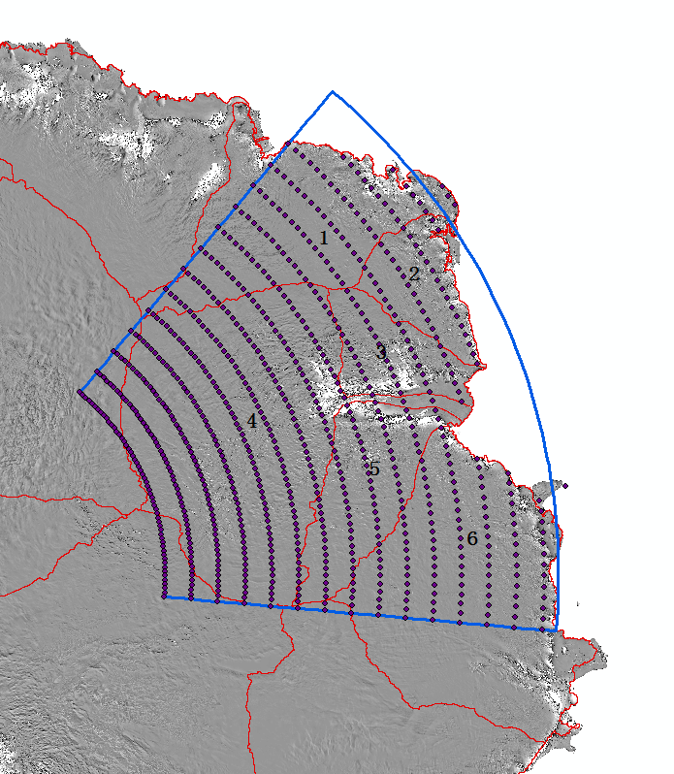

Fig. S2. Spatial distribution of GRACE points in the LAS.

References are listed in the main body of the paper.

