**Direct detonation initiation in hydrogen/air mixture: effects of compositional gradient and hotspot condition**

*Xiongbin Jia1,2, Yong Xu2, Hongtao Zheng1, and Huangwei Zhang2[1]*

1 *College of Power and Energy Engineering, Harbin Engineering University, Harbin, 150001, China*

2 *Department of Mechanical Engineering, National University of Singapore, 9 Engineering Drive 1, Singapore 117576, Singapore*

1. **Verification of mesh resolution**

The effect of mesh resolution on the simulation results are examined by comparing the cellular detonation evolutions at two levels of 16 pts/*l*1/2 and 20 pts/*l*1/2 for case B (see Table 1). Previous studies have extensively demonstrated that 20 pts/*l*1/2 is sufficient to capture the detonation frontal structure during the cylindrical detonation initiation and evolution (Jiang et al. 2009; Shen & Parsani 2017). Therefore, finer mesh resolution of 20 pts/*l*1/2 are performed for the mesh validation. Figure S1 shows the maximum pressure histories obtained with the two mesh resolutions. It is seen that the cell patterns and size are much similar for various mesh resolution, indicating the mesh independency. Therefore, considering the computational cost based on predicting accuracy, mesh resolution of 16 pts/*l*1/2 is chosen for the following simulations in this manuscript.

网格独立性.emf

Figure S1: Cellular detonation evolutions of case B: (a) 16 pts/*l*1/2, (b) 20 pts/*l*1/2.

JIANG, Z., HAN, G., WANG, C., ZHANG, F. 2009 Self-organized generation of transverse waves in diverging cylindrical detonations. *Combust. Flame* **156**,1653-1661.

SHEN, H., PARSANI, M. 2017 The role of multidimensional instabilities in direct initiation of gaseous detonations in free space. *J. Fluid Mech.* **813**, 1-13.

1. **Model validation**

For model validations, we compared the simulated detonation speed (case B) with theoretical value predicted by Shock & Detonation Toolbox (Shepherd 2021) and cell development of a cylindrical detonation with experiment (Vasiliev & Trotsyuk 2003).

Figure S2 shows the comparison of detonation speed between the numerical data (case B) and CJ value. Note that the mean detonation speed from the simulation is obtained from the position where detonation cells first occur (*R* = 0.12 m) to the domain edge (*R* = 0.5 m). In general, we can see that our prediction is reasonable. The detonation propagates with periodic fluctuation around a mean speed due to the periodic appearance of the incident and Mach shocks. The mean speed is slightly lower than that from the theory. This could be a consequence of the effects of curvature (Qi & Chen 2017; Ng & Lee 2003) and/or cellular instability (Han *et al.* 2018), both of which cause reduction of the detonation speed.



Figure S2 Comparison of the detonation speed between theoretical and numerical results

Figure S3 further compares the detonation cell evolution in the critical regime between simulation (case B) and experiment by blast initiation (Vasiliev & Trotsyuk 2003). Although the mixtures are different for simulation (H2+Air) and experiment (C2H2+O2), however, both mixtures are considered relatively stable for detonation development (Austin 2003). Therefore, based on Fig. S3, their cellular detonation evolution is qualitatively similar. Three stages, i.e., Ⅰ-no cell; Ⅱ-cell growth; Ⅲ-cell divergence featuring a successful initiation, are observable. Furthermore, secondary cells (generated at the end of stage Ⅱ due to increased instability) exists in both experiment and simulation, as shown in the circled region. This validates, albeit qualitatively, the ability of the current model in predicting details of detonation development and structure by direct initiation.



Figure S3 Comparison of detonation cell evolution between experiment (a) and simulation (b)

SHEPHERD, J. Shock and Detonation Toolbox. 2021 Version. https://shepherd.Caltech. Edu/edl/publicresources/sdt/.

VASILIEV, A.A., TROTSYUK, A.V. 2003 Experimental investigation and numerical simulation of an expanding multifront detonation wave. *Combust. Explos. Shock Waves* **39**, 80.

QI, C., CHEN, Z. 2017 Effects of temperature perturbation on direct detonation initiation. *Proc. Combust. Inst.* **36** (2), 2743-2751.

NG, H.D., LEE, J.H.S. 2003 Direct initiation of detonation with a multi-step reaction scheme. *J. Fluid Mech.* **476**, 179-211.

HAN, W., KONG, W., LAW, C.K. 2018 Propagation and failure mechanism of cylindrical detonation in free space. *Combust. Flame* **192**, 295-313.

AUSTIN, J.M. 2003 The role of instability in gaseous detonation. Ph.D. thesis, California Institute of Technology, Pasadena, CA.

1. **Theoretical detonation property**

Figure. S4 shows the main theoretical detonation properties, i.e., CJ detonation speed, half-reaction length, cell size with various ERs (Equivalence ratios) of 0.3-1. Specifically, the characteristic cell size is predicted by the Ng correlation model (Ng, Ju & Lee 2007): , where is fit coefficient related to the non-dimensional stability parameter , is the induction zone length. Obviously, the change of HRL (Half reaction length) is directly proportional to the cell size. As the ER decreases, the cell size and HRL increase, whilst the CJ (Chapman–Jouguet) speed decreases, indicating a drop in reactivity of local mixtures. Furthermore, the mixture reactivity varies gently near ER = 1, while decreases dramatically at about ER < 0.6. These reactivity features play important role in the direct initiation and the subsequent detonation wave evolution.



Figure S4: Theoretical change of key detonation parameters with gas equivalence ratio

NG, H.D., JU, Y., LEE, J.H. 2007 Assessment of detonation hazards in high-pressure hydrogen storage from chemical sensitivity analysis. *Int. J. Hydrogen Energy* **32**, 93-99.

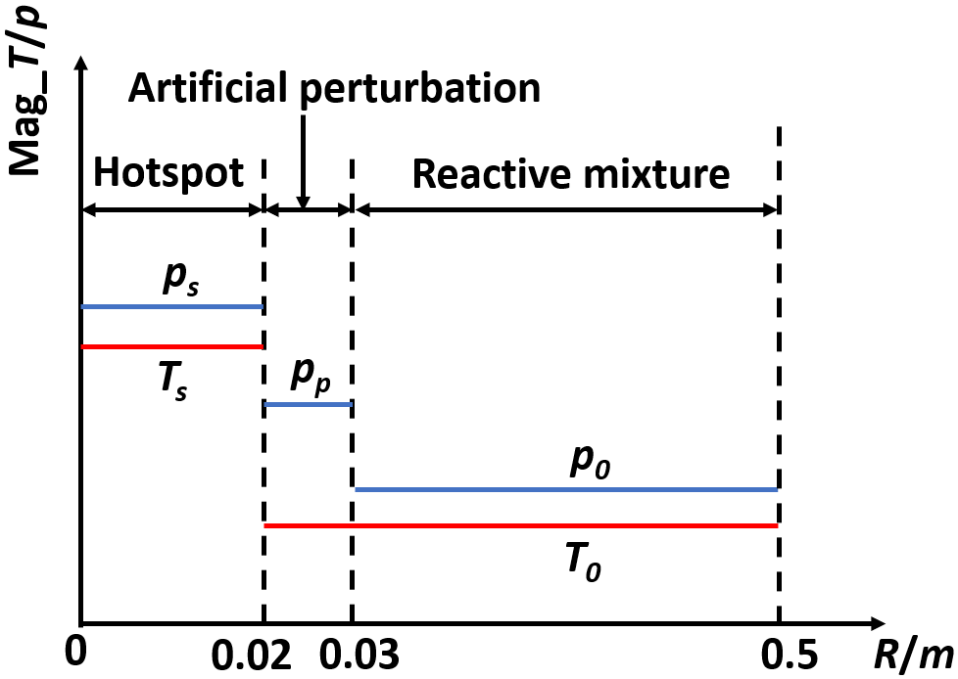

Figure S5. Schematic of pressure fluctuation setup at initial condition

1. **Effect of pressure perturbation on direct initiation**

Artificial perturbation applied near the hotspot significantly affects the direct detonation initiation (Qi & Chen 2017). In the current study, a pressure fluctuation (*pp*) at the hotspot interface is added to check if the artificial perturbation influences the cellular formation and instability induced by the curvature. The setup is consistent with case B in the manuscript, except for the pressure perturbation at the hotspot interface, as shown in Fig. S5. In pressure perturbation region raging from *R* = 0.02 m (hotspot vicinity) to *R* = 0.03 m, the pressure is *pp* = 100 *p0*. The remaining parameters in the artificial perturbation regionis same with the reactive mixtureregion. For convenience, we use Bp to represent “case B with pressure perturbation”.



Figure S6: Histories of maximum pressure of case B (a) and case Bp (b). The selected time is 98 μs.



Figure S7: Changes of pressure, temperature, and HRR along the monitoring line at 50 μs (a) and 73 μs (b) in case Bp.

Fig. S6 compares the the maximum pressure histories of case B (Fig. S6a) and Bp (Fig. S6b) at 98 μs. It is seen that the the cell forms at about *R* = 0.1 m after the decay the overdriven detonation in case B, whilst no cell appears in Fig. S6(b) since it is still in the overdrive state. Figure S7 shows the pressure, temperature, and heat release rate along the monitoring line (from [0, 0] to [0.2 m, 0.2 m]) at 50 μs and 73 μs in case Bp. The shock couples with the rapid reaction at 50 μs; meanwhile, the peak pressure is about 5 times that of theoretical von Neumann spike. This is the highly shocked gas induced by the pressure perturbation (see the inset of Fig. S7) ahead of the detonation front that makes the detonation wave in an extremely strong overdrive. As the detonation front overlaps the shock ahead of it, the pressure peak of detonation drops a lot, as shown in Fig S7(b). Nevertheless, the detonation is still overdriven due to too large degree of overdrive influenced by the pressure perturbation.

Therefore, in the studied condition, the cell formation is significantly affected by an artificial perturbation at the hotspot interface. This again demonstrates the sensitivity of the detonation development to the hotspot properties.

QI, C., CHEN, Z. 2017 Effects of temperature perturbation on direct detonation initiation. *Proc. Combust. Inst.* **36** (2), 2743-2751.

1. Corresponding author. Email: Huangwei.zhang@nus.edu.sg.