Supplementary file of

Lattice Boltzmann modelling of colloidal suspensions drying in porous media accounting for local nanoparticle effects

Feifei Qin1,2, Linlin Fei2,*, Jianlin Zhao3,2, Qinjun Kang4, Dominique Derome5, Jan Carmeliet2

1Institute of Extreme Mechanics and School of Aeronautics, Northwestern Polytechnical University, Xi’an 710072, China

2Chair of Building Physics, Department of Mechanical and Process Engineering, ETH Zürich (Swiss Federal Institute of Technology in Zürich), Zürich 8092, Switzerland

3College of Petroleum Engineering, China University of Petroleum-Beijing, Beijing 102249, China

4Earth and Environment Sciences Division (EES-16), Los Alamos National Laboratory (LANL), Los Alamos, NM 87545, USA

5Dep. of Civil and Building Engineering, Université de Sherbrooke, Sherbrooke Qc  J1K 2R1 Canada

KEYWORDS: colloidal suspension, drying, local nanoparticle effects, porous media, lattice Boltzmann model

*Corresponding author: [linfei@ethz.ch](mailto:linfei@ethz.ch)

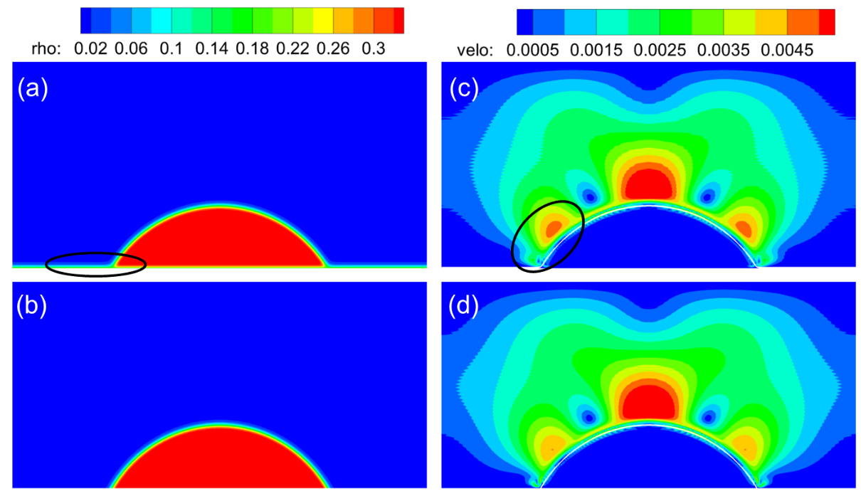

**Figure S1** Comparison of fluid density (a-b) and spurious current (c-d) of droplet on flat surface with a constant angle of . (a, c) Result using fixed virtual density scheme. (b, d) Result using geometrical formulation scheme (Ding & Spelt [Phys. Rev. E 75, 046708 (2007)]). The ellipses in subfigure a and c indicate the unphysical fluid layer and stronger spurious current, when using the fixed virtual density scheme.

**Figure S2** Comparison of fluid density (a-b) and spurious current (c-d) of droplet on curved surface with a constant angle of . (a, c) Result using fixed virtual density scheme. (b, d) Result using improved virtual density scheme (Li et al. [Phys. Rev. E 100, 053313 (2019)]). The ellipses in subfigure a and c indicate the unphysical fluid layer and stronger spurious current, when using the fixed virtual density scheme.

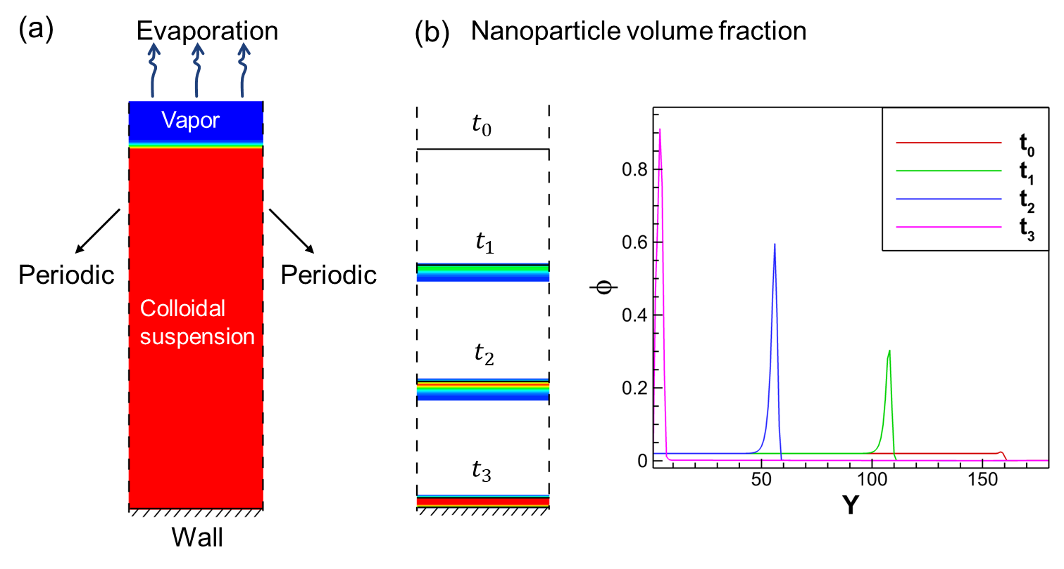

**Figure S3** (a) Simulation setup of one-dimensional evaporation of colloidal suspension. (b) Liquid-vapor interface locations and nanoparticle volume fraction profiles at different time during evaporation. In the simulation, with the value of  in Eq.(2.25), over 98% of nanoparticles are conserved in the liquid phase during drying, indicating very high model accuracy.

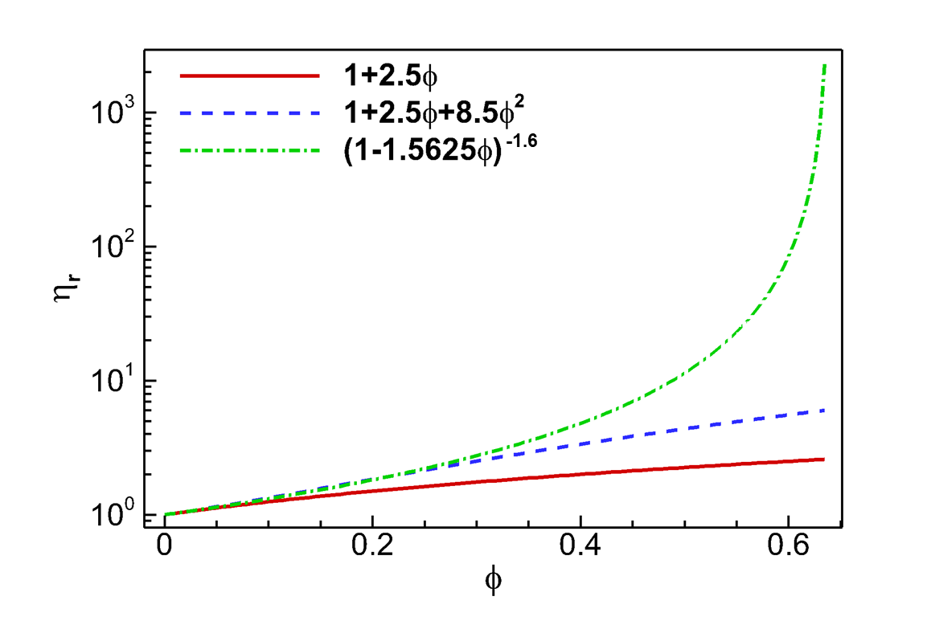

Figure S4 Comparison of the three equations for viscosity ratio under different nanoparticle concentration : Red solid: linear equation for dilute regime ; blue dashed: polynomial equation for semi-dilute regime ; green dot-dashed: non-liner equation for dense regime . It is observed that the non-linear equation agrees well with other two equations in the corresponding working range.

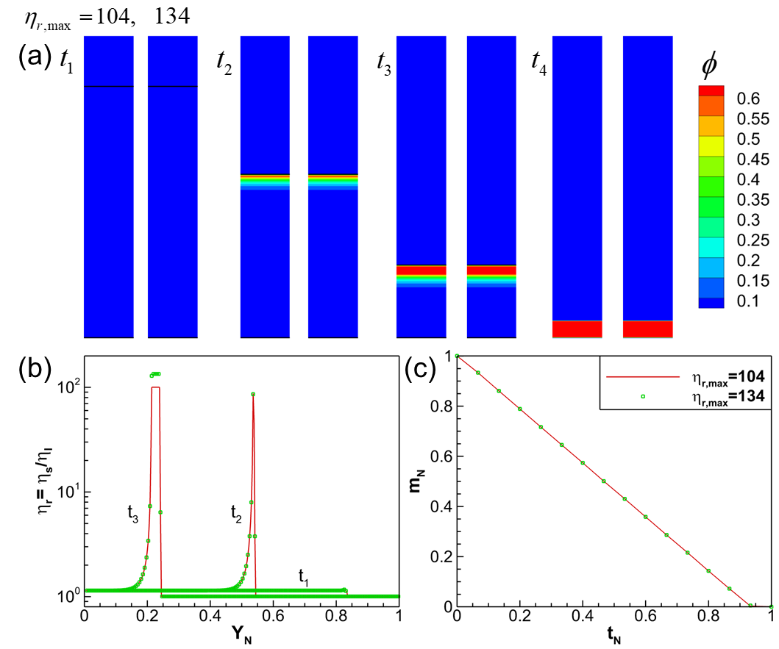

**Figure S5** Comparison of one-dimensional evaporation of colloidal suspension (same setup as in Figure S3) with maximum colloid to base liquid viscosity ratio  and , respectively. (a) Evolution of nanoparticle volume fraction  with the receding of liquid-vapor interface. (b) Colloid to base liquid viscosity ratio  at different time during the evaporation. (c) Decrease of normalized colloid mass .

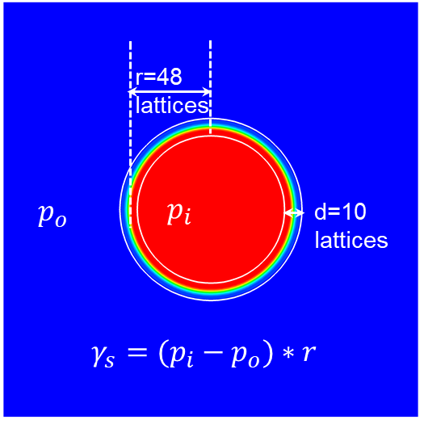

Figure S6 Implementation of nanoparticle effect on surface tension. First, the nanoparticle interfacial fraction  is obtained at the interface. Then,  is given at all lattices within the distance range d sitting on the interface, to realize the correct surface tension . The  is calculated based on Laplace’s law.

**Table S1** Pressure and surface tension for different distance ranges.

|  |  |  |  |  |
| --- | --- | --- | --- | --- |
| d | r | $$p_{i}$$ | $$p_{o}$$ | $$γ_{s}$$ |
| 30 | 48 | 9.58e-4 | 9.04e-4 | 2.563e-3 |
| 20 | 48 | 9.58e-4 | 9.05e-4 | 2.556e-3 |
| 10 | 48 | 9.58e-4 | 9.05e-4 | 2.542e-3 |

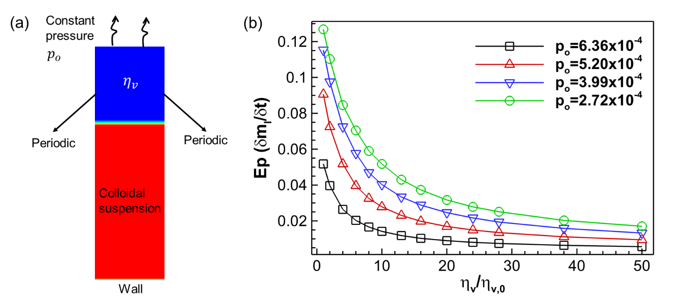

Figure S7 Modeling of the influence of vapor viscosity ratio  on drying rate *Ep* using a simple 1D case. (a) Simulation setup with constant outlet pressure  at top, periodic at left/right sides, and wall at bottom. (b) Drying rate under different outlet pressure  and vapor viscosity ratio .

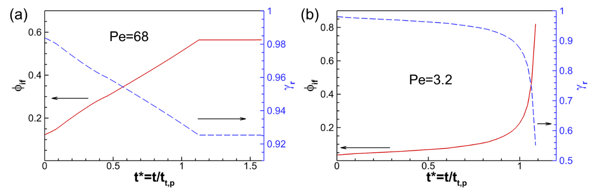

**Figure S8** Evolution of nanoparticle interfacial fraction  and surface tension ratio  during the drying of a suspended droplet at (a)  and (b) 

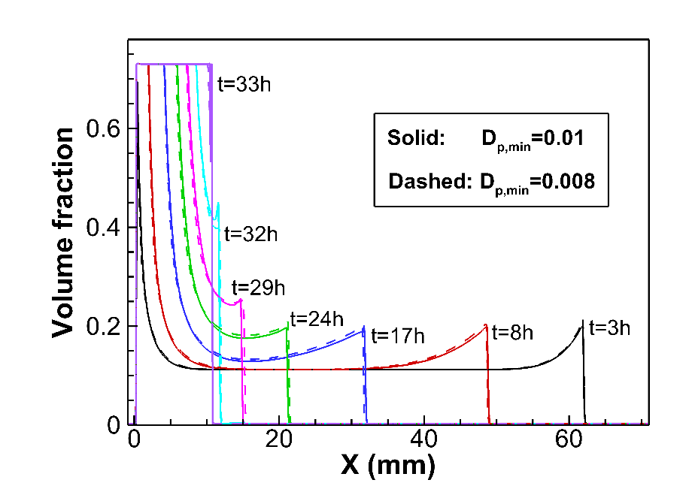

**Figure S9** Comparison of nanoparticle volume fraction in drying of a capillary tube with both open ends considering two minimum nanoparticle diffusion coefficients of  and 

Figure S10 Comparison of normalized evaporated colloid mass  from the left and right open ends considering 4 different cases, where  is the total evaporated colloid mass. Case 1: without considering any local nanoparticle effect. Case 2: considering nanoparticle effects on colloidal suspension viscosity  and thus nanoparticle diffusion coefficient . Case 3: considering nanoparticle effects on ,  and surface tension . Case 4: considering nanoparticle effects on , ,  and local drying rate ratio .

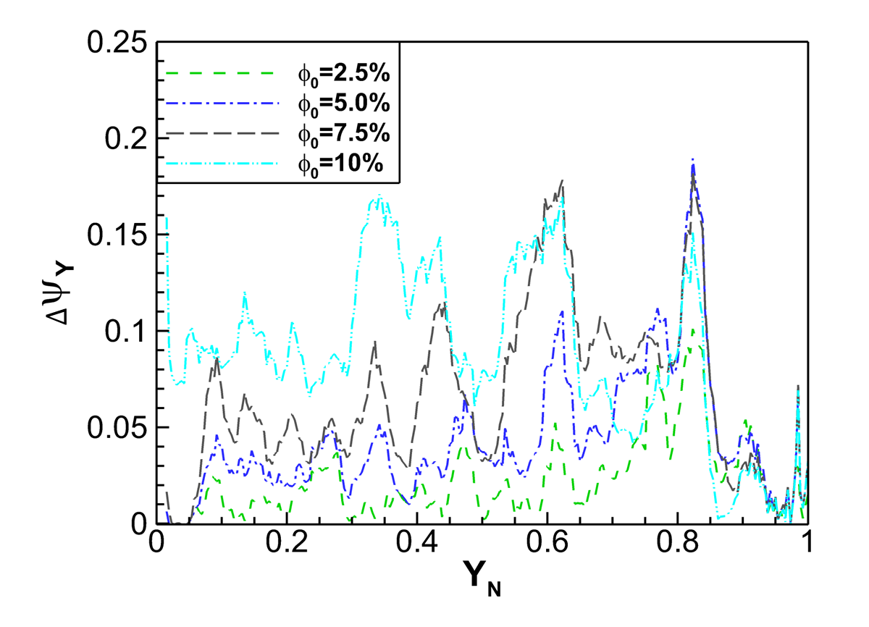

**Figure S11** Comparison of the decrease of  at final deposition at each vertical slice  of the porous medium with different initial nanoparticle volume fraction .

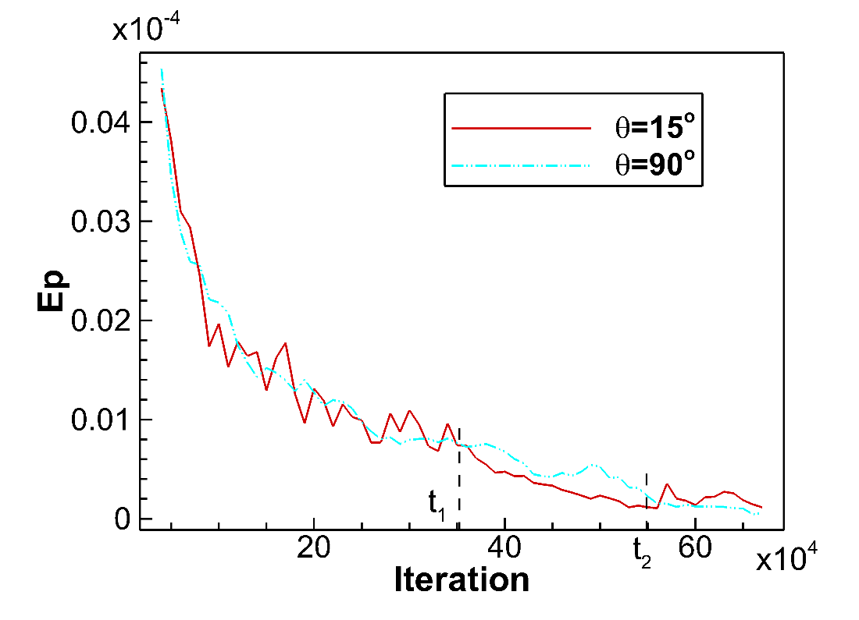

**Figure S12** Comparison of evaporation rate during the drying process between the two cases of porous medium contact angles and $90°$.

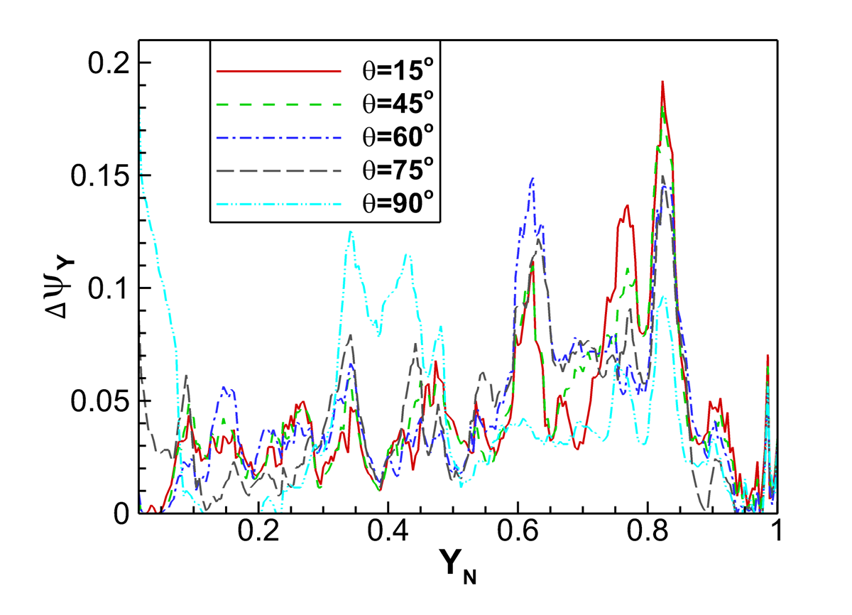

**Figure S13** Comparison of the decrease of  in final deposition at each vertical slice  of the porous medium with different contact angles, , of the porous medium.

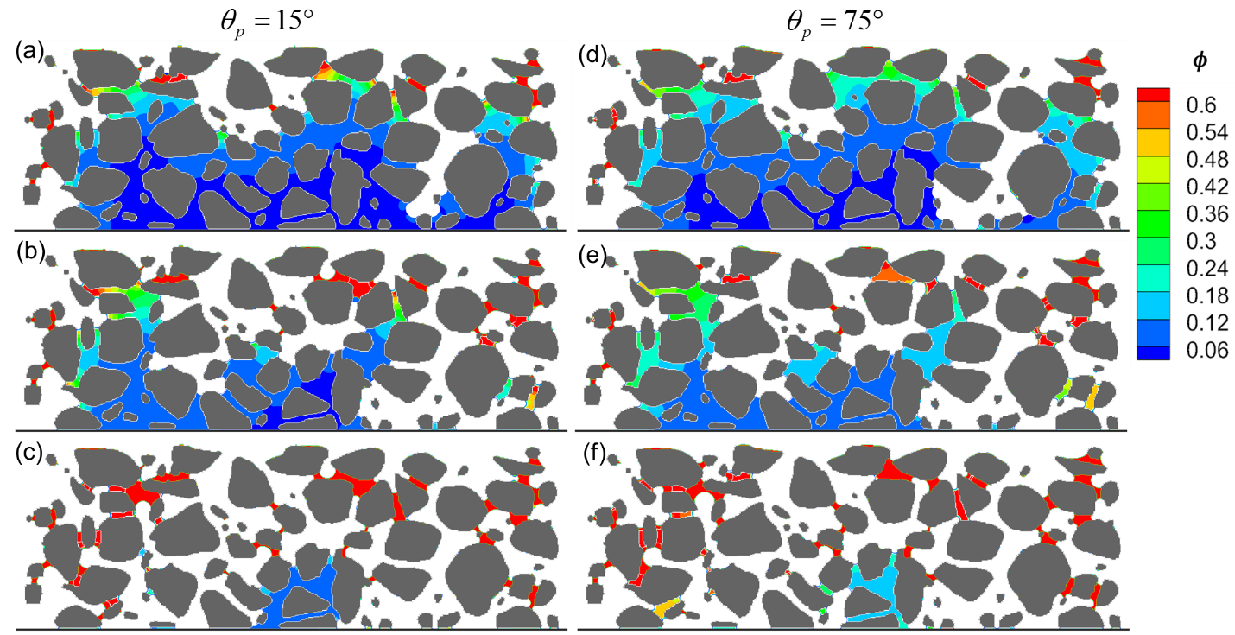

**Figure S14** Comparison of drying and nanoparticle deposition process between two cases with nanoparticle contact angles (a-c)  and (d-f) .

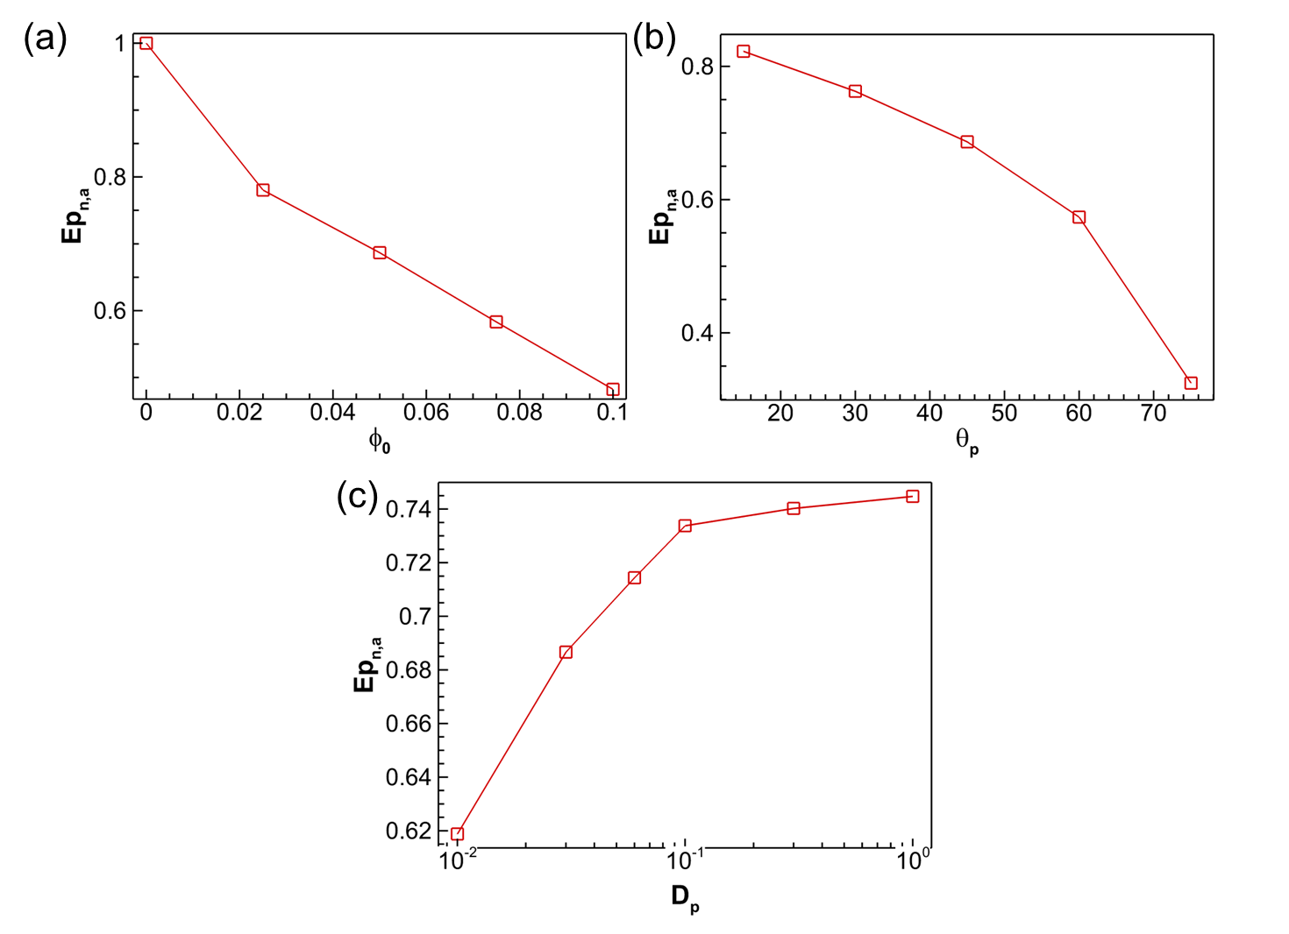

**Figure S15** Normalized average drying rate  under different conditions: (a) varied initial nanoparticle concentration , (b) varied nanoparticle contact angle , (c) varied nanoparticle diffusion coefficient .