Online Appendix to the article Urban Political Structure and Inequality

Online Appendix 1: Historical Background

Urban Germany and Nördlingen
Some historical background information is essential to appreciate the analysis in the main text. In early modern Germany roughly 4,000 cities existed. The majority were territorial cities, that is, under the control of a territorial overlord. Most territorial cities had nevertheless wide-ranging self-governance rights — a characteristic feature of the politically highly fragmented Holy Roman Empire — for example in fiscal and military affairs (Schilling and Ehrenpreis 2015). The Free Imperial Cities were usually the largest and economically most vibrant cities in Germany and had even more self-governance right. However, they were in economic and political decline over the early modern period: at the end of the eighteenth century only 37 had been able to maintain their independent status (Schilling 1994, p. 108).
In the early modern period, when the medieval concept of “municipal law families” (Stadtrechtsfamilien) had lost its importance, all territorial and city states in the Empire were subject to the “Imperial Police Ordinance” (Reichspolizeyordnung). This legislation, not to be confused with the modern notion of police, provided a common legal framework for all Imperial Estates for how to regulate, for instance, commerce, crime punishment or other spheres of public life. But every polity had large discretion over how to fill that framework with local legislation (Isenmann 2014, p. 192-195; Härter 2010). Of course, there were other factors that had an influence on how the political institutions of a city were set up, such as its economic orientation. For instance, while merchants were very influential in the city politics of the trade-oriented Hanseatic towns, craftsmen were often part of the government in manufacturing-oriented towns (see Ogilvie 2011, p. 11; Isenmann 2014, p. 807).
Nördlingen was, as mentioned, well-known for its textile production and long-distance trade. Two great medieval trade routes intersected in Nördlingen, a northeast-southwestern one that connected Bohemia and the area around Lake Constance, and one that went from the Low Countries to Frankfurt a.M. and then southward to Switzerland and Italy. About half of the citizenry participated in production for the export oriented sectors of the economy. However, already from the fifteenth century onwards trade routes and fair started to decline in importance (Friedrichs 1979, p. 6-7, 79). Nevertheless, Nördlingen continued to grow, at least in terms of population size, during the first part of the early modern period. It had approximately 6,300 inhabitants around 1500, and 8,400 inhabitants around 1600. But it experienced a decline during the crisis-ridden seventeenth century, to around 5,700 inhabitants in 1700 (Schaff 2022), a decline from which the city could not recover until 1800, when it had roughly 6,000 inhabitants (Bairoch et al. 1988).
The closure of Nördlingen’s political system, following the intervention of the Holy Roman Emperor in the sixteenth century, was in line with a broader European trend. Similar developments towards more closed political systems in the early modern period could be observed in other parts of Germany but also, for example, in Italy and the Dutch Republic (Andermann 2001, p. 379; Alfani 2023, p. ch. 5; De Vries and Van der Woude 1997, p. 586-596).
Nördlingen’s city council had four broad areas of activity. First, it was the legislator of Nördlingen. Within the large room left by the Imperial constitution, council members created legislation to regulate social welfare, criminal behaviour, construction activity, public hygiene, trade and commerce, including limits to competition, and many other things. Closely related to that the council was, second, also the highest court of Nördlingen. It decided over criminal cases, disputes over property rights, dowries, inheritance, prohibited individuals or groups commercial activity, approved craft bylaws and fixed prices. For example, in 1681 the council banned tanners from trading raw wool and finished cloth, following the complaints of Swiss merchants. And in 1698 the council suspended temporarily all export activity of the Wörner merchant family (Friedrichs 1979, p. 266, 279).
Third, the council also decided over and oversaw administrative matters, such as the inspection of manufactured goods, security provision, tax collection, the management of municipal finances, and gave permission to individuals to change jobs or residency. It reportedly even specified the number of guests permitted at a wedding. Fourth, council members were in charge of foreign affairs. They represented the city-state at the Imperial diet or the meetings of the Schwäbische Städtebund alliance, and decided over military and defence issues (Voges 1988, p. 26-28; Friedrichs 1979, p. 144-148, 199-206; Bátori 1990, 2007). There was certainly variation in what councils did in other German cities, but the enormous breadth of concerns was a general characteristic of municipal governments (see Isenmann 2014, p. 448-605). Note that the council’s powers were, however, basically restricted to the area within the city walls. The city could claim territorial rulership over only two villages, because the surrounding area was mostly controlled by the house of Oettingen (Friedrichs 1979, p. 19-21).

Historical Examples of Patronage and Embezzlement
Qualitative evidence suggests that patronage was part of the mechanism behind political elites’ private enrichment. For instance, in the seventeenth century the municipal court of Nördlingen enforced the internal rules of the weavers craft organisation — a private organisation of businessmen — aiming to exclude craftsmen that employed different techniques and produced higher quantities than the ones prescribed by the craft organisation (see for example Kluge 2007). In one case the municipal court sentenced a weaver to death for having produced cloth in a way that deviated from the organisation’s rules, and for selling more than the quantity he was allowed to sell (Kluge 2007, p. 296). Craft organisations were politically disempowered in Nördlingen, at least formally in terms of seats on the city council. But they could still influence city politics. Yet this would have been supposedly more expensive without formal representation, as it would have required the craft organisations to lobby officeholders. In one telling incident from the year 1620, just after the Thirty Years’ War had begun, the weaver craft organisation incurred (an unfortunately unspecified amount of) costs to lobby Nördlingen’s political authorities, to enforce entry barriers against an outside individual. The weavers wanted to keep an individual out of their organisation whose father also had connections to individuals working with leather, that is, their competitors (see Ogilvie 2019 “Qualitative Guilds Database”; also Stuart 1999, p. 96). In other words, craft organisations obtained privileges from the town government, and political elites received material favours in return.
Embezzlement is even harder to demonstrate. But an episode from the history of the nearby city of Ehingen demonstrates that embezzlement of public money by officeholders was a frequent phenomenon at the time and in the region, and it is possible that it explains part of the enrichment of Nördlingen’s political elites. In 1681 it was discovered that several thousand florins were missing from the treasury. The mayor and another high official were accused of having misappropriated the money, but the case could never be solved. In 1688 the city suffered heavily from attacks of the French army during the Palatine Succession War (1688-98). The year after the beginning of the war another check of the treasury was conducted. Again, a huge (but unspecified) amount was missing. Again, the mayor and other high officials were suspected of having taken the money, and this time it was also impossible to solve the case. Six years later — the war was still ongoing — another check was conducted, and for the third time in less than two decades money was missing. This time the large amount of 297,830 florins had disappeared, but it was not possible to solve the case (Quarthal 1979, p. 8).
There also exists evidence of embezzlement of money specifically during the Thirty Years’ War. A famous example was Wallentein’s theft of 96,000 thalers from the treasury of the Bohemian estates in 1619 (Mann 1987, p. 138-142). A minor delict was, for example, the bailiff of the city of Calw employing public money for private for-profit money lending during the war. And the administrator of the city of Lauffen used the emergency situation of the war to frighten the local population in order to coerce them to pay money to him (Fritz 2004, p. 135, 143-144), not dissimilar to what the council of Nördlingen did when the city was threatened by soldiers (see above and Friedrichs 1979, p. 217). Moreover, the waves of plague that happened during the war in the late 1620s and 1630s all over Europe were reportedly exploited by officials to defraud and steal public money and other assets. For example, in 1630/31 Florence, an independent city-state like Nördlingen, a high city clerk working in the local pesthouse defrauded the public health funds by claiming more money than he had actually paid out in grave-diggers’ wages (Henderson 2019, p. 242-243, 267-268).

Online Appendix 2: Localities and Independent Variables in the City-Level Dataset
The panel-data on top wealth shares in 33 early modern German cities comes from Schaff (2022), where the data are discussed in great detail. This is an extended version of the dataset of Alfani et al. (2022), in which benchmark years have been extended to 25-year intervals. The dataset is, to the best of my knowledge, the largest currently available for the study of wealth inequality in early modern German cities. There exist of course other datasets of early modern German cities that are much larger. But these do not include any measure of household-level income or wealth inequality. This Appendix describes how the independent variables employed in the city-level analysis have been coded and which localities are included in the dataset, divided by Free Imperial and territorial and cities.
The Free Imperial Cities are Augsburg, Erfurt, Frankfurt a.M., Heilbronn, Leutkirch, Lübeck, Mühlhausen i.T., Nördlingen, Ravensburg, Schwäbisch Hall, Überlingen and Wangen. The territorial cities are Bad Königshofen, Bregenz, Eckartsberga, Freiburg i.B., Hachenburg, Hersfeld, Hildesheim, Kitzingen, Koblenz, Konstanz, Krempe, Leonberg, München, Naumburg, Quedlinburg, Rostock, Stockach, Straubing, Traunstein, Wildberg and Zeitz.
Most of the information was taken from the Deutsches Städtebuch (Keyser 1939-74; Baltzarek et al. 1973), a multi-volume encyclopedia of German cities. The encyclopedia was a collaborative project of hundreds of local historians, and provides information about several city characteristics in a very systematic way, for example about political institutions, the population or important events such as epidemics and wars.
The council elections-variable is a dummy that indicates whether (at least part of) the local population could participate in politics through regularly held “participative elections”, that is, electing the city council or the mayor. I followed the approach of Wahl (2019). Information was taken from Section 9 of the Städtebuch. One example of a place in the dataset that introduced elections to the city council would be the small city of Hersfeld, for which the Städtebuch provides the following information: “The city council (first mentioned in 1321), had initially 2, then since 1355 4 members and was elected by the citizenry two or three days after Martini day (11th of November). Half [of the council] was elected from the college of lay judges, the other half from the rest of the upper-class citizenry” (my translation) (Keyser 1957, p. 236). One might be wondering what exactly counted as having elections and what not in a context where large parts of the population, such as women or unmarried people, were excluded anyways from voting. If, as for example in fifteenth-century Straßburg, government members were elected by an electoral college, which was itself selected by the members of the local craft organisations (Isenmann 2014, p. 353) — which usually made up only a small share of the total population — then this would count as a participative election. If, as for example in seventeenth-century Augsburg, new government members were elected only by sitting government members, then this would not count as a participative election. It was also possible that elections were introduced, abolished at some point and later re-introduced.
The other controls have been taken from Schaff (2023a). The population size of a locality is a continuous variable that has been obtained by multiplying the number of taxpayers in a given year with the presumed average household size. The household size typically assumed for preindustrial German towns is 4.5 (Minns et al. 2020, p. 611). The epidemic-variable is a dummy that indicates whether there was an outbreak of an epidemic in a locality in the preceding period. The Protestant-Reformation variable is a dummy that indicates whether the Protestant Reformation has been introduced in a locality after 1517. The introduction date is when a town council or local ruler officially introduced the Reformation. A warfare-dummy indicates whether a locality was exposed to battle action or a siege within a radius of 25 km. Log-university distance-variable indicates the log-distance (km) of a locality to the closest university in every given year.

Online Appendix 3: Construction of the Nördlingen Dataset
The dataset contains all households (6,557) living in Nördlingen between 1579-1700, in 3 to 6 year intervals (22 points of observation). Since the tax registers were meticulously ordered by alphabetical order of names of household heads — an example for the initials A.H. in the year 1627 can be seen in Figure A1.1 — it is possible to connect and trace individuals over time. This has been done by Christopher Friedrichs in the early 1970s, and led to the publication of a book (see Friedrichs 1979). Professor Friedrichs generously made available his paper-based records which I then digitised to create a panel-dataset.

Figure A1.1 – Archival Sources: Tax Register from Nördlingen (1627)
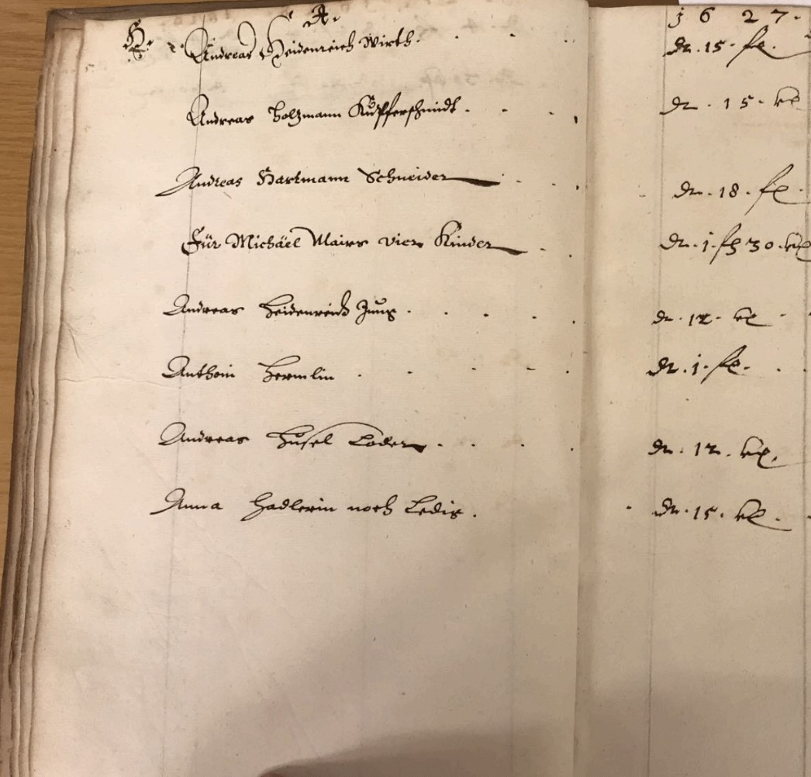
Source: Stadtarchiv Nördlingen.

For every household I collected the following information: abbreviated family name, abbreviated first name, gender, tax payment in the year concerned (expressed in florin (fl.) or fractions thereof), occupation. Importantly, tax payments could be easily converted into actual wealth levels because the uniform tax rate is known. Over the whole period of study the tax rate was 0.5 percent of an individual’s total wealth (Friedrichs 2016, p. 1). Unfortunately, the sources only give information about the total amount of property, but do not give information about different asset categories. The total annual tax rate applied to peoples’ property was usually between 0.5 and one percent during the sixteenth and seventeenth centuries (Friedrichs 1979, p. 158). Note, however, that the base tax rate with which citizens’ property tax duty was calculated was uniformly 0.5 percent, and this is the value recorded in the registers. But the tax could be levied several times per year, leading effectively to higher annual tax rates. Note also that the population of Nördlingen had to pay not just property taxes, but also several consumption taxes, such as the ones on beer and wine, and also tolls. Additionally, in periods of warfare special war taxes (Anlagen) were levied. All these other taxes were recorded separately from the property tax. The regular property tax only had a relatively small share in the receipts of the city treasury, of about 19.7 percent in 1700, while the share of beer and wine taxes was almost twice as large. The exact rates for all the different taxes are not known. But we know, for example, that in 1634 the property tax was levied 11.5 times, and in 1643 the Anlagen was levied 33 times, that is, each citizen had to pay 11.5 or 33 times the amount assigned to them (Friedrichs 1979, p. 157-162).
To begin with, I have randomly picked hundred taxpayers from the Friedrichs-records, each with several tax payments. I have then compared their tax payment in the Friedrichs-records with the payment recorded in the original archival sources. I did not find any mistake in the transcription. I then converted the abbreviated family and first names into full names. For that I used lists of the abbreviations in the city archive of Nördlingen. Only the full names made it possible to determine which individuals were at some point part of the city government. I took information about who was a magistrate, who was a mayor and for which years these offices were held from Friedrichs (1979, p. Appendix), information that is based on the original lists of city council members in the city archive of Nördlingen. In the analysis I only use information about those individuals for which I observe the year in which they made their first tax payment. This made it possible to calculate for how long an individual had been paying taxes at any point in time. I used this information as a proxy for an individual taxpayer’s age.
The original tax registers give very detailed information about the occupation of taxpayers. Friedrichs (1979) sorted all individuals into 60 occupational categories. I created a dummy variable for every category, which I have then employed in the empirical analysis. The categories are the following:
wool weaving, fine cloth weaving, linen weaving, other basic textile producing trades (e.g. dyer), tailoring, other clothing and rare textile producing trades (e.g. silk maker), furs, tanning, shoemaking, other leather working trades (e.g. saddler), masons, other construction trades (e.g. bricklayer), cabinet maker, other woodworking trades (e.g. barrel maker), smiths weaponry, smiths riding gear, smiths tools, fixtures, etc. (e.g. locksmith), smiths domestic equipment, metal casters, goldsmith, rope maker, brushes and baskets, pottery and glass, complex instruments (e.g. clock maker), books and paper (e.g. printer), artists (e.g. painter), miscellaneous craftsmen, baker, confectioners, butchers, fishmongers, brewers and distillers, millers, merchants, retailers, taverners, learned occupations religious, learned occupations legal, learned occupations medical, learned occupations pedagogical (e.g. schoolmaster), learned occupations writing (e.g. notary), non-municipal administrator (e.g. of religious foundation), learned occupations other, city secretaries, high city administrative positions (e.g. legal counsel, armaments superintendent), city offices related to tax collections, city offices related to inspection of products, watchmen, mounted and forest officials, municipal servants, carters, messengers, musicians, healthy and hygiene workers, agricultural workers, menial workers (e.g. day labourers), soldiers, miscellaneous non-craftsmen, no occupation wealth above 1 gulden (e.g. only city council member), no occupation wealth below 1 gulden (e.g. unemployed).

Online Appendix 4: Additional Results for the City-Level Analysis

Estimates with Bootstrap Standard Errors
In the city-level analysis in the main text I have reported robust standard errors. One might be concerned that the limited size of the dataset is insufficient to fulfil the necessary asymptotic requirements for robust standard errors. For that reason I repeat the analysis but report bootstrap standard errors. The results in Table A4.1 are relatively similar to the ones in the main text. Bootstrapped standard errors are slightly larger in some columns, but not much.
Table A4.1 – Bootstrap Standard Errors: Wealth Inequality and Elections in Early Modern German Cities (Top-Wealth Shares)
 | (1) | (2) | (3) | (4) | (5) | (6)
 | Top 10% | Top 10% | Top 5% | Top 5% | Top 1% | Top 1%
Council elections | -4.429*** | -4.457** | -5.908*** | -6.097*** | -5.198* | -5.468**
 | (1.217) | (1.835) | (1.903) | (2.265) | (2.740) | (2.732)
Controls | NO | YES | NO | YES | NO | YES
City FE | YES | YES | YES | YES | YES | YES
Time FE | YES | YES | YES | YES | YES | YES
Observations | 241 | 241 | 241 | 241 | 241 | 241
R-squared | 0.209 | 0.215 | 0.139 | 0.142 | 0.100 | 0.108
Cities | 33 | 33 | 33 | 33 | 33 | 33
Mean of dependent variable | 51.94 | 51.94 | 36.89 | 36.89 | 14.37 | 14.37

Notes: Estimation method is OLS. Bootstrap standard errors in parentheses. *** p<0.01, ** p<0.05, * p<0.1

Economic Polarisation Measures
In the main text I have analysed the relationship between top wealth shares and the presence of council elections in the panel of early modern German cities. Top wealth shares are the preferred metric to measure inequality from the top of the wealth or income distribution. But one might also be interested in how the wealth of the economic elites developed in relation to other parts of the population, especially the middling and bottom parts. For that reason I have constructed inter-percentile shares (see Alfani and Di Tullio 2019, p. 110), of the top one percent wealth share, relative to the share of the middling 40 and bottom 50 percent, which have been taken from Schaff (2023b) for the same sample of cities. These can be interpreted as indicators of economic polarisation. Table A4.2 reports the conditional correlations between these shares and the presence of council elections, where I have used the same econometric specification as in the main text.
Table A4.2 – Wealth Inequality and Elections in Early Modern German Cities (Inter-Percentile Shares)
 | (1) | (2) | (3) | (4)
 | Top 1%/  Mid. 40% | Top 1%/  Mid. 40% | Top 1%/  Bot. 50% | Top 1%/  Bot. 50%
Council elections | -0.554*** | -0.470* | -1.071** | -0.794
 | (0.164) | (0.242) | (0.499) | (0.644)
Controls | NO | YES | NO | YES
City FE | YES | YES | YES | YES
Time FE | YES | YES | YES | YES
Observations | 241 | 241 | 238 | 238
R-squared | 0.046 | 0.061 | 0.053 | 0.066
Cities | 33 | 33 | 33 | 33
Mean of dependent variable | 1.226 | 1.226 | 3.179 | 3.179
Notes: Estimation method is OLS. Standard errors clustered at locality level in parentheses. *** p<0.01, ** p<0.05, * p<0.1
The results show that economic polarisation between the top one percent and middling 40 percent of the population (Columns 1 and 2), and between the top one percent and bottom 50 percent (Columns 3 and 4), was considerably lower in places with elections. This result holds regardless of whether controls are added or not. With controls, the estimate in Column 4 becomes just insignificant. Note that the slightly lower number of observations in Columns 3 and 4 is due to the Bottom 50 percent wealth share being zero in a few cases, that is, half of the population had nothing. Overall, these results are reassuring because they show that the positive relationship between a more closed political system and inequality holds also if measured with other inequality indicators that capture in particular changes at the upper end of the distribution.

Online Appendix 5: Additional Results for the Nördlingen Analysis

TWFE Estimates
The analysis of the Nördlingen-dataset in the main text has been conducted using the treatment heterogeneity-robust estimator of De Chaisemartin and D’Haultfœuille (2020; 2022). In this Appendix I conduct parts of the main analysis employing a conventional two-way-fixed-effects (TWFE) OLS estimator.

Table A5.1 – Political Office and Wealth (Diff-in-Diff Estimates)
 | (1) | (2) | (3) | (4) | (5) | (6) | (7)
 | ln-Wealth | ln-Wealth | Percentile | Top 5% | ln-Wealth | Percentile | Top 5%
Council member × Post | 0.777*** | 0.708*** | 4.455*** | 0.239*** | 0.678*** | 4.172*** | 0.232***
 | (0.105) | (0.132) | (1.557) | (0.048) | (0.130) | (1.568) | (0.048)
Mayor × Post |  |  |  |  | 0.698*** | 6.527** | 0.167*
 |  |  |  |  | (0.260) | (2.830) | (0.085)
Controls | NO | YES | YES | YES | YES | YES | YES
Linear & quadratic time trends | YES | YES | YES | YES | YES | YES | YES
Taxpayer FE | YES | YES | YES | YES | YES | YES | YES
Time FE | YES | YES | YES | YES | YES | YES | YES
Observations | 21,579 | 21,579 | 21,579 | 21,579 | 21,579 | 21,579 | 21,579
R-squared | 0.096 | 0.113 | 0.071 | 0.041 | 0.113 | 0.071 | 0.042
Taxpayers | 4,490 | 4,490 | 4,490 | 4,490 | 4,490 | 4,490 | 4,490
Mean of dependent variable | 5.292 | 5.292 | 46.48 | 0.0484 | 5.292 | 46.48 | 0.0484
Notes: Estimation method is OLS. Standard errors clustered at the household level in parentheses. *** p<0.01, ** p<0.05, * p<0.1
The results in Table A5.1 point into the same direction as the results reported in the main text, but they are considerably larger. This suggests that the concerns raised by the recent DiD literature (see De Chaisemartin and D’Haultfœuille 2020; Goodman-Bacon 2021; Wooldridge 2021) of potentially severely inflated aggregate treatment estimates is an issue for this study. The alternative estimates do not reveal a “flip” in the coefficients compared to the TWFE results, but differences are still notable. The alternative estimates reported in the main text should be seen as giving a more realistic picture of the effect of council membership on personal wealth and inequality. Nevertheless I report some results obtained with OLS here. These should be interpreted with great care because of potential bias, but the direction of the correlations is most likely still informative.
In Table A5.2 I report full regression results, including the coefficients for all occupational categories in Column 3.

Table A5.2 – Full Regression Output
 | (1) | (2) | (3)
 | ln-Wealth | ln-Wealth | ln-Wealth
Council member × Post | 0.856*** | 0.777*** | 0.708***
 | (0.102) | (0.105) | (0.132)
Wool weaving |  |  | 0.065
 |  |  | (0.147)
Fine cloth weaving |  |  | -0.391
 |  |  | (0.401)
Linen weaving |  |  | -0.185
 |  |  | (0.270)
Other basic textile producing trades |  |  | 0.340
 |  |  | (0.207)
Tailoring |  |  | 1.533
 |  |  | (0.973)
Other clothing and rare textile producing trades |  |  | 0.352
 |  |  | (0.335)
Furs |  |  | -0.427
 |  |  | (0.382)
Tanning |  |  | -0.218
 |  |  | (0.238)
Shoemaking |  |  | 0.279
 |  |  | (0.503)
Other leather working trades |  |  | -0.238
 |  |  | (0.263)
Masons |  |  | 0.256
 |  |  | (0.470)
Other construction trades |  |  | 0.048
 |  |  | (0.240)
Cabinet maker |  |  | -0.474
 |  |  | (0.433)
Other woodworking trades |  |  | 0.226
 |  |  | (0.418)
Smiths weaponry |  |  | 1.123
 |  |  | (0.904)
Smiths riding gear |  |  | -0.028
 |  |  | (0.238)
Smiths tools |  |  | 0.542
 |  |  | (0.979)
Smiths domestic equipment |  |  | 0.060
 |  |  | (0.258)
Metal casters |  |  | 0.547
 |  |  | (0.643)
Goldsmith |  |  | 1.143**
 |  |  | (0.543)
Rope maker |  |  | 0.467
 |  |  | (0.343)
Brushes and baskets |  |  | 1.195***
 |  |  | (0.223)
Pottery and glass |  |  | 0.223
 |  |  | (0.194)
Complex instruments |  |  | 4.216***
 |  |  | (0.980)
Books and paper |  |  | -1.664
 |  |  | (1.205)
Artists |  |  | 1.672
 |  |  | (1.091)
Miscellaneous craftsmen |  |  | 0.196
 |  |  | (0.387)
Baker |  |  | 0.517*
 |  |  | (0.265)
Confectioners |  |  | 0.072
 |  |  | (0.175)
Butchers |  |  | 0.097
 |  |  | (0.309)
Fishmongers |  |  | 1.584***
 |  |  | (0.090)
Brewers and distillers |  |  | 0.347
 |  |  | (0.343)
Millers |  |  | -0.331
 |  |  | (0.395)
Merchants |  |  | 0.857**
 |  |  | (0.354)
Retailers |  |  | 0.759***
 |  |  | (0.203)
Taverners |  |  | 0.472**
 |  |  | (0.202)
Learned occupations religious |  |  | -1.963***
 |  |  | (0.635)
Learned occupations legal |  |  | 0.716
 |  |  | (0.486)
Learned occupations medical |  |  | 0.488***
 |  |  | (0.112)
Learned occupations pedagogical |  |  | 0.002
 |  |  | (0.285)
Learned occupations writing |  |  | -0.081
 |  |  | (0.723)
Non-municipal administrator |  |  | -1.301
 |  |  | (1.201)
Learned occupations other |  |  | 1.378***
 |  |  | (0.441)
City secretaries |  |  | 0.592
 |  |  | (0.469)
High city administrative positions |  |  | 0.914*
 |  |  | (0.512)
City offices related to tax collections |  |  | 0.942***
 |  |  | (0.287)
City offices related to inspection of products |  |  | 0.233
 |  |  | (0.261)
Watchmen |  |  | 0.327
 |  |  | (0.241)
Mounted and forest officials |  |  | 0.337
 |  |  | (0.577)
Municipal servants |  |  | 0.319
 |  |  | (0.216)
Carters |  |  | -0.030
 |  |  | (0.317)
Messengers |  |  | 0.471
 |  |  | (0.341)
Musicians |  |  | 0.499*
 |  |  | (0.282)
Health and hygiene workers |  |  | 0.087
 |  |  | (0.255)
Agricultural workers |  |  | -0.017
 |  |  | (0.231)
Menial workers |  |  | -0.039
 |  |  | (0.266)
Soldiers |  |  | -0.518
 |  |  | (0.325)
Miscellaneous non-craftsmen |  |  | 0.967***
 |  |  | (0.325)
No occupation wealth above 1 gulden |  |  | 0.791**
 |  |  | (0.322)
No occupation wealth below 1 gulden |  |  | 0.174
 |  |  | (0.683)
Women taxpayer |  |  | -0.594***
 |  |  | (0.080)
Linear time trend |  | -0.021 | 0.029
 |  | (0.053) | (0.054)
Quadratic time trend |  | -0.015*** | -0.015***
 |  | (0.002) | (0.002)
Controls | NO | NO | YES
Linear & quadratic time trends | NO | YES | YES
Taxpayer FE | YES | YES | YES
Time FE | YES | YES | YES
Observations | 21,579 | 21,579 | 21,579
R-squared | 0.090 | 0.096 | 0.113
Taxpayers | 4,490 | 4,490 | 4,490
Mean of dependent variable | 5.292 | 5.292 | 5.292
Notes: Estimation method is OLS. Standard errors clustered at the household level in parentheses. *** p<0.01, ** p<0.05, * p<0.1

Alternative Log-Transformation of Main Dependent Variable
In the main text the principle dependent variable is log-transformed wealth. In order to keep observations with the value zero, I substituted the zeros with the value 0.1 before the log transformation. This is a common approach in the literature. An alternative approach would be to add a one to all level values before the log transformation. This is a relevant issue because how one treats the zeros before the log-transformation can potentially influence the correlation between log-transformed and level values of the variable in question.
Table A5.3 – Alternative log-transformed Outcome: Political Office and Wealth (de Chaisemartin and D’Haultfœuille (2020; 2022) Diff-in-Diff Estimates)
 | (1) | (2) | (3) | (4) | (5) | (6) | (7)
Nr | Y | Specification | ATT | SE | Up. 95% CI | Lo 95% CI | N
Treatment: Council member × Post
1 | ln-Wealth | Only FE | 0.487 | 0.138 | 0.758 | 0.217 | 16315
2 | ln-Wealth | Baseline | 0.464 | 0.137 | 0.732 | 0.195 | 16315
3 | ln-Wealth | Baseline + Controls | 0.376 | 0.152 | 0.673 | 0.078 | 16315
Notes: Regression estimates of the effect of becoming a council member on ln-wealth following de Chaisemartin and D’Haultfœuille (2020; 2022). This consists of estimating aggregate impacts comparing all changers with non-changers when treatment begins. All regressions include a full set of taxpayer and time fixed effects. The baseline specification also includes linear and quadratic time trends. Block-bootstrapped standard errors are clustered at the household level. Confidence intervals indicate significance at the 95-percent level.
In this Appendix I repeat some of the baseline regressions following the alternative approach, that is, adding the value 1 to all level values before log-transforming the variable. The coefficients and significance levels reported in Table A5.3 are very similar to the ones reported in the main text. The treatment of zeros before the log-transformation does not seem to make a large difference for the results.

Estimates only with Males
In the main text women are included in the dataset. On average, between 1579 and 1700, 16.64 percent of taxpayers were women (see Friedrichs 1979, p. 321). I control in many regressions for whether or not a taxpayer was female. But since women were not allowed in political office, the comparison with office-holders could be conflated with gender. For that reason I run the main regressions again in this Appendix with males only.
Table A5.4 – Males Only: Political Office and Wealth (de Chaisemartin and D’Haultfœuille (2020,
2022) Diff-in-Diff Estimates)
 | (1) | (2) | (3) | (4) | (5) | (6) | (7)
Nr | Y | Specification | ATT | SE | Up. 95% CI | Lo. 95% CI | N
Treatment: Council member × Post
1 | ln-Wealth | Only FE | 0.545 | 0.148 | 0.834 | 0.255 | 15654
2 | ln-Wealth | Baseline | 0.527 | 0.155 | 0.830 | 0.224 | 15654
3 | ln-Wealth | Baseline + Controls | 0.527 | 0.187 | 0.894 | 0.160 | 15654
Notes: Regression estimates of the effect of becoming a council member on ln-wealth following de Chaisemartin and D’Haultfœuille (2020; 2022). This consists of estimating aggregate impacts comparing all changers with non-changers when treatment begins. All regressions include a full set of taxpayer and time fixed effects. The baseline specification also includes linear and quadratic time trends. In the specifications in Rows 8 and 9 I also control for Council member × Post. Block-bootstrapped standard errors are clustered at the household level. Confidence intervals indicate significance at the 95-percent level.
The coefficients and significance levels reported in Table A5.4 are very similar to the ones reported in the main text. The effects of being a council member and of being a women do not seem conflated to a degree that could change the main results of the analysis.

Event Study Placebo Test
In this Appendix I employ a placebo of the main treatment variable to validate the main results. In the main analysis the treatment indicator switches on if an individual is in their individual post-period. The first period after treatment begins, that is, the individual enters the city council of Nördlingen, is t = 0. Here I have coded an alternative variable so that the individual post-period begins one period later, in t + 1 after entering the council, and not in period 0. In other words, the missing reference category in this analysis is actually the first period after treatment. If the event study results do not depend on the reference category chosen, then we would expect, first, a similar pattern of coefficients overall, and, second, smaller and less significant coefficients in the periods after treatment begins.
Figure A5.1 – Political Office and Wealth (de Chaisemartin and D’Haultfœuille (2020; 2022) Flexible Diff-in-Diff Placebo Estimates)
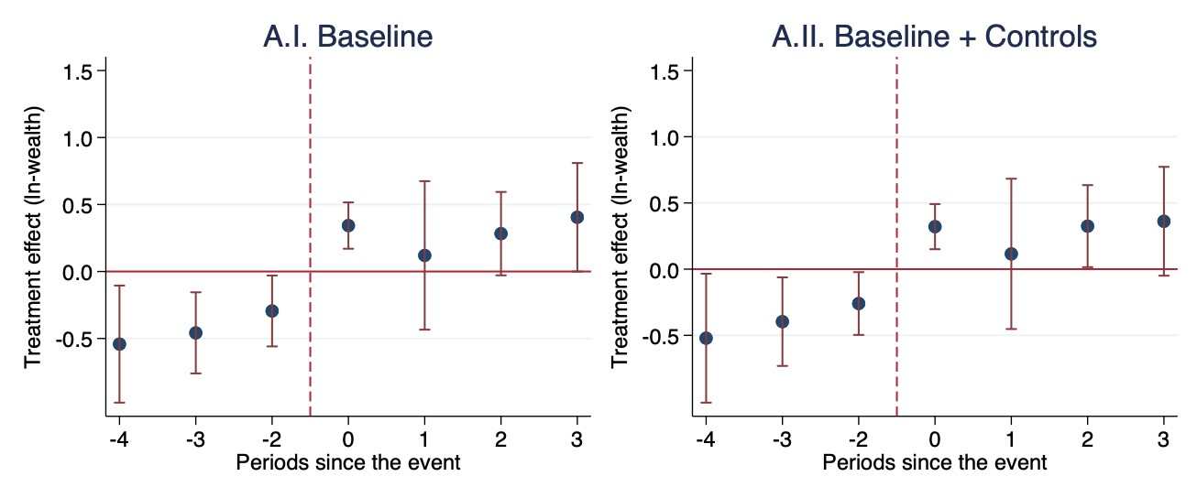
Notes: Regression estimates of ln-wealth before and after becoming city council member (vertical red line), following de Chaisemartin and D’Haultfœuille (2020; 2022). This consists of estimating aggregate impacts comparing all changers with non-changers in the respective period. The omitted reference period (period 0) is indicated by the intersection of the two red lines. All regressions include a full set of taxpayer and time fixed effects, a linear and a quadratic time trend, to control for age and age-squared of the taxpayer. Block-bootstrapped standard errors clustered at the household level in parentheses. Confidence intervals indicate significance at the 95-percent level.
The results in Figure A5.1 show exactly that pattern. The placebo treatment that switches on in period t + 1 produces coefficients that are similar in their pattern but smaller and less statistically significant than the results in the main text. This result suggests that the event study results do not depend on the reference category. Moreover, the fact that the treatment variable employed in the main text captures larger and more statistically significant effects suggests that what drives the observed effect on wealth is the change occurring just before period t = 0, that is, entering the city council, and not some other event.

Wealth Changes of Main Occupational Groups on the City Council
In the main text I have shown that being a merchant while at the same time being a city council member does not explain the substantial enrichment of Nördlingen’s political elites. I have interpreted this result as evidence that better business opportunities were probably not a major channel through which the magistrates enriched themselves when entering office. One might ask whether other occupational groups instead benefited significantly from holding an office. Besides merchants, retailers, taverners and food producers (an umbrella category for several food-producing trades: bakers, confectioners, butchers, brewers and millers) were among the most frequent occupational groups on the city council Friedrichs (1979, p. 175).
Table A5.5 – Mechanisms: Wealth of Other Occupational Groups (de Chaisemartin and D’Haultfœuille (2020; 2022) Diff-in-Diff Estimates)
 | (1) | (2) | (3) | (4) | (5) | (6) | (7)
Nr | Y | Specification | ATT | SE | Up. 95% CI | Lo. 95% CI | N
Treatment: Council member × Post × Retailer
1 | ln-Wealth | Baseline | -0.315 | 0.270 | 0.213 | -0.844 | 5095
2 | ln-Wealth | Baseline + Controls | -0.278 | 0.225 | 0.162 | -0.719 | 5095
Treatment: Council member × Post × Taverner
3 | ln-Wealth | Baseline | 0.183 | 0.245 | 0.663 | -0.297 | 6335
4 | ln-Wealth | Baseline + Controls | 0.226 | 0.243 | 0.702 | -0.251 | 6335
Treatment: Council member × Post × Food producer
5 | ln-Wealth | Baseline | 0.014 | 0.298 | 0.598 | -0.571 | 2603
6 | ln-Wealth | Baseline + Controls | 0.029 | 0.248 | 0.515 | -0.456 | 2603
Notes: Regression estimates of the effect of becoming a council member that “inherited” the seat on the government (Rows 1 and 2), of becoming a council member while also being a merchant (Rows 3 and 4) and of being a city clerk (Rows 5 and 6) on ln-wealth following de Chaisemartin and D’Haultfœuille (2020; 2022). This consists of estimating aggregate impacts comparing all changers with non-changers when treatment begins. All regressions include a full set of taxpayer and time fixed effects, linear and quadratic time trends, and I control for Council member × Post. In the specifications in Rows 1 and 2 I also control for being a retailer. In the specifications in Rows 3 and 4 I also control for being a taverner. In the specifications in Rows 5 and 6 I also control for being a food producer. Block-bootstrapped standard errors are clustered at the household level. Confidence intervals indicate significance at the 95-percent level.

In Table A5.5 I interact these occupational groups with being a city council member. As for merchants, none of these groups had a significant differential wealth share increase. I interpret these results as further evidence that channels other than business opportunities have to be taken into account for explaining the large increase in personal wealth of officeholders.

TWFE Estimates: Wealth and Inequality during the Thirty Years’ War
The analysis of magistrates’ enrichment during the Thirty Years’ War has been conducted using the treatment heterogeneity-robust estimator of De Chaisemartin and D’Haultfœuille (2020; 2022). In this Appendix I conduct parts of the Thirty Years’ War-analysis employing a conventional two-way-fixed-effects (TWFE) OLS estimator.

Table A5.6 – Political Office and Wealth During the 30-Years’ War (Diff-in-Diff Estimates)
 | (1) | (2) | (3) | (4) | (5) | (6)
 | ln-Wealth | ln-Wealth | Percentile | Percentile | Top 5% | Top 5%
Council member × Post × 30-Years’ War | 0.871*** | 0.862*** | 5.975** | 6.069** | 0.204* | 0.190*
 | (0.245) | (0.246) | (2.997) | (3.057) | (0.120) | (0.114)
Council member × Post | YES | YES | YES | YES | YES | YES
Controls | NO | YES | NO | YES | NO | YES
Linear & quadratic time trends | YES | YES | YES | YES | YES | YES
Taxpayer FE | YES | YES | YES | YES | YES | YES
Time FE | YES | YES | YES | YES | YES | YES
R-squared | 0.112 | 0.142 | 0.059 | 0.095 | 0.029 | 0.047
Taxpayers | 1,155 | 1,155 | 1,155 | 1,155 | 1,155 | 1,155
Mean of dependent variable | 5.248 | 5.248 | 48.01 | 48.01 | 0.0596 | 0.0596
Notes: Estimation method is OLS. The period of analysis is 1603-1646. Standard errors clustered at the household level in parentheses. *** p<0.01, ** p<0.05, * p<0.1
The results in Table A5.6 point into the same direction as the results reported in the main text, but they are considerably larger, as the main results for the whole period of study reported above. This suggests again that the concerns raised by the recent DiD literature (see De Chaisemartin and D’Haultfœuille 2020; Goodman-Bacon 2021; Wooldridge 2021) of potentially severely biased aggregate treatment estimates is an issue, also for the part of the analysis that zooms in on the time of the Thirty Years’ War. For this period, too, the alternative estimates reported in the main text should be seen as giving a more realistic picture of the effect of council membership on personal wealth and inequality.

Wealth Changes of Magistrates in Office before the Thirty Years’ War
One concern about the results reported in the main text could be that the wealth increase of magistrates during the Thirty Years’ War was driven by the selection of richer individuals into the city council. The analysis was already restricted to all individuals for which there is at least one observation before and one after the beginning of the war. Here I make the comparison even more stringent, by dropping all magistrates that were recorded in the tax registers before the war began, but that entered their office afterwards.

Figure A5.2 – Political Office and Wealth (de Chaisemartin and D’Haultfœuille (2020; 2022) Flexible Diff-in-Diff Placebo Estimates)
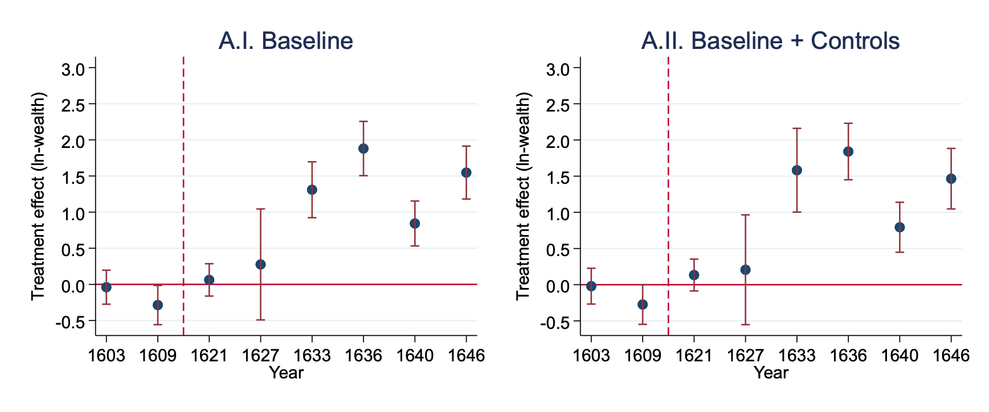
Notes: Regression estimates of ln-wealth before and after becoming city council member (vertical red line), following de Chaisemartin and D’Haultfœuille (2020; 2022). This consists of estimating aggregate impacts comparing all changers with non-changers in the respective period. The omitted reference period (period 0) is indicated by the intersection of the two red lines. The period of analysis is 1603-1646. All regressions include a full set of taxpayer and time fixed effects, a linear and a quadratic time trend. Block-bootstrapped standard errors clustered at the household level in parentheses. Confidence intervals indicate significance at the 95-percent level.
The flexible results in Figure A5.2 show that even those magistrates that were already in office before the war began experienced large personal wealth increases as soon as the war began. Estimates are noisier and confidence intervals are larger, which is most likely the result of the smaller number of treated units, but most post-treatment coefficients are nevertheless large and highly statistically significant. These results hold even when controls are added.

Actual Wealth Changes of Magistrates during the Thirty Years’ War
The analysis in the main text suggests that the magistrates of Nördlingen gained substantially in terms of log-wealth points compared to the rest of the population during the Thirty Years’ War. To get a better sense of the magnitudes of the effect, I repeat the baseline analysis below, but taking actual wealth measured in florin as outcome. The coefficients in Table A5.7 suggest that a city council member on average gained between 1,997 and 2,151 florins during the war, with respect to the rest of the population. These effects are highly statistically significant.
Table A5.7 – Actual Wealth of Magistrates During the 30-Years’ War (de Chaisemartin and
D’Haultfœuille (2020; 2022) Diff-in-Diff Estimates)
 | (1) | (2) | (3) | (4) | (5) |  | (6) | (7)
Nr | Y | Specification | ATT | SE | Up. 95% CI |  | Lo. 95% CI | N
Treatment: Council member × Post × 30-Years’ War
1 | Wealth | Only FE | 1997.415 | 949.809 |  | 3859.041 | 135.790 | 3354
2 | Wealth | Baseline | 2022.971 | 976.980 |  | 3937.851 | 108.091 | 3354
3 | Wealth | Baseline + Controls | 2151.823 | 992.038 |  | 4096.218 | 207.428 | 3354
Notes: Regression estimates of the effect of becoming a council member during the Thirty Years’ War on actual wealth following de Chaisemartin and D’Haultfœuille (2020; 2022). This consists of estimating aggregate impacts comparing all changers with non-changers when treatment begins. The period of analysis is 1603-1646. All regressions include a full set of taxpayer and time fixed effects, and I control for Council member × Post. Block-bootstrapped standard errors are clustered at the household level. Confidence intervals indicate significance at the 95-percent level.

References Appendix
Alfani, Guido. As Gods among Men. A History of the Rich in the West. Princeton: Princeton University Press, 2023.
Alfani, Guido, and Matteo Di Tullio. The Lion’s Share. Inequality and the Rise of the Fiscal State in Preindustrial Europe. Cambridge: Cambridge University Press, 2019.
Alfani, Guido, Victoria Gierok, and Felix Schaff. “Economic Inequality in Preindustrial Germany, ca. 1300 – 1850.” Journal of Economic History 82, no. 1 (2022), 87–125.
Andermann, Kurt. Zwischen Zunft Und Patriziat: Beobachtungen Zur Sozialen Mobilität in Oberdeutschen Städten Des Späten Mittelalters. In Kurt Andermann and Peter Johanek (Eds.), Zwischen Adel Und Nicht-Adel; Konstanzer Arbeitskreis Bd. 53: Vorträge und Forschungen., pp. 361–382. Stuttgart: Jan Thorbecke Verlag, 2001.
Bairoch, Paul, Jean Batou, and Pierre Chèvre. The Population of European Cities from 1300 to 1850. Geneva: Librairie Droz, 1988.
Baltzarek, Franz, Johanne Pradel, and Roman Sandgruber. Österreichisches Städtebuch, Bd. 3: Die Städte Vorarlbergs. Wien: Verlag der Österreichischen Akademie der Wissenschaften, 1973.
Bátori, Ingrid. Daily Life and Culture of an Urban Elite: The Imperial City of Nördlingen in the 15th and 16th Century. History of European Ideas 11, no. 1 (1990): 621–627.
_____. “Ratsräson und Bürgersinn. Zur Führungsschicht der Reichsstadt Nördlingen im 15. und 16. Jahrhundert.” In Christoph Ocker (Ed.), Politics and Reformations: Communities, Politics, Nations and Empires. Essays in Honour of Thomas A. Brady Jr., pp. 85–119. Leiden: Brill, 2007.
De Chaisemartin, Clemens and Xavier D’Haultfœuille. “Two-Way Fixed Effects Estimators with Heterogeneous Treatment Effects.” American Economic Review 110, no. 9 (2020): 2964–2996.
_____. “Difference-in-Differences Estimators of Intertemporal Treatment Effects.” Unpublished manuscript, Sciences Po, 2022.
De Vries, Jan and Ad Van der Woude (1997). The First Modern Economy: Success, Failure, and Perseverance of the Dutch Economy, 1500-1815. Cambridge: Cambridge University Press.
Friedrichs, Christopher. Urban Society in an Age of War: Nördlingen, 1580-1720. Princeton: Princeton University Press, 1979.
_____. Guide to the statistical output sheets containing data from the Steuerregister of Nördlingen, 1579-1700 with code book. Vancouver: Manuscript University of British Columbia, 2016.
Fritz, Gerhard. Des Herzogs ungetreue Diener. Vögte und Amtleute in Altwürttemberg zwischen Legitimität, Korruption und Untertanenprotest. Zeitschrift für württembergische Landesgeschichte 63, no. 1 (2004): 119–167.
Goodman-Bacon, Andrew. Difference-in-Differences with Variation in Treatment Timing. Journal of Econometrics 225, no. 2 (2021):254–277.
Härter, Karl. Security and “Gute Policey” in Early Modern Europe: Conepts Laws and Instruments. Historical Social Research 35, no. 4 (2010):41–65.
Henderson, John. Florence under siege: surviving plague in an early modern city. New Haven: Yale University Press, 2019.
Isenmann, Eberhard. Die Deutsche Stadt im Mittelalter 1150-1550. Köln: Böhlau, 2014.
Keyser, Erich. Deutsches Städtebuch. Stuttgart: Kohlhammer, 1939-74.
Kluge, Arnd. Die Zünfte. Stuttgart: Franz Steiner Verlag, 2007.
Mann, Golo. Wallenstein: sein Leben. Frankfurt: S. Fischer, 1987.
Minns, Chris, Clare Crowston, Raoul de Kerf, Bert de Munck, Marcel Hoogenboom, Christopher Kissane, Marten Prak, and Patrick Wallis (2020). “The extent of citizenship in pre-industrial England, Germany, and the Low Countries.” European Review of Economic History 24, no. 3 (2020): 601–625.
Ogilvie, Sheilagh. Institutions and European Trade: Merchant Guilds, 1000-1800. Cambridge: Cambridge University Press, 2011.
_____. The European Guilds: An Economic Analysis. Princeton: Princeton University Press, 2019.
Quarthal, Franz. “’Die besten, getreuesten und anhänglichsten Untertanen’ - Zur Geschichte der schwäbisch-österreichischen Landstände.“ Beiträge zur Landeskunde: Regelmäßige Beilage zum Staatsanzeiger für Baden Württemberg 1, no. February (1979): 1–13.
Schaff, Felix. Exploring the Political Economy Causes of Inequality in Pre-Industrial Germany (c. 1350-1850). Unpublished Ph.D. Dissertation, London School of Economics, 2022.
_____. “Warfare and Economic Inequality: Evidence from Preindustrial Germany (c.1400-1800).” Explorations in Economic History 89, no. 2 (2023a): 101495.
_____. “The Unequal Spirit of the Protestant Reformation: Particularism and Wealth Distribution in Early Modern Germany”, Unpublished manuscript, European University Institute Florence, 2023b.
Schilling, Heinz. Aufbruch und Krise: Deutschland 1517-1648. Berlin: Siedler, 1994.
Schilling, Heinz and Stefan Ehrenpreis. Die Stadt in der Frühen Neuzeit. München: Oldenbourg, 2015.
Stuart, Kathy. Defiled Trades and Social Outcasts: Honor and Ritual Pollution in Early Modern Germany. Cambridge: Cambridge University Press, 1999.
Voges, Dieter. Die Reichsstadt Nördlingen. München: C. H. Beck, 1988.
Wahl, Fabian. Political participation and economic development. Evidence from the rise of participative political institutions in the late medieval German Lands. European Review of Economic History 23, no. 2 (2019): 193–213.
Wooldridge, Jeffrey. Two-Way Fixed Effects, the Two-Way Mundlak Regression, and Difference-in-Differences Estimators. Unpublished manuscript, Michigan State University, 2021.

