*Classicism and Modern Growth: The Shadow of the Sages*

*Online Appendix*

Chicheng Ma

The University of Hong Kong

July 2023

**Appendix 1. Tables**

Table A1. Descriptive Statistics

|  |  |  |  |  |  |
| --- | --- | --- | --- | --- | --- |
| Variable name | Obs. | Mean | Std. Dev. | Min | Max |
|  |  |  |  |  |  |
| Variables on economic modernization |  |  |  |  |  |
| Industrial firms 1858–1927 | 269 | 10.82 | 53.43 | 0 | 735 |
| Industrial firms 1906–1927 | 269 | 8 | 39.86 | 0 | 600 |
| Modern banks 1897–1927 | 269 | 2.97 | 8.93 | 0 | 98 |
|  |  |  |  |  |  |
| Variables on traditional economic prosperity | |  |  |  |  |
| Population 1580 (per 1,000 people) | 269 | 630.78 | 688.58 | 5.79 | 3,646 |
| Population 1820 (per 1,000 people) | 269 | 1,398.22 | 1,240.60 | 18 | 6,663 |
| Agricultural tax 1820 (silver *liang*) | 269 | 114,000 | 132,860 | 90.32 | 701,788 |
| Silk textile center | 269 | 0.09 | 0.29 | 0 | 1 |
|  |  |  |  |  |  |
| Variables on classical and non-classical worship | |  |  |  |  |
| Sage temples | 269 | 1.25 | 1.71 | 0 | 11 |
| Non-sage temples | 269 | 11.79 | 11.04 | 0 | 75 |
| Number of sages (IV) | 269 | 0.52 | 2.88 | 0 | 44 |
|  |  |  |  |  |  |
| Variables on modern knowledge/human capital | | | |  |  |
| Modern journals 1872–1927 | 269 | 1.58 | 9.21 | 0 | 108 |
| Engineers 1880-1920 (per million people) | 269 | 26 | 47.05 | 0 | 310.64 |
| Modern school enrollment 1907–1914 (per million people) | 269 | 6,408 | 8,572.43 | 0 | 113,434.3 |
|  |  |  |  |  |  |
| Control variables |  |  |  |  |  |
| Distance to coast (km) | 269 | 511.84 | 370.16 | 2.18 | 1,925.51 |
| Distance to river (km) | 269 | 6.93 | 7.39 | 0.03 | 55.72 |
| Terrain ruggedness index | 269 | 184.61 | 139.94 | 1.28 | 790.1 |
| Land area (km2) | 269 | 16,149.84 | 19,854.16 | 923.68 | 198,269 |
| Agricultural suitability index | 269 | 24.47 | 16.86 | 0 | 80.48 |
| Treaty port | 269 | 0.16 | 0.37 | 0 | 1 |
| Number of counties | 269 | 5.75 | 3.97 | 0 | 26 |
| Number of post offices | 269 | 5.23 | 2.99 | 0 | 18 |
| Exam degree holders (*jinshi*, 1371–1820) | 269 | 139.43 | 216.95 | 0 | 1192 |
| Exam quota (late nineteenth century) | 269 | 110.12 | 77.59 | 0 | 423 |
| Number of Chinese Christians | 260 | 1,232 | 2,500 | 0 | 25,359 |
| Longitude | 269 | 111.55 | 5.83 | 95.33 | 121.67 |
| Latitude | 269 | 30.71 | 5.05 | 19.19 | 42.24 |
|  |  |  |  |  |  |
| Contemporary industrial innovation |  |  |  |  |  |
| Proportion of industrial firms with patents (%, 1998-2007) | 266 | 2.69 | 2.37 | 0 | 11.04 |
| Number of patents per industrial firm (1998-2007) | 266 | 0.18 | 0.27 | 0 | 2.48 |
| Number of high-tech firms by 2021 per million people | 263 | 1.84 | 6.37 | 0 | 88.82 |
| Number of industrial firms (1998-2007) | 266 | 1,635.76 | 3,253.93 | 5 | 26,004 |

Table A2. Classical Worship and Economic Modernization in Alternative Measures

|  |  |  |  |  |  |
| --- | --- | --- | --- | --- | --- |
|  | Industrial firms  1858–1927, winsorized | Industrial firms  1858–1927,  non-zero | Industrial firms  1858–1927,  per million people, winsorized | Industrial firms  1906–1927,  per million people, winsorized, classical education abolished | Modern banks 1927 |
|  | (1) | (2) | (3) | (4) | (5) |
|  | Panel A. OLS estimates | | | | |
| Sage temples | -2.697** | -5.735** | -0.730** | -0.500** | -0.855** |
|  | (1.157) | (2.383) | (0.325) | (0.224) | (0.353) |
| Non-sage temples | 0.584 | 0.520 | 0.209 | 0.169* | 0.225* |
|  | (0.478) | (0.642) | (0.136) | (0.090) | (0.115) |
| Controls | Yes | Yes | Yes | Yes | Yes |
| Observations | 269 | 143 | 269 | 269 | 269 |
| R-squared | 0.397 | 0.228 | 0.357 | 0.333 | 0.316 |
|  | Panel B. IV estimates | | | | |
| Sage temples | -2.980** | -5.025*** | -0.663** | -0.642*** | -1.408*** |
|  | (1.513) | (1.884) | (0.299) | (0.226) | (0.390) |
| Non-sage temples | 0.595 | 0.491 | 0.207 | 0.175** | 0.248** |
|  | (0.489) | (0.650) | (0.134) | (0.086) | (0.112) |
| Controls | Yes | Yes | Yes | Yes | Yes |
| Observations | 269 | 143 | 269 | 269 | 269 |
| *R*-squared | 0.396 | 0.228 | 0.357 | 0.332 | 0.308 |
| First stage K-P *F*-statistics | 40.42 | 22.29 | 22.87 | 22.87 | 22.87 |

*Notes*: Column 1 winsorizes the top 1% distribution of the number of industrial firms, column 2 excludes prefectures without industrial firms during the sample period, and columns 3 and 4 normalize the number of industrial firms by the average prefectural population of 1910 and 1920 and winsorize its top 1% distribution. Column 5 uses the number of modern banks established by Chinese as an alternative measure of economic modernization. Panel A replicates the cross-prefectural estimation in column 2 of Table 1; Panel B replicates the 2SLS cross-prefectural estimation in column 2 of Table 2. Both control for geography (log distance to coast, log distance to the nearest navigable river, terrain ruggedness index, log land area, and agricultural suitability index for planting wheat and rice), economic conditions (log population in 1820, treaty port), state capacity (number of counties and number of postal offices), and classical human capital (exam degree holders and quota). Standard errors in (parentheses) are clustered within a radius of 136 km to account for possible spatial correlation among neighboring prefectures based on Colella et al. (2019). *, **, and *** indicate the level of significance at 10 percent, 5 percent, and 1 percent level, respectively.

*Source*: See the text.

Table A3. Classical Worship and Industrial Development by Sector

|  |  |  |  |  |  |
| --- | --- | --- | --- | --- | --- |
|  | The dependent variable is the number of industrial firms in the following sectors: | | | | |
|  | Textile | Food processing | Chemical industry | Machinery + transport + mining | Construction + water + electricity |
|  | (1) | (2) | (3) | (4) | (5) |
|  | Panel A. OLS estimates | | | | |
| Sage temples | -2.186** | -0.684* | -0.304* | -0.790** | -0.378* |
|  | (1.087) | (0.384) | (0.174) | (0.340) | (0.207) |
| Non-sage temples | 0.001 | 0.224 | 0.034 | 0.110 | 0.066 |
|  | (0.291) | (0.140) | (0.033) | (0.085) | (0.053) |
|  | Panel B. Poisson estimates | | | | |
| Sage temples | -0.613*** | -0.285** | -0.179* | -0.236*** | -0.114* |
|  | [0.171] | [0.127] | [0.108] | [0.085] | [0.061] |
| Non-sage temples | 0.030 | 0.067*** | 0.025* | 0.034** | 0.014 |
|  | [0.024] | [0.020] | [0.013] | [0.015] | [0.014] |
|  |  |  |  |  |  |
| Controls | Yes | Yes | Yes | Yes | Yes |
| Observations | 269 | 269 | 269 | 269 | 269 |
| Mean of dependent variable | 3.35 | 1.57 | 1.03 | 2.18 | 1.96 |

*Notes*: Panel A replicates column 2 of Table 1, and Panel B replicates column 3 of Table 1; both divide the number of industrial firms by sector. Standard errors in (parentheses) are clustered within a radius of 136 km to account for possible spatial correlation among neighboring prefectures based on Colella et al. (2019). Robust standard errors are in [brackets]. *, **, and *** indicate the level of significance at 10 percent, 5 percent, and 1 percent level, respectively.

*Source*: See the text.

Table A4. Number of Sages (IV), Classical Worship, and Industrial Firms

|  |  |  |  |  |  |  |  |
| --- | --- | --- | --- | --- | --- | --- | --- |
|  | Sage temples | Sage temples | Non-sage temples | Non-sage temples | Industrial firms  1858–1927 | Industrial firms  1858–1927 | Industrial firms  1858–1927 |
|  | (1) | (2) | (3) | (4) | (5) | (6) | (7) |
|  |  |  |  |  |  |  |  |
| Number of sages (IV) | 0.181*** | 0.147*** | 0.377 | 0.048 | -0.453* | -0.457* | 0.251 |
|  | (0.048) | (0.030) | (0.242) | (0.079) | (0.243) | (0.246) | (0.277) |
| Non-sage temples |  |  |  |  |  | 0.322 | 0.513 |
|  |  |  |  |  |  | (0.607) | (0.561) |
| Sage temples |  |  |  |  |  |  | -4.807** |
|  |  |  |  |  |  |  | (2.147) |
| Population 1393/1820 (log) |  | 0.190* |  | 1.432** | -10.218* | -10.416* | -10.888* |
|  |  | (0.098) |  | (0.638) | (5.647) | (5.677) | (5.658) |
| Treaty port |  |  |  |  | 34.983** | 34.353** | 34.743** |
|  |  |  |  |  | (16.321) | (16.521) | (16.766) |
| Number of counties |  |  |  |  | -0.361 | -0.424 | -0.721 |
|  |  |  |  |  | (1.319) | (1.255) | (1.268) |
| Number of post offices |  |  |  |  | 2.328 | 2.379 | 2.290 |
|  |  |  |  |  | (1.668) | (1.651) | (1.521) |
| Degree holders (log) |  | 0.293*** |  | 2.862*** | -0.883 | -1.078 | -0.560 |
|  |  | (0.077) |  | (0.561) | (1.926) | (1.885) | (1.769) |
| Exam quota |  |  |  |  | 0.173* | 0.144 | 0.184 |
|  |  |  |  |  | (0.090) | (0.113) | (0.116) |
| Geographic controls |  | Yes |  | Yes | Yes | Yes | Yes |
| Observations | 269 | 269 | 269 | 269 | 269 | 269 | 269 |
| *R*-squared | 0.093 | 0.292 | 0.010 | 0.420 | 0.188 | 0.190 | 0.205 |

*Notes*: The instrumental variable is the number of sages born in each prefecture between 580 BCE and 1630. Geographic controls are the same as those in Table 1. Columns 2 and 4 control for the population in 1393 in accordance with the period of temple building. All columns are OLS estimates. Standard errors in parentheses are clustered within a radius of 136 km to account for possible spatial correlation among neighboring prefectures based on Colella et al. (2019). *, **, and *** indicate the level of significance at 10 percent, 5 percent, and 1 percent level, respectively.

*Source*: See the text.

Table A5. Number of Sages (IV) and Prefectural Characteristics

|  |  |  |  |  |
| --- | --- | --- | --- | --- |
|  | Distance to coast (log) | Distance to river (log) | Terrain ruggedness index (log) | Agricultural suitability index |
|  | (1) | (2) | (3) | (4) |
| Number of sages | -0.025* | -0.008 | -0.060*** | -0.015 |
|  | (0.015) | (0.026) | (0.021) | (0.147) |
| Observations | 269 | 269 | 269 | 269 |
| R-squared | 0.004 | 0.000 | 0.016 | 0.000 |
|  | Population in 1820 (log) | Number of degree holders 1393–1820 (*jinshi*, log) | Number of clans in 1857 (genealogy books) | Number of Chinese Christians 1920 |
|  | (5) | (6) | (7) | (8) |
| Number of sages | 0.037** | 0.008 | 0.778 | 0.023 |
|  | (0.015) | (0.012) | (2.007) | (0.017) |
| Geographic controls | Yes | Yes | Yes | Yes |
| Population 1820 (log) |  | Yes | Yes | Yes |
| Treaty port |  |  |  | Yes |
| Observations | 269 | 269 | 269 | 260 |
| *R*-squared | 0.534 | 0.669 | 0.169 | 0.543 |

*Notes*: The table reports OLS estimates on the correlation between the number of sages and prefectural characteristics. In column 7, clans are measured by genealogy books that had been compiled by 1857 (before the first industrial firm appeared in China) based on the data of Chen, Ma, and Sinclair (2022). Geographic controls are the same as those in Table 1. Standard errors in parentheses are clustered within a radius of 136 km to account for possible spatial correlation among neighboring prefectures based on Colella et al. (2019). *, **, and *** indicate the level of significance at 10 percent, 5 percent, and 1 percent level, respectively.

*Source*: See the text.

Table A6. Testing the Spillover Effect of the Neighboring Sages

|  |  |  |  |
| --- | --- | --- | --- |
|  | (1) | (2) | (3) |
|  | Panel A. Industrial firms 1858–1927 | | |
| Number of sages in 200 km (outside the local) | -0.317 |  |  |
|  | (0.282) |  |  |
| Number of sages in 200-300 km |  | -0.454 |  |
|  |  | (0.307) |  |
| Number of sages in 300-400 km |  |  | -0.366 |
|  |  |  | (0.375) |
|  | Panel B. Industrial firms 1906–1927 | | |
| Number of sages in 200 km (outside the local) | -0.221 |  |  |
|  | (0.235) |  |  |
| Number of sages in 200-300 km |  | -0.341 |  |
|  |  | (0.246) |  |
| Number of sages in 300-400 km |  |  | -0.276 |
|  |  |  | (0.307) |
| Geographic controls | Yes | Yes | Yes |
| Observations | 269 | 269 | 269 |

*Notes*: The table reports OLS estimates of the correlation between the number of industrial firms and the number of sages in the neighboring prefectures. The neighboring sages are those born within 200 (excluding the sages born in this prefecture), 200-300 or 300-400 kilometers of the prefectural centroid. 400 kilometers approximately covers a prefecture’s neighboring prefectures and their neighbors further around. Geographic controls are the same as those of Table 1. Robust standard errors are reported in parentheses. *, **, and *** indicate the level of significance at 10 percent, 5 percent, and 1 percent level, respectively.

*Source*: See the text.

Table A7. Correlations between the Explanatory Variables

|  |  |  |  |  |  |  |  |  |  |  |  |  |
| --- | --- | --- | --- | --- | --- | --- | --- | --- | --- | --- | --- | --- |
|  | Longitude | Latitude | Distance to coast | Distance to river | Terrain ruggedness | Land area | Agricultural suitability | Treaty port | Population 1820 | Exam degree holders | Exam quota | Number of counties |
| Latitude | 0.21*** |  |  |  |  |  |  |  |  |  |  |  |
| Number of sages | 0.13** | 0.11* |  |  |  |  |  |  |  |  |  |  |
| Sage temples | 0.32*** | -0.02 |  |  |  |  |  |  |  |  |  |  |
| Non-sage temples | 0.38*** | 0.15** |  |  |  |  |  |  |  |  |  |  |
| Distance to coast | -0.71*** | 0.14** |  |  |  |  |  |  |  |  |  |  |
| Distance to river | -0.17*** | -0.04 | 0.10* |  |  |  |  |  |  |  |  |  |
| Terrain ruggedness | -0.52*** | -0.37*** | 0.45*** | 0.13** |  |  |  |  |  |  |  |  |
| Land area (km2) | -0.26*** | 0.02 | 0.19*** | 0.06 | 0.24*** |  |  |  |  |  |  |  |
| Agricultural suitability | 0.53*** | -0.14** | -0.40*** | -0.18*** | -0.50*** | -0.22*** |  |  |  |  |  |  |
| Treaty port | 0.19*** | -0.12* | -0.33*** | -0.10* | -0.15** | 0.11* | 0.20*** |  |  |  |  |  |
| Population 1820 | 0.52*** | 0.11* | -0.37*** | -0.21*** | -0.42*** | 0.31*** | 0.47*** | 0.29*** |  |  |  |  |
| Exam degree holders | 0.60*** | 0.21*** | -0.38*** | -0.23*** | -0.42*** | 0.06 | 0.44*** | 0.18*** | 0.79*** |  |  |  |
| Exam quota | 0.45*** | 0.10 | -0.31*** | -0.21*** | -0.31*** | 0.27*** | 0.31*** | 0.25*** | 0.80*** | 0.80*** |  |  |
| Number of counties | 0.16*** | 0.08 | -0.16*** | -0.14** | -0.14** | 0.47*** | 0.02 | 0.23*** | 0.63*** | 0.53*** | 0.78*** |  |
| Number of post offices | 0.15** | 0.12* | -0.08 | -0.14** | -0.12** | 0.44*** | 0.04 | 0.10* | 0.65*** | 0.58*** | 0.80*** | 0.80*** |

*Notes*: The sample includes 269 prefectures of China proper. *, **, and *** indicate the level of significance at 10 percent, 5 percent, and 1 percent level, respectively.

*Source*: See the text.

Table A8. Multicollinearity Tests for the Explanatory Variables

|  |  |  |
| --- | --- | --- |
|  | Industrial firms 1906-1027 | |
|  | Coef. [s.e.] | VIF |
|  | (1) | (2) |
|  |  |  |
| Constant | 25.859 [70.709] |  |
| Sage temples | -2.535 [1.272]* | 1.74 |
| Non-sage temples | 0.678 [0.418] | 3.01 |
| Distance to coast | -5.780 [2.574]** | 4.67 |
| Distance to river | 1.603 [0.970] | 1.16 |
| Terrain ruggedness index | -4.043 [4.805] | 3.22 |
| Land area | -0.157 [1.267] | 2.83 |
| Agricultural suitability index | 0.145 [0.160] | 3.63 |
| Population in 1820 | -7.396 [6.109] | 6.49 |
| Treaty port | 22.943 [13.209] | 1.34 |
| Number of counties | 0.321 [1.262] | 4.99 |
| Number of post offices | 1.530 [1.247] | 4.93 |
| Exam degree holders | 1.042 [2.114] | 5.7 |
| Exam quota | 0.032 [0.072] | 11.13 |
| Longitude | 0.036 [0.839] | 14.67 |
| Latitude | 1.136 [0.929] | 12.58 |
| Macroregion dummies | 48,639.57 (0.000)  *F*-statistic (*p*-value) for joint significance | 22.63  (Mean VIF) |
| Observations | 269 |  |
| *R*-squared | 0.216 |  |

*Notes*: The table examines the degree of multicollinearity for each independent variable used to predict the number of industrial firms based on the variance inflation factor (VIF) approach. Macroregions refer to 18 physiographic regions of China proper based on the division by Skinner, Henderson, and Yue (2013); and their *F*-statistic and average VIF value are reported. Standard errors in [bracket] are clustered within macroregions. *, **, and *** indicate the level of significance at 10 percent, 5 percent, and 1 percent level, respectively.

*Source*: See the text.

Table A9. Classical Worship and Contemporary Industrial Development

|  |  |  |  |  |
| --- | --- | --- | --- | --- |
|  | Number of industrial firms in 1984 (log) | Number of industrial firms in 1984 (log) | Proportion of industrial output in GDP (%, 1999-2018 average) | Proportion of industrial output in GDP (%, 1999-2018 average) |
|  | OLS | IV | OLS | IV |
|  | (1) | (2) | (3) | (4) |
|  |  |  |  |  |
| Sage temples | -0.019 | 0.060 | 0.046 | 0.489 |
|  | (0.031) | (0.048) | (0.253) | (0.353) |
| Non-sage temples | 0.019** | 0.016* | 0.008 | -0.010 |
|  | (0.009) | (0.009) | (0.051) | (0.051) |
| Geographic controls | Yes | Yes | Yes | Yes |
| Economic conditions | Yes | Yes | Yes | Yes |
| State capacity | Yes | Yes | Yes | Yes |
| Classical education | Yes | Yes | Yes | Yes |
| Observations | 267 | 267 | 263 | 263 |
| *R*-squared | 0.409 | 0.399 | 0.180 | 0.172 |

*Notes*: The table examines the effect of the number of sage temples on contemporary industrial development at the prefectural level. The number of industrial firms in 1984 approximately reflects the industrial achievement under the Socialist Industrialization during the state planning period (circa 1953-1978). The proportion of industrial output in GDP (1999-2018 average) reflects the industrial development level since the market reform. The data were obtained from China City Statistical Yearbooks of the National Bureau of Statistics of China (1985, 2000-2019), and are matched to the prefectural boundaries of the Qing Dynasty in 1820 based on CHGIS (version 6). Sage temples are instrumented by the number of sages in columns 2 and 4. Controls are the same as those in Table 1. Standard errors in (parentheses) are clustered within a radius of 136 km to account for possible spatial correlation between neighboring prefectures based on Colella et al. (2019). *, **, and *** indicate the level of significance at 10 percent, 5 percent, and 1 percent level, respectively.

*Source*: See the text.

**Appendix 2. Figures**

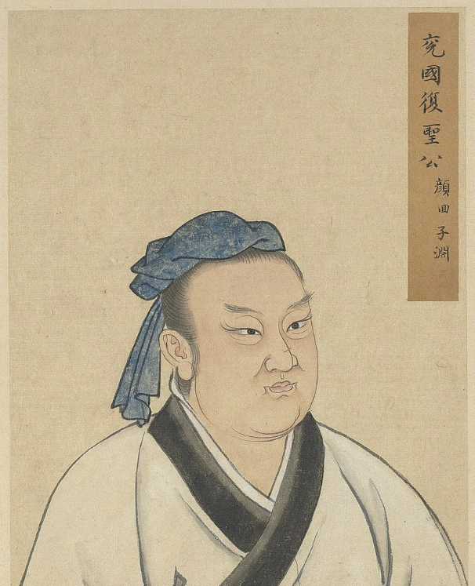 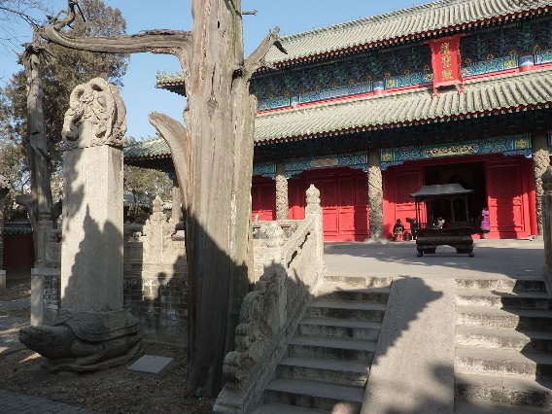 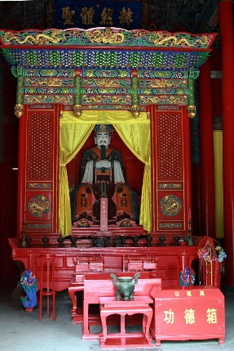

(a) Yan Hui (circa 521–481 BCE), co-author of the classic book *The Analects*, and his temple in his home prefecture of Yanzhou, Shandong Province

 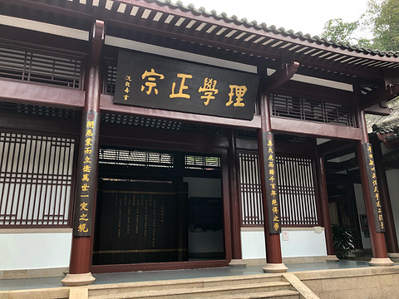 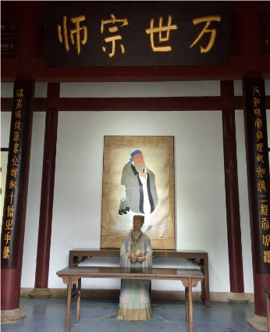

(b) Zhu Xi (1130–1200), master of the Neo-Confucian school and author of the classic book *Notes on the Four Books*, and his temple in his home prefecture of Jianning, Fujian Province

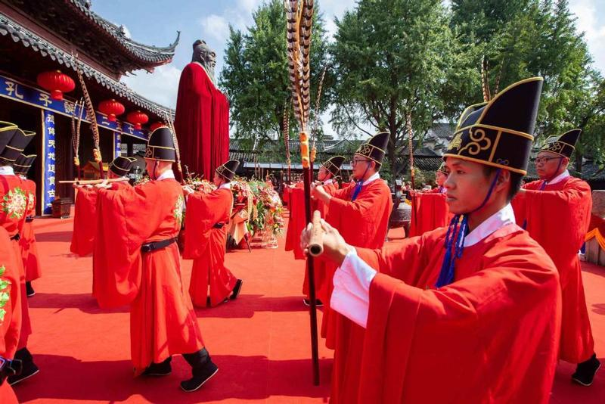 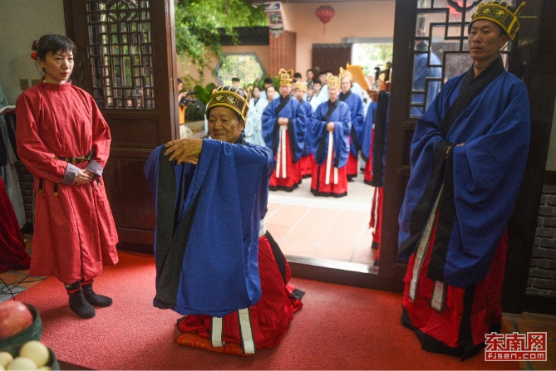

(c) Performing traditional sacrificial ceremonies in the Confucius Temple of Nanjing in 2020 (left) and in Zhu Xi Temple of Tong-An county in 2017 (right)

Figure A1. Sages, Sage Temples, and Sacrificial Activities in China

*Source*: (a) Wikepedia: en.wikipedia.org/wiki/Yan_Hui; (b) Wikepedia: en.wikipedia.org/wiki/Zhu_Xi; Qunar.com: travel.qunar.com/p-oi718697-wuyijingshe. (c) China Daily: www.chinadailyhk.com/article/144858; Kknews: kknews.cc/culture/b4n9jan.html.

Figure A2. Number of Chinese Industrial Firms Established in Each Year, by Sector

*Notes*: 233 (8%) of industrial firms have no record of the year of establishment (shown in the column ‘Unknown’).

*Source*: The data are based on Du (1991).



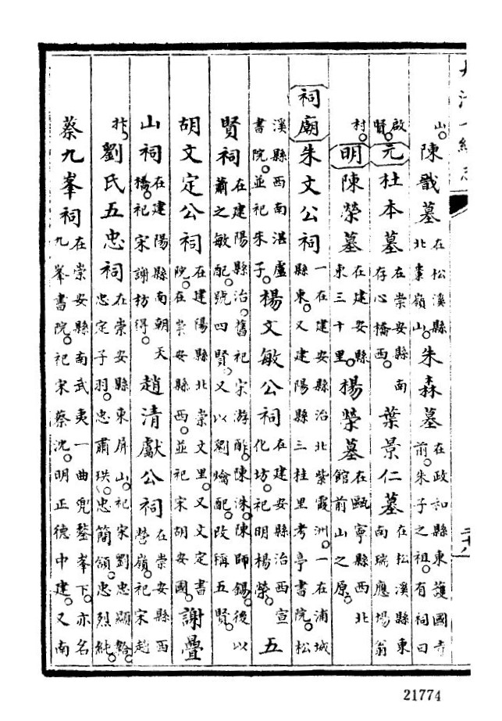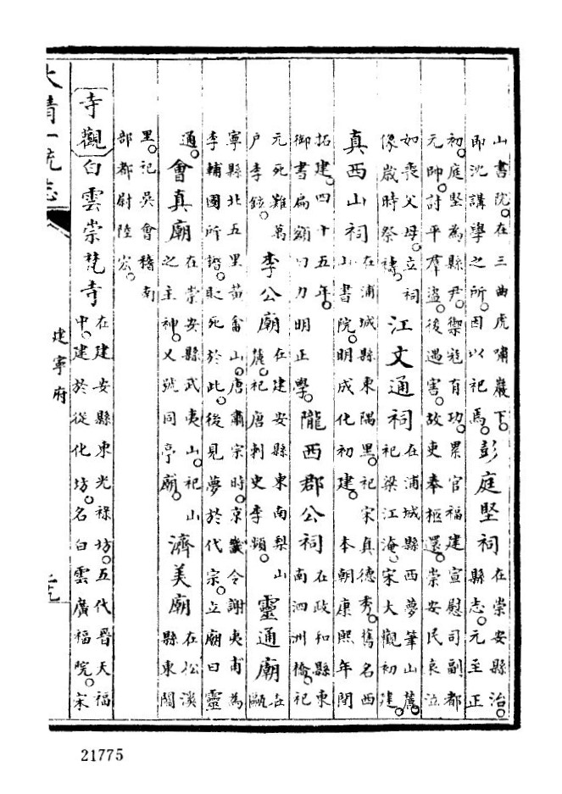

Figure A3. Records of the Temples in the *Unified Chorography of the Qing Dynasty* (*Jiaqing Chongxiu Daqing Yitong Zhi*).

*Notes*: The pages list some of the temples that existed in 1820 in Jianning Prefecture of Fujian Province, home of the neo-Confucian master Zhu Xi (1130–1200) who was first conferred as a sage in 1241. Temples enshrining sages (non-sages) are indicated in pink (blue).

*Source*: *Unified Chorography of the Qing Dynasty.*

(a)

(b)

Figure A4. Distribution of Values in the Main Variables

*Source*: See the text.

Figure A5. Dynamic Effect of Classical Worship on Industrial Firms

*Notes*: The figure compares the effects of sage temples vs. non-sage temples on the number of industrial firms, based on the panel regression specification:

Firms*it* =*α* +*β1* *t* × SageTemples*i* + *β2* *t* × NonSageTemples*i* + *λ* *t* × **X**’ + *Pi* + *Dt* + *εit*,

in which *β1* and *β2* are plotted in the figure, with the decade 1858-1867 as the reference. **X**’ denotes a vector of control variables that are the same as those used in Table 1 (column 2). *Pi* and *Dt* denote prefectural and decadal fixed effects, respectively. Standard errors are clustered at the prefectural level.

*Source*: See the text

(a) By sages’ living times

(b) By type of non-sage figures

Figure A6. Decomposing the Temple Effect

*Notes*: The two charts plot the OLS estimates (coefficients with 95 percent confidence intervals) of Equation (2), dividing the temples by type and comparing their relative importance in affecting the number of industrial firms. In Figure (a), sage temples are divided into three groups based on when the enshrined sages lived. Figure (b) divides non-sage temples into six types based on the identity of the figures enshrined. The controls are the same as those used in column 2 of Table 1. Standard errors in parentheses are clustered within a radius of 136 km to account for possible spatial correlation among neighboring prefectures based on Colella et al. (2019).

*Source*: See the text.



(a) Correlation without controls



(b) Correlation with controls

Figure A7. Correlation between the Number of Sages and the Number of Sage Temples

*Notes*: The correlation plots correspond to the regressions for the 269 prefectures in columns (1) and (2) of Table A4, except that the top 1% in the distribution of the number of sages is winsorized. Figure (b) controls for geographic factors (that are the same as those in Table 1), log population in 1393, and log number of degree holders (*jinshi*) between 1371 and 1820.

*Source*: See the text.

Figure A8. Times of the Sages and Their Temple Building

*Notes*: The figure displays in which centuries the sages lived and when sage temples were built. The year of construction is available for 42% of the temples in the sample.

*Source*: See the text.

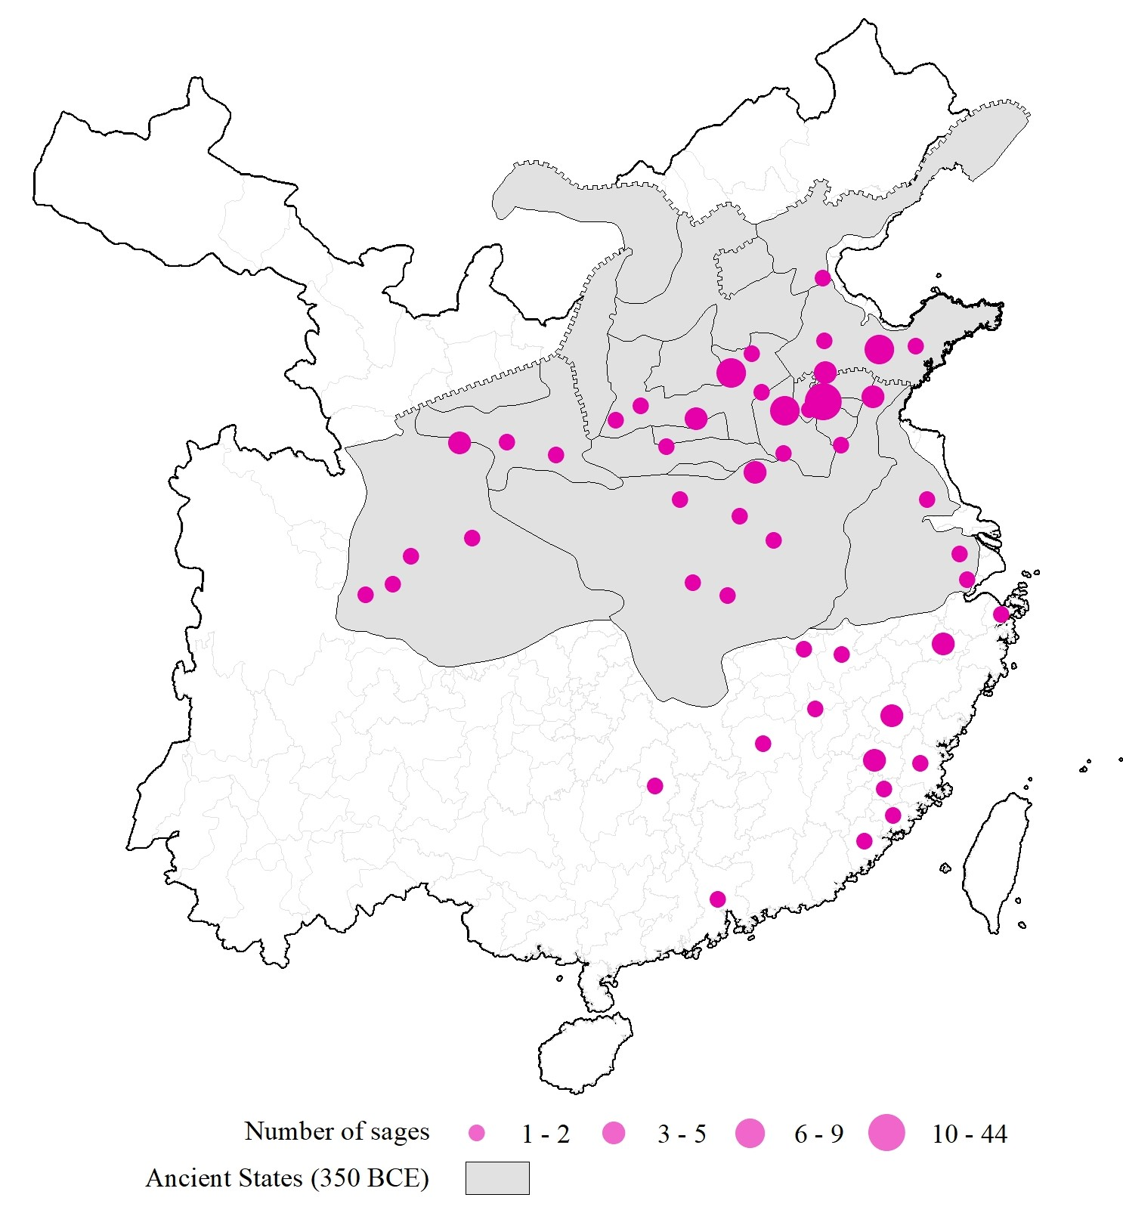

Figure A9. Sages and Ancient States

*Notes*: Ancient states refer to the vassals during the Eastern Zhou period (771-256 BCE) where and when the majority of sages were born. The state borders are based on the situation of 350 BCE according to Herrmann (1935).

*Source*: See the text.

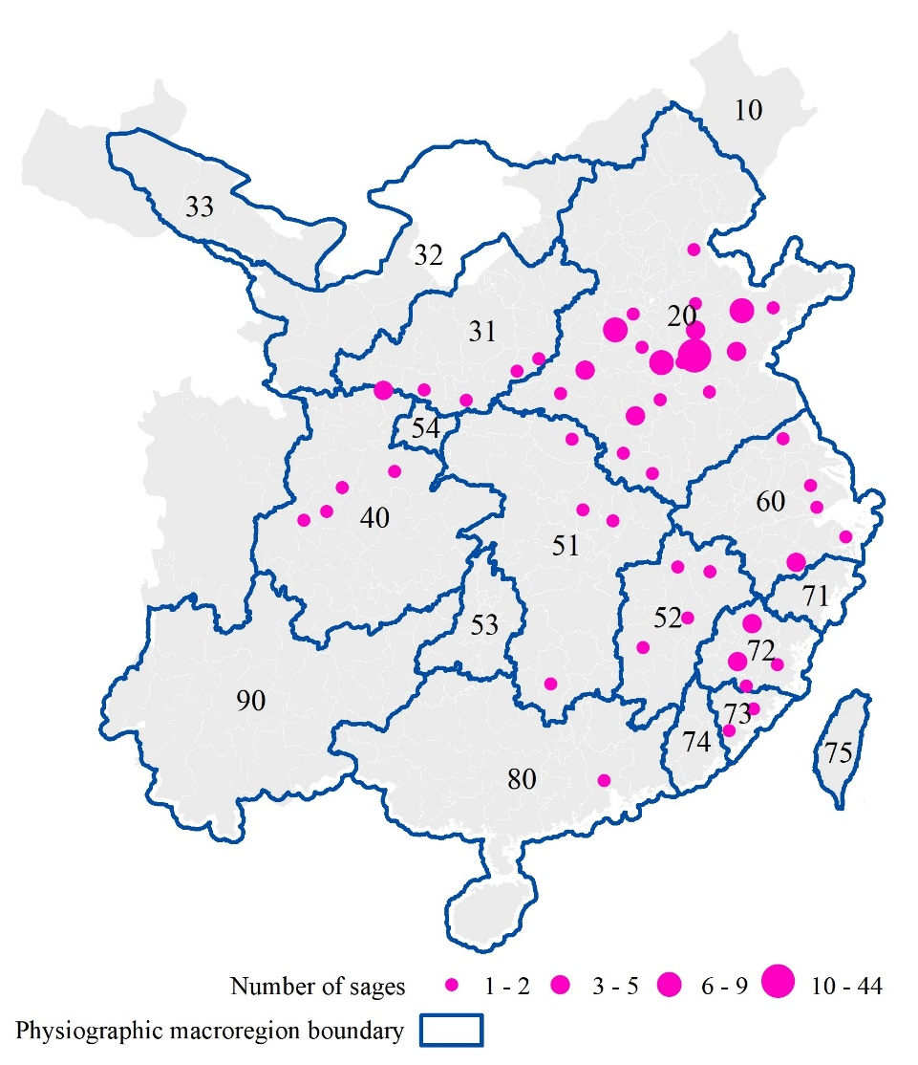

Figure A10. Sages in the Physiographic Macroregions

*Notes*: The boundaries of the 18 macroregions are based on Skinner, Henderson, and Yue’s (2013) physiographic macroregion systems in 19th-century China. There are four prefectures falling outside the macroregions but are counted in their nearest macroregions in the regression analyses. Sages refer to the acknowledged masters of classical learning who lived between 580 BCE and 1630; before 1820 the imperial authorities formally conferred their sanctity. The map shows 269 prefectures of China proper based on the Qing Dynasty administration in 1820 (CHGIS, version 6).

*Source*: See the text.

*Macroregion codes and names*: 10 Northeast China (Manchuria). 20 North China. 31 Wei-Fen Basins. 32 Upper Huang Basin. 33 Gansu Corridor. 40 Upper Yangzi. 51 Middle Yangzi proper. 52 Gan Basin. 53 Yuan Basin. 54 Upper Han Basin. 60 Lower Yangzi. 71 Ou-Ling Basins. 72 Min Basin. 73 Zhang-Quan. 74 Han Basin. 75 Taiwan. 80 Lingnan. 90 Yungui.

**Appendix 3. Data for Contemporary Industrial Innovation**

*The Proportion of Firms That Took Out Patents in 1998 to 2007*

The data for industrial firms are obtained from the National Bureau of Statistics of China’s Annual Survey of Manufacturing Enterprises, which covers all state-owned enterprises (SOEs) and large non-SOEs (with annual sales above five million CNY). For each firm, I check its patent information from the State Intellectual Property Office of China. Between 1998 and 2007, 435,111 firms were located in the boundaries of 266 prefectures of 1820; of which 21,403 firms produced 235,792 patents.

The industrial statistics after 2007 only targeted large SOEs and large non-SOEs whose annual sales were over five million CNY; after 2011, this threshold was further raised to 20 million CNY. For the sake of data consistency and representativeness, I do not include the post-2007 firms in the analysis. The data for industrial firms and patents are at the county level. Based on the GIS maps of the county divisions of China in 2000 and on the Qing prefectures in 1820 (CHGIS, version 6), I identified the counties that fall within the prefectural boundaries of 1820 and aggregate the relevant county data to the prefectural level. For more details about the data of industrial firms and patents, see Liu and Qiu (2016).

*The Density of High-tech Firms Established by 2021*

China’s Ministry of Science and Technology accredited High and New Technology Firms from 1991. In the 263 sample prefectures, 269,621 firms were accredited until 2021. Since there are no statistics for the number of all firms at the prefectural level during this period, I cannot use the proportion of high-tech firms in all firms as the dependent variable. Instead, I normalize the number of the high-tech firms by the population in millions and take its logarithm.

The data were obtained from the Announcements of the Accreditation of the High and New Technology Firms of the Ministry of Science and Technology of China. According to the Principles of Accreditation and Administration of the High and New Technology Firms issued by the Ministry of Science and Technology of China in 2016, a High and New Technology Firm has to meet the following criteria: 1) have existed for at least one year, 2) patent(s) play a core technological role in firm’s main production or service business, 3) the core technology of the firm is in the realm of the National Sponsored Fields of High and New Technologies, 4) the R&D staff are not less than 10 percent of the firm employees, 5) the R&D expenses are not less than 3 percent of the firm’s total expenses over the recent three accounting years, 6) at least 60 percent of the sale revenue was generated from high-tech products or services in the previous year, 7) passing the assessment of innovation capability, 8) no serious accidents in security and quality in the previous year. The data for high-tech firms are also at the county level and are matched and aggregated to the prefectural boundaries of 1820.

REFERENCES

Chen, Zhiwu, Chicheng Ma, and Andrew J. Sinclair. “Banking on the Confucian Clan: Why China Developed Financial Markets So Late.” *The Economic Journal* 132 (2022): 1378-1413.

Colella, Fabrizio, Rafael Lalive, Seyhun Orcan Sakalli, and Mathias Thoenig. “Inference with Arbitrary Clustering.” IZA Discussion Paper No. 12584, 2019.

Du, Xuncheng. *Minzu Ziben Zhuyi Yu Jiu Zhongguo Zhengfu (1840-1937)*. Shanghai: Shanghai Shehui Kexueyuan Chubaishe, 1991.

Herrmann, Albert. “The Contending States - Boundaries of 350 B.C.” In Norman B. Leventhal Map Center Collection, Cambridge Mass.: Harvard University Press, 1935. Available online at https://collections.leventhalmap.org/search/commonwealth:q524n184b.

Liu, Qing, and Larry D. Qiu. “Intermediate Input Imports and Innovations: Evidence from Chinese Firms’ Patent Filings.” *Journal of International Economics* 103 (2016): 166-183.

Skinner, G. W, Mark Henderson, and Zumou Yue. “Physiographic Macroregions of China.” Harvard Dataverse, V1, 2013. Available online at https://doi.org/10.7910/DVN/4BEKKX.