Institutions, Trade, and Growth: The Ancient Greek Case of Proxenia
Pier Paolo Creanza

Online appendix

Table A1
Keywords for trade proxies
Variable | Expression | Keywords
Phoenicians | from Tyre | τυρι*
 | from Sidon | σιδων*, σιδον*
 | from Arados | αραδ*
 | from Berytus | βηρυτ*
 | from Carthage | καρχαδον*, καρχηδον*
Trade mentions | trade/commerce root | εμπορ*
 | shipowner and merchant | ναυκλερ*, ναυκληρ*
 | cargo | φορτηγ*

Table A2
Positive attestations for trade proxies
Variable | Phoenicians | Trade mentions | Cargos | All trade proxies | Proxeny
Total attestations | 444 | 421 | 397 | 1,262 | 4,048
Dated attestations | 317 | 304 | 322 | 943 | 4,002
Used attestations | 231 | 189 | 191 | 611 | 2,994
Cities matched | 29 | 22 | 32 | 64 | 360
Source: author’s datasets based on PNAW, PHI, Strauss (2013) and Parker (1992).
Note: Total attestations: for the epigraphic proxies, Phoenicians and Trade mentions, this corresponds to the number of keyword matches from PHI, cleaned from spurious findings (like personal names) or repeated entries; for Cargos, it reflects the number of shipwrecks with enough information on their origin, destination or cargo. Dated attestations: the number of observations that are, at least approximately, dated and thus can be matched (or not) to the range of interest, 500-0 BCE. Used attestations: how many dated observations could be matched to individual cities in IACP and 500-0 BCE: attrition is due to observations out of our time range, observations lacking geographic information, or locations that are absent in IACP (all non-Greek and late settlements). Cities matched: row shows how many IACP locations have positive trade attestations. For comparison, the last column reports similar entries for the dataset on proxeny grants.

Table A3
Descriptive statistics for the main sample
 | Observations | Mean | Std. Dev. | Min | Max
Trade index | 1,035 | 0.015 | 0.13 | 0 | 2.74
Phoenicians | 1,035 | 0.015 | 0.14 | 0 | 2.54
Trade mentions | 1,035 | 0.011 | 0.13 | 0 | 3.22
Cargos | 1,035 | 0.18 | 1.72 | 0 | 34
Weighted EC | 360 | 0.04 | 0.08 | 0 | 1
Uneighted EC | 360 | 0.09 | 0.11 | 0 | 1
SR weighted EC | 360 | 0.07 | 0.10 | 0 | 1
Weighted EC (EP1) | 271 | 0.04 | 0.11 | 0 | 1
Weighted EC (EP0) | 185 | 0.12 | 0.17 | 0 | 1
Polisity | 1035 | 2.33 | 0.78 | 1 | 3
Hellenicity | 951 | 3 | 0.49 | 1 | 3
Fame | 1,035 | 1.35 | 1.67 | 0.1 | 21
Silver coinage | 1,035 | 1.63 | 2.37 | 0 | 6
Colonies | 1035 | 0.30 | 2.04 | 0 | 39
Victors | 1,035 | 0.17 | 0.65 | 0 | 4
Walls | 1,035 | 0.52 | 0.50 | 0 | 1
Delian league | 1,035 | 0.31 | 0.46 | 0 | 1
Sanctuary | 1,035 | 0.01 | 0.11 | 0 | 1
Peloponnesian War | 1,035 | 0.89 | 0.72 | 0 | 2
Size | 671 | 2.41 | 1.31 | 1 | 5
Source: author’s dataset based on PNAW and POLIS.

Table A4
Descriptive statistics for the dyadic sample
 | Observations | Mean | Std. Dev. | Min | Max
Proxeny link | 137,270 | 0.82 | 9.04 | 0 | 100
Link weight | 137,270 | 1.01 | 0.37 | 1 | 77
Dyadic distance | 136,530 | 458 | 320 | 0 | 2655
Same dialect | 137,270 | 0.04 | 0.19 | 0 | 1
Same region | 137,270 | 0.19 | 0.39 | 0 | 1
Colonized by | 137,270 | 0.00 | 0.03 | 0 | 1
Colony of | 137,270 | 0.00 | 0.03 | 0 | 1
Delian league ally | 137,270 | 0.58 | 0.49 | 0 | 1
Peloponnesian war | 137,270 | 0.35 | 0.48 | 0 | 1
Source: author’s dataset based on PNAW and POLIS.

Table A5
Regression results for different weighting schemes
 | Dependent variable: unweighted eigencentrality |  |  |  | Dependent variable: SR-weighted eigencentrality
 | (1) | (2) | (3) | (4) | (5) | (6) | (7) | (8)
Phoenicians | 0.184*** |  |  |  | 0.206***
 | (0.026) |  |  |  | (0.039)
Trade mentions |  | 0.144** |  |  |  | 0.180***
 |  | (0.050) |  |  |  | (0.054)
Cargos |  |  | 0.114** |  |  |  | 0.169***
 |  |  | (0.040) |  |  |  | (0.025)
Trade index |  |  |  | 0.182*** |  |  |  | 0.232***
 |  |  |  | (0.026) |  |  |  | (0.022)
Fame index | 0.400*** | 0.406*** | 0.410*** | 0.379*** | 0.384*** | 0.383*** | 0.375*** | 0.346***
 | (0.044) | (0.041) | (0.065) | (0.056) | (0.062) | (0.040) | (0.055) | (0.043)
Controls | Y | Y | Y | Y | Y | Y | Y | Y
Dialect & Region FEs | Y | Y | Y | Y | Y | Y | Y | Y
Observations | 312 | 312 | 312 | 312 | 312 | 312 | 312 | 312
R² | 0.69 | 0.67 | 0.67 | 0.69 | 0.69 | 0.67 | 0.69 | 0.71
Source: author’s dataset based on PNAW and POLIS.
Note: *** indicates significance at 1 percent level, ** at 5 percent level, * at 10 percent level. Standard errors are clustered at the regional level. Controls: distance from coast, elevation, distance*elevation, polisity, hellenicity, walls, colonies, panhellenic sanctuary, Olympic victors, earliest coinage, size.

Table A6
Regression results for indegree
 | Dependent variable: indegree
 | (1) | (2) | (3) | (4)
Phoenicians | 0.332***
 | (0.075)
Trade mentions |  | 0.366***
 |  | (0.082)
Cargos |  |  | 0.264***
 |  |  | (0.016)
Trade index |  |  |  | 0.401***
 |  |  |  | (0.057)
Fame index | 0.211** | 0.186*** | 0.203** | 0.140***
 | (0.072) | (0.052) | (0.075) | (0.036)
Controls | Y | Y | Y | Y
Dialect & Region FEs | Y | Y | Y | Y
Observations | 323 | 323 | 323 | 323
R² | 0.72 | 0.75 | 0.70 | 0.80
Source: author’s dataset based on PNAW and POLIS.
Note: *** indicates significance at 1 percent level, ** at 5 percent level, * at 10 percent level. Standard errors are clustered at the regional level. Controls: distance from coast, elevation, distance*elevation, polisity, hellenicity, walls, colonies, panhellenic sanctuary, Olympic victors, earliest coinage, size.

Table A7
Regression results for weighted eigencentrality – robustness to top cities
 | Dependent variable: indegree
City removed: | Kaunos | Tomis | Lindos | Samos | Chios
Trade index | 0.237*** | 0.235*** | 0.232*** | 0.234*** | 0.235***
 | (0.021) | (0.021) | (0.022) | (0.021) | (0.021)
Fame index | 0.338*** | 0.345*** | 0.346*** | 0.339*** | 0.357***
 | (0.042) | (0.043) | (0.043) | (0.042) | (0.051)
Observations | 311 | 311 | 312 | 311 | 311
R² | 0.71 | 0.71 | 0.71 | 0.71 | 0.70
City removed: | Korinthos | Kos | Delos | Rhodos | Athens
Trade index | 0.239*** | 0.255*** | 0.232*** | 0.207*** | 0.189***
 | (0.024) | (0.030) | (0.022) | (0.039) | (0.047)
Fame index | 0.327*** | 0.341*** | 0.346*** | 0.348*** | 0.341***
 | (0.052) | (0.047) | (0.043) | (0.043) | (0.046)
Observations | 311 | 311 | 312 | 311 | 311
R² | 0.71 | 0.71 | 0.71 | 0.69 | 0.61
Controls | Y | Y | Y | Y | Y
Dialect & Region FEs | Y | Y | Y | Y | Y
Source: author’s dataset based on PNAW and POLIS.
Note: *** indicates significance at 1 percent level, ** at 5 percent level, * at 10 percent level. Standard errors are clustered at the regional level. Controls: distance from coast, elevation, distance*elevation, polisity, hellenicity, walls, colonies, panhellenic sanctuary, Olympic victors, earliest coinage, size.

Table A8
Regression results for weighted eigencentrality, different EP definitions
 | Dependent variable: Weighted eigencentrality
 | Subsample: EP=1 |  |  | Subsample: EP=0
 | Def. 4 | Def. 2 | Def. 3 | Def. 4 | Def. 2 | Def. 3
 | (1) | (2) | (3) | (4) | (5) | (6)
Trade index | 0.243*** | 0.218*** | 0.218*** | 0.172** | 0.185*** | 0.187***
 | (0.035) | (0.062) | (0.063) | (0.053) | (0.025) | (0.026)
Fame index | -0.046 | -0.050 | -0.053 | 0.243*** | 0.263*** | 0.272***
 | (0.072) | (0.046) | (0.046) | (0.060) | (0.058) | (0.058)
Controls | Y | Y | Y | Y | Y | Y
Dialect & Region FEs | Y | Y | Y | Y | Y | Y
Observations | 254 | 247 | 246 | 164 | 205 | 208
R² | 0.50 | 0.60 | 0.60 | 0.55 | 0.51 | 0.52
Source: author’s dataset based on PNAW and POLIS.
Note: *** indicates significance at 1 percent level, ** at 5 percent level, * at 10 percent level. Standard errors are clustered at the regional level. Controls: distance from coast, elevation, distance*elevation, polisity, hellenicity, walls, colonies, panhellenic sanctuary, Olympic victors, earliest coinage.

Table A9
Regression results for weighted eigencentrality, EP subsamples – robustness
 | Dependent variable: Eigencentrality
 | Subsample: EP=1 |  |  | Subsample: EP=0
 | Unweighted | SR-weighted | Pre 166 BCE | Unweighted | SR-weighted | Pre 166 BCE
 | (1) | (2) | (3) | (4) | (5) | (6)
Trade index | 0.208*** | 0.228*** | 0.208** | 0.103** | 0.131*** | 0.053
 | (0.056) | (0.054) | (0.073) | (0.043) | (0.033) | (0.097)
Fame index | -0.021 | -0.007 | -0.004 | 0.355** | 0.332*** | 0.235***
 | (0.070) | (0.061) | (0.041) | (0.120) | (0.088) | (0.056)
Controls | Y | Y | Y | Y | Y | Y
Dialect & Region FEs | Y | Y | Y | Y | Y | Y
Observations | 262 | 262 | 242 | 177 | 177 | 159
R² | 0.38 | 0.47 | 0.48 | 0.48 | 0.49 | 0.40
Source: author’s dataset based on PNAW and POLIS.
Note: *** indicates significance at 1 percent level, ** at 5 percent level, * at 10 percent level. Standard errors are clustered at the regional level. Controls: distance from coast, elevation, distance*elevation, polisity, hellenicity, walls, colonies, panhellenic sanctuary, Olympic victors, earliest coinage.
Table A10
Dyadic regression results for proxeny link
 | Dependent variable: Proxeny link
 | Subsample: EP=1 |  |  |  | Subsample: EP=0
 | (1) | (2) | (3) | (4) | (5) | (6) | (7) | (8)
Phoenicians (T) | 0.92** |  |  |  | 0.57**
 | (0.33) |  |  |  | (0.21)
Phoenicians (S) | 0.83 |  |  |  | 0.95*
 | (0.49) |  |  |  | (0.49)
Trade mentions (T) |  | 1.16** |  |  |  | 0.59**
 |  | (0.45) |  |  |  | (0.20)
Trade mentions (S) |  | -0.49 |  |  |  | 1.33***
 |  | (0.44) |  |  |  | (0.18)
Cargos (T) |  |  | 0.76*** |  |  |  | 0.58**
 |  |  | (0.22) |  |  |  | (0.19)
Cargos (S) |  |  | -0.48 |  |  |  | 0.11
 |  |  | (0.61) |  |  |  | (0.23)
Trade index (T) |  |  |  | 1.18** |  |  |  | 0.72***
 |  |  |  | (0.40) |  |  |  | (0.22)
Trade index (S) |  |  |  | -0.00 |  |  |  | 0.87*
 |  |  |  | (0.51) |  |  |  | (0.45)
Fame index (T) | 0.32** | 0.22 | 0.32** | 0.15 | 0.71* | 0.70* | 0.68* | 0.61
 | (0.13) | (0.15) | (0.12) | (0.13) | (0.37) | (0.37) | (0.31) | (0.35)
Fame index (S) | 3.15* | 3.62* | 3.63* | 3.44* | 1.64* | 1.47* | 1.95* | 1.61*
 | (1.61) | (1.82) | (1.82) | (1.78) | (0.77) | (0.78) | (0.89) | (0.83)
Controls | Y | Y | Y | Y | Y | Y | Y | Y
Dialect & Region FEs | Y | Y | Y | Y | Y | Y | Y | Y
Observations | 68,107 | 68,107 | 68,107 | 68,107 | 40,099 | 40,099 | 40,099 | 40,099
R² | 0.28 | 0.28 | 0.27 | 0.27 | 0.07 | 0.08 | 0.07 | 0.07
Source: author’s dataset based on PNAW and POLIS.
Note: *** indicates significance at 1 percent level, ** at 5 percent level, * at 10 percent level. (T) indicates the coefficient of the target node, (S) indicates that of the source. Standard errors are clustered at the regional level of the source. Controls: distance from coast, elevation, distance*elevation, polisity, hellenicity, walls, colonies, panhellenic sanctuary, Olympic victors, earliest coinage, dyadic distance, same dialect, same region, colony of, colonized by, same side in Peloponnesian war, Delian league ally, size.

Table A11
Panel regression results for trade attestations, 25-year bins
 | Dependent variable: Trade (t)
 | (1) | (2) | (3) | (4) | (5) | (6) | (7)
Indegree (t-1) | 0.100* |  |  | 0.101* | 0.111* | 0.113**
 | (0.055) |  |  | (0.058) | (0.058) | (0.055)
Indegree (t) |  | 0.015 |  | -0.017 | -0.020
 |  | (0.011) |  | (0.020) | (0.023)
Indegree (t+1) |  |  | 0.011 | -0.008 | -0.003
 |  |  | (0.011) | (0.015) | (0.014)
Outdegree (t-1) |  |  |  |  |  | 0.072*
 |  |  |  |  |  | (0.040)
Degree (t-1) |  |  |  |  |  |  | 0.097*
 |  |  |  |  |  |  | (0.058)
City & Time FEs | Y | Y | Y | Y | Y | Y | Y
Time x Fame FE | Y | Y | Y | Y | Y | Y | Y
Time x Coinage FE | N | N | N | N | Y | Y | Y
Time x Size FE | N | N | N | N | Y | Y | Y
Observations | 8,257 | 8,257 | 8,257 | 7,898 | 7,040 | 7,360 | 7,360
R² | 0.17 | 0.16 | 0.16 | 0.17 | 0.22 | 0.23 | 0.22
Number of poleis | 359 | 359 | 359 | 359 | 320 | 320 | 320
Source: author’s dataset based on PNAW and POLIS.
Note: *** indicates significance at 1 percent level, ** indicates at 5 percent level, * at 10 percent level. Standard errors are clustered at each polis.

Table A12
Regression results for trade proxies
Dependent variable: | Trade index |  |  |  |  | Phoenicians | T. mentions | Cargos
 | (1) | (2) | (3) | (4) | (5) | (6) | (7) | (8)
Trade access | 0.016 | -0.205* | -0.133 | -0.278 | -0.201 | -0.255 | -0.012 | -0.208
 | (0.176) | (0.094) | (0.167) | (0.280) | (0.273) | (0.247) | (0.260) | (0.310)
Trade access via proxeny |  | 1.263*** |  | 1.337*** | 1.098*** | 1.049** | 1.063*** | 0.746**
 |  | (0.306) |  | (0.286) | (0.309) | (0.431) | (0.172) | (0.237)
Trade access via dialect |  |  | -0.225 | 0.004 | -0.054 | -0.117 | -0.468** | 0.360
 |  |  | (0.366) | (0.345) | (0.291) | (0.294) | (0.205) | (0.313)
Trade access via alliance |  |  | 0.332 | -0.009 | -0.055 | 0.099 | -0.020 | -0.232
 |  |  | (0.288) | (0.206) | (0.186) | (0.172) | (0.251) | (0.169)
Trade access via colony |  |  | 0.135 | 0.293*** | 0.290*** | 0.246*** | 0.026 | 0.431***
 |  |  | (0.121) | (0.079) | (0.057) | (0.068) | (0.034) | (0.083)
Proxeny EC |  |  |  |  | 0.420*** | 0.184 | 0.290 | 0.617*
 |  |  |  |  | (0.065) | (0.140) | (0.183) | (0.283)
Fame index | 0.455* | 0.185 | 0.453* | 0.151 | 0.041 | 0.030 | 0.095 | -0.006
 | (0.244) | (0.153) | (0.237) | (0.143) | (0.119) | (0.142) | (0.155) | (0.161)
Controls | Y | Y | Y | Y | Y | Y | Y | Y
Dialect & Region FEs | Y | Y | Y | Y | Y | Y | Y | Y
Observations | 323 | 323 | 323 | 323 | 303 | 303 | 303 | 303
R² | 0.41 | 0.66 | 0.42 | 0.68 | 0.71 | 0.59 | 0.69 | 0.56
Source: author’s dataset based on PNAW and POLIS.
Note: *** indicates significance at 1 percent level, ** at 5 percent level, * at 10 percent level. Standard errors are clustered at the regional level. Controls: distance from coast, elevation, distance*elevation, polisity, hellenicity, walls, colonies, panhellenic sanctuary, Olympic victors, earliest coinage.

Table A13
Regression results for trade proxies
Dependent variable: | Phoenicians | T. mentions | Cargos
 | (1) | (2) | (3)
Trade access | -0.300 | 0.214 | -0.206
 | (0.302) | (0.252) | (0.461)
Trade access via proxeny | 0.675** | 0.989*** | 0.477***
 | (0.285) | (0.160) | (0.112)
Trade access via dialect | -0.137 | -0.811** | 0.679
 | (0.332) | (0.346) | (0.451)
Trade access via alliance | 0.366 | 0.155 | -0.421
 | (0.359) | (0.433) | (0.358)
Trade access via colony | -0.135 | -0.152 | 0.239
 | (0.093) | (0.130) | (0.245)
Proxeny EC | 0.335* | 0.308 | 0.764*
 | (0.162) | (0.185) | (0.351)
Fame index | 0.076 | 0.133 | 0.059
 | (0.139) | (0.154) | (0.145)
Controls | Y | Y | Y
Dialect & Region FEs | Y | Y | Y
Observations | 303 | 303 | 303
R² | 0.53 | 0.70 | 0.50
Source: author’s dataset based on PNAW and POLIS.
Note: *** indicates significance at 1 percent level, ** at 5 percent level, * at 10 percent level. Standard errors are clustered at the regional level. Controls: distance from coast, elevation, distance*elevation, polisity, hellenicity, walls, colonies, panhellenic sanctuary, Olympic victors, earliest coinage.

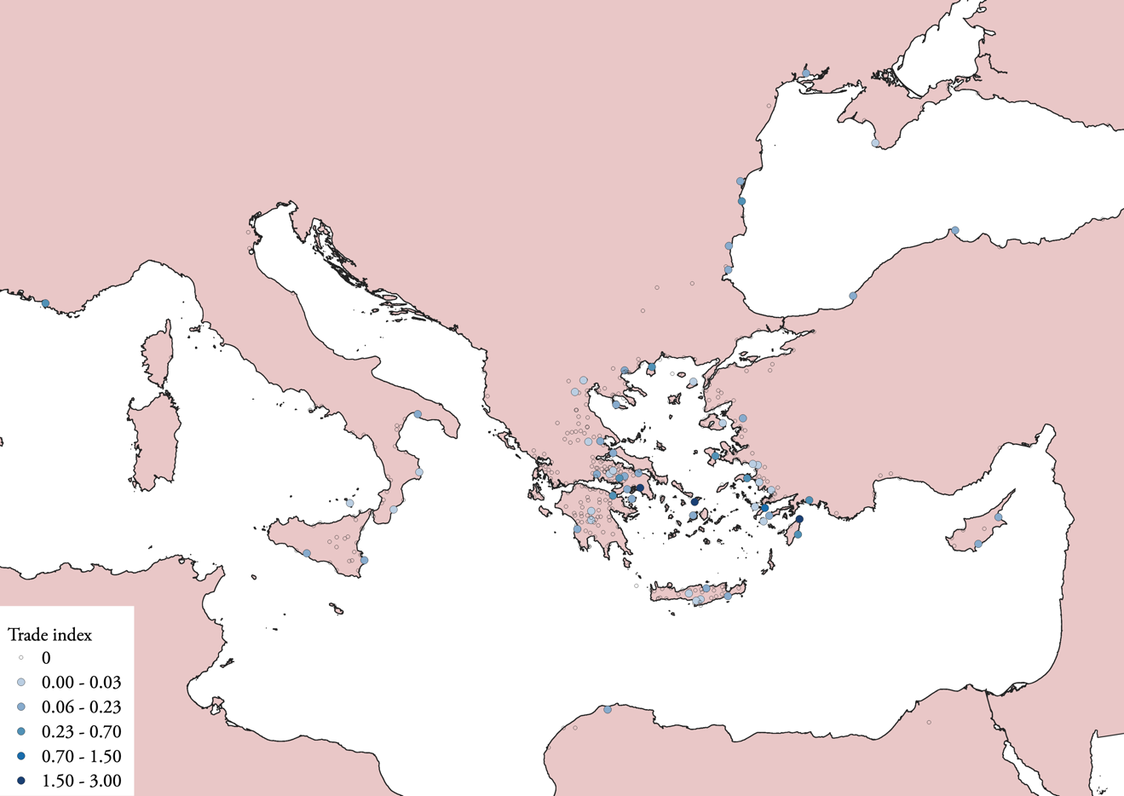
Figure A1
Spatial distribution of the trade index
Source: author’s dataset.

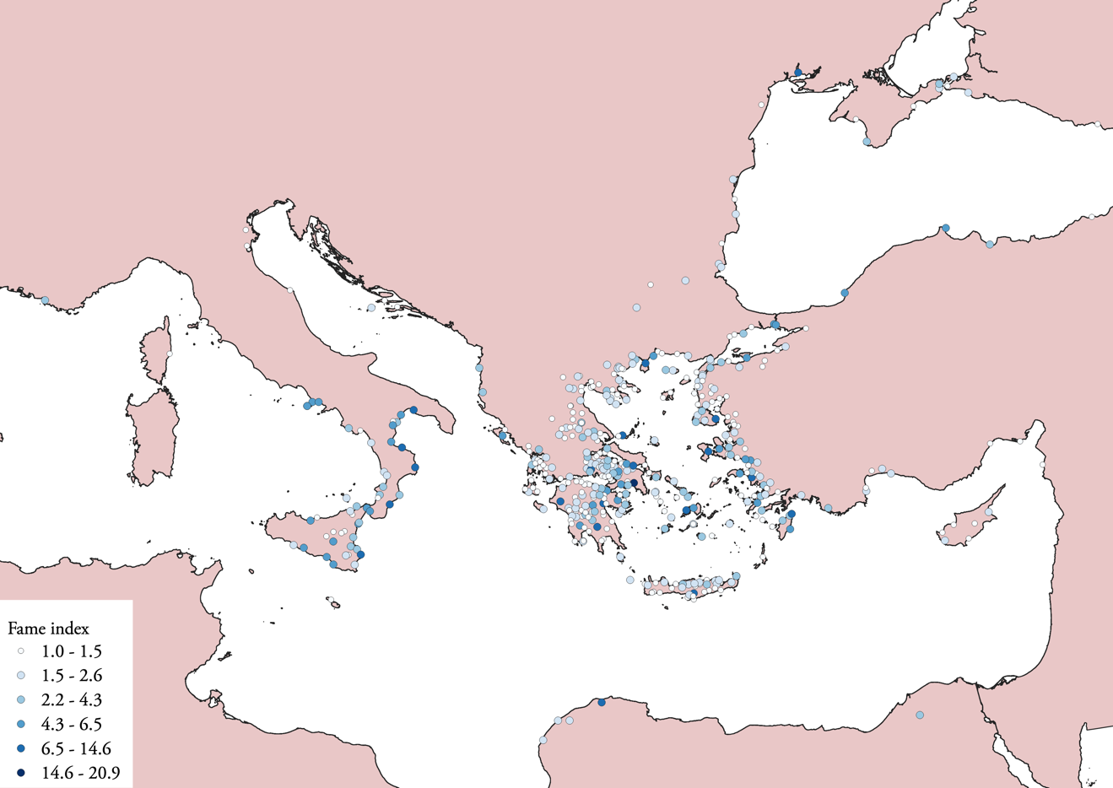
Figure A2
Spatial distribution of the fame index
Source: POLIS dataset.
Note: near-zero entries are omitted.

