Online Appendix

Political Conflict and Development Dynamics: Economic Legacies of the Cultural Revolution

Supplemental Figures

This appendix contains several supplemental figures. Here’s a complete list of items:

  - Figure A1: Data on 1953 Industrialization from County Gazetteers
  - Figure A2: Regional Distribution of Revolutionary Intensity (For a larger sample of 1486 counties)
  - Figure A3: Comparison between 1953 and 1964 Base Year Samples
  - Figure A4: Regional Distribution of Change in Industrialization Rates 1964-1982 (For a larger sample of 1486 counties)
  - Figure A5: Revolutionary Intensity and Industrialization: 1964-2000 (For a larger sample of 1486 counties)
  - Figure A6: Revolutionary Intensity and Sex Ratios
  - Figure A7: Revolutionary Intensity, Education, and Labor Market Outcomes: 1936-40 cohorts as comparison group
  - Figure A8: Revolutionary Intensity, Education, and Labor Market Outcomes: 1941-45 cohorts as comparison group

Figure A1: Data on 1953 Industrialization from County Gazetteers
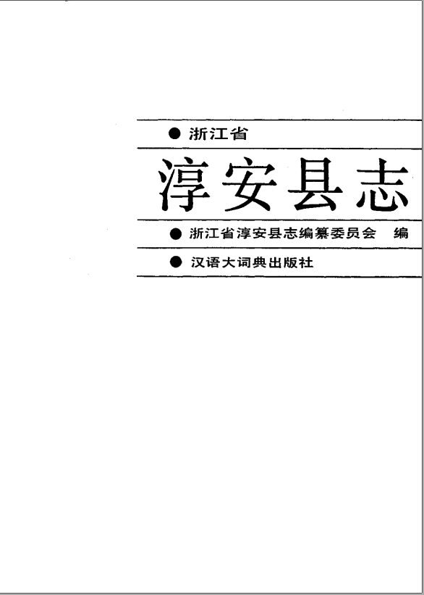
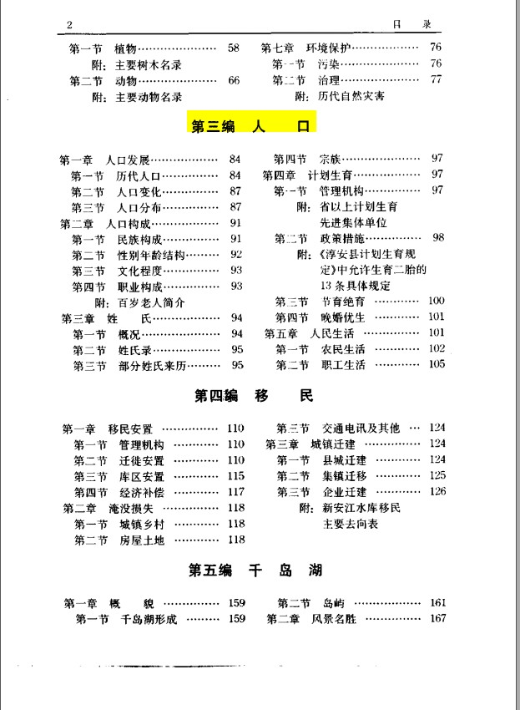
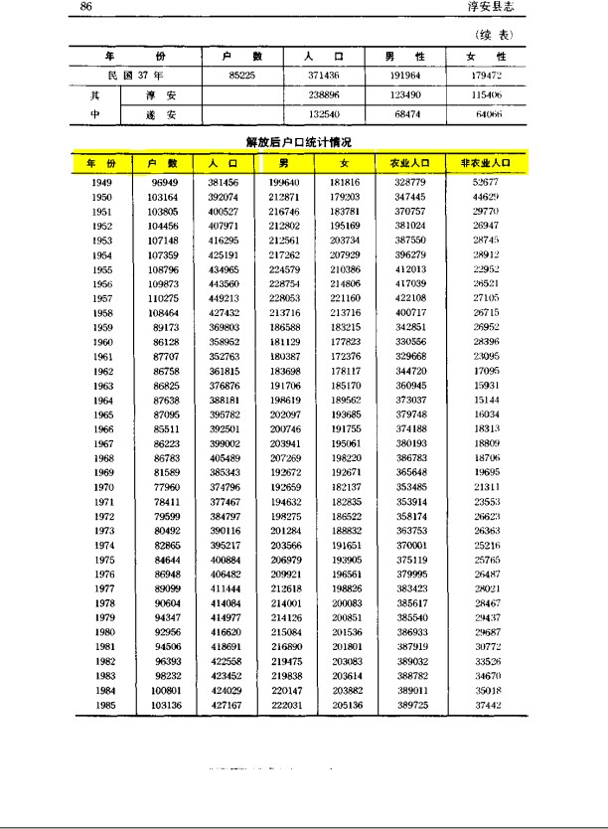

Note: This is an image of the archives from which data on county-level rates of industrialization in 1953 was digitized. The county shown here is Chun’An county from Zhejiang Province. Within the gazetteer, there is a separate section on local population (chapter 3), where the number of agricultural and non-agricultural individuals are listed for selected years.

Figure A2: Regional Distribution of Revolutionary Intensity (Quintiles)

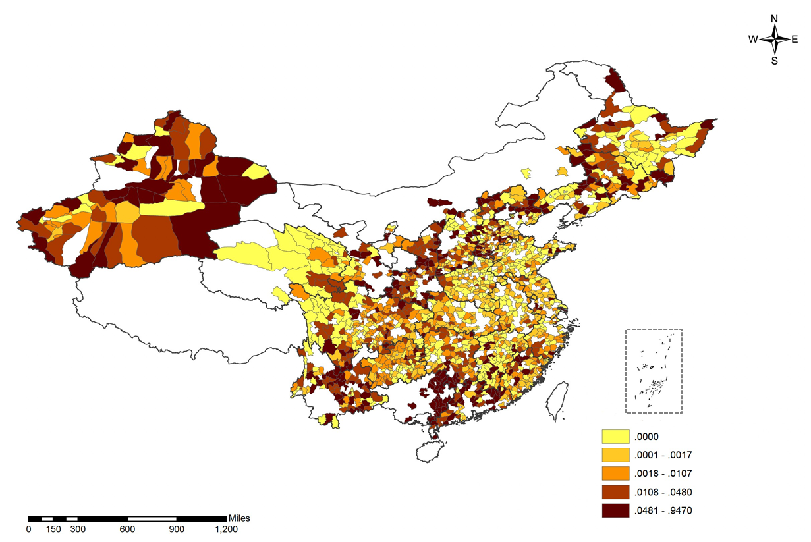

Note: This figure maps revolutionary intensity at the county level, as proxied by revolution-related deaths as a proportion of 1964 population, formally Log(1 + deaths/population ∗ 100). Cutoff thresholds are quintiles. Shaded counties correspond to our 1964-base year sample (N = 1486). Unshaded counties are excluded either because of missing values in revolutionary intensity or industrialization.

Figure A3: Comparison between 1953 and 1964 Base Year Samples
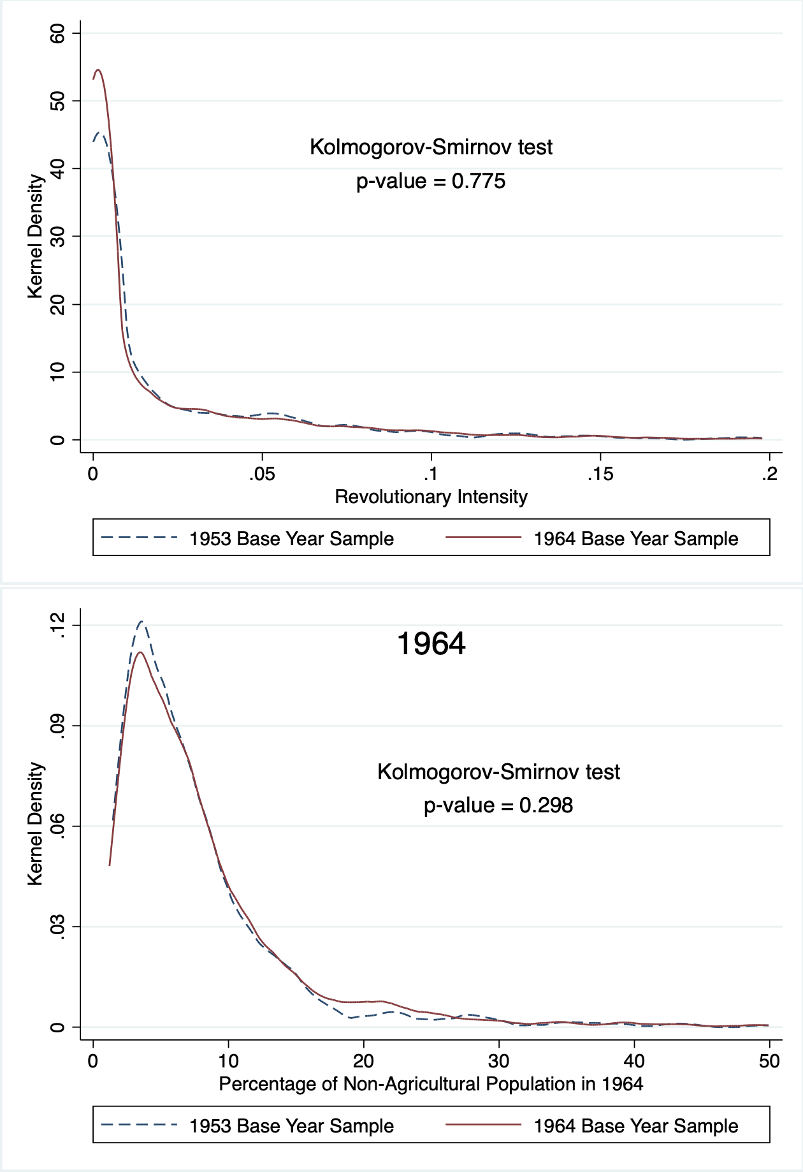
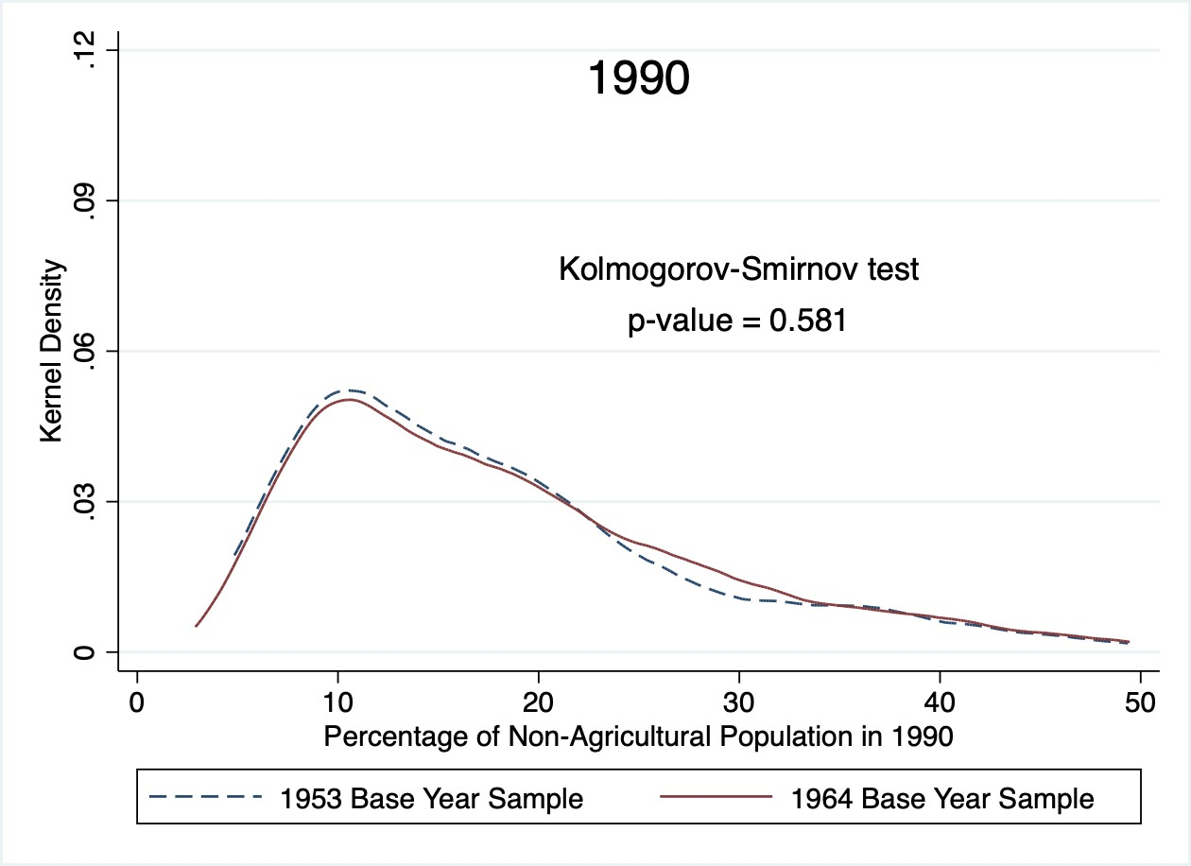
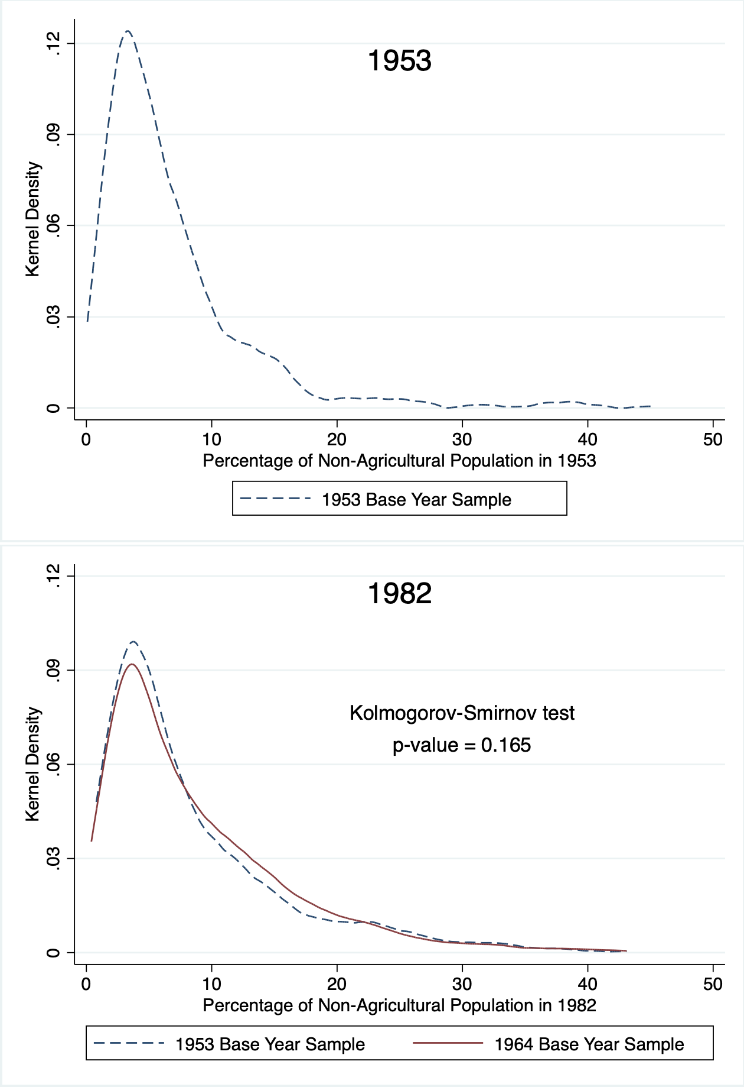
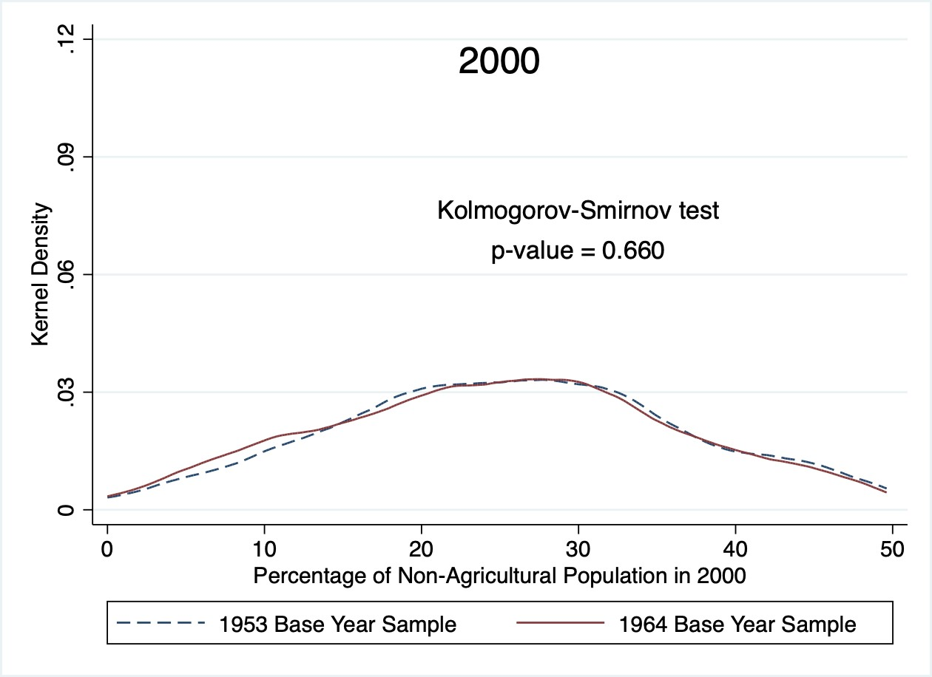

Note: This figure compares our two analytical samples at the county level - starting in 1953 and 1964 respectively - in terms of their distributions in both the explanatory variable (revolutionary intensity) and the outcome variable (the share of non-agricultural population for each census year). The solid line corresponds to the 1486 counties with baseline data starting in 1964, while the dashed line corresponds to the 600 counties with baseline data starting in 1953. The Kolmogorov-Smirnov test reports the combined K-S p-value.

Figure A4: Regional Distribution of Change in Industrialization Rates 1964-1982 (Quintiles)

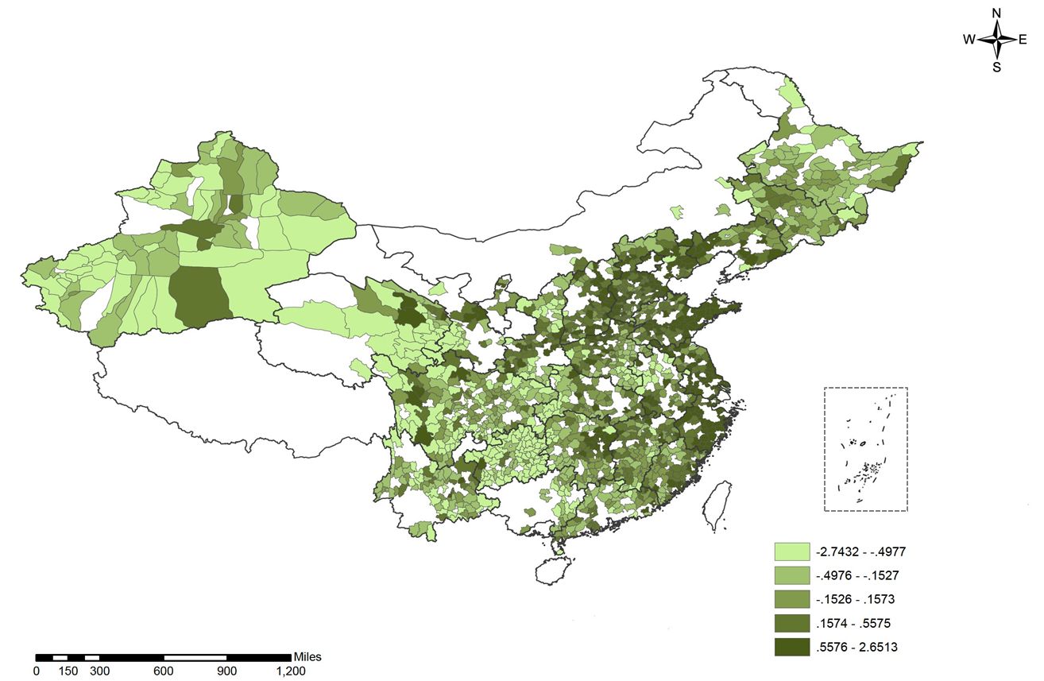

Note: This figure maps industrialization at the county level, as proxied by the change in share of local population working in non- agricultural sectors between 1964 and 1982, formally Log(Industrialization1982) −Log(Industrialization1964). Cutoff thresholds are quintiles. Shaded counties correspond to our 1964-base year sample (N = 1486). Unshaded counties are excluded either because of missing values in revolutionary intensity or industrialization.

Figure A5: Revolutionary Intensity and Industrialization: 1964-2000

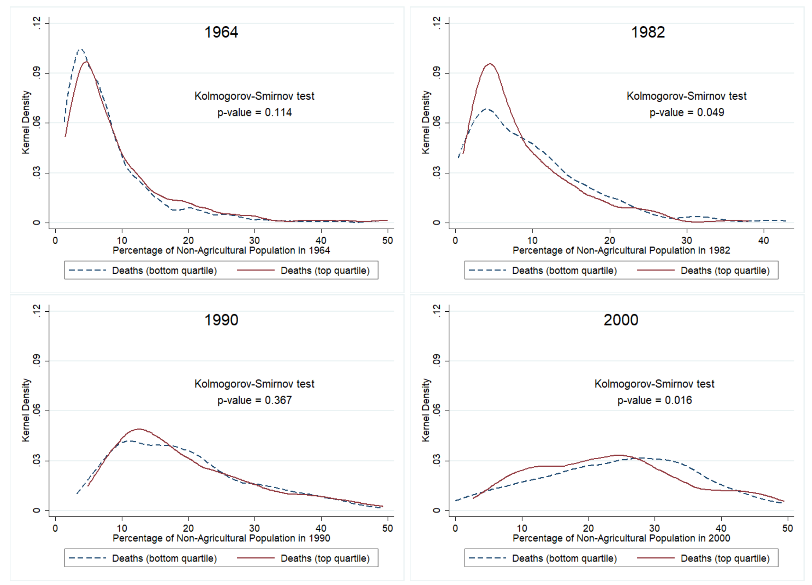
Note: This figure plots the distribution of the share of non-agricultural population in selected counties for the census years 1964, 1982, 1990 and 2000. The solid line corresponds to counties in the top quartile of revolution-related deaths, while the dashed line corresponds to counties in the bottom quartile. The sample consists of the 1486 counties for which we have data during 1964-2000.

-.5

Figure A6: Revolutionary Intensity and Sex Ratios

1956 1961 1966 1971 1976 1981 1986 1991 1996
5-year bins (range: 1951-2000; base = [1951,1955])
Coef. of CR Intensity * Year Bin Dummy
0
.5

Note: This figure plots coefficients on the interaction between revolutionary intensity and 5-year-Bin dummies, corresponding to the analysis of sex ratios. We use province-level data for the period 1951-2000. The dependent variable is the population sex ratio, and the regression controls for province and year fixed effects.
-1

Figure A7: Revolutionary Intensity, Education, and Labor Market Outcomes - 1936-40 cohorts as comparison group
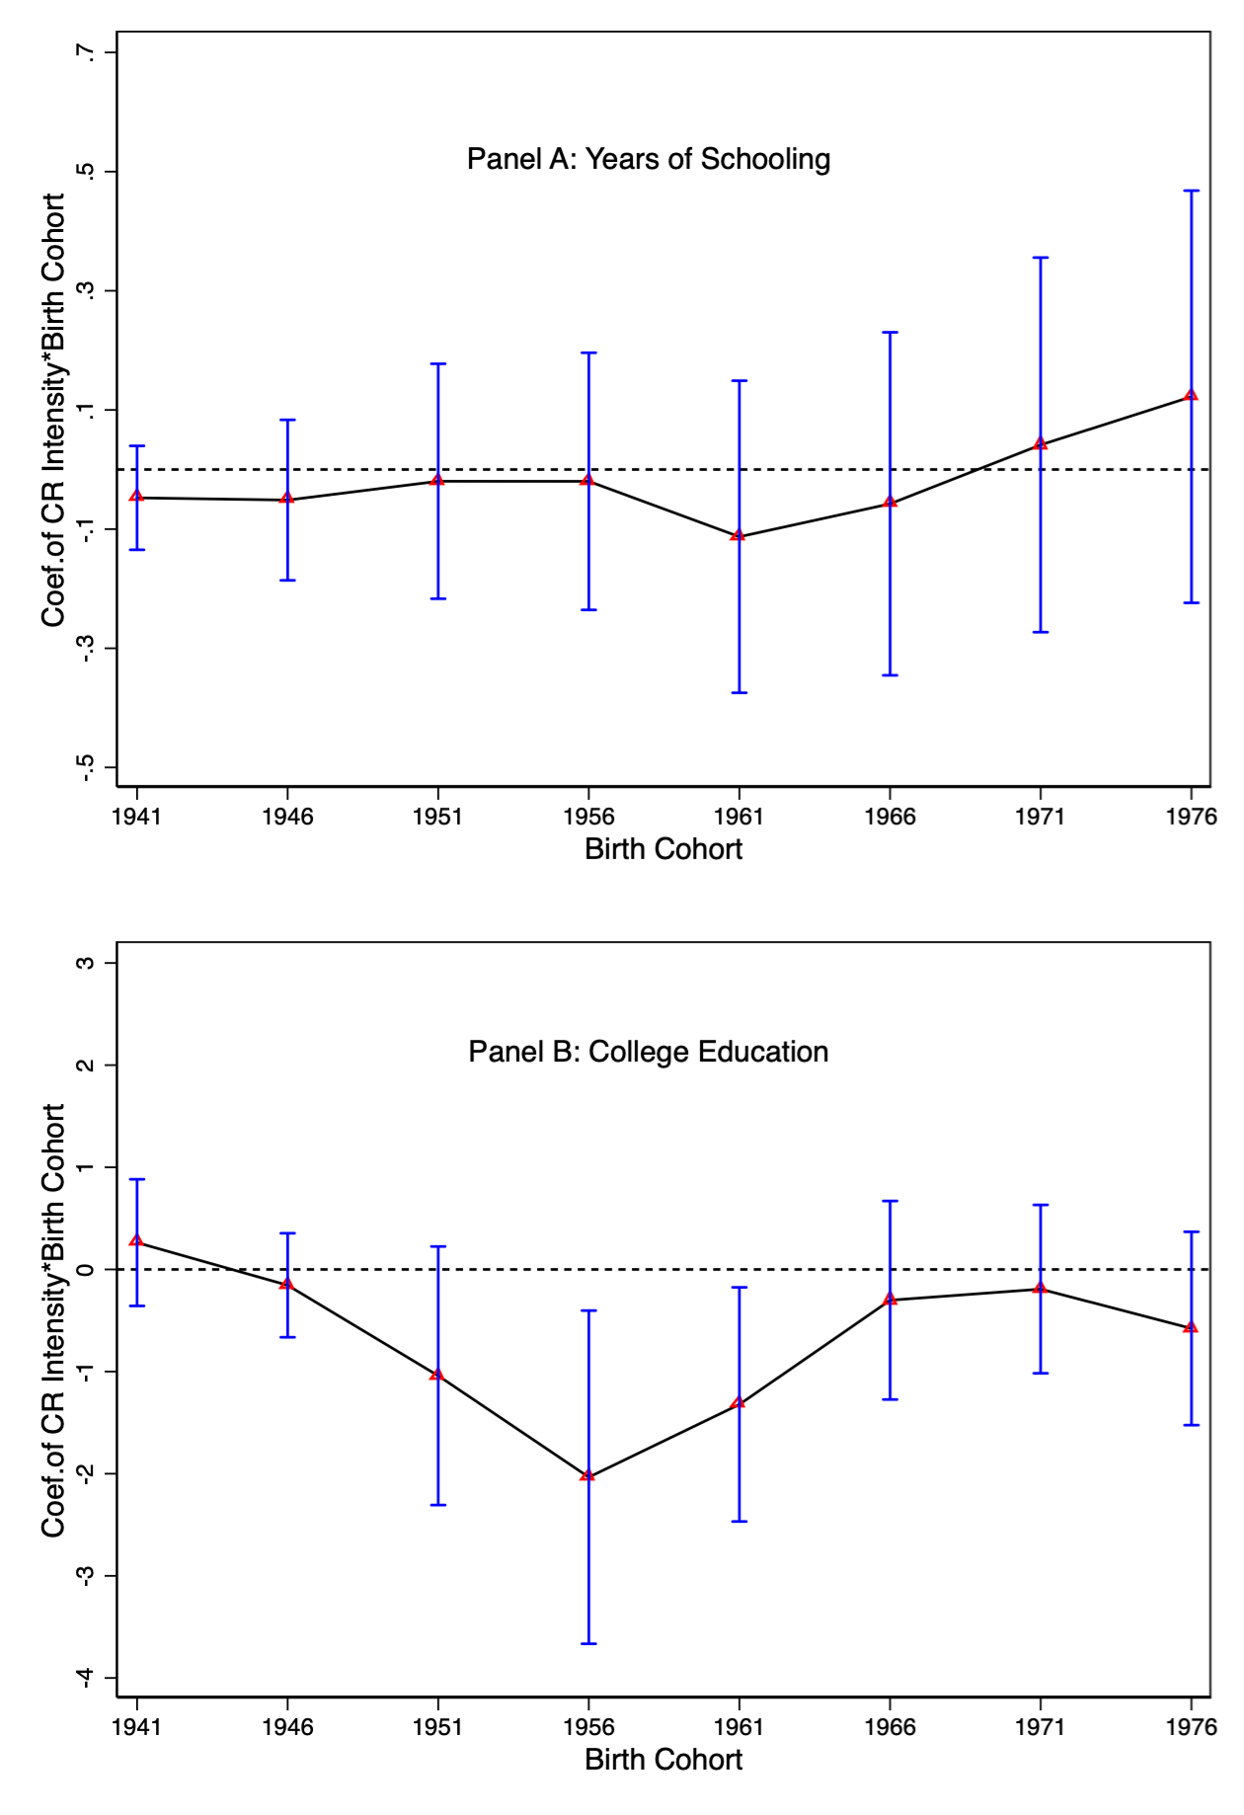
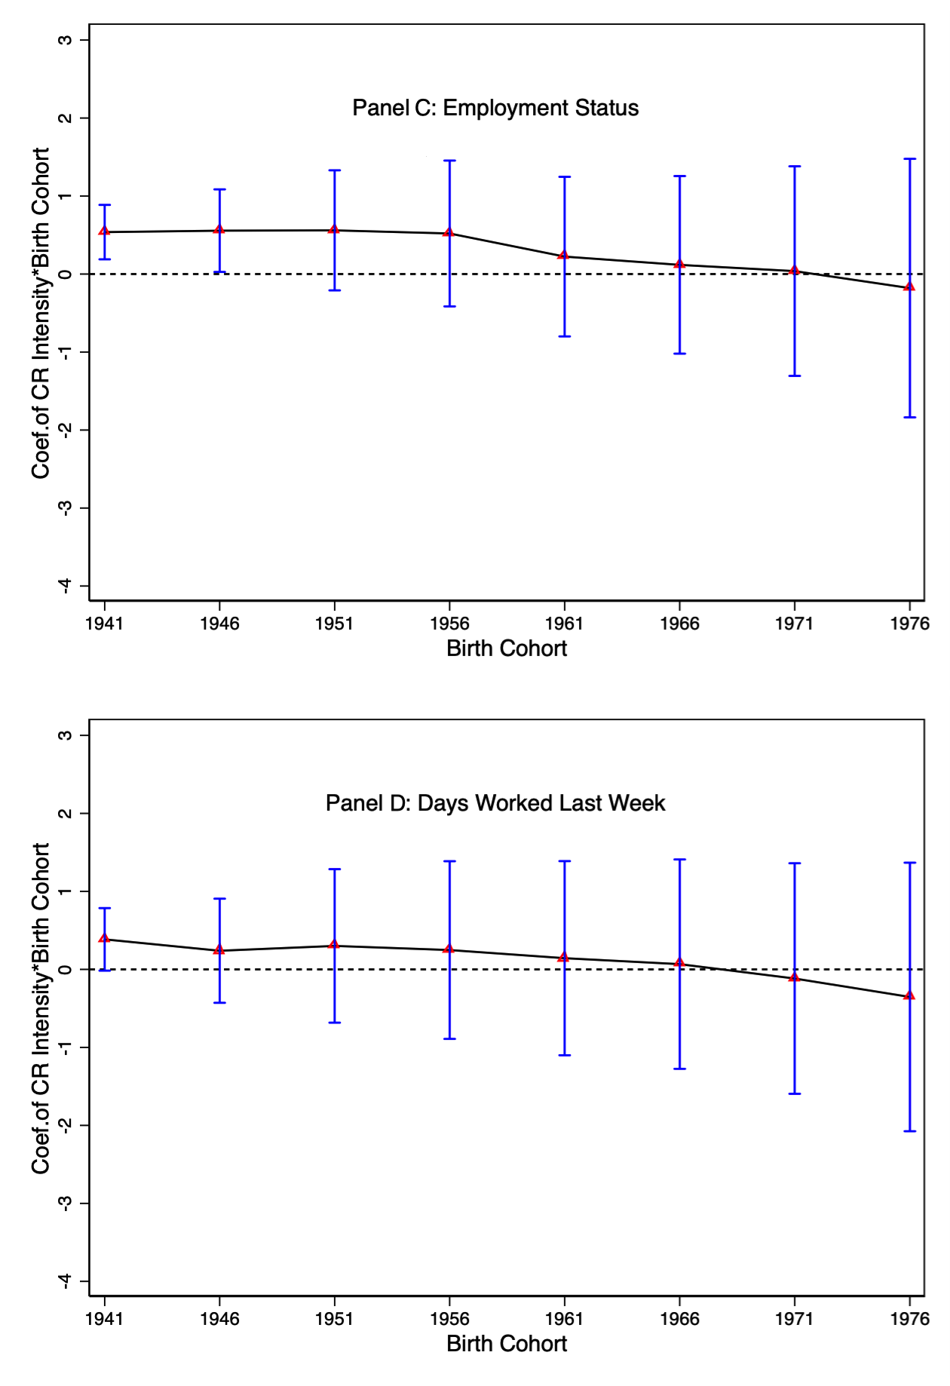
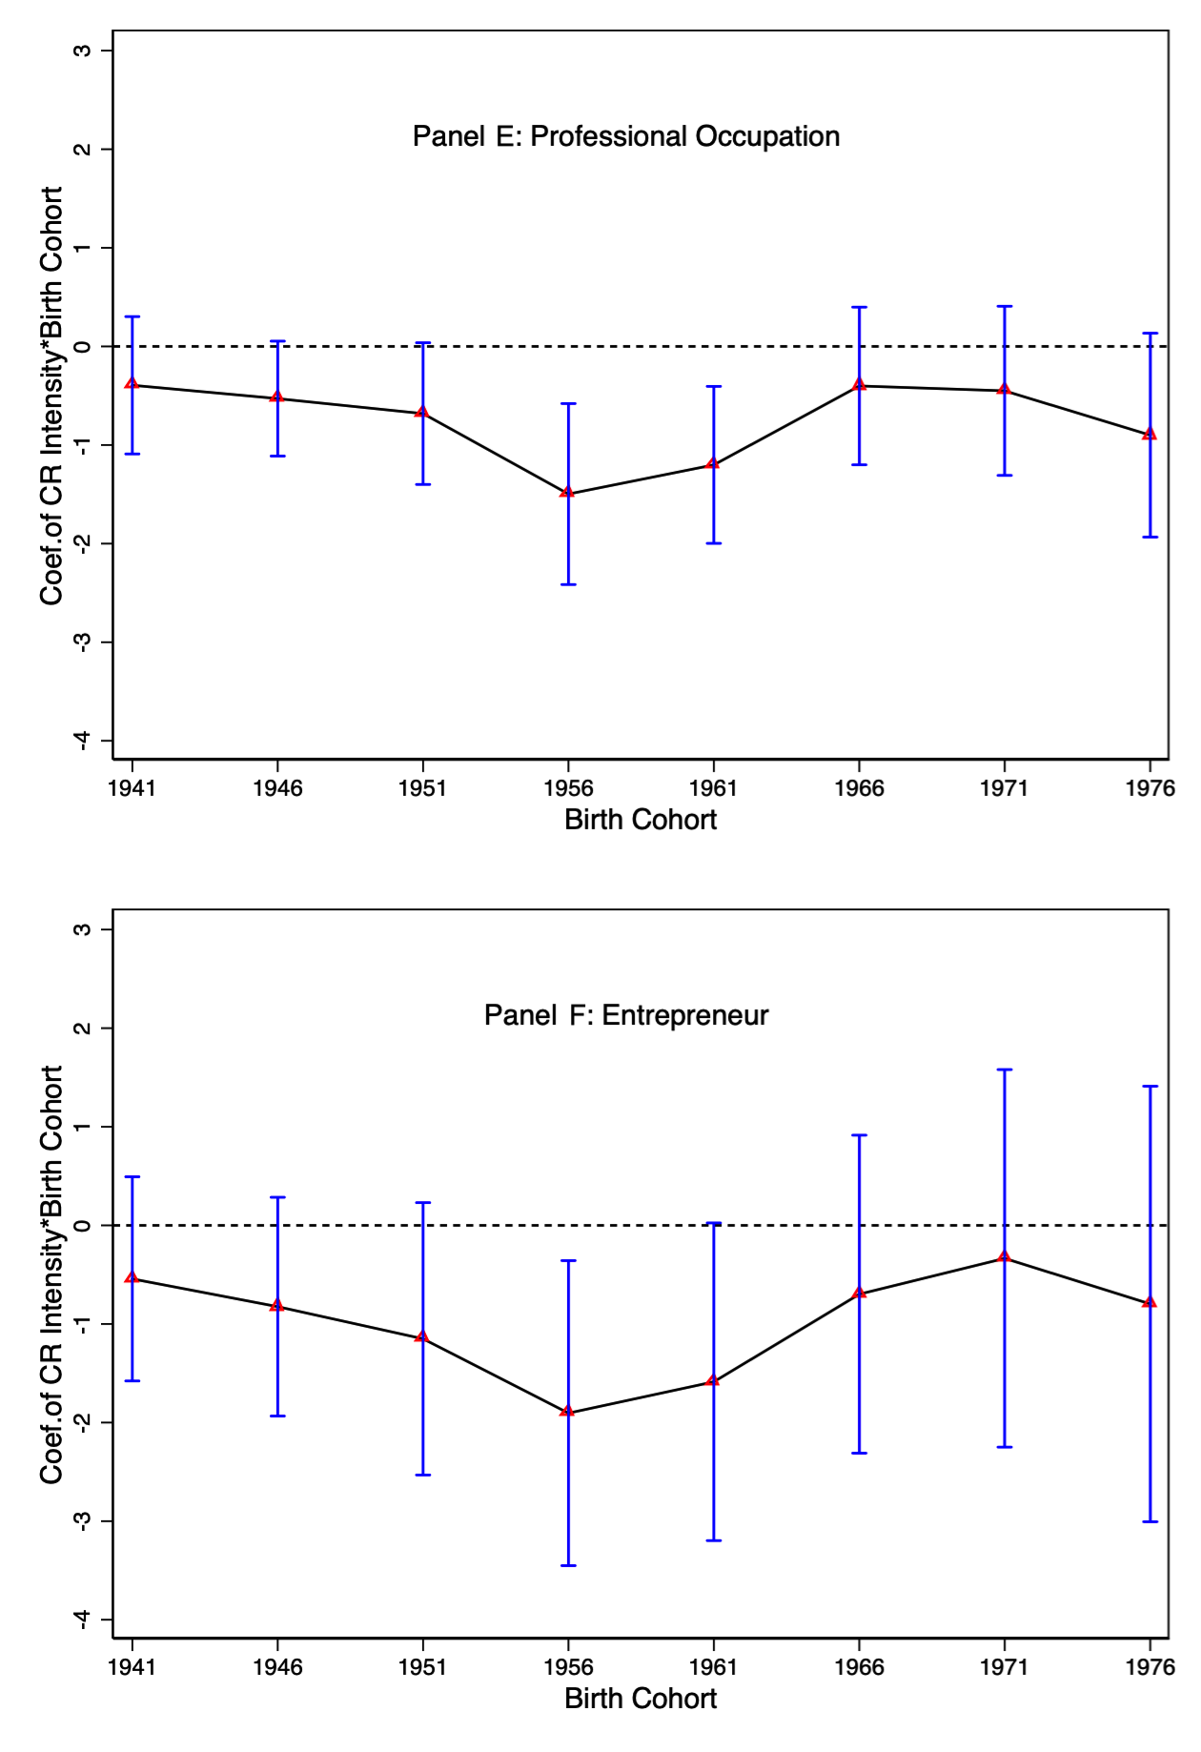

Figure A8: Revolutionary Intensity, Education, and Labor Market Outcomes - 1941-45 cohorts as comparison group
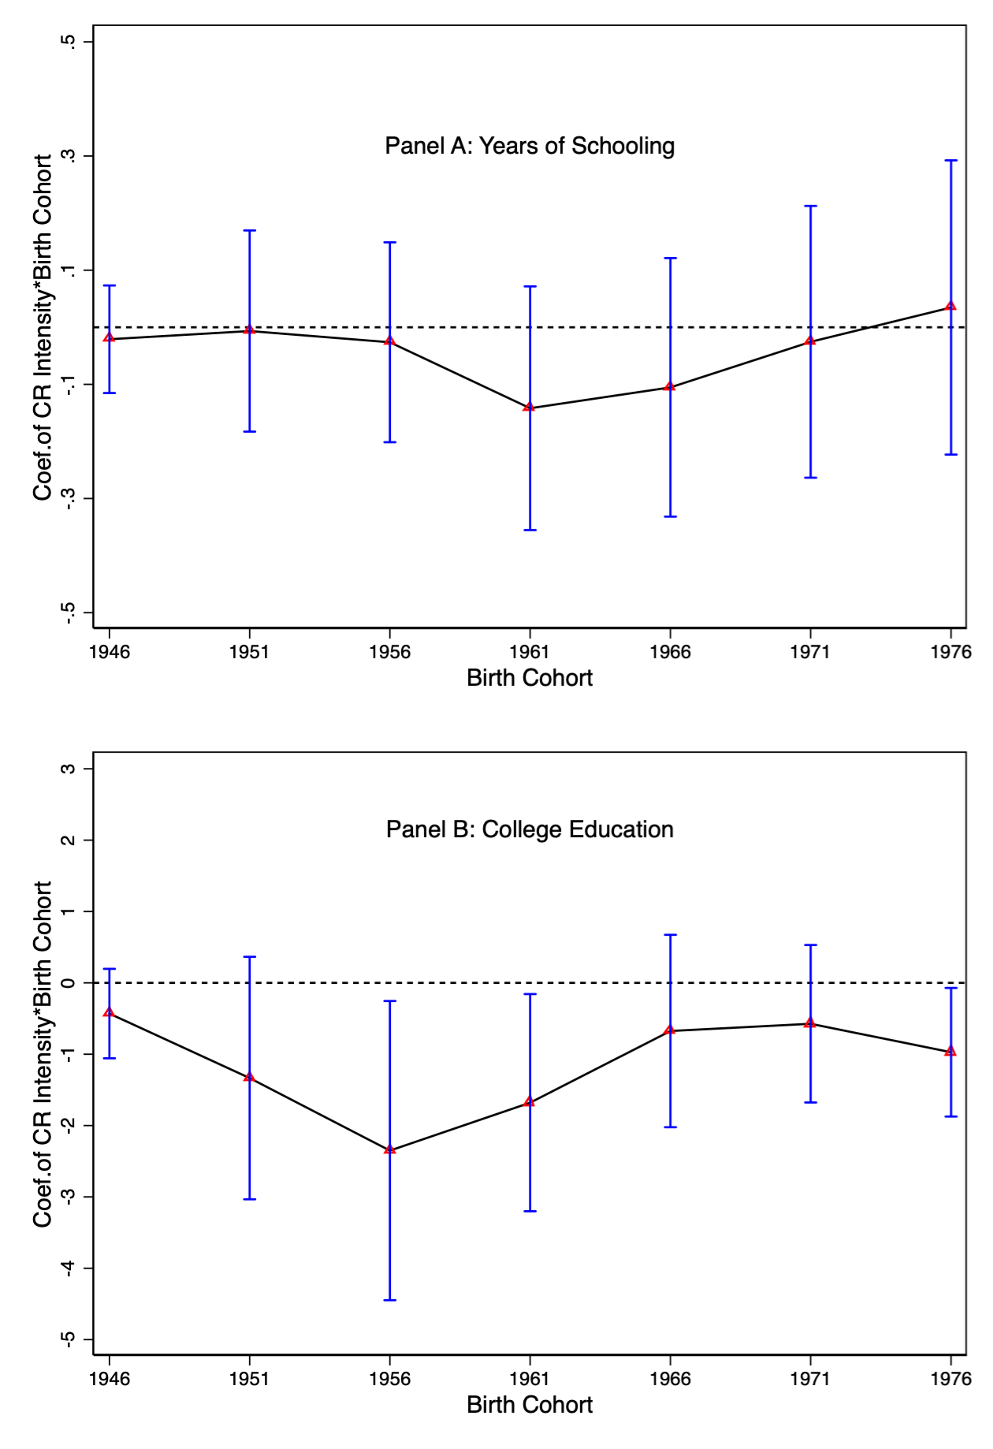
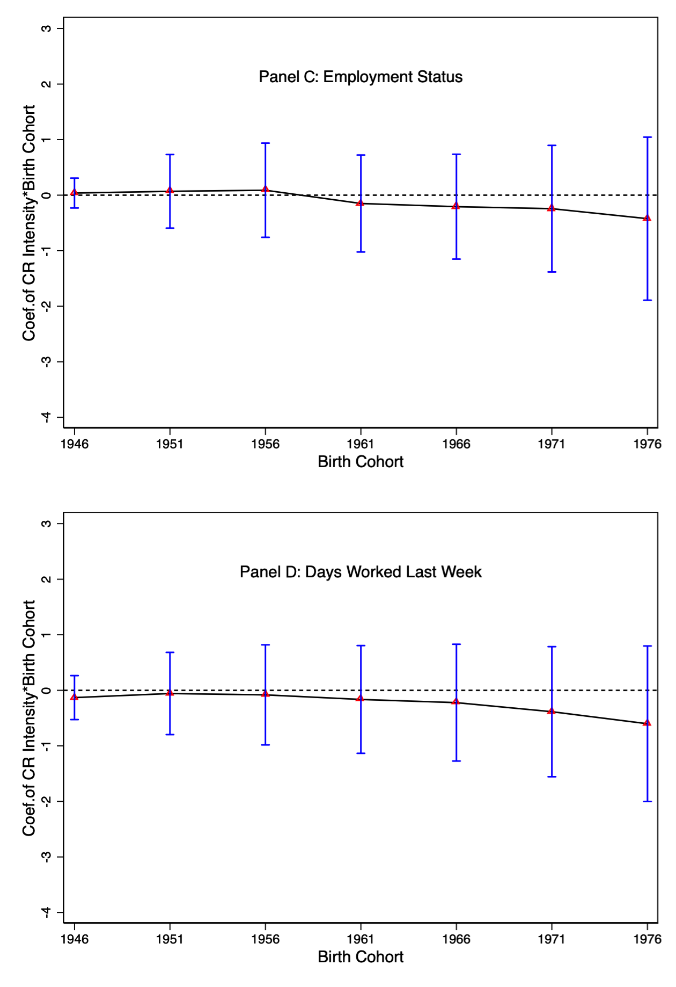
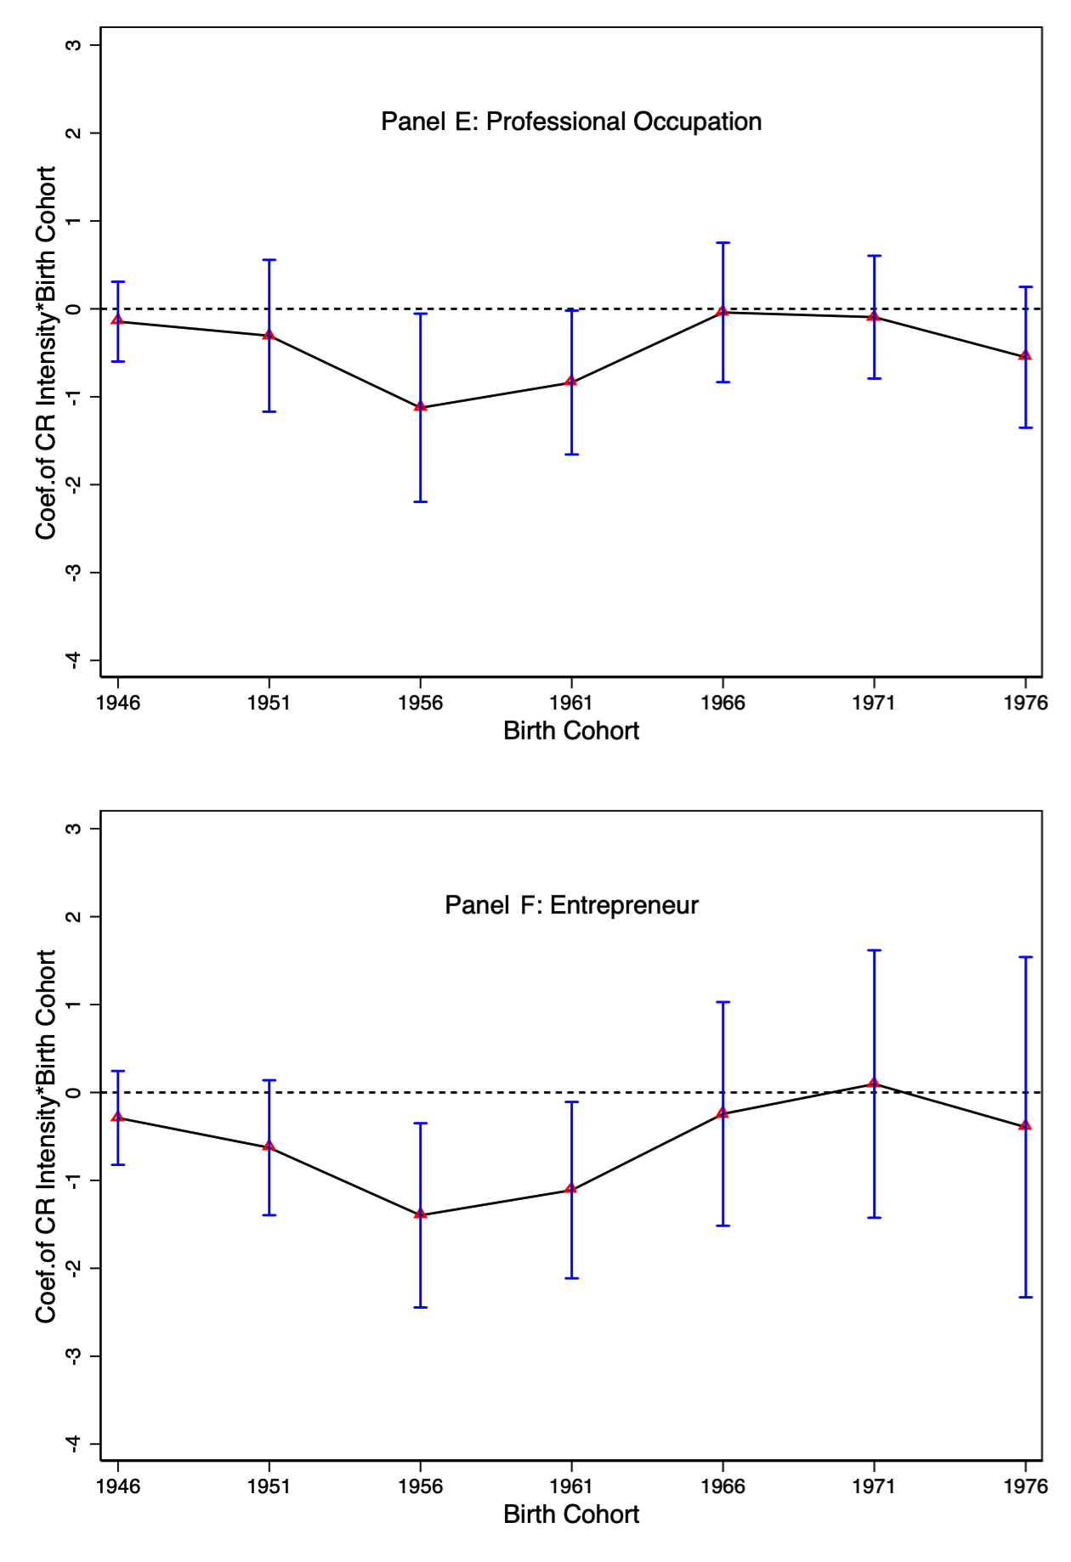

Supplemental Tables

This appendix contains several supplemental tables. Here’s a complete list of items:

  - Table B1: County-level Panel Results: Revolutionary Intensity and Industrialization: Raw Measure
  - Table B2: County-level Panel Results: Revolutionary Intensity and Industrialization: Alter- native Denominators
  - Table B3: County-level Panel Results: Binary Measure of Revolutionary Intensity
  - Table B4: County-level Panel Results: Controlling for Famine Severity
  - Table B5: County-level Panel Results: Revolutionary Intensity and Industrialization: Con- trolling for Migration and Population Density
  - Table B6: Revolutionary Intensity and Industrialization: Controlling for Mean Reversion
  - Table B7: County-level Panel Results: Revolutionary Intensity and Industrialization: Quantile Regressions
  - Table B8: County-level Panel Results: Revolutionary Intensity and Industrialization: Non- Linear Effects
  - Table B9: Prefecture-level Panel Results: Revolutionary Intensity and Industrialization
  - Table B10: Individual-level Analysis: Summary Statistics
  - Table B11: Individual-level Results: Revolutionary Intensity and Perceived Return to Education

Table B1: County-level Panel Results: Revolutionary Intensity and Industrialization: Raw Measure

A. 1953 Base-year Sample (n = 3000) B. 1964 Base-year Sample (n = 5944)

Dep. Var: % of non-agr. population | (1) | (2) | (3) | (4) |  | (5) | (6) | (7) | (8)
Deaths (% of county pop.) x D1964 | -3.336 | -2.384 | -2.538 | -3.026
Deaths (% of county pop.) x D1982 | (2.770)  -14.549*** | (2.760)  -11.567*** | (3.254)  -11.972** | (3.378)  -12.670** |  | -10.393*** | -8.761*** | -11.849*** | -11.632***
 | (4.494) | (4.168) | (5.369) | (5.763) |  | (2.723) | (2.683) | (4.124) | (4.183)
Deaths (% of county pop.) x D1990 | -16.225*** | -12.785** | -13.303** | -13.292* |  | -12.426*** | -11.203*** | -15.663*** | -14.268***
 | (5.745) | (5.561) | (6.576) | (7.098) |  | (3.262) | (3.370) | (5.260) | (5.287)
Deaths (% of county pop.) x D2000 | -12.949* | -8.527 | -9.184 | -7.819 |  | 1.768 | 5.402 | -0.775 | -1.386
 | (7.346) | (7.159) | (9.882) | (10.550) |  | (6.037) | (6.049) | (9.009) | (9.122)
Pre-CR Social Capital x Year dummies | Yes | Yes | Yes | Yes |  | Yes | Yes | Yes | Yes
Pre-CR Ethnic Frag. x Year dummies | Yes | Yes | Yes | Yes |  | Yes | Yes | Yes | Yes
Pre-CR Inequality x Year dummies | Yes | Yes | Yes | Yes |  | Yes | Yes | Yes | Yes
Avg. Terrain Slope x Year dummies | No | Yes | Yes | Yes |  | No | Yes | Yes | Yes
Dist. to Prov. Capital x Year dummies | No | Yes | Yes | Yes |  | No | Yes | Yes | Yes
Provincial Time Trend | No | No | Yes | Yes |  | No | No | Yes | Yes
Word Count x Year dummies | No | No | No | Yes |  | No | No | No | Yes
Post-Deng Pub. x Year dummies | No | No | No | Yes |  | No | No | No | Yes
R-squared | 0.784 | 0.790 | 0.834 | 0.835 |  | 0.801 | 0.806 | 0.841 | 0.842
County FE | Yes | Yes | Yes | Yes |  | Yes | Yes | Yes | Yes
Year FE | Yes | Yes | Yes | Yes |  | Yes | Yes | Yes | Yes

Notes: Robust standard errors - clustered at the county level - are in parentheses. */**/*** denotes significance at the 10% / 5% / 1% levels. The years 1953, 1964, 1982, 1990 and 2000 are census years. All results are weighted using 1964 population. Pre-revolution inequality is measured by the educational Gini coefficient, calculated using the 1982 census among individuals born before 1966. Pre-revolution ethnic fragmentation index is calculated following Alesina et al. (2003), using the same sample. Pre-revolution social capital is proxied with the number of historical charity organizations (Wang 2013). Province time trends are interaction terms of province dummies with a linear time trend.

Table B2: County-level Panel Results: Revolutionary Intensity and Industrialization: Alternative Denominators

A. Alternative Denominator B. Alternative Denominator
(deaths during 1966-1976) (deaths during 1966-1971)

Dep. Var: % of non-agr. population | (1) | (2) |  | (3) | (4)
Deaths (% of county deaths.) x D1964 | 0.032 |  |  | 0.019
Deaths (% of county deaths.) x D1982 | (0.055)  -0.153* | -0.217*** |  | (0.044)  -0.114* | -0.162***
 | (0.089) | (0.042) |  | (0.069) | (0.032)
Deaths (% of county deaths.) x D1990 | -0.046 | -0.118*** |  | -0.031 | -0.087***
 | (0.086) | (0.042) |  | (0.068) | (0.031)
Deaths (% of county deaths.) x D2000 | 0.004 | -0.061 |  | 0.007 | -0.046
 | (0.095) | (0.059) |  | (0.075) | (0.043)
Pre-CR Characteristics x Year dummies Geographic Characteristics x Year dummies Reporting style x Year dummies | Yes Yes Yes | Yes Yes Yes |  | Yes Yes Yes | Yes Yes Yes
Observations | 3,000 | 5,944 |  | 3,000 | 5,944
R-squared County FE Year FE  Provincial Time Trend | 0.849  Yes Yes Yes | 0.870  Yes Yes Yes |  | 0.849  Yes Yes Yes | 0.870  Yes Yes Yes

Notes: Robust standard errors - clustered at the county level - are in parentheses. */**/*** denotes significance at the 10% / 5% / 1% levels. Columns 1 and 3 correspond to the 1953-base year sample, while Columns 2 and 4 to the 1964-base year sample. The years 1953, 1964, 1982, 1990 and 2000 are census years. All results are weighted using 1964 population. Pre-CR characteristics include inequality, ethnic fragmentation, and social capital. Geographic characteristics include average terrain slope, distance to provincial capital, and distance to provincial border. Reporting style controls include the word count measure as well as the indicator for whether the gazetteer is published during the post-Deng period. Province time trends are interaction terms of province dummies with a linear time trend.

Table B3: County-level Panel Results: Binary Measure of Revolutionary Intensity

A. 1953 Base-year Sample B. 1964 Base-year Sample

Dep. Var: % of non-agr. population | (1) | (2) | (3) | (4) |  | (5) | (6) | (7) | (8)
Deaths (dummy) x D1964 | -0.049 | -0.045 | -0.012 | -0.009
Deaths (dummy) x D1982 | (0.063)  -0.303*** | (0.061)  -0.235** | (0.063)  -0.148* | (0.064)  -0.142* |  | -0.158*** | -0.113** | -0.101** | -0.087*
 | (0.100) | (0.099) | (0.082) | (0.085) |  | (0.052) | (0.051) | (0.046) | (0.047)
Deaths (dummy) x D1990 | -0.224*** | -0.169** | -0.057 | -0.055 |  | -0.115*** | -0.082** | -0.065* | -0.049
 | (0.081) | (0.079) | (0.066) | (0.068) |  | (0.041) | (0.041) | (0.035) | (0.035)
Deaths (dummy) x D2000 | -0.153* | -0.097 | 0.045 | 0.042 |  | -0.046 | -0.004 | 0.019 | 0.010
 | (0.091) | (0.091) | (0.072) | (0.073) |  | (0.052) | (0.054) | (0.039) | (0.040)
Pre-CR Social Capital x Year dummies | Yes | Yes | Yes | Yes |  | Yes | Yes | Yes | Yes
Pre-CR Ethnic Frag. x Year dummies | Yes | Yes | Yes | Yes |  | Yes | Yes | Yes | Yes
Pre-CR Inequality x Year dummies | Yes | Yes | Yes | Yes |  | Yes | Yes | Yes | Yes
Avg. Terrain Slope x Year dummies | No | Yes | Yes | Yes |  | No | Yes | Yes | Yes
Dist. to Prov. Capital x Year dummies | No | Yes | Yes | Yes |  | No | Yes | Yes | Yes
Provincial Time Trend | No | No | Yes | Yes |  | No | No | Yes | Yes
Word Count x Year dummies | No | No | No | Yes |  | No | No | No | Yes
Post-Deng Pub. x Year dummies | No | No | No | Yes |  | No | No | No | Yes
Observations | 3000 | 3000 | 3000 | 3000 |  | 5944 | 5944 | 5944 | 5944
R-squared | 0.806 | 0.814 | 0.848 | 0.849 |  | 0.824 | 0.829 | 0.868 | 0.869
County FE | Yes | Yes | Yes | Yes |  | Yes | Yes | Yes | Yes
Year FE | Yes | Yes | Yes | Yes |  | Yes | Yes | Yes | Yes

Notes: Robust standard errors - clustered at the county level - are in parentheses. */**/*** denotes significance at the 10% / 5% / 1% levels. The years 1953, 1964, 1982, 1990 and 2000 are census years. All results are weighted using 1964 population. Pre-revolution inequality is measured by the educational Gini coefficient, calculated using the 1982 census among individuals born before 1966. Pre-revolution ethnic fragmentation index is calculated following Alesina et al. (2003), using the same sample. Pre-revolution social capital is proxied with the number of historical charity organizations (Wang 2013). Province time trends are interaction terms of province dummies with a linear time trend.

Table B4: County-level Panel Results: Controlling for Famine Severity

A. 1953 Base-year Sample (n = 3000) B. 1964 Base-year Sample (n = 5944)

Dep. Var: % of non-agr. population | (1) | (2) | (3) | (4) |  | (5) | (6) | (7) | (8)
Deaths (% of county pop.) x D1964 | -0.034 | 0.037 | 0.045 | 0.044
Deaths (% of county pop.) x D1982 | (0.369)  -1.373*** | (0.361)  -0.995** | (0.375)  -0.974** | (0.373)  -0.997** |  | -1.254*** | -0.969*** | -1.280*** | -1.274***
 | (0.505) | (0.436) | (0.453) | (0.464) |  | (0.275) | (0.250) | (0.320) | (0.325)
Deaths (% of county pop.) x D1990 | -0.944* | -0.631 | -0.604 | -0.662 |  | -0.664*** | -0.473** | -0.922*** | -0.922***
 | (0.520) | (0.468) | (0.506) | (0.516) |  | (0.218) | (0.204) | (0.295) | (0.302)
Deaths (% of county pop.) x D2000 | -0.274 | 0.002 | 0.036 | -0.017 |  | 0.335 | 0.561* | -0.061 | -0.130
 | (0.569) | (0.540) | (0.623) | (0.642) |  | (0.309) | (0.302) | (0.411) | (0.424)
Pre-CR Characteristics x Year dummies | Yes | Yes | Yes | Yes |  | Yes | Yes | Yes | Yes
Geographic Characteristics x Year dummies | No | Yes | Yes | Yes |  | No | Yes | Yes | Yes
Provincial Time Trend | No | No | Yes | Yes |  | No | No | Yes | Yes
Word Count x Year dummies | No | No | No | Yes |  | No | No | No | Yes
Post-Deng Pub. x Year dummies | No | No | No | Yes |  | No | No | No | Yes
Famine Severity x Year dummies | Yes | Yes | Yes | Yes |  | Yes | Yes | Yes | Yes
R-squared | 0.813 | 0.822 | 0.858 | 0.858 |  | 0.839 | 0.844 | 0.880 | 0.881
County FE | Yes | Yes | Yes | Yes |  | Yes | Yes | Yes | Yes
Year FE | Yes | Yes | Yes | Yes |  | Yes | Yes | Yes | Yes

Notes: Robust standard errors - clustered at the county level - are in parentheses. */**/*** denotes significance at the 10% / 5% / 1% levels. The years 1953, 1964, 1982, 1990 and 2000 are census years. All results are weighted using 1964 population. The Great Famine (1959-1961) Severity is measured as one minus the ratio of average famine cohort size (1959-61) to average pre-famine cohort size (1955-57). The calculation is at the prefecture level using the 1982 census. Pre-revolution inequality is measured by the educational Gini coefficient, calculated using the 1982 census among individuals born before 1966. Pre-revolution ethnic fragmentation index is calculated following Alesina et al. (2003), using the same sample. Pre-revolution social capital is proxied with the number of historical charity organizations (Wang 2013). Province time trends are interaction terms of province dummies with a linear time trend.

Table B5: County-level Panel Results: Controlling for Migration and Population Density

1964 Base-year Sample

Dep. Var: % of non-agr. population | (1) | (2) | (3)
Deaths(% of county pop.) x D1982 (log) Deaths(% of county pop.) x D1990 (log) | -1.100*** (0.292)  -0.729***  (0.277) | -1.096*** (0.293)  -0.762***  (0.282) | -1.095*** (0.291)  -0.723***  (0.275)
Deaths(% of county pop.) x D2000 (log) | -0.153 | -0.169 | -0.150
 | (0.430) | (0.432) | (0.428)
Observations | 5,944 | 5,944 | 5,944
R-squared | 0.870 | 0.869 | 0.870
Pre-CR Characteristics x Year dummies | Yes | Yes | Yes
Geographic Characteristics x Year dummies | Yes | Yes | Yes
Reporting style x Year dummies | Yes | Yes | Yes
County FE | Yes | Yes | Yes
Year FE | Yes | Yes | Yes
Provincial Time Trend | Yes | Yes | Yes
Migration | Yes | No | Yes
Population Density | No | Yes | Yes

Notes: Robust standard errors - clustered at the county level - are in parentheses. */**/*** denotes significance at the 10% / 5% / 1% levels. The proportion of migrants among the labor force (aged 16-60) is constructed for the census years (1964, 1982, 1990 and 2000), using the population census of 1982, 1990 and 2000. All results are weighted using 1964 population. Pre-revolution socioeconomic characteristics include inequality, ethnic fragmentation index, and social capital. Geographic characteristics include average terrain slope, distance to provincial capital, and distance to provincial border. Reporting style controls include the word count measure as well as the indicator whether the gazetteer is published during the post-Deng period. Province time trends are interaction terms of province dummies with a linear time trend.

Table B6: Revolutionary Intensity and Industrialization: Controlling for Mean Reversion

A. ∆ industrialization (1964-1982) B. ∆ industrialization (1964-1990)
Dep. Var: ∆ industrialization | (1) | (2) | (3) | (4) |  | (5) | (6) | (7) | (8)
Log Deaths (% of county pop.) | -0.904*** | -0.816*** | -0.870*** | -0.940*** |  | -0.595** | -0.495** | -0.434** | -0.519***
Industrialization 1964 | (0.253) | (0.237)  -0.495*** (0.059) | (0.199) | (0.184)  -0.445*** (0.032) |  | (0.232) | (0.203)  -0.560*** (0.043) | (0.175) | (0.137)  -0.538*** (0.023)
Pre-CR Social Capital | Yes | Yes | Yes | Yes |  | Yes | Yes | Yes | Yes
Pre-CR Ethnic Frag. | Yes | Yes | Yes | Yes |  | Yes | Yes | Yes | Yes
Pre-CR Inequality | Yes | Yes | Yes | Yes |  | Yes | Yes | Yes | Yes
Avg. Terrain Slope | Yes | Yes | Yes | Yes |  | Yes | Yes | Yes | Yes
Dist. to Prov. Capital | Yes | Yes | Yes | Yes |  | Yes | Yes | Yes | Yes
Dist. to Prov. Border | Yes | Yes | Yes | Yes |  | Yes | Yes | Yes | Yes
Word Count | Yes | Yes | Yes | Yes |  | Yes | Yes | Yes | Yes
Post-Deng Period Pub. | Yes | Yes | Yes | Yes |  | Yes | Yes | Yes | Yes
Observations | 600 | 600 | 1486 | 1486 |  | 600 | 600 | 1486 | 1486
R-squared | 0.173 | 0.298 | 0.191 | 0.321 |  | 0.144 | 0.388 | 0.158 | 0.441

Notes: Robust standard errors are in parentheses. */**/*** denotes significance at the 10% / 5% / 1% levels. This table presents results of cross-sectional regressions. The dependent variable is changes of industrialization: changes in 1964-1982 (Column 1-4) and 1964-1990 (Columns 5-7). The key explanatory variable is the revolution intensity at county level. To test “mean-reversion”, we control for the baseline industrialization performance in the year of 1964. Columns 1, 2, 5 and 6 correspond to the 1953-base sample counties (N=600), while Columns 3, 4, 7 and 8 correspond to the 1964-base sample counties (N=1486). Pre-revolution inequality is measured by the educational Gini coefficient, which is calculated using the 1982 census among individuals born before 1966. Pre-revolution ethnic fragmentation index is calculated following Alesina et al. (2003), using the same sample. Pre-revolution social capital is proxied with the number of historical charity organizations (Wang 2013). All regressions are weighted using 1964 population.

Table B7: County-level Panel Results: Revolutionary Intensity and Industrialization: Quantile Regressions

Dep. Var: % of non-agr. population A. 1953 Base-year Sample (n = 2400)

Quantile: | (0.1) | (0.2) | (0.3) | (0.4) | (0.5) | (0.6) | (0.7) | (0.8) | (0.9)
Deaths (% of county pop.) x D1982 | -0.782* | -0.086 | -0.116 | -0.241 | -0.555 | -0.710* | -0.695** | -0.956*** | -1.145***
 | (0.409) | (0.396) | (0.351) | (0.323) | (0.406) | (0.369) | (0.309) | (0.266) | (0.229)
Deaths (% of county pop.) x D1990 | -0.661** | -0.530 | -0.546* | -0.532 | -0.805 | -0.704 | -0.383 | -0.527* | -0.606**
 | (0.309) | (0.333) | (0.317) | (0.464) | (0.602) | (0.561) | (0.322) | (0.304) | (0.267)
Deaths (% of county pop.) x D2000 | 0.322 | 0.322 | 0.279 | 0.107 | -0.236 | -0.158 | -0.149 | -0.159 | -0.389
 | (0.315) | (0.334) | (0.332) | (0.454) | (0.598) | (1.237) | (0.800) | (0.580) | (0.368)
B. 1964 Base-year Sample (n = 5944)
Deaths (% of county pop.) x D1982 | -0.775*** | -0.474 | -0.527*** | -0.681*** | -0.641*** | -0.876*** | -0.841*** | -0.899*** | -0.631
 | (0.226) | (0.308) | (0.186) | (0.255) | (0.207) | (0.244) | (0.181) | (0.242) | (0.773)
Deaths (% of county pop.) x D1990 | -0.567** | -0.609*** | -0.669*** | -0.615*** | -0.655*** | -0.680* | -0.474** | -0.370 | -0.278
 | (0.246) | (0.170) | (0.204) | (0.233) | (0.235) | (0.387) | (0.225) | (0.306) | (0.385)
Deaths (% of county pop.) x D2000 | -0.793* | -0.198 | -0.075 | -0.173 | -0.116 | -0.474 | -0.393 | -0.296 | -0.119
 | (0.424) | (0.229) | (0.396) | (0.426) | (0.338) | (0.319) | (0.401) | (1.041) | (0.551)
Pre-CR Social Capital x Year dummies | Yes | Yes | Yes | Yes | Yes | Yes | Yes | Yes | Yes
Pre-CR Ethnic Frag. x Year dummies | Yes | Yes | Yes | Yes | Yes | Yes | Yes | Yes | Yes
Pre-CR Inequality x Year dummies | Yes | Yes | Yes | Yes | Yes | Yes | Yes | Yes | Yes
Avg. Terrain Slope x Year dummies | Yes | Yes | Yes | Yes | Yes | Yes | Yes | Yes | Yes
Dist. to Prov. Capital x Year dummies | Yes | Yes | Yes | Yes | Yes | Yes | Yes | Yes | Yes
Provincial Time Trend | Yes | Yes | Yes | Yes | Yes | Yes | Yes | Yes | Yes
Word Count x Year dummies | Yes | Yes | Yes | Yes | Yes | Yes | Yes | Yes | Yes
Post-Deng Pub. x Year dummies | Yes | Yes | Yes | Yes | Yes | Yes | Yes | Yes | Yes
County FE | Yes | Yes | Yes | Yes | Yes | Yes | Yes | Yes | Yes
Year FE | Yes | Yes | Yes | Yes | Yes | Yes | Yes | Yes | Yes

Notes: Robust standard errors - clustered at the county level - are in parentheses. */**/*** denotes significance at the 10% / 5% / 1% levels. The years 1953, 1964, 1982, 1990 and 2000 are census years. Panel A uses the 1953-base year counties (n = 600) during 1964-2000, and Panel B uses the 1964-base year counties (n = 1486) during 1964-2000. Pre-revolution inequality is measured by the educational Gini coefficient, calculated using the 1982 census among individuals born before 1966. Pre-revolution ethnic fragmentation index is calculated following Alesina et al. (2003), using the same sample. Pre-revolution social capital is proxied with the number of historical charity organizations (Wang 2013). Province time trends are interaction terms of province dummies with a linear time trend.

Table B8: County-level Panel Results: Revolutionary Intensity and Industrialization: Non-Linear Effects

A. 1953 Base-year Sample (n = 3000) B. 1964 Base-year Sample (n = 5944)

Dep. Var: % of non-agr. population | (1) | (2) | (3) | (4) |  | (5) | (6) | (7) | (8)
Deaths (% of county pop.) x D1964 | -0.385 | -0.204 | -0.043 | -0.026
 | (0.727) | (0.740) | (0.784) | (0.776)
Deaths² (% of county pop.) x D1964 | 0.726 | 0.514 | 0.198 | 0.159
 | (1.123) | (1.112) | (1.121) | (1.101)
Deaths (% of county pop.) x D1982 | -2.764*** | -1.851* | -1.425 | -1.393 |  | -2.384*** | -1.862*** | -1.987*** | -1.917***
 | (1.047) | (1.031) | (1.077) | (1.085) |  | (0.497) | (0.500) | (0.513) | (0.525)
Deaths² (% of county pop.) x D1982 | 3.208* | 2.053 | 1.219 | 1.122 |  | 2.768*** | 2.159*** | 1.815** | 1.722**
 | (1.656) | (1.580) | (1.517) | (1.499) |  | (0.789) | (0.797) | (0.845) | (0.864)
Deaths (% of county pop.) x D1990 | -2.091** | -1.345 | -0.801 | -0.836 |  | -1.458*** | -1.095** | -1.275*** | -1.216**
 | (0.937) | (0.940) | (1.055) | (1.075) |  | (0.428) | (0.437) | (0.465) | (0.480)
Deaths² (% of county pop.) x D1990 | 2.669* | 1.726 | 0.661 | 0.630 |  | 1.925*** | 1.489** | 0.992 | 0.908
 | (1.455) | (1.410) | (1.472) | (1.464) |  | (0.655) | (0.656) | (0.733) | (0.769)
Deaths (% of county pop.) x D2000 | -1.710 | -0.858 | -0.168 | -0.278 |  | -1.068 | -0.493 | -0.743 | -0.920
 | (1.164) | (1.155) | (1.240) | (1.279) |  | (0.730) | (0.741) | (0.644) | (0.655)
Deaths² (% of county pop.) x D2000 | 2.642 | 1.577 | 0.225 | 0.314 |  | 2.665** | 2.015* | 1.328 | 1.534
 | (2.012) | (1.918) | (1.703) | (1.730) |  | (1.204) | (1.222) | (1.192) | (1.194)
Pre-CR Social Capital x Year dummies | Yes | Yes | Yes | Yes |  | Yes | Yes | Yes | Yes
Pre-CR Ethnic Frag. x Year dummies | Yes | Yes | Yes | Yes |  | Yes | Yes | Yes | Yes
Pre-CR Inequality x Year dummies | Yes | Yes | Yes | Yes |  | Yes | Yes | Yes | Yes
Avg. Terrain Slope x Year dummies | No | Yes | Yes | Yes |  | No | Yes | Yes | Yes
Dist. to Prov. Capital x Year dummies | No | Yes | Yes | Yes |  | No | Yes | Yes | Yes
Provincial Time Trend | No | No | Yes | Yes |  | No | No | Yes | Yes
Word Count x Year dummies | No | No | No | Yes |  | No | No | No | Yes
Post-Deng Pub. x Year dummies | No | No | No | Yes |  | No | No | No | Yes
R-squared | 0.805 | 0.813 | 0.848 | 0.849 |  | 0.825 | 0.830 | 0.869 | 0.869
County FE | Yes | Yes | Yes | Yes |  | Yes | Yes | Yes | Yes
Year FE | Yes | Yes | Yes | Yes |  | Yes | Yes | Yes | Yes

Notes: Robust standard errors - clustered at the county level - are in parentheses. */**/*** denotes significance at the 10% / 5% / 1% levels. The years 1953, 1964, 1982, 1990 and 2000 are census years. All results are weighted using 1964 population. Pre-revolution inequality is measured by the educational Gini coefficient, calculated using the 1982 census among individuals born before 1966. Pre-revolution ethnic fragmentation index is calculated following Alesina et al. (2003), using the same sample. Pre-revolution social capital is proxied with the number of historical charity organizations (Wang 2013). Province time trends are interaction terms of province dummies with a linear time trend.

Table B9: Prefecture-level Panel Results: Revolutionary Intensity and Industrialization

A. 1953 Base-year Sample B. 1964 Base-year Sample

Dep. Var: % of non-agr. population | (1) | (2) | (3) | (4) |  | (5) | (6) | (7) | (8)
Deaths (% of pref. pop.) x D1964 | -0.080 | 0.092 | 0.188 | 0.270
 | (0.491) | (0.466) | (0.569) | (0.609)
Deaths (% of pref. pop.) x D1982 | -1.730** | -1.233 | -0.981 | -0.854 |  | -1.760*** | -1.405** | -1.749** | -1.672**
 | (0.875) | (0.768) | (0.988) | (1.043) |  | (0.661) | (0.640) | (0.786) | (0.733)
Deaths (% of pref. pop.) x D1990 | -1.112 | -0.677 | -0.356 | -0.255 |  | -0.866* | -0.685 | -1.183 | -1.137
 | (0.879) | (0.792) | (1.160) | (1.206) |  | (0.492) | (0.502) | (0.798) | (0.792)
Deaths (% of pref. pop.) x D2000 | -0.341 | 0.152 | 0.560 | 0.631 |  | 0.542 | 0.913 | 0.224 | 0.078
 | (0.848) | (0.761) | (1.145) | (1.242) |  | (0.735) | (0.743) | (1.049) | (1.044)
Pre-CR Social Capital x Year dummies | Yes | Yes | Yes | Yes |  | Yes | Yes | Yes | Yes
Pre-CR Ethnic Frag. x Year dummies | Yes | Yes | Yes | Yes |  | Yes | Yes | Yes | Yes
Pre-CR Inequality x Year dummies | Yes | Yes | Yes | Yes |  | Yes | Yes | Yes | Yes
Avg. Terrain Slope x Year dummies | No | Yes | Yes | Yes |  | No | Yes | Yes | Yes
Dist. to Prov. Capital x Year dummies | No | Yes | Yes | Yes |  | No | Yes | Yes | Yes
Provincial Time Trend | No | No | Yes | Yes |  | No | No | Yes | Yes
Word Count x Year dummies | No | No | No | Yes |  | No | No | No | Yes
Post-Deng Pub. x Year dummies | No | No | No | Yes |  | No | No | No | Yes
Observations | 825 | 825 | 825 | 825 |  | 776 | 776 | 776 | 776
R-squared | 0.850 | 0.864 | 0.902 | 0.906 |  | 0.867 | 0.877 | 0.921 | 0.924
Prefecture FE | Yes | Yes | Yes | Yes |  | Yes | Yes | Yes | Yes
Year FE | Yes | Yes | Yes | Yes |  | Yes | Yes | Yes | Yes

Notes: Robust standard errors - clustered at the prefecture level - are in parentheses. */**/*** denotes significance at the 10% / 5% / 1% levels. The years 1953, 1964, 1982, 1990 and 2000 are census years. All results are weighted using 1964 population. The prefecture-level characteristics, including pre-CR characteristics, geographic characteristics, and reporting style, are generated as county-level averages weighted by county population in 1964, for the 1953-based sample and the 1964-based sample, respectively.

Table B10: Summary Statistics - Individual-level Analysis

Variable Name | Mean | Std. Dev. | Min | Max | N
Panel A. Demographics
Age in 2000 | 39.971 | 12.815 | 19 | 69 | 7268154
Gender (Male = 1, Female = 0) | 0.508 | 0.5 | 0 | 1 | 7268154
Ethnicity (Han = 1, Otherwise = 0) | 0.928 | 0.71 | 0 | 1 | 7268154
HH Registration Status (Urban = 1, Otherwise = 0) | 0.289 | 0.597 | 0 | 1 | 7268154
Marital Status (Married = 1, Otherwise = 0) | 0.842 | 0.365 | 0 | 1 | 7268154
Panel B. Education Outcomes
Years of Schooling | 7.926 | 3.417 | 0 | 18 | 7268154
College Graduate (Yes = 1, No = 0) | 0.048 | 0.213 | 0 | 1 | 7268154
Panel C. Labor Market Outcomes
Employment Status (Employed = 1, Otherwise = 0) | 0.825 | 0.38 | 0 | 1 | 7268154
Days Worked Last Week | 4.675 | 2.664 | 0 | 7 | 7268154
Professional Occupation (Yes = 1, No = 0) | 0.05 | 0.218 | 0 | 1 | 7268154
Entrepreneur (Yes = 1, No = 0) | 0.009 | 0.094 | 0 | 1 | 7268154

Notes: This table reports summary statistics for the key variables in our analytical sample at the individual level. The data come from the 2000 population census from IPUMS. Our sample includes cohorts born between 1931 and 1980.

Table B11: Individual-level Results: Revolutionary Intensity and Perceived Return to Education

(1) |  | (2) | (3)
Dependent Variable: How important is education for success?
Deaths (% of prov. pop.) x D1941-1945 | -0.168 | -0.340 | -0.356
Deaths (% of prov. pop.) x D1946-1950 | (1.036)  -1.868** (0.760) | (1.048)  -2.066** (0.783) | (1.030)  -2.219** (0.887)
Deaths (% of prov. pop.) x D1951-1955 | -1.226* | -1.188* | -1.427
Deaths (% of prov. pop.) x D1956-1960 | (0.626)  -1.681** (0.702) | (0.669)  -1.848** (0.720) | (1.152)  -2.119* (1.163)
Deaths (% of prov. pop.) x D1961-1965 | -0.507 | -0.533 | -0.909
 | (0.538) | (0.586) | (1.507)
Deaths (% of prov. pop.) x D1966-1970 | -1.803*** | -1.811** | -2.260
 | (0.597) | (0.656) | (1.854)
Deaths (% of prov. pop.) x D1971-1975 | -0.995 | -0.942 | -1.488
 | (0.766) | (0.819) | (2.135)
Deaths (% of prov. pop.) x D1976-1980 | -0.862 | -0.816 | -1.453
 | (0.576) | (0.584) | (2.362)
Observations | 8,776 | 8,776 | 8,776
R-squared | 0.043 | 0.049 | 0.057
Province FE | Yes | Yes | Yes
Year of Birth FE | Yes | Yes | Yes
Individual Controls | No | Yes | Yes
Province Cohort Trends | No | No | Yes

Notes: Robust standard errors - clustered at the province level - are in parentheses. */**/*** denotes significance at the 10% / 5% / 1% levels. All results are weighted using survey weights. Since the CGSS 2006 only contains a provincial identifier, we use province-level revolutionary intensity. Individual controls include gender, ethnicity and household registration status. Year of birth and province fixed effects are controlled throughout, and province cohort trends are interaction terms between province dummies and a linear cohort trend. Our sample includes cohorts born between 1936 and 1980, and we take the comparison group cohorts born during 1936-40.

