Appendix: Railways, Development, and
Literacy in India
We study the effect of railroads, the single largest public investment in colonial India, on human capital. Using district-level data on literacy and two different identification strategies, we find railroads had positive effects on literacy, in particular on male and English literacy. We show that railroads increased literacy by raising secondary and elite primary, rather than vernacular primary, schooling. Our mediation analysis suggests that non-agricultural income, urbanisation, and opportunities for skilled employment are important mechanisms, while agricultural income is not.

Appendix Figures
FIGURE 1. Distribution of Literacy
Total Literacy Male Literacy
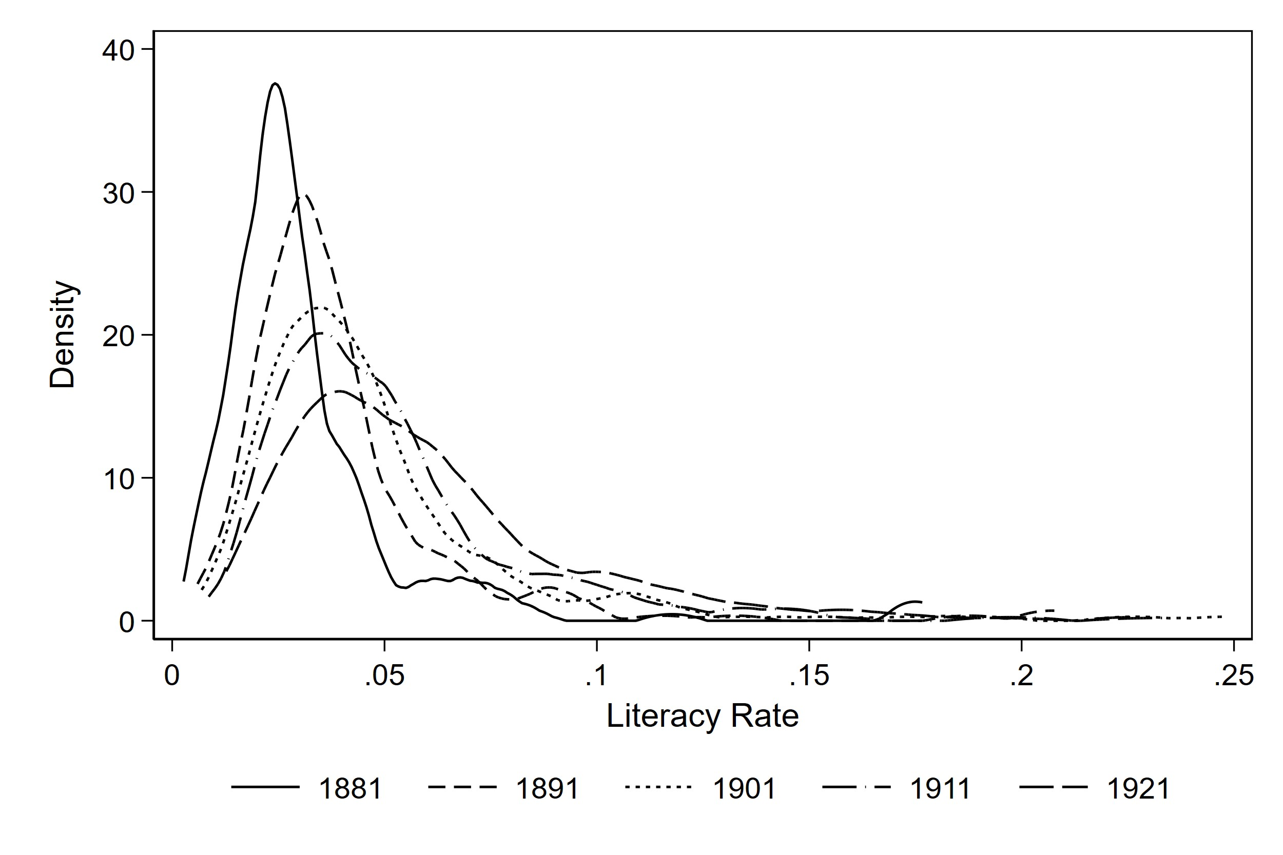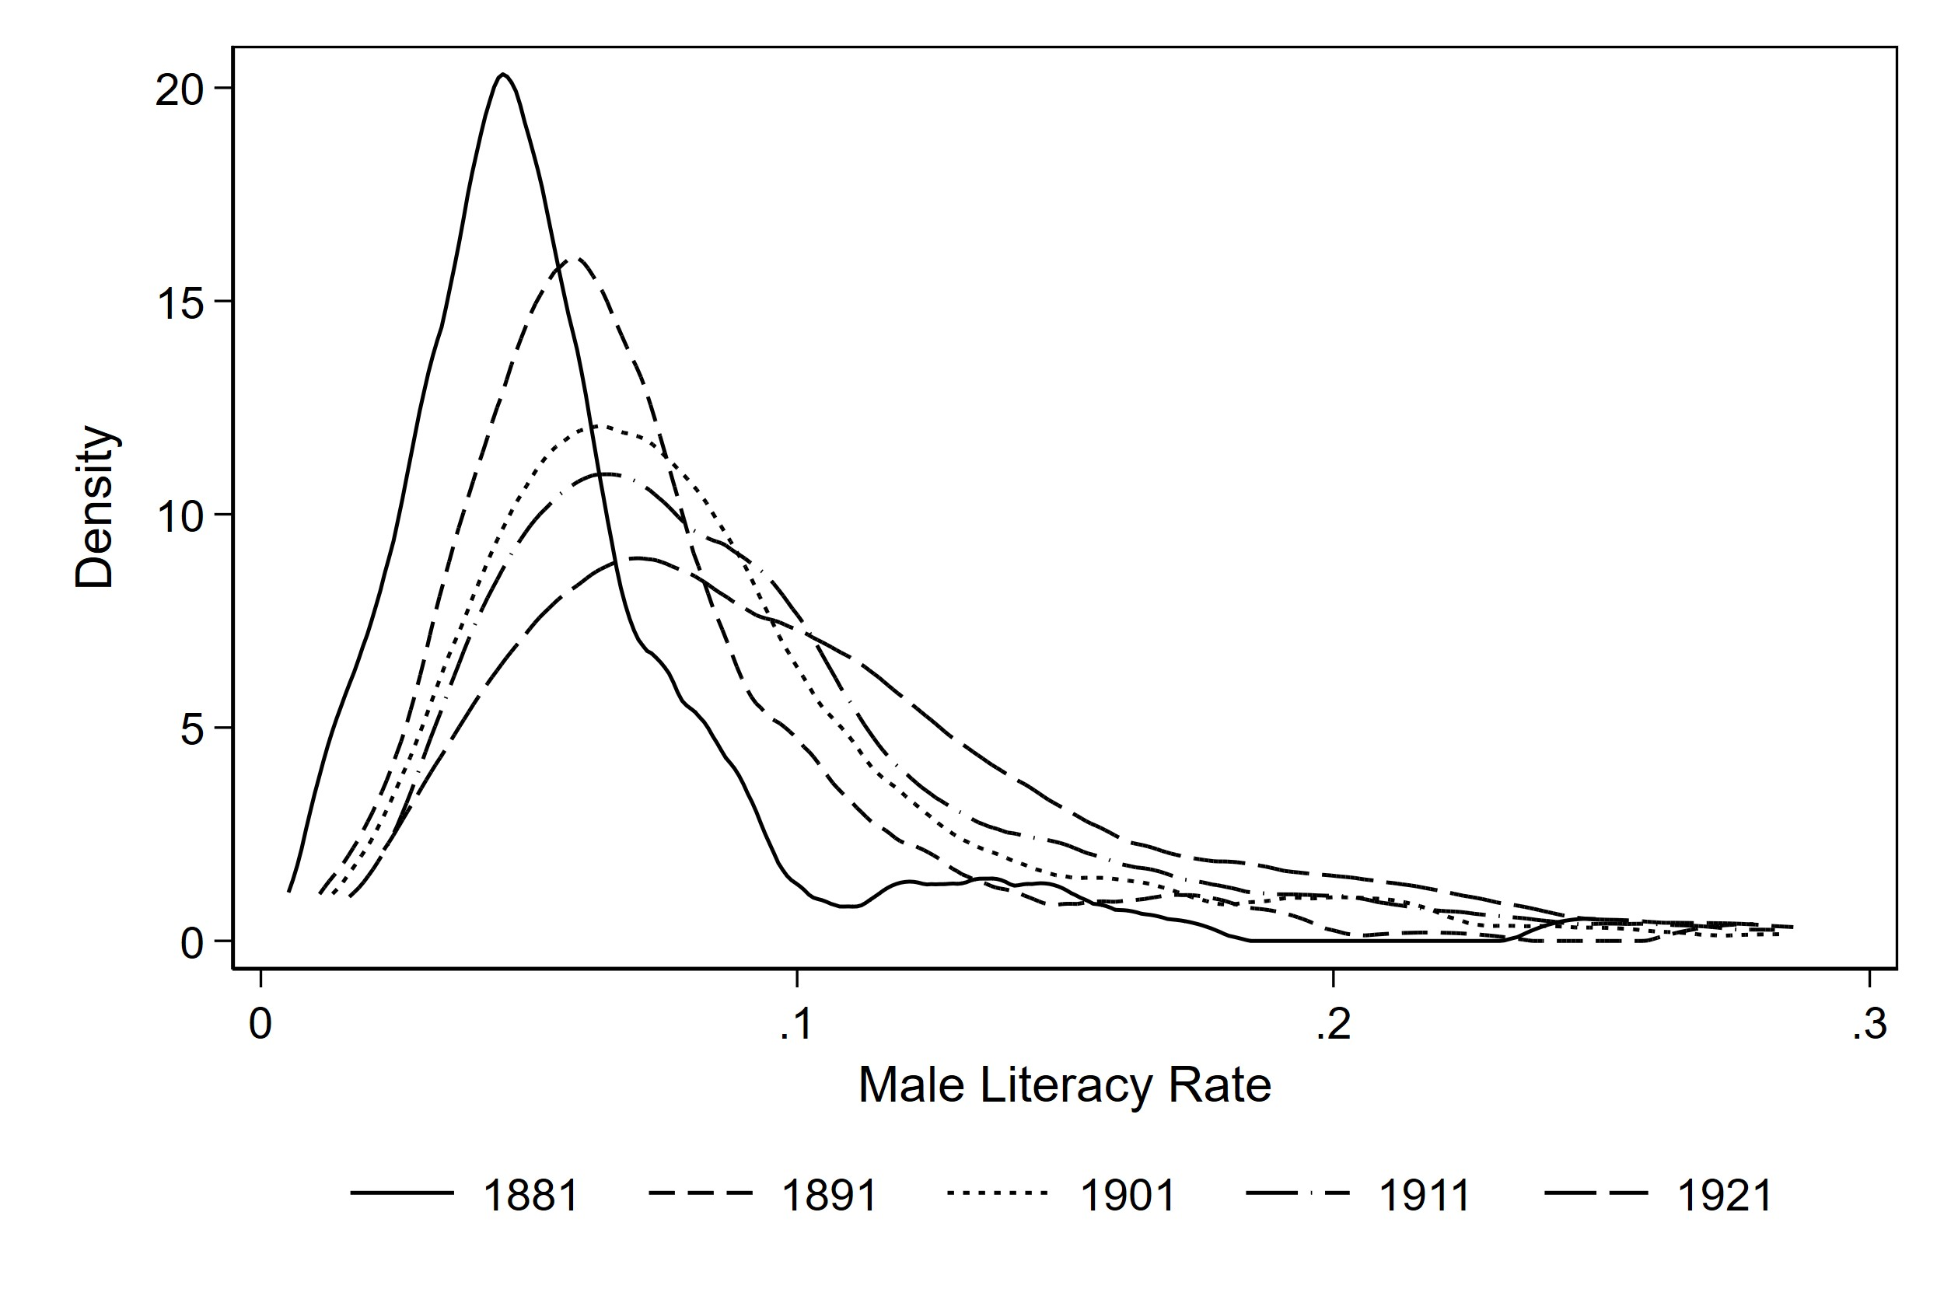
Female Literacy
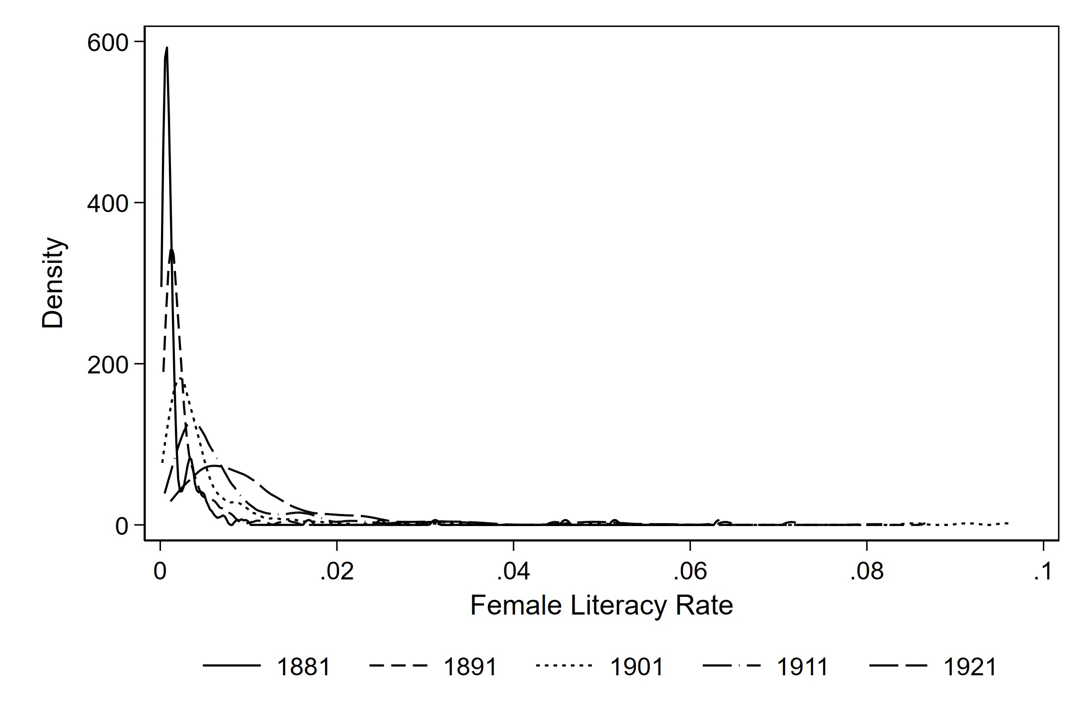
Total distribution truncated at 25%, male distribution at 30%, and female distribution at 10%. Fewer than 1% of observations are above these cutoff.

FIGURE 2. Map of Total Literacy, 1881-1921, Quintiles
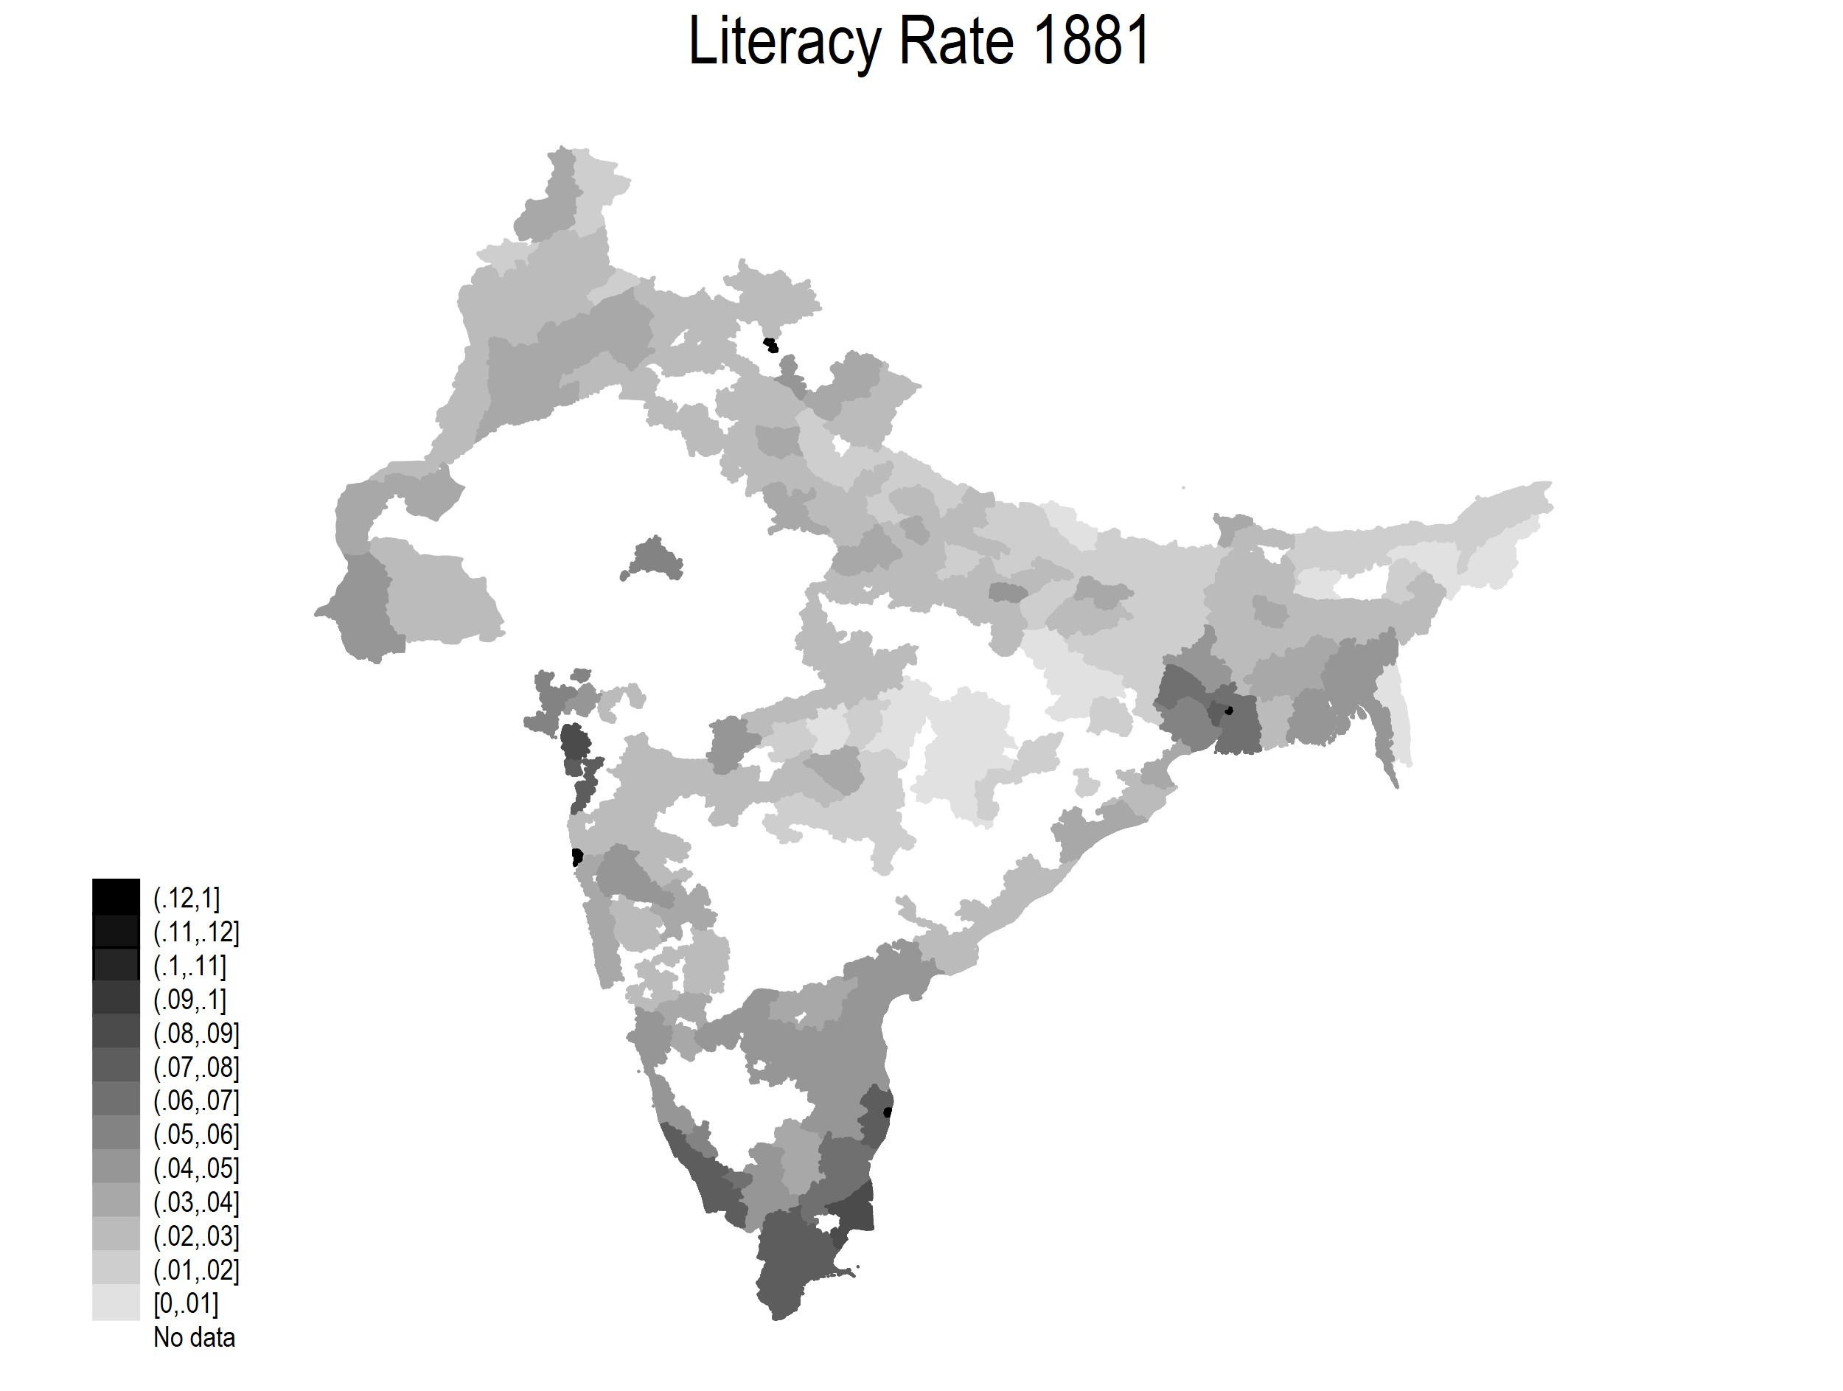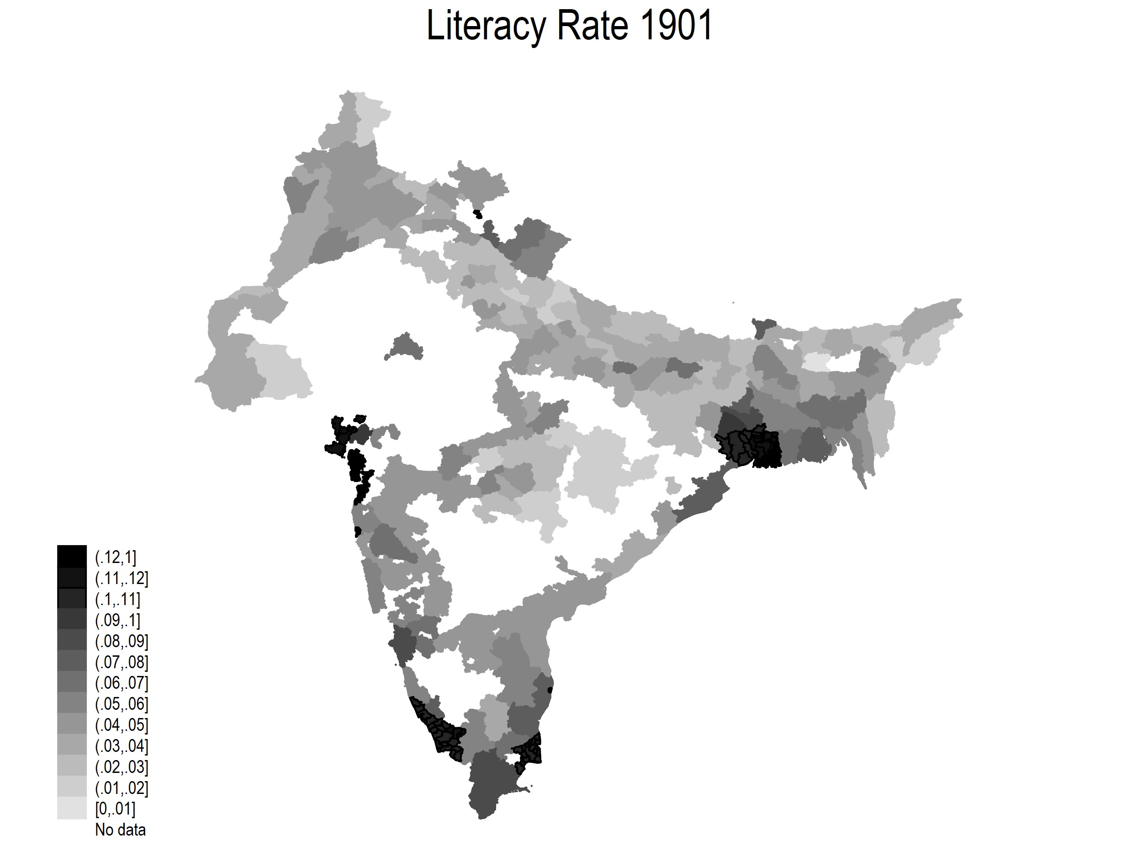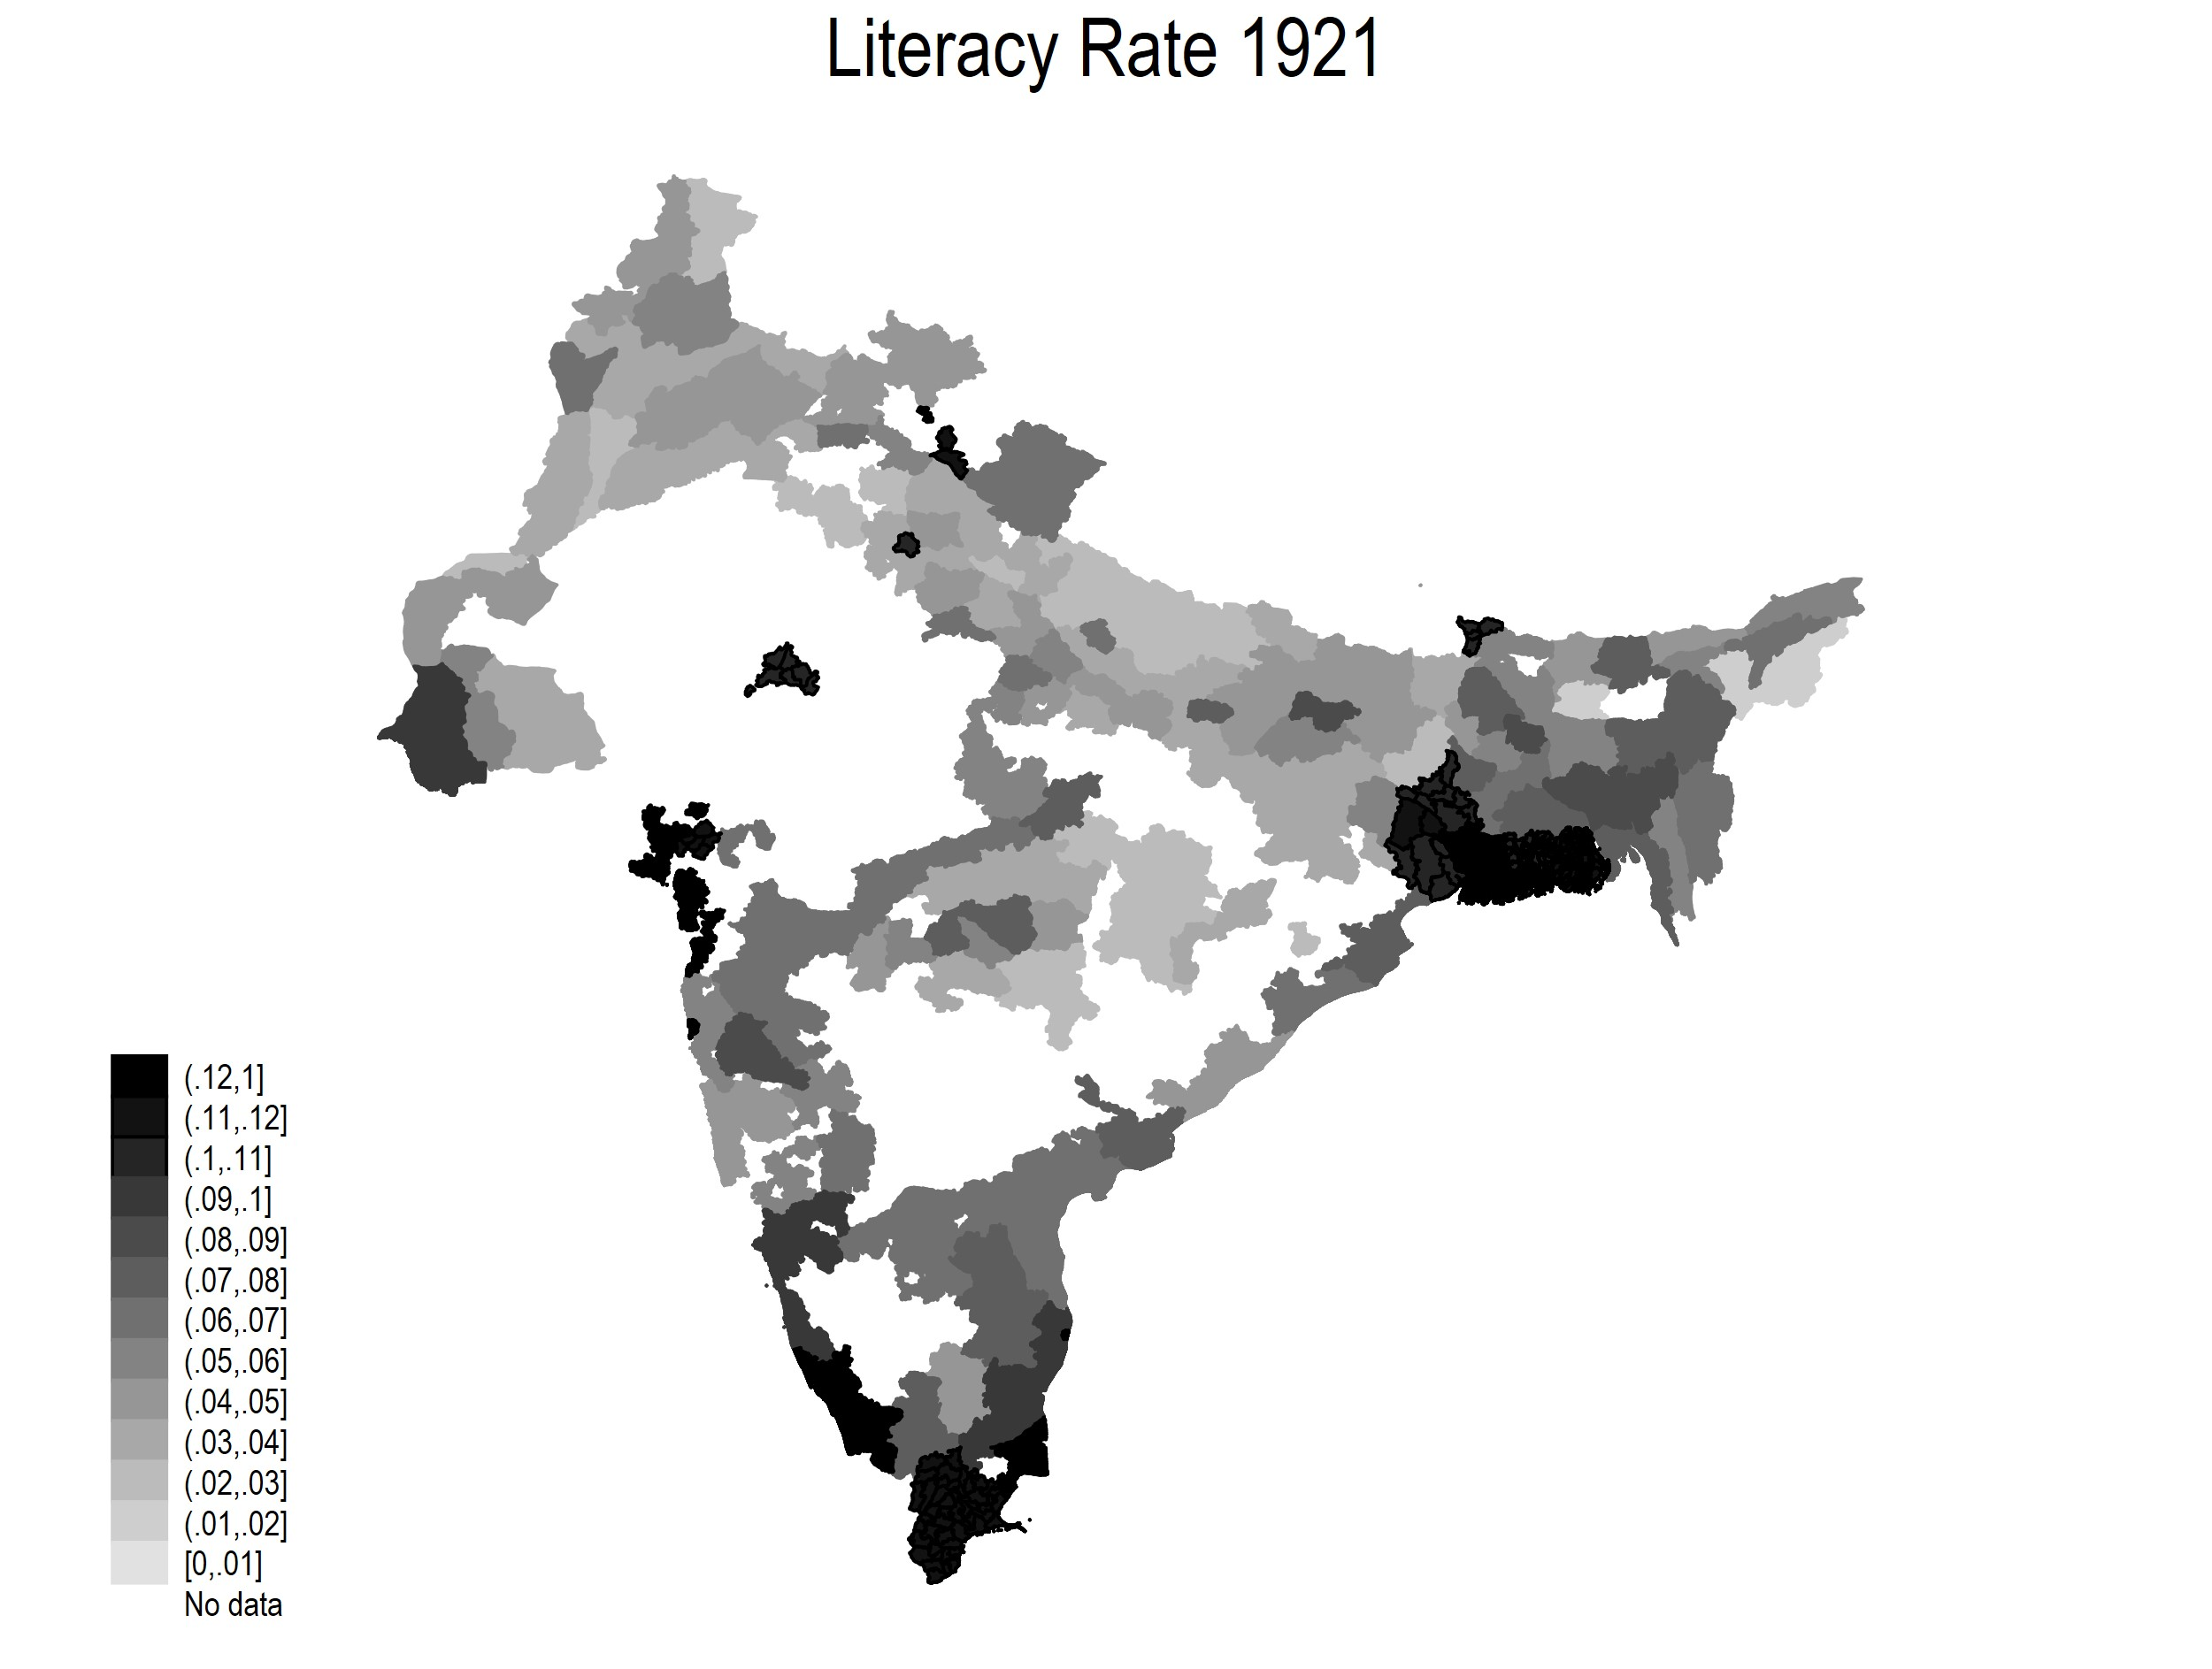

FIGURE 3. Scatterplot of Railroad Years and Literacy, 1881
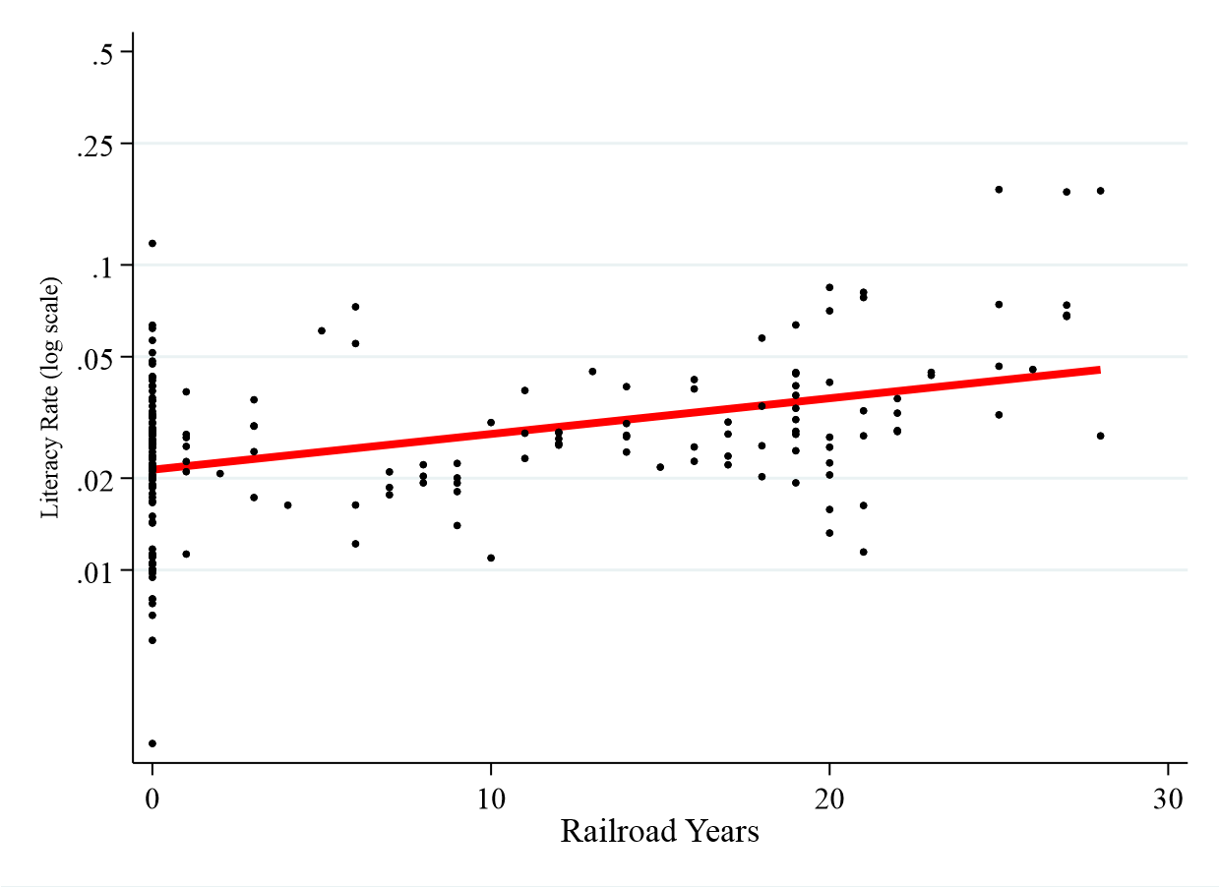
FIGURE 4. Scatterplot of Railroad Years and Literacy, 1921
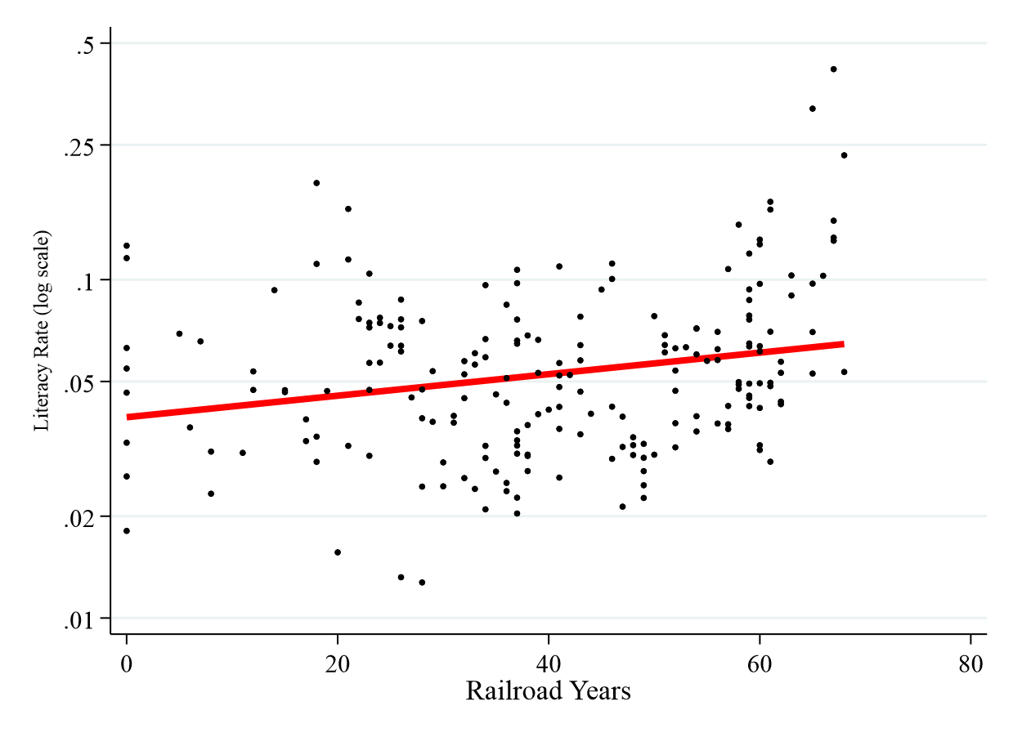

REFERENCES
Chandler, T. and Fox, G. (1974). Three Thousand Years of Urban Growth. Academic Press, New York.
Conley, T. G. (1999). GMM estimation with cross sectional dependence. Journal of Econometrics, 92(1):1–45.

