APPENDIX A

Data sources

Data at the Swedish county-level were collected for the years 1870 to 1990 from the Swedish Central Bureau of Statistics (SCB). The SCB, founded in 1858, collected and processed parish records performed by Tabellverket over the 1749-1858 period. After 1860, Swedish censuses were published regularly every 10 years until 1960, and every 5 years since then. While the census is available from 1860, we chose to collect data from 1870 onwards because of limitations in the data for the year 1860.
From 1997, the structure of the counties changed. Until 1997, Sweden consisted of 24 counties. Skåne was created as a combination of Malmöhus county and Kristianstad county. A year later, Skaraborg county, Gothenburg och Bohus county, and Älvsborg county merged to become Västra Götaland county, leaving Sweden with 21 counties. To keep consistency over time, we decided to limit our analysis to the study of the original 24 counties over the 1870-1990 period.
We have collected and manually entered the county-level data (länvis) to construct our variables. The only exception was for wage data already collected, digitized, and made available by the University of Gothenburg. The tables contain Swedish industrial and wage data from 1865 to 1990 by gender and county.

Table A1: Structure of the Historical Gender Gap Index
Sub-index | Variables | Sources
Economic Opportunity | Ratio: female labor force over male value | BiSOS A Tredje – Folkräkningen – Folk och bostads-räkningen  Swedish Central Bureau of Statistics (SCB)
 | Ratio: female wage over male value | BiSOS N – Lönestatistisk Årsbok  HILD University of Gothenburg
Health and Survival | Ratio: female living births over male value | BiSOS A – Befolkningsrörelsen  Swedish Central Bureau of Statistics (SCB)
 | Ratio (inverted): female mortality over male value | BiSOS A – Befolkningsrörelsen  Swedish Central Bureau of Statistics (SCB)
Political Empowerment | Ratio: female elected in municipal elections over male value | Valstatistik  Swedish Central Bureau of Statistics (SCB)

Variables construction

- Economic opportunities

Female-to-male labor force participation. – In order to calculate the female-to-male labor force participation we needed to construct the female labor force participation and the male labor force participation separately.
The statistics about employed individuals are organized by sector. The years 1870 and 1880 include the following sectors: agriculture, industry, ‘Handel och sjofart’, ‘Förvaltning’, ‘Undervisning’, and ‘Sjukvard’. We calculated the size of the labor force by summing the number of individuals employed in the various sectors. For the years 1870 to 1900, we included the head of household, servants, and assistants. We safeguarded against the risk of double counting by adding only the head of household of the category ‘tjenstehjon utan […]’ and ‘arbetare med obestamdt slag’. The sectors differ slightly from one year to the next. Since we summed the number of people employed in all sectors, this did not affect our labor force variables.
For the years 1910 to 1950, the employed population is given in the column ‘yrkesutövare’, which includes the following sectors: agriculture, industry, ‘Handel och samfardsel’, ‘Allman tjenst’, ‘Husligt arbete’, ‘Utan närmare angivet yrke’ (for some years ‘f.d. yrkesutövare m. fl.’ or ‘Ospecificerad verksamhet’). We used the sum of ‘yrkesutövare’ and ‘tjänare’, while the ‘yrkesutövare’ of ‘utan närmare angivet yrke’ was taken out, to avoid double counting. Servants were included. Then the ‘yrkesutövare’ of ‘arbetare av obestämt slag’ were added; not their ‘tjänare,’ to avoid double counting. For the years 1940 and 1950, the statistics include the distinction ‘with unspecified workers’ and ‘without unspecified workers’. We decided to exclude the unspecified workers. The difference is small and hardly affects the ratios.
The female (male) labor force participation was calculated as the number of female (male) employed divided by the female (male) population aged 15 and over. The ratio was constructed as the female labor force participation over the male value.

Note: Despite the presence of child workers, the census data did not measure children among the working population; children under the age of 15 were enumerated in a separate category. The same threshold was held for the whole period 1870-1990, although assisting labor was not mentioned after 1950. Furthermore, up to 1970 the data for any woman with gainful employment were provided. Since then, however, figures have been distinguished by the number of hours worked per week. For consistency’s sake, a 20-hour working week was chosen as the measure. By doing so, we hope to address some concerns regarding possible overestimation of the female labor force in the late twentieth century, since female working hours have increased much less quickly than the female labor force, suggesting that a large share of the increase in female LFP was due to increases in the number of part-time working women (Stanfors, 2014). Nonetheless, part-time employment has arguably played a role in empowering women on the labor market, and should therefore not be overlooked, which is why we took the decision to use part-time as the threshold.

Female-to-male wages. – Female and male wages were calculated using information about wages in agriculture and in industry.
Agricultural wages by county and gender from 1865 until 1945 are available. From 1940, data about women wages are not available for all counties. We constructed female-to-male wage ratios using statistics for workers in agriculture for the decadal years 1870-1920. The statistics offer information about agricultural daily wages in winter and summer.
For the years 1870 and 1880, the statistics integrate additional information giving minimum and maximum daily wages. We decided to use the average of the female-to-male ratios for the minimum and maximum daily wages in winter and in summer. For the year 1870, statistics are missing for 3 counties: Kalmar, Gotland, and Jämtland. Ratios were calculated for the closest year for which data are available. Hence, for Kalmar we used information for the year 1869, and for Gotland and Jämtland, we used statistics for the year 1872.
From 1890 to 1910, we found no information about minimum and maximum amounts. We therefore simply calculated the female-to-male ratios in winter and in summer and used the average of the two.
In 1920, the daily wage (daglönare) was divided into “fixed” (fasta) and “temporary” (‘tillfälliga) wages, and each of these was further divided into “at own cost” (i egen kost) and “at employer’s cost” (i arbetsgivares kost). All this information is available for winter and for summer. Here, we decided to calculate the ratios for every situation. Because the ratios of the different types of wage were very similar to each other, we decided to use the average of the eight types of ratios.
From 1930 onwards, we used statistics about industrial wages to construct our female-to-male wage ratios. The 1930s correspond to the decades from which the industrial sector becomes as important as the agricultural sector in Sweden. Statistics about industrial wages are available for the periods 1931-1949 and 1963-1990. For the decadal years 1930, 1950, and 1960, we used information from the closest statistics, namely 1931, 1948, and 1963.
In the first period (1931-1949), wages were given as the average for adult workers (‘genomsnittlig löneinkomst för vuxna arbetare [exkl. förmän] i kr’) by county and gender. The wages were available as hourly, daily, or annual wages. Hourly wages were further divided into “all companies” (samtliga företag), “export-oriented companies (exportinriktade företag), “mixed” (blandade), and home-market companies (hemmamarkn. Företag). To avoid differences in hours worked to skew wages in favour of men – and to maintain the data comparable with later statistics – we used the average hourly wage for all companies and calculated the female-to-male ratio.
In 1963 and 1970, the average hourly wage (genomsnittliga timförtjänster) was given in öre by county, gender, and specific industry. Here we used the female and male wages for the combined industries (samtliga industrigrupper). In 1980, the average hourly wages were no longer given as an average of the present industries, but separately for each type of industry. The number of hours worked (‘arbetstimmar’) by gender are included. Therefore, the average wage was calculated by multiplying the wages by their hours worked and dividing by the total number of hours worked by county and gender. For 1990, we calculated the ratios in each industry and weighted each ratio by the weight of each industry (measured by the total number of hours worked in the considered industry). A greater weight was therefore given to larger types of industry.

- Health and survival

Female-to-male mortality (inverted). – To measure gender differences in mortality, we used the mortality ratio. We separately constructed the female and male crude death rates. The crude death rate may be defined as the number of (female/ male) deaths per thousand (female/male) individuals.
We then used the inverted female-to-male ratio to capture the ability of Swedish counties to close the gender gap in mortality. Mortality is a “negative” variable: using the female-to-male ratio would capture the opposite effect to the one we wanted to measure. Using the inverted ratio allowed us to give high values to counties in which female mortality was lower than male mortality, and low values to counties in which female mortality was higher than male mortality.

APPENDIX B
Some Notes on the Education Sub-index
The original version of the GGI has a sub-index for education, made up of four components: literacy rate, enrollment in primary education, enrollment in secondary education and enrollment in tertiary education (Hausmann, Tyson and Zahidi, 2006). We have so far not been able to construct the education sub-index for the period between 1870 and 1990 in the same way as the other sub-indices. This appendix briefly explains why and presents some preliminary figures for the four components, as well as their average, for Sweden as a whole. Our ongoing research is aiming to add the spatial dimension to the education data.
A complicating feature of the Swedish system of schooling as it emerged in the nineteenth century was its heterogeneous structure. There were two parallel systems: on the one hand, the elementary school for the children of peasants and workers, the so-called folkskola, formally established in 1842, and on the other, grammar schools for the upper classes, so called läroverk. Whereas the folkskola was a dead end, the läroverk prepared for tertiary education.
There is hardly any previous research on literacy rates in Sweden in the twentieth century, which suggests that basic literacy was close to universal and there were very small differences between men and women. A study of catechetical examinations in a parish in northern Sweden for the period 1845-1873 did not find significant gender differences (Johansson, 1972). A study on some parishes in the southern part of the country argues that men had higher levels of functional literacy; that is, men were not only able to read but also to write (Nilsson, Pettersson and Svensson, 1999). Over time, it seems as though much of the gender gap in literacy had closed in the South also, even before the system of primary schooling had fully expanded. Finally, a study of school absenteeism in four parishes of western Sweden in the period 1865-1920 documents insignificant gender differences (Sjöberg, 1996). There may have been a small gap, with girls being more absent in particular years at the beginning of the period, but this pattern disappeared towards the end of the period of investigation. Based on this fragmentary evidence, we think it is reasonable to assume a certain gender gap in literacy that narrowed over time.
Primary school enrollment was not broken down by gender in the Swedish public statistics (see BiSOS P, various years). This was probably because gender differences were small, not because contemporary observers regarded sex as an irrelevant category of analysis in general. We assume that future research will reveal some gender differences in enrollment in the primary education of the relevant age group in the late nineteenth century and that the gap was closed by 1890.
For non-compulsory schooling, the story is different. Here, the official statistics do clearly pay attention to the sex of the pupils. The main challenge for us is that the system of schooling for a long time was so heterogeneous, and segregated by sex, that it is difficult to identify groups and forms of schooling that can be compared to today’s secondary schooling. Until 1927, public grammar schools were open only to boys. The grammar schools included some primary education, as well as lower- and upper-level secondary education. Excluded from the public grammar schools, girls could obtain secondary education only in some of the private girls’ schools that had been founded in cities in the nineteenth century (Schånberg, 2001). The heterogeneity of the schooling system makes it difficult to calculate enrollment rates. Instead, we decided to compare graduation rates in relation to the age group 15-19 years. It should be mentioned that secondary schooling in Sweden was reserved for a very tiny proportion of each age cohort until the second half of the twentieth century.
The same applies to tertiary education. This level of education was formally opened to women in 1873, but at that date very few women could apply, since most girls’ schools did not prepare students for entry to higher education. For a long time, the tertiary level of education was also geographically concentrated in the cities of Uppsala, Lund, Stockholm and Göteborg. However, in the second half of the century private girls’ schools were established in many cities, opening up opportunities for secondary education (and eventually tertiary education) for women. Consistent time series of enrollment in tertiary education by gender can easily be obtained for the period until 1950. Tertiary education in Sweden expanded and became more multifaceted, creating some initial problems of classification. For simplicity, the enrollment rates presented in this appendix concern the five original sites of higher education (Uppsala universitet, Lunds universitet, Göteborgs högskola, Stockholms högskola, and Karolinska institutet).

Figure B: Education Sub-index and its Components
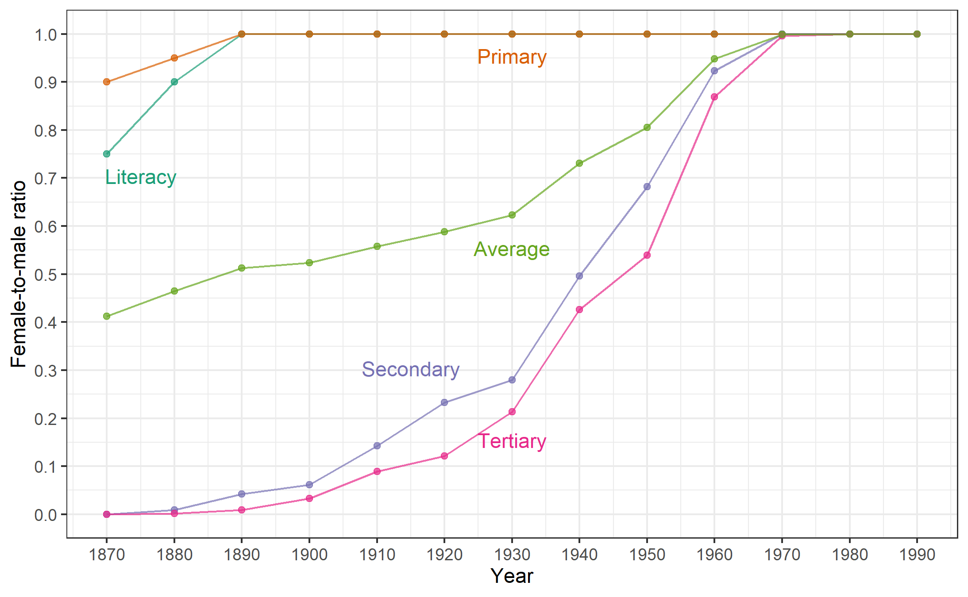
Note: The values for literacy and primary education rates for the earlier decades are partly based on qualitative knowledge of enrollment and ability to read and to write in Sweden in the period under study (see text).
Source: BiSOS P; Graduation rates have been extracted from Vinge (1977) and the number of men and women in the relevant age group from Befolkningsutvecklingen (1999).

Based on our assumptions, the education gender gap steadily narrowed, reaching parity at all levels in 1970 as can be seen in Figure B. Although parity in literacy and primary education was already achieved in 1890, institutional barriers kept women out of secondary and tertiary schooling for a longer period. Following the opening of public secondary schooling for girls in 1927, a rapid improvement is seen in both secondary and higher education. Interesting to note is the relatively small lag between the two. Moreover, adding the education sub-index in its current state to our existing index would alter the shape only slightly, because some gains in decreasing the distance to parity had already occurred in education in the nineteenth century. That said, the most significant gains were made after 1930, in accordance with our current HGGI index.
APPENDIX C

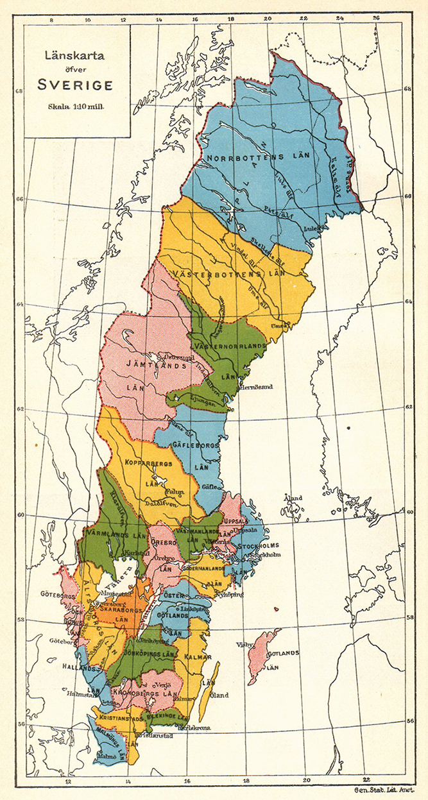
Source: Project Runeberg
Table C1: List of Counties’ Codes and Names
ID | County Code | County Name
3 | UPP | Uppsala län
4 | SML | Södermanlands län
5 | OGL | Östergötlands län
6 | JNK | Jönköpings län
7 | KRO | Kronobergs län
8 | KLM | Kalmar län
9 | GOT | Gotlands län
10 | BLK | Blekinge län
11 | KRS | Kristianstads län
12 | MAL | Malmöhus län
13 | HAL | Hallands län
14 | GBL | Göteborgs och Bohus län
15 | ELF | Älvsborgs län
16 | SKA | Skaraborgs län
17 | VRM | Värmlands län
18 | ORE | Örebro län
19 | VML | Västmanlands län
20 | KPB | Kopparbergs län
21 | GFL | Gävleborgs län
22 | VNL | Västernorrlands län
23 | JMT | Jämtlands län
24 | VBL | Västerbottens län
25 | NBL | Norrbottens län
111 | STM | Stockholm län and city

Figure C1: Spread of Data
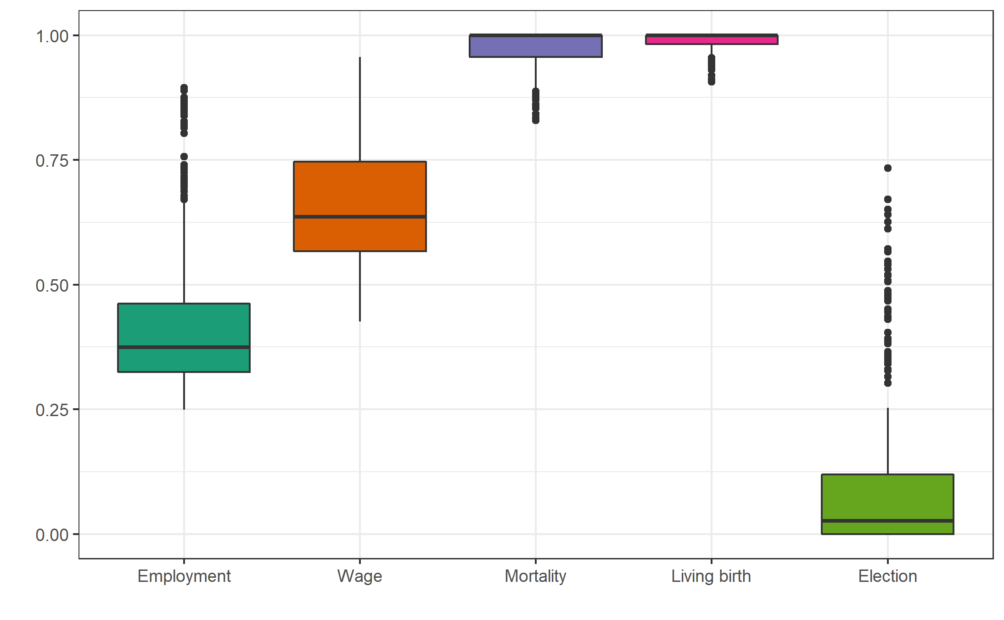

Table C2: Description of Sub-indices and Calculation of Weights
Economic Opportunity | Standard Deviation | Standard Deviation per 1% | Weights
Female-to-male labor force | 0.1627 | 0.0615 | 0.4562
Female-to-male wages | 0.1365 | 0.0732 | 0.5438
Total |  | 0.1347 | 1
Health and Survival | Standard Deviation | Standard Deviation per 1% | Weights
Female-to-male mortality (reversed) | 0.0429 | 0.2332 | 0.2934
Female-to-male living births | 0.0178 | 0.5616 | 0.7066
Total |  | 0.7947 | 1
Political Empowerment | Standard Deviation | Standard Deviation per 1% | Weights
Female-to-male election ratio | 0.1658 | 0.0603 | 1
Total |  | 0.0603 | 1

Figure C2: HGGI Components – Weighted by population size of the counties
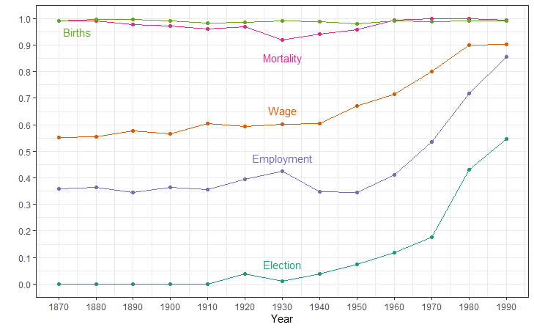

Figure C3: Labor Force Participation (average)
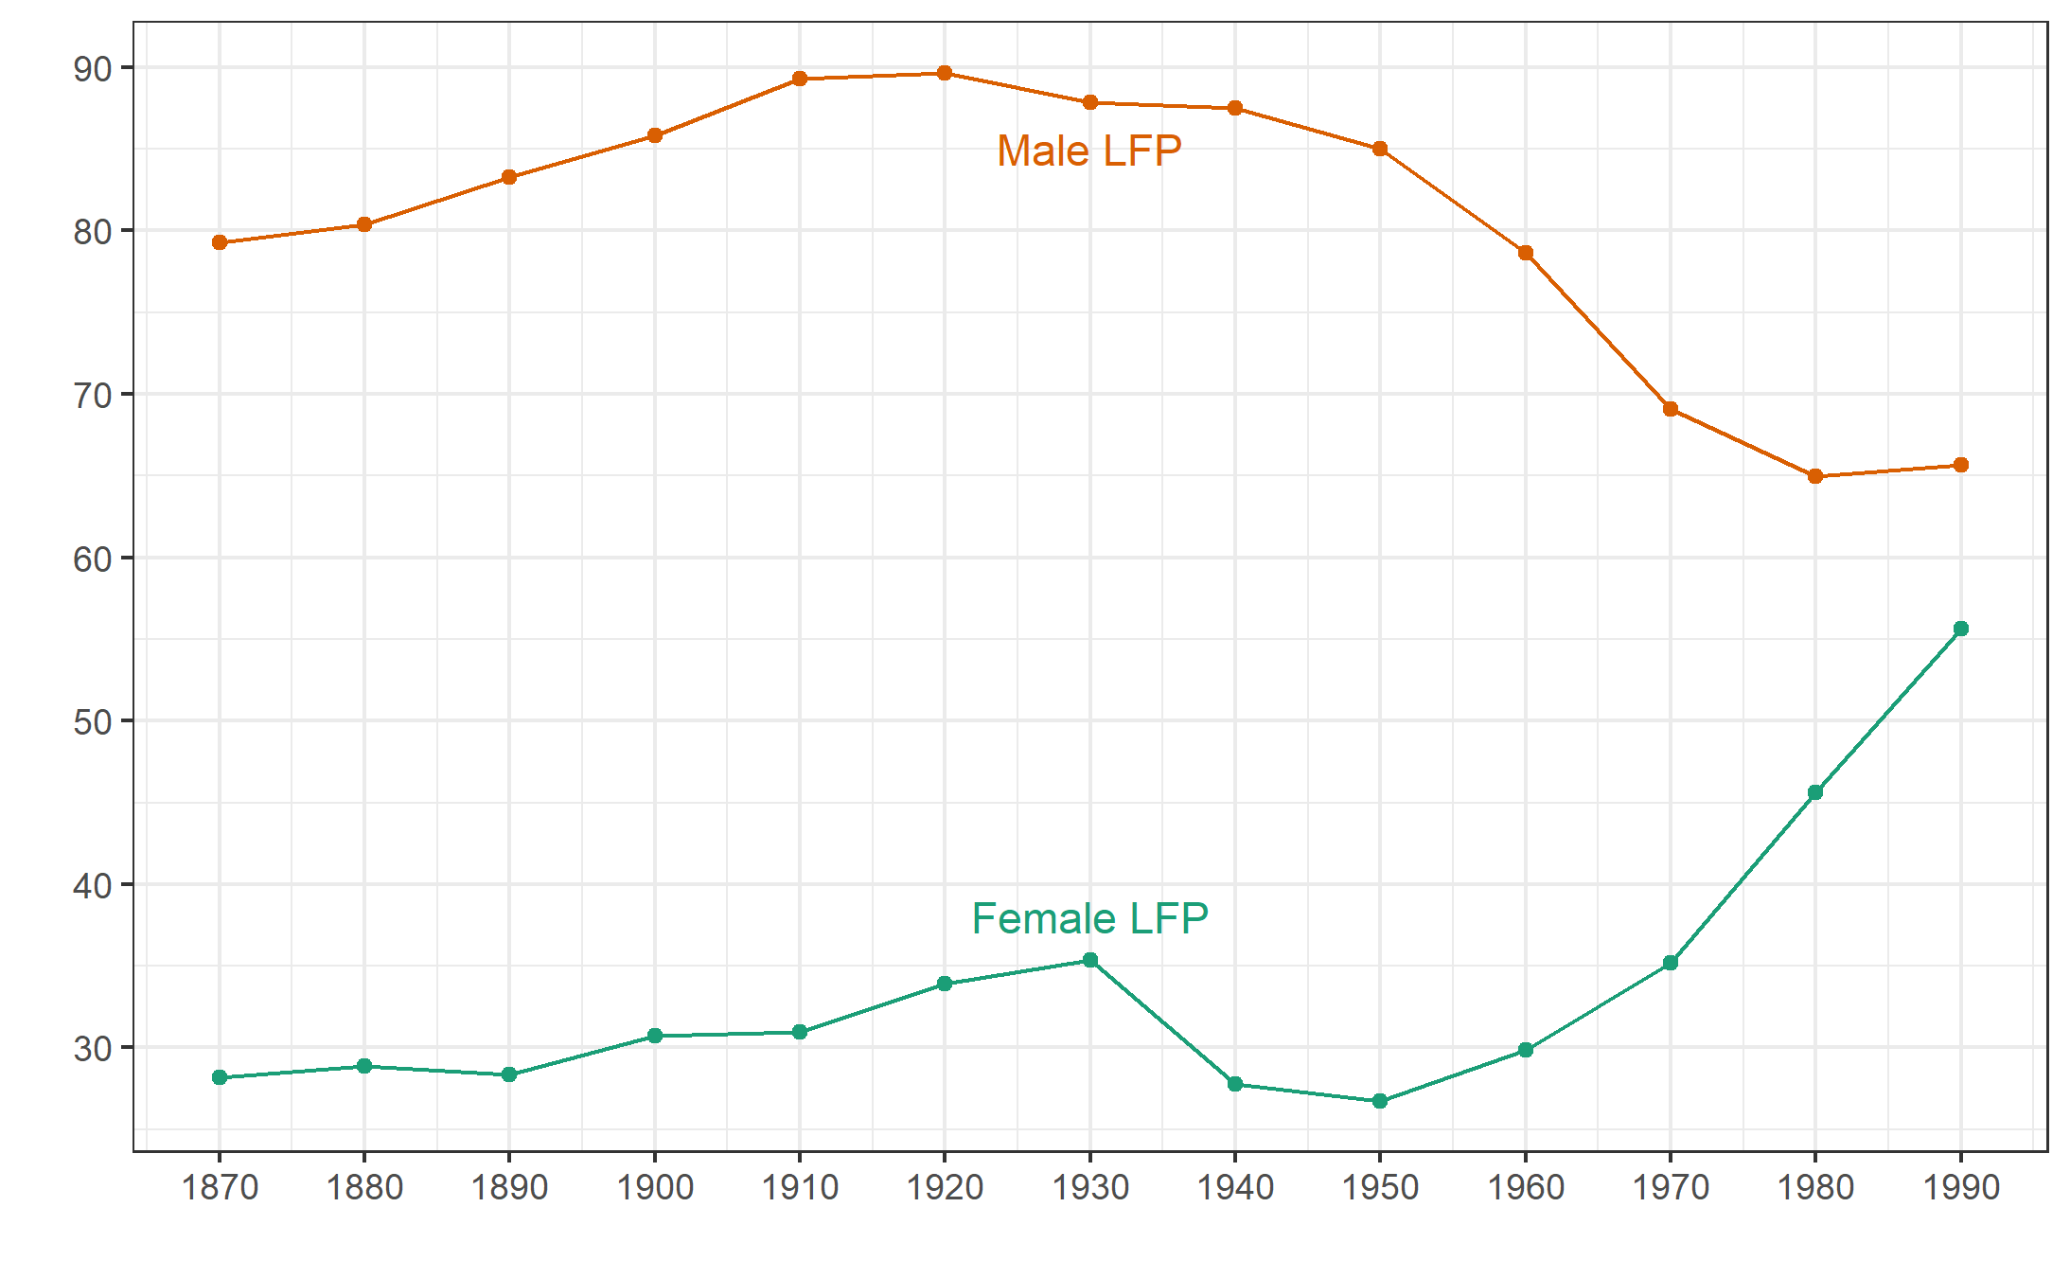

Figure C4: Mortality Rate (average)
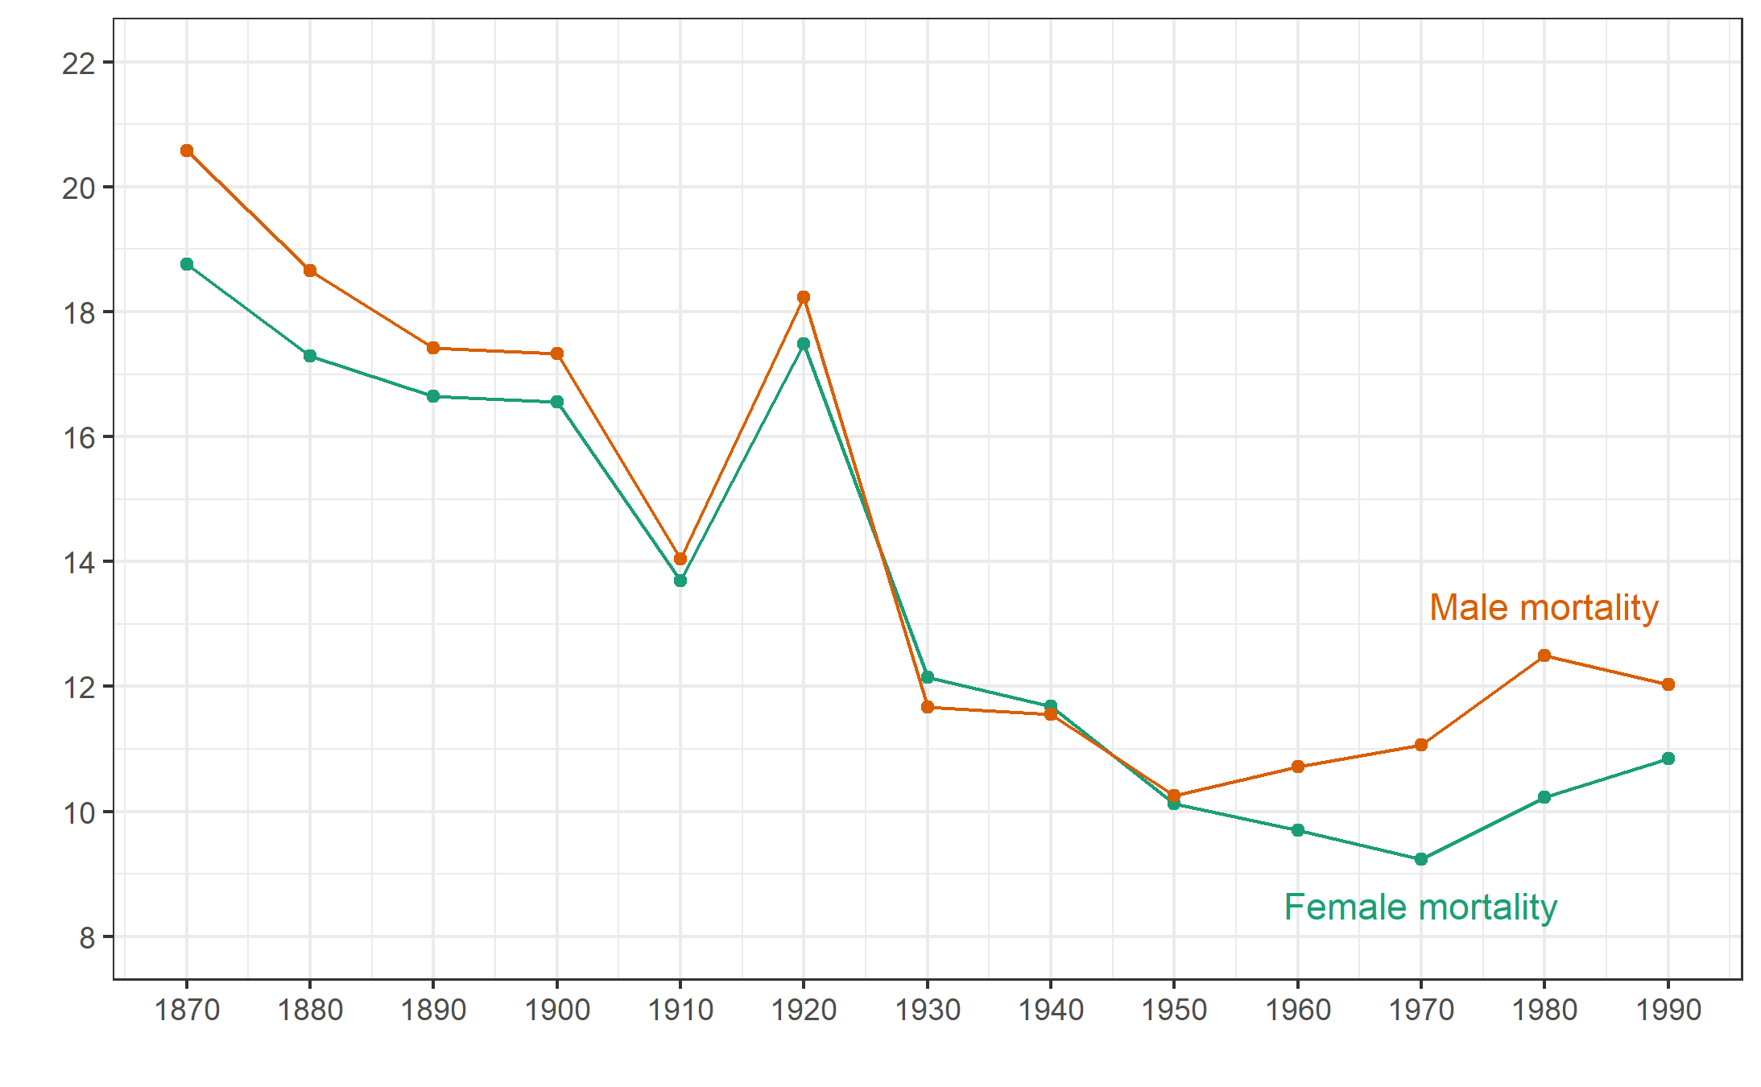
Figure C5. Distribution of HGGI – Jenks intervals by year
- 1870  Stockholm  Malmö  Göteborg  Stockholm  Malmö  Göteborg  Stockholm  Malmö  Göteborg  Stockholm  Malmö  Göteborg | - 1900
- 1940 | - 1990
Note: The Jenks intervals are calculated so as to reduce the variance within classes and maximize the variance between classes (Jenks, 1967).

Figure C6. HGGI by year and county, 1870-1990
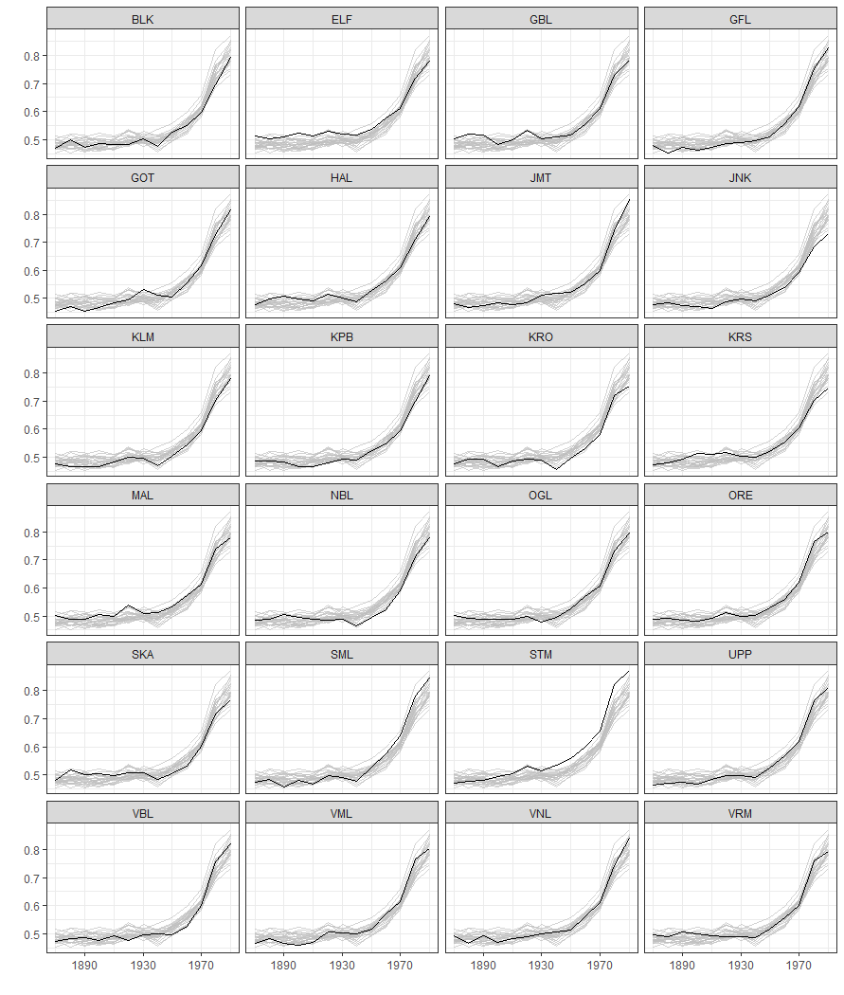

REFERENCES (APPENDIX)

Befolkningsutvecklingen (1999), Befolkningsutvecklingen under 250 år: historisk statistik för Sverige [Population development in Sweden from a 250-year perspective], Stockholm: Statistiska centralbyrån.
BiSOS P, Undervisningsväsendet. Berättelse om folkskolorna för år (1887–1912) [The education system. Account on primary schools for the year (1887-1912)], Stockholm: Statistiska centralbyrån.
Folkräkningen (1937), Folkräkningen den 31 december 1930 6 Hushåll. Skolbildning. Yrkesväxling. Biyrke m.m. [Census of 31 December 1930 6 Households. Schooling. Career change. Sideline etc]. Stockholm: Statistiska centralbyrån.
Hausmann R., Tyson, L. Zahidi, S. (2006), The global gender gap report 2006, World Economic Forum.
Jenks, G. (1967), “The Data Model Concept in Statistical Mapping”, International Yearbook of Cartography, vol. 7, pp. 186–190.
Johansson, E. (1972), En studie med kvantitativa metoder av folkundervisningen i Bygdeå socken 1845–1878 [A study with quantitative methods of public education in Bygdeå parish 1845–1878]. Umeå: Umeå universitet.
Nilsson, A., Pettersson, L., Svensson, P. (1999), “Agrarian transition and literacy: The case of nineteenth century Sweden”, European Review of Economic History, vol. 3, n° 1, pp. 79-96.
Schånberg, I. (2001), Genus och utbildning: ekonomisk-historiska studier i kvinnors utbildning ca 1870–1970 [Gender and education: economic-historical studies in women's education around 1870-1970]. Lund University.
Sjöberg, Mats (1996), Att säkra framtidens skördar: Barndom, skola och arbete i agrar miljö: Bolstad pastorat 1860–1930 [Securing the harvests of the future: Childhood, school and work in an agrarian environment: Bolstad pastorate 1860–1930]. Linköping: Linköpings universitet.
Stanfors, M. (2014), “Women in a changing economy: the misleading tale of participation rates in a historical perspective”, The History of the Family, vol. 19, pp. 513–536.
Vinge, M. (1977), Elever i icke-obligatoriska skolor 1864–1970 [Pupils in secondary schools in Sweden 1864-1970], Stockholm: Statistiska centralbyrån.

We expect to find geographical variation in education in particular with regard to enrollment rates in secondary and tertiary education. A snapshot of these differences reveals that the spread of the female-to-male ratio in tertiary education (among those aged 30-40) ranged between 0.09 and 0.27 (calculations based on data from the education census of 1930 – Folkräkningen (1937). Although nationally in 1990 women in tertiary education outnumbered men, the education census of that year also shows that certain counties (for example Östergötland and Värmland) had not achieved parity.

