Online Appendix

Table A1. Number of patents granted in France by technology class (1791-1844)
Category | Description | 1791- 1815 |  | 1816 - 1830 |  | 1831 - 1843
 |  | n | % | n | % | n | %
1 | Agriculture | 39 | 4.2 | 126 | 4.4 | 500 | 5.7
2 | Hydraulic | 20 | 2.2 | 93 | 3.3 | 286 | 3.2
3 | Steam engines and engines | 19 | 2.1 | 101 | 3.5 | 517 | 5.9
4 | Textile machines and fabrics | 161 | 17.5 | 503 | 17.6 | 1,234 | 14
5 | Other machines, devices and tools | 8 | 0.9 | 63 | 2.2 | 150 | 1.7
6 | Navigation | 29 | 3.1 | 139 | 4.9 | 233 | 2.6
7 | Construction | 30 | 3.3 | 105 | 3.7 | 540 | 6.1
8 | Metallurgy | 41 | 4.4 | 108 | 3.8 | 336 | 3.8
9 | Hardware (lock and cutlery) | 31 | 3.4 | 137 | 4.8 | 364 | 4.1
10 | Bodywork, saddlery, ropes and brushwork | 26 | 2.8 | 114 | 4.0 | 294 | 3.3
11 | Weapons | 11 | 1.2 | 64 | 2.2 | 171 | 1.9
12 | Precision and surgical instruments | 49 | 5.3 | 111 | 3.9 | 445 | 5.1
13 | Mineral substances and ceramic | 29 | 3.1 | 84 | 2.9 | 225 | 2.6
14 | Chemical products, food and cosmetics | 143 | 15.5 | 334 | 11.7 | 1,041 | 11.8
15 | Lighting, heating and fuels | 95 | 10.3 | 216 | 7.6 | 805 | 9.1
16 | Clothing and shoes | 44 | 4.8 | 152 | 5.3 | 524 | 6.0
17 | Fine arts and musical instruments | 55 | 6.0 | 168 | 5.9 | 435 | 4.9
18 | Stationery | 39 | 4.2 | 108 | 3.8 | 353 | 4.0
19 | Leather | 14 | 1.5 | 25 | 0.9 | 93 | 1.1
20 | Miscellaneous products | 39 | 4.2 | 101 | 3.5 | 255 | 2.9
Notes: Patents have been classified according to the 1853 technological classification.
Sources: Institut National de la Propriété Industrielle (INPI) dataset for patents and Empotz and Marchal (2002) for technological classes.

Table A2. Most representative occupations by HISCO category
Category | Category label | Most represented professions | English translation
0_1 | Small proprietor | Négociant | Trader/Storekeeper
 |  | Parfumeur | Perfumer
 |  | Bijoutier | Jeweller
0_2 | Large proprietor | Propriétaire | Owner
 |  | Fabricant | Manufacturer/Producer
 |  | Manufacturier | Manufacturer/Producer
 |  | Rentier | Rentier
1 | Higher manager | Banquier | Banker
 |  | Chef des ateliers [...] | Factory manager
 |  | Colonel | Colonel
2 | Higher professionals | Ingénieur mécanicien | Mechanical engineer
 |  | Ingénieur civil | Civil engineer
 |  | Ingénieur | Engineer
 |  | Docteur en médecine | Doctor (medical)
 |  | Architecte | Architect
3 | Lower manager | Pharmacien | Pharmacist
 |  | Dessinateur | Draftsman
 |  | Capitaine d'artillerie | Artillery captain
 |  | Capitaine au long cours | Long-haul captain
4 | Lower professionals, and clerical and sales personnel | Chimiste | Chemist
 |  | Distillateur | Spirit maker
 |  | Géomètre | Surveyor
5 | Lower clerical and sales personnel | Employé | Clerk
 |  | Commis négociant | Shop assistant
6 | Foremen (artisans) | Horloger | Clock maker
 |  | Horloger mécanicien | Mechanic clock maker
 |  | Menuisier | Carpenter
 |  | Maître de forges | Smith
 |  | Facteur de pianos | Piano maker
7 | Medium skilled workers | Mécanicien | Mechanic
 |  | Serrurier mécanicien | Mechanic locksmith
 |  | Serrurier | Locksmith
 |  | Filateur | Spinner
8 | Farmers and fishermen | Cultivateur | Farmer
9 | Lower skilled workers | Arquebusier | Armed soldier
 |  | Lampiste | Lamp attendant
10 | Lower skilled farm workers | Hacheur de bois | Woodcutter
 |  | Jardinier | Gardener
 |  | Marinier | Sailor
11 | Unskilled workers | Emballeur | Packer
Notes: The Table reports the patentees’ occupations with the highest frequency for each HISCO category.
Sources: Institut National de la Propriété Industrielle (INPI) dataset for patents and Van Leeuwen, Maas and Miles (2002) for HISCO occupations.

Table A3. Distribution of patents by total patentee career by countries (1791-1842)
Period | 1 Patent |  | 2 Patents |  | 3 Patents |  | 4+ Patents
 | n | row % | n | row % | n | row % | n | row %
1791-1804
France | 196 | 57.5 | 83 | 24.3 | 18 | 5.3 | 44 | 12.9
England | 576 | 49.4 | 213 | 18.3 | 106 | 9.1 | 272 | 23.3
USA | 77 | 46.1 | 35 | 21.0 | 12 | 7.2 | 43 | 25.7
1805-1811
France | 276 | 57.1 | 95 | 19.7 | 38 | 7.9 | 74 | 15.3
England | 338 | 43.7 | 123 | 15.9 | 98 | 12.7 | 214 | 27.7
USA | 186 | 53.3 | 63 | 18.1 | 50 | 14.3 | 50 | 14.3
1812-1822
France | 735 | 54.7 | 300 | 22.3 | 107 | 8.0 | 201 | 15.0
England | 579 | 43.0 | 201 | 14.9 | 138 | 10.3 | 427 | 31.7
USA | 388 | 56.8 | 117 | 17.1 | 50 | 7.3 | 128 | 18.7
1823-1829
France | 1,128 | 56.1 | 370 | 18.4 | 176 | 8.8 | 337 | 16.8
England | 547 | 42.9 | 228 | 17.9 | 115 | 9.0 | 385 | 30.2
USA | 435 | 58.2 | 132 | 17.6 | 52 | 7.0 | 129 | 17.2
1830-1836
France | 1,747 | 53.1 | 693 | 21.0 | 314 | 9.5 | 539 | 16.4
England | 728 | 39.3 | 275 | 14.8 | 213 | 11.5 | 638 | 34.4
USA | 686 | 57.4 | 190 | 15.9 | 95 | 7.9 | 225 | 18.8
1837-1842
France | 4,692 | 62.0 | 1,385 | 18.3 | 547 | 7.2 | 941 | 12.4
England | 1,486 | 45.2 | 590 | 18.0 | 335 | 10.2 | 873 | 26.6
USA | 416 | 57.4 | 127 | 17.5 | 61 | 8.4 | 121 | 16.7
Notes: data for France and England consist of the total number of patents granted in the period 1791-1844. Instead, data for the United States consist of patents granted from 1790 to 1846.
Source: our own elaboration of the INPI dataset for France and on Woodcroft (1854) for England. Sokoloff and Khan (1990, Table 1) for the United States.

Table A4. Summary statistics
Variables | Mean | Median | Standard Deviation | Minimum | Maximum
Dependent Variables
Quality class (5; 10; 15 years) | 1.69 | 1 | 0.79 | 1 | 3
Quality class (300; 800; 1500 Francs) | 685.01 | 300 | 467.69 | 300 | 1,500
Patent duration in days | 2,699.38 | 1,826 | 1,555.34 | 18 | 5,479
Independent Variables
British origins (BO) | 0.09 | 0 | 0.28 | 0 | 1
British connection (BC) | 0.03 | 0 | 0.18 | 0 | 1
Famous inventor* | 0.02 | 0 | 0.19 | 0 | 4
Engineer/Scientist | 0.08 | 0 | 0.27 | 0 | 1
Skilled worker | 0.09 | 0 | 0.29 | 0 | 1
Award | 0.01 | 0 | 0.1 | 0 | 1
Number of patentees per patent | 1.2 | 1 | 0.49 | 1 | 6
Maximum experience in the applying group (based on name and location) | 0.69 | 0 | 3 | 0 | 63
Maximum number of Encyclopédie subscriptions in the applying group | 430.23 | 487 | 229.9 | 1 | 1,078
Rouen-Geneva line | 0.72 | 1 | 0.45 | 0 | 1
Sources: Institut National de la Propriété Industrielle (INPI) dataset for patents and Murray (2003), Schich et al. (2014), Gergaud,Louenan and Wasmer (2016) and Yu et al. (2016) for famous inventors and Annuarie de la Société d’encouragement pour l’Industrie Nationale (1852) for awards.

Table A5. Determinants of patent quality in France (Dependent variable: duration in days)
Variables | (1) | (2) | (3) | (4)
British origins (BO) |  | 1,144*** |  | 1,031***
 |  | (52.37) |  | (46.88)
British origins (BO) British address | 1,199*** |  | 1,044***
 | (56.71) |  | (50.35)
British origins (BO) no British address | 932.4*** |  | 975.4***
 | (114.6) |  | (103.8)
British connection (BC) | 381.6*** |  | 536.9***
 | (85.87) |  | (88.03)
British connection (BC) patent agent |  | 353.4*** |  | 511.1***
 |  | (90.31) |  | (93.12)
British connection (BC) no patent agent |  | 597.2** |  | 718.0***
 |  | (265.5) |  | (259.3)
Number of patentees | 10.94 | 8.012 | 49.86* | 48.90
 | (28.23) | (28.16) | (29.87) | (29.78)
Experience | 6.966* | 7.450* | 6.154* | 6.271*
 | (4.067) | (4.028) | (3.446) | (3.427)
Famous inventor | 351.8*** | 324.9*** | 326.9*** | 319.7***
 | (79.68) | (78.61) | (73.15) | (71.43)
Engineer/Scientist | 263.1*** | 262.2*** | 425.1*** | 424.1***
 | (54.91) | (54.95) | (55.77) | (55.82)
Skilled worker | -108.9** | -113.3*** | -104.8** | -105.8**
 | (43.96) | (43.94) | (48.51) | (48.45)
Period (1791-1815) | 541.5*** | 538.2*** | 28.59 | 26.66
 | (51.42) | (51.41) | (52.78) | (52.77)
Period (1816-1829) | 283.9*** | 281.6*** | -59.32* | -61.00*
 | (34.23) | (34.22) | (35.97) | (35.97)
Technological classes | YES | YES | YES | YES
Constant | 2,559*** | 2,564*** | 2,985*** | 2,987***
 | (67.22) | (67.16) | (71.97) | (71.88)
Observations | 12,573 | 12,573 | 9,698 | 9,698
R-squared | 0.097 | 0.097 | 0.113 | 0.113
Note: Robust standard errors in parentheses. *** p<0.01, ** p<0.05, * p<0.1.

Table A6. Determinants of patent quality in France
Variables | (1) | (2) | (3) | (4) | (5)
Foreign inventor (non- British) | 415.4*** | 415.1*** | 392.4*** | 410.3*** | 259.5***
 | (88.97) | (88.45) | (89.87) | (86.82) | (88.88)
Number of patentees |  | -23.84 | -21.38 | 16.57 | 46.28
 |  | (28.61) | (28.68) | (30.19) | (30.24)
Experience |  | 32.53*** | 31.31*** | 29.45*** | 23.20***
 |  | (4.229) | (4.219) | (3.731) | (3.523)
Famous inventor |  | 492.3*** | 484.9*** | 473.4*** | 433.2***
 |  | (80.21) | (81.13) | (74.59) | (74.82)
Engineer/Scientist |  | 279.1*** | 271.6*** | 456.2*** | 425.6***
 |  | (56.34) | (56.75) | (56.57) | (56.57)
Skilled worker |  | -177.8*** | -175.6*** | -177.4*** | -149.6***
 |  | (44.02) | (43.82) | (48.72) | (48.65)
Period (1791-1815) | 423.6*** | 424.2*** | 415.0*** | -96.97* | -144.9***
 | (52.36) | (51.67) | (51.97) | (52.96) | (53.59)
Period (1816-1829) | 260.9*** | 274.5*** | 272.0*** | -81.39** | -108.5***
 | (35.01) | (34.88) | (35.11) | (36.72) | (36.72)
Technological classes | YES | YES | YES | YES | YES
Department FE | NO | NO | YES | YES | YES
Constant | 2,638*** | 2,638*** | 2,654*** | 3,070*** | 3,264***
 | (58.79) | (67.49) | (70.31) | (71.95) | (74.47)
Observations | 12,573 | 12,573 | 12,573 | 9,698 | 9,698
R-squared | 0.047 | 0.059 | 0.070 | 0.074 | 0.098
Notes: Dependent variable is “real” patent duration in days. OLS regressions with robust standard errors in parentheses. *** p<0.01, ** p<0.05, * p<0.1. Models (4) and (5) do not include withdrawn patents.
Source: Institut National de la Propriété Industrielle (INPI) dataset.

Table A7. Determinants of patent quality in France (only domestic patents, excluding the Seine Department (Paris))
Variables | (1) | (2) | (3) | (4) | (5) | (6) | (7) | (8)
British origins (BO) | 1,196*** | 1,165*** | 1,173*** | 1,179*** | 860.5*** | 837.5*** | 819.3*** | 778.6***
 | (55.46) | (59.07) | (58.65) | (52.80) | (96.61) | (98.01) | (98.28) | (93.12)
British connection (BC) | 666.3*** | 651.1*** | 657.4*** | 823.7*** | 663.8*** | 654.1*** | 645.6*** | 809.5***
 | (147.7) | (146.9) | (146.5) | (137.7) | (149.4) | (148.7) | (148.8) | (137.7)
Number of patentees |  | 31.28 | 34.77 | 27.58 |  | 36.47 | 42.06 | 16.43
 |  | (39.11) | (39.39) | (39.96) |  | (39.86) | (40.07) | (40.71)
Experience |  | -0.127 | 0.0106 | -4.642 |  | -1.038 | -0.935 | -5.762**
 |  | (3.922) | (3.759) | (2.854) |  | (3.925) | (3.760) | (2.856)
Famous inventor |  | 352.0** | 379.0*** | 385.4*** |  | 328.0** | 350.8*** | 352.0***
 |  | (146.0) | (142.4) | (110.4) |  | (137.8) | (133.2) | (103.7)
Engineer/Scientist |  | 302.3*** | 356.6*** | 403.0*** |  | 296.1*** | 333.5*** | 401.3***
 |  | (78.44) | (77.64) | (75.53) |  | (79.52) | (78.70) | (76.33)
Skilled worker |  | -68.82 | -83.86 | -103.3 |  | -56.23 | -75.47 | -94.99
 |  | (63.92) | (63.73) | (66.83) |  | (63.16) | (62.78) | (66.52)
Period (1791-1815) | 524.8*** | 523.9*** | 539.4*** | 179.1** | 450.2*** | 451.1*** | 464.6*** | 84.91
 | (79.38) | (79.07) | (79.71) | (81.41) | (81.19) | (80.98) | (81.35) | (83.35)
Period (1816-1829) | 222.3*** | 219.4*** | 211.6*** | -16.02 | 227.1*** | 224.1*** | 220.1*** | -6.124
 | (49.74) | (49.72) | (49.77) | (50.14) | (50.14) | (50.11) | (50.07) | (50.29)
High-tech sectors |  |  | 189.9*** |  |  |  | 224.9***
 |  |  | (39.27) |  |  |  | (41.06)
Technological classes | YES | YES | NO | YES | YES | YES | NO | YES
Department FE | NO | NO | NO | NO | YES | YES | YES | YES
Constant | 2,564*** | 2,519*** | 2,482*** | 2,863*** | 2,453*** | 2,441*** | 2,345*** | 2,531***
 | (69.46) | (82.63) | (53.73) | (86.85) | (196.0) | (198.2) | (187.7) | (199.4)
Observations | 6,083 | 6,083 | 6,083 | 5,151 | 6,083 | 6,083 | 6,083 | 5,151
R-squared | 0.107 | 0.112 | 0.097 | 0.144 | 0.134 | 0.138 | 0.125 | 0.174
Notes: Dependent variable is “real” patent duration in days. OLS regressions with robust standard errors in parentheses for domestic patents, excluding the Seine Department, only. *** p<0.01, ** p<0.05, * p<0.1. Models (4) and (8) do not include withdrawn patents.
Source: Institut National de la Propriété Industrielle (INPI) dataset.

Table A8. Determinants of patent quality in France (alternative indicators of patent quality)
Variables | (1) | (2) | (3) | (4) | (5) | (6) | (7) | (8)
Dependent variables | Cost in French francs without additions | Cost in French francs with additions | Duration by class | Duration by class without withdrawn patents | Cost in French francs without additions | Cost in French francs with additions | Duration by class | Duration by class without withdrawn patents
British origins (BO) | 327.4*** | 323.1*** | 1.313*** | 1.300*** | 234.8*** | 235.3*** | 0.927*** | 0.944***
 | (14.84) | (15.00) | (0.0562) | (0.0611) | (22.37) | (22.68) | (0.0871) | (0.0975)
British connection (BC) | 145.0*** | 146.9*** | 0.631*** | 0.727*** | 141.8*** | 143.8*** | 0.633*** | 0.718***
 | (23.97) | (24.44) | (0.0978) | (0.116) | (24.08) | (24.58) | (0.0996) | (0.118)
Number of patentees | 15.21* | 14.20* | 0.0812** | 0.0731* | 19.21** | 18.44** | 0.0993*** | 0.101**
 | (8.457) | (8.571) | (0.0354) | (0.0402) | (8.452) | (8.573) | (0.0358) | (0.0407)
Experience | 1.651 | 1.807 | 0.00754* | 0.00480 | 1.172 | 1.314 | 0.00591 | 0.00240
 | (1.118) | (1.146) | (0.00395) | (0.00395) | (1.122) | (1.148) | (0.00399) | (0.00389)
Famous inventor | 112.9*** | 112.6*** | 0.474*** | 0.475*** | 116.8*** | 115.8*** | 0.497*** | 0.486***
 | (22.98) | (23.12) | (0.121) | (0.133) | (23.08) | (23.24) | (0.122) | (0.134)
Engineer/Scientist | 126.4*** | 130.5*** | 0.524*** | 0.575*** | 123.9*** | 127.8*** | 0.518*** | 0.560***
 | (15.98) | (16.34) | (0.0646) | (0.0742) | (16.07) | (16.43) | (0.0656) | (0.0756)
Skilled worker | -40.71*** | -41.80*** | -0.189*** | -0.148** | -34.85*** | -35.97*** | -0.170*** | -0.127*
 | (13.02) | (13.22) | (0.0633) | (0.0717) | (13.02) | (13.22) | (0.0640) | (0.0725)
Period (1791-1815) | 61.08*** | 55.94*** | 0.215*** | 0.00735 | 48.19*** | 43.07** | 0.161** | -0.0710
 | (16.60) | (16.74) | (0.0730) | (0.0765) | (16.72) | (16.86) | (0.0742) | (0.0782)
Period (1816-1829) | 19.30* | 16.93 | 0.0817* | -0.0926* | 19.11* | 16.37 | 0.0855* | -0.105**
 | (10.60) | (10.73) | (0.0472) | (0.0519) | (10.63) | (10.76) | (0.0479) | (0.0529)
Technological classes | YES | YES | YES | YES | YES | YES | YES | YES
Department FE | NO | NO | NO | NO | YES | YES | YES | YES
cut1 |  |  | 0.276*** | 0.165* |  |  | 0.207** | 0.0326
 |  |  | (0.0855) | (0.0976) |  |  | (0.0906) | (0.104)
cut2 |  |  | 1.657*** | 1.581*** |  |  | 1.605*** | 1.471***
 |  |  | (0.0871) | (0.0993) |  |  | (0.0923) | (0.106)
Constant | 630.0*** | 690.1*** |  |  | 650.2*** | 711.8***
 | (20.22) | (20.51) |  |  | (21.08) | (21.38)
Observations | 12,573 | 12,573 | 12,573 | 9,698 | 12,573 | 12,573 | 12,573 | 9,698
R-squared | 0.109 | 0.106 |  |  | 0.123 | 0.120
Notes: Dependent variables are indicated in the column headings. Models (1)-(2) and (5)-(6) are OLS, models (3)-(4) and (7)-(8) are Ordered logistic regressions. Models (4) and (8) do not include withdrawn patents. Robust standard errors in parentheses. *** p<0.01, ** p<0.05, * p<0.1.
Source: Institut National de la Propriété Industrielle (INPI) dataset.

Figure A1. Number of patents granted in France by year (1791-1844)

Source: Institut National de la Propriété Industrielle (INPI) dataset.

Figure A2. Geography of French patents (1791-1844)
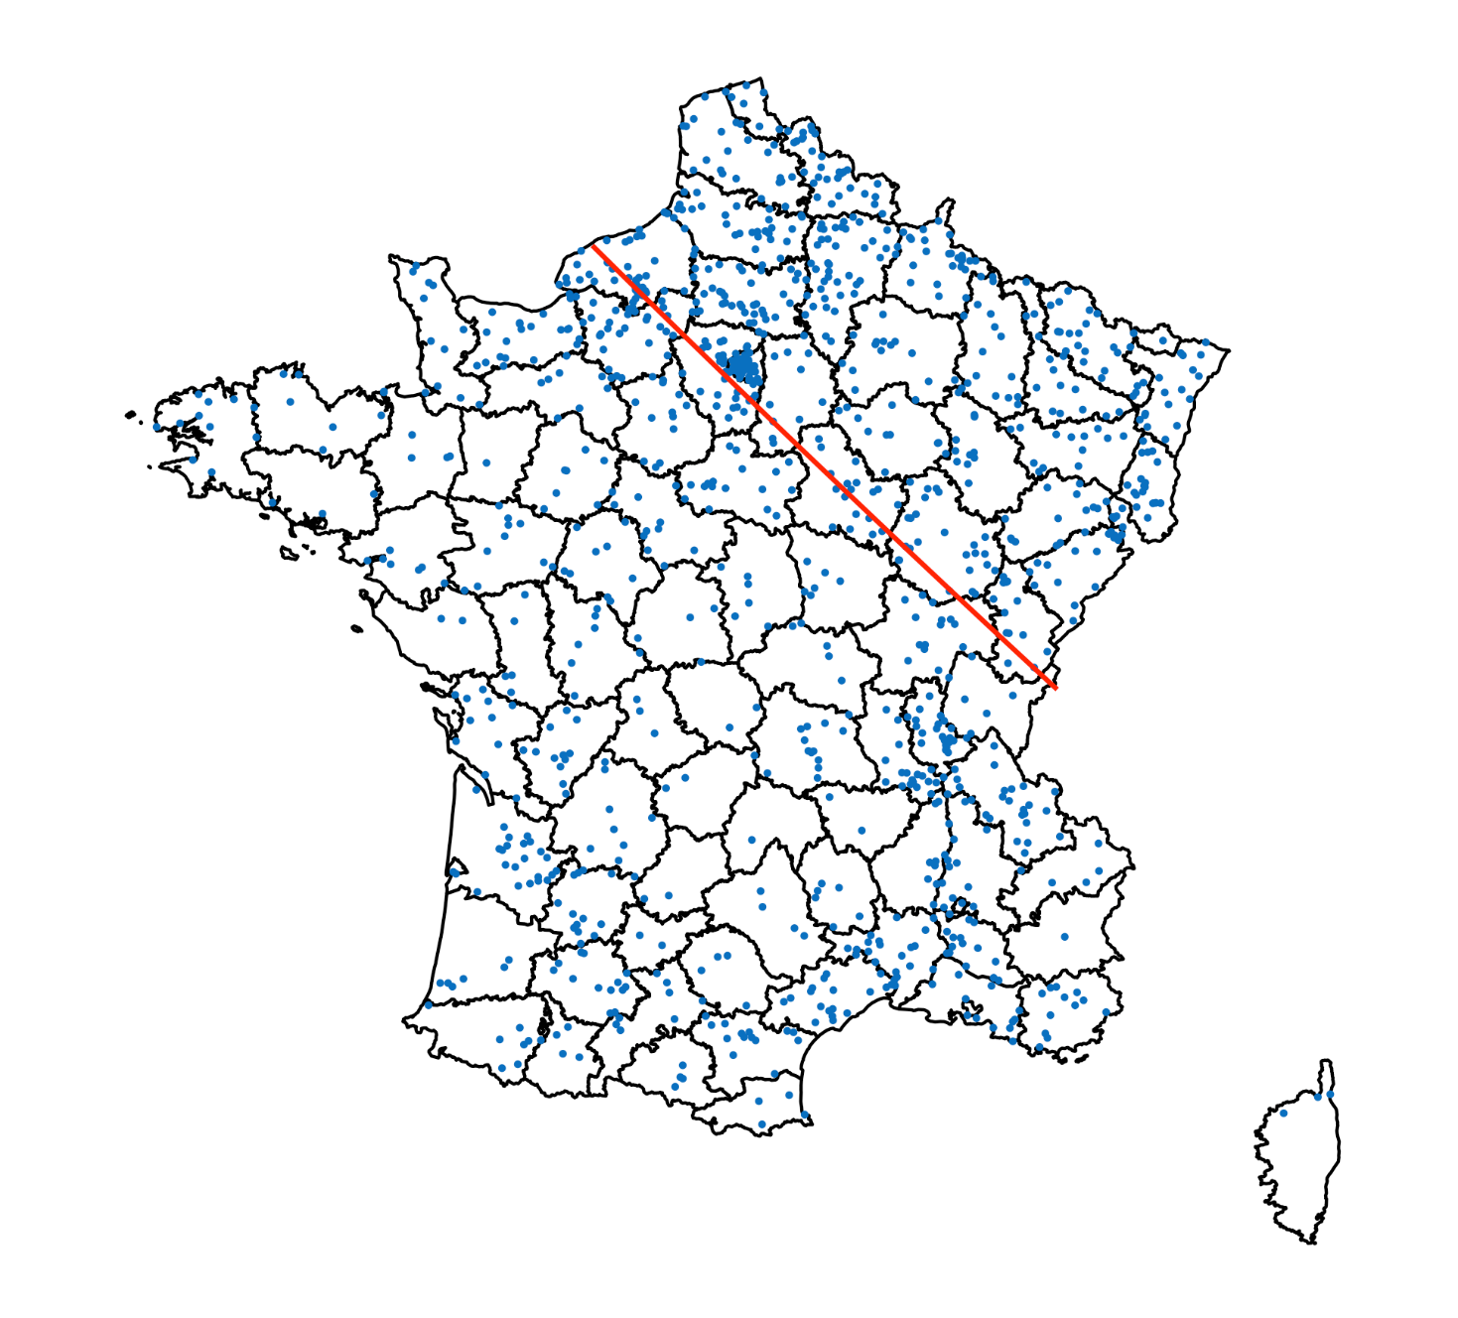

Notes: Each dot indicates a municipality with at least one patent. The map also reports the Rouen-Geneva line.
Sources: Institut National de la Propriété Industrielle (INPI) dataset for patents and http://www.datavis.ca/gallery/guerry/maps.html for the map of France Department boundaries of 1830.

Figure A3. Number of patents granted in France by technology class and patentees’ residence (1791-1844)

Notes: the technology classes are: 1 = agriculture; 2 = hydraulic; 3 = steam engines and engines; 4 = textile machines and fabrics; 5 = other machines, devices and tools; 6 = navigation; 7 = construction; 8 = metallurgy; 9 = hardware (lock and cutlery); 10 = bodywork, saddlery, ropes and brushwork; 11 = weapons; 12 = precision and surgical instruments; 13 = mineral substances and ceramic; 14 = chemical products, food and cosmetics; 15 = lighting, heating and fuels; 16 = clothing and shoes; 17 = fine arts and musical instruments; 18 = stationery; 19 = leather; 20 = miscellaneous products.
Sources: Institut National de la Propriété Industrielle (INPI) dataset for patents and Empotz and Marchal (2002) for technological classes.
Figure A4. Number of patents granted in France by technology class (1791-1844)

Notes: the technology classes are: 1 = agriculture; 2 = hydraulic; 3 = steam engines and engines; 4 = textile machines and fabrics; 5 = other machines, devices and tools; 6 = navigation; 7 = construction; 8 = metallurgy; 9 = hardware (lock and cutlery); 10 = bodywork, saddlery, ropes and brushwork; 11 = weapons; 12 = precision and surgical instruments; 13 = mineral substances and ceramic; 14 = chemical products, food and cosmetics; 15 = lighting, heating and fuels; 16 = clothing and shoes; 17 = fine arts and musical instruments; 18 = stationery; 19 = leather; 20 = miscellaneous products.
Sources: Institut National de la Propriété Industrielle (INPI) dataset for patents and Empotz and Marchal (2002) for technological classes.

Figure A5. Distribution of real duration (days) and withdrawn patents by patentees’ social class

Notes: ‘high social class’ patentees are defined as those belonging to 0_1-5 of the HISCO classification: 0_1 = small proprietor; 0_2 = large proprietor; 1 = higher manager; 2 = higher professionals; 3 = lower manager; 4 = lower professionals, and clerical and sales personnel; 5 = lower clerical and sales personnel.
Sources: Institut National de la Propriété Industrielle (INPI) dataset for patents and Van Leeuwen, Maas and Miles (2002) for HISCO occupations.

Figure A6. Distribution of real duration (days) and withdrawn patents by patentees’ social class (high social class excluding ‘small proprietors’)

Notes: ‘high social class’ patentees are defined as those belonging to 0_2-5 of the HISCO classification: 0_2 = large proprietor; 1 = higher manager; 2 = higher professionals; 3 = lower manager; 4 = lower professionals, and clerical and sales personnel; 5 = lower clerical and sales personnel.
Sources: Institut National de la Propriété Industrielle (INPI) dataset for patents and Van Leeuwen, Maas and Miles (2002) for HISCO occupations.

Figure A7. Distribution of real duration (days) and withdrawn patents by patentees’ social class (high social class excluding ‘small proprietors’ and low levels of non-manual workers)

Notes: ‘high social class’ patentees are defined as those belonging to the following classes of the HISCO classification: 0_2 = large proprietor; 1 = higher manager; 2 = higher professionals.
Sources: Institut National de la Propriété Industrielle (INPI) dataset for patents and Van Leeuwen, Maas and Miles (2002) for HISCO occupations.

