State Capacity, Property Rights, and External Revenues:
Haiti, 1932-1949
Craig Palsson

A Online Appendix

A.1 Synthetic Income Tax Revenue
To estimate the counterfactual growth in tax revenues, I collect seven macroeconomic variables that should correlate with income growth but should not be affected by the tax reform or changes in state capacity: the amount of deposits in Haitian banks, the amount of loans from Haitian banks, the total value of exports from Haiti, and the price of four main commodity exports (coffee, cotton, sisal, and sugar). I adjust all indicators for inflation using the Bulmer-Thomas index. I then take the natural logarithm of income tax revenues and the seven control variables, and I normalize all to be zero in 1941 (thus, the transformed variables reflect growth relative to 1941). The synthetic control process finds a set of weights for the seven macroeconomic variables such that the weighted time series before the revenue shock mimics the time series of the income tax revenue. Applying the weights to the post-mobilization period gives a synthetic counterfactual path for income tax revenue growth.
The results are displayed in Figure A1. The dashed gray line shows the synthetic revenue growth while the solid black line depicts the actual growth path of income tax revenues. In the pre-period, the two time series are similar. But following mobilization, the two series diverge. Both are increasing, consistent with mobilization increasing incomes. But income tax revenue grows much faster than the synthetic control. Importantly, most of this growth comes in the first year of the income tax reform’s full implementation.
Figure A2 depicts the predicted differences for income tax revenues (solid black line) and the seven donor macroeconomic variables (light gray lines) when the synthetic control is run separately for each variable. Thus, the light gray lines provide placebo effects when assuming, for example, that loans from Haitian banks were treated by mobilization and income tax revenues are a control. In the pre-mobilization period, income tax revenues are in the middle of the series, indicating no significant difference in pre-treatment trends. But after mobilization, income tax revenues diverge distinctly from any other series. When comparing the post-treatment differences in income tax revenue growth to the distribution of differences in the donor variables, every year after 1942 is statistically different.

A.2 Comparing Synthetic Control to Event Study
The synthetic control analysis presented in Figure 9 provides convincing evidence that the refugees and the capacity expansion had significant effects on tax revenues. But a weakness of the synthetic control analysis is that researchers have some degrees of freedom in selecting the synthetic control. To assuage concerns about researcher bias, I also estimate a difference-in-differences event study and compare the estimated treatment effects to the synthetic control. To test for refugee effects on tax receipts, I run the following regression
$\ln{T_{it}}=δ_{i}+δ_{t}+β_{t}\left(Refugee_{i}×δ_{t}\right)+ε_{it}$
where $T_{it}$ is, for tax precinct $i$ in year $t$, the tax receipts from land rentals (though in other situations below, the dependent variable will be taxes in other categories). The regression includes fixed effects for the year ($δ_{t}$) and the precinct ($δ_{i}$). The $Refugee_{i}$ variable is an indicator for whether the tax precinct hosted a refugee camp, and the $β_{t}$ gives, for year $t$, the difference in receipts between refugee and non-refugee tax precincts. Because there are only 10 precincts, I obtain confidence intervals for $β_{t}$ using the wild bootstrap-t methods described in Cameron et al. (2008) and implemented in Stata by Judson Caskey.
Appendix Table A1 compares the estimates from the synthetic control and event study. Both show similar results.

A.3 Proof
$$\frac{∂U}{∂π_{1}}=\frac{α\left(τ_{1}^{*}Y-L^{'}\left(π_{1}^{*}-π_{0}\right)\right)}{τ_{1}^{*}π_{1}^{*}Y+M-L\left(π_{1}^{*}-π_{0}\right)-F\left(τ_{1}^{*}-τ_{0}\right)}+\frac{1}{π_{1}^{*}}=0$$
$$\frac{∂U}{∂π_{1}}=\frac{α\left(π_{1}^{*}Y-F^{'}\left(τ_{1}^{*}-τ_{0}\right)\right)}{τ_{1}^{*}π_{1}^{*}Y+M-L\left(π_{1}^{*}-π_{0}\right)-F\left(τ_{1}^{*}-τ_{0}\right)}-\frac{1}{{1-τ}_{1}^{*}}=0$$

The Hessian of the system is
$$\left(\begin{matrix}-\frac{αΩL^{''}\left(π_{1}-π_{0}\right)+α{\left(τ_{1}Y-L^{'}\left(π_{1}-π_{0}\right)\right)}^{2}}{Ω^{2}}-\frac{1}{π_{1}^{2}} & \frac{αΩY-α\left(τ_{1}Y-L^{'}\left(π_{1}-π_{0}\right)\right)\left(π_{1}Y-F^{'}\left(τ_{1}-τ_{0}\right)\right)}{Ω^{2}} \\ \frac{αΩY-α\left(τ_{1}Y-L^{'}\left(π_{1}-π_{0}\right)\right)\left(π_{1}Y-F^{'}\left(τ_{1}-τ_{0}\right)\right)}{Ω^{2}} & -\frac{αΩF^{''}\left(τ_{1}-τ_{0}\right)+α{\left(π_{1}Y-F^{'}\left(τ_{1}-τ_{0}\right)\right)}^{2}}{Ω^{2}}-\frac{1}{{\left(1-τ_{1}\right)}^{2}}\end{matrix}\right)$$
Where $Ω=τ_{1}π_{1}Y+M-L\left(π_{1}-π_{0}\right)-F(τ_{1}-τ_{0})$. For this to be an optimum, the determinant of this matrix has to be positive.
Note that at the optimum
$$\frac{α}{τ_{1}^{*}π_{1}^{*}Y+M-L\left(π_{1}^{*}-π_{0}\right)-F(τ_{1}^{*}-τ_{0})}=\frac{1}{\left(1-τ_{1}\right)π_{1}Y}$$
$$α\left(1-τ_{1}\right)π_{1}Y=τ_{1}^{*}π_{1}^{*}Y+M-L\left(π_{1}^{*}-π_{0}\right)-F\left(τ_{1}^{*}-τ_{0}\right)=Ω$$
So the sign of $\frac{∂π_{1}^{*}}{∂M}$ is the sign of
$$-\left(-\frac{α\left(τ_{1}^{*}Y-L\left(π_{1}^{*}-π_{0}\right)\right)}{Ω^{*2}}\right)\left(-\frac{αΩF^{''}\left(τ_{1}-τ_{0}\right)+α{\left(π_{1}Y-F^{'}\left(τ_{1}-τ_{0}\right)\right)}^{2}}{Ω^{*2}}-\frac{1}{{\left(1-τ_{1}\right)}^{2}}\right)+\left(-\frac{α\left(π_{1}^{*}Y-F^{'}\left(τ_{1}^{*}-τ_{0}\right)\right)}{Ω^{*2}}\right)\left(\frac{αΩY-α\left(τ_{1}Y-L^{'}\left(π_{1}-π_{0}\right)\right)\left(π_{1}Y-F'\left(τ_{1}-τ_{0}\right)\right)}{Ω^{*2}}\right)$$
$$=\frac{αF^{''}\left(τ_{1}^{*}-τ_{0}\right)}{{Ω^{*}}^{2}π_{1}^{*}}+\frac{1+α}{αΩ^{*}π_{1}^{*}{\left(1-τ_{1}^{*}\right)}^{2}}-\frac{1+α}{αΩ^{*}π_{1}^{*}{\left(1-τ_{1}^{*}\right)}^{2}}$$
$$=\frac{αF^{''}\left(τ_{1}^{*}-τ_{0}\right)}{Ω^{*2}π_{1}^{*}}>0$$
And the sign of $\frac{∂τ_{1}^{*}}{∂M}$ is the sign of
$$-\left(-\frac{α\left(π_{1}^{*}Y-F^{'}\left(τ_{1}^{*}-τ_{0}\right)\right)}{Ω^{*2}}\right)\left(-\frac{αΩL^{''}\left(π_{1}-π_{0}\right)+α{\left(τ_{1}Y-L^{'}\left(π_{1}-π_{0}\right)\right)}^{2}}{Ω^{*2}}-\frac{1}{π_{1}^{2}}\right)+\left(-\frac{α\left(τ_{1}^{*}Y-L^{'}\left(π_{1}^{*}-π_{0}\right)\right)}{Ω^{*2}}\right)\left(\frac{αΩY-α\left(τ_{1}Y-L^{'}\left(π_{1}-π_{0}\right)\right)\left(π_{1}Y-F'\left(τ_{1}-τ_{0}\right)\right)}{Ω^{*2}}\right)$$
$$=-\frac{αL^{''}\left(π_{1}^{*}-π_{0}\right)}{{Ω^{*}}^{2}\left(1-τ_{1}^{*}\right)}-\frac{1+α}{αΩ^{*}{π_{1}^{*}}^{2}\left(1-τ_{1}^{}\right)}+\frac{1+α}{αΩ^{*}{π_{1}^{*}}^{2}\left(1-τ_{1}^{}\right)}$$
$$=-\frac{αL^{''}\left(π_{1}^{*}-π_{0}\right)}{{Ω^{*}}^{2}\left(1-τ_{1}^{*}\right)}<0$$

A.4 Augmented Model
$$\frac{∂U}{∂π_{1}}=\frac{α\left(τ_{1}^{*}Y-L_{π}\left(π_{1}^{*}-π_{0},τ_{1}\right)-F_{π}\left(τ_{1}^{*}-τ_{0},π_{1}\right)\right)}{τ_{1}^{*}π_{1}^{*}Y+M-L\left(π_{1}^{*}-π_{0},τ_{1}\right)-F\left(τ_{1}^{*}-τ_{0},π_{1}\right)}+\frac{1}{π_{1}^{*}}=0$$
$$\frac{∂U}{∂π_{1}}=\frac{α\left(π_{1}^{*}Y-L_{τ}\left(π_{1}^{*}-π_{0},τ_{1}\right)-F_{τ}\left(τ_{1}^{*}-τ_{0},π_{1}\right)\right)}{τ_{1}^{*}π_{1}^{*}Y+M-L\left(π_{1}^{*}-π_{0},τ_{1}\right)-F\left(τ_{1}^{*}-τ_{0},π_{1}\right)}-\frac{1}{{1-τ}_{1}^{*}}=0$$
The Hessian of the system created by Equations (6) and (7) is
$$\left(\begin{matrix}-\frac{αΩ\left(L_{ππ}+F_{ππ}\right)+α{\left(τ_{1}Y-L_{π}-F_{π}\right)}^{2}}{Ω^{2}}-\frac{1}{π_{1}^{2}} & \frac{αΩ\left(Y-L_{πτ}-F_{πτ}\right)-α\left(τ_{1}Y-L_{π}-F_{π}\right)\left(π_{1}Y-L_{τ}-F_{τ}\right)}{Ω^{2}} \\ \frac{αΩ\left(Y-L_{πτ}-F_{πτ}\right)-α\left(τ_{1}Y-L_{π}-F_{π}\right)\left(π_{1}Y-L_{τ}-F_{τ}\right)}{Ω^{2}} & -\frac{αΩ\left(L_{ττ}+F_{ττ}\right)+α{\left(π_{1}Y-L_{τ}-F_{τ}\right)}^{2}}{Ω^{2}}-\frac{1}{{\left(1-τ_{1}\right)}^{2}}\end{matrix}\right)$$
The sign of $\frac{∂π_{1}^{*}}{∂M}$ is the sign of
$$sign\left(\frac{α{\left(1-τ_{1}^{*}\right)}^{2}\left(L_{ττ}+F_{ττ}\right)+απ_{1}^{*}\left(1-τ_{1}^{*}\right)\left(L_{πτ}+F_{πτ}\right)}{Ω^{2}π_{1}^{8}{\left(1-τ_{1}\right)}^{2}}\right)$$
Note that $L_{ττ}+F_{ττ}>0$ and $L_{πτ}+F_{πτ}<0$, so the sign is determined by the relative size of these terms.
The sign of $\frac{∂τ_{1}^{*}}{∂M}$ is the sign of
$$sign\left(-\frac{απ_{1}^{*2}\left(L_{ππ}+F_{ππ}\right)+απ_{1}^{*}\left(1-τ_{1}^{*}\right)\left(L_{πτ}+F_{πτ}\right)}{Ω^{2}π_{1}^{*2}\left(1-τ_{1}^{*}\right)}\right).$$
Just as above, $L_{ππ}+F_{ππ}>0$ and $L_{πτ}+F_{πτ}<0$, so the sign is determined by the relative size of these terms.

References
Cameron, A. Colin, Jonah B. Gelbach, and Douglas L. Miller. “Bootstrap-based improvements for inference with clustered errors.” The Review of Economics and Statistics 90 no. 3 (2008), 414–27.

Table A1. Treatment effect estimates for synthetic control and difference-in-differences analysis
Land Rental Receipts Property Transfer Receipts
SC | ES | SC | ES
1938 0.20 | 0.22 | 0.09 | 0.11
[0.00] | [0.095] | [0.27] | [0.51]
1939 0.20 | 0.15 | 0.02 | 0.023
[0.02] | [0.073] | [0.83] | [0.68]
1940 0.23 | 0.23 | -0.17 | -0.13
[0.14] | [0.061] | [0.38] | [0.51]
1941 0.23 | 0.22 | -0.30 | -0.27
[0.06] | [0.025] | [0.02] | [0.077]
1942 0.47 | 0.45 | 0.03 | 0.069
[0.00] | [0.001] | [0.83] | [0.69]
1943 0.50 | 0.50 | 0.30 | 0.34
[0.00] | [0.0001] | [0.03] | [0.017]
1944 0.49 | 0.42 | 0.12 | 0.16
[0.00] | [0.0013] | [0.44] | [0.25]
1945 0.53 | 0.45 | -0.01 | 0.014
[0.02] | [0.0032] | [0.92] | [0.94]
1946 0.51 | 0.43 | 0.10 | 0.13
[0.02] | [0.013] | [0.69] | [0.38]
1947 0.47 | 0.39 | 0.13 | 0.16
[0.08] | [0.025] | [0.55] | [0.31]
1948 0.53 | 0.42 | 0.15 | 0.20
[0.11] | [0.040] | [0.45] | [0.32]
1949 0.49 | 0.39 | 0.10 | 0.14
[0.17] | [0.074] | [0.38] | [0.28]
Notes: P-values in brackets. The column headers indicate the approach used to estimate the treatment effects—SC means synthetic control and ES means event study.

Figure A1. Income tax growth compared to a synthetic income tax path
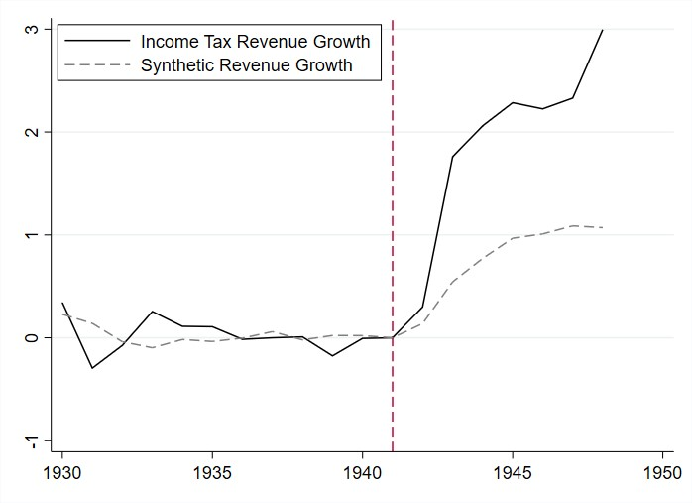
Source: Data come from the Annual Reports of the Fiscal Representative.

Figure A2. Prediction differences for treatment and all donors
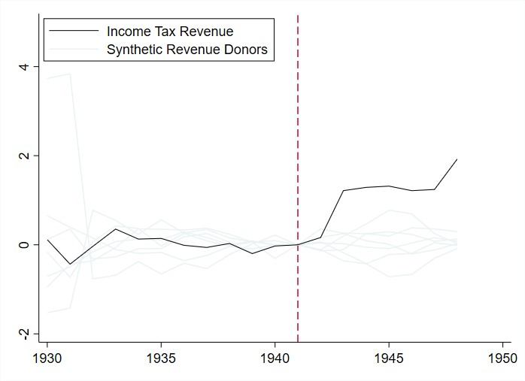
Source: Data come from the Annual Reports of the Fiscal Representative.

All variables are collected from the Annual Reports.

