Online Appendix

Effects on School Quality
Our paper studies on how religious competition contributed to an increased supply denominational institutions. A remaining question is whether this was a positive development. The strength of the U.S. higher education system lies in both the quantity of institutions and their quality. In this appendix, we investigate the relationship between the greater entry of colleges and institutional quality.
Our ability to do this is somewhat limited. We track the development of denominational institutions over time and show that denomination fragmentation played a significant role in their transformation during an important juncture, the onset of the Second Industrial Revolution.
Denominational colleges had modest beginnings. In 1880, a typical college had on average fewer than 200 students and 10 faculty. The scope of academic activities was also very limited. There was little research activity, and the fixed set of curricula featuring Latin and Greek, resembling more of high schools than the private research universities today. This steady state was disrupted after 1890 when demand for scientific education expanded.
Figure A1 shows the increase in the average number of students per college from 1880 to 1910s. During this period, colleges doubled their class size from 1880s to 1910s. We further document, in figure A2, that the growth in enrollment was disproportionately concentrated in colleges located in religious fragmented markets.
Next, we investigate whether colleges located in more religious fragmented counties had higher growth rate in capacity and exhibited higher quality in teaching and research. To do so, we construct short run measures of growth and quality using data from the Annual Report to the Commissioner of Education. We take reports every 5 years from 1870 to 1910 plus 1914, the last report in decade 1910. From each report, we transcribed the name and location of each institution, its total students, total faculty, total endowment, enrollment of graduate students and majors offered.. Eventually, we were able to compile a panel of colleges spanning from 1870 to 1914. The growth variables of interests are growth rate of students and faculty. The quality measures are indicator of having graduate school and number of majors offered by 1910s.
Table A1 shows differentiated short run outcomes for colleges in more religious fragmented places, measured by DenomFraction. Columns 1&2 estimate that if DenomFraction in 1870 increases by 0.1, the underlying college will have 38 percent more students by 1890 and 31 percent more faculty for the same undergraduate enrollment. Columns 3&4 indicate an increasing scope in academic activity. A 0.1 increase in DenomFraction in 1870 raises the probability of research activity (measured by the existence of graduate school) by 6 percent in 1910; it also induced a wider range of majors being offered by 1910.
Figure A1: Growth of average enrollment in private colleges
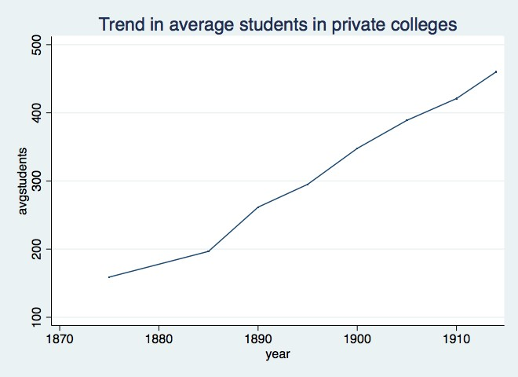
Data Source: Report of the Commissioner of Education
Figure A2: Growth of student by religious fragmentation of local markets
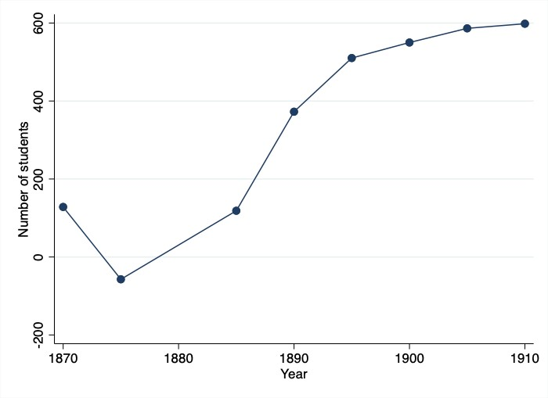
Each point represents the coefficient from the cross-sectional regression of the number of students on religious fragmentation in the year indicated. The sample consists of all colleges operating in a given year.
Table A1: Short Run College Quality
Dependent Variable: | ∆ Students | ∆ Faulty | Grad school | Majors
DenomFraction | 379.6821* | 313.4685** | 0.5975** | 0.4489*
 | (198.3482) | (126.3346) | (0.2759) | (0.2438)
State fixed effects | Yes | Yes | Yes | Yes
County level controls | Yes | Yes | Yes | Yes
Denominational Controls | Yes | Yes | Yes | Yes
Total students | No | Yes | Yes | Yes
Observations | 229 | 229 | 422 | 422
R2 | .32 | .48 | .23 | .13
Notes: The table reports OLS estimates. An observation is a private college. The dependent variable in Column 1 is the percent growth of total students from 1870 to 1890. The dependent variable in Column 2 is the percent growth of total faculty from 1870 to 1890. The dependent variable in Column 3 is a dummy that equals 1 if a college had graduate students in 1910. The dependent variable in Column 4 is variable that equals 0 if a college in 1910 had no major, equals 1 if it had 1-5 majors and equals 2 if it had more than 5 majors. DenomFraction is our index of denomination competition in 1870. County-level controls include religiosity measured by total sitting capacity in churches, share of population corresponding to people in urban area, male, aged 5 to 18, white, foreigners, farm productivity, access to railroad, miles of railroad, access to steam-boat navigated rivers, manufacturing output, manufacturing employment, manufacturing investment. *** Significant at the 1% level; ** Significant at the 5% level; * Significant at the 10% level.

Event Study
Identification in our panel framework relies on the conditional independence assumption, that is, the changes in denominational competition must be un-correlated with time-varying unobservables which may also affect college development. This would be violated if, for instance, the counties which became more religiously diverse was already experiencing increases in the number of colleges for reasons unrelated to denominational competition. In this section, we assess the validity of this concern.
To do so, we employ an event study strategy to examine the extent to which the timing of college growth coincides with the increase in denominational diversity.
Specifically, we consider two treatments that correspond to the level of denominational diversity: above median number of denominations and above median level of denomination fragmentation. We use the median value from the median year (1870) as the fixed threshold. The median number of denominations in 1870 was 9. The median level of denomination fragmentation in 1870 was 0.68, approximately represents a county having three denominations with equal market share.
We define an indicator variable that equals 1 when the county contains above median number of denominations, and an indicator variable equaling 1 when a county reaches an above median denomination fragmentation. Then, we investigate the decade-by-decade differences in the college counts in arcsine transformation before and after a county was treated using the following flexible specification:
$\operatorname{arcsinh}\left(\# of {colleges}_{ct}\right)=\sum_{j≥-3,j≠-1}^{2}{β_{j}{Treatment}_{cjt}+δ_{c}+λ_{t}+ε_{ct}}$ (5)
where δ_{c} and λ_{t} are county and decade fixed effects. Treatment_{cjt} are a set of dummies indicating the normalized year j relative to the moment that county reaches above median religious diversity. The estimated effect for the decade prior to the treated year (j=-1) is normalized to zero. If the identification assumption holds, we should expect a consistently positive effect for counties that became religiously competitive and no differences before the treatment happened.
Estimated college counts with 95% confidence intervals are plotted in figure A4. We show the figures separately for the two treatment definitions using the sample of counties which are untreated in 1850 (below median number of denominations in Panel A and below median denominational fragmentation in Panel B). For both measures, the switch to higher denominational diversity is associated with significant trend-break in the trajectory of college growth.
Importantly, these counties exhibit no tendency to establish colleges before it became more religiously competitive. However, there is a notable increase in college establishments after a county passed the median threshold in denominational diversity.
This exercise helps us rule out the possible concern that the growth of higher education preceded denominational diversity. The absence of a pre-trend in this event provides supportive evidence that the counties which became religiously diverse was not evolving along differential trends with respect to higher education and the counterfactual assumption is likely to hold.

Additional Tables & Figures
 | 1850 |  | 1860 |  | 1870 |  | 1890
 | mean | max | mean | max | mean | max | mean | max
Baptist | 0.269 | 1.0 | 0.250 | 1.0 | 0.249 | 1.0 | 0.271 | 1.0
Christian | 0.024 | 1.0 | 0.043 | 1.0 | 0.047 | 1.0 | 0.045 | 1.0
Dutch Reformed | 0.006 | 1.0 | 0.005 | 0.6 | 0.003 | 0.5 | 0.003 | 1.0
Episcopal | 0.031 | 1.0 | 0.034 | 1.0 | 0.033 | 1.0 | 0.027 | 1.0
Quaker | 0.010 | 0.7 | 0.007 | 0.6 | 0.004 | 1.0 | 0.005 | 0.3
German Reformed | 0.005 | 0.4 | 0.006 | 0.4 | 0.006 | 0.5 | 0.009 | 0.5
Jewish | 0.000 | 0.1 | 0.000 | 0.1 | 0.000 | 0.2 | 0.001 | 0.1
Lutheran | 0.022 | 1.0 | 0.025 | 0.7 | 0.030 | 1.0 | 0.049 | 1.0
Mennonite | 0.001 | 0.1 | 0.000 | 0.0 | 0.000 | 0.0 | 0.001 | 0.4
Methodist | 0.357 | 1.0 | 0.382 | 1.0 | 0.360 | 1.0 | 0.314 | 1.0
Moravian | 0.005 | 0.4 | 0.001 | 1.0 | 0.000 | 0.0 | 0.000 | 0.2
Presbyterian | 0.134 | 1.0 | 0.099 | 1.0 | 0.116 | 1.0 | 0.086 | 1.0
Catholic | 0.065 | 1.0 | 0.080 | 1.0 | 0.098 | 1.0 | 0.083 | 1.0
Swedenborgian | 0.000 | 0.0 | 0.000 | 0.1 | 0.000 | 0.0 | 0.000 | 0.1
Tunker | 0.001 | 0.2 | 0.000 | 0.0 | 0.008 | 0.3 | 0.026 | 0.6
Union | 0.015 | 1.0 | 0.025 | 0.8 | 0.000 | 0.0 | 0.000 | 0.0
Unitarian | 0.002 | 0.2 | 0.002 | 0.2 | 0.001 | 0.2 | 0.002 | 0.2
Universalist | 0.006 | 0.2 | 0.006 | 0.2 | 0.002 | 0.2 | 0.003 | 0.2
Congregational | 0.026 | 0.7 | 0.030 | 1.0 | 0.031 | 1.0 | 0.040 | 1.0
Adventist | 0.000 | 0.0 | 0.000 | 0.1 | 0.000 | 0.1 | 0.005 | 1.0
Mormon | 0.000 | 0.0 | 0.005 | 1.0 | 0.010 | 1.0 | 0.011 | 1.0
Shaker | 0.000 | 0.0 | 0.000 | 0.0 | 0.000 | 0.0 | 0.000 | 0.0
Spiritualist | 0.000 | 0.0 | 0.000 | 0.0 | 0.000 | 0.0 | 0.000 | 0.1
Evangelical | 0.000 | 0.0 | 0.000 | 0.0 | 0.003 | 0.4 | 0.009 | 0.3
Pentecostal | 0.000 | 0.0 | 0.000 | 0.0 | 0.000 | 0.0 | 0.001 | 0.1
Table A2: Descriptive Statistics

Notes: The table reports the average and maximum share of denomination accommodation at county level for each denomination.

Figure A3: Revivalism Activity Across Time
(a) No. of Revivals by Year
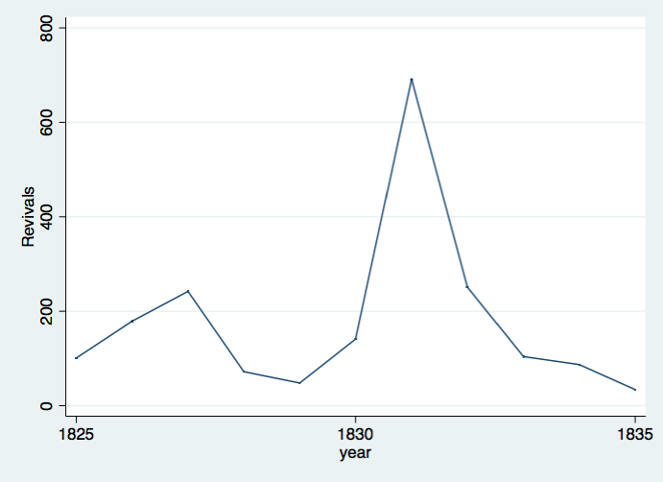
(a) No. of Converts by Year
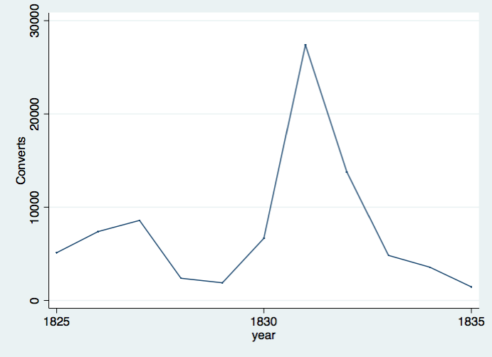
(c) No. of Counties involved in Revivals by year
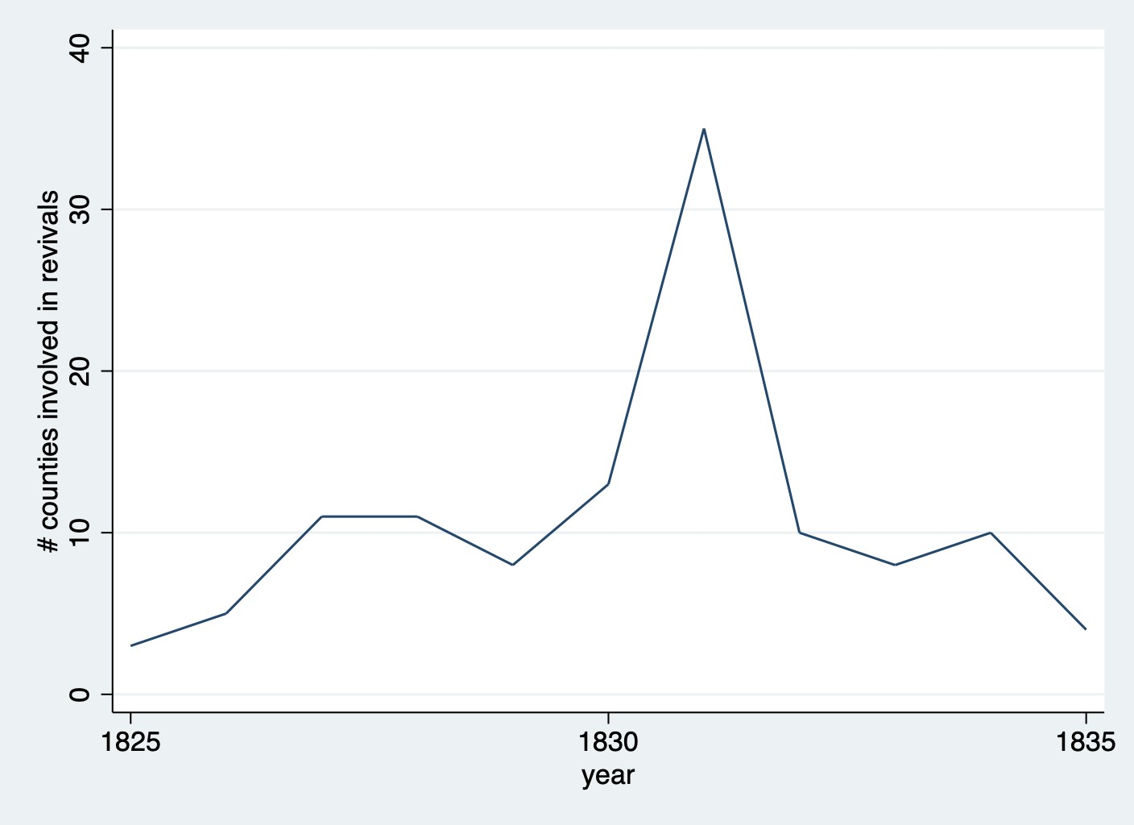
Figure (a), Figure (b) and Figure (c) present the trend of revival activity measured by total number of revival meetings, total number of converts and total number of affected counties respectively.

Figure A4: The effect of rising denominational competition on college establishment
- Treatment is above median number of denominations
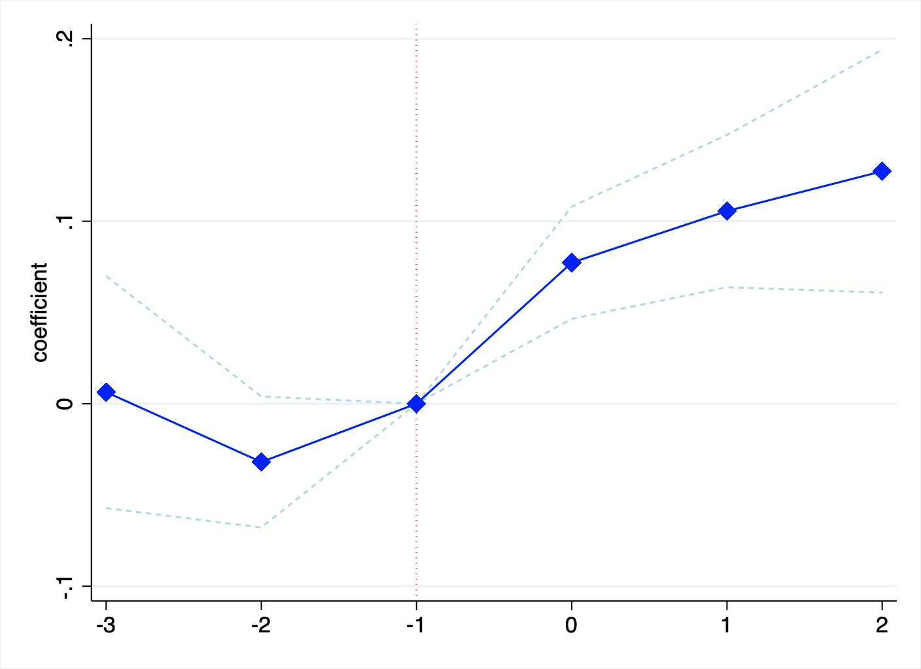
- Treatment is above median degree of denominational fragmentation
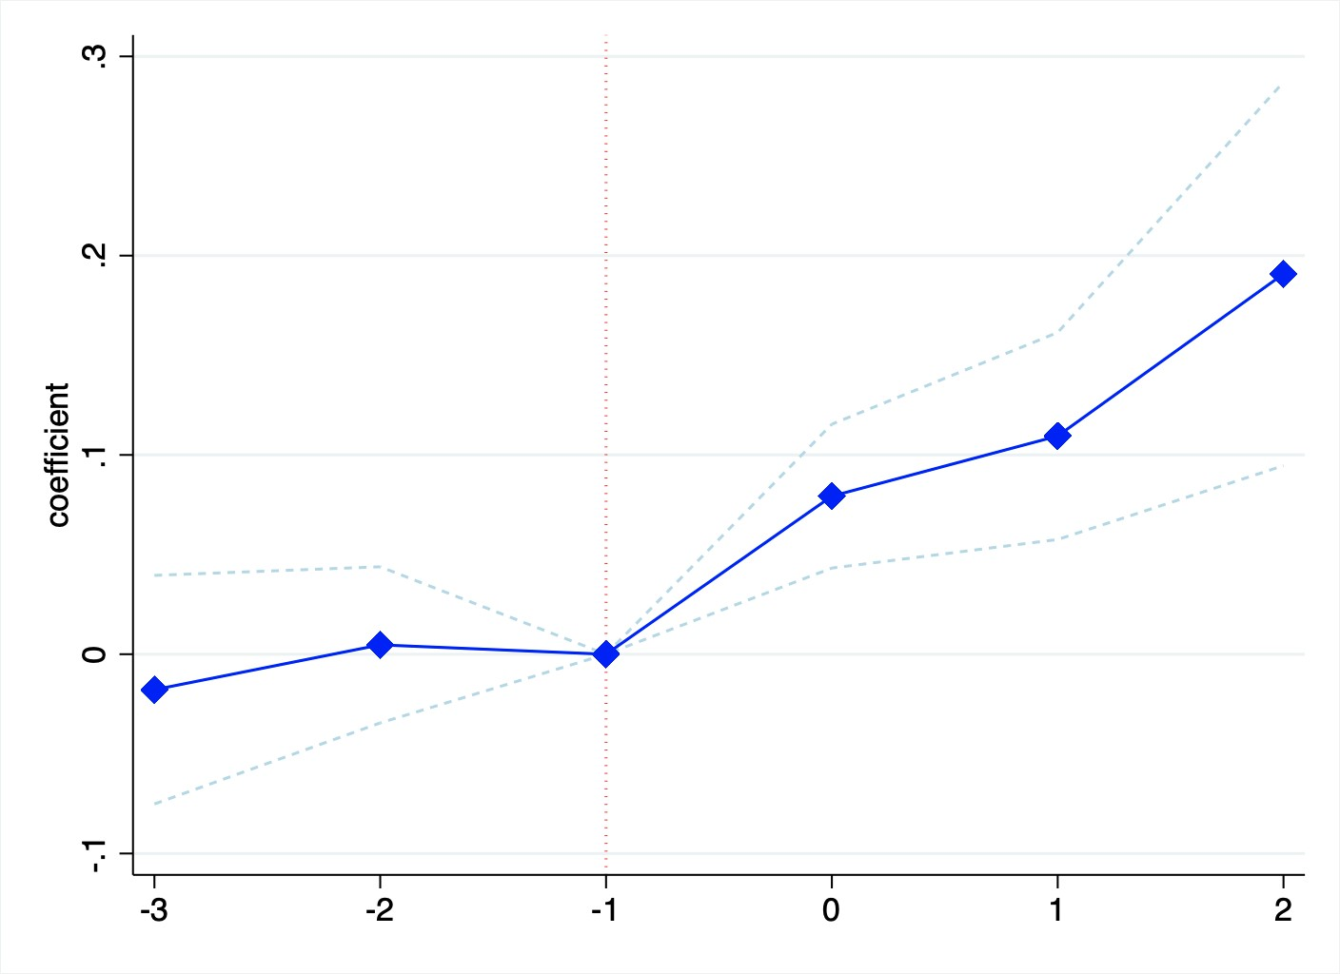
Notes: The figure depicts the effects of rising denominational competition on the number of colleges in Inverse
Hyperbolic Sine (IHS) transformation. The markers and capped spikes represent the OLS estimators and 95% confidence intervals. Time 0 is normalized to the decade before when the county experienced an increase in
religious competition to above median number of denominations or above median Denomfraction of 1870. The regression includes county fixed effects and year fixed effects. Standard errors are clustered by county.

Figure A5: Secularization of higher education over time
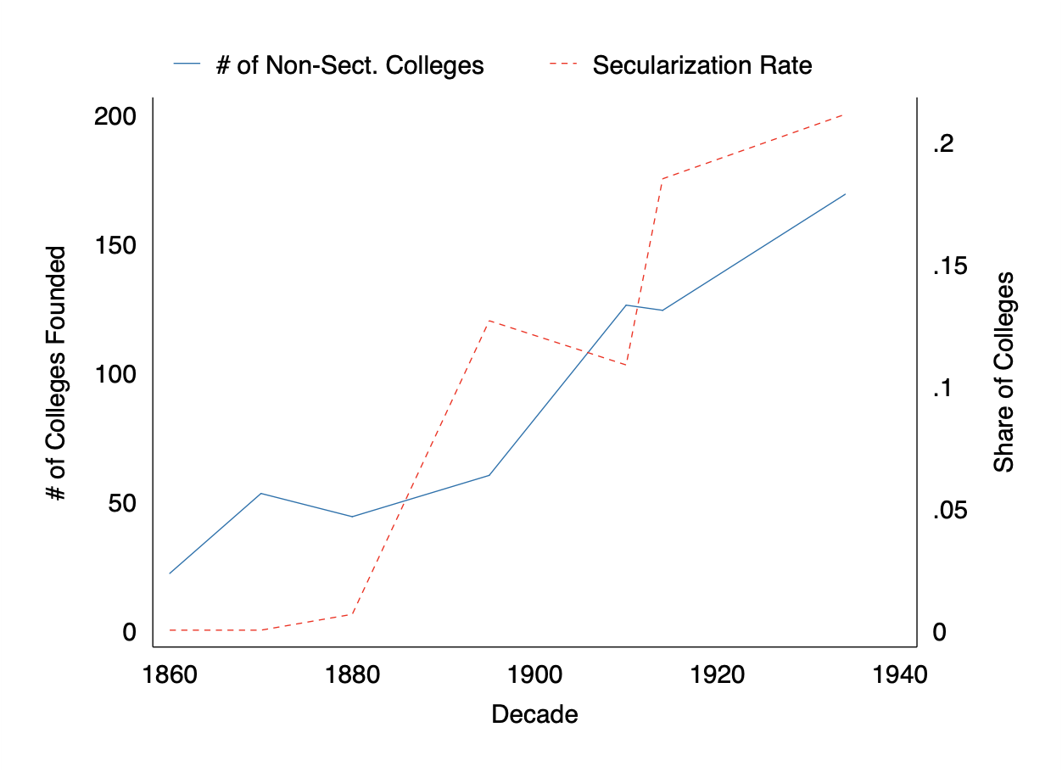
Figure A6: Distance Traveled from Hometown to College: CDF
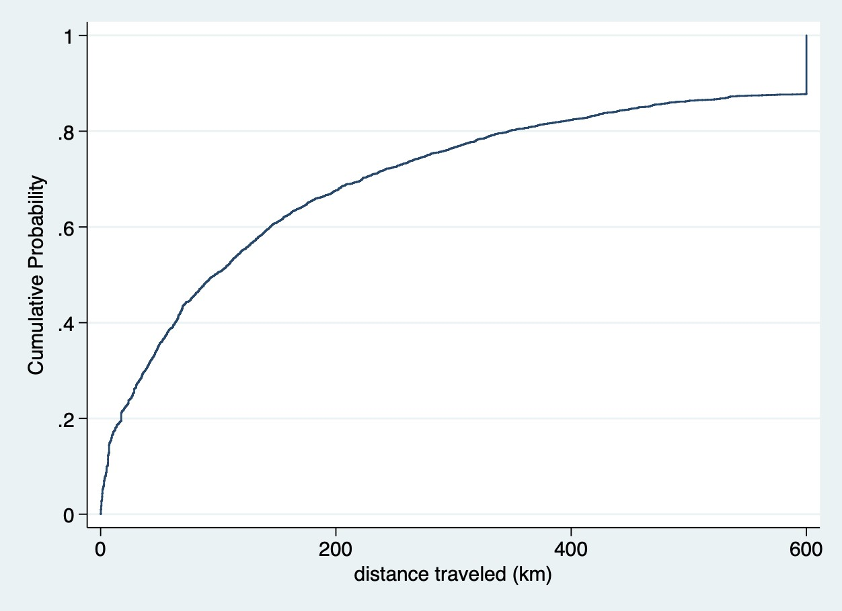
Notes: The figure shows the CDF of the distance (in km) which students traveled from home to college. Distances longer than 600 km are truncated at 600. Source: student-college linked data

Figure A7: College and enrollment growth at private colleges
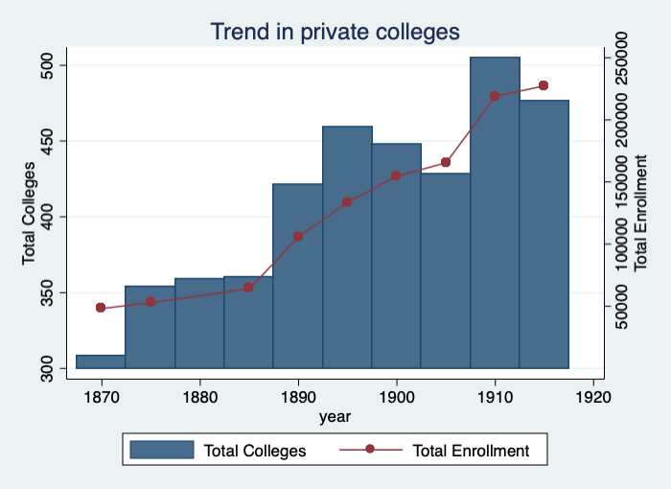
Data Source: Report of the Commissioner of Education

Figure A8: Enrollment by major at private colleges, 1910
- Men
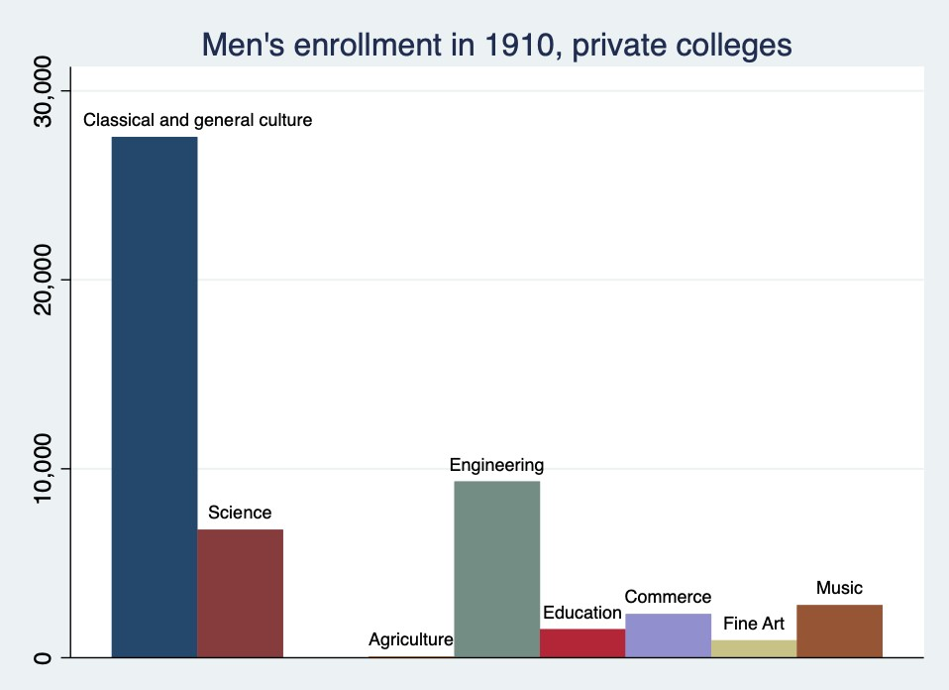
- Women
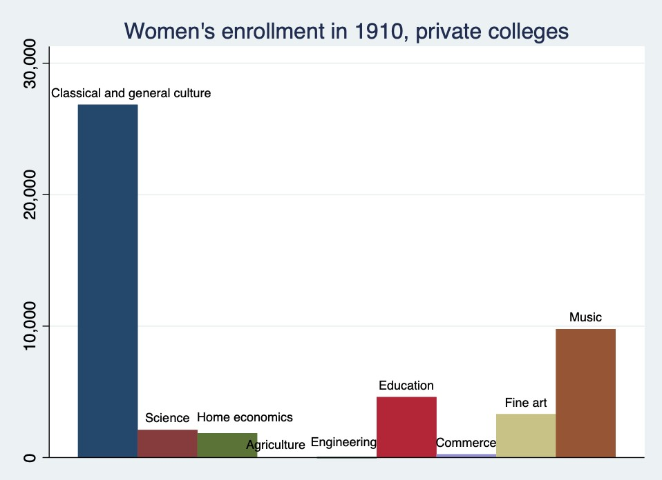
Figure (a), Figure (b) present the total enrollment by major at private colleges in 1910

Number of graduate students and majors offered were reported in 1985, 1990 and 1914 only
About half of colleges in this period experienced some changes in names due to expansion, merger or relocation etc. For instance, Yale College switched into Yale University, Alabama Baptist Colored University renamed as Selma University, and Iowa College became Grinnell College, just to name a few. We investigated each case of ambiguous name change by consulting several secondary sources including Burke 1982, Wikipedia and Phonydiploma.com

