**FOR ONLINE PUBLICATION ONLY**

Figures A-1, A-2, and A-3: RESULTS distinguishing between metallic reserves and foreign exchange

Figures A-1, A-2, A-3 complement figures 1, 2 and 3 in the main text. Our baseline results draw on the “international portfolio” of central banks. Figures A-1, A-2 and A-3 separate this combined series into its components, namely “metallic reserves” (time series 1) and “foreign exchange” (time series 2 and 3, i.e., “foreign paper” plus “foreign funds”).

As foreign exchange data for France only begin in 1907 and do not exist at all for Germany (on a monthly basis), we cannot do this distinction for either country (cf. data appendix for details). Consequently, we decided to calculate Belgium, Austria-Hungary and the Netherlands separately and list results as Figures A-1A, A-1B and A-1C.



Figure A-1a. The reaction of Belgium to an English discount rate shock of 100 basis points in the first eight months.

Sources: Own calculations based on sources as described in the main text and the appendix.

Units: Percentage change compared to month t = -1 (positive exchange-rate response in lower right panel indicates depreciation).

Notes: “foreign exchange” and “metallic reserves” combined denote the international portfolio of central banks. Individually, “foreign exchange” stands for the sum of “foreign paper” (time series 2) and “foreign funds” (time series 3); “metallic reserves” is time series 1. “domestic” denote the domestic portfolio and “rate” denote the discount rate of central banks. “x” is the exchange rate on London.



A-1B. The reaction of AUSTRIA-hungary to an English discount rate shock of 100 basis points in the first eight months.

Sources: Own calculations based on sources as described in the main text and the appendix.

Units: Percentage change compared to month t = -1 (positive exchange-rate response in lower right panel indicates depreciation).

Notes: “foreign exchange” and “metallic reserves” combined denote the international portfolio of central banks. Individually, “foreign exchange” stands for the sum of “foreign paper” (time series 2) and “foreign funds” (time series 3); “metallic reserves” is time series 1. “domestic” denote the domestic portfolio and “rate” denote the discount rate of central banks. “x” is the exchange rate on London.



A-1C. The reaction of the netherlands to an English discount rate shock of 100 basis points in the first eight months.

Sources: Own calculations based on sources as described in the main text and the appendix.

Units: Percentage change compared to month t = -1 (positive exchange-rate response in lower right panel indicates depreciation).

Notes: “foreign exchange” and “metallic reserves” combined denote the international portfolio of central banks. Individually, “foreign exchange” stands for the sum of “foreign paper” (time series 2) and “foreign funds” (time series 3); “metallic reserves” is time series 1. “domestic” denote the domestic portfolio and “rate” denote the discount rate of central banks. “x” is the exchange rate on London.



A-2. The reaction of CENTRAL BANKS in GOLD STANDARD PERIPHERAL COUNTRIES to an English discount rate shock of 100 basis points in the first eight months.

Sources: Own calculations based on sources as described in the main text and the appendix.

Units: Percentage change compared to month t = -1 (positive exchange-rate response in lower right panel indicates depreciation).

Notes: “foreign exchange” and “metallic reserves” combined denote the international portfolio of central banks. Individually, “foreign exchange” stands for the sum of “foreign paper” (time series 2) and “foreign funds” (time series 3); “metallic reserves” is time series 1. “domestic” denote the domestic portfolio and “rate” denote the discount rate of central banks. “x” is the exchange rate on London.



A-3. The reaction of central banks in fiat standard countries to an English discount rate shock of 100 basis points in the first eight months.

Sources: Own calculations based on sources as described in the main text and the appendix.

Units: Percentage change compared to month t = -1 (positive exchange-rate response in lower right panel indicates depreciation).

Notes: “foreign exchange” and “metallic reserves” combined denote the international portfolio of central banks. Individually, “foreign exchange” stands for the sum of “foreign paper” (time series 2) and “foreign funds” (time series 3); “metallic reserves” is time series 1. “domestic” denote the domestic portfolio and “rate” denote the discount rate of central banks. “x” is the exchange rate on London.

Figures A-4: US RESULTS WITHOUT DOMESTIC PORTFOLIO

Figure A-4 complements figure 4 in the main text (baseline result). It suppresses the domestic portfolio, thereby discounting any proto-central bank function which the U.S. Treasury might have played before the establishment of the Federal Reserve System. The results remain qualitatively unchanged.



Figure A-4. The reaction of the U.S. monetary system to an English discount rate shock of 100 basis points in the first eight months.

Sources: Own calculations based on sources as described in the main text and the appendix.

Units: Percentage change compared to month t = -1 (positive exchange-rate response in lower right panel indicates depreciation).

Notes: “international” denotes the gold reserves of the U.S. Treasury, “rate” is the commercial paper rate in New York and “x” the exchange rate in New York on London.

Figures A-5, A-6, A-7: US RESULTS BASED ON CALL MONEY RATE INSTEAD OF COMMERCIAL MONEY RATE

Figure A-5 complements figure 4 in the main text (baseline result). Figure 4 in the main text is based on the commercial paper rate in New York, as taken from the *Commercial and Financial Chronicle*. By contrast, figure A-5 is based on the call money rate in New York as reproduced in Neal and Weidenmier (2003). The results remain qualitatively unchanged.



Figure A-5. The reaction of the U.S. monetary system to an English discount rate shock of 100 basis points in the first eight months.

Sources: Own calculations based on sources as described in the main text and the appendix.

Units: Percentage change compared to month t = -1 (positive exchange-rate response in lower right panel indicates depreciation).

Notes: “international” denotes the gold reserves of the U.S. Treasury, “rate” is the call money rate in New York and “x” the exchange rate in New York on London.

Figures A-6 and A-7 complement figure 6 in the main text and figure A-12 in this appendix (robustness checks). Figure 6 in the main text and figure A-12 in this appendix are based on the commercial paper rate in New York, as taken from the *Commercial and Financial Chronicle*. By contrast, figures A-6 and A-7 are based on the call money rate in New York as reproduced in Neal and Weidenmier (2003).



Figure A-6. The reaction of the U.S. monetary system to an English discount rate shock of 100 basis points in the first eight months. Alternative measure based on Lennard (2018) and English control variables included.

Sources: Own calculations based on sources as described in the main text and the appendix.

Units: Percentage change compared to month t = -1 (positive exchange-rate response in lower right panel indicates depreciation).

Notes: “international” denotes the gold reserves of the U.S. Treasury, “rate” is the call money rate in New York and “x” the exchange rate in New York on London.



Figure A-7 The reaction of the U.S. monetary system to an English discount rate shock of 100 basis points in the first eight months. Alternative measure based on GREEN (2018) as discussed in this section.

Sources: Own calculations based on sources as described in the main text and the appendix.

Units: Percentage change compared to month t = -1 (positive exchange-rate response in lower right panel indicates depreciation).

Notes: “international” denotes the gold reserves of the U.S. Treasury, “rate” is the call money rate in New York and “x” the exchange rate in New York on London.



A-8. The REACTION OF INTEREST RATES OF THE U.S. AND OF EUROPEAN CORE COUNTRIES to an English discount rate shock of 100 basis points in the first eight months.

Sources: Own calculations based on sources as described in the main text and the appendix.

Units: Percentage change compared to month t = -1

Notes: We report the central estimate, replicating results from figures 1 and 4 for the European core countries (Austria, Belgium, France, Germany and the Netherlands) and the U.S., respectively (red and blue lines). To this we add an estimate for the response of the private market rates of the European core countries (green line). Please see footnote 29 in the main text for details.

Figures A-9, A-10, A-11: Robustness checks I

Figures A-9, A-10, and A-11 complement figure 6 in the main text. Figure 6 shows a robustness check for the U.S. based on Lennard (2018). Figures A-9, A-10 and A-11 complement figure 6 by showing the same robustness checks for gold standard core countries, gold standard peripheral countries and floating countries. The results remain qualitatively unchanged.



Figure A-9. The reaction of central banks in gold standard core countries to an English discount rate shock of 100 basis points in the first eight months. Alternative measure based on Lennard (2018) and English control variables included.

Sources: Own calculations based on sources as described in the main text and the appendix.

Units: Percentage change compared to month t = -1 (positive exchange-rate response in lower right panel indicates depreciation).

Notes: “international” and “domestic” denote the international and domestic portfolios of central banks, “rate” is the discount rate of central banks and “x” the exchange rate on London.

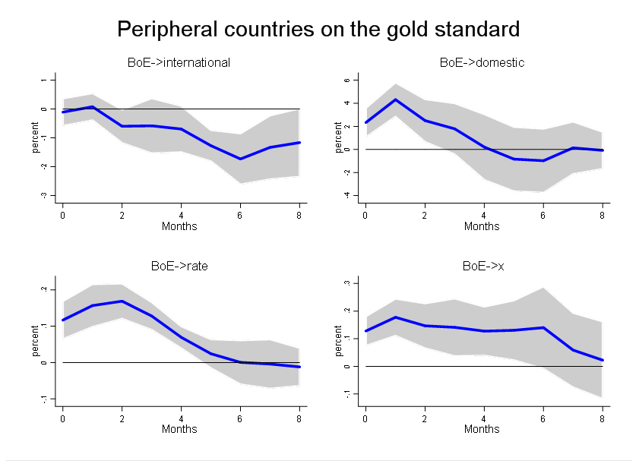

Figure A-10. The reaction of central banks in gold standard peripheral countries to an English discount rate shock of 100 basis points in the first eight months. Alternative measure based on Lennard (2018) and English control variables included.

Sources: Own calculations based on sources as described in the main text and the appendix.

Units: Percentage change compared to month t = -1 (positive exchange-rate response in lower right panel indicates depreciation).

Notes: “international” and “domestic” denote the international and domestic portfolios of central banks, “rate” is the discount rate of central banks and “x” the exchange rate on London.

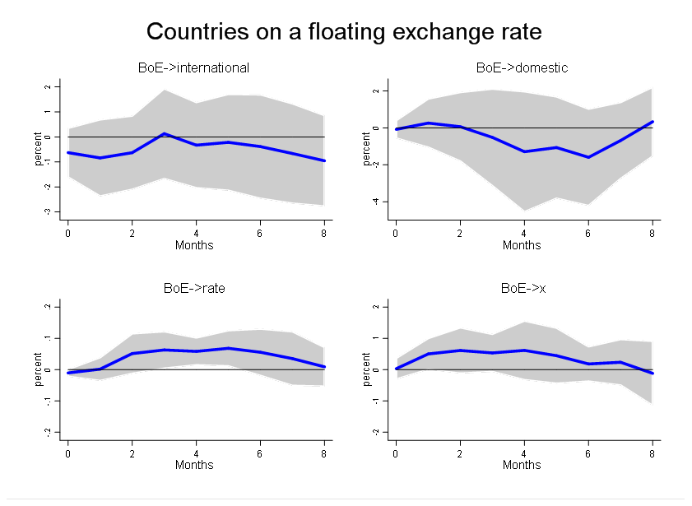

Figure A-11. The reaction of central banks in fiat standard countries to an English discount rate shock of 100 basis points in the first eight months. Alternative measure based on Lennard (2018) and English control variables included.

Sources: Own calculations based on sources as described in the main text and the appendix.

Units: Percentage change compared to month t = -1 (positive exchange-rate response in lower right panel indicates depreciation).

Notes: “international” and “domestic” denote the international and domestic portfolios of central banks, “rate” is the discount rate of central banks and “x” the exchange rate on London.

Figure A-12: Robustness checks II

Figure A-12 complements figure 6 in the main text. Figure 6 shows a robustness check for the U.S. based on Lennard (2018). Figure A-12 complements figure 6 by showing a robustness check based on Green (2018). The results remain qualitatively unchanged.



Figure A-12. The reaction of the U.S. monetary system to an English discount rate shock of 100 basis points in the first eight months. Alternative measure based on GREEN (2018) as discussed in this section.

Sources: Own calculations based on sources as described in the main text and the appendix.

Units: Percentage change compared to month t = -1 (positive exchange-rate response in lower right panel indicates depreciation).

Notes: “international” denotes the gold reserves of the U.S. Treasury, “rate” is the commercial paper rate in New York and “x” the exchange rate in New York on London.

Figures A-13, A-14, A-15, A-16: RESULTS BASED ON MONTHLY FIXED EFFECTS INSTEAD OF TIME TREND

Figures A-13, A-14, A-15 and A-16 complement figures 1, 2, 3 and 4 in the main text. Our baseline results are based on a time trend. By contrast, figures A-13, A-14, A-15 and A-16 are based on monthly fixed effects. The results remain qualitatively unchanged.



Figure A-13. The reaction of central banks in gold standard core countries to an English discount rate shock of 100 basis points in the first eight months.

Sources: Own calculations based on sources as described in the main text and the appendix.

Units: Percentage change compared to month t = -1 (positive exchange-rate response in lower right panel indicates depreciation).

Notes: “international” and “domestic” denote the international and domestic portfolios of central banks, “rate” is the discount rate of central banks and “x” the exchange rate on London.



Figure A-14 The reaction of central banks in gold standard peripheral countries to an English discount rate shock of 100 basis points in the first eight months.

Sources: Own calculations based on sources as described in the main text and the appendix.

Units: Percentage change compared to month t = -1 (positive exchange-rate response in lower right panel indicates depreciation).

Notes: “international” and “domestic” denote the international and domestic portfolios of central banks, “rate” is the discount rate of central banks and “x” the exchange rate on London.



Figure A-15. The reaction of central banks in fiat standard countries to an English discount rate shock of 100 basis points in the first eight months.

Sources: Own calculations based on sources as described in the main text and the appendix.

Units: Percentage change compared to month t = -1 (positive exchange-rate response in lower right panel indicates depreciation).

Notes: “international” and “domestic” denote the international and domestic portfolios of central banks, “rate” is the discount rate of central banks and “x” the exchange rate on London.



figure a-16. The reaction of the U.S. monetary system to an English discount rate shock of 100 basis points in the first eight months.

Sources: Own calculations based on sources as described in the main text and the appendix.

Units: Percentage change compared to month t = -1 (positive exchange-rate response in lower right panel indicates depreciation).

Notes: “international” denotes the gold reserves of the U.S. Treasury, “rate” is the commercial paper rate in New York and “x” the exchange rate in New York on London.