Online Appendices

A Model details
We focus on characterizing the following perfect Bayesian equilibrium of the above game. The gentry will recommend $\hat{a}=1$ when observing message $m=1$, or message $m=0$, but the additional utility $x$ exceeds a threshold $\overline{x}$. Intuitively, when observing message $m=1$, the gentry believes that the state is more likely to equal 1. Since $v\left(a=1,ω=1\right)=1>v\left(a=0,ω=1\right)=0$, $\hat{a}=1$ is recommended. In contrast, when observing message $m=0$, although the gentry believes that the state is more likely to equal 0, she still recommends $\hat{a}=1$ so long as the additional utility from surcharge is high enough. Fully anticipating the gentry’s strategy, the commoner adopts the following strategy: when the gentry recommends $\hat{a}=1$, the commoner will make a protest if he observes a sufficiently low signal $s<s_{1}$ and hence believes that state $ω=$0 is very likely; when the gentry recommends $\hat{a}=0$, the commoner will make a protest if he observes a sufficiently high signal $s>s_{0}$ and hence believes that state $ω=$1 is very likely. So, the characterisation of the equilibrium involves solving the three cut-offs: $\overline{x}$, $s_{0}$, and $s_{1}$.
We follow the standard procedure to solve the equilibrium cut-offs. First of all, given the gentry’s strategy, we can calculate the commoner’s posterior belief about $ω=1$ when observing message $s$ and recommended action $\hat{a}$ using Bayes rule:
- $ρ\left(s,\hat{a}=0\right)≜\operatorname{Pr}\left(ω=1 | s,\hat{a}=0\right)=\frac{\left(1-π\right)l\left(s\right)}{\left(1-π\right)l\left(s\right)+π};$
- $ρ\left(s,\hat{a}=1\right)≜\operatorname{Pr}\left(ω=1 | s,\hat{a}=1\right)=\frac{\left[\left(1-π\right)(1-\overline{x})+π\right]l\left(s\right)}{\left[\left(1-π\right)(1-\overline{x})+π\right]l\left(s\right)+1-π+π(1-\overline{x})},$
where $l\left(s\right)=\frac{f^{1}(s)}{f^{0}(s)}=e^{\frac{2s-1}{2σ^{2}}}$ is the likelihood ratio with $f^{ω}\left(s\right)=\frac{e^{-\frac{{(s-ω)}^{2}}{2σ^{2}}}}{\sqrt{2πσ^{2}}}$. Notice that the monotone likelihood ratio property is satisfied as $l\left(s\right)$ is strictly increasing in $s$.
Based on the gentry’s strategy, the commoner knows $m=0$ for sure when the gentry recommends $\hat{a}=0$, and hence the belief about $ω=1$ is $1-π$. This belief together with the message $s$ observed by the commoner will induce posterior belief $ρ\left(s,\hat{a}=0\right)$ defined by Equation (1). When the gentry recommends $\hat{a}=1,$the commoner believes that $ω=1$ occurs with probability $\frac{\left(1-π\right)(1-\overline{x})+π}{2-\overline{x}}<π$ because the gentry may recommend $\hat{a}=1$ when $m=0$ and $x>\overline{x}$. We can immediately derive Equation (2) using this updated belief.
When the gentry recommends $\hat{a}=0$, the commoner decides to make a protest if and only if:
$$θρ\left(s,\hat{a}=0\right)+\left(1-θ\right)\left(1-ρ\left(s,\hat{a}=0\right)\right)-c≥1-ρ\left(s,\hat{a}=0\right).$$
Without a protest, $\hat{a}=0$ is the final action and the commoner’s expected utility is the probability of $ω=$0, $1-ρ\left(s,\hat{a}=0\right)$. If the commoner pays a cost $c$ to make a protest and the protest succeeds with probability $θ,$ the expected net utility is $θρ\left(s,\hat{a}=0\right)+\left(1-θ\right)\left(1-ρ\left(s,\hat{a}=0\right)\right)-c$. Therefore, the commoner will make a protest if and only if $ρ\left(s,\hat{a}=0\right)≥\frac{θ-c}{2θ}>0$. Using Equation (1), we can derive the cutoff $s_{0}$ to satisfy:
- $l\left(s_{0}\right)=\frac{π}{1-π}×\frac{θ+c}{θ-c}.$
Similarly, we can solve $s_{1}$ to satisfy:
- $l\left(s_{1}\right)=\frac{1-π+π(1-\overline{x})}{\left(1-π\right)(1-\overline{x})+π}×\frac{θ+c}{θ-c}.$
Finally, at $\overline{x}$, the gentry is indifferent between recommending $\hat{a}=0$ and $\hat{a}=1$. This implies:
- $Ξ_{1}(\overline{x},s_{0})=Ξ_{2}(\overline{x},s_{1})$,
where
$Ξ_{1}\left(\overline{x},s_{0}\right)=πF_{0}\left(s_{0}\right)+π\left(1-θ\right)\left(1-F_{0}\left(s_{0}\right)\right)+θ\left(1-π\right)\left(1-F_{1}\left(s_{0}\right)\right)+θπ\left(1-F_{0}\left(s_{0}\right)\right)\overline{x}-θ[π\left(1-F_{0}\left(s_{0}\right)\right)+\left(1-π\right)\left(1-F_{1}\left(s_{0}\right)\right)](y+β$Z)
and
$Ξ_{2}\left(\overline{x},s_{1}\right)=\left(1-π\right)F_{1}\left(s_{1}\right)+\left(1-π\right)\left(1-θ\right)\left(1-F_{1}\left(s_{1}\right)\right)+θπF_{0}\left(s_{1}\right)+[πF_{0}\left(s_{1}\right)+π\left(1-θ\right)\left(1-F_{0}\left(s_{1}\right)\right)]\overline{x}-θ[πF_{0}\left(s_{1}\right)+\left(1-π\right)F_{1}\left(s_{1}\right)](y+β$Z).
Equations (3)-(5) constitute a system of equations about three unknowns: $\overline{x}$, $s_{0}$, and $s_{1}$. After plugging Equation (3) and (4) into Equation (5), we obtain an equation about $\overline{x}$. We can numerically solve this equation and Figure A1.1 plots how POUM $β$ affects $\overline{x}$. It is not surprising to see that $\overline{x}$ is positively associated with $β$. This reflects the deterrence effect of future career concerns. A higher $β$ implies a higher loss to the gentry when there is a successful protest. As a result, the gentry will avoid protest by increasing $\overline{x}$, which implies that the gentry is less likely to recommend $\hat{a}=1$ when receiving message $m=0$.

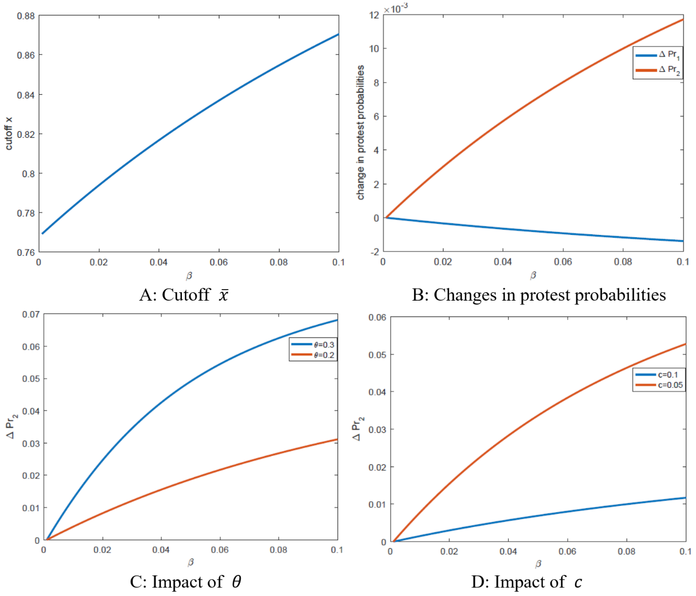
Figure A1. Model simulations.

Figure A1.2 plots the changes in the probability of protest after the abolition of the civil service exam as a function of $β$. The abolition of the civil exam reduces $β$ to zero and hence affects both $\overline{x}$ and the probability of protest. This figure plots the difference of protest probability before and after the civil exam abolition. We differentiate two different protests: the first is the protest when the gentry recommends $\hat{a}=0$ (i.e., protest over doing nothing); while the second is the protest when the gentry recommends $\hat{a}=1$ (i.e., protest over surcharge). We use $∆{Pr}_{1}$ (resp. $∆{Pr}_{2}$) to denote the change in the probability of the first (resp. second) protest. It is interesting to note that changes in POUM $β$ have opposite effects on $∆{Pr}_{1}$ and $∆{Pr}_{2}$.
First of all, Figure A1.2 shows that $∆{Pr}_{1}<0$ is decreasing in $β$ while $∆{Pr}_{2}>0$ is increasing in $β$. Intuitively, as seen from Figure 6.1, the civil exam abolition will lead to a lower $\overline{x}$: when receiving message $m=0$, the gentry is less likely to recommend $\hat{a}=0$ and more likely to recommend $\hat{a}=1$. As a result, the probability of the first protest decreases after the abolition and is decreasing in $β$ (as a higher $β$ leads to a larger reduction of $\overline{x}$), while the probability of the second protest increases after the abolition and is increasing in $β$.
Secondly, the magnitudes of $∆{Pr}_{1}$ and $∆{Pr}_{2}$ are also very different. This is because the commoner’s cutoff for the first protest, $s_{0}$, does not change with $\overline{x}$, as seen from Equation (3). So, the change in $∆{Pr}_{1}$ is purely driven by the fact that the gentry is less likely to recommend $\hat{a}=0$. In contrast, the commoner’s cutoff for the second protest, $s_{1}$, changes with $\overline{x}$. As $\overline{x}$ decreases, the commoners are also more likely to make a protest when observing $\hat{a}=1$. This makes $∆{Pr}_{2}$ much more significant in magnitude than $∆{Pr}_{1}$. This also justifies our empirical investigation of the second protest.
In the following figures, we focus on the second protest and plot how $∆{Pr}_{2}$ changes with $β$ under different parameter values. Figure A1.3 shows that as the probability of having a successful protest$θ$ increases, the effect of the civil exam abolition on the increase of surcharge protest probability becomes larger. Figure A1.4 shows that as the cost of protest$c$ decreases, the effect of the civil exam abolition on the increase of surcharge protest probability becomes larger. We relate the parameter $θ$ to state monitory capacity. With greater state monitory capacity, the state becomes more likely to conceive and punish the local elite’s corruption when a protest occurred, which means a protest is more likely to be successful. We relate the parameter $c$ to costs of collective actions. With lower costs of collective actions, the commoner is more likely to protest when the gentry recommends $\hat{a}=1$.
We have demonstrated that under exam system the expected loss for the local elite to corrupt (i.e., to collect surtax when it was not needed) is a product of the likelihood of protest, the likelihood of protest being successful, the prospect upward mobility for the lower gentry, and the future rents from being an upper gentry. Three things follow, as elaborated in Corollary 1-3.
A straightforward extension of our model is to include an outside option yielding utility $\overline{V}$, which could be interpreted as utility gained from taking other professions other than being a gentry. A gentry will participate in local public goods provision only when the resulting expected utility is higher than $\overline{V}$, or equivalently when the additional utility $x$ exceeds another threshold $\underline{x}$. This participation constraint implies that the support of $x$ changes from the interval $[0,1]$ to the interval $[\underline{x},1]$. As a result, Equation (4) changes to:
- $l\left(s_{1}\right)=\frac{1-π+π\frac{1-\overline{x}}{1-\underline{x}}}{\left(1-π\right)\frac{1-\overline{x}}{1-\underline{x}}+π}×\frac{θ+c}{θ-c}.$
Due to the civil service exam abolition, the expected utility from being a gentry decreases by $β$Z, and hence the cut-off $\underline{x}$ has to increase to satisfy the participation constraint. Since the right-hand-side of Equation (6) is increasing in $\underline{x}$, this ultimately implies that $s_{1}$ will increase after the civil service exam abolition. Hence, the commoners were more likely to protest against surcharges. The above discussions ultimately imply another selection effect of POUM, as is elaborated in corollary 4.

B Who engaged in public service after 1905?
We have established that there was a greater number of modern school students per capita after 1905 in areas with a higher POUM. In this section, using hand-collected micro-data on elected officials from the Suzhou prefecture in 1909, we establish that those elites who stayed in rural areas and engaged themselves in local public services (including new comers) were more likely to come from families with lower social and economic status.
We constructed a micro dataset on the electorate of a prefecture, combined with surname-level data, to determine whether those who stayed in rural areas providing local public service were on average less likely to come from high family backgrounds. The data came from a first-hand document recording 1600 people who were eligible to vote from the Suzhou prefecture in 1909. The Suzhou prefecture was recognized as the most prosperous area of China and the role model of local autonomy. The list reports individual surname, age, residence, and eligibility to vote. One might be eligible to vote if he obtained an exam degree, had wealth greater than 5000 silver dollars, or had participated in gentry service. The list only reports one item as eligibility. 300 people (20%) among all the electors were rural gentry directors. In addition, we construct four kinship/surname-specific variables indicating kinship backgrounds of the voter:
$${rr_degree}_{i}=\frac{{share in exam title holders}_{i}}{{population share}_{i}}$$
$${rr_rich}_{i}=\frac{{share in people with asset}_{i}}{{population share}_{i}}$$
$${rr_chaste}_{i}=\frac{{share in chaste women}_{i}}{{population share}_{i}}$$
$${rr_college}_{i}=\frac{{share in college student}_{i}}{{population share}_{i}}$$
where the population shares of surnames were derived from a name list of people who died in the Taiping Rebellion in 1851–1865. Records indicate that 8000 people across all social classes died in the Wu county, thereby providing us a good estimate of historical surname distribution. Essentially, these variables measure to what extent a kinship, relative to the average population, was more successfully producing exam degree holders, rich people, chaste women, and college students. This data was calculated from various name lists of notable people of the Wu county in the period 1645–1911.
In Table B1, we conduct a logistic cross-sectional regression exploring what affects the likelihood of local gentry being in public service. The dependent variable is a dummy variable that equals 1 if the elector serves as a gentry director, namely the representative of lowest level councils (a village or town). The repressors include dummies of age, residence, and four kinship/surname-specific variables indicating kinship background of the elector. In columns (1) and (2), we find that an elector was less likely to serve as a gentry director if he was younger, and if he resided in urban area. More importantly, an elected individual was less likely to serve as a gentry director if he came from a kinship with greater wealth and human capital. In column (3), we only include those elected individuals under the age of 30 and find similar but greater magnitude of results. In column (4), we only include those electors whose surname frequency was less than 100 among the sample of people who died in the Taiping rebellion. Thus, we exclude elected individuals with common surnames, many of whom were immigrants (Hao and Xue 2017).
Table B1. The determinants of doing public service in Wu County, 1909
Whether a voter was a gentry service director
(Logistic regression)
 | (1)  Baseline | (2)  Robust error | (3)  Age<30 | (4)  Sample population<100
age | 0.0212*** | 0.0212*** | 0.0789 | 0.0269***
 | (0.00624) | (0.00605) | (-0.144) | (0.00791)
urban | -2.961*** | -2.961*** | -2.913*** | -2.865***
 | (0.231) | (0.229) | (0.817) | (0.287)
rr_degree | -0.278*** | -0.278*** | -0.460* | -0.282***
 | (0.104) | (0.102) | (0.277) | (0.107)
rr_rich | -0.185** | -0.185* | -1.472*** | -0.188*
 | (0.0938) | (0.0999) | (0.556) | (0.107)
rr_chaste | -0.0317 | -0.0317 | 0.121 | -0.0428
 | (0.0848) | (0.0758) | (0.164) | (0.0771)
rr_college | 0.0523 | 0.0523 | 0.360* | 0.0654
 | (0.0978) | (0.0966) | (0.205) | (0.0994)
Observations | 1,604 | 1,604 | 261 | 1,013
Notes: Robust standard errors in parentheses. ***, **, * represent significance at the 1%, 5%, and 10% levels.
we construct four kinship/surname-specific variables indicating kinship backgrounds of the vote: ${{rr}_{degree}}_{i}=\frac{{share in exam title holders}_{i}}{{population share}_{i}}, {{rr}_{rich}}_{i}=\frac{{share in people with asset}_{i}}{{population share}_{i}}, {{rr}_{chaste}}_{i}=\frac{{share in chaste women}_{i}}{{population share}_{i}}$,${ rr_college}_{i}=\frac{{share in college student}_{i}}{{population share}_{i}}$, where the population share of surnames was derived from a name list of people who died in the Taiping Rebellion from 1851–1865.

C Other competing stories
State extraction. Our result could be driven by the increasing state extraction from commoners instead of the deterioration of local governance. As the Qing government tried to collect more taxes and surcharges to finance huge war reparations and modernization initiatives, the bulk of tax burden was undertaken by the tenants and small landowners. Consequently “class struggle” assumed between commoners and local elites, many of whom were large landowners and tax farmers (Skocpol 1979). Commoners might protest against the gentry to simply express their dissatisfaction over excessive tax rates and rent rates, even though the incentive and selection of local public agents remained intact. To check whether our results are driven by state extraction, we use two proxies of state extraction: provincial level fiscal revenue in 1908 and the number of commercial tax (lijin) bureaus. We add the interaction between the proxies and post dummy to our baseline specification. As shown in columns (1) and (2) of Online Appendix Table C1, the effects of the POUM remain similar.
Lower gentry’s authority. One might also argue that the POUM of local elites might also positively correlate with their authority, affecting the extent to which commoners respect gentries and treat them with obedience. With a decline in the lower’s gentry authority after the exam, abolition commoners were more likely to protest against quasi-taxes. We use two proxies for this confounder. First, we directly measure lower gentries’ authority using the number of provincial assembly members with a lower gentry background from a prefecture. In 1909, all provincial assembly members were elected by qualified electorates at the local level (Chang 1969). Upper gentry accounted for 36% of provincial assembly members, while lower gentry accounted for 54%. Hence, the number of lower gentry members who were elected as provincial assembly members should positively correlate with their authority at the local level. Second, we measure lower gentry authority using the number of incumbent governmental officials from a prefecture (with place of origin) in 1905. Before the abolition of the civil exam, local elites had the authority to impose quasi-taxes because they had the ability to bargain with the state over local interests (Fei 1946). One source of this ability consisted of their political connections with incumbent officials sharing the same hometowns. Losing the exam titles and the possibility of entering the upper gentry, they no longer benefited from such connections. Columns (3) and (4) of Online Appendix Table C1 report the results after controlling for both measures of lower gentry authority. Our key results remain similar.
Trade openness. Our result could also be driven by the “absentee landlord” fueled by the forced open of the treaty ports. These institutional enclaves attracted local elites in the neighborhood to explore the new opportunities in international trade and modern industry (Brandt et al. 2014, Esherick 1981). At the same time, they left rural public services to the rent seekers, leading to the deterioration of local governance (Huang 1995). The endogeneity problem arises if such phenomenon was more salient in the area with a larger POUM after 1905. We explore this alternative explanation by adding the dummy of treaty ports and the distance to the nearest treaty ports interacted with the post-dummy. The results are shown in columns (5) and (6) of Online Appendix Table C1. The main effect of the POUM remains positive and significant, implying that trade openness does not drive our key result.

Table C1. Other competing stories
 | Anti-elite protests
VARIABLES | (1) | (2) | (3) | (4) | (5) | (6)
POUM × Post | 0.141*** | 0.104*** | 0.097*** | 0.132*** | 0.127*** | 0.123***
 | (0.038) | (0.034) | (0.034) | (0.045) | (0.037) | (0.037)
ln (Fiscal revenue per capita) | 0.322***
× Post | (0.091)
Commercial tax bureaus |  | 0.027*
× Post |  | (0.015)
Governmental officials |  |  | 0.002
× Post |  |  | (0.002)
Lower gentry in provincial assembly |  |  |  | 0.007
× Post |  |  |  | (0.016)
Treaty port |  |  |  |  | 0.140
× Post |  |  |  |  | (0.151)
Distance to the nearest treaty port |  |  |  |  |  | -0.035
× Post |  |  |  |  |  | (0.028)
Prefecture FE | Y | Y | Y | Y | Y | Y
Other controls × Post | Y | Y | Y | Y | Y | Y
Year FE | Y
Province × Year FE |  | Y | Y | Y | Y | Y
Observations | 2,620 | 2,620 | 2,620 | 2,260 | 2,620 | 2,620
R-squared | 0.346 | 0.501 | 0.501 | 0.504 | 0.500 | 0.501
Notes: This table reports the results examining other competing stories in Alternative Explanations Section. Robust standard errors in parentheses are clustered at the prefecture-level. ***, **, * represent significance at the 1%, 5%, and 10% levels. Other controls include dummy variables for proximity to coast and main river, urbanization classifications, and rice and sweet potato suitability.

D Supplementary figures and tables
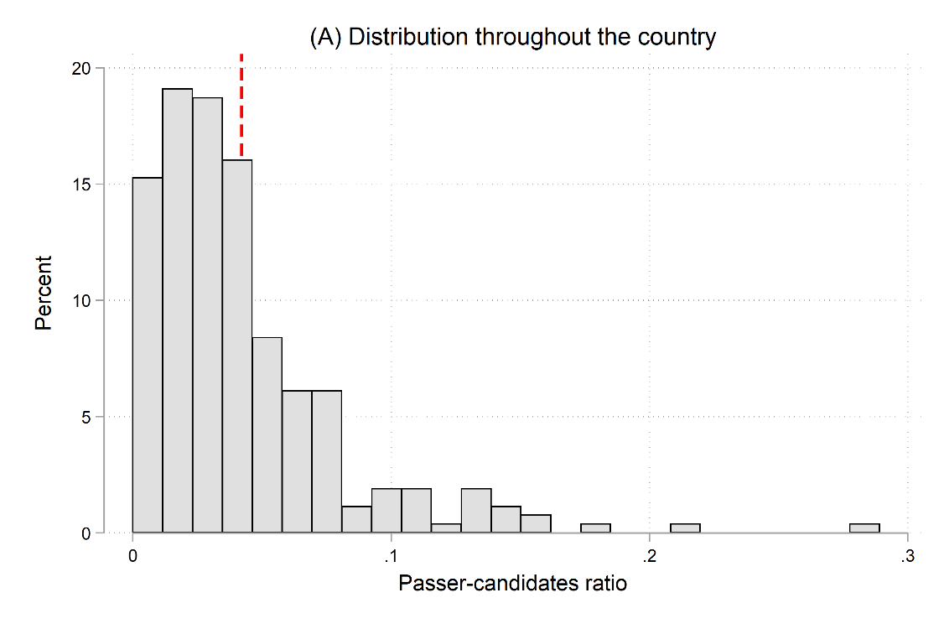
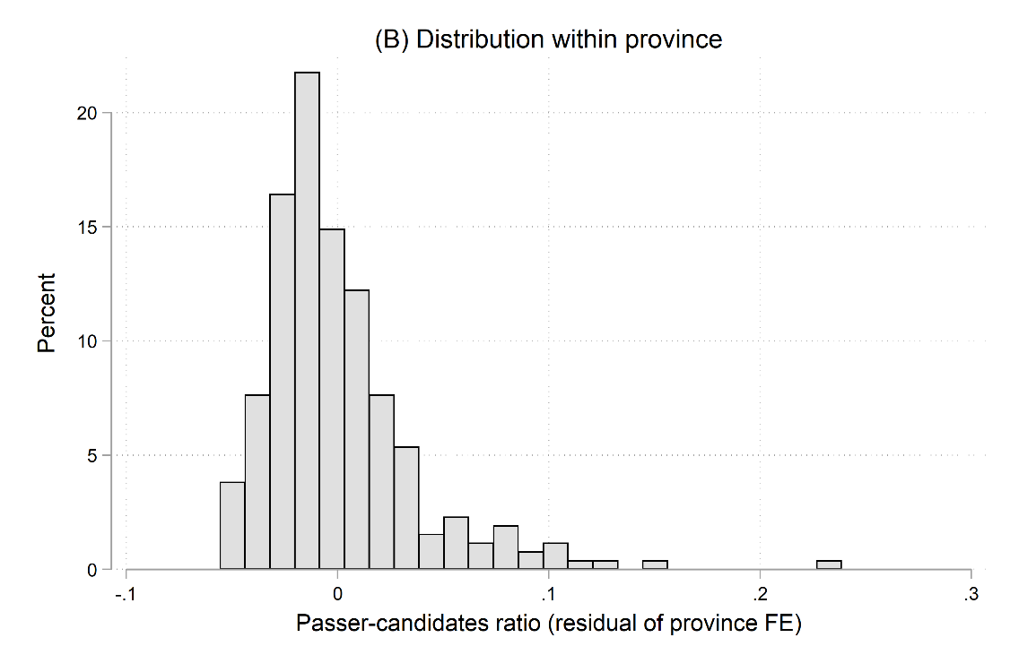
Figure D1. Distribution of the passer-candidates ratio
Notes: This figure presents a histogram showing the distribution of passer-candidates ratio across prefectures in the 13 provincial exams held from 1875–1905. Panel A uses the raw data and Panel B uses the residuals from regressing the passer-candidates ratio on province fixed effects. The vertical dashed line in Panel A corresponds to the mean of the passer-candidates ratio.

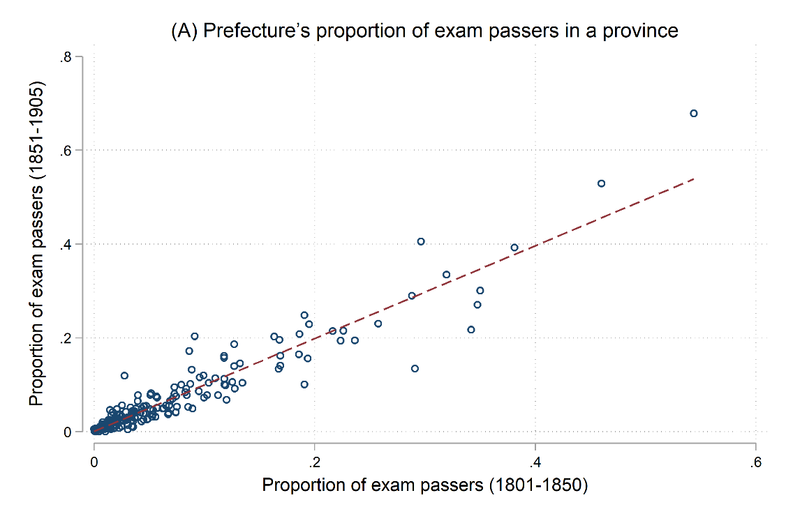
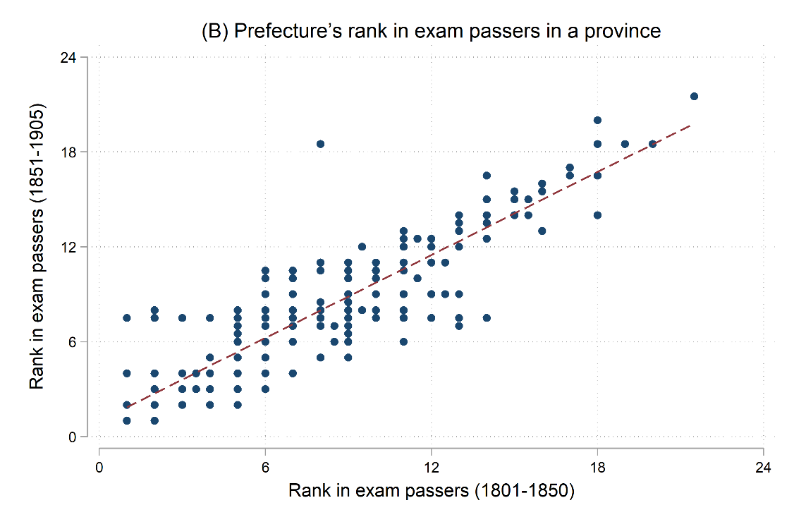
Figure D2. The Persistence of relative exam success within the province
Notes: Panel A plots prefecture’s exam passers (Juren) as the proportion of total exam passers in a province in 1851–1905 against that in 1801–1850. Panel B plots the prefecture’s rank in the number of exam passers in a province in 1851–1905 against that in 1801–1850.

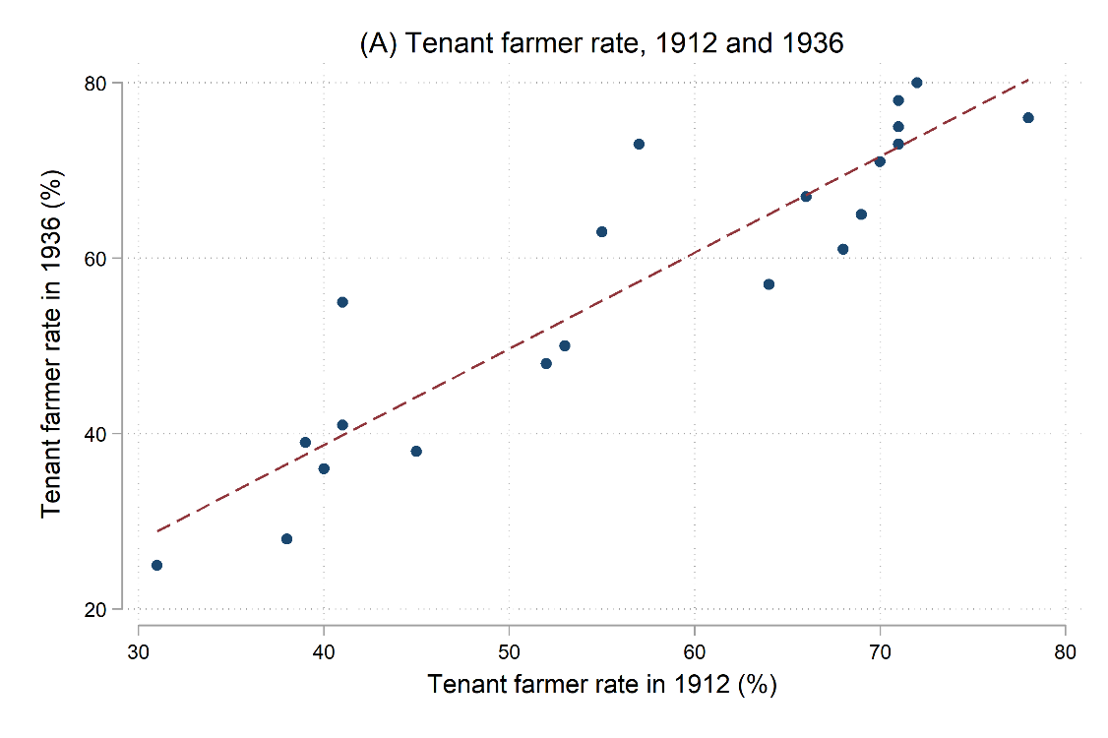
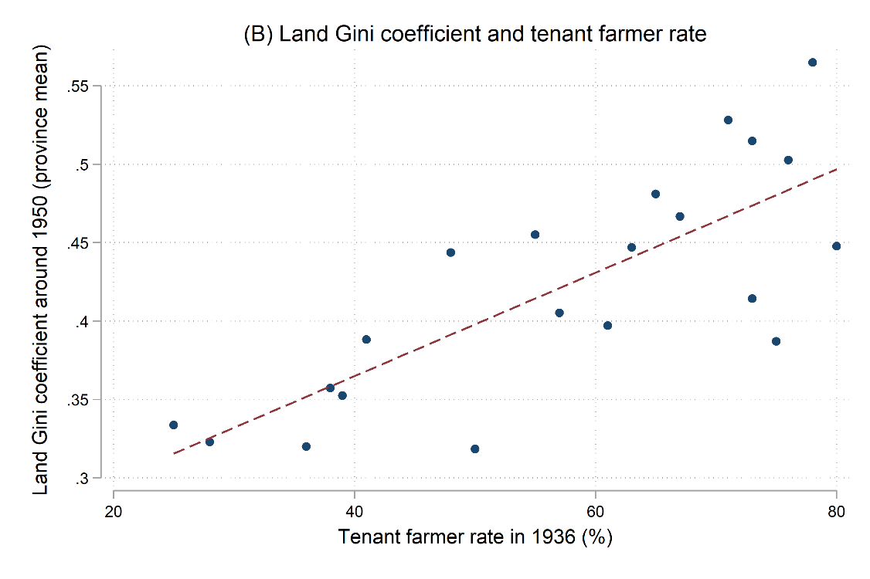
Figure D3. The correlation among land inequality in 1912, 1936, and 1950
Notes: Panel A plots the provincial level tenant farmer rate in 1936 against that in 1912, using data from Statistics Bureau of Republic China (1942). Panel B plots the provincial average land Gini coefficient around 1950 against the tenant farmer rate in 1936. Data on land Gini coefficient are from Pang, Xu and Guan (2021).

Table D2. Summary Statistics and Data Sources
Variable definition | Source | Observation | Mean | S.D.
A. Protest type
Anti-elite Protest | A | 2,620 | 0.236 | 0.828
School destroying | B | 2,096 | 0.0802 | 0.419
Anti-church protest | A | 2,620 | 0.0347 | 0.210
Anti-government rebellion | A | 2,620 | 0.0523 | 0.292
Gang rebellion | C | 2,620 | 0.0546 | 0.317
B. Measures of exam
# Quotas | D | 262 | 113.8 | 75.73
# Juren after 1875 | E | 262 | 74.71 | 105.5
Passers-candidates ratio | D, E | 262 | 0.042 | 0.038
POUM (ln Passers-candidates ratio) | D, E | 262 | -0.879 | 0.838
C. Prefecture characteristics
Treaty port | D | 262 | 0.115 | 0.319
Coast region | D | 262 | 0.134 | 0.341
Small city | F | 262 | 0.198 | 0.400
Middle city | F | 262 | 0.122 | 0.328
Large city | F | 262 | 0.0382 | 0.192
Sweet potato suitability | G | 262 | 2.622 | 0.991
Rice suitability | G | 262 | 1.991 | 1.075
Weather shocks | H | 2,620 | 0.129 | 0.335
D. Selection proxies
Military students per capita | I | 1,310 | 0.976 | 2.668
Secondary school student (per 10,000) | J | 262 | 0.584 | 1.335
Source: A: Zhang and Ding (1980); B: Tian and Chen (2009); C: Liu (1992); D: Bai and Jia (2016); E: local gazetteers; F: Rozman (1973); G: Food and Agriculture Organization; H: State Meteorological Society (1981); I: Chen (2006); and J: The Ministry of Education of the Qing.

Table D3. Persistence of relative exam success within the province
 | Passers proportion (1851–1905)
 | (1) | (2) | (3) | (4)
Passers proportion (1801–1850) | 0.989***
 | (0.0657)
Passers proportion (1751–1800) |  | 0.980***
 |  | (0.0974)
Passers proportion (1701–1750) |  |  | 0.902***
 |  |  | (0.111)
Passers proportion (1645–1700) |  |  |  | 0.906***
 |  |  |  | (0.107)
Province FE | Y | Y | Y | Y
Observations | 197 | 181 | 181 | 181
R-squared | 0.892 | 0.784 | 0.658 | 0.608
Notes: This table shows the prefecture’s exam passers (Juren) as the proportion of all exam passers in a province remained stable over a long period. Robust standard errors in parentheses. ***, **, * represent significance at the 1%, 5%, and 10% levels.

Table D4. The Effect of POUM on anti-elite protests: alternative measure
 | Anti-elite protests
 | (1) | (2) | (3) | (4) | (5)
ln (Jinshi/Shengyuan) × Post | 0.193*** | 0.194*** | 0.165*** | 0.129*** | 0.145***
 | (0.056) | (0.056) | (0.044) | (0.047) | (0.048)
Weather shock |  | -0.051 | -0.037 | -0.012 | -0.010
 |  | (0.034) | (0.034) | (0.045) | (0.045)
Prefecture FE | Y | Y | Y | Y | Y
Year FE | Y | Y | Y
Province-specific trend |  |  | Y
Province × Year FE |  |  |  | Y | Y
Other controls × Post |  |  |  |  | Y
Observations | 2,620 | 2,620 | 2,620 | 2,620 | 2,620
R-squared | 0.334 | 0.334 | 0.379 | 0.499 | 0.501
Notes: This table reports the results using the alternative measure of POUM. Robust standard errors in parentheses are clustered at the prefecture-level. ***, **, * represent significance at the 1%, 5%, and 10% levels. Other controls include dummy variables for proximity to coast and main river, urbanization classifications, and rice and sweet potato suitability.

Table D5. Robustness: more controls
 | Anti-elite protests
 | (1) | (2) | (3) | (4) | (5)
POUM× Post | 0.138*** | 0.127*** | 0.126*** | 0.125*** | 0.146**
 | (0.040) | (0.037) | (0.038) | (0.037) | (0.057)
Revolutionaries× Post | -0.003
 | (0.004)
Fragmentation index × Post |  | 0.577
 |  | (0.853)
Polarization index × Post |  | -0.302
 |  | (0.489)
Land tax per capita × Post |  |  | 0.059
 |  |  | (0.344)
Grain price |  |  |  |  | 0.001
 |  |  |  |  | (0.001)
Political importance indicators |  |  |  | Y
Prefecture FE | Y | Y | Y | Y | Y
Province × Year FE | Y | Y | Y | Y | Y
Other controls × Post | Y | Y | Y | Y | Y
Observations | 2,620 | 2,620 | 2,610 | 2,620 | 1,694
Notes: Robust standard errors in parentheses are clustered at the prefecture level. ***, **, and * represent significance at the 1%, 5%, and 10% levels. Political importance indicators are four dummies indicating whether the prefecture is important in transportation, important in business, difficult to tax and has high crime. Other controls include dummy variables for proximity to coast and main river, urbanization classifications, and rice and sweet potato suitability.

Table D6. The upward prospect for other segments in the exam hierarchy
 | Anti-elite protests
 | (1) | (2) | (3)
ln (Quota/Population) × Post | 0.068
 | (0.052)
ln (Jinshi/Juren) × Post |  | 0.050
 |  | (0.064)
ln (Official/Jinshi) × Post |  |  | -0.003
 |  |  | (0.039)
Prefecture FE | Y | Y | Y
Province × Year FE | Y | Y | Y
Other controls × Post | Y | Y | Y
R-squared | 0.498 | 0.497 | 0.496
Observations | 2,620 | 2,580 | 2,540
Notes: This table reports the results examining the upward prospect of other segments in the exam hierarchy. Robust standard errors in parentheses are clustered at the prefecture-level. ***, **, * represent significance at the 1%, 5%, and 10% levels. Other controls include dummy variables for proximity to coast and main river, urbanization classifications, and rice and sweet potato suitability.

