Online Appendix
Atsushi Kobayashi
Appendix I: Spread of indirect exchange rates against direct rates
First, we explain how to compute the indirect exchange rates. The indirect exchange rates are expressed as a combination of direct exchange rates. For the remittance from India to the UK via China, exchange rate of pound per rupee (combination of arrows (3) and (4) in Figure 4) is expressed as $X_{H}^{I}X_{L}^{H}$. For the remittance from the UK to China via India, dollar per pound (combination of arrows (1) and (3) in Figure 6) is $X_{I}^{L}X_{H}^{I}$. For the remittance from China to India via the UK, rupee per dollar (combination of arrows (4) and (5) in Figure 5) is $X_{L}^{H}X_{I}^{L}$. All series of direct exchange rates were converted into spot rates. To compute the indirect exchange rates, we multiplied the two spot exchange rates at the same month, except for $X_{L}^{H}X_{I}^{L}$. As for the exception, because the bills on London drawn in Hong Kong were discounted in Indian cities one month later (transport duration, see Appendix III, Interest loss), we multiplied the current rate of $X_{L}^{H}$in Hong Kong by the next month’s rate of $X_{I}^{L}$ that was converted from six months into five months sight by UK’s annual interest rate (five percent). The spread of indirect exchange rates against direct rates between London and Hong Kong is defined as $S_{L}^{H}=\left(\left(1/\left(X_{I}^{L}X_{H}^{I}\right)\right)/X_{L}^{H}\right)-1$. The spread of other indirect exchange rates are defined as $S_{H}^{I}$ and $S_{I}^{L}$ in the same way. The series of spreads are shown in Appendix Figure 1.

Appendix II: Defining the triangular silver points
Based on the Equations (1) (2) and (3) in the main text, we devise the following equations to express the operations of indirect remittances explained in the second section and Appendix I.
$\left(1-c_{s}^{LI}\right)\frac{p_{s}^{I}}{p_{s}^{L}}\left(1-c_{s}^{IH}\right)\frac{p_{s}^{H}}{p_{s}^{I}}≤X_{I}^{L}X_{H}^{I}≤\left(1+c_{s}^{IL}\right)\frac{p_{s}^{I}}{p_{s}^{L}}\left(1+c_{s}^{HI}\right)\frac{p_{s}^{H}}{p_{s}^{I}}$ (A1)
$\left(1-c_{s}^{IH}\right)\frac{p_{s}^{H}}{p_{s}^{I}}\left(1-c_{s}^{HL}\right)\frac{p_{s}^{L}}{p_{s}^{H}}≤X_{H}^{I}X_{L}^{H}≤\left(1+c_{s}^{HI}\right)\frac{p_{s}^{H}}{p_{s}^{I}}\left(1+c_{s}^{LH}\right)\frac{p_{s}^{L}}{p_{s}^{H}}$ (A2)
$\left(1-c_{s}^{HL}\right)\frac{p_{s}^{L}}{p_{s}^{H}}\left(1-c_{s}^{LI}\right)\frac{p_{s}^{I}}{p_{s}^{L}}≤X_{L}^{H}X_{I}^{L}≤\left(1+c_{s}^{LH}\right)\frac{p_{s}^{L}}{p_{s}^{H}}\left(1+c_{s}^{IL}\right)\frac{p_{s}^{I}}{p_{s}^{L}}$ (A3)
The Equation (A1) expresses the silver points mechanism in Hong Kong with London via Indian cities. This inequality defines the silver import points as a combination of Indian cities’ silver import points with London and Hong Kong’s silver import points with India cities. The silver export point is defined in the same way. Likewise, the Equations (A2) and (A3) are silver points in London with Indian cities via Hong Kong, and Indian cities with Hong Kong via London, respectively.
Regarding the silver point mechanism regulating the exchange rate $X_{L}^{H}$, we derive the following three inequalities from the Equations (1), (A2), and (A3) after simplifying the terms according to Table 2.
$α≤X_{L}^{H}≤β$ (A4)
$α\left(f/X_{H}^{I}\right)≤X_{L}^{H}≤β\left(j/X_{H}^{I}\right)$ (A5)
$α\left(d/X_{I}^{L}\right)≤X_{L}^{H}≤β\left(e/X_{I}^{L}\right)$ (A6)
Finally, we derive the equation of silver points for the triangular settlements in London with Hong Kong from (A4), (A5), and (A6), as shown in Equation (4) in the main text. In the same manner, we obtain the equations of the triangular silver point mechanism in Indian cities with London (A7), and in Hong Kong with Indian cities (A8).
$Max\left\{d\left(f/X_{H}^{I}\right);d\left(α/X_{L}^{H}\right);d\right\}≤X_{I}^{L}≤Min\left\{e;e\left(j/X_{H}^{I}\right);e\left(β/X_{L}^{H}\right)\right\}$ (A7)
$Max\left\{f\left(α/X_{L}^{H}\right);f\left(d/X_{I}^{L}\right);f\right\}≤X_{H}^{I}≤Min\left\{j;j\left(β/X_{L}^{H}\right);j\left(e/X_{I}^{L}\right)\right\}$ (A8)

Appendix III: Reconstructing silver points between Asian cities and London
Sources: The reconstruction of silver points relied on the monthly bullion quotes in commercial newspapers in Asian cities. In the newspapers issued in Hong Kong, the exchange rates for bills on London (six months sight), on Bengal (30 days sight), and on Bombay (30 days sight) were quoted at a monthly frequency from the 1840s. Similarly, the prices of a variety of bullions were recorded. In Calcutta, the Bengal Hurkaru published the monthly quotations of the bill of exchange on London (six months sight) and various bullions from the 1840s to August 1862. However, because the source does not report the exchange rates of the bill on London from January 1846 until April 1849, we collected these data from The Economist. In Bombay, a series of local newspapers reported the monthly rates of the bill on London (six months sight), and bullion prices from the 1840s until December 1866. In addition, we used the published data of monthly quotes for silver bar in London during the same period (Spalding 1924, p. 330; Schneider, Schwarzer, and Zellfelder 1991, p. 265-67).
Silver prices: To estimate the arbitrated pars, we extracted the unit price (per troy ounce) of silver in each market from the bullion quotations. In Hong Kong (where the currency unit was the dollar), we derived silver prices from the premium on sycee, Spanish (Carolus) dollar, and Mexican (Republican) dollar. We calculated the unit price of silver from the premium on sycee based on its average weight (1.2089 ounce), fineness (0.95), and standard value (1 sycee ingot = 1 tael = 1.39 silver dollars, King 1965, pp. 73, 82, 88; Von Glahn 2007, p. 63). Similarly, we computed the silver prices from the premium on dollars according to the standard silver contents. For the unit price of silver in Calcutta (Company’s rupee), we estimated silver price from the rupee quotations of sycee, Spanish dollar, and Mexican dollar in line with the standard silver contents. Likewise, we derived silver prices in Bombay (Company’s rupee) from the rupee quotes for sycee, Spanish dollar, and Mexican dollar according to their metallic contents. The metallic contents in ounces of each coin are as follows (Seyd 1868, pp. 290, 351, 366). A Carolus peso silver coin is 0.7857, a Mexican Republican dollar silver coin is 0.7832, and a Company’s rupee silver coin is 0.34375.
Exchange rate: Because the analysis of bullion points uses the spot prices of precious metals, we derived the spot exchange rates from the monthly exchange rates using the interest rate (Nogues-Marco 2013, p. 466). In Chinese cities, the exchange rates of bills on London (six months sight) were adjusted by Britain’s annual interest rate at 5%, and the exchange rates of bills on Calcutta and Bombay (30 days sight) were changed to the spot rates according to India’s annual interest rate at 7% (Crawfurd 1837, p. 298). In Indian cities, the exchange rates of bills on London (six months sight) were processed using Britain’s interest rate.
Freight: Because freight was the primary cost of bullion arbitrage, we set the three periodical divisions for the changing freight. The first period ranges from 1846 to 1855 because after the inauguration of the first steamship line of Peninsula and Oriental Steam Navigation in Calcutta in 1842 and in Hong Kong in 1845, a new route of bullion shipping from Europe to Asia via Alexandria in Egypt and the Red Sea was established by the early 1850s, in place of the route via the Cape of Good Hope (Harcourt 2006, pp. 67-68). Around the mid-1860s, the accurate data on arbitrage between Europe and Asia started to be available, so we set the second period from 1856 to 1865. Last, the third period covers from 1866 to 1870 for our analysis. We arrange the costs in the benchmark months, January 1846, January 1856, and January 1866 to interpolate and extrapolate the cost of each period, as the main text explains.
First, we estimated the freight between India and the UK. The bullion freight between Indian cities and London by steamship was 2% in the mid-1860s (Seyd 1868, p. 257). Hence, we applied this numbers to the freight of silver in January 1866. However, because we did not find a source of bullion freight during the 1840s and 1850s, we calculated the estimated rates based on the steamer’s general freight per ton between Bombay and London. The average freight was 1.549 pound per ton in the mid-1860s (2% for silver shipping), 3.125 pounds during the period 1845-49 (the estimate of 4.034%), and 2.531 pounds during the period 1850-59 (the estimate of 3.267%), respectively. Second, the freight of silver between Southern China and London were 2.25% in the mid-1860s (Seyd 1868, p. 257). Hence, we applied this to the freight in January 1866. Likewise, due to the lack of information on bullion freight during the 1840s and 1850s, we estimated them in the same manner as between India and the UK. Because the average freight per ton between Hong Kong and London was 2.5 pounds during the early 1860s (2.25% for silver shipping), the rates of freight were computed at 4.519% (5.021 pounds per ton) during the period 1846-49 and 3.086% (3.429 pounds per ton) during the period 1850-59. Last, since we could not find first-hand information on bullion freight between Indian and Chinese cities, we estimated it using the general freight over the 1830s-60s. In the 1830s, the freight between Canton and Bombay was five pounds per ton, and seven pounds between Canton and London, which appears to be consistent with the freight of two pounds between Bombay and London. Therefore, we computed the freight of silver between China and India using the above-mentioned rates of bullion freight between China and London and the proportion of the general freight from China (five pounds to Bombay against seven pounds to London). As a result, the silver freight became 4.034% in January 1846 and 2.204% in January 1856, not far from the actual freight of bullion between Shanghai and Indian cities, 1.5-2.5% in the mid-1850s (Harcourt 2006, p. 109).

Insurance: The insurance rates for bullion shipment between Calcutta and London were 2.58% during the early 1840s and 0.5% in the mid-1860s (Bengal Hurkaru, 05 Jan. 1840, 04 Jan. 1841, 02 Jan. 1842; Seyd 1868, p. 257). The insurance rates between Southern Chinese cities and London were 2.75% in the mid-1830s and 0.75% in the mid-1860s, and the rate between Southern Chinese cities and Indian cities was 2.5% in the mid-1830s and 0.5% in the mid-1860s (Canton General Price Current, 06 May, 07 Oct. 1834; Seyd 1868, p. 257). Due to the lack of first-hand information during the 1840s and 1850s, we interpolated those rates between the mid-1830s and mid-1860s with three periodical divisions (from the-mid 1830s to the mid-1840s, thereafter to the mid-1850s, and thereafter to the mid-1860s), for the insurance costs in January 1846 and January 1856.
Brokerage fee: When remitters sent bullion to remote cities, they employed consignees to conduct arbitrage transactions. In London, the brokerage cost of silver was 0.125% (Seyd 1868, p. 409). Regarding the brokerage in Asian cities, the Chinese tea trade with Britain charged 1-1.5% for brokerage in the mid-1830s (Williams 1856, p. 349). In Bombay, the commission for the foreign exchange was 1-1.5% in the 1830s (Crawfurd 1837, p. 291). Accordingly, we estimated a minimum 1% for the brokerage in Asian cities in the mid-1830s. Because we supposed that Asia’s brokerage gradually converged to the European standard through the economic liberalisation and improvement of communications, we set 0.5%, 0.3%, and 0.2% for the brokerage in January 1846, January 1856, and January 1866.
Assay: In Europe, assay fees amounted to 0.03% for silver (Flandreau 2004, p. 62-63). The assay fee for coining bullion at the Calcutta mint was minimum 0.24% (Williams 1856, p. 356). Presumably, the assay fee at the bazaar was more reasonable due to the business competition among assayers. Therefore, we set 0.2% on silver assay in Asian cities.
Interest loss: The arbitrage cost includes interest loss. In the mid-nineteenth century, the average annual interest rate was 5% in Britain, 7% in India, and 10-15% in China (Crawfurd 1837, p. 298; Williams 1856, p. 294). Due to such a large gap in interest, arbitragers were supposed to finance their operations at a favourable rate to derive profits from intensive price competition. Hence, we used Britain’s interest rate for the arbitrage between the UK and Asia, and India’s interest rate for the arbitrage between India and China. The bullion transport spent most of the time on arbitrage operations. The estimated durations of bullion transports by steamer are two months between India and the UK, three months between China and the UK, and one month between India and China (BPP 1850, p. 8; Morse 1926, p. 227).
Time lag: We need to consider the time lag of transactions caused by the long-term transport period. Even if merchants remitted bullion in search of arbitrage profits calculated with the bullion prices at a certain month, when the bullion arrived in another country a few months later, the quotations could deviate from the original values. To cope with the time lag, we incorporated the bullion transport durations into the calculations of arbitrated pars. To calculate the arbitrated pars for export points in London with Hong Kong, we combined the silver price in London at the current month with silver price in Hong Kong at three months later. The arbitrated pars for import points were computed using London’s silver price at the current month and Hong Kong’s price quoted at three months ago. The silver arbitrated pars in Indian cities with London (two-months lag) and in Hong Kong with Indian cities (one-month lag) were calculated in the same manner. Additionally, we incorporated the bullion transport durations into the estimates of triangular silver points too. For the concise and traceable calculations, we assumed that after the arrival of silver in a recipient country triangular silver points were estimated to judge whether to resend it to the third country. For instance, the triangular silver export points in London with Hong Kong were computed by combining the bilateral silver export point at the current month and the bilateral silver export point and the spot exchange rate in Hong Kong with Indian cities at three months later (transport duration between the UK and China), and same sort of data in Indian cities with London at four months later (additional transport duration, one month, between China and India). We conducted the same for other triangular silver points.

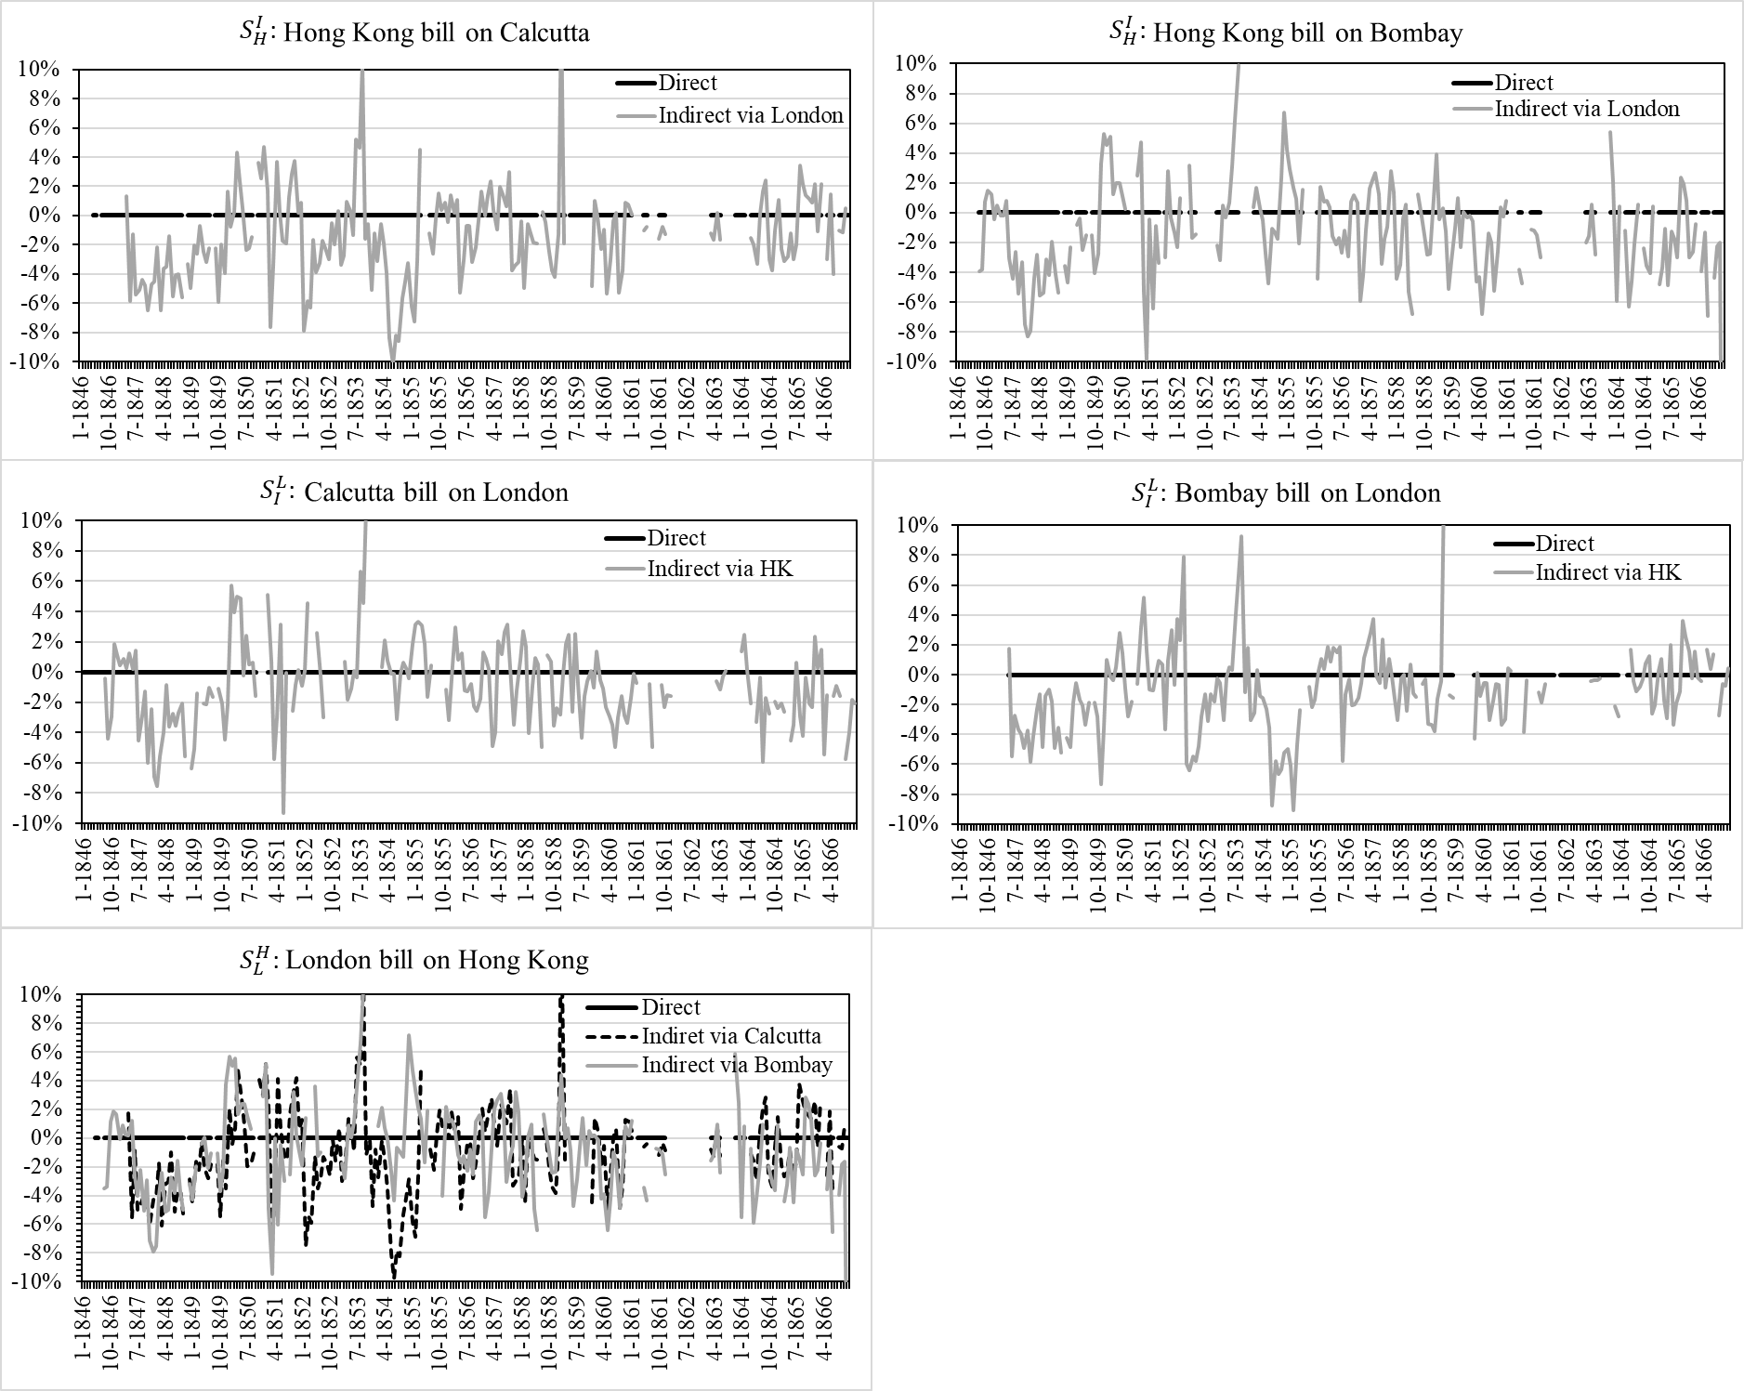
Appendix Figure 1. Spread of indirect exchange rates against direct rates in London, Hong Kong, and Indian cities, Jan. 1846-Dec. 1866.
Sources: See Table 1.

REFERENCES (unlisted in the main paper’s references)
British Parliamentary Papers (BPP). First Report from the Select Committee on the Affairs of the East India Company. (China trade), no. 644. London: UK Parliament, 1830a.
———. Steam Communication between Suez and Bombay, between Suez and Calcutta or Ceylon and Hong Kong, and with the Australian Colonies, no. 693 and no. 693-I. London: UK Parliament, 1850.
———. Abyssinia. Return of the Number and Tonnage of Transports Employed in the Abyssinian Expedition, Including Those Chartered by the Council of India, no. 71. London: UK Parliament, 1870.
Canton General Price Current. January 1834–December 1837, various dates.
Harcourt, Freda. Flagships of Imperialism: The P&O Company and the Politics of Empire from its Origins to 1867. Manchester, UK and New York, NY: Manchester University Press, 2006.
Morse, Hosea Ballou. The Chronicles of the East India Company Trading to China 1635–1834, vol. I-V. Oxford, UK: The Clarendon Press, 1926.

Hong Kong, Overland Register; China Overland Trade Report; The China Mail.
Bombay Times; Bombay Times Standard; Times of India.
The average freight in 1868 was calculated by the freight of steamers from Liverpool to Bombay for the Abyssinian expedition of 1868 obtained from BPP 1870, p. 2; the freights during the periods 1845-49 and 1850-59 were the average of freight published by Bombay Times (at the column of ‘freights’) from 1845 to 1859, excluding 1847 due to the abnormal value.
The average freight was derived from the data in the column of ‘freight’ in Hong Kong, Overland Register from 1846 to 1861, excluding 1847 due to the abnormal value.
Freight between Canton and Bombay was obtained from BPP 1830b, p. 400; freight between Bombay to the UK was obtained from BPP 1830a, p. 180; freight between Canton and London was derived from the data in the column of ‘freights’ in Canton General Price Current, in 1834.

