Appendix to the article Economic inequality in preindustrial Germany

Table of Contents
Appendix 1: The German Historical School and Inequality Research 2
Appendix 2: Gini Indexes – Complete Results 6
Appendix 3: Urban-Rural-Classification and Population Numbers 19
Appendix 4: Re-Grouping Full Distributions into Tax Brackets 52
Appendix 5: In-Depth Analysis of Local Fiscal Systems 56
Appendix 6: Aggregation Methods and Robustness Checks 65
Appendix 7: Difference-in-Differences Estimates – Data and Model Specification 85
Appendix 8: Primary and Secondary Data Sources 87
Appendix References 95

Appendix 1: The German Historical School and Inequality Research
When Kuznets wrote his 1955 seminal article Economic Growth and Income Inequality, he relied almost solely on data from the early industrial German Wilhelmine Empire. This is in stark contrast with research today, as Germany is essentially absent from the debate on preindustrial inequality at the household level. However, looking back reveals a wealth of research on pre-industrial inequality in Germany. In the late nineteenth and early twentieth centuries the German Historical School of Economics, and more precisely the Younger School around its main representative Gustav Schmoller, asked itself the same questions as those researching into inequality do today. Many data used in this paper come from the publications of this group of social scientists. The School took shape in the early industrialization period, which started around 1850 in Germany (Ogilvie 1996, p. 121). The industrialization process brought about immense social tensions in Germany, as elsewhere, so that in the eyes of the School’s members nothing less than the social order and the integrity of the new German state were at risk. They were united in their belief that in such a moment arguing with pure economic theory was downright dangerous, the more so because the neo-classic, marginalist-mathematic theory claimed that unlimited self-interest would lead to social harmony. These fears led the School to advocate for social reform, such as factory legislation, legal protection of trade unions, universal schemes for medical insurance and old-age pensions. In their view, such reforms would attenuate social frictions and thus avoid the anticipated apocalyptic Marxian revolution (Grimmer-Solem and Romani 1999; Grant 2005).
The distribution of income and wealth played a central role in this context. According to Schmoller, the social structure of a society should reflect a ladder, where one can easily move up and down. Only then would a society be cohesive, and, as a consequence, politically stable. Large-scale inequality constituted a risk that the middle rungs of the ladder might break, which is to say that Schmoller was concerned about the middle class being marginalized in an increasingly bi-polar society, the consequence of which would be social tensions and political frictions (Dumke 1988, p. 6).
The German Historical School argued in “institutionalist” terms to explain patterns in inequality and changes in the functional distribution of income. Inequality was seen as the result of a social agreement, one-sided but man-made. They analyzed for example how the Prussian three-class electoral system favored the interests of industrialist families such as the Siemens and the Krupp. From the same conviction stems the school’s pervasive interest in medieval guilds, which were seen as a historical example of how welfare could be an encompassing social agreement which worked for large parts of society, if the institutional structure of the economy was set up in the right way (Grimmer-Solem and Romani 1999, p. 351). Given this, the school’s members frequently compared the present-day income distribution with that of the late medieval and early modern times (see for example Eulenberg 1895; Hartung 1898; or Schmoller 1895).
The German Historical School not only left an empirical legacy, but also bestowed upon us a new conceptual framework. It can be argued that some of these scholars were in fact forerunners of the “Kuznets curve” interpretation of long-term inequality change (Dumke 1988, p. 6; Grant 2005, p. 295). Gustav Schmoller, for example, suggested that inequality followed an up and down pattern. In mid-nineteenth century Germany, in the first phase of industrialization, inequality rose. This was followed by growing incomes of the lower classes and decreasing inequality towards the end of the century. The same pattern of one group benefitting from economic progress first, followed by the catch-up of another group, could also be observed in the fifteenth and sixteenth centuries among merchants and craftsmen, and in the thirteenth to the fifteenth century among landlords and peasants (Schmoller 1895, p. 8). Schmoller has not been very specific in his examples but it is clear that he saw inequality as rising in economically progressive periods and declining afterwards, leading to a kind of sequence of Kuznets-curves. This idea is similar to the recently-introduced concept of Kuznets waves (see Milanovic 2016, p. 50). A crucial question was what drove inequality down, if it really followed the pattern of multiple Kuznets-curves. In Schmoller’s view the transmission of knowledge from the skilled to the unskilled would allow the ascent of disadvantaged groups over time, thereby reducing inequality (Schmoller 1895, pp. 7-8). In this sense, Schmoller anticipated scholars, like Williamson and Lindert (1980), who have also insisted on the long-term relationship between increases in human capital and inequality. Many German historians followed the methodological approaches of the Historical School, producing a large body of literature on the social structure of preindustrial cities and villages.
The third and “youngest” generation of the German Historical School, consisting of Max Weber, Werner Sombart and their fellows Arthur Spiethoff and Horst Jecht, was also deeply interested in the social structure of medieval cities and their distribution of wealth and income (Fügedi 1980, pp. 62-63). They focused on the role played by the guilds. Weber categorized the medieval city according to its administrative structure either as “plebeian” or “patrician”. In the former the guilds hold the power and in the latter the patricians do (Weber 1921, pp. 757-760). Sombart differentiated between the political-administrative and the economic orientation of a city and defined consumer- and producer-cities based on their economies. Jecht synthesized both categorizations and introduced a three-way classification of cities according to their main activities: the agrarian city (for example, Dresden), the locally-oriented crafts and commerce city (for example, Hildesheim) and the export city (for example, Augsburg) (Jecht 1926, pp. 57-59). A city’s economic orientation was considered the main explanation for how wide the scissors of the wealth distribution opened. The more a city tended towards export, long-distance trade and specialized manufacture, the more differentiation took place and the more some capitalist entrepreneurs would amass a fortune as they extended their companies (Jecht 1926, p. 81). In contrast to the ideal type of export-oriented city just described, both the locally-oriented crafts and commerce city and the agrarian city exhibited substantially lower specialization, lower inequality and smaller fluctuations in distribution. Moreover, increased specialization and inequality were associated with larger urban populations (Fügedi 1980, p. 63; Jecht 1926, pp. 70-71).
In the Weberian logic, city size was the result of the administrative structure of the city. Different ruling groups supposedly had different preferences regarding the economic orientation of the city. The guilds governing “plebeian” cities preferred to keep social differences small and thus favoured a locally-oriented economic model (Jecht 1926, pp. 82-83). Instead, patrician, export-oriented cities experienced growing specialization, growing population and, proportional to these, rising inequality.
Weber placed his hypotheses into an even broader theoretical framework. According to him the “Western” city, with its community character of a “sworn fraternity” (in other words, associational structure, cooperative, partial autonomy, own court and autonomous law, fortifications, market, etc.), whose members had aligned economic interests, differed from the “Oriental” city (Weber 1921, pp. 736-38). These claims have been much debated in recent scholarship. Weber causally connected these characteristics of the urban society to the emergence of the capitalist economy, of the rational-bureaucratic state and of Western democracy (Weber 1923). In his view this eventually led to the economic superiority of the West since the end of the Middle Ages, culminating in the Industrial Revolution which resulted somehow automatically out of this process (Vanhaute 2013, p. 106).

Appendix 2: Gini Indexes – Complete Results
In this appendix we provide some additional information about the communities included in our database. Table A2.1 reports all Gini indexes of the urban communities in our sample. Table A2.2 reports all Gini indexes of the rural communities in our sample.

Table A2.1 – Economic Inequality in German cities, 1300-1850 (Gini indexes clustered around reference years, actual year between parentheses)

 | Augsburg | Bautzen | Dresden | Eisenach | Erfurt | Esslingen | Flensburg | Frankfurt  a.M. | Görlitz | Hersfeld
1300

1350 |  |  |  |  |  | 0.755  (1362) |  | 0.766  (1354)
1400 |  | 0.528  (1414) |  |  |  | 0.657  (1403) |  | 0.719  (1420)
1450 |  | 0.539  (1436) |  |  |  | 0.627  (1447) |  | 0.773  (1475) | 0.488  (1443)
1500 | 0.449  (1498) |  | 0.677  (1502) |  | 0.792  (1511) |  |  | 0.789  (1495)
1550 | 0.760  (1554) |  |  | 0.498  (1557) | 0.789  (1569) |  |  | 0.749  (1556) | 0.745  (1528)
1600 | 0.843  (1604) |  |  |  | 0.785  (1620) |  | 0.592  (1620) | 0.718  (1593) | 0.643  (1592) | 0.571  (1614)
1650 | 0.751  (1660) |  |  |  | 0.731  (1661) |  | 0.566  (1648) |  |  | 0.478  (1653)
1700 | 0.742  (1702) |  |  |  |  |  | 0.493  (1696) |  |  | 0.433  (1696)
1750 |  |  |  |  |  |  | 0.548  (1769) |  |  | 0.508  (1747)
1800 |  |  |  |  |  |  | 0.539  (1803)
1850 |  |  |  |  |  |  | 0.600  (1860)

 | Hildesheim | Kiel | Konstanz | Krempe | Lübeck | Mühlhausen i. Th. | München | Naumburg | Nördlingen | Quedlinburg
1300 |  |  |  |  |  |  |  |  |  | 0.463  (1320)
1350 |  |  |  |  |  |  | 0.747  (1369)
1400 | 0.512  (1404) |  | 0.716  (1425) |  |  | 0.659  (1418) | 0.659  (1401) |  | 0.430  (1415)
1450 | 0.460  (1450) | 0.453  (1448) | 0.736  (1450) |  | 0.476  (1460) | 0.593  (1446) | 0.605  (1462) |  | 0.489  (1448)
1500 | 0.719  (1504) | 0.437  (1488) | 0.705  (1500) |  | 0.568  (1502) | 0.648  (1504) | 0.598  (1500) |  | 0.484  (1504) | 0.396  (1525)
1550 | 0.637  (1552) |  | 0.712  (1550) |  |  | 0.657  (1552) |  | 0.426  (1551) |  | 0.533  (1548)
1600 | 0.682  (1572) |  | 0.764  (1600) | 0.531  (1627) |  |  |  | 0.558  (1569) | 0.746  (1579) | 0.395  (1585)
1650 |  |  | 0.713  (1650) | 0.498  (1630) | 0.435  (1664)
1700 |  |  | 0.697  (1700) | 0.465  (1713) | 0.497  (1701)
1750 |  |  | 0.725  (1775) | 0.472  (1769) | 0.478  (1750)
1800 |  |  | 0.732  (1800) | 0.520  (1805) | 0.491  (1784)
1850 |  |  |  | 0.485  (1865)
* From 1460-1502 Lübeck data are based on the entire city, from 1664-1784 data are based on the two neighborhoods of Marien- and Johannis-Quartier only.

 | Rostock | Stuttgart | Schwäbisch Hall | Trier | Tübingen | Überlingen | Wangen | Weimar | Zeitz
1300
1350
1400 | 0.486  (1409) |  | 0.790  (1396)
1450 | 0.566  (1454) |  | 0.767  (1460) |  |  | 0.672  (1444)
1500 | 0.617  (1490) |  |  |  |  | 0.593  (1503) | 0.634  (1505)
1550 | 0.640  (1552) | 0.612  (1544) | 0.735  (1545) |  | 0.501  (1544) | 0.675  (1563) | 0.671  (1546) | 0.491  (1557) | 0.520  (1542)
1600 | 0.634  (1569) |  | 0.757  (1618) | 0.704  (1624) |  | 0.663  (1596) | 0.736  (1600) |  | 0.448  (1568)
1650 |  |  | 0.607  (1652) | 0.669  (1653) |  | 0.585  (1656) | 0.575  (1650)
1700 |  |  | 0.622  (1680) |  |  | 0.615  (1700) | 0.575  (1703)
1750 |  |  | 0.658  (1750) |  |  | 0.571  (1750) | 0.469  (1750)
1800 |  |  | 0.658  (1800) |  |  | 0.608  (1800) | 0.499  (1800)
1850

Sources: See the main text and Appendix 8.

Table A2.2 – Economic Inequality in German rural areas, 1300-1850 (Gini indexes clustered around reference years, actual year between parentheses)

 | Buttelstedt (district) |  |  |  |  |  |  |  | Dresden  suburbs* | Eckartsberga
 | Bachstedt | Daasdorf | Großobringen | Hottelstedt |  | Oberndorf | Ottmannshausen | Schwerstedt
1300

1350 | 0.470  (1333) | 0.705  (1333) | 0.476  (1333) | 0.629  (1333) | 0.521  (1333) |  | 0.680  (1333) | 0.590  (1333)
1400

1450
1500 |  |  |  |  |  |  |  |  | 0.377  (1502)
1550 |  |  |  |  |  |  |  |  |  | 0.565  (1551)
1600 |  |  |  |  |  |  |  |  |  | 0.647  (1569)
1650
1700
1750
1800
1850
*Suburbs are not specified by name.

 | Königshofen Area |  |  |  | Langenburg | County of Lippe
 | Königshofen | Großeibstadt | Herbstadt | Ipthausen |  | Blomberg | Brake | Detmold | Heiden | Horn
1300

1350
1400
1450 |  |  |  |  |  | 0.359  (1467) | 0.328  (1467) | 0.374  (1467) | 0.471  (1467) | 0.384  (1467)
1500 | 0.518  (1515) |  |  |  | 0.368  (1528) | 0.384  (1497) | 0.446  (1497) | 0.374  (1497) | 0.481  (1497) | 0.408  (1497)
1550 | 0.512  (1550) |  |  |  | 0.450  (1553) | 0.405  (1545) | 0.465  (1545) | 0.346  (1545) | 0.528  (1545) | 0.463  (1545)
1600 | 0.565  (1601) |  |  |  | 0.588  (1581) | 0.514  (1590) | 0.564  (1590) | 0.426  (1590) | 0.550  (1590) | 0.549  (1590)
1650 | 0.436  (1664) | 0.421  (1664) | 0.371  (1664) | 0.588  (1664)
1700 | 0.433  (1700) | 0.432  (1700) | 0.423  (1700) | 0.533  (1700)
1750 | 0.497  (1750) | 0.422  (1750) | 0.473  (1750) | 0.451  (1750)
1800 | 0.467  (1800) | 0.386  (1800) | 0.426  (1800) | 0.443  (1800)
1850 | 0.490  (1850) | 0.449  (1850) | 0.414  (1850) | 0.609  (1850)

 | County of Lippe |  |  |  | Mecklenburg |  |  |  | Mühlhausen suburbs** | County of Tecklenburg
 | Lage | Oerlinghausen | Schötmar |  | Boizenburg | Crivitz-Parchim | Gadebusch | Neustadt |  | Cappeln | Ladbergen
1300

1350

1400 |  |  |  |  |  |  |  | 0.294  (1407) | 0.579  (1418)
1450 | 0.319  (1467) | 0.398  (1467) | 0.438  (1467) |  | 0.234  (1450) |  | 0.348  (1448/53) | 0.287  (1427) | 0.616  (1446)
1500 | 0.364  (1497) | 0.528  (1497) | 0.459  (1497) |  | 0.201  (1479) | 0.374  (1518) | 0.383  (1518) |  | 0.654  (1504)
1550 | 0.405  (1545) | 0.552  (1545) | 0.571  (1545) |  | 0.258  (1560) | 0.373  (1569) | 0.341  (1557) | 0.225  (1553) | 0.802 (1552)
1600 | 0.519  (1590) | 0.617  (1590) | 0.656  (1590) |  | 0.346  (1584) | 0.423  (1584) | 0.486  (1577) | 0.272  (1572) |  | 0.433  (1580) | 0.486  (1580)
1650 |  |  |  |  |  |  |  |  |  | 0.362  (1634) | 0.335  (1634)
1700

1750

1800
1850 |  |  |  |  |  |  |  |  |  | 0.645  (1831) | 0.724  (1831)

 | County of Tecklenburg |  |  |  |  |  |  |  | Umpferstedt | Traunstein
 | Ledde | Leeden | Lengerich | Lienen | Lotte | Schale | Wersen
1300

1350

1400

1450
1500 |  |  |  |  |  |  |  | 0.479  (1510) |  | 0.669  (1506)
1550 |  |  |  |  |  |  |  | 0.393  (1559) |  | 0.658  (1548)
1600 | 0.418  (1580) | 0.368  (1580) | 0.514  (1580) | 0.484  (1580) | 0.450  (1580) | 0.441  (1580) | 0.429  (1580) |  |  | 0.693  (1600)
1650 | 0.353  (1634) | 0.337  (1634) | 0.458  (1634) | 0.419  (1634) | 0.410  (1634) | 0.361  (1634) | 0.421  (1634) |  |  | 0.628  (1649)
1700 |  |  |  |  |  |  |  |  |  | 0.585  (1703)
1750 |  |  |  |  |  |  |  |  |  | 0.565  (1750)
1800 |  |  |  |  |  |  |  |  |  | 0.609  (1800)
1850 | 0.509  (1831) | 0.467  (1831) | 0.653  (1831) | 0.601  (1831) | 0.602  (1831) | 0.610  (1831) | 0.633  (1831)

 | County of Wertheim
 | Altfeldt | Bestenheid | Bettingen | Boettigheim | Dertingen | Ebenheid | Esselbach | Freudenberg | Greussenheim | Hasloch
1300

1350 | 0.491  (1359) | 0.541  (1373) | 0.454  (1359) | 0.410  (1359) | 0.505  (1359) | 0.476  (1373) | 0.586  (1359) | 0.467  (1373) | 0.535  (1359) | 0.542  (1359)
1400

1450

1500

1550
1600

1650

1700

1750

1800

1850

 | County of Wertheim
 | Helmstadt | Hoehefeld | Holzkirchen | Holzkirchhausen | Karbach | Kreuzwertheim | Lengfurt | Marktheidenfeld | Michelrieth | Nassig
1300
1350 | 0.503  (1359) | 0.209  (1359) | 0.663  (1359) | 0.587  (1359) | 0.479  (1373) | 0.540  (1359) | 0.461  (1359) | 0.452  (1359) | 0.342  (1359) | 0.351  (1359)
1400
1450
1500
1550
1600

1650
1700
1750
1800
1850

 | County of Wertheim
 | Ober- und Unterleinach | Reichholzheim | Reistenhausen | Remlingen | Sachsenhausen | Sonderriet | Steinmark | Tiefenthal | Trennfeld | Unter-wittbach
1300
1350 | 0.453  (1373) | 0.432  (1359) | 0.479  (1373) | 0.552  (1359) | 0.485  (1359) | 0.479  (1373) | 0.484  (1359) | 0.516  (1359) | 0.311  (1359) | 0.301  (1359)
1400
1450
1500
1550
1600

1650
1700
1750
1800
1850

 | County of Wertheim |  |  |  | Wangen Area |  |  |  | Duchy of Württemberg
 | Urphar | Wenkheim | Wuestenzell |  | Deuchelried | Niederwangen | Thann-Wohmbrecht |  | Adelberg | Erbstetten | Göppingen | Kirchheim unter Teck
1300
1350 | 0.516  (1359) | 0.376  (1359) | 0.451  (1359)
1400
1450
1500 |  |  |  |  | 0.449  (1505) | 0.407  (1505) | 0.250  (1505)
1550 |  |  |  |  | 0.429  (1546) | 0.603  (1546) | 0.362  (1546) |  | 0.243  (1544) | 0.326  (1544) | 0.553  (1544) | 0.533  (1544)
1600 |  |  |  |  | 0.534  (1600) | 0.564  (1600) | 0.515  (1600)
1650 |  |  |  |  | 0.333  (1650) | 0.359  (1650) | 0.288  (1650)
1700 |  |  |  |  | 0.251  (1697) | 0.326  (1697) | 0.212  (1697)
1750 |  |  |  |  | 0.290  (1750) | 0.289  (1750) | 0.205  (1750)
1800 |  |  |  |  | 0.384  (1800) | 0.266  (1800) | 0.248  (1800)
1850

 | Duchy of Württemberg
 | Nabern | Schorndorf | Urach | Vaihingen an der Enz | Wildberg
1300

1350
1400
1450
1500
1550 | 0.523  (1544) | 0.613  (1544) | 0.521  (1544) | 0.599  (1544) | 0.674  (1544)
1600 |  |  |  |  | 0.758  (1614)
1650 |  |  |  |  | 0.625  (1643)
1700 |  |  |  |  | 0.536  (1711)
1750 |  |  |  |  | 0.555  (1750)
1800 |  |  |  |  | 0.573  (1807)
1850

Sources: See the main text and Appendix 8.

Appendix 3: Urban-Rural-Classification and Population Numbers
This appendix provides a detailed overview of our urban-rural classification as well as population estimates for each locality included in our sample. It also provides an in-depth discussion of our urban-rural classification scheme and comparing it to the relevant German historiography as well as the wider European context.

Section A3.1: Classification and Population Numbers
Table A3.1 provides the following information: column 3 shows our urban-rural classification. Columns 4-6 show our population estimates by year compared to Bairoch et al.’s (1988) and De Vries’ (1984) estimates. Column 7 lists the years in which the city was granted official city status. Column 8 lists the type of tax (city, territorial or imperial) found in the tax registers. Column 9 specifies which type of source we have drawn our data from.
The urban-rural classification has been assigned in the following way: we classify as urban all those communities that exceed a population threshold of 3,000 inhabitants and had official city status. We also classify as urban those communities that enjoyed the status of Imperial City, as these were de facto independent city-states. The next section provides an in-depth discussion of this classification scheme.
Our population estimates are based on the number of taxpaying households multiplied by a factor of 4.5.This is consistent with the literature, as both individual urban case studies as well as recent comparative studies use multiplication factors of a similar magnitude (see for example Isenmann 2014, pp. 58-59; Kirchgässner 1960, p. 150; Minns et al. 2020, p. 611; von Hippel 2009, p. 38). Bairoch et al.’s (1988) and De Vries’ (1984) estimates cover only cities and are available in 50- or 100-year intervals only. In general, they are in line with our estimates – this is not surprising as some of these estimates are based on the same source material that we use. The information on city status is taken from the 11-volume series Deutsches Städtebuch edited by Erich Keyser and Heinz Stoob (1939-1974). The information on the type of taxation is taken directly from the original archival source.
Communities are listed in alphabetical order. Note that rural communities are nested within their larger administrative units – this is made recognizable by indention; administrative units have been marked in cursive.

Table A3.1 - Urban-Rural Classification, Population Numbers and City Status

# | Locality | Classification | Years | Population Size  (own estimates) | Population Size  (Bairoch/De Vries) | City Status  (since) | Type of Tax | Source
1 | Augsburg | urban | 1498  1512  1526  1540  1554  1558  1576  1590  1604  1618  1632  1646  1660  1674  1688  1702  1712  1717 | 24,084  24,656  27,437  32,198  37,089  39,461  39,177  40,811  45,311  42,890  32,396  21,776  24,030  22,883  23,355  25,142  24,633  17,334 | 30,000/20,000  – /45,000  45,000/48,000  – /21,000  21,000/21,000 | since 1156  since 1316 Imperial City | city | secondary (GHS)
2 | Bautzen | urban | 1400  1414  1415  1416  1417  1418  1419  1420  1421  1422  1431  1432  1433  1434  1435  1436 | 4,662  4,518  4,541  4,505  4,482  4,298  4,257  4,487  4,473  4,451  3,852  3,641  3,645  3,479  2,975  2,970 | 5,000/ – | since 1213 | city | secondary (GHS)
3 | Dresden | urban | 1488  1502 | 5,184  4,910 | 5,000/5,000 | since 1216 | territorial | secondary (GHS)
4 | Eisenach | urban | 1542  1557 | 2,844  3,366 | 4,000/ –  5,000/ – | since ca. 1080 | imperial | secondary
5 | Erfurt | urban | 1511  1569  1620  1661 | 13,901  18,387  20,003  15,836 | 19,000/15,000  – / 18,000  19,000/19,000  17,000/15,000 | since ca. 1167 (civitas) | city | secondary (GHS)
6 | Esslingen | urban | 1362  1370  1380  1389  1403  1411  1417  1430  1437  1447  1458 | 10,193  8,897  9,171  8,307  7,956  7,439  7,308  6,939  6,017  6,080  4,950 |  | since 1229 (codified) | city | secondary
7 | Flensburg | urban | 1620  1648  1696  1769  1803  1860 | 4,838  4,581  3,533  4,865  6,615  11,579 | 6,000/ <10,000  – / <10,000  7,000/ –  13,000/13,000  16,000/ – | since 1284 | city | secondary
8 | Frankfurt am Main | urban | 1354  1420  1475  1495  1556  1567  1593  1607 | 11,781  10,724  11,912  11,457  10,116  11,610  13,541  10,188 | 11,000/ –  12,000/12,000  – /12,000  20,000/18,000 | since ca. 1150  since 1372 Imperial City | city | secondary (GHS)
9 | Görlitz | urban | 1426  1472  1570 | no estimates available |  | since ca. 1215 | imperial | secondary (GHS)
10 | Hersfeld | urban | 1614  1621  1624  1653  1696  1747 | 2,700  2,858  2,552  2,597  3,168  4,397 |  | since ca. 1036 | city | secondary
11 | Hildesheim | urban | 1404  1425  1450  1463  1484  1504  1525  1552  1572 | 5,549  6,858  6,462  6,521  6,206  6,903  7,884  6,710  8,622 | 6,000/ –  10,000/11,000  – / <10,000  9,000/<10,000 | since 1217 (codified) | city | secondary
12 | Kiel | urban | 1448  1472  1474  1486  1488 | 2,163  2,156  2,156  2,086  2,261 |  | since 1242 (civitas) | city | secondary
13 | Konstanz | urban | 1418  1425  1450  1500  1550  1600  1650  1700  1750  1800 | 7,853  8,496  10,013  7,484  6,903  6,062  4,527  3,902  4,050  4,545 | 5,000/ – | since 613 (civitas)  since 999 market rights  since 1237 Imperial City | city | secondary &  primary (archival)
14 | Krempe | urban | 1627  1630  1713  1769  1805  1835  1865 | 2,637  1,449  869  747  860  932  1,116 | 5,000/ –  1,000/ –  1,000/ – | since ca. 1240 | city | secondary
15 | Lübeck | urban | 1460  1487  1502  1664  1702  1750  1774  1784 | 15,552  16,871  20,664  13,383  13,419  14,796  18,927  19,197 | 25,000/24,000  – /31,000  23,000/ –  21,000/ –  25,000/23,000 | since ca. 1143 | city | secondary (GHS) &  primary (archival)
16 | Mühlhausen i. Th. | urban | 1418  1446  1457  1471  1475  1485  1504  1511  1521  1529  1540  1547  1552 | 5,369  4,446  4,671  5,265  5,265  4,923  5,328  5,211  4,874  5,004  5,117  5,531  5,117 |  | since ca. 1180 (civitas imperatoris) | city | secondary
17 | München | urban | 1369  1390  1397  1401  1431  1462  1500 | 9,095  9,698  10,053  9,644  9,594  12,726  12,857 | 13,000/13,000 | since 1158 | city | secondary
18 | Naumburg (Saale) | urban | 1551  1569 | 2,588  4,019 | 5,000/ –  8,000/ – | since 1028 | territorial | secondary
19 | Nördlingen | urban | 1404  1447  1495  1543 | 5,814  6,107  6,264  9,369 | 5,000/ –  6,000/ – | since 1215 (civitas)  since ca. 1290 (codified) | city | secondary & primary (archival)
 |  |  | 1579 | 6,939 | 8,000/ –
20 | Quedlinburg | urban | 1320  1525  1548  1585 | 2,934  3,222  3,551  4,842 | 3,000/ –  5,000/<10,000  – /<10,000  6,000/<10,000 | since 994 | city | secondary
21 | Rostock | urban | 1378  1409  1454  1490  1552  1569 | 9,095  11,016  9,117  8,955  8,627  8,325 | 14,000/–  10,000/<10,000  – /<10,000  15,000/<10,000 | since 1218 | city | secondary
22 | Stuttgart | urban | 1544 | 6,174 | 9,000/10,000 | since ca. 1294 | imperial | primary (published)
23 | Schwäbisch Hall | urban | 1396  1421  1432  1442  1450  1460  1545  1618  1652  1680  1750  1800 | 5,418  5,342  4,797  5,207  5,382  4,545  5,058  5,306  4,406  4,140  4,784  6,642 | 6,000/ –  6,000/ –  5,000/ –  7,000/ – | since 1280 | city | secondary
24 | Trier | urban | 1624  1653 | 5,310  3,150 | 5,000/ – | since 1190 | city | secondary
25 | Tübingen | urban | 1544 | 3,263 |  | since ca. 1231 | imperial | primary (published)
26 | Überlingen | urban | 1444  1503  1563  1596  1656  1700  1750  1800 | 5,598  5,211  4,671  4,604  2,813  2,921  3,209  3,209 |  | since 1211 (urbs)  later Imperial City | city | primary (archival)
27 | Wangen | urban | 1505  1546  1600  1650  1703  1750  1800 | 2,205  2,516  2,043  1,269  1,535  1,706  1,742 |  | since 1217  since 1286 Imperial City | city | primary  (archival)
28 | Weimar | urban | 1542  1557 | 3,150  4,275 | 2,000/ –  4,000/ – | since 1254 (civitas)  since 1348 (codified) | imperial | secondary
29 | Zeitz | urban | 1542  1568 | 1,868  2,327 |  | since ca. 1210 (civitas)  since 1278 (codified) | territorial | secondary
 | Buttelstedt (district) |  |  |  |  |  |  | secondary
1 | Bachstedt | rural | 1333 | 126
2 | Daasdorf | rural | 1333 | 50
3 | Großobringen | rural | 1333 | 167
4 | Hottelstedt | rural | 1333 | 113
5 | Oberndorf | rural | 1333 | 108
6 | Ottmannhausen | rural | 1333 | 95
7 | Schwerstedt | rural | 1333 | 180
8 | Eckartsberga | rural | 1530  1551  1552  1561  1569 | 540  648  671  675  761 |  | since ca. 1288 | territorial | secondary
 | Königshofen Area
9 | Königshofen | rural | 1515  1550  1601  1664  1700  1750  1800  1850 | 1,377  1,593  1,611  1,409  1,503  1,764  1,521  1,485 |  | since ca. 1315 | city | primary (archival)
10 | Großeibstadt | rural | 1664  1700  1750  1800  1850 | 72  77  90  135  108 |  |  | city | primary (archival)
11 | Herbstadt | rural | 1664  1700  1750  1800  1850 | 149  153  216  306  243 |  |  | city | primary (archival)
12 | Ipthausen | rural | 1515  1550  1601  1664  1700  1750  1800  1850 | 45  59  122  68  81  239  212  144 |  |  | city | primary (archival)
 | Langenburg (district)
13 | Atzenrod | rural | 1528  1553  1562  1573  1581  1595  1605  1630  1653  1681 | 54  99  162  189  180  216  234  266  144  144 |  |  |  | secondary
14 | Bächlingen | rural | 1528  1553  1562  1573  1581  1595  1605  1630  1653  1681 | 99  118  158  193  190  217  226  253  174  187 |  |  |  | secondary
15 | Billingsbach | rural | 1528  1553  1562  1573  1581  1595  1605  1630  1653  1681 | 110  154  241  241  236  253  248  303  181  171 |  |  |  | secondary
16 | Binselberg | rural | 1528  1553  1562  1573  1581  1595  1605  1630  1653  1681 | 27  27  27  28  28  28  25  30  29  29 |  |  |  | secondary
17 | Brüchlingen | rural | 1528  1553  1562  1573  1581  1595  1605  1630  1653  1681 | 23  20  34  33  27  29  28  28  37  28 |  |  |  | secondary
18 | Hürden | rural | 1528  1553  1562  1573  1581  1595  1605  1630  1653  1681 | 22  31  59  59  51  54  59  59  22  28 |  |  |  | secondary
19 | Kupferhof | rural | 1528  1553  1562  1573  1581  1595  1605  1630  1653  1681 | 9  9  9  9  9  18  9  9  9  9 |  |  |  | secondary
20 | Langenburg | rural | 1528  1553  1562  1573  1581  1595  1605  1630  1653  1681 | 95  177  220  224  235  281  193  283  225  293 |  | since ca. 1226 (castrum et oppidum) |  | secondary
21 | Nesselbach | rural | 1528  1553  1562  1573  1581  1595  1605  1630  1653  1681 | 90  107  166  166  170  207  202  199  125  129 |  |  |  | secondary
22 | Oberregenbach | rural | 1528  1553  1562  1573  1581  1595  1605  1630  1653  1681 | 37  69  87  87  99  91  96  104  90  96 |  |  |  | secondary
23 | Raboldshausen | rural | 1528  1553  1562  1573  1581  1595  1605  1630  1653  1681 | 58  62  130  134  112  142  138  177  130  121 |  |  |  | secondary
24 | Unterregenbach | rural | 1528  1553  1562  1573  1581  1595  1605  1630  1653  1681 | 52  138  142  142  138  179  157  190  112  85 |  |  |  | secondary
 | Lippe (county)
 | Blomberg (parish)
25 | Belle | rural | 1467  1497  1545  1562  1590 | 9  113  171  185  239 |  |  | territorial | primary (published)
26 | Dalborn | rural | 1467  1497  1545  1562  1590 | 27  54  63  45  50 |  |  | territorial | primary (published)
27 | Großenmarpe | rural | 1467  1497  1545  1562  1590 | 117  135  144  144  158 |  |  | territorial | primary (published)
28 | Herrentrup | rural | 1467  1497  1545  1562  1590 | 54  45  68  86  99 |  |  | territorial | primary (published)
29 | Höntrup | rural | 1467  1497  1545  1562  1590 | 27  36  41  45  59 |  |  | territorial | primary (published)
30 | Istrup | rural | 1467  1497  1545  1562  1590 | 32  45  59  95  117 |  |  | territorial | primary (published)
31 | Kleinemarpe | rural | 1467  1497  1545  1562  1590 | 32  63  77  81  86 |  |  | territorial | primary (published)
32 | Mossenberg | rural | 1467  1497  1545  1562  1590 | 32  41  54  54  63 |  |  | territorial | primary (published)
33 | Reelkirchen | rural | 1467  1497  1545  1562  1590 | 27  41  59  54  72 |  |  | territorial | primary (published)
34 | Tintrup | rural | 1467  1497  1545  1562  1590 | 45  41  72  72  99 |  |  | territorial | primary (published)
35 | Wellentrup | rural | 1467  1497  1545  1562  1590 | 32  41  108  117  189 |  |  | territorial | primary (published)
36 | Wöhren | rural | 1467  1497  1545  1562  1590 | 36  36  27  32  32 |  |  | territorial | primary (published)
 | Brake (parish)
37 | Brake | rural | 1467  1497  1545  1562  1590 | 23  23  23  23  104 |  |  | territorial | primary (published)
38 | Hillentrup | rural | 1467  1497  1545  1562  1590 | 18  23  149  140  162 |  |  | territorial | primary (published)
 | Detmold (parish)
39 | Barkhausen | rural | 1467  1497  1545  1562  1590 | 18  23  207  23  23 |  |  | territorial | primary (published)
40 | Brokhausen | rural | 1467  1497  1545  1562  1590 | 50  50  72  50  59 |  |  | territorial | primary (published)
41 | Hackedahl | rural | 1467  1497  1545  1562  1590 | 32  32  27  27  27 |  |  | territorial | primary (published)
42 | Leistrup | rural | 1467  1497  1545  1562  1590 | 9  9  9  9  23 |  |  | territorial | primary (published)
43 | Lenstrup | rural | 1467  1497  1545  1562  1590 | 14  9  14  14  14 |  |  | territorial | primary (published)
44 | Meiersfeld | rural | 1467  1497  1545  1562  1590 | 23  18  23  18  18 |  |  | territorial | primary (published)
45 | Mosebeck | rural | 1467  1497  1545  1562  1590 | 45  50  50  50  72 |  |  | territorial | primary (published)
46 | Nieder- & Oberschönhagen | rural | 1467  1497  1545  1562  1590 | 90  86  77  90  99 |  |  | territorial | primary (published)
47 | Obernhausen | rural | 1467  1497  1545  1562  1590 | 9  14  9  9  14 |  |  | territorial | primary (published)
48 | Remmighausen | rural | 1467  1497  1545  1562  1590 | 23  23  18  18  23 |  |  | territorial | primary (published)
49 | Schönemark | rural | 1467  1497  1545  1562  1590 | 54  50  54  54  54 |  |  | territorial | primary (published)
50 | Spork | rural | 1467  1497  1545  1562  1590 | 86  59  45  45  45 |  |  | territorial | primary (published)
51 | Vahlhausen | rural | 1467  1497  1545  1562  1590 | 45  54  59  86  95 |  |  | territorial | primary (published)
 | Heiden (parish)
52 | Heiden | rural | 1467  1497  1545  1562  1590 | 270  72  113  108  104 |  |  | territorial | primary (published)
53 | Heßloh | rural | 1467  1497  1545  1562  1590 | 36  45  50  50  59 |  |  | territorial | primary (published)
54 | Lückhausen | rural | 1467  1497  1545  1562  1590 | 14  18  14  14  14 |  |  | territorial | primary (published)
55 | Nienhagen | rural | 1467  1497  1545  1562  1590 | 63  81  86  81  90 |  |  | territorial | primary (published)
 | Horn (parish)
56 | Büntrup | rural | 1467  1497  1545  1562  1590 | 68  63  68  59  77 |  |  | territorial | primary (published)
57 | Meinberg | rural | 1467  1497  1545  1562  1590 | 59  90  135  144  189 |  |  | territorial | primary (published)
58 | Wehren | rural | 1467  1497  1545  1562  1590 | 5  77  72  81  81 |  |  | territorial | primary (published)
59 | Wilberg | rural | 1467  1497  1545  1562  1590 | 27  18  23  23  23 |  |  | territorial | primary (published)
 | Lage (parish)
60 | Ehrentrup | rural | 1467  1497  1545  1562  1590 | 27  36  27  32  77 |  |  | territorial | primary (published)
61 | Hagen | rural | 1467  1497  1545  1562  1590 | 63  81  72  77  77 |  |  | territorial | primary (published)
62 | Hüntrup | rural | 1467  1497  1545  1562  1590 | 18  72  68  77  27 |  |  | territorial | primary (published)
63 | Stadenhausen | rural | 1467  1497  1545  1562  1590 | 14  14  18  23  23 |  |  | territorial | primary (published)
64 | Wissentrup | rural | 1467  1497  1545  1562  1590 | 14  23  23  32  41 |  |  | territorial | primary (published)
 | Oerlinghausen (parish)
65 | Hovedissen | rural | 1467  1497  1545  1562  1590 | 54  117  108  99  81 |  |  | territorial | primary (published)
65 | Mackenbruch | rural | 1467  1497  1545  1562  1590 | 95  99  99  99  140 |  |  | territorial | primary (published)
66 | Oerlinghausen | rural | 1467  1497  1545  1562  1590 | 18  32  63  59  90 |  |  | territorial | primary (published)
 | Schötmar (parish)
67 | Aspe | rural | 1467  1497  1545  1562  1590 | 27  18  23  23  63 |  |  | territorial | primary (published)
68 | Biemsen | rural | 1467  1497  1545  1562  1590 | 18  32  50  50  77 |  |  | territorial | primary (published)
69 | Hölsen | rural | 1467  1497  1545  1562  1590 | 41  27  41  41  45 |  |  | territorial | primary (published)
70 | Holzhausen | rural | 1467  1497  1545  1562  1590 | 63  104  23  32  32 |  |  | territorial | primary (published)
71 | Papenhausen | rural | 1467  1497  1545  1562  1590 | 23  36  23  23  23 |  |  | territorial | primary (published)
72 | Retzen | rural | 1467  1497  1545  1562  1590 | 45  50  50  50  63 |  |  | territorial | primary (published)
73 | Schötmar | rural | 1467  1545  1562  1590 | 68  108  113  171 |  |  | territorial | primary (published)
 | Mühlhausen suburbs |  | only aggregate available
74 | St. Nikolaus | rural | 1418  1446  1457  1471  1475  1485  1504  1511  1521  1529  1540  1547  1552 | 2,871  1,958  2,192  3,078  1,899  1,899  2,205  2,516  2,030  2,277  2,763  2,957  2,466 |  |  | city | secondary
75 | St. Peter | rural |  |  |  |  | city | secondary
76 | St. Margaret | rural |  |  |  |  | city | secondary
77 | St. Georg | rural |  |  |  |  | city | secondary
78 | St. Martin | rural |  |  |  |  | city | secondary
 | Tecklenburg (county)
 | Cappeln (parish)
79 | Düte & Lada | rural | 1580  1621  1634  1831 | 113  113  113  162 |  |  | territorial | primary (published)
80 | Handarpe & Hambüren | rural | 1580  1621  1634  1831 | 135  131  149  221 |  |  | territorial | primary (published)
81 | Metten | rural | 1580  1621  1634  1831 | 135  158  162  288 |  |  | territorial | primary (published)
82 | Oster- & Westerbeck | rural | 1580  1621  1634  1831 | 216  257  234  513 |  |  | territorial | primary (published)
83 | Seeste | rural | 1580  1621  1634  1831 | 180  167  189  495 |  |  | territorial | primary (published)
84 | Sennlich | rural | 1580  1621  1634  1831 | 158  117  117  221 |  |  | territorial | primary (published)
 | Lengerich (parish)
85 | Aldrup & Antrup | rural | 1580  1621  1634  1831 | 189  45  198  369 |  |  | territorial | primary (published)
86 | Hohne & Intrup | rural | 1580  1621  1634  1831 | 189  131  212  266 |  |  | territorial | primary (published)
87 | Lengerich | rural | 1580  1621  1634  1831 | 153  50  261  725 |  | since 1727 | territorial | primary (published)
88 | Niederlengerich | rural | 1580  1621  1634  1831 | 54  5  59  90 |  |  | territorial | primary (published)
89 | Ringel & Settel | rural | 1580  1621  1634  1831 | 158  54  144  189 |  |  | territorial | primary (published)
90 | Schollbruch | rural | 1580  1621  1634  1831 | 77  59  59  108 |  |  | territorial | primary (published)
91 | Wechte | rural | 1580  1621  1634  1831 | 203  234  230  356 |  |  | territorial | primary (published)
 | Lienen (parish)
92 | Aldrup | rural | 1580  1621  1634  1831 | 90  117  117  270 |  |  | territorial | primary (published)
93 | Holperdorf | rural | 1580  1621  1634  1831 | 77  81  81  108 |  |  | territorial | primary (published)
94 | Holzhausen | rural | 1580  1621  1634  1831 | 113  122  122  153 |  |  | territorial | primary (published)
95 | Höste | rural | 1580  1621  1634  1831 | 63  81  81  158 |  |  | territorial | primary (published)
96 | Lienen | rural | 1580  1621  1634  1831 | 162  198  203  437 |  |  | territorial | primary (published)
97 | Meckelwege | rural | 1580  1621  1634  1831 | 189  216  207  140 |  |  | territorial | primary (published)
98 | Westerbeck | rural | 1580  1621  1634  1831 | 126  122  135  153 |  |  | territorial | primary (published)
99 | Lotte | rural | 1580  1621  1634  1831 | 212  252  270  639 |  |  | territorial | primary (published)
100 | Schale | rural | 1580  1621  1634  1831 | 234  50  225  513 |  |  | territorial | primary (published)
101 | Wersen | rural | 1580  1621  1634  1831 | 207  225  239  459 |  |  | territorial | primary (published)
102 | Umpferstedt | rural | 1510  1528  1542  1559 | 207  266  324  369 |  |  | territorial | secondary
103 | Traunstein | rural | 1506  1548  1600  1649  1703  1750  1800 | 653  1,008  1,220  1,431  1,332  1,305  1,454 |  | since 1311 | city | primary (archival)
 | Wertheim (county)
104 | Altfeld | rural | 1359 | 50 |  |  | territorial | primary (published)
105 | Bestenheid | rural | 1373 | 117 |  |  | territorial | primary (published)
106 | Bettingen | rural | 1359 | 113 |  |  | territorial | primary (published)
107 | Boettigheim | rural | 1359 | 72 |  |  | territorial | primary (published)
108 | Dertingen | rural | 1359 | 554 |  |  | territorial | primary (published)
109 | Ebenheid | rural | 1373 | 77 |  |  | territorial | primary (published)
110 | Esselbach | rural | 1359 | 108 |  |  | territorial | primary (published)
111 | Freudenberg | rural | 1373 | 243 |  | since 1333 | territorial | primary (published)
112 | Greussenheim | rural | 1359 | 113 |  |  | territorial | primary (published)
113 | Hasloch | rural | 1359 | 63 |  |  | territorial | primary (published)
114 | Helmstadt | rural | 1359 | 329 |  |  | territorial | primary (published)
115 | Hoehefeld | rural | 1359 | 59 |  |  | territorial | primary (published)
116 | Holzkirchen | rural | 1359 | 203 |  |  | territorial | primary (published)
117 | Holzkirchhausen | rural | 1359 | 95 |  |  | territorial | primary (published)
118 | Karbach | rural | 1373 | 171 |  |  | territorial | primary (published)
119 | Kreuzwertheim | rural | 1359 | 342 |  |  | territorial | primary (published)
120 | Lengfurt | rural | 1359 | 221 |  |  | territorial | primary (published)
121 | Marktheidenfeld | rural | 1359 | 72 |  | market rights in 1750, no city rights | territorial | primary (published)
122 | Michelrieth | rural | 1359 | 54 |  |  | territorial | primary (published)
123 | Nassig | rural | 1359 | 50 |  |  | territorial | primary (published)
124 | Ober- und Unterleinach | rural | 1373 | 68 |  |  | territorial | primary (published)
125 | Reicholzheim | rural | 1359 | 176 |  |  | territorial | primary (published)
126 | Reistenhasuen | rural | 1373 | 149 |  |  | territorial | primary (published)
127 | Remlingen | rural | 1359 | 212 |  |  | territorial | primary (published)
128 | Sachsenhausen | rural | 1359 | 45 |  |  | territorial | primary (published)
129 | Sonderriet | rural | 1359 | 63 |  |  | territorial | primary (published)
130 | Steinmark | rural | 1359 | 77 |  |  | territorial | primary (published)
131 | Tiefenthal | rural | 1359 | 45 |  |  | territorial | primary (published)
132 | Trennfeld | rural | 1359 | 68 |  |  | territorial | primary (published)
133 | Unterwittbach | rural | 1359 | 45 |  |  | territorial | primary (published)
134 | Urphar | rural | 1359 | 131 |  |  | territorial | primary (published)
135 | Wenkheim | rural | 1359 | 113 |  |  | territorial | primary (published)
136 | Wuestenzell | rural | 1359 | 99 |  |  | territorial | primary (published)
 | Wangen Area
137 | Deuchelried | rural | 1505  1546  1600  1650  1697  1750  1800 | 333  446  653  545  441  504  513 |  |  | city | primary (archival)
138 | Niederwangen | rural | 1505  1546  1600  1650  1697  1750  1800 | 486  657  761  662  473  509  446 |  |  | city | primary (archival)
139 | Thann-Wohmbrecht | rural | 1505  1546  1600  1650  1697  1750  1800 | 315  446  675  576  423  482  450 |  |  | city | primary (archival)
 | Württemberg (duchy)
140 | Adelberg | rural | 1544 | 333 |  |  | imperial | primary (published)
141 | Erbstetten | rural | 1544 | 225 |  |  | imperial | primary (published)
142 | Göppingen | rural | 1544 | 1,886 | 2,000/ – | since ca. 1130 | imperial | primary (published)
143 | Kirchheim unter Teck | rural | 1544 | 2,000 |  | since ca. 1261 | imperial | primary (published)
144 | Nabern | rural | 1544 | 135 |  |  | imperial | primary (published)
145 | Schorndorf | rural | 1544 | 2,336 |  | since 1359 | imperial | primary (published)
146 | Urach | rural | 1544 | 1,998 |  | since ca. 1316 (oppidum, cives) | imperial | primary (published)
147 | Vaihingen an der Enz | rural | 1544 | 1,836 |  | since 1239 (oppidum)  since 1456 (city status) | imperial | primary (published)
148 | Wildberg | rural | 1544  1614  1639  1643  1661  1711  1750  1807 | 914  1,701  1,688  1,571  1,373  2,111  1,368  738 |  | since ca. 1285 (in foro) | city | secondary & primary (archival)

Notes: All population numbers here are based on our own calculations using the number of taxpayers and a multiplier of 4.5. The only exception is the city of Kiel where we followed Landgraf (1959, p. 29) and used a multiplier of seven as the tax registers were strictly limited to citizens and a multiplier of four would lead to a substantial underestimation of Kiel’s population.
Sources: See the main text and Appendix 8.

Section A3.2: Urban-Rural Classification - An In-Depth Look at Small Towns
This section provides a discussion of the urban-rural classification introduced in the main text. We begin by discussing certain classification criteria described in the literature on cities in preindustrial Germany. Thereafter, we focus on those communities that we have classified as “rural” because of their small population despite having official (legal) city status. We show that our classification does not bias the results and is in line with similar studies of wealth inequality as well as with the specialized German historiography.

Defining German (and European) cities: a brief overview of a complex debate
The issue of defining what constitutes “a city” or “a town” in the Holy Roman Empire is known to be a “sticky” problem (Scott and Scribner 1996: 114; Isenmann 2014: 40ff.). In the literature, we find definitions based strictly on legal status, population size and density as well as on the existence of a city wall or market rights (Scott and Scribner 1996, pp. 113-115; Weber 1972, p. 728). Additionally, Walker (1971, pp. 26-27) introduced the concept of “home town” in his renowned study of Germany’s urban landscape. He described home towns as “neither city nor village, but a kind of polity quite different from both” (Walker 1971, p. 26). According to him, the main distinguishing feature of these towns resided in their economic self-sufficiency and in having a citizenry that dominated the town politics and economy without constituting a separate ruling class (Walker 1971, pp. 28-29). While he argued that no strict population criteria fully capture this type of community, he suggested that a “home town” would not exceed 10,000-15,000 inhabitants and would most likely not be smaller than 750 inhabitants (Walker 1971, p. 27-30). In this view, a “distinctive civic character” and the presence of craft guilds form an essential requisite to identify home towns (Walker 1971, pp. 27-30).
It is important to consider these debates when distinguishing communities into “urban” and “rural” as more than 90 percent of the 3,000 to 4,000 towns in the Holy Roman Empire which had legal city status had a population of less than 2,000 inhabitants (Isenmann 2014, pp. 61-62 based on Ammann 1978 and Stoob 1985). This being said, a very small population might also be indicative of the local absence of typically urban functions that are potentially relevant in defining overall inequality levels. Consequently, and in the light of the literature about other European areas, we are wary of including very small places in our urban sample. Given this, we believe that our classification, based on the three characteristics outlined in Section 3 (having official city status and a population exceeding 3,000, or having attained the status of an Imperial Free City) adequately categorizes the communities in our sample while being respectful, at the same time, of the literature on German cities and of the general literature on cities around Europe. In fact, other studies of preindustrial inequality in Europe set the population threshold at 4,000 inhabitants for Italy (Alfani 2015, p. 1082), at 5,000 inhabitants for Spain (Álvarez-Nogal and Prados de la Escosura 2013, p. 13), and at 2,000 inhabitants for Poland (Malinowski and van Zanden 2017, p. 382). Moreover, in their extensive database of European cities Bairoch et al. consider only places that exceed a population of 5,000 (Bairoch et al. 1998, p. IX). Taking this into account, but giving due consideration to the fact that the Holy Roman Empire was pre-eminently characterized by small urban communities, we consider a threshold of 3,000 inhabitants adequate. It should be noted that all of the communities in our sample which had been classified as home towns by Walker are also classified as urban in this study. These include the towns of Hildesheim, Bautzen, Erfurt, Nördlingen, Esslingen, Tübingen and Reutlingen (see Walker 1971, p. 23).

Too small to be a city: a discussion of some difficult-to-classify cases
We now focus on a small group of communities that we have classified as rural because their population is well below the 3,000 mark, but which possessed the official status of “cities”. In our entire sample of 148 rural communities, there are only seven communities with this characteristic: Eckartsberga, Königshofen, Langenburg, Lengerich, Traunstein, Freudenberg and Wildberg. To demonstrate that this classification does not artificially alter our reconstructed inequality trends, we show that these places largely follow the same trend as those communities which are unequivocally rural communities.
Figure A3.1 plots the Gini indexes for these dubious cases (lines in bold) in comparison to other rural communities without city status (dotted lines). As the figure shows, there is no substantial difference in terms of inequality levels between the two kinds of communities. Even more importantly, all communities follow the same trend, following the four phases outlined in the main text. Additionally, as these communities constitute only a small percentage of the total rural sample, their impact on the aggregate reconstruction is quite limited.

Figure A3.1 – Comparison: Gini indexes of rural communities with and without city status
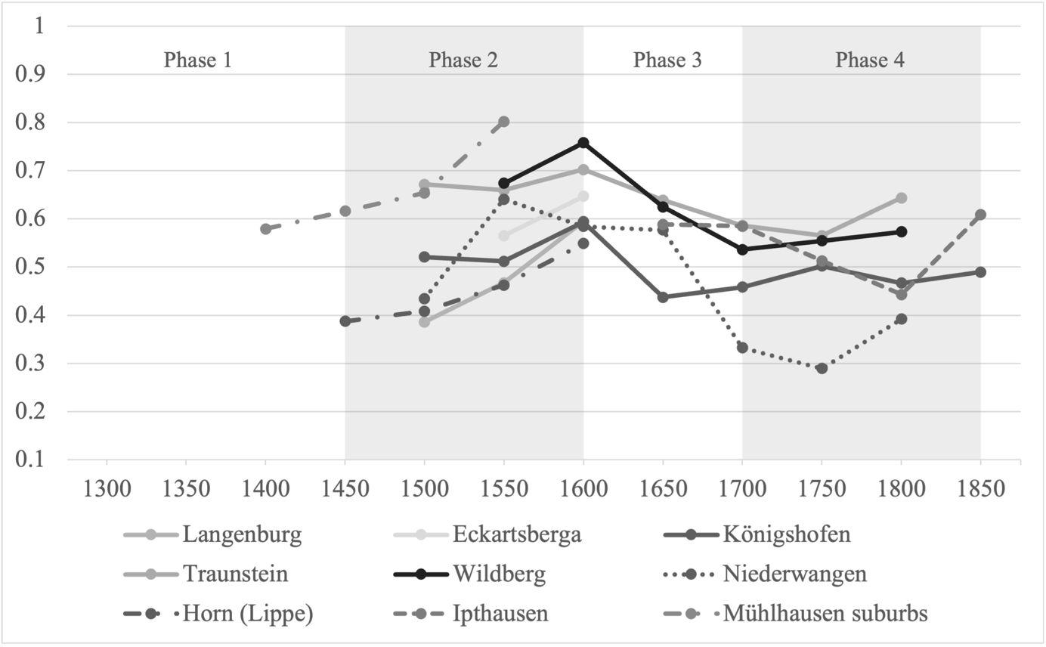
Sources: See the main text and Appendix 8.
As a final consideration, close inspection of each of these communities reveals that most of them should be considered as “rural” even following Walker’s definition of a “home town”, which is meant to be less stringent than a definition of proper “cities”. In fact, both Freudenberg and Langenburg clearly fall below the lower-bound population threshold given by Walker (1971, p. 30). Robisheaux even describes Langenburg as “more like [a] walled village than [a] proud and independent town” in his in-depth case study of the region (Robisheaux 1989, p. 22). Freudenberg only received its official city status 40 years prior to its first inclusion in our sample. Hence, we do not believe that classifying both of these communities as “rural” is controversial.
The same argument can be applied to Lengerich, which only gained city status in 1727. While we observe Lengerich until 1831, most of our observations relate to the period 1580 to 1634 when the community had not yet been granted city rights. We therefore consider it justified to classify it as a rural community. Eckartsberga is a more controversial case, as it had city rights since 1288. However, if we follow Walker’s argument that a town is characterized by its strong citizenry which is distinct from a princely bureaucracy, Eckartsberga does not meet even the requirement for a “home town”, as it was ruled remotely through a princely servant from ca. 1540 onwards (Radestock 1972, p. 10).
In conclusion, we believe that our urban-rural classification appropriately captures the nature of the communities in our sample.

Appendix 4: Re-Grouping Full Distributions into Tax Brackets
Our secondary sources provide information on the wealth distribution among taxpayers in the form of tables which divide the population into different tax brackets. For example, the taxpaying population of the city of Augsburg is divided into 12 tax brackets, where the first bracket captures those paying between one and three florins and the last bracket captures those paying more than 500 florins (Hartung 1898, pp. 188-189, replicated in Table A4.1 below). This division into tax brackets is imposed by the scholars from whom we draw our information and does not reflect a historical reality, in other words, division into taxpayers according to these brackets by the city government. This leads to the loss of information about within-brackets inequality, as it must be assumed that all those within a given bracket possessed equal wealth. However, as shown in the following paragraph, within-bracket inequality was low and does not lead to a significant loss of information. Most importantly, it did not change significantly over time and therefore does not distort our estimates of inequality trends.

Table A4.1 – Replication of Hartung’s Table III showing taxpayers per bracket for each year
Steuer-klasse | 1558 | 1576 | 1590 | 1604 | 1618 | 1632 | 1646 | 1660 | 1674 | 1688 | 1702 | 1712 | 1717³
nur stuira minor | 4161 | 3871 | 3985 | 4293 | 4120 | 3154 | 1573 | 1501 | 1345 | 1247 | 1571 | 1500 | 974
bis 3 fl. | 3536 | 3771 | 3887 | 4213 | 3777 | 2854 | 2518 | 3014 | 2858 | 3078 | 2922 | 2647 | 1908
3 – 10 | 545 | 494 | 559 | 768 | 765 | 589 | 390 | 440 | 482 | 482 | 605 | 818 | 582
10 – 20 | 157 | 199 | 212 | 277 | 270 | 224 | 171 | 199 | 179 | 175 | 249 | 286 | 197
20 – 30 | 96 | 99 | 106 | 119 | 137 | 109 | 62 | 56 | 87 | 82 | 81 | 78 | 63
30 – 50 | 86 | 105 | 110 | 138 | 153 | 111 | 67 | 69 | 65 | 61 | 78 | 73 | 51
50 – 70 | 46 | 52 | 70 | 80 | 84 | 50 | 20 | 27 | 29 | 28 | 29 | 22 | 22
70 – 100 | 56 | 35 | 43 | 52 | 75 | 33 | 15 | 14 | 21 | 21 | 20 | 16 | 21
100 – 150 | 40 | 41 | 45 | 47 | 55 | 40 | 7 | 11 | 8 | 7 | 21 | 16 | 12
150 – 200 | 13 | 17 | 16 | 30 | 32 | 12 | 8 | 1 | 6 | 5 | 6 | 7 | 9
200 – 300 | 19 | 9 | 19 | 21 | 27 | 11 | 5 | 3 | 2 | 4 | 2 | 6 | 5
300 – 500 | 7 | 6 | 10 | 16 | 20 | 7 | 3 | 5 | - | 1 | 2 | 3 | 4
über 500 | 8 | 7 | 7 | 15 | 13 | 5 | - | - | 3 | 1 | 1 | 2 | 4
Gesamt-summe der Steuerzahler | 8770 | 8706 | 9069 | 10,069 | 9528 | 7199 | 4893 | 5340 | 5085 | 5190 | 5587 | 5474 | 3852
dat heuer nihil | 249 | 212 | 218 | 242 | 230 | 48 | 83 | 82 | 100 | 86 | 76 | 67 | 55
Ohne Steuerbetrag | 768 | 746 | 867 | 644 | ?² | 477 | 1083 | 657 | 645 | 465 | 396 | 866 | 2546
verspätete Zahlung | – | – | – | – | – | – | 4585 | 736 | 1415 | 1351 | 2437 | 1728 | –
Bürger im Auslande | –¹ | 81 | 61 | 105 | ?² | –¹ | –¹ | –¹ | 117 | – | –¹ | 73 | 69

1 Nicht angegeben.
2 Nicht gezählt.
3 Siehe S. 190 u. 191.
Sources: See the main text and Appendix 8.

Across our secondary sources the number of tax brackets varies from at least five (as in Württemberg) to up to thirty-nine brackets (in the case of Nördlingen). Obviously, the more brackets a scholar provides the smaller the information loss. To show that even a division into only five brackets does not lead to a significant distortion in the inequality measures, we take the case of the County of Lippe, for which we have information on the full distribution among individual households. As the authors of the studies from which we have taken part of our data were aware of the potential obfuscation created by tax brackets, they explained their methodology of grouping taxpayers into brackets in detail. Most paid attention to the mean and median of the distribution. Therefore, we group the distribution of the county of Lippe – made up of eight parishes – into five and twelve tax brackets respectively. Note that having information for just five brackets constitutes the worst-case scenario, which is rarely encountered. The median is comprised in the middle bracket, in other words, bracket three or bracket five/six respectively. Calculating our Gini indexes anew based on these bracketed distributions shows that brackets cause only minimal distortions. Moreover, as expected, the more brackets one applies, the closer one gets to the original distribution and hence to the original Gini index. Indeed, when the brackets used in our sources are 10 or more, the Gini indexes calculated on the complete distributions and on the bracketed ones can be reasonably expected to be virtually indistinguishable.
Figure A4.1 shows the results of calculating Gini indexes based on the distributions created from 5 or 12 tax brackets compared to the Gini indexes obtained from the full distribution. The information loss that results from the tax brackets leads to a slight under-estimation of the Gini indexes. However, this underestimation is small and more importantly it is quite stable over time. Indeed, the reported trend mirrors exactly that built upon the complete distribution. Hence, we conclude that using information from tax brackets does not bias our results. Table A4.2 reports the Gini indexes for all distributions.

Figure A4.1 – Gini indexes for the County of Lippe
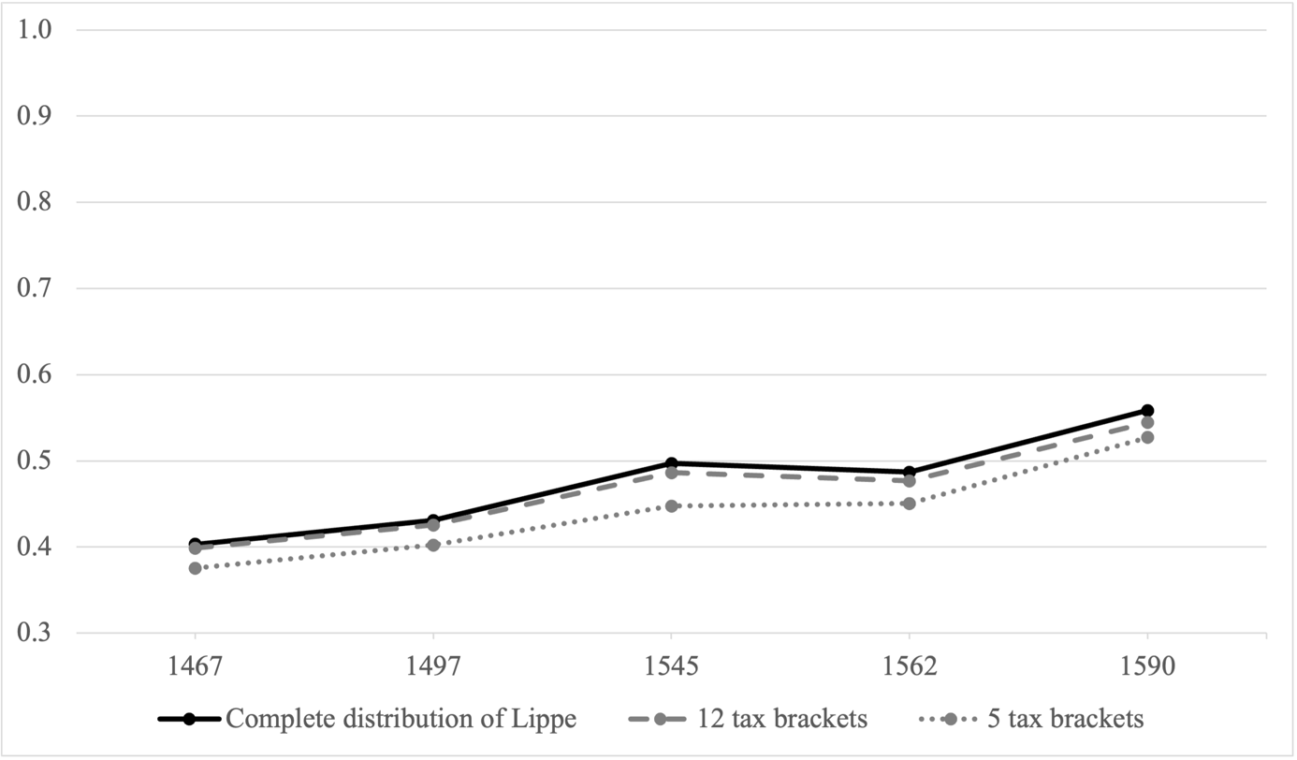
Sources: See the main text and Appendix 8.

Table A4.2 – Gini indexes for bracketed and complete distributions
 | Gini based on Complete Distribution | Gini based on 12 Tax Brackets | Gini based on 5 Tax Brackets
County of Lippe (8 parishes)
1467 | 0.403 | 0.399 | 0.375
1497 | 0.431 | 0.425 | 0.402
1545 | 0.497 | 0.486 | 0.448
1562 | 0.487 | 0.477 | 0.451
1590 | 0.558 | 0.544 | 0.527
Sources: See the main text and Appendix 8.

Appendix 5: In-Depth Analysis of Local Fiscal Systems
This appendix provides additional information about the fiscal systems in use in the communities included in our database. It focuses on aspects that might influence the information we have available and elaborates on the general discussion provided in the main text.

Tax-exempt groups
Table A5.1 shows tax-exempt groups for the cities for which this information is available. The clergy was usually tax-exempt, as were monasteries and religious foundations (Stift). However, as cities wanted to prevent the loss of taxable property through donations to the church, many of them instituted regulations that required the clergy to pay for property acquired within the city. This was the case, for example, in Esslingen, Hildesheim, Nördlingen and Rostock (Kirchgässner 1964, p. 77; Uthmann 1957, p. 8; Dorner 1905, p. 17; Staude 1912, pp. 135-136). Similar regulations were in place for the tax-exempt nobility that acquired citizenship or property within the city. In general, tax exemptions for noblemen were less common than they were for the clergy. For example, in the sixteenth century, there were 26 noble families residing in the city of Quedlinburg (Wozniak 2013, p. 213). These noble families were required to pay regular wealth taxes on the property they owned in the city, although they were exempt from swearing an oath to the city council as was common for regular citizens (Wozniak 2013, p. 207). Similarly, the noble residents of Mühlhausen were required to pay taxes as shown by an extract from the registers (Vetter 1910, p. 12). In Nördlingen, many noblemen applied for, and were granted, citizenship. Becoming a citizen carried the obligation to pay regular wealth taxes (Dorner 1905, p. 14). In other cities, such as Esslingen, Konstanz and Nördlingen, nobles were taxed at lump-sum rates (Kirchgässner 1964, p. 84; Kirchgässner 1960, pp. 106-107; Dorner 1905, pp. 14-18). Finally, exemptions were frequently given to the poor below a certain threshold of wealth, public servants and certain professionals whom the city sought to attract, such as doctors or master-builders. In contrast to these exemptions from city taxes, the tax codes of the imperial Türkensteuer obliged also the clergy and nobility to pay their fair share, however, their contributions were often paid anonymously under oath, so that no register exists of the actual sum paid (von Hippel 2009, p. 6).

Tax basis, estimation method and valuation
Across the communities included in the sample, there were some differences regarding the tax basis (for example, real estate, agricultural produce, household objects, livestock, cash), the estimation method (for example, sworn estimators authorized by the city council, self-estimation) and the valuation (for example, value in use, sales value). Table A5.2 shows taxable property and exemptions for the cities and rural towns for which this information survived. In all places, real estate was the key component of taxable wealth. Many also taxed cash, interest-paying loans, annuities and perpetuities as well as goods that were commercially used or went beyond a threshold that was deemed sufficient for a household. In some cases, debt was deducted from the estimated total wealth, thereby lowering the tax burden. Despite these differences in tax codes across communities and regions, we find substantial overlap between what actually constituted taxable wealth. Figure A5.1 shows the relative overlap of taxable wealth across 19 cities for which enough detailed information on their tax codes is available. The figure should be read the following way: in 14 out of 19 communities (74 percent) were cash reserves taxed. As some tax codes list taxable wealth in great detail, whereas others provide only rough descriptions (for example, along the lines of “all movable property is taxed”), these estimates shown in Figure A5.1 should be seen as lower-bound estimates.

Figure A5.1 – Taxable Wealth in 19 Cities
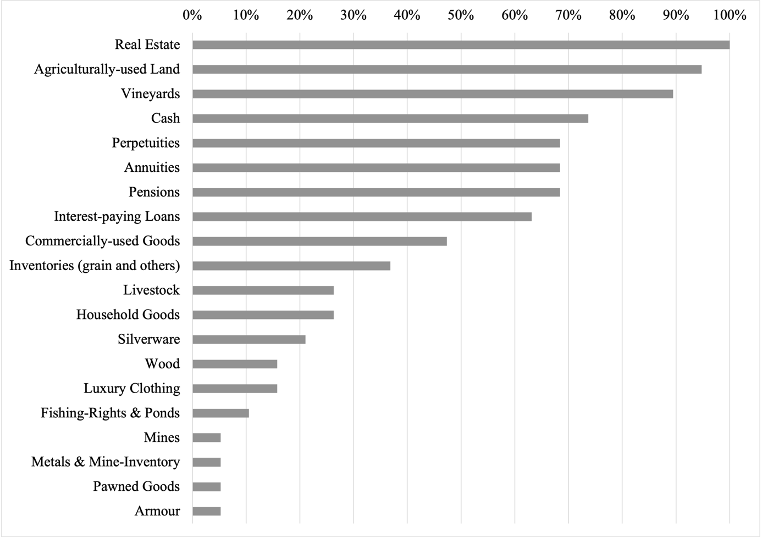
Sources: See the main text and Appendix 8.

Pawned goods might have been taxed in more than one city, but only in Augsburg was it specifically mentioned in the tax code. The figure clearly shows that immobile wealth such as real estate and land was the main body of wealth that was taxed in all communities. This makes us confident that our inequality estimates, even though they are not based on identical definitions of wealth, are broadly comparable. Moreover, even in a trading city like Augsburg, where inventory and commercially-used goods could make up a substantial portion of household wealth, the data show that in terms of monetary value immobile wealth accounted for 64 percent of all taxed wealth in 1698 (Hartung 1898, p. 176-177).

Ultimately, we want to emphasize that our alternative regression-based estimates of inequality change (see Figure 5 in the main text) show the same trends as our case studies and as the aggregate reconstructions obtained by using our preferred method. This is an important result, because the panel regression with locality fixed effects holds cross-sectional differences among communities, including the tax system, constant. We can thus be confident that differences between communities, for example who received tax exemptions or what kind of wealth was taxed beyond real estate, do not significantly bias our results.

Table A5.1 – Tax-exemptions by city

City | Year | Clergy | Monasteries | Foundations (“Stift”) | Nobility | Public servants | Poor | certain  professions | Other
Augsburg | 1498-1717 | x |  | x |  | partly |  | x | the sick, heads of newly founded households,  partly the very rich (incl. Fugger)
Bautzen | 1400-1436 | x | x | x |  | partly | x |  | people living in houses owned by the diocese
Esslingen | 1360-1460 |  | lump sum | x | lump sum
Frankfurt a. M. | 1420 | x | x
Hildesheim | 1404-1572 | x |  |  | x |  |  |  | servants with wealth less than 10 Mark, honoured citizens
Kiel | 1448-1488 | x |  |  | x | x | x |  | servants
Konstanz | 1418-1460 | lump sum |  |  |  |  |  | x
Lübeck | 1460-1784 | x | ? | ? | x |  | x |  | guests, soldiers, certain professions paid a flat-rate
Mühlhausen i. Th. | 1418-1552 | x | x |  |  | partly |  |  | servants
Nördlingen | 1415-1504 | x | x | x | lump sum |  |  | x
Quedlinburg | 1310-1585 | x |  | x |  | partly | ? | ?
Rostock | 1404-1430 | x |  |  | ? | x |  | x | servants
Schwäbisch Hall | 1460-1545 | x |  |  |  |  |  | x | temporary tax-exemptions for the very rich
Notes: A question mark indicates that the information is not available in our sources.
Sources: See the main text and Appendix 8.

Table A5.2 – Taxable and tax-exempt property in selected cities and rural towns

City | Taxable immobile property | Taxable mobile property | Tax-exempt property | Debt deductible
Augsburg | - real estate  - perpetuities  - pensions (monetary or in kind)  - mines | - cash  - interest-paying loans  - grain inventory  - livestock at its current value  - commercially used beds, household goods and tools  - annuities  - pawned goods  - metals and mine inventory | - loans that do not pay interest  - household goods  - clothing  - golden and silver jewelry and crockery  - savings relative to the total amount of wealth but not above 600 guilders
Buttelstedt | - real estate (agricultural land only)
Dresden | - real estate  - vineyards
Esslingen | - real estate |  | - armour
Frankfurt a.M. | - real estate |  | - a third of the primary dwelling  - one horse & one cow  - household goods  - clothing  - two silver cups per family  - personal stock of grain, wine, firewood, feed, straw | yes
Hildesheim | - real estate | - pensions/annuities  - “mobile capital”
Kiel | - real estate
Konstanz | - real estate  - vineyards  - wood  - fishing rights | - interest-paying loans  - pensions  - commercially used household goods and tools  - silk clothing | - personal wine stock  - personal grain stock  - household goods  - clothing | yes
Lübeck | - real estate  - meadows  - orchards | - inheritance  - merchandise  - commercially used buildings |  | yes
Mühlhausen | - real estate  - vineyards  - gardens & orchards  - wood | - armour  - clothing  - pensions  - cash |  | yes
Nördlingen | - real estate | - interest-paying loans  - pensions  - “mobile goods” (comprises all household goods and other mobile goods – very complete) | - weapons & harness
Nuremberg | - real estate  - annuities  - perpetuities  - rent in kind  - orchards & vineyards | - cash  - commercially-used goods  - credit | - household goods & tools  - clothing & jewelry
Quedlinburg | - real estate  - agriculturally-used land | - “mobile capital” (not specified)
Rostock | - real estate  - pensions/annuity/perpetuity  - commercially-used land | - commercially-used household goods (such as tools, barrels, pots, pans, cauldrons)  - inventory (grain, beer)  - cash  - silverware
Wertheim | - real estate
Sources: See the main text and Appendix 8.

Appendix 6: Aggregation Methods and Robustness Checks
This appendix provides a detailed explanation of our preferred aggregation method, followed by a robustness check via a regression-based aggregation method. Additionally, we calculate confidence intervals for our estimates using bootstrapping. Finally, we provide a robustness check of our results to the exclusion or inclusion of propertyless households.

Section A6.1: Aggregation Method and Data (Preferred Method)
The method we use has been developed in the context of the project EINITE-Economic Inequality across Italy and Europe, 1300-1800. The method requires a sample of local wealth distributions, both urban and rural, based on which one overall aggregate distribution is modelled. This aggregate distribution is representative of the area under study. One aggregate distribution is reconstructed for each year included in the analysis (see Alfani 2015; Alfani and Ryckbosch 2016, Appendix D; Alfani and Di Tullio 2019, Appendix). This distribution can then be used to compute any conceivable inequality indicator, such as the Gini index, the Theil index, wealth shares or polarization measures.
In the ideal case, one would like to know the actual distribution of wealth, based on information from every household in Germany expressed in one uniform currency. Unfortunately, such census-like information is not generally available for preindustrial societies. A practical solution to this problem is to model the aggregate distribution from sampled local distributions. Then one can weight these local distributions according to major population statistics so that the sample reflects the overall structural characteristics of the population. The goal of the aggregation method is thus to approximate the actual distribution of wealth as best as possible. Note that it would not be sufficient to simply average the local Gini values in order to obtain a regional estimate. In fact, by averaging local values, precious information on inequality between the localities would be lost. Additionally, this procedure would not allow us to further explore the distribution in meaningful ways.
We base our reconstruction of Germany’s wealth distribution on the data of all those communities for which we have at least two data points in steps of 50 years. The only exception to this rule are the rural communities in the year 1350. As we do not have any continuous rural series for this early period, we include also those rural communities for which we have only one data point in our reconstruction. Moreover, individual parish-level data of the same area and drawn from the same archival source were merged into one distribution representative of the whole area. We did this in order to avoid several small rural communities from one area dominating the aggregate trend unduly. This applies to the cases of the County of Tecklenburg, the County of Lippe, the bailiwick of Buttelstedt, the County of Wertheim, the Duchy of Mecklenburg, the rural communities around Wangen and the rural communities of Königshofen.

Step 1. Modelling fictitious distributions
As a first step, for every sample community in a given year we modelled a corresponding “fictitious distribution” consisting of exactly 100 elements or “fictitious households”. Each fictitious household received an empirically estimated wealth value, based on the wealth shares calculated from the original distribution reconstructed from archival sources. For each decile of wealth, 10 fictitious households were modelled, each having the same share of wealth (1/10 of the decile’s wealth share). For example, the first ten fictitious households (1-10) in Konstanz in 1500 were assigned a value equal to 1/10 of the wealth share that had been calculated for the first decile of the population in Konstanz in 1500 (1.29 percent/10=0.129 percent). The next ten fictitious households (11-20) were assigned a value equal to 1/10 of the wealth share of the second decile of the population in 1500 (1.82 percent/10=0.182 percent), and so on. The top decile (households 91-100) was modelled in greater detail, based on the wealth share estimates of the richest top 10 percent, top 5 percent and top 1 percent of the tax-paying population. It is important to model the top decile with greater precision because it has been shown that its dynamics tend to shape the overall trends in Gini values: an empirical regularity which seems to be valid for preindustrial, as well as for today’s societies (Atkinson et al. 2011; Alvaredo et al. 2013; Alfani 2021). Note that 100-elements fictitious distributions modelled in this way mirror quite precisely, in distributive terms, the original distributions, as can be seen when comparing the Gini index calculated on the original, and on the fictitious distribution. Again, in the case of Konstanz, while the Gini index of wealth inequality calculated for year 1500 based on the original distribution is equal to 0.705, the Gini calculated based on the corresponding fictitious distribution is equal to 0.699. As can be seen in Figure A6.1, the series based on the actual distribution and the one based on a decile-based reconstruction using fictitious households are almost indistinguishable. This confirms that this procedure does not lead to distortions or to information loss for the purpose of producing aggregate distributions.

Figure A6.1 - Gini indexes in Konstanz and Überlingen from actual distributions vs. decile-based reconstructions (fictitious distributions)
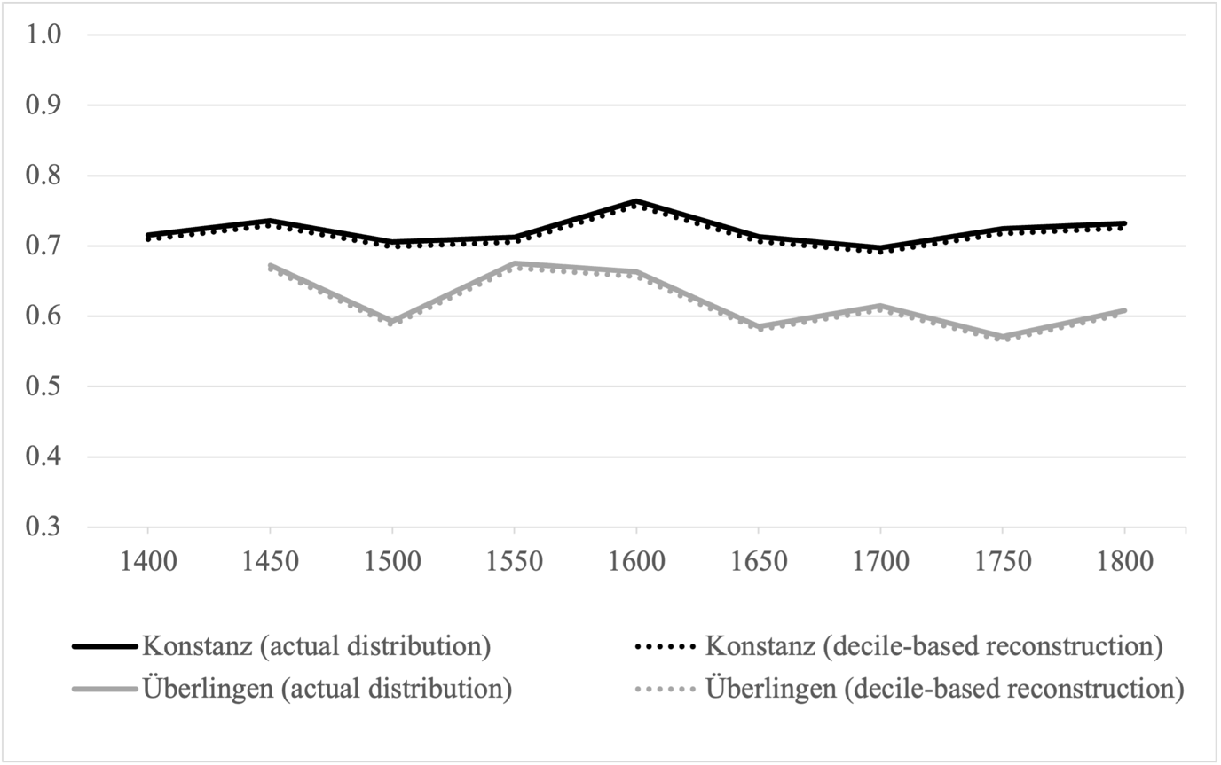
Sources: See the main text and Appendix 8.

Replacing the actual wealth distributions with the fictitious distributions presents a number of advantages. First of all, this procedure provides an immediate solution to the problem of having one, or few, communities of large size dominating the trend. As each original distribution is compressed to a fictitious distribution of exactly 100 households, each single community gets an implicit weight of one in the reconstructed urban and rural distributions. This improves the ability of the reconstruction to represent broad trends across communities.
A second advantage is that using fictitious distributions allows us to overcome problems of comparability in the values with which each original distribution is expressed. Indeed, one might wonder why we take the wealth shares of the population deciles and not the actual wealth of households. The problem here is that we cannot directly compare the taxable wealth of different communities because it is expressed in different currencies that cannot be converted into a common one. Even the most comprehensive dataset of currencies and their conversion rates in preindustrial Germany (Boerner and Volckart 2011) does not even come close to allowing us to convert, for the entire period we study and for all communities, the plethora of local currencies that characterized preindustrial Germany. Allocating to each fictitious household a value based on the wealth share of the respective decile – which, being a percentage, is a pure number, meaning that it is not expressed in any specific unit of measurement – automatically provides a solution to the problem of incomparable currencies (see the case of Piedmont/Sabaudian State for further discussion of this important point: Alfani 2015, pp. 1064, 1081). The downside of this procedure is that we are assuming implicitly that every community had the same average household wealth. This is unlikely to be true, especially when comparing cities and rural communities, which is why we first estimate an aggregate distribution reflecting the rural and the urban environment separately (Step 2). When, at a later stage (Step 3) we aggregate further the urban and rural distributions to produce our overall regional reconstruction, we introduce more realistic assumptions about differences in the average wealth between communities.

Step 2. Building representative urban and rural distributions
In the second step, the fictitious distributions for each city and year are merged into an overall “urban” distribution. Similarly, the distributions for each single rural community and year are merged into an overall “rural” distribution. This step does not present any difficulties, as weighing and comparability issues have already been accounted for by replacing the original distributions with the fictitious ones (see Step 1 for a discussion). Figure A6.2 plots the Gini indexes for the urban and rural distributions constructed in this way (see main text for further discussion).

Figure A6.2 - Long-term trends in wealth inequality in Germany, 1350-1850: the urban and rural reconstructions (Gini indexes)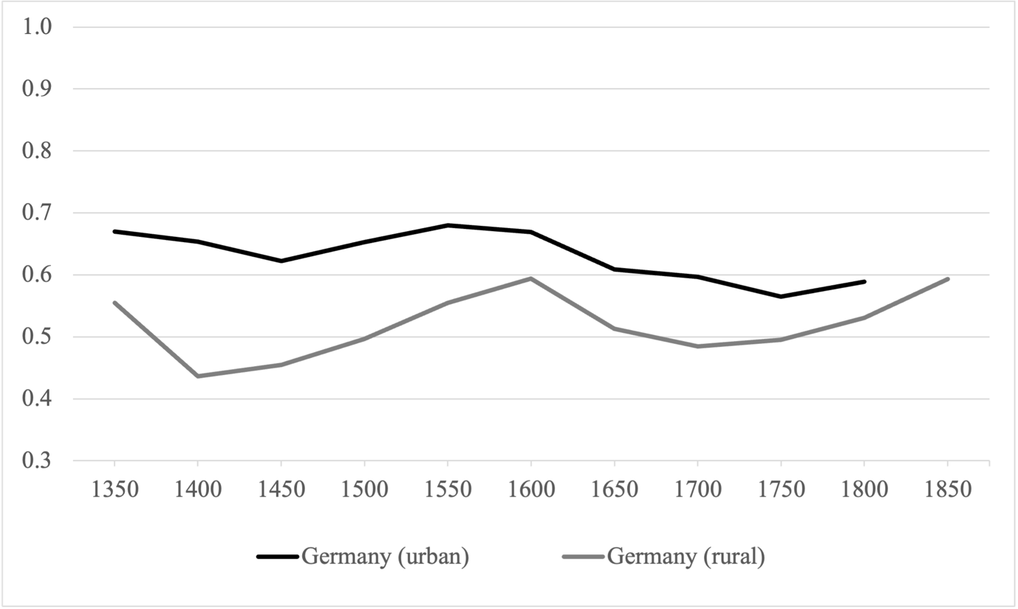Sources: See the main text and Appendix 8.

Step 3. Building the regional distribution
In order to combine the aggregate urban and rural distribution in an overall “regional” distribution representative of the whole of Germany, two additional weighing issues remain to be solved.
First, it is a well-known fact that rural households had on average lower wealth compared to urban households. To take this into account, we have calculated the rural-urban wealth ratio for the period from 1418 to 1552, based on data from the city of Mühlhausen i. Th. and its surrounding villages. Unfortunately, this is the only period and case for which we have data on wealth for cities and their surrounding rural areas denoted in the same currency and produced along the same criteria, and which are therefore comparable. For simplicity, we apply the average of those rural-urban ratios to the whole period covered. Our calculations yield a rural-urban wealth ratio of 21 percent, which is similar to the range of 21 to 29 percent found for Tuscany (Alfani and Ryckbosch 2016, Appendix D) or to the 17 to 21 percent ratio found for the Republic of Venice (Alfani and Di Tullio, 2019, p. 188). This is to say that a rural household, on average, had approximately one fifth of the wealth of an urban household. This weight is then applied to the value reported for each household included in the aggregate rural distribution.
Secondly, we have to consider that only a small share of the German preindustrial population lived in cities. The majority resided in rural settings, so we have to make sure that the overall aggregation reflects this characteristic feature of the overall population. The method we use is analogous to that discussed by Milanovic (2005) to calculate “weighted international inequality”. We define the weights based on urbanization rates for cities with at least 5,000 inhabitants. This threshold, which has also been used in earlier reconstructions (for example, Alfani 2015, p. 1082), seems appropriate as preindustrial Germany had few large cities. According to the most recent estimates Germany had an urbanization rate of 10 percent in 1500 and also in 1800, with minimal changes in between (Pfister 2020, p. 16). For ease of calculation, an urbanization rate of 10 percent has been assumed throughout the period we study. In practice, this means that a one-to-nine urban-rural ratio was systematically maintained between the elements of the final aggregate distribution. When needed, the appropriate ratio was obtained by copying multiple times the elements of the rural or urban distribution in the aggregate distribution. For example, in 1600, when we have a 900-element rural distribution and a 1800-element urban distribution we built a 18,000-element distribution representative of the whole of Germany by adding the rural distribution 18 times and adding the urban distribution once.
After completing this step, our aggregate distributions representing the whole of Germany were finally ready to use. Based on them, we were able to provide a picture of the overall tendencies of wealth inequality from 1350 to 1850: in the main text Figure 4 and Table 2.

As a final comment, it would obviously have been desirable to account for regional wealth differences when producing our aggregate distributions, because it is likely that, for example, the Rhineland was more prosperous than Pomerania in the early modern period. In order to account for such differences across the regions of preindustrial Germany, we would need regional GDP estimates (or similar information) from 1350 until 1800. Unfortunately, no systematic measure of regional economic development is currently available for the whole period we study. The earliest and most recent measures available refer to the beginning of the nineteenth century (see Pfister 2020, p. 18) and there is no way to retro-project them in a meaningful way. Differences in regional prosperity cannot, therefore, be considered for modelling the wealth distributions. This is tantamount to assuming that average household wealth was the same among all rural communities, and among all urban communities respectively, although there would be a difference between the urban communities and the rural communities. As a result, we do not fully capture wealth differences between localities of different regions. In descriptive terms: we capture the wealth difference between the city of Frankfurt a.M. and the village of Eckartsberga, but we do not capture a potential difference in average wealth between the village of Eckartsberga and the villages of Langenburg, because the villages of Langenburg are in a different region of Germany that might have had a different level of average prosperity.

Section A6.2: Aggregation robustness check via a regression-based method
In this section we provide a simple regression-based robustness check for our reconstruction of economic inequality across the whole of Germany, from 1350 to 1800. The aim is to verify whether, by employing a totally different method for identifying long-term trends in inequality, we obtain the same trends which our preferred method yields. Note that our preferred method has two advantages over alternative approaches: first, it is the same method employed by all other recent reconstructions of regional-level inequality; secondly, it leads to producing a representative distribution, not a single inequality indicator, hence it allows for greater flexibility by permitting us to compute a multitude of inequality indicators.
In principle, the alternative method used here is similar to the one employed by Clark (2005) to estimate wage series for preindustrial and industrial England. We estimate a regression of the following form:

$${Gini}_{i, t}= α_{i}+\sum_{τ=1350}^{1800}{β_{τ} Year+ϵ_{i,t}}$$

Our dependent variable is the $Gini$ coefficient in locality i in year t (1350 to 1800, in steps of 50 years). These are the same Gini coefficients – for cities such as Rostock or Augsburg and rural towns such as Umpferstedt or Eckartsberga – that we present in the main text. Our unbalanced panel consists of 168 observations. $α_{i}$ is a full set of locality fixed effects, which capture time-invariant locality-specific characteristics. Our main interest is to estimate the parameters on the $Year$-dummies (1350 to 1800) to derive average Gini change. The omitted reference category is the year 1600.
It is important to recognize that this approach differs substantially from our preferred methodology outline above. The results of the regression-based approach indicate inequality change based on many local distributions. Instead, the aggregation method that we present in the main text and that has been employed in several published studies (see Alfani 2015; Alfani and Ryckbosch 2016; Alfani and Ammannati 2017; Alfani and Di Tullio 2019) centres on the idea of constructing one overall distribution that is representative of the whole area under study in a given year and to calculate a Gini coefficient based on this distribution. The dynamics within such an overall distribution do not necessarily have to be exactly the same compared to the average dynamics found across communities.
Notwithstanding this major conceptual difference, the results of the two approaches yield similar results (see Figure A6.3). The parameters on the year-dummies show a pattern that is quite similar compared to our aggregate series: economic inequality declined after the Black Death and started to rise again around 1450. A temporary peak was reached around 1600, just before the Thirty Years’ War. During the half-century of the war inequality declined sharply.

Figure A6.3 – Gini change in Germany, 1350-1800 (regression coefficients)
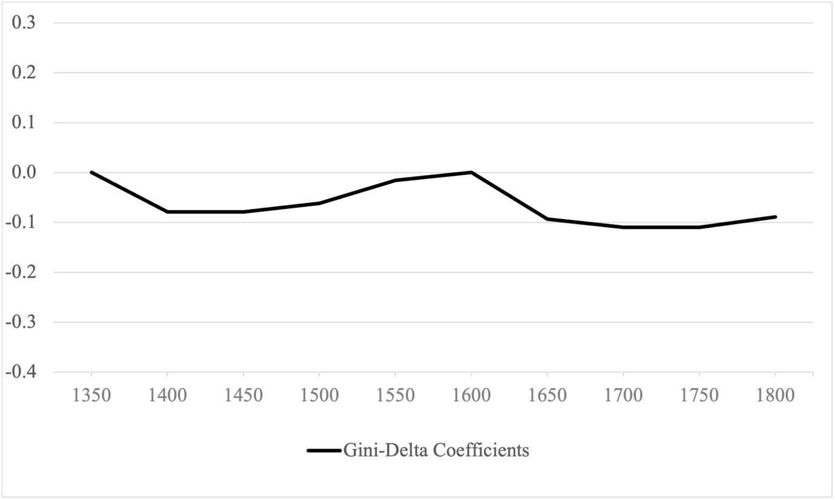

Notes: Gini-Delta coefficients indicate the change in the Gini coefficient with respect to the reference year 1600.
Sources: See the main text and Appendix 8.

From 1700 until 1800, economic inequality rose continuously. The results of the regression show that inequality growth continued until 1800, as we hypothesized in the main text based on the aggregation of rural towns. Overall, the results of the regression show trends that are remarkably similar to those obtained by the established aggregation approach, which supports the view that the trends presented in the main text are indeed robust to the method employed for the reconstruction.
This regression method produces a “dimensionless index”. This means that the Delta coefficients plotted in Figure A6.3 show the average change in inequality relative to the benchmark year of 1600. Inequality in the benchmark year is not estimated directly, hence the estimate in that year is set to zero. However, this dimensionless index can be transformed into an estimate of inequality levels by anchoring a benchmark year to an independently estimated Gini value. Using the aggregate Gini value for the year 1600 calculated via our preferred method, we obtain the results discussed in the main text (Figure 4). The alternative series is found to follow closely the trends we have calculated from our reconstructed aggregate distributions.

Section A6.3: Confidence intervals
One might wonder whether our overall estimates of economic inequality in Germany are the result of actual re-distributional effects, triggered by the Black Death and the Thirty Years’ War, or whether they are instead simply the result of random variation in the sample. Such variation in the sample might, for example, be due to mistakes in the original archival sources or mistakes in the transcription of the sources. In order to address such concerns about the statistical significance of our estimates, we employ bootstrap techniques to calculate confidence intervals (for applications in studies of historical inequality see Mills and Zandvakili 1997; Steckel and Moehling 2001; Santiago-Caballero 2011; Alfani 2021).
The bootstrap analysis for obtaining 95 percent confidence intervals is done in the following way (see Steckel and Moehling 2001, pp. 168-169): for each distribution of size n in year t, we build a resample of size n by randomly drawing with replacement from our original distribution. The bootstrap distributions are then used to calculate Gini coefficients. We use 200 iterations, as in Alfani (2021). The confidence intervals that we obtain through this procedure make it possible to judge whether, for example, the observed Gini in year 1650 is significantly different from the Gini in year 1600.

Figure A6.4 – Economic inequality in Germany with 95% confidence intervals (Gini indexes)
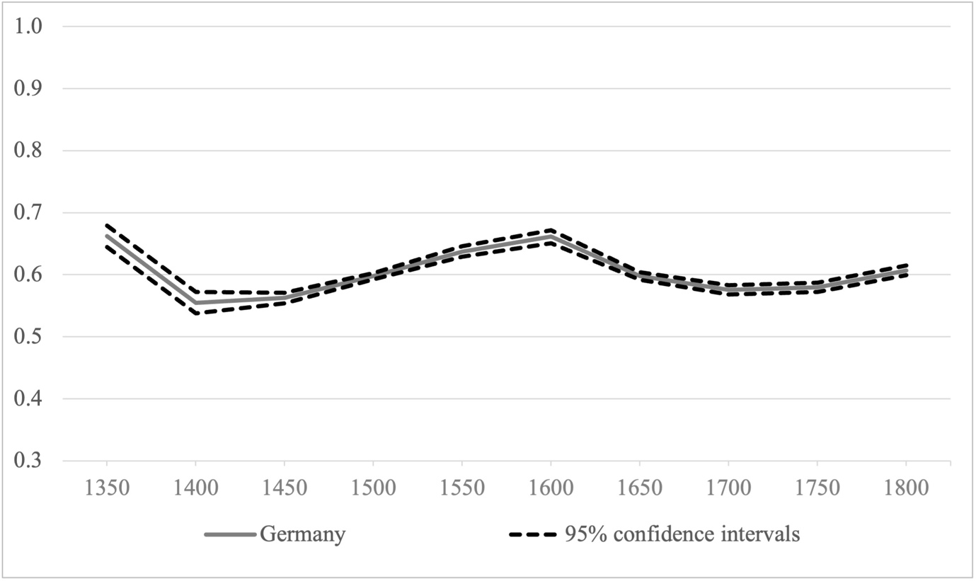
Sources: See the main text and Appendix 8..

The solid line in Figure F4 shows the aggregate Gini indices (see discussion in the main text) while the dashed lines mark the 95 percent confidence interval obtained by bootstrap analysis. Standard errors are between 0.003 (1500) and 0.01 (1350). Confidence intervals are quite tight and show little overlap, which suggests that our inequality estimates are not dependent upon specific observations, hence they are robust to (for example) mistakes or omissions in wealth assessments or in data collection, or even imprecision in independently-estimated variables (like the urbanization rates) that affect the final composition of the aggregate distribution. Note that there is no overlap between the initial and final inequality level for each of the four phases that we have identified: 1350-1450, 1450-1600, 1600-1700 and 1700-1800. This suggests that the reported inequality change during these periods is statistically significant. Overall, these results suggest that the main phases of inequality growth and decline presented in this article are robust to this kind of statistical test and could not be reasonably attributed to random variation in the sample.

Section A6.4: Propertyless robustness check
Some of our sources do not provide any information about the number of fiscally propertyless households. Hence, our Gini estimates in the main text are based on distributions excluding the propertyless to ensure comparability across communities. In this appendix we examine whether this omission could bias our findings about inequality trends. We do this first for the individual communities for which this information is available, then for the aggregate distribution. Note that we are not attempting to provide estimates for the general prevalence of the poor among the entire population, but simply for the prevalence of households considered propertyless by the contemporary fiscal systems. Although the vast majority of these households was surely quite poor, there is an important conceptual difference and we are not making any claim about the prevalence of poverty in preindustrial Germany.

Individual Cases
In the case of individual communities, including the propertyless is a simple matter of adding the proper number of fiscally propertyless households to the existing distribution, each with a wealth of zero. Gini indexes and any other inequality measures can then be calculated directly on the resulting distribution.
To clarify this point and to show that our reconstructed trends are robust to the inclusion of these households, we selected two urban and two rural communities for which we have data on the propertyless and calculated the Gini indexes on the complete distributions. We chose the cities of Augsburg and München as they cover the entire time span of our analysis. As Figure F5 and F6 show, the Gini indexes based on the entire distribution including the propertyless are higher than those excluding the propertyless, but the trend remains the same. The actual Gini indexes can be found in Table A6.1. Note that across our sample, Augsburg stands out for being the city where the absence of the propertyless causes the most substantial under-estimation of inequality levels – hence it should be understood as an exceptional case. The fact that not even in Augusburg does the inclusion of the propertyless alter the trend further supports the conclusion that the tendencies identified when excluding them are genuine.
As examples for rural areas we chose the community of Oerlingshausen in the county of Lippe and the rural town of Traunstein. As the prevalence of propertyless households was relatively low in rural areas, both the levels and trends are essentially the same – to the point of being often indistinguishable, as can be seen in Figures F7 and F8. One additional clarification is needed. Our distributions are household-level (as is often the case also in studies of modern-day inequality), as taxes were administered at the level of the household. Especially for the rural areas, it is possible that the number of dependent individuals – such as maids, day-labourers or farmhands – increased over time. However, this would not be reflected in the fiscal records. Note that this does not represent a problem for our inequality measures, as indeed this situation properly reflects a household-level distribution of wealth, in which all co-residents constitute a household independently of their relations one to the other.

Figure A6.5 – München, 1350-1500, Gini indexes including and excluding the propertyless
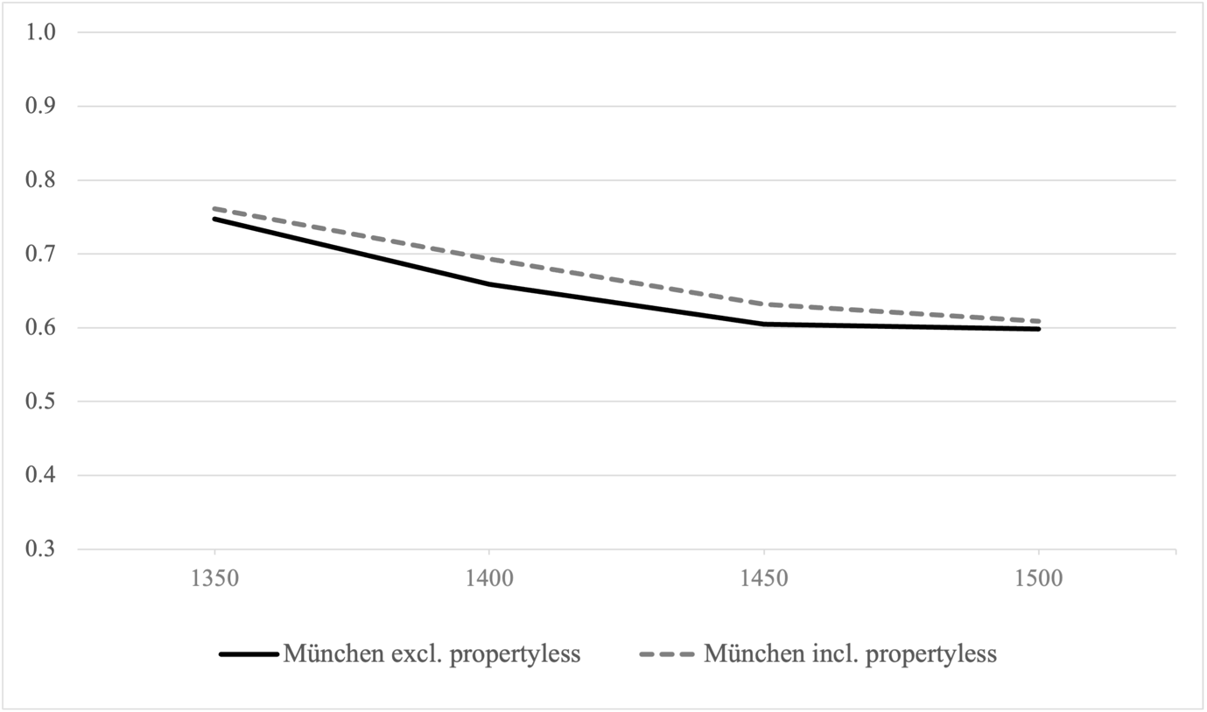Sources: See the main text and Appendix 8.

Figure A6.6 – Augsburg, 1500-1750, Gini indexes including and excluding the propertyless
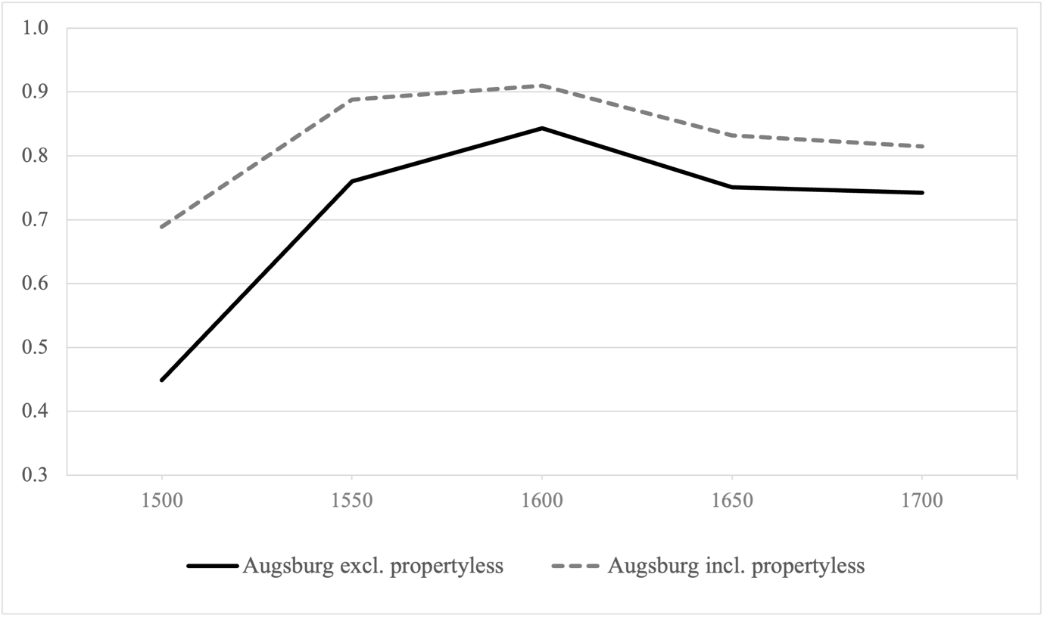
Sources: See the main text and Appendix 8.

Figure A6.7 – Oerlingshausen, 1450-1600, Gini indexes including and excluding the propertyless
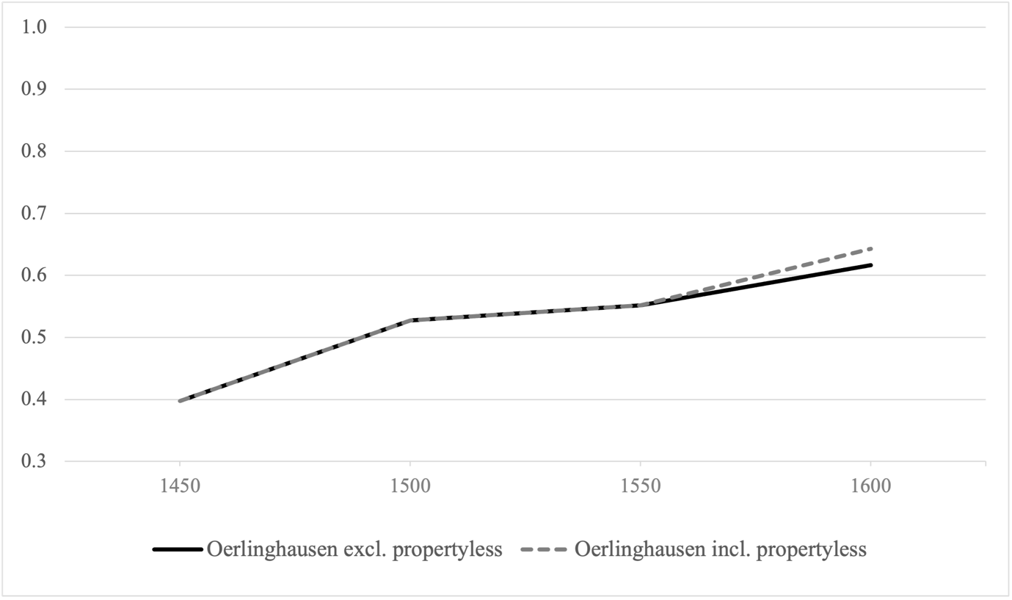
Sources: See the main text and Appendix 8.

Figure A6.8 – Traunstein, 1500-1800, Gini indexes including and excluding the propertyless
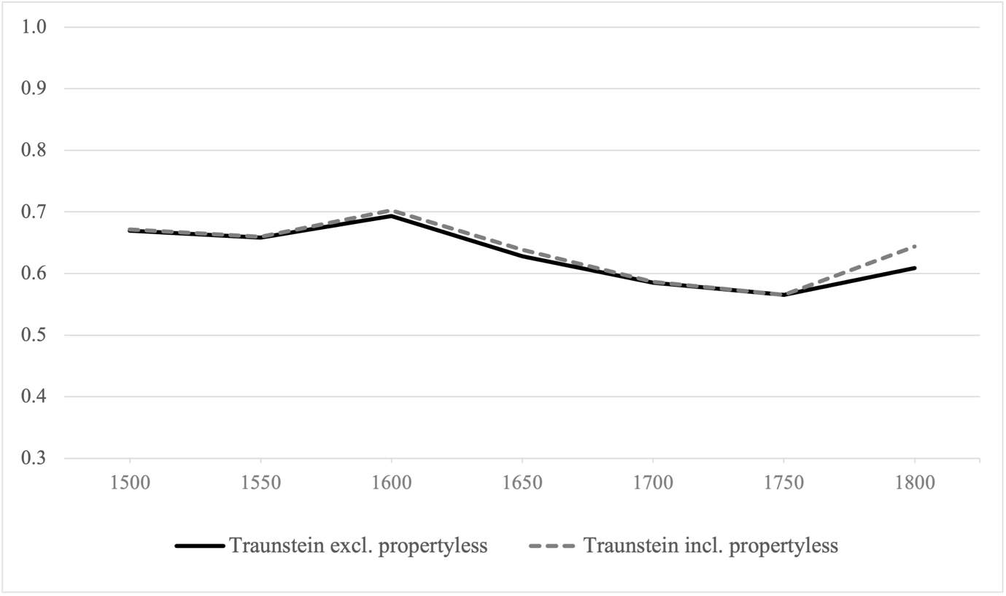
Sources: See the main text and Appendix 8.
Table A6.1 – Gini indexes including and excluding the propertyless
 | Gini incl. Propertyless | Gini excl. Propertyless | Difference
München
1350 | 0.761 | 0.747 | 0.014
1400 | 0.693 | 0.659 | 0.034
1450 | 0.632 | 0.605 | 0.027
1500 | 0.609 | 0.598 | 0.011
Augsburg
1500 | 0.689 | 0.449 | 0.240
1550 | 0.888 | 0.760 | 0.128
1600 | 0.910 | 0.843 | 0.067
1650 | 0.832 | 0.751 | 0.081
1700 | 0.815 | 0.742 | 0.073
1750 | 0.835 | 0.780 | 0.055
Oerlingshausen (Lippe)
1450 | 0.398 | 0.398 | 0.000
1500 | 0.528 | 0.528 | 0.000
1550 | 0.552 | 0.552 | 0.000
1600 | 0.643 | 0.617 | 0.026
Traunstein
1500 | 0.672 | 0.669 | 0.002
1550 | 0.660 | 0.658 | 0.002
1600 | 0.702 | 0.693 | 0.009
1650 | 0.639 | 0.628 | 0.011
1700 | 0.586 | 0.585 | 0.001
1750 | 0.565 | 0.565 | 0.000
1800 | 0.644 | 0.609 | 0.035
Sources: See the main text and Appendix 8.

Aggregate Results
To apply the same kind of robustness check to our aggregate distribution, we have to estimate the prevalence of fiscally propertyless households for each benchmark year from 1350 to 1800. We do this based on data from 20 cities and 69 rural communities for which we have information about the prevalence of the propertyless. After having obtained an estimate of the prevalence of the propertyless households in cities and rural communities separately, we calculate the weighted average assuming a 10 percent urbanization rate. This yields a time series of the prevalence of the propertyless across Germany during the entire period under study. This series reports a low of 0.81 percent of fiscally propertyless in 1400 and a high of 8.4 percent in 1550. We then use this series to calculate the appropriate number of propertyless households that need to be added to our aggregate distributions. For example, our aggregate distribution in the year 1400 contains 10,000 households and the average prevalence of propertyless households in that same year is 0.81 percent. This means that we need to add 81.6 households (rounded to 82) with a wealth of zero to our distribution to reflect the prevalence of the propertyless (82/10,082 = 0.0081). Subsequently, we calculate the Gini index of this new aggregate distribution which includes the propertyless. We find that including the propertyless leads to slightly higher Gini estimates, but does not change the observed trends. Therefore, we have direct confirmation that excluding the propertyless, while leading to a limited systematic under-estimation of wealth inequality, does not bias our results on long-term inequality trends. This is clearly shown in Table A6.2. See the main text for further discussion.

Table A6.2 – Gini indexes including and excluding the propertyless
 | Gini excluding propertyless | Gini including propertyless | Difference
Germany Total
1350 | 0.662 | 0.690 | 0.028
1400 | 0.555 | 0.559 | 0.004
1450 | 0.562 | 0.569 | 0.007
1500 | 0.598 | 0.604 | 0.007
1550 | 0.637 | 0.668 | 0.030
1600 | 0.661 | 0.675 | 0.013
1650 | 0.598 | 0.619 | 0.021
1700 | 0.575 | 0.589 | 0.014
1750 | 0.580 | 0.597 | 0.017
1800 | 0.607 | 0.617 | 0.010

Sources: See the main text and Appendix 8.

Appendix 7: Difference-in-Differences Estimates – Data and Model Specification
This appendix provides additional information about the difference-in-differences estimates of the effect of the Thirty Years’ War (1618-1648) on wealth inequality.
The data we use is the following:
1) for Germany, we use information about inequality from Tables A2.1 and A2.2, and about population size from Table A3.1;
2) for the Sabaudian State / Piedmont, we use the information on inequality and population published by Alfani (2015).
Note that the complete dataset is provided as part of our replication files and can be downloaded from https://www.openicpsr.org/openicpsr/project/144241/version/V1/view . Needless to say, we only include those communities in the analysis for which a comparison of inequality before and after the Thirty Years’ War is possible.
To measure the effect of the Thirty Years’ War on inequality we estimate this linear specification:

$${Gini}_{i, t}= α_{i}+π_{t}+ β{(30YW}_{i}×{Post}_{t})+δ\ln\left(P_{i,t}\right)+{Trend}_{i}+ϵ_{i,t}$$

Our dependent variable is the$Gini$ coefficient in locality i in year t (1500 to 1700 or 1800, depending on the specification, in steps of 50 years). The coefficient of interest is the beta on the interaction between treatment status (${30YW}_{i}$) and post-treatment period (${Post}_{t}$). We code all localities in Germany as “treated” and all communities in Piedmont as “non-treated”, because only the German localities lie in areas that were substantially exposed to the Thirty Years’ War (see Franz 1961, p. 8). The first year of the post-treatment period is 1650.
The identifying assumption is: communities that were treated by the Thirty Years’ War would have experienced a similar inequality development as communities that were not treated by the Thirty Years’ War, had the war not happened. Subject to this assumption (see for evidence Figure 6 in the main text), the beta-coefficient identifies the causal effect of the Thirty Years’ War on economic inequality. $ϵ_{i,t}$ is a random error term. Our benchmark model accounts for unobserved characteristics that may influence inequality and exposure to the Thirty Years’ War. $α_{i}$ is a full set of locality fixed effects, which capture time-invariant locality-specific characteristics, such as differences in the local tax systems or the physical environment. $π_{t}$ are time fixed effects that account for widespread shocks that affect all localities, such as general economic trends. Standard errors are robust, clustered by locality.
One might be concerned about unobserved time-varying locality-specific characteristics that might influence inequality. We address this concern by modifying the benchmark model to include locality-specific time trends (${Trend}_{i}$). This more stringent specification helps to account for changes in unobserved factors at the locality level, such as economic development or state formation. Note that the inclusion of time trends allows us to relax the common trend assumption (Angrist and Pischke 2009, p. 238). We also control for a locality’s population size $P$ (in logs) in our specification.

Appendix 8: Primary and Secondary Data Sources
In this appendix we list all the primary and secondary date sources we have used to reconstruct inequality for the communities included in our database.

Primary Manuscript Sources
Stadtarchiv Bad Königshofen
- I/65 Beet Register 1515/16
- I/65 Beet Register 1550
- I/65 Beet Register 1601
- I/65 Beet Register 1664
- I/65 Beet Register 1700
- I/65 Beet Register 1750
- I/65 Beet Register 1800
- III/21 Beet & Brau Rechnungen & Beilagen 1850

Stadtarchiv Konstanz
- L4 Steuerbuch 1425
- L 28 Steuerbuch 1450
- L 78 Steuerbuch 1500 I
- L 79 Steuerbuch 1500 II
- L 128 Steuerbuch 1550
- L 182 Steuerbuch 1600
- L 235 Steuerbuch 1650
- L 285 Steuerbuch 1700
- L 236 Steuerbuch 1775
- L 381 Steuerbuch 1800

Stadtarchiv Nördlingen
- R7 F12 Nr 3 Steuerbuch 1404
- R7 F12 Nr 6 Steuerbuch 1447
- R7 F13 Nr 4 Steuerbuch 1495
- R7 F14 Nr 9 Steuerbuch 1543-45

Stadtarchiv Traunstein
- R5 Steuerregister 1506
- R5 Steuerregister 1548
- R5 Steuerregister 1600
- R5 Steuerregister 1649
- R5 Steuerregister 1703
- R5 Steuerregister 1750
- R5 Steuerregister 1800

Stadtarchiv Überlingen
- Steuerbuch 1444
- Spektavit 1503
- Spektavit 1563
- Spektavit 1596
- Spektavit 1656
- Spektavit 1700
- Spektavit 1750
- Steuerbuch 1800

Stadtarchiv Wangen im Allgäu
- Steuerbuch 1505
- Steuerbuch 1546
- Steuerbuch 1600
- Steuerbuch 1650
- Landsteuerbuch 1696-1702
- Steuerbuch 1703-1706
- Ordinari Steuerbuch der Reichsstadt Wangen 1750
- Ordinaristeuerbuch der des heil. röm. Reiches Stadt Wangischen Landschaft 1750
- Ordinari Steuerbuch der Reichsstadt Wangen 1800
- Ordinaristeuerbuch der des heil. röm. Reiches Stadt Wangischen Landschaft 1800

Hauptstaatsarchiv Stuttgart
- A 261 Steuereinschätzung 1480, 1522-1807
- A 573 Stadt und Amt Wildberg 1488-1882

Archiv der Hansestadt Lübeck
- 03.04-05 01.01 Marien-Quartier: 003 Schoßbuch Marien-Quartier 1664
- 03.04-05 01.01 Marien-Quartier: 012 Schoßbuch Marien-Quartier 1701-1709
- 03.04-05 01.01 Marien-Quartier: 015 Schoßbuch Marien-Quartier 1737-1750
- 03.04-05 01.01 Marien-Quartier: 022 Schoßbuch Marien-Quartier 1774-1784
- 03.04-05 01.02 Johannis-Quartier: 026 Schoßbuch Johannis-Quartier 1664
- 03.04-05 01.02 Johannis-Quartier: 027 Schoßbuch Johannis-Quartier 1701-1709
- 03.04-05 01.02 Johannis-Quartier: 032 Schoßbuch Johannis-Quartier 1740-1751
- 03.04-05 01.02 Johannis-Quartier: 035 Schoßbuch Johannis-Quartier 1774-1784

Primary Printed Sources (transcriptions of manuscripts)
Cordshagen, Christa. Quellen zur ländlichen Siedlungs-, Wirtschafts-, Rechts- und Sozialgeschichte Mecklenburgs im 15. und 16. Jahrhundert. Amt Neustadt. Rostock: VEB Hinstorff Verlag, 1965.
Endler, Carl. Steuerlisten mecklenburgischer Bauerndörfer des 15. und 16. Jahrhunderts. Amt Gadebusch mit Kloster Rhena. Teil I. Köln, Wien: Böhlau Verlag, 1978.
Endler, Carl. Steuerlisten mecklenburgischer Bauerndörfer des 15. und 16. Jahrhunderts. Amt Gadebusch mit Kloster Rehna. Teil II. Rostock: Verlag Schmidt-Römhild, 1995.
Friese, Alfred. “Die ältesten Steuerverzeichnisse der Grafschaft Wertheim.” Wertheimer Jahrbuch 7, (1954): 46–66.
Leesch, Wolfgang. Schatzungs- und Sonstige Höferegister der Grafschaft Tecklenburg 1494 bis 1831. Westfälische Schatzungs- und Steuerregister Band 4. Münster in Westfalen: Aschendorffsche Verlagsbuchhandlung, 1974.
Steinmann, Paul. Quellen zur ländlichen Siedlungs- Wirtschafts-, Rechts- und Sozialgeschichte Mecklenburgs im 15. und 16. Jahrhundert. Amt Crivitz. Vogtei Crivitz (mit Land Silesen) und Vogtei Parchim. Schwerin: Petermänken Verlag, 1962.
Stöwer, Herbert. Die Lippischen Landschatzregister von 1590 und 1618. Westfälische Schatzungs- und Steuerregister Band 1. Münster in Westfalen: Aschendorffsche Verlagsbuchhandlung, 1964.
Stöwer, Herbert. Die ältesten Lippischen Landschatzregister von 1467, 1488, 1497 und 1507. Lippische Geschichtsquellen: Veröffentlichung des Naturwissenschaftlichen und Historischen Vereins für das Land Lippe e.V. und des Lippischen Heimatbundes e.V. Band 25. Detmold: Schriftleitung Lippische Geschichtsquellen, 2001.
Tessin, Georg. Mecklenburgische Bauernlisten des 15. und 16. Jahrhunderts. Heft 1: Das Amt Boizenburg. Schwerin: Bärensprungschen Hofbuchdruckerei, 1937.
Tümmler, Hans. “Ein Bedeverzeichnis des Distriktes Buttelstedt vom Jahre 1333.” Zeitschrift des Vereins für thüringische Geschichte 29, (1931): 190-206.
Verdenhalven, Fritz. Die Lippischen Landschatzregister von 1535, 1545, 1562 und 1572. Westfälische Schatzungs- und Steuerregister Band 3. Münster in Westfalen: Aschendorffsche Verlagsbuchhandlung, 1971.

Secondary Sources
Bothe, Friedrich. Die Entwicklung der direkten Besteuerung in der Reichsstadt Frankfurt bis zur Revolution 1612-1614. Leipzig: Duncker und Humblot, 1906.
Bücher, Karl. Die Entstehung der Volkwirtschaft - Vorträge und Schriften. Tübingen: Verlag der H. Laupp’schen Buchhandlung, 1917.
Dorner, Friedrich. Die Steuern Nördlingens zu Ausgang des Mittelalters. Nördlingen: Kommissionsverlag der C.B. Beck’schen Buchhandlung, 1905.
Eberhardt, Hans. Die Land-und Türkensteuerregister des 16. Jahrhunderts und die Möglichkeiten ihrer Auswertung. In: Soziale Struktur und Besitzverhältnisse der ländlichen Bevölkerung Ostthüringens im 16. Jahrhundert. Weimar: Verlag Hermann Böhlhaus Nachfolger, 1975.
Feige, Georg. Das Stift Zeitz-Naumburg und seine Türken-, Defensions- und Landsteuerregister 1530-1568/9. Schriftenreihe der Stiftung Stoye der Arbeitsgemeinschaft für mittelalterliche Familienforschung e.V. Nr. 13. Neustadt an der Aisch: Verlag Degener & Co, 1983.
Fügedi, Erik. “Steuerlisten, Vermögen und soziale Gruppen in mittelalterlichen Städten.” In Städtische Gesellschaft und Reformation (Spätmittelalter und Frühe Neuzeit. Tübinger Beiträge zur Geschichtsforschung 12), edited by Ingrid Bátori, 58-96. Stuttgart: Klett-Cotta, 1980.
Friendrichs, Cristopher. Urban Society in an Age of War: Nördlingen 1580-1720. Princeton: Princeton University Press, 1979.
Hartung, Johannes. “Die direkten Steuern und die Vermögensentwicklung in Augsburg von der Mitte des 16. bis zum 18. Jahrhundert.” Jahrbuch für Gesetzgebung, Verwaltung und Volkswirtschaft im Deutschen Reich 22, no. 1 (1898): 167-209.
Hartwig, J. Der Lübecker Schoss bis zur Reformationszeit. Leipzig: Duncker & Humblot, 1903.
Hennings, Lars. Städte in Schleswig-Holstein am Ende des 18. Jahrhunderts: Beiträge zur Sozial- und Wirtschaftsgeschichte mit den Schwerpunkten Flensburg, Husum, Rendsburg, Krempe und Kiel - Volkszählung, Steuer, Topografie, Beruf, Haushalt, Schichtung. Unpublished PhD dissertation Universität Hamburg, 1990.
Jecht, Horst. “Studien zur gesellschaftlichen Struktur der mittelalterlichen Städte.” Vierteljahreszeitschrift für Sozial- und Wirtschaftsgeschichte 19, no. 1, (1926): 48-85.
Jütte, Robert. Obrigkeitliche Armenfürsorge in Deutschen Reichsstädten der Frühen Neuzeit: Städtisches Armenwesen in Frankfurt am Main und Köln. Köln: Böhlau. 1964.
Kirchgässner, Bernhard. “Probleme quantitativer Erfassung städtischer Unterschichten im Spätmittelalter, besonders in den Reichsstädten Konstanz und Esslingen.” In Gesellschaftliche Unterschichten in den südwestdeutschen Städten, edited by Erich Maschke and Jürgen Sydow, 75-89. Stuttgart: W. Kohlhammer, 1967.
Kirchgässner, Bernhard. Das Steuerwesen der Reichsstadt Konstanz 1418-1460. Konstanz: Kommissions-Verlag Jan Thorbecke, 1960.
Laufer, Wolfgang. Die Sozialstruktur der Stadt Trier in der frühen Neuzeit. Bonn: Ludwig Röhrscheid Verlag, 1973.
Loffing, Aloys. Die soziale und wirtschaftliche Gliederung der Bevölkerung Erfurts in der zweiten Hälfte des 16. Jahrhunderts. Inaugural-Dissertation zur Erlangung der Doktorwürde. Erfurt: A. Stenger, 1910.
Neubauer, Theodor. “Die sozialen und wirtschaftlichen Verhältnisse der Stadt Erfurt vor Beginn der Reformation.” Mitteilungen des Vereins für die Geschichte und Altertumskunde von Erfurt, 34, (1913): 1-78.
Ogilvie, Sheilagh. Early Proto-Industry, Corporatism, and the State: Wildberg Weavers and Calw Merchant-Dyers 1600-1740. Unpublished fellowship dissertation Trinity College, University of Cambridge, 1984.
Radestock, Hans-Joachim. Sieben Land- und Türkensteuerregister von Eckartsberga in Thüringen 1497-1565/69. Schriftenreihe der Stiftung Stoye der Arbeitsgemeinschaft für mitteldeutsche Familienforschung e.V. Nr.2. Neustadt an der Aisch: Verlag Degener & Co, 1972.
Reiche, Gustav. Wirtschaftliche Verhältnisse in Erfurt am Anfang des dreißigjährigen Krieges. Festschrift zum 350-jährigen Bestehen des Gymnasiums zu Erfurt, Teil 2. Erfurt: G.A. Koenig, 1911.
Richter, Otto. “Zur Bevölkerungs- und Vermögensstatistik Dresdens im 15. Jahrhundert.” Neues Archiv für Sächsische Geschichte und Altertumskunde 2, (1881): 273-289.
Robisheaux, Thomas. Rural society and the search for order in early modern Germany. Cambridge: Cambridge University Press, 1989.
Schildhauer, Johannes. “Die Sozialstruktur der Hansestadt Rostock von 1378-1569.” Hansische Studien: Heinrich Spromberg zum 70. Geburtstag, (1961): 341-353.
Schrader, Friedrich. “Die Stadt Erfurt in ihren wirtschaftlichen und sozialen Verhältnissen nach Beendigung des 30jährigen Krieges.” Mitteilungen des Vereins für die Geschichte und Altertumskunde von Erfurt 40/41, (1921): 142-162.
Solleder, Fridolin. München im Mittelalter. Aalen: Scientia Verlag, 1938.
Störmer, Wilhelm. “Probleme der spätmittelalterlichen Grundherrschaft und Agrarstruktur in Franken.” Zeitschrift für Bayerische Landesgeschichte 30, (1967): 118-160.
Tümmler, Hans. “Ein Bedeverzeichnis des Distrikts Buttelstedt vom Jahre 1333.” Zeitschrift des Vereins für Thüringische Geschichte NF 29, (1930): 190-206.
Uthmann, Karl (1957). Sozialstruktur und Vermögensbildung im Hildesheim des 15. und 16. Jahrhunderts. Bremen-Horn: Walter Dorn Verlag.
Vetter, Arno. Bevölkerungsverhältnisse der ehemals freien Reichsstadt Mühlhausen i. Th. im 15. Und 16. Jahrhundert. Leipzig: Quelle & Meyer, 1910.
Witzel, Jörg. Hersfeld 1525 bis 1756 – Wirtschafts-, Sozial- und Verfassungsgeschichte einer mittleren Territorialstadt. Marburg: N. G. Elwert Verlag, 1994.
Wozniak, Thomas. Quedlinburg im 14. Und 16. Jahrhundert – Ein sozialtopographischer Vergleich. Berlin: Akademie Verlag, 2013.
Wunder, Gerd. Die Bürger von Hall. Sigmaringen: Jan Thorbecke Verlag, 1980.
von Hippel, Wolfgang. Türkensteuer und Bürgerzählung. Stuttgart: W. Kohlhammer Verlag, 2009.

Appendix References
Alfani, Guido. “Economic inequality in northwestern Italy: a long-term view (fourteenth to eighteent centuries).” Journal of Economic History 75, no. 4 (2015): 1058-96.
_____. “Preindustrial Inequality: Europe and Beyond.” Journal of Economic Literature 59, no. 1 (2021): 3-44.
Alfani, Guido, and Francesco Ammannati. “Long-term trends in economic inequality: the case of the Florentine state, ca. 1300-1800.” Economic History Review 70, no. 4 (2017): 1072-1102
Alfani, Guido, and Wouter Ryckbosch. “Growing apart in early modern Europe? A comparison of inequality trends in Italy and the Low Countries, 1500-1800.” Explorations in Economic History 62 (2016): 143-53.
Alfani, Guido, and Matteo di Tullio. The Lion’s Share. Inequality and the Rise of the Fiscal State in Preindustrial Europe. Cambridge: Cambridge University Press, 2019.
Alvaredo, Facundo, Atkinson, Anthony B., Piketty, Thomas and Emmanuel Saez. “The Top 1 Percent in International and Historical Perspective.” Journal of Economic Perspectives 27, no. 3 (2013): 3–20.
Álvarez-Nogal, Carlos, and Leandro Prados de la Escosura. “The Rise and Fall of Spain (1270-1850).” Economic History Review 66, no. 1 (2013): 1-37.
Ammann, Hector. “Wie groß war die mittelalterliche Stadt?” In Die Stadt des Mittelalters, Erster Band, edited by Carl Haase, 415-22. Darmstadt: Wissenschaftliche Buchgesellschaft, 1978.
Angrist, Joshua, and Jörn-Steffen Pischke. Mostly Harmless Econometrics. Princeton: Princeton University Press, 2009.
Atkinson, Anthony B., Piketty, Thomas and Emmanuel Saez. “Top Incomes in the Long Run of History.” Journal of Economic Literature 49, no. 1 (2011): 3–71.
Bairoch, Paul, Batou, Jean and Pierre Chèvre. La population des villes européennes. Banque des données et analyse sommaire des résultats, 800 à 1850. Geneva: Librairie Droz, 1988.
Boerner, Lars, and Oliver Volckart. “The utility of a common coinage: Currency unions and the integration of money markets in late Medieval Central Europe.” Explorations in Economic History 48, (2011): 53–65.
Bücher, Karl. Die Entstehung der Volkswirtschaft: Vorträge und Schriften. Tübingen: Verlag der H. Laupp’schen Buchhandlung, 1917.
Clark, Gregory. „The Condition of the Working Class in England, 1209-2004.” Journal of Political Economy 113, no. 6 (2005): 1307-40.
De Vries, Jan. European Urbanization, 1500-1800. London: Methuen, 1984.
Dorner, Friedrich. Die Steuern Nördlingens zu Ausgang des Mittelalters. Nördlingen: Kommissionsverlag der C.B. Beck’schen Buchhandlung, 1905.
Dumke, Rolf H. ). Income Inequality and Industrialization in Germany, 1850-1913. Research in Economic History 11 (1988): 1-47.
Eulenberg, Franz. “Zur Bevölkerungs- und Vermögensstatistik des 15. Jahrhunderts.” Zeitschrift für Social- und Wirtschaftsgeschichte 3, no. 3, (1895): 424-67
Franz, Günther, 1961. Der Dreißigjährige Krieg und das deutsche Volk. Stuttgart: Gustav Fischer, 1961.
_____. Geschichte des deutschen Bauerntums: vom frühen Mittelalter bis zum 19. Jahrhundert. Stuttgart: Eugen Ulmer, 1976.
Friedrichs, Christopher R. “ German Social Structure 1300-1600.” In: Germany: A New Social and Economic History 1450-1630 edited by Bob Scribner, 233-58. London: Arnold, 1996
Friese, Alfred (1954). “Die ältesten Steuerverzeichnisse der Grafschaft Wertheim.” Wertheimer Jahrbuch 7, (1954): 46–66.
Fritze, Konrad. “Die Bevölkerungsstruktur Rostocks, Stralsunds und Wismars am Anfang des 15. Jahrhunderts: Versuch einer sozialstatistischen Analyse.“ Greifswald-Stralsunder Jahrbuch 4, (1964): 69-80.
Fügedi, Erik. „Steuerlisten, Vermögen und soziale Gruppen in mittelalterlichen Städten.“ In Städtische Gesellschaft und Reformation (Spätmittelalter und Frühe Neuzeit. Tübinger Beiträge zur Geschichtsforschung 12), edited by Ingrid Bátori, 58-96. Stuttgart: Klett-Cotta, 1980.
Grant, Oliver. Migration and Inequality in Germany 1870-1913. Oxford: Oxford University Press, 2005.
Grimmer-Solem, Erik and Roberto Romani. “In search of full empirical reality: historical political economy, 1870-1900.” The European Journal of the History of Economic Thought 6, no. 3 (1999): 333-364.
Hartung, Johannes. “Die direkten Steuern und die Vermögensentwicklung in Augsburg von der Mitte des 16. bis zum 18. Jahrhundert.” Jahrbuch für Gesetzgebung, Verwaltung und Volkswirtschaft im Deutschen Reich 22, no. 1 (1898): 167-209.
Hartwig, J. Der Lübecker Schoss bis zur Reformationszeit. Leipzig: Duncker & Humblot, 1903.
Isenmann, Eberhard. Die Deutsche Stadt im Mittelalter 1150-1550. Stadtgestalt, Recht, Verfassung, Stadtregiment, Kirche, Gesellschaft, Wirtschaft. Wien Köln Wismar: Böhlau Verlag, 2014.
Jatzwauk, Jakob. “Die Bevölkerungs- und Vermögensverhältnisse der Stadt Bautzen zu Anfang des 15. Jahrhunderts.” Inaugural-Dissertation zur Erlangung der Doktorwürde der Hohen philosophischen Fakultät der Universität Leipzig, 1912.
Jecht, Horst. „Studien zur gesellschaftlichen Struktur der mittelalterlichen Städte.“ Vierteljahreszeitschrift für Sozial- und Wirtschaftsgeschichte 19, no.1, (1926): 48-85.
Keyser, Erich. Deutsches Städtebuch, Bd. 1 Nordostdeutschland. Stuttgart: Kohlhammer, 1939.
_____. Deutsches Städtebuch, Bd. 2 Mitteldeutschland. Stuttgart: Kohlhammer, 1941.
_____. Deutsches Städtebuch, Bd. 3.1 Niedersachsen und Bremen. Stuttgart: Kohlhammer, 1952.
_____. Deutsches Städtebuch, Bd. 3.2 Westfalen. Stuttgart: Kohlhammer, 1954.
_____. Deutsches Städtebuch, Bd. 3.3 Landschaftsverband Rheinland. Stuttgart: Kohlhammer, 1956.
_____. Deutsches Städtebuch, Bd. 4.1 Hessen. Stuttgart: Kohlhammer, 1957.
_____. Deutsches Städtebuch, Bd. 4.2 Teilband Baden. Stuttgart: Kohlhammer, 1959.
_____. Deutsches Städtebuch, Bd. 4.3 Rheinland-Pfalz und Saarland. Stuttgart: Kohlhammer, 1964.
_____. Deutsches Städtebuch, Bd. 5.1 Bayern. Stuttgart: Kohlhammer, 1971.
_____. Deutsches Städtebuch, Bd. 5.2 Bayern. Stuttgart: Kohlhammer, 1974.
Kirchgässner, Bernhard. Das Steuerwesen der Reichsstadt Konstanz 1418-1460. Konstanz: Kommissions-Verlag Jan Thorbecke, 1960.
_____. Wirtschaft und Bevölkerung der Reichsstadt Eßlingen im Spätmittelalter: Nach den Steuerbüchern 1360-1460. Esslinger Studien Band 9. Esslingen: Stadtarchiv Esslingen am Neckar, 1964.
Krüger, Kersten. Sozialstruktur der Stadt Oldenburg 1630 und 1678: Analysen in historischer Finanzsoziologie anhand staatlicher Steuerregister. Oldenburg: Bibliotheks- und Informationssystem der Universität Oldenburg, 1986.
Kuznets, Simon. “Economic Growth and Income Inequality.” The American Economic Review, 45, no. 1, (1955): 1-28.
Landgraf, Henning. Bevölkerung und Wirtschaft Kiels im 15. Jahrhundert. Neumünster: Karl Wachholtz Verlag, 1959.
Laufer, Wolfgang. Die Sozialstruktur der Stadt Trier in der frühen Neuzeit. Bonn: Ludwig Röhrscheid Verlag, 1973.
Malinowski, Mikolaj, and Jan Luiten van Zanden. „Income and its distribution in preindustrial Poland.” Cliometrica 11, no. 3 (2017): 375-404.
Milanovic, Branko. Worlds Apart. Measuring International and Global Inequality. Princeton: Princeton University Press, 2005.
_____. Global Inequality: A New Approach for the Age of Globalization. Massachusetts: Harvard University Press, 2016.
Mills, Jeffrey A., and Sourushe Zandvakili. “Statistical Inference via Bootstrapping for Measures of Inequality.” Journal of Applied Econometrics 12, no. 2 (1997): 133-50.
Minns, Chris, Crowston, Clare H., de Kerf, Raoul, de Munck, Bert, Hoogenboom, Marcel J., Kissane, Christopher M., Prak, Maarten and Patrick H. Wallis. “The extent of citizenship in pre-industrial England, Germany, and the Low Countries.” European Review of Economic History 24, (2020): 601–625.
Ogilvie, Sheilagh. “Proto-Industrialization in Germany.” In European proto-industrialization, edited by Sheilagh Ogilvie and Markus Cerman, 118-36. Cambridge: Cambridge University Press, 1996.
_____. The European Guilds: an Economic Analysis. Princeton: Princeton University Press, 2019.
Pfister, Ulrich. “The Inequality of Pay in Pre-Modern Germany, Late 15th century to 1889.” Jahrbuch für Wirtschaftsgeschichte 60, no. 1, (2019): 209-43.
_____. “Urban population in Germany, 1500-1850.” Working Paper, University of Münster Center for Quantitative Economics, 2020.
Procopovich, Sergei. “The Distribution of National Income”. The Economic Journal 36, no. 141, (1926): 69-82.
Radestock, Hans-Joachim. Sieben Land- und Türkensteuerregister von Eckartsberga in Thüringen 1497-1565/69. Schriftenreihe der Stiftung Stoye der Arbeitsgemeinschaft für mitteldeutsche Familienforschung e.V. Nr.2. Neustadt an der Aisch: Verlag Degener & Co., 1972.
Richter, Otto. “Zur Bevölkerungs- und Vermögensstatistik Dresdens im 15. Jahrhundert.” Neues Archiv für Sächsische Geschichte und Altertumskunde, 2, (1881): 273-289.
Robisheaux, Thomas. Rural society and the search for order in early modern Germany. Cambridge: Cambridge University Press, 1989.
Santiago-Caballero, Carlos. C. “Income inequality in central Spain, 1690-1800.” Explorations in Economic History 48, no.1 (2011): 83-96.
Schmidt, Georg. Die Reiter der Apokalypse. Geschichte des Dreißigjährigen Krieges. München: C.H. Beck, 2018.
Schmoller, Gustav. “Die Einkommensverteilung in alter und neuer Zeit.” Jahrbuch für Gesetzgebung, Verwaltung und Volkswirtschaft 19 (1895): 1067-94.
Scott, Tom and Bob Scribner. “The Urban Network of Early Modern Germany.” In Germany: A New Social and Economic History 1450-1630 edited by Bob Scribner, 113-44. London: Arnold, 1996.
Staude, Wilhelm. “Die direkten Steuern der Stadt Rostock im Mittelalter.” Jahrbücher des Vereins für Mecklenburgische Geschichte und Altertumskunde 77, (1912): 127-175.
Steckel, Richard H., and Carolyn M. Moehling. “Rising Inequality: Trends in the Distribution of Wealth in Industrializing New England.” Journal of Economic History 61, no. 1 (2001): 160-83.
Stoob, Heinz. “Stadtformen und städtisches Leben im späten Mittelalter.” In Die Stadt edited by Heinz Stoob, 151-90. Köln: Böhlau Verlag, 1985.
Tümmler, Hans. (1931). “Ein Bedeverzeichnis des Distriktes Buttelstedt vom Jahre 1333.” Zeitschrift des Vereins für thüringische Geschichte 29, (1931): 190-206.
Uthmann, Karl J. Sozialstruktur und Vermögensbildung im Hildesheim des 15. und 16. Jahrhunderts. Bremen, Horn: Walter Dorn Verlag, 1957.
Vanhaute, Eric. World History – An Introduction. London: Routledge, 2013.
Vetter, Arno. Bevölkerungsverhältnisse der ehemals freien Reichsstadt Mühlhausen i. Th. im 15. Und 16. Jahrhundert. Leipzig: Quelle & Meyer, 1910.
Von Hippel, Wolfgang. Türkensteuer und Bürgerzählung. Stuttgart: W. Kohlhammer Verlag, 2009.
Walker, Mack. German Home Towns. Ithaca: Cornell University Press, 1971.
Weber, Max. Wirtschaft und Gesellschaft: Grundriss der verstehenden Soziologie – 5. rev. Auflage. Tübingen: Mohr Siebeck, 1921.
_____. Wirtschaftsgeschichte: Abriß der universalen Sozial- und Wirtschaftsgeschichte – 6. Auflage. Berlin: Duncker & Humblot, 1923.
Williamson, Jeffrey G. and Peter H. Lindert. American inequality: a macroeconomic history. New York: Academic Press, 1980.
Wozniak, Thomas. Quedlinburg im 14. Und 16. Jahrhundert – Ein sozialtopographischer Vergleich. Berlin: Akademie Verlag, 2013.
Wunder, Gerd. “Die Sozialstruktur der Reichsstadt Schwäbisch Hall im späten Mittelalter. ” In Untersuchungen zur Gesellschaftlichen Struktur der mittelalterlichen Städte in Europa, 25-52. Sigmaringen: Jan Thorbecke Verlag, 1974.

Recent scholarship casts serious doubts on the presumed egalitarian character of German guilds (Pfister 2019; Schmidt 2018, pp. 96-97.; Ogilvie 2019, pp. 7, 524-525).
It is not surprising that Kuznets reached conclusions that were very similar to those of the scholars of the German Historical School – as he took his Prussian tax data from Procopovich (1926), who in his turn had taken them from Ernst Engel. The latter was the director of the Prussian statistical bureau, well-known for “Engel’s law” and himself a member of the younger school around Schmoller (Grant 2005, pp. 295-297).
Among scholars who have contributed to this tradition, see Franz (1970), Fügedi (1980) and Robisheaux (1989). For a summary of the literature on social structure in preindustrial Germany see Friedrichs (1996).
Reference years are set in 50-year steps.
Data was taken from wealth records created in preparation of a city tax.
The parish of Blomberg does not include the city of Blomberg. In our analysis, we included only those villages of the parish listed here.
The parish of Detmold does not include the city of Detmold. In our analysis, we included only those villages of the parish listed here.
The parish of Horn does not include the city of Horn. In our analysis, we included only those villages of the parish listed here.
The parish of Lage does not include the city of Lage. In our analysis, we included only those villages of the parish listed here.
Oerlinghausen only became a city in 1926 (Keyser 1954, p. 276).
Schötmar only became a city in 1921 (Keyser 1954, p. 316)
The suburbs of Mühlhausen fell under the fiscal jurisdiction of the city of Mühlhausen.
We only cover a sample of nine villages of the Duchy of Württemberg and not the entire Duchy which consists of 750 localities by 1550.
Data was taken from wealth records created in preparation of a city tax.
Additionally, there are six urban communities in the Duchy of Württemberg that we classify as rural that had official city status: Göppingen, Kirchheim unter Teck, Schorndorf, Urach and Vaihingen an der Enz. However, as we only have data for a single year (1544) for these communities, they are not included in any of our aggregate analyses.
The definition of poverty could vary substantially from city to city. The poverty line in Esslingen for example, was set at a very low level - only people below a wealth of 5 Pounds-Heller (a common unit of currency; one Pounds-Heller equalled 240 Heller) were considered poor (Kirchgässner 1964, p. 75). In contrast, the poverty line in Konstanz was set at 150 Pounds-Heller (Kirchgässner 1960, p. 87). Even within cities, the threshold was not always applied equally and much lay in the discretion of the public officials who were assessing the wealth of the poor (Kirchgässner 1960, pp. 110-111, Vetter 1910, p. 12). In Konstanz for example, the city’s tax collectors were more lenient towards the poor in good years, but collected from a broader tax base in years of financial distress. In some cases, even people with the same wealth could be taxed at different rates, depending on the tax collector’s personal assessment of a person’s situation (for example, chronic diseases such as blindness often led to tax-reductions or exemptions) (Kirchgässner 1960, pp. 83-85).
Given the order of society at the time, noblemen were not required to make their wealth public. Instead, they had to place a coin purse with their estimated contribution into a collection chest under the eyes of a witness of befitting rank, while swearing under oath that their contribution was just (von Hippel 2009, p. 8).
The exact relation of immobile to mobile wealth can only be obtained for a few cities, as most recorded only the total sum of wealth per person. In Konstanz, the proportion of immobile wealth varied between 41 percent and 54 percent of total wealth in the years between 1418 and 1460 (Kirchgässner 1960, p. 188). In Augsburg, immobile property accounted for a greater share: real estate made up 64 percent of taxable wealth in 1698 (Hartung 1898, p. 176-177). In Oldenburg, houses alone constituted 49 percent of taxable wealth in 1630. Adding farm houses and land, real estate reached 61 percent of total wealth (Krüger 1986, p. 105). In Trier, immobile wealth accounted for 73 percent of total taxable wealth in 1624, but only made up 59 percent in 1653 (Laufer 1973, p. 236).
Of those 19 cities, 13 are cities included in our sample, whereas the other six cities do not form part of our sample. These are Bregenz, Enns, Ingolstadt, Linz, Nürnberg and Oldenburg. The estimates shown in Figure A5.1 do not change much when these additional six cities are removed, hence we included them as they provide additional support to the view that tax codes were quite similar across the German territories.
The public servants were only required to pay taxes on their immobile wealth but not their mobile wealth (Hartung 1898, p. 169).
Jatzwauk 1912, p. 7.
The mayor (Bürgermeister) was tax exempt. Whether the other members of the city council were exempt from the wealth tax cannot be determined.
Kirchgässner 1964, pp. 67-68.
Monasteries and nobility that had acquired citizenship were often charged a lump sum tax, which was generally lower than what they would have to pay if the regular tax rate was applied (Kirchgässner 1964, pp. 77).
Bücher 1917, pp. 416-17
Uthmann 1957, p. 8.
Citizens who made significant sacrifices for the good of the city could be given tax exemption status (Uthmann. 1957, p. 8).
Landgraf 1959, pp. 28-31.
The poor here refers to „Einwohner“, in other words, citizens without real estate or property (Landgraf 1959, p. 31).
Kirchgässner 1960, pp. 94-95, 114
Hartwig 1903, pp. 19-29, Hartwig refers to the period from 1460-1502, our data covers tax registers until 1784
The tax registers often record the professions “Knochenhauer” and “Stecknitzfahrer” separately, subsumed under their “Amtshaus” (a sort of “headquarters” of this profession, which was not a guild). All citizens of those professions paid the same amount of taxes (only in rare cases did individual payments deviate). It can be assumed however, that these professionals had similar incomes and that the flat-rate tax captured their wealth adequately enough.
Vetter 1910, pp. 7-9
The mayor (Stadthauptmann) was exempt from taxes (Vetter 1910, pp. 7-9).
Dorner 1905, pp. 14-18
Wozniak 2013, pp. 210-213
From 1604 onwards, the mayor was tax exempt as the only public servant (Wozniak 2013, pp. 210-13).
Fritze 1964, p. 72; Staude 1912, pp. 135-36
Wunder 1974, pp. 32, 54
Hartung 1898, pp. 176-77
Tümmler 1931, p. 191
Richter 1881, pp. 283-285. The data used here is not a city tax but a territorial tax (“außerordentliche Landessteuer”). However, the tax basis appears to be very similar.
Kirchgässner 1964, pp. 74-84
Bücher 1917, p. 417; Isenmann 2014, p. 530
Uthmann 1957, p. 8.
The term “mobile capital” is not clarified. It probably includes the usual household goods as well as cash (Uthmann 1957, p. 8).
Landgraf 1959, pp. 31-33
Kirchgässner 1960, p. 130
Vetter 1910, pp. 14-16
Dorner 1905, p. 12
Isenmann 2014, p. 528
Wozniak 2013, p. 107
Staude 1912, pp. 153-158
Friese 1954, p. 47
www.dondena.unibocconi.it/EINITE
For example, we have data for nine rural communities in the county of Tecklenburg. Had we included these communities individually in the aggregation, they would have certainly dominated the aggregate trend. This would have reduced the representativity of our aggregate figures.

