Online Appendix

Interest Rates, Sanitation Infrastructure, and Mortality Decline
in Nineteenth-Century England and Wales

A Additional Historical Background
This Appendix provides additional information on the development of town sanitation in England and Wales before 1900. The ﬁrst subsection identiﬁes the means towns used to gain sanitary authority before the 1872 Public Health Act. The second uses the ﬁnancial dataset to analyze the development of municipal trading in England and Wales. The third subsection breaks down investment in sanitation infrastructure into diﬀerent component parts, and reports the usual length of loan repayment for diﬀerent purposes. The fourth and ﬁfth subsections then present additional data regarding borrowing via stock issues and from the Public Works Loan Board.
A.1 Local Acts and Sanitary Authority before 1872
The advantage large towns held in gaining Local Acts of Parliament is exempliﬁed by the process of gaining sanitary authority at all prior to 1872, as shown in Figure A.1. Before the 1872 Public Health Act towns had to opt-in to the power of gaining sanitary authority and, prior to 1848, such powers were obtainable only on a case by case basis through private acts of Parliament (“Improvement Acts”), which imposed an often prohibitive cost on smaller and poorer towns. Few towns obtained powers in such a way: even amongst towns between 50,000 and 100,000 population, only 43% gained sanitary authority under such an Act, and amongst smaller towns the proportion was even lower. Under the PHA, in contrast, local taxpayers (“ratepayers”) were given a straightforward procedure to establish a local board of health with standardized powers over sanitary expenditure. Almost 70% of towns had obtained sanitary authority in this way by 1871; however by doing so they did not obtain some of the borrowing powers granted through Local Acts, such as the right to raise stock.

Figure A.1: Provisions of 1848 Public Health Act were widely taken up widely, except in largest towns.
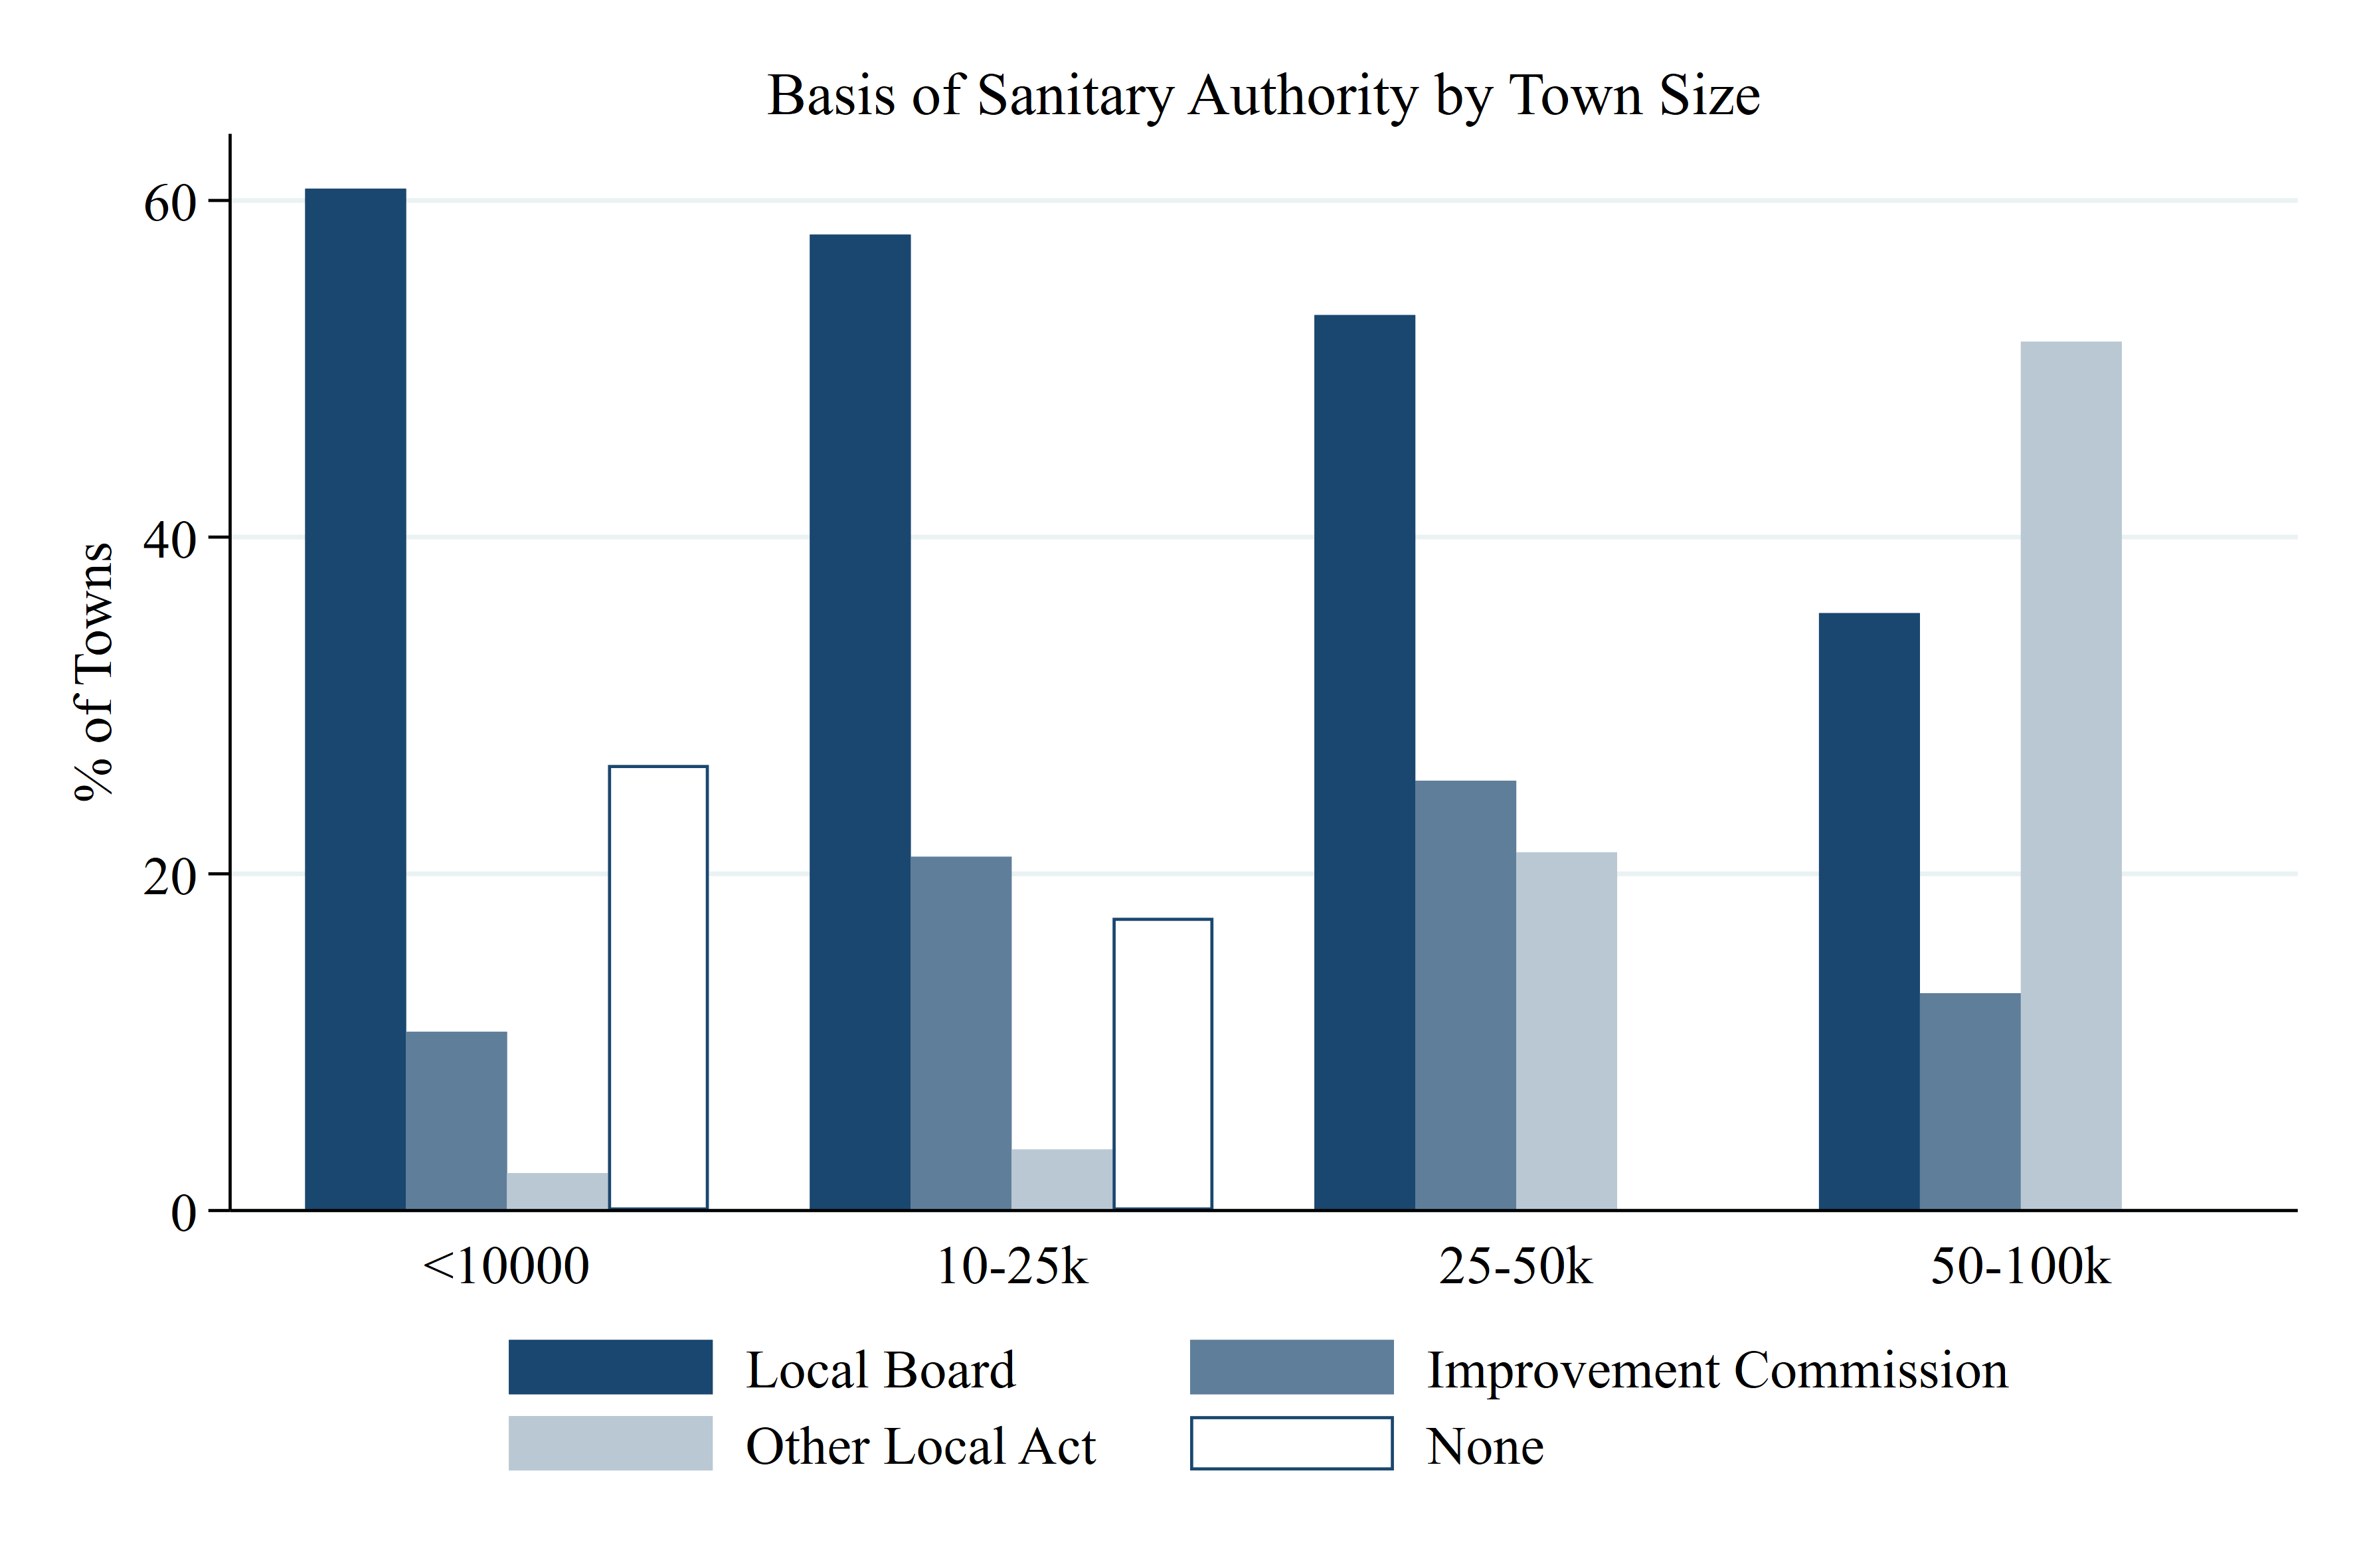
Note: “Local Board” includes boards created under the 1848 Public Health Act or the 1858 Local Government Act. “Improvement Commission” includes boards established as local improvement commissions. “Other local act” includes towns where sanitary authority was obtained under a diﬀerent form (for municipal boroughs only). Town size based on 1871 population: Small: <10,000 population, Medium: 10-25,000, Large: 25,000-50,000, and Very Large=>50,000.
Source: Census of England and Wales, 1871 (PP 1872 [Cd. C.676]), Returns showing Boroughs (PP 1874 (304) LVI.853) and Local Taxation Returns.

A.2 Municipal Trading
The accounts allow us to estimate the extent to which towns were making proﬁts on their trading activities between 1884 and 1903. Previous authors have emphasized that towns would use gas, tram and electricity undertakings to subsidize other activities; water supply, on the other hand would generally make a loss Millward (e.g., 2000).
I identify a trading operation in the annual accounts if a town has both current revenue and current expenditure in a single year. Proﬁts cannot directly be calculated in the period we study because loan charges (interest and principal) are not separated by activity. However, we can estimate the extent to which a town made a proﬁt by apportioning these charges according to the proportion of the outstanding stock attributed to that entity:
$${GrossProfit}_{i}={Revenue}_{i}-{CurrentExpenditure}_{i}$$
And estimate:
$${NetProfit}_{i}= {GrossProfit}_{i}-\left(\frac{{loansOutstanding}_{i} }{{loansOutstanding}_{Total}}\right){∙ loanMaintenance}_{Total}$$

where i in each case refers to the entity (for instance, water or gas supply).
The results of this analysis, summarized in Figure A.2, suggest that trading proﬁts were not generally a major contributor to town revenue. The left hand panel shows that these trading activities were not widespread—less than two-thirds of towns had even water supply operations in 1900. Further, as shown in the right hand panel, most operations were not making proﬁts that could subsidize other operations. Finally, proﬁts were not huge: the median gas proﬁt was 12% of rate revenue; for water 8%, and even less for Trams (2%) and Electric Lighting (1%).

Figure A.2: Municipal Trading Activities 1884-1903.

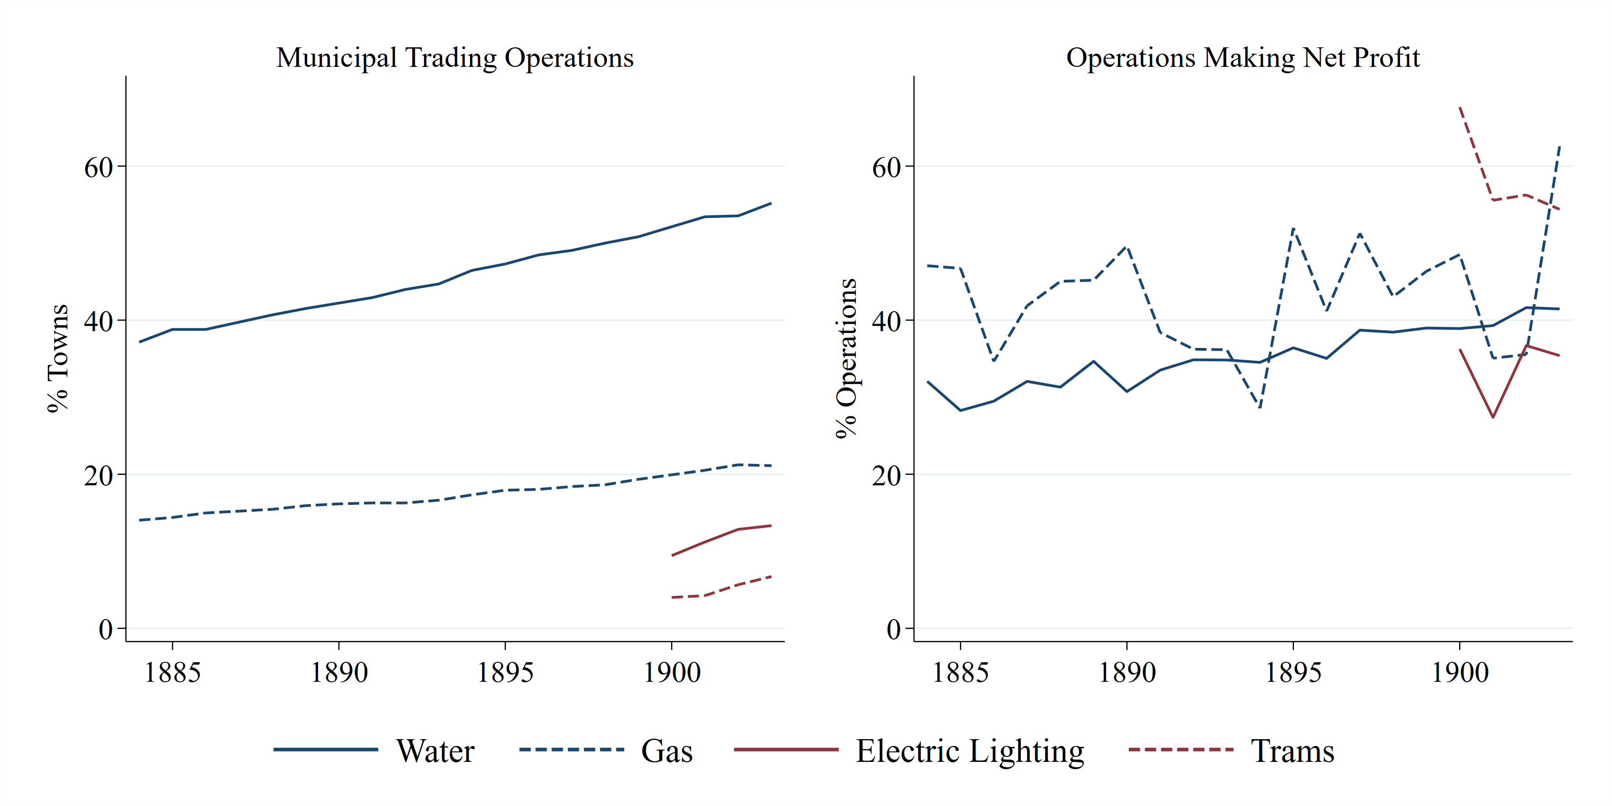
Note: A town is identiﬁed as having a trading activity if they report current revenue and expenditure in that year. Electric Lighting and Gas are only reported as separate categories from 1900 onwards, and only for municipal boroughs. Net proﬁt is calculated based on estimated loan charges: see text for details.
Source: See section “Data” and Data Appendix.

A comparison to more detailed trading accounts from 1902 supports the conclusion that trading activities did not make a major contribution to rates, although the rate of proﬁt making may have been higher than shown in Figure A.2. The report of the Royal Commission on Local Taxation (PP 1901 [Cd. 638] XXIV.413) provides detailed proﬁt and loss ﬁgures for undertakings in municipal boroughs averaged across the four year period 1898–1902, accounting for operating expenses, depreciation, and also loan maintenance payments. Doing so, it appears that the accounts methodology may underestimate the percentage of proﬁt-making enterprises: 76% of gas and 53% of water operations are proﬁt-making—whereas the estimated rates for the same entities in a single year (1901) using the methodology above are 54% and 35% respectively. The estimated contribution of proﬁts to rates is, however, similar: around 9% of rate revenue for proﬁt-making gas entities, 4% for water supply, and even less for trams and electricity supply.
A.3 Sanitation Investment
Figure A.3 displays the distribution of outstanding loans of each type in 1884 and 1903. The growth in investment reﬂected both new towns investing—as seen clearly in the fourth panel—and growing spending by those towns that had invested previously.

Figure A.3: Investment in all categories of sanitation infrastructure grew between 1884 and 1903.
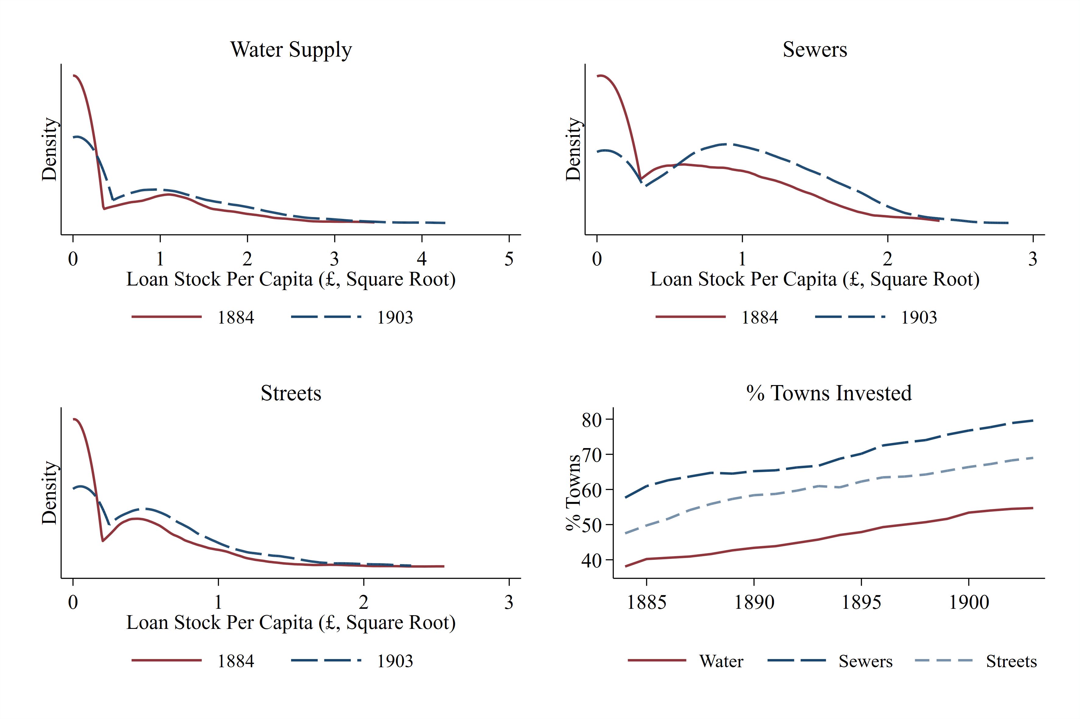
Note: Panels 1–3 display kernel density plots with bandwidth chosen by rule-of-thumb estimator. In the fourth panel, a town is identiﬁed as “invested” if they have loans outstanding in the relevant infrastructure type.
Source: See section “Data” and Data Appendix.

Table A.1 provides further detail on the type of sanitation projects sanctioned by the Local Government Board. The second column gives an indication of the expected life of the asset, as this was used to determine the loan term.

Table A.1: Usual length of loans granted for sanitation purposes.
Purpose of Loan |  | Usual Payment Period (Years)
Sewers:  Tanks, filters etc.  Sewage lifts  Shone’s ejector  Polarite  Sludge presses  Farm Stock  Streets:  First formation  Excavation and filling  Concrete foundation  Granite paving  Wood paving (hard)  Wood paving (soft)  Sanitary block or asphalt paving  Macadam  Kerbing and channeling  Trees on roads  Water supply:  Mains and pipes  Reservoirs  Water towers  Experimental works (boring)  Waste water meters  Purchase of existing undertaking |  | 30  30  15  10  10  5-10  20  30  20  20  Up to 10  Up to 5  10  5  15-20  10  30  30  30  5  10  Up to 30
Source: Select Committee on Repayment of Loans (PP 1902, VIII.239), Appendix 1.

Larger towns borrowed more frequently, and relied more on loans to ﬁnance sanitation. Figure A.4 shows the degree to which towns relied on loans to ﬁnance expenditure on sanitation. We can see that there was a growing dependence on loans particularly after 1890. Throughout the period, larger towns relied more on loans: over 45% of sanitation spending was ﬁnanced this way in 1903 in the largest towns. Smaller towns also borrowed less frequently: between 1884 and 1903, the smallest towns (1891 population <10,000) borrowed in 5 years on average, compared to 10 for those with a population of 10-50,000; and 15 for those above 50,000. This pattern remains after controlling for both the total amount borrowed and the average interest rate paid, suggesting it could reﬂect diﬀerent access to credit markets and not simply diﬀerences in demand. In particular, smaller towns may have had “lumpier” borrowing due to the diﬃculties associated with needing to return to the LGB to sanction each project.

Figure A.4: Larger towns were more reliant on borrowing to fund sanitation investment.
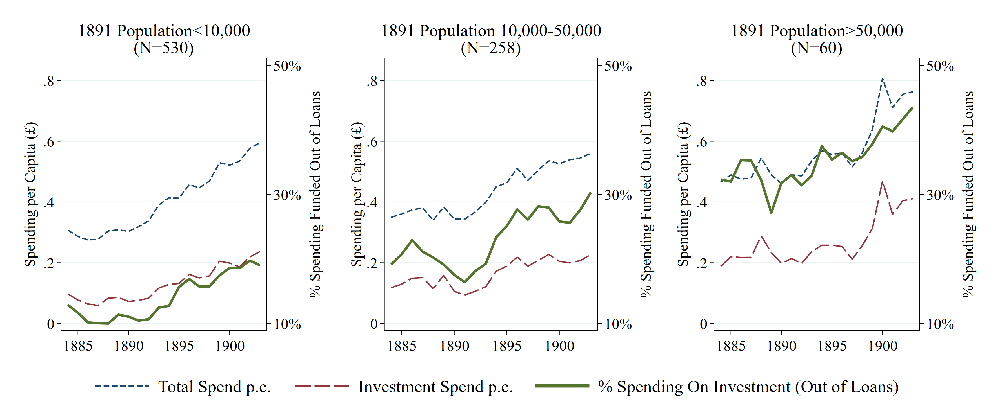
Note: “Total spend” includes all spending on water supply, sewers, and streets. “Investment spend” is then the portion that was ﬁnanced “out of loans”, with the remainder being spent “not out of loans”.
Source: See section “Data” and Data Appendix.

A.4 Town Council Stock Issues
This subsection presents further detail regarding the history of town council stock issues. Information regarding stock issues was collected from the Global Financial Database, which reports stocks listed on the London Stock Exchange. This data was then supplemented with information from Burdett (1894) which lists some additional stocks, and also identiﬁes the way in which towns obtained authorization to issue stock. Details of authorizations after 1894 were obtained from the annual reports of the Local Government Board.
Figure A.5 reports displays trends in stock issues between 1870 and 1910. We can see clearly that larger town councils issued stock earlier, with all of the very largest towns issuing stock by the early 1880s, and nearly all those with a population of over 100,000 issuing stock before 1890. Towns between 25,000 and 100,000 began to issue stock in the 1890s, with the number of towns issuing stock for the ﬁrst time peaking in 1895.
The peak in stock issues closely followed changes that made it easier for towns to gain authorization to issue stock. From 1892 onwards, towns could gain such authorization through a consent order from the Local Government Board rather than through a Local Act; after this point no towns were reported by the LGB to have gained authorization through Local Acts. This trend suggests that the changes wrought by the 1890 Public Health Act encouraged towns to issue stock, but we cannot cleanly disentangle such an eﬀect from growing demand due to the fall in interest rates after 1890.

Figure A.5: Stock issuance became more common after 1880.
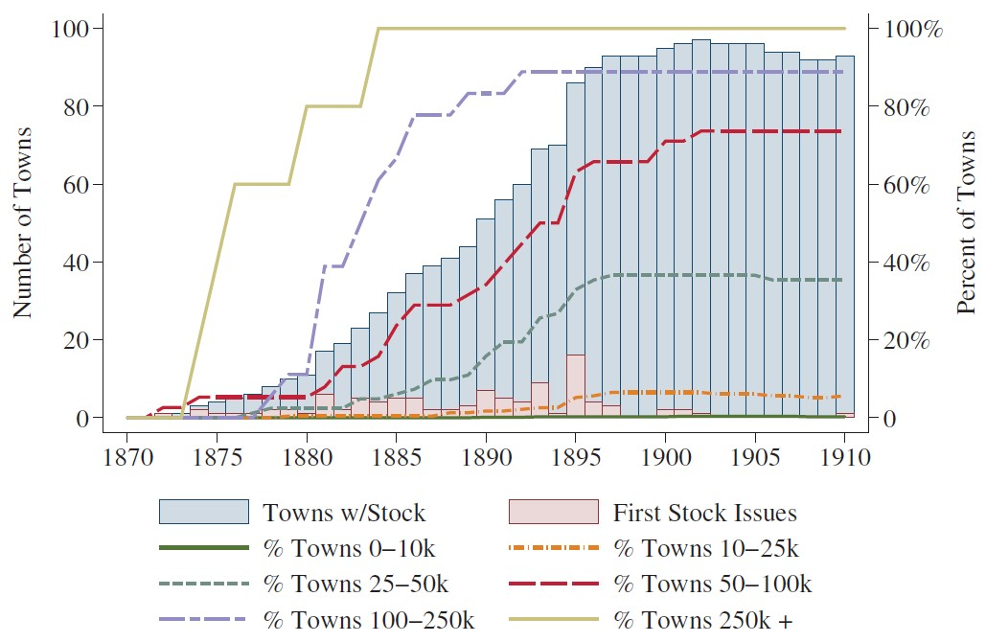
Note: “Towns w/ stock” represent the number of towns with stock issues outstanding each year, with percentages referring to the proportion of towns in each category holding outstanding stock. “First stock issues” represents the number of towns issuing stock for the ﬁrst time.
Source: See section “Data” and Data Appendix.

A.5 Borrowing from the Public Works Loan Board
This subsection provides additional information regarding borrowing from the Public Works Loan Board between 1882 and 1903.
Information on the amounts borrowed from the PWLB was published in the Annual Reports of the Public Works Loan Board from 1876 onward. From 1882 onward, this information included the outstanding balance of PWLB loans for each town. To understand the pattern of borrowing I thus collect this information for a series of cross-sections across our analysis period: 1882, 1886, 1892, 1896, 1897, 1898, 1899, and 1903—the clustering of years around 1897 was designed to understand changes in borrowing patterns following the 1897 cut to PWLB interest rates.

Figure A.6: Borrowing from PWLB increased after 1897 interest rate cut.
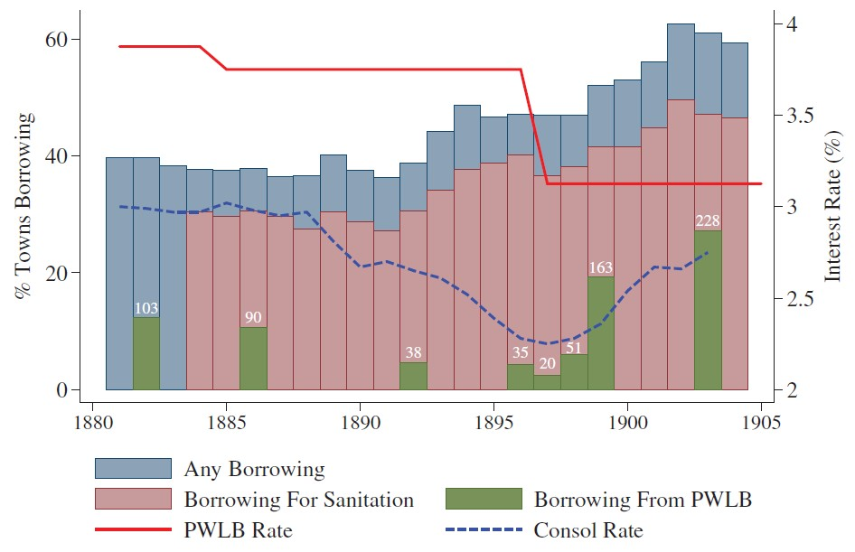
Note: The ﬁgure displays the percent of towns borrowing each year. Information on borrowing for sanitation purposes is available from 1884 onwards. PWLB data only available for a subset of years—see surrounding text for details. “PWLB rate” is the mid-point of the range of interest rates oﬀered by the Public Works Loan Board for sanitation investment.
Source: See section “Data” and Data Appendix.

The data, displayed in Figures A.6– A.8, show that borrowing from the PWLB declined between 1882 and 1896 before rebounding following the interest rate cut. Notably, Figure A.7 shows that this pattern was similar for towns of all sizes—even the largest towns started borrowing from the PWLB again after 1897. Figure A.8 displays the percent of outstanding loans borrowed from the PWLB, showing that the reliance on PWLB loans varied considerably across towns throughout the period. Some towns used the PWLB for the considerable majority of their loans, while for others it was a relatively small part of their total borrowing—the average share of loans from the PWLB, conditional on borrowing from them at all, was around 50%.

Figure A.7: Trends in PWLB borrowing were similar across town sizes.
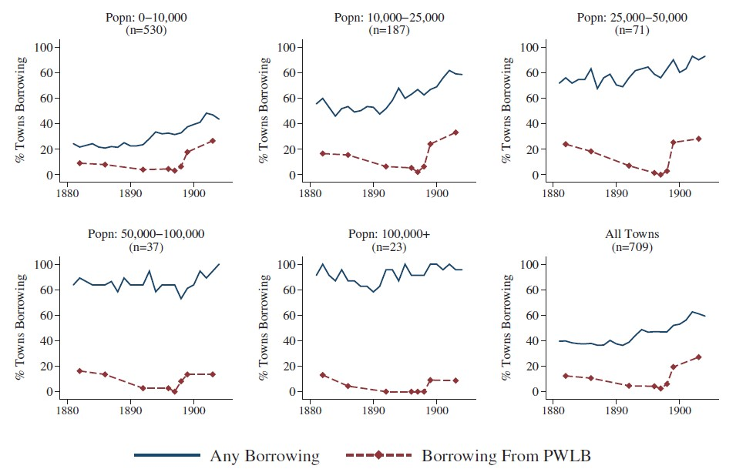
Note: The ﬁgure displays the percent of towns borrowing from PWLB and in total each year. PWLB data only available for a subset of years—see surrounding text for details. Town size is deﬁned based on 1891 population.
Source: See section “Data” and Data Appendix.

Figure A.8: Variation in proportion of loans borrowed from PWLB.
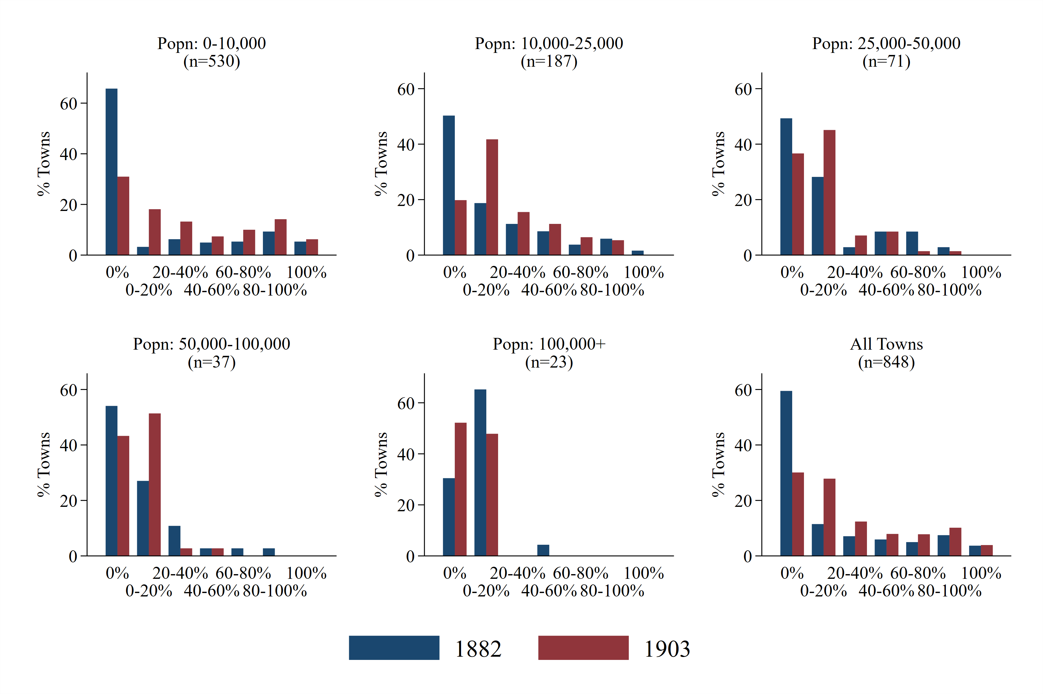
Note: The ﬁgure displays the percent of outstanding loans that were owed to the PWLB in 1882 and 1903. Town size is deﬁned based on 1891 population.
Source: See section “Data” and Data Appendix.

B Additional Results and Robustness
B.1 Robustness of Panel Regressions
This subsection reports robustness tests for the results in Tables 1 and 2. Table B.2 includes the lagged loan stock as a control variable—i.e., capturing previous investments in sanitation infrastructure. Table B.3 interacts a linear time trend with our measure of infant mortality for 1881–86. Doing so allows ﬂexibly for diﬀerential demand for public goods that is correlated with the initial disease environment—for instance, if high mortality towns tended to demand more spending for reasons that are not captured by the other control variables. Table B.4 includes the lagged interest rate as the key independent variable to check for possible reverse causality whereby high spending is artiﬁcially associated with a low interest rate due to the way the variable is constructed. Table B.5 limits the sample to three cross-sections, to reduce concerns about autocorrelation. The results are very similar across these speciﬁcations—the main change being that the magnitude of the eﬀect is lower when controlling for the lagged loan stock. This is not surprising given that the lagged term will capture some longer-term eﬀects of lower interest rates.
A second set of speciﬁcations checks that the results are not driven by outliers of either the interest rate or the dependent variables. While the square-root transformation addresses the potential for outliers to skew the results in part, the ﬁnancial variables are still right-skewed, and the interest rate variable is also noisy. As such, in Table B.6 I remove observations with the 5% lowest or highest value of the interest rate and in Table B.7 I remove the largest 10%positive values of the dependent variables in each year. In Table B.8 I log the dependent variables (meaning some observations with zero loans are lost). None of these adjustments signiﬁcantly changes the results.
The third set of specifications reports additional results regarding annual capital investment expenditure. Table B.9 presents speciﬁcations with the dependent variable measuring new loans each year—that is any addition to the outstanding loan stock, plus any principal repayments during the year. Tables B.10, B.11, and B.12 report investment spending—spending out of loans—on each of water supply, sewers, and streets respectively. Similarly to Table 2 they also report speciﬁcations with current expenditure on the relevant item. We can see consistent evidence that higher interest rates were strongly associated with lower capital spending, but little evidence of any negative relationship with current expenditure.

B.2 First Stage Results and Robustness of Instrumental Variables Regressions
This section additional first stage results, and the results of additional robustness tests for the instrumental variable regressions. Table B.13 displays the ﬁrst stage results for the regressions reported in Table 5. Table B.14 and Table B.15 present the IV speciﬁcations limiting the sample to only small towns (those with 1891 population less than 10,000). Table B16 replicates the results in Table 4, distinguishing between the diﬀerent types of sanitation spending. Dependent variables here are standardized in terms of total sanitation investment, so that the coeﬃcients are directly comparable to those in the table in the main text. The coeﬃcients are consistently negative, although not always statistically distinguishable from zero. Table B.17 displays speciﬁcations testing the eﬀect of investment on mortality, using the raw interest rate—rather than the predicted values—as an instrument. The coeﬃcients are consistently negative, and similar in magnitude to the main results, but noisier—often not distinguishable from zero.

Table B.2: Robustness to including lagged loan stock.
 | DV = (Standardized) per capita loans outstanding on:
 | Sanitation |  |  | Water |  |  | Sewers |  |  | Streets
Interest Rate | -0.07*** | -0.09*** |  | -0.03*** | -0.04*** |  | -0.06*** | -0.07*** |  | -0.02*** | 0.03***
 | (0.006) | (0.007) |  | (0.004) | (0.006) |  | (0.006) | (0.008) |  | (0.003) | (0.004)
Lag loans outstanding p.c. | 0.96*** | 0.83*** |  | 0.98*** | 0.84*** |  | 0.95*** | 0.87*** |  | 0.96*** | 0.80***
 | (0.004) | (0.011) |  | (0.003) | (0.018) |  | (0.003) | (0.009) |  | (0.004) | (0.013)
Tax base p.c. | 0.01*** | 0.03** |  | -0.00 | 0.01 |  | 0.01*** | 0.02 |  | 0.01*** | 0.01
 | (0.003) | (0.012) |  | (0.002) | (0.012) |  | (0.004) | (0.015) |  | (0.003) | (0.013)
Property receipts p.c. | -0.00* | -0.00 |  | -0.00 | 0.00 |  | -0.00 | -0.00 |  | -0.00** | -0.01*
 | (0.002) | (0.001) |  | (0.001) | (0.001) |  | (0.003) | (0.001) |  | (0.002) | (0.003)
Tolls & trading revenue p.c. | 0.01*** | 0.01 |  | 0.01** | 0.01 |  | 0.00 | 0.01 |  | 0.01** | 0.01
 | (0.003) | (0.012) |  | (0.003) | (0.013) |  | (0.003) | (0.011) |  | (0.003) | (0.011)
Transfers p.c.: streets | -0.00 | -0.00 |  | -0.00 | -0.00 |  | 0.00 | -0.00 |  | -0.01*** | -0.00
 | (0.003) | (0.004) |  | (0.002) | (0.003) |  | (0.004) | (0.006) |  | (0.002) | (0.004)
Transfers p.c.: other | 0.00 | -0.01*** |  | -0.00 | -0.01*** |  | -0.00 | 0.00 |  | 0.00 | 0.01
 | (0.003) | (0.003) |  | (0.002) | (0.003) |  | (0.003) | (0.003) |  | (0.003) | (0.004)
Town FE | N | Y |  | N | Y |  | N | Y |  | N | Y
Year FE | Y | Y |  | Y | Y |  | Y | Y |  | Y | Y
Controls | Y | Y |  | Y | Y |  | Y | Y |  | Y | Y
Observations | 12,991 | 12,991 |  | 12,991 | 12,991 |  | 12,991 | 12,991 |  | 12,991 | 12,991
No. of towns | 812 | 812 |  | 812 | 812 |  | 812 | 812 |  | 812 | 812
R-squared | 0.95 | 0.77 |  | 0.95 | 0.70 |  | 0.93 | 0.77 |  | 0.94 | 0.65
Note: “Lag Loans Outstanding” refers to loans in the relevant infrastructure category. See notes to Table 1 for further details.
Source: Author’s calculations; see text for details.

Table B.3: Robustness to allowing for differential time paths according to 1881–1886 infant mortality.
 | DV = (Standardized) per capita loans outstanding on:
 | Sanitation |  |  | Water |  |  | Sewers |  |  | Streets
Interest rate | -0.19*** | -0.11*** |  | -0.10*** | -0.06*** |  | -0.15*** | -0.10*** |  | -0.06*** | -0.02***
 | (0.014) | (0.010) |  | (0.013) | (0.009) |  | (0.014) | (0.012) |  | (0.013) | (0.008)
Tax base p.c. | 0.24*** | 0.12*** |  | 0.01 | 0.08** |  | 0.30*** | 0.08* |  | 0.22*** | 0.06
 | (0.028) | (0.036) |  | (0.029) | (0.034) |  | (0.036) | (0.043) |  | (0.030) | (0.041)
Property receipts p.c. | -0.01 | 0.01* |  | -0.01 | 0.00 |  | -0.01 | 0.01*** |  | 0.01 | -0.00
 | (0.013) | (0.005) |  | (0.017) | (0.005) |  | (0.022) | (0.003) |  | (0.024) | (0.004)
Tolls & trading revenue p.c. | 0.24*** | 0.05 |  | 0.27*** | 0.05 |  | 0.08*** | 0.04 |  | 0.14*** | 0.03
 | (0.032) | (0.043) |  | (0.043) | (0.050) |  | (0.026) | (0.037) |  | (0.034) | (0.037)
Transfers p.c.: streets | -0.00 | 0.02 |  | -0.04* | -0.01 |  | 0.05* | 0.03 |  | -0.09*** | 0.00
 | (0.021) | (0.016) |  | (0.022) | (0.010) |  | (0.027) | (0.021) |  | (0.022) | (0.012)
Transfers p.c.: other | 0.16*** | 0.00 |  | 0.18*** | -0.01 |  | -0.02 | 0.02** |  | 0.02 | 0.00
 | (0.033) | (0.010) |  | (0.044) | (0.014) |  | (0.021) | (0.010) |  | (0.029) | (0.009)
Infant mortality_{1881–1886} | 0.04 |  |  | 0.02 |  |  | 0.02 |  |  | 0.02
 | (0.032) |  |  | (0.038) |  |  | (0.035) |  |  | (0.034)
Infant mortality x Time | -0.00 | 0.00 |  | -0.01*** | -0.00 |  | 0.01* | 0.00 |  | -0.00 | 0.00
 | (0.002) | (0.002) |  | (0.002) | (0.002) |  | (0.003) | (0.003) |  | (0.002) | (0.003)
Town FE | N | Y |  | N | Y |  | N | Y |  | N | Y
Year FE | Y | Y |  | Y | Y |  | Y | Y |  | Y | Y
Controls | Y | Y |  | Y | Y |  | Y | Y |  | Y | Y
Observations | 12,991 | 12,991 |  | 12,991 | 12,991 |  | 12,991 | 12,991 |  | 12,991 | 12,991
No. of towns | 812 | 812 |  | 812 | 812 |  | 812 | 812 |  | 812 | 812
R-squared | 0.34 | 0.17 |  | 0.20 | 0.06 |  | 0.18 | 0.11 |  | 0.34 | 0.07
Note: “Infant Mortality x Time” is the interaction of a linear time trend with (standardized) 1881–1886 infant mortality. See notes to Table 1 for further details.
Source: Author’s calculations; see text for details.

Table B.4: Robustness to lagging interest rate.
 | DV = (Standardized) per capita loans outstanding on:
 | Sanitation |  |  | Water |  |  | Sewers |  |  | Streets
Lag interest rate | -0.18*** | -0.11*** |  | -0.10*** | -0.06*** |  | -0.15*** | -0.10*** |  | -0.05*** | -0.01
 | (0.016) | (0.010) |  | (0.015) | (0.010) |  | (0.016) | (0.013) |  | (0.015) | (0.008)
Tax base p.c. | 0.24*** | 0.12*** |  | 0.02 | 0.08** |  | 0.29*** | 0.06 |  | 0.22*** | 0.06
 | (0.028) | (0.038) |  | (0.030) | (0.037) |  | (0.036) | (0.045) |  | (0.030) | (0.041)
Property receipts p.c. | -0.02 | 0.01* |  | -0.01 | 0.00 |  | -0.02 | 0.01*** |  | 0.00 | -0.00
 | (0.014) | (0.005) |  | (0.016) | (0.005) |  | (0.024) | (0.003) |  | (0.023) | (0.004)
Tolls & trading revenue p.c. | 0.23*** | 0.05 |  | 0.27*** | 0.05 |  | 0.08*** | 0.04 |  | 0.14*** | 0.03
 | (0.032) | (0.043) |  | (0.043) | (0.050) |  | (0.026) | (0.037) |  | (0.033) | (0.036)
Transfers p.c.: streets | -0.00 | 0.02 |  | -0.04* | -0.00 |  | 0.05** | 0.02 |  | -0.09*** | 0.00
 | (0.021) | (0.014) |  | (0.022) | (0.010) |  | (0.027) | (0.019) |  | (0.022) | (0.012)
Transfers p.c.: other | 0.17*** | 0.00 |  | 0.19*** | -0.01 |  | -0.01 | 0.03*** |  | 0.02 | 0.00
 | (0.037) | (0.010) |  | (0.047) | (0.015) |  | (0.021) | (0.010) |  | (0.029) | (0.009)
Town FE | N | Y |  | N | Y |  | N | Y |  | N | Y
Year FE | Y | Y |  | Y | Y |  | Y | Y |  | Y | Y
Controls | Y | Y |  | Y | Y |  | Y | Y |  | Y | Y
Observations | 12,154 | 12,154 |  | 12,154 | 12,154 |  | 12,154 | 12,154 |  | 12,154 | 12,154
No. of towns | 811 | 811 |  | 811 | 811 |  | 811 | 811 |  | 811 | 811
R-squared | 0.34 | 0.16 |  | 0.19 | 0.06 |  | 0.18 | 0.10 |  | 0.34 | 0.06
Note: notes to Table 1.
Source: Author’s calculations; see text for details.

Table B.5: Robustness to limiting sample to three cross-sections.
 | DV = (Standardized) per capita loans outstanding on:
 | Sanitation |  |  | Water |  |  | Sewers |  |  | Streets
Interest rate | -0.16*** | -0.13*** |  | -0.09*** | -0.07*** |  | -0.13*** | -0.12*** |  | -0.04** | -0.01
 | (0.021) | (0.023) |  | (0.018) | (0.015) |  | (0.022) | (0.029) |  | (0.015) | (0.015)
Tax base p.c. | 0.24*** | 0.14*** |  | 0.01 | 0.09** |  | 0.29*** | 0.12** |  | 0.24*** | 0.08
 | (0.027) | (0.046) |  | (0.029) | (0.042) |  | (0.032) | (0.059) |  | (0.031) | (0.060)
Property receipts p.c. | -0.02 | 0.03 |  | 0.04 | 0.04 |  | -0.08*** | -0.01 |  | 0.01 | 0.06
 | (0.035) | (0.039) |  | (0.041) | (0.036) |  | (0.030) | (0.048) |  | (0.071) | (0.052)
Tolls & trading revenue p.c. | 0.24*** | 0.06 |  | 0.26*** | 0.06 |  | 0.09*** | 0.04 |  | 0.15*** | 0.04
 | (0.030) | (0.039) |  | (0.040) | (0.042) |  | (0.024) | (0.044) |  | (0.031) | (0.044)
Transfers p.c.: streets | 0.00 | 0.03 |  | -0.03 | -0.01 |  | 0.05* | 0.03 |  | -0.09*** | 0.01
 | (0.025) | (0.030) |  | (0.025) | (0.022) |  | (0.031) | (0.042) |  | (0.025) | (0.028)
Transfers p.c.: other | 0.12*** | -0.04 |  | 0.13*** | -0.07 |  | -0.02 | -0.01 |  | 0.02 | 0.04*
 | (0.036) | (0.029) |  | (0.047) | (0.047) |  | (0.025) | (0.024) |  | (0.040) | (0.021)
Town FE | N | Y |  | N | Y |  | N | Y |  | N | Y
Year FE | Y | Y |  | Y | Y |  | Y | Y |  | Y | Y
Controls | Y | Y |  | Y | Y |  | Y | Y |  | Y | Y
Observations | 2,293 | 2,293 |  | 2,293 | 2,293 |  | 2,293 | 2,293 |  | 2,293 | 2,293
No. of towns | 811 | 811 |  | 811 | 811 |  | 811 | 811 |  | 811 | 811
R-squared | 0.33 | 0.20 |  | 0.18 | 0.09 |  | 0.18 | 0.12 |  | 0.35 | 0.10
Note: Regressions include only observations for 1887, 1895, and 1903. See notes to Table 1 for further details.
Source: Author’s calculations; see text for details.

Table B.6: Robustness to excluding observations with extreme interest rates.
 | DV = (Standardized) per capita loans outstanding on:
 | Sanitation |  |  | Water |  |  | Sewers |  |  | Streets
Interest rate | -0.40*** | -0.29*** |  | -0.24*** | -0.14*** |  | -0.32*** | -0.27*** |  | -0.10** | -0.08***
 | (0.044) | (0.021) |  | (0.047) | (0.020) |  | (0.045) | (0.029) |  | (0.041) | (0.019)
Tax base p.c. | 0.24*** | 0.11*** |  | 0.01 | 0.09*** |  | 0.28*** | 0.04 |  | 0.22*** | 0.07
 | (0.029) | (0.036) |  | (0.030) | (0.035) |  | (0.037) | (0.043) |  | (0.031) | (0.044)
Property receipts p.c. | -0.01 | 0.01 |  | 0.00 | 0.00 |  | -0.02 | 0.01*** |  | 0.01 | -0.00
 | (0.013) | (0.005) |  | (0.019) | (0.006) |  | (0.024) | (0.003) |  | (0.026) | (0.005)
Tolls & trading revenue p.c. | 0.23*** | 0.06 |  | 0.26*** | 0.06 |  | 0.08*** | 0.06 |  | 0.14*** | 0.03
 | (0.032) | (0.045) |  | (0.043) | (0.052) |  | (0.026) | (0.036) |  | (0.034) | (0.037)
Transfers p.c.: streets | -0.01 | 0.02 |  | -0.05** | -0.00 |  | 0.06** | 0.02 |  | -0.10*** | 0.00
 | (0.020) | (0.015) |  | (0.022) | (0.011) |  | (0.027) | (0.018) |  | (0.021) | (0.013)
Transfers p.c.: other | 0.16*** | 0.00 |  | 0.18*** | -0.01 |  | -0.02 | 0.02** |  | 0.01 | -0.00
 | (0.034) | (0.011) |  | (0.045) | (0.016) |  | (0.023) | (0.010) |  | (0.030) | (0.010)
Town FE | N | Y |  | N | Y |  | N | Y |  | N | Y
Year FE | Y | Y |  | Y | Y |  | Y | Y |  | Y | Y
Controls | Y | Y |  | Y | Y |  | Y | Y |  | Y | Y
Observations | 11,693 | 11,693 |  | 11,693 | 11,693 |  | 11,693 | 11,693 |  | 11,693 | 11,693
No. of towns | 801 | 801 |  | 801 | 801 |  | 801 | 801 |  | 801 | 801
R-squared | 0.34 | 0.16 |  | 0.20 | 0.06 |  | 0.16 | 0.10 |  | 0.34 | 0.07
Note: Observations with interest rates in the top 5% or 95% of the sample are excluded. See notes to Table 1 for further details.
Source: Author’s calculations; see text for details.

Table B.7: Robustness to excluding observations with extreme values of dependent variables.
 | DV = (Standardized) per capita loans outstanding on:
 | Sanitation |  |  | Water |  |  | Sewers |  |  | Streets
Interest rate | -0.17*** | -0.11*** |  | -0.08*** | -0.05*** |  | -0.12*** | -0.08*** |  | -0.05*** | -0.02***
 | (0.012) | (0.009) |  | (0.011) | (0.007) |  | (0.012) | (0.009) |  | (0.011) | (0.007)
Tax base p.c. | 0.18*** | 0.08** |  | -0.00 | 0.03 |  | 0.15*** | 0.02 |  | 0.15*** | 0.07***
 | (0.022) | (0.035) |  | (0.026) | (0.031) |  | (0.025) | (0.036) |  | (0.024) | (0.028)
Property receipts p.c. | 0.00 | 0.01** |  | 0.01 | 0.00 |  | -0.01 | 0.01*** |  | -0.00 | -0.01***
 | (0.011) | (0.004) |  | (0.016) | (0.002) |  | (0.016) | (0.003) |  | (0.016) | (0.002)
Tolls & trading revenue p.c. | 0.15*** | 0.02 |  | 0.21*** | 0.02 |  | 0.08*** | 0.04 |  | 0.06** | 0.00
 | (0.023) | (0.031) |  | (0.035) | (0.025) |  | (0.023) | (0.032) |  | (0.025) | (0.032)
Transfers p.c.: streets | 0.01 | 0.03* |  | -0.03 | -0.00 |  | 0.01 | 0.01 |  | -0.08*** | -0.00
 | (0.019) | (0.015) |  | (0.020) | (0.009) |  | (0.029) | (0.021) |  | (0.019) | (0.009)
Transfers p.c.: other | 0.04* | 0.02** |  | 0.03 | -0.00 |  | -0.02 | 0.03** |  | -0.01 | -0.00
 | (0.022) | (0.009) |  | (0.031) | (0.007) |  | (0.019) | (0.011) |  | (0.020) | (0.006)
Town FE | N | Y |  | N | Y |  | N | Y |  | N | Y
Year FE | Y | Y |  | Y | Y |  | Y | Y |  | Y | Y
Controls | Y | Y |  | Y | Y |  | Y | Y |  | Y | Y
Observations | 11,768 | 11,768 |  | 12,312 | 12,312 |  | 11,981 | 11,981 |  | 12,108 | 12,108
No. of towns | 775 | 775 |  | 789 | 789 |  | 799 | 799 |  | 790 | 790
R-squared | 0.22 | 0.16 |  | 0.09 | 0.05 |  | 0.14 | 0.09 |  | 0.23 | 0.06
Note: Top 10% of positive values of each dependent variable in each year are excluded. See notes to Table 1 for further details.
Source: Author’s calculations; see text for details.

Table B.8: Results with logged dependent variables.
 | DV = Log per capita loans outstanding on:
 | Sanitation |  |  | Water |  |  | Sewers |  |  | Streets
Interest Rate | -0.33*** | -0.22*** |  | -0.22*** | -0.13*** |  | -0.23*** | -0.11*** |  | -0.18*** | -0.08***
 | (0.032) | (0.017) |  | (0.041) | (0.022) |  | (0.031) | (0.022) |  | (0.040) | (0.023)
Tax base p.c. | 0.30*** | 0.15*** |  | 0.21*** | 0.04 |  | 0.26*** | 0.10* |  | 0.36*** | 0.22***
 | (0.031) | (0.049) |  | (0.051) | (0.060) |  | (0.040) | (0.057) |  | (0.040) | (0.072)
Property receipts p.c. | 0.00 | 0.01*** |  | 0.02 | 0.02 |  | -0.02 | -0.00 |  | 0.02 | -0.01
 | (0.014) | (0.004) |  | (0.041) | (0.015) |  | (0.028) | (0.004) |  | (0.031) | (0.006)
Tolls & trading revenue p.c. | 0.23*** | 0.03 |  | 0.15*** | 0.04 |  | 0.13*** | 0.16*** |  | 0.14*** | 0.10**
 | (0.031) | (0.038) |  | (0.047) | (0.032) |  | (0.032) | (0.054) |  | (0.039) | (0.045)
Transfers p.c.: streets | 0.03 | 0.01 |  | -0.04 | -0.02 |  | 0.14*** | -0.01 |  | -0.09* | -0.04
 | (0.026) | (0.014) |  | (0.048) | (0.020) |  | (0.040) | (0.016) |  | (0.054) | (0.025)
Transfers p.c.: other | 0.13*** | 0.00 |  | 0.17*** | 0.01 |  | 0.02 | 0.04*** |  | -0.00 | 0.02
 | (0.032) | (0.008) |  | (0.041) | (0.006) |  | (0.024) | (0.013) |  | (0.052) | (0.014)
Town FE | N | Y |  | N | Y |  | N | Y |  | N | Y
Year FE | Y | Y |  | Y | Y |  | Y | Y |  | Y | Y
Controls | Y | Y |  | Y | Y |  | Y | Y |  | Y | Y
Observations | 12,320 | 12,320 |  | 6,887 | 6,887 |  | 10,158 | 10,158 |  | 8,914 | 8,914
No. of towns | 791 | 791 |  | 486 | 486 |  | 707 | 707 |  | 637 | 637
R-squared | 0.29 | 0.14 |  | 0.20 | 0.03 |  | 0.11 | 0.04 |  | 0.23 | 0.04
Note: Dependent variables are logged, with zero values excluded. See notes to Table 1 for further details.
Source: Author’s calculations; see text for details.

Table B.9: Falling interest rates associated with lower new loans per capita.
 | DV = (Standardized) New Loans per capita
 | Pooled  OLS |  | Tobit |  | Fixed  Effects |  | Fixed  Effects |  | FE  > 0
Interest rate | -0.28*** |  | -0.36*** |  | -0.32*** |  | -0.32*** |  | -0.40***
 | (0.022) |  | (0.021) |  | (0.025) |  | (0.025) |  | (0.032)
Tax base p.c. | 0.15*** |  | 0.14*** |  | 0.04 |  | 0.07* |  | 0.11**
 | (0.017) |  | (0.015) |  | (0.034) |  | (0.035) |  | (0.049)
Property receipts p.c. | -0.02* |  | -0.02 |  | -0.01* |  | -0.01 |  | 0.05*
 | (0.011) |  | (0.017) |  | (0.006) |  | (0.006) |  | (0.028)
Tolls & trading revenue p.c. | 0.20*** |  | 0.15*** |  | 0.27*** |  | 0.28*** |  | 0.27***
 | (0.017) |  | (0.012) |  | (0.045) |  | (0.048) |  | (0.054)
Transfers p.c.: streets | -0.03*** |  | -0.03*** |  | -0.05*** |  | -0.04*** |  | -0.06***
 | (0.014) |  | (0.015) |  | (0.014) |  | (0.014) |  | (0.021)
Transfers p.c.: other | 0.01 |  | 0.01 |  | -0.01 |  | -0.00 |  | -0.01
 | (0.012) |  | (0.010) |  | (0.012) |  | (0.012) |  | (0.012)
Lag loan stock p.c. |  |  |  |  |  |  | -0.21*** |  | -0.28***
 |  |  |  |  |  |  | (0.033) |  | (0.041)
Town FE | N |  | N |  | Y |  | Y |  | Y
Year FE | Y |  | Y |  | Y |  | Y |  | Y
Controls | Y |  | Y |  | Y |  | Y |  | Y
Observations | 12,991 |  | 12,991 |  | 12,991 |  | 12,991 |  | 8,085
No. of towns | 812 |  | 812 |  | 812 |  | 812 |  | 795
R-squared | 0.29 |  | - |  | 0.17 |  | 0.18 |  | 0.21
Note: ``New loans’’=Change in loans outstanding, plus repayment of principal. See notes to Table 2 for details of specifications.
Source: Author’s calculations; see text for details.

Table B.10: Falling interest rates associated with lower capital spending on water supply.
 | Spending Out of Loans p.c.: |  |  |  |  |  |  |  |  |  |  | Current Spending p.c.:  (Placebo Test)
 | Pooled  OLS |  | Tobit |  | Fixed  Effects |  | Fixed  Effects |  | FE  > 0 |  |  |  | Pooled  OLS |  | Fixed Effects
Interest rate | -0.15*** |  | -0.18*** |  | -0.16*** |  | -0.16*** |  | -0.39*** |  |  |  | -0.04*** |  | -0.00
 | (0.016) |  | (0.019) |  | (0.021) |  | (0.021) |  | (0.069) |  |  |  | (0.015) |  | (0.008)
Tax base p.c. | 0.02 |  | 0.02 |  | 0.04 |  | 0.03 |  | 0.17 |  |  |  | 0.03 |  | 0.08**
 | (0.019) |  | (0.021) |  | (0.042) |  | (0.043) |  | (0.132) |  |  |  | (0.034) |  | (0.037)
Lag loan stock p.c. |  |  |  |  |  |  | 0.08 |  | -0.82***
 |  |  |  |  |  |  | (0.059) |  | (0.116)
Property receipts p.c. | -0.02 |  | -0.03 |  | -0.00 |  | 0.00 |  | 0.09 |  |  |  | 0.04 |  | 0.01***
 | (0.013) |  | (0.025) |  | (0.007) |  | (0.006) |  | (0.092) |  |  |  | (0.027) |  | (0.003)
Tolls & trading revenue p.c. | 0.13*** |  | 0.12*** |  | 0.06 |  | 0.06 |  | 0.07 |  |  |  | 0.24*** |  | 0.08**
 | (0.027) |  | (0.017) |  | (0.059) |  | (0.058) |  | (0.125) |  |  |  | (0.036) |  | (0.038)
Transfers p.c.: streets | -0.03* |  | -0.03 |  | -0.02 |  | -0.02 |  | -0.09 |  |  |  | 0.01 |  | 0.02
 | (0.014) |  | (0.021) |  | (0.013) |  | (0.013) |  | (0.057) |  |  |  | (0.028) |  | (0.014)
Transfers p.c.: other | 0.05* |  | 0.03* |  | -0.06*** |  | -0.06*** |  | -0.01 |  |  |  | -0.00 |  | -0.02
 | (0.027) |  | (0.017) |  | (0.015) |  | (0.015) |  | (0.051) |  |  |  | (0.032) |  | (0.022)
Town FE | N |  | N |  | Y |  | Y |  | Y |  |  |  | N |  | Y
Year FE | Y |  | Y |  | Y |  | Y |  | Y |  |  |  | Y |  | Y
Controls | Y |  | Y |  | Y |  | Y |  | Y |  |  |  | Y |  | Y
Observations | 12,990 |  | 12,990 |  | 12,990 |  | 12,990 |  | 3,403 |  |  |  | 12,991 |  | 12,991
No. of towns | 812 |  | 812 |  | 812 |  | 812 |  | 445 |  |  |  | 812 |  | 812
R-squared | 0.07 |  | - |  | 0.04 |  | 0.04 |  | 0.15 |  |  |  | 0.09 |  | 0.09
Note: See notes to Table 2.
Source: Author’s calculations; see text for details.

Table B.11: Falling interest rates associated with lower capital spending on sewers.
 | Spending Out of Loans p.c.: |  |  |  |  |  |  |  |  |  | Current Spending p.c.:  (Placebo Test)
 | Pooled  OLS |  | Tobit |  | Fixed  Effects |  | Fixed  Effects |  | FE  > 0 |  | Pooled  OLS |  | Fixed Effects
Interest rate | -0.20*** |  | -0.27*** |  | -0.20*** |  | -0.19*** |  | -0.35*** |  | 0.01 |  | 0.02*
 | (0.019) |  | (0.020) |  | (0.021) |  | (0.021) |  | (0.045) |  | (0.015) |  | (0.009)
Tax base p.c. | 0.12*** |  | 0.12*** |  | 0.09 |  | 0.08 |  | 0.22** |  | 0.27*** |  | 0.13***
 | (0.016) |  | (0.015) |  | (0.056) |  | (0.054) |  | (0.097) |  | (0.033) |  | (0.038)
Lag loan stock p.c. |  |  |  |  |  |  | 0.23*** |  | -0.29***
 |  |  |  |  |  |  | (0.033) |  | (0.054)
Property receipts p.c. | -0.03* |  | -0.08*** |  | -0.01* |  | -0.01** |  | 0.05 |  | 0.01 |  | 0.00
 | (0.014) |  | (0.023) |  | (0.005) |  | (0.005) |  | (0.049) |  | (0.013) |  | (0.005)
Tolls & trading revenue p.c. | 0.03* |  | 0.03*** |  | 0.04 |  | 0.03 |  | 0.16** |  | 0.06** |  | 0.02
 | (0.017) |  | (0.013) |  | (0.054) |  | (0.050) |  | (0.065) |  | (0.027) |  | (0.030)
Transfers p.c.: streets | 0.03* |  | 0.03** |  | -0.03 |  | -0.04 |  | -0.06** |  | 0.08*** |  | 0.03**
 | (0.016) |  | (0.015) |  | (0.021) |  | (0.022) |  | (0.032) |  | (0.028) |  | (0.015)
Transfers p.c.: other | -0.02 |  | -0.03* |  | -0.01 |  | -0.02 |  | -0.02 |  | -0.04* |  | 0.02
 | (0.017) |  | (0.015) |  | (0.014) |  | (0.013) |  | (0.026) |  | (0.024) |  | (0.015)
Town FE | N |  | N |  | Y |  | Y |  | Y |  | N |  | Y
Year FE | Y |  | Y |  | Y |  | Y |  | Y |  | Y |  | Y
Controls | Y |  | Y |  | Y |  | Y |  | Y |  | Y |  | Y
Observations | 12,991 |  | 12,991 |  | 12,991 |  | 12,991 |  | 4,889 |  | 12,991 |  | 12,991
No. of towns | 812 |  | 812 |  | 812 |  | 812 |  | 624 |  | 812 |  | 812
R-Squared | 0.09 |  | - |  | 0.06 |  | 0.08 |  | 0.09 |  | 0.17 |  | 0.16
Note: See notes to Table 2.
Source: Author’s calculations; see text for details.

Table B.12: Falling interest rates associated with lower capital spending on streets.
 | Spending Out of Loans p.c.: |  |  |  |  |  |  |  |  |  | Current Spending p.c.:  (Placebo Test)
 | Pooled  OLS |  | Tobit |  | Fixed  Effects |  | Fixed  Effects |  | FE  > 0 |  | Pooled  OLS |  | Fixed Effects
Interest rate | -0.09*** |  | -0.12*** |  | -0.08*** |  | -0.08*** |  | -0.27*** |  | -0.01 |  | -0.00
 | (0.011) |  | (0.016) |  | (0.012) |  | (0.012) |  | (0.048) |  | (0.012) |  | (0.006)
Tax base p.c. | 0.14*** |  | 0.12*** |  | 0.02 |  | 0.00 |  | -0.02 |  | 0.42*** |  | 0.19***
 | (0.019) |  | (0.018) |  | (0.040) |  | (0.039) |  | (0.093) |  | (0.023) |  | (0.031)
Lag loan Stock p.c. |  |  |  |  |  |  | 0.18*** |  | -0.13**
 |  |  |  |  |  |  | (0.034) |  | (0.067)
Property receipts p.c. | -0.01 |  | -0.03 |  | 0.00 |  | 0.00 |  | 0.05 |  | 0.01 |  | 0.01*
 | (0.014) |  | (0.028) |  | (0.006) |  | (0.006) |  | (0.082) |  | (0.011) |  | (0.004)
Tolls & trading revenue p.c. | 0.07*** |  | 0.04*** |  | 0.09** |  | 0.08** |  | 0.19*** |  | 0.03* |  | 0.03*
 | (0.024) |  | (0.014) |  | (0.042) |  | (0.041) |  | (0.062) |  | (0.017) |  | (0.016)
Transfers p.c.: streets | -0.04*** |  | -0.06*** |  | -0.01 |  | -0.01 |  | -0.02 |  | 0.46*** |  | 0.24***
 | (0.013) |  | (0.020) |  | (0.015) |  | (0.014) |  | (0.050) |  | (0.060) |  | (0.046)
Transfers p.c.: other | -0.01 |  | -0.02 |  | 0.02 |  | 0.02 |  | 0.01 |  | 0.02 |  | 0.01*
 | (0.019) |  | (0.015) |  | (0.017) |  | (0.016) |  | (0.027) |  | (0.019) |  | (0.009)
Town FE | N |  | N |  | Y |  | Y |  | Y |  | N |  | Y
Year FE | Y |  | Y |  | Y |  | Y |  | Y |  | Y |  | Y
Controls | Y |  | Y |  | Y |  | Y |  | Y |  | Y |  | Y
Observations | 12,991 |  | 12,991 |  | 12,991 |  | 12,991 |  | 4,313 |  | 12,991 |  | 12,991
No. of towns | 812 |  | 812 |  | 812 |  | 812 |  | 577 |  | 812 |  | 812
R-Squared | 0.18 |  | - |  | 0.04 |  | 0.05 |  | 0.05 |  | 0.53 |  | 0.33
Note: See notes to Table 2.
Source: Author’s calculations; see text for details.

Table B.13: First stage regressions for specifications reported in Tables 5 and B.17.
 |  | DV = (Standardized) Sanitation Investment p.c. _{1887–1903}
 |  | (1) |  |  | (2) |  |  |  |  |  | (3) |  |  |  |  |  | (4) |  |  |  |  |  | (5) |  |  |  |  |  | (6)
Predicted: Δ Interest rate₁₈₈₇₋₁₉₀₃ |  | -0.15*** |  |  |  | -0.24*** |  |  |  |  |  | -0.17***
 |  | (0.038) |  |  |  | (0.037) |  |  |  |  |  | (0.039)
Δ Interest rate₁₈₈₇₋₁₉₀₃ |  |  |  |  |  |  |  |  |  |  |  |  |  |  |  |  |  | -0.33*** |  |  |  |  |  | -0.37*** |  |  |  |  |  | -0.33***
 |  |  |  |  |  |  |  |  |  |  |  |  |  |  |  |  |  | (0.085) |  |  |  |  |  | (0.085) |  |  |  |  |  | (0.082)
Loan stock p.c.₁₈₈₆ |  |  |  |  |  | 0.28*** |  |  |  |  |  | 0.15*** |  |  |  |  |  |  |  |  |  |  |  | 0.22*** |  |  |  |  |  | 0.08*
 |  |  |  |  |  | (0.043) |  |  |  |  |  | (0.050) |  |  |  |  |  |  |  |  |  |  |  | (0.045) |  |  |  |  |  | (0.049)
Tax base p.c.₁₈₈₆ |  |  |  |  |  |  |  |  |  |  |  | 0.16*** |  |  |  |  |  |  |  |  |  |  |  |  |  |  |  |  |  | 0.19***
 |  |  |  |  |  |  |  |  |  |  |  | (0.043) |  |  |  |  |  |  |  |  |  |  |  |  |  |  |  |  |  | (0.042)
Δ Tax base p.c.₁₈₈₆₋₁₉₀₃ |  |  |  |  |  |  |  |  |  |  |  | 0.16*** |  |  |  |  |  |  |  |  |  |  |  |  |  |  |  |  |  | 0.15***
 |  |  |  |  |  |  |  |  |  |  |  | (0.040) |  |  |  |  |  |  |  |  |  |  |  |  |  |  |  |  |  | (0.040)
Demographic controls |  | Y |  |  |  |  | Y |  |  |  |  |  | Y |  |  |  |  |  | Y |  |  |  |  |  | Y |  |  |  |  |  | Y
Revenue controls |  | N |  |  |  |  | N |  |  |  |  |  | Y |  |  |  |  |  | N |  |  |  |  |  | N |  |  |  |  |  | Y
Kleibergen-Papp stat |  | 16.8 |  |  |  |  | 39.9 |  |  |  |  |  | 18.3 |  |  |  |  |  | 15.4 |  |  |  |  |  | 19.6 |  |  |  |  |  | 15.9
Observations |  | 641 |  |  |  |  | 641 |  |  |  |  |  | 641 |  |  |  |  |  | 641 |  |  |  |  |  | 641 |  |  |  |  |  | 641
Note: The ﬁrst three columns are the ﬁrst stage regressions for the speciﬁcations in Table 5, using the predicted change in interest rate. Speciﬁcations 4–6 are the ﬁrst stage regressions for the speciﬁcations in Table B.17, using the actual change in interest rate as an instrument. Tax base, expenditure, and loan stock variables are square-root-transformed. Demographic controls include population, population density, and population growth. Revenue variables include the average per capita revenue from property, grants for roads, other grants, and fees.
Source: Author’s calculations; see text for details.

Table B.14: Robustness of results in Table 4 to limiting sample to small towns.
 | DV = (Standardized) Sanitation Investment p.c.
 | 1887-1903: |  |  |  |  |  |  |  | 1898-1903
Panel A: OLS and Second Stage from 2SLS Specifications
 | OLS |  | IV |  | OLS |  | IV |  | OLS |  | IV
Δ Interest rate₁₈₈₇₋₁₉₀₃ | -0.43*** |  | -0.96*** |  | -0.42*** |  | -1.19***
 | (0.112) |  | (0.286) |  | (0.110) |  | (0.297)
Δ Interest rate₁₈₈₇₋₁₈₉₇ |  |  |  |  |  |  |  |  | -0.20 |  | -1.00**
 |  |  |  |  |  |  |  |  | (0.129) |  | (0.443)
Loan stock p.c.₁₈₈₆ | 0.07 |  | 0.10 |  | 0.03 |  | 0.05 |  | 0.05 |  | 0.12
 | (0.079) |  | (0.082) |  | (0.085) |  | (0.088) |  | (0.080) |  | (0.089)
Tax base p.c.₁₈₈₆ | 0.17*** |  | 0.15** |  | 0.21*** |  | 0.19*** |  | 0.15** |  | 0.13*
 | (0.063) |  | (0.064) |  | (0.066) |  | (0.068) |  | (0.066) |  | (0.070)
Δ Tax base p.c.₁₈₈₆₋₁₉₀₃ |  |  |  |  | 0.14*** |  | 0.13***
 |  |  |  |  | (0.052) |  | (0.052)
Δ Tax base p.c.₁₈₉₇₋₁₉₀₃ |  |  |  |  |  |  |  |  | 0.05 |  | 0.04
 |  |  |  |  |  |  |  |  | (0.055) |  | (0.054)
Panel B: Abbreviated First Stage Regressions (D.V.=Δ Interest Rate)
Predicted: Δ Interest rate₁₈₈₇₋₁₉₀₃ |  |  | 0.38*** |  |  |  | 0.41*** |  |  |  | 0.28***
 |  |  | (0.058) |  |  |  | (0.064) |  |  |  | (0.054)
 |  |  | 0.24*** |  |  |  | 0.24*** |  |  |  | 0.16***
 |  |  | (0.054) |  |  |  | (0.058) |  |  |  | (0.045)
Demographic controls | Y |  | Y |  | Y |  | Y |  | Y |  | Y
Revenue controls | Y |  | N |  | Y |  | Y |  | Y |  | Y
Kleibergen-Papp stat | - |  | 25.8 |  | - |  | 24.8 |  | - |  | 19.0
Bootstrap-c p-value | 0.00 |  | 0.00 |  | 0.00 |  | 0.00 |  | 0.10 |  | 0.03
Hansen J overid. p-value | - |  | 0.03 |  | - |  | 0.12 |  | - |  | 0.73
Endogeneity test p-value | - |  | 0.05 |  | - |  | 0.10 |  | - |  | 0.05
Observations | 351 |  | 351 |  | 351 |  | 351 |  | 347 |  | 347
Note: The table reports the same specifications as in Table 4, but with the sample limited to towns with population under 10,000 in 1891. See notes to that table for further details.
Source: Author’s calculations; see text for details.

Table B.15: Robustness of results in Table 5 to limiting sample to small towns.
 | DV = Δ Infant Mortality 1881–1910 (Standardized)
 | OLS |  | IV |  | OLS |  | IV |  | OLS |  | IV
Sanitation investment p.c._{1887–1903} | -0.20*** |  | -0.35 |  | -0.20*** |  | -0.32 |  |  |  | -0.44
 | (0.045) |  | (0.273) |  | (0.046) |  | (0.248) |  |  |  | (0.321)
Infant mortality₁₈₈₁₋₁₈₈₆ | -0.41*** |  | -0.42*** |  | -0.41*** |  | -0.41*** |  | -0.47*** |  | -0.46***
 | (0.079) |  | (0.079) |  | (0.079) |  | (0.079) |  | (0.081) |  | (0.082)
Loan stock p.c.₁₈₈₆ |  |  |  |  | 0.02 |  | 0.03 |  | 0.02 |  | 0.02
 |  |  |  |  | (0.059) |  | (0.065) |  | (0.060) |  | (0.063)
Δ Tax base p.c.₁₈₈₆₋₁₉₀₃ |  |  |  |  |  |  |  |  | -0.14*** |  | -0.10*
 |  |  |  |  |  |  |  |  | (0.043) |  | (0.061)
Tax base p.c.₁₈₈₆ |  |  |  |  |  |  |  |  | -0.08 |  | -0.02
 |  |  |  |  |  |  |  |  | (0.057) |  | (0.095)
Demographic controls | Y |  | Y |  | Y |  | Y |  | Y |  | Y
Revenue controls | N |  | N |  | N |  | N |  | N |  | N
Kleibergen-Papp stat | - |  | 13.4 |  | - |  | 17.0 |  | - |  | 9.8
Bootstrap-c p-value | 0.00 |  | 0.28 |  | 0.00 |  | 0.24 |  | 0.00 |  | 0.22
Endogeneity test p-value | - |  | 0.58 |  | - |  | 0.61 |  | - |  | 0.37
Observations | 351 |  | 351 |  | 351 |  | 351 |  | 351 |  | 351
Note: The table reports the same speciﬁcations as in Table 5, but with the sample limited to towns with population under 10,000 in 1891. See notes to that table for further details.
Source: Author’s calculations; see text for details.

Table B.16: Instrumental Variables Regressions for Different Spending Types.
 | DV = (Standardized) Sanitation Investment p.c. ₁₈₈₇₋₁₉₀₃
 | Water |  |  |  | Sewers |  |  |  | Streets
 | OLS |  | IV |  | OLS |  | IV |  | OLS |  | IV
Δ Interest rate₁₈₈₇₋₁₉₀₃ | -0.09 |  | -0.24 |  | -0.24*** |  | -0.59** |  | -0.01 |  | -0.21
 | (0.076) |  | (0.266) |  | (0.071) |  | (0.260) |  | (0.044) |  | (0.149)
Loan stock p.c.₁₈₈₆ | 0.31*** |  | 0.32*** |  | -0.10*** |  | -0.08** |  | 0.15*** |  | 0.14***
 | (0.042) |  | (0.041) |  | (0.033) |  | (0.037) |  | (0.026) |  | (0.026)
Tax base p.c.₁₈₈₆ | 0.02 |  | 0.02 |  | 0.15*** |  | 0.14*** |  | 0.12*** |  | 0.11***
 | (0.040) |  | (0.040) |  | (0.033) |  | (0.035) |  | (0.025) |  | (0.025)
Δ Tax base p.c.₁₈₈₆₋₁₉₀₃ | 0.09** |  | 0.08** |  | 0.12*** |  | 0.11*** |  | 0.05* |  | 0.04
 | (0.038) |  | (0.039) |  | (0.033) |  | (0.035) |  | (0.029) |  | (0.028)
Demographic controls | Y |  | Y |  | Y |  | Y |  | Y |  | Y
Revenue controls | Y |  | Y |  | Y |  | Y |  | Y |  | Y
Kleibergen-Papp stat | - |  | 30.4 |  | - |  | 23.1 |  | - |  | 27.7
Bootstrap-c p-value | 0.23 |  | 0.38 |  | 0.00 |  | 0.03 |  | 0.79 |  | 0.18
Hansen J overid. p-value | - |  | 0.63 |  | - |  | 0.60 |  | - |  | 0.37
Endogeneity test p-value | - |  | 0.58 |  | - |  | 0.14 |  | - |  | 0.15
Observations | 641 |  | 641 |  | 641 |  | 641 |  | 641 |  | 641
Note: Tax base, expenditure, and loan stock variables are square-root-transformed and standardized. Interest variables are instrumented using the % of Loans from the PWLB in 1882, and any PWLB loan being taken out 1882–1886. Demographic controls include population density and population growth. Revenue variables include the average per capita revenue from property, grants for roads, other grants, and fees.
Source: Author’s calculations; see text for details.

Table B.17: Mortality Results with Interest Rate as Instrument.
 | DV = Δ Infant Mortality 1881–1911 (Standardized)
 | OLS |  | IV |  | OLS |  | IV |  | OLS |  | IV
Sanitation investment p.c._{1887–1903} | -0.14*** |  | -0.40* |  | -0.15*** |  | -0.34 |  | -0.12*** |  | -0.30
 | (0.036) |  | (0.240) |  | (0.038) |  | (0.209) |  | (0.038) |  | (0.231)
Infant mortality₁₈₈₁₋₁₈₈₆ | -0.48*** |  | -0.49*** |  | -0. 48*** |  | -0. 48*** |  | -0.53*** |  | -0.53***
 | (0.058) |  | (0.058) |  | (0.056) |  | (0.057) |  | (0.054) |  | (0.055)
Loan stock p.c.₁₈₈₆ |  |  |  |  | 0.06* |  | 0.10* |  | 0.08** |  | 0.09**
 |  |  |  |  | (0.037) |  | (0.056) |  | (0.039) |  | (0.042)
Δ Tax base p.c.₁₈₈₆₋₁₉₀₃ |  |  |  |  |  |  |  |  | -0.15*** |  | -0.12**
 |  |  |  |  |  |  |  |  | (0.035) |  | (0.049)
Tax base p.c.₁₈₈₆ |  |  |  |  |  |  |  |  | -0.18*** |  | -0.14**
 |  |  |  |  |  |  |  |  | (0.040) |  | (0.060)
Demographic controls | Y |  | Y |  | Y |  | Y |  | Y |  | Y
Revenue controls | N |  | N |  | N |  | N |  | Y |  | Y
Kleibergen-Papp stat | - |  | 15.4 |  | - |  | 19.6 |  | - |  | 15.9
Bootstrap-c p-value | 0.00 |  | 0.12 |  | 0.00 |  | 0.14 |  | 0.00 |  | 0.23
Endogeneity test p-value | - |  | 0.26 |  | - |  | 0.36 |  | - |  | 0.42
Observations | 641 |  | 641 |  | 641 |  | 641 |  | 641 |  | 641
Note: The dependent variable is the diﬀerence between infant mortality between 1881–1886 and 1904–1911. Tax base, expenditure, and loan stock variables are square-root-transformed. All variables. Sanitation investment is instrumented using the change in interest rate between 1887 and 1903. Demographic controls include population, population density, and population growth. Revenue variables include the average per capita revenue from property, grants for roads, other grants, and fees.
Source: Author’s calculations; see text for details.

