*Malthus Goes to China: The Effect of “Positive Checks” on Grain Market Development, 1736-1910*

*Online Appendix*

Appendix A: **A Band-TAR Model**

We use a Band-TAR model to calculate the speed of price adjustment—a method widely used in the studies of market integration—and thus measure the level of market efficiency (Ejrnæs and Persson 2000; Federico 2012; Jacks 2005; Jacks 2006).

Consider the case where there are only two prefectures and that the first prefecture is a net importer and the second a net exporter. Further suppose that a well-functioning market exists between them, so that prices in the first prefecture will be adjusted smoothly in the market of the second prefecture. Denote the prices of the first prefecture and the second prefecture in period *t* by $P_{t}^{1}$ and $P_{t}^{2}$, respectively. We expect $P_{t}^{1}≤P_{t}^{2}+C_{t}^{21}$, where $C_{t}^{21}$ is the transaction cost of delivering the goods from the second prefecture to the first prefecture, including transportation costs and taxes. In the case of ${ P}_{t}^{1}>P_{t}^{2}+C_{t}^{21}$, the market of the second prefecture will adjust the price in the first prefecture to the equilibrium price, namely ${ P}_{t}^{1}=P_{t}^{2}+C_{t}^{21}$. As transaction costs must be positive, we infer that

${-C}_{t}^{21}≤P_{t}^{2}-P_{t}^{1},$ (A1a)

$P_{t}^{1}-P_{t}^{2}≤C_{t}^{21},$ (A1b)

where $C_{t}^{21}>0$.

Likewise, if prices in the second prefecture will similarly be adjusted in the market of the first prefecture but not vice versa, we can infer the following inequalities: $P_{t}^{2}≤P_{t}^{1}+C_{t}^{12}$, where $C_{t}^{12}≥0$. We can also infer the following two inequalities:

${-C}_{t}^{12}≤P_{t}^{1}-P_{t}^{2},$ (A2a)

$P_{t}^{2}-P_{t}^{1}≤C_{t}^{12},$ (A2b)

where $C_{t}^{12}>0$.

A complicated case arises, however, when prices in the markets of the two prefectures mutually adjust to one other. In this case, the above inequalities will be simultaneously satisfied. If we define the price difference between the two prefectures as $P_{t}^{1}-P_{t}^{2}=D_{t}^{12}$ and $P_{t}^{2}-P_{t}^{1}=D_{t}^{21}$, then $D_{t}^{21}=-D_{t}^{12}.$ According to equations (1a), (1b), (2a), and (2b), the restrictions on D can be inferred as

${-C}_{t}^{12}≤D_{t}^{12}≤C_{t}^{21},$ (A3a)

${-C}_{t}^{21}≤D_{t}^{21}≤C_{t}^{12}.$ (A3b)

To operate inequalities (3a) and (3b), we continue to define the change in price in the first prefecture at time *t* as the price at *t* minus the price at *t*-1 in that prefecture; that is, $∆P_{t}^{1}=P_{t}^{1}-P_{t-1}^{1}$. If the price differential between the two markets at *t*-1 exceeds the transaction costs of the sale of grain from the second to the first prefecture, or $D_{t-1}^{12}>C_{t-1}^{21}$, the merchants would make a profit ( $D_{t-1}^{12}-C_{t-1}^{21})$ via trade. In other words, $∆P_{t}^{1}$ is related to ${ D}_{t-1}^{12}$. Likewise, if $D_{t-1}^{12}<{-C}_{t-1}^{12}$, then $∆P_{t}^{1}$ will also be related to $D_{t-1}^{12}$. But if the margin of the price difference between the two prefectures at *t*-1 is within the band of the transaction costs, the merchants will not gain any profits and $∆P_{t}$ will change randomly. This allows us to infer the following inequalities:

$∆P_{t}^{1}=\left\{\begin{aligned}ρ_{1}\left(D_{t-1}^{12}-C_{t-1}^{21}\right)+ε_{t}^{1} if D_{t-1}^{12}>C_{t-1}^{21} , \\ ε_{t}^{1} {{ if-C}_{t-1}^{12}≤D}_{t-1}^{12}≤C_{t-1,}^{21} \\ ρ_{1}\left(D_{t-1}^{12}+C_{t-1}^{12}\right)+ε_{t}^{1} if D_{t-1}^{12}<{-C}_{t-1}^{12}, \end{aligned}\right.$ (A4)

$∆P_{t}^{2}=\left\{\begin{aligned}ρ_{2}\left(D_{t-1}^{21}-C_{t-1}^{12}\right)+ε_{t}^{2} if D_{t-1}^{21}>C_{t-1}^{12} , \\ ε_{t}^{2} {{ if-C}_{t-1}^{21}≤D}_{t-1}^{12}≤C_{t-1,}^{12} \\ ρ_{2}\left(D_{t-1}^{21}+C_{t-1}^{21}\right)+ε_{t}^{2} if D_{t-1}^{21}<{-C}_{t-1}^{21}, \end{aligned}\right.$ (A5)

where ($ε_{t}^{1},ε_{t}^{2}$) $\sim Nid(0,Ω$).

When a potential profit exists in a well-functioning market, namely $D_{t-1}^{12}-C_{t-1}^{21}>0$ or $D_{t-1}^{21}-C_{t-1}^{12}$ > 0, prices will adjust to the equilibrium. The equilibrium price in period *t* is always between the prices in the two prefectures in the *t*-1 period. Therefore, $ρ_{1} and ρ_{2}$ are always less than or equal to zero and more than or equal to minus one, namely $ρ_{1},ρ_{2}$*∈* [-1,0]. The sum of the $ρ$-coefficients will also be equal to zero in the case of no integration and minus one (or less) in the case of perfect integration. A higher absolute value suggests a more rapid adjustment of prices and a higher degree of integration between the two markets.

Because the model is nonlinear, a closed form of the estimates does not exist. The estimation of the model is based on the maximization of the likelihood function. The parameters in the model are *ρ1, ρ2, C12, C21*, and *Ω*. Following Canjels, Prakash-Canjels and Taylor (2004)*,* we employ a two-step procedure to estimate these parameters. Although *C12* and *C21* are unknown in a functioning market, they must be less than the absolute value of the margin of prices in the two prefectures, namely $C^{12},C^{21}≤|D^{12}|$*,* in a functioning market. Therefore, by keeping *C12* and *C21* fixed we can estimate the parameters of *ρ1, ρ1*, and *Ω* using the OLS model. The log likelihood function can then be calculated using the following likelihood function:

$logL=-\frac{TM}{2}\log\left(2π\right)-\frac{T}{2}\log\left|Ω\right|-\frac{1}{2}\sum_{t=1}^{T}{{ε'}_{t}Ω^{-1}ε_{t}}$*,* (A6)

where *T* is the number of observations and *M* the number of equations. We can then perform a grid search over all possible combinations of (*||, ||*) to estimate all of the possible sets of these parameters. The parameters *ρ1, ρ2, C12, C21*, and *Ω* can finally be obtained by maximizing the corresponding likelihood function.

Appendix A

Figure A1: Grain trade inland waterways in Qing China

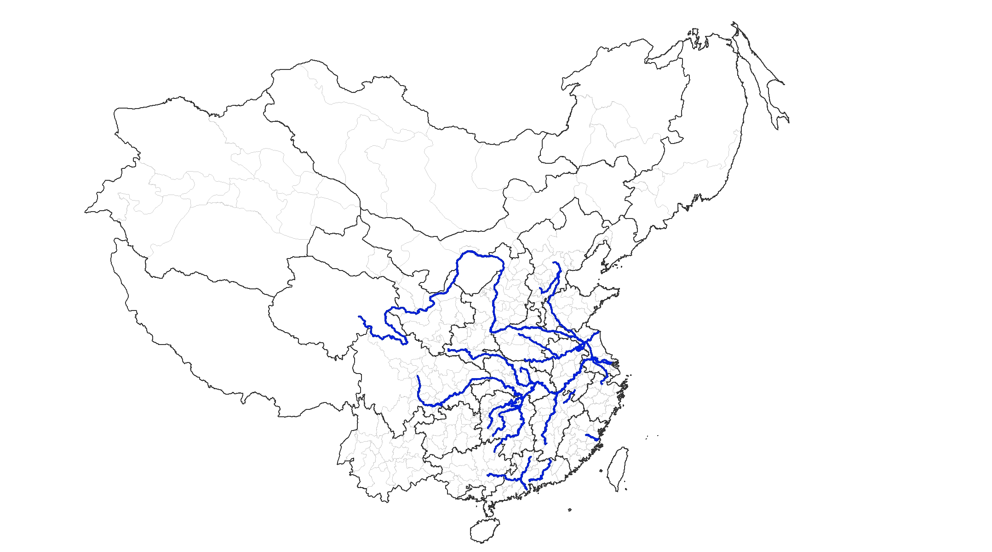

*Sources*: Deng (1994, 1995); Fang et al. (2000); Wang (1992).

Appendix B: Construction of Weather Extremities

We begin our reconstruction task by first identifying the precise location of each prefecture. Suppose there are four hypothetical regions in China, with each typically contains a few prefectures. Consider the straightforward case whereby a prefecture falls into the boundary of a single region (e.g., prefecture A), the reconstruction of temperature for this prefecture is straightforward, i.e., ${temp}_{A}$ = $L_{A in R1}$/ $L_{A}$ ${temp}_{R1}$* (where L denotes land area and R stands for region, $L_{A in R1}$ = $L_{A}$ in this case). Where a prefecture falls into the boundary of two regions (e.g., prefecture B), extreme temperature for this prefecture would be weighted according to the percentage of land area of that prefecture in these two regions:

i.e., ${temp}_{B}$ = $L_{B in R1}$/ $L_{B}$ ${temp}_{R1}$*+ $L_{B in R2}$/ $L_{B}$ ${temp}_{R2}$

*

In the extreme instance where a prefecture covers the land area of up to four regions (e.g., prefecture C), extreme temperature will be calculated using basically the same formula:

i.e., ${temp}_{C}$ = $L_{C in R1}$/ $L_{C}$ ${temp}_{R1}$*+ $L_{C in R2}$/ $L_{C}$ ${temp}_{R2}$*+ $L_{C in R3}$/ $L_{C}$ ${temp}_{R3}$*+ $L_{C in R4}$/ $L_{C}$ ${temp}_{R4}$*, (refer again to Figure B1 for illustration).

In converting the decadal temperature data into a 15-year interval, which is what we use for measuring market integration, we similarly assign different weights to each decade depending on the share of years that each decade occupies in a given decade. For instance, if we want to obtain the extreme temperature for the year 1776, which involves the extreme temperature of the following three decades, 1760s (bracketing 1769), 1770s, and 1780s, it should be calculated by the following formula:

${temp1776}_{i}$ = ${temp1760s}_{i}$*1/15+ ${temp1770s}_{i}$*10/15+ ${temp1780s}_{i}$*4/15

Appendix B

Figure B1: Construction of Weather Extremities

Prefecture A

Prefecture B

Prefecture C

Region 1

Region 2

Region 4

Region 3

*Source*: Author’s illustration

Appendix C: **Robustness Checks –** A Difference-in-differences estimation

In 1851, the Taiping Rebellion—the largest peasant rebellion ever—broke out and killed some 73 million people (Cao, 2000). While devastating, the Taiping did not hit every part of China equally; hence it provides us with a unique opportunity to examine the effect of the recovery of population growth on market integration, by comparing it with prefectures unaffected by this catastrophe. The geographic distribution of the Taiping Rebellion is shown in Figure C1, which reveals that the southeastern part of China was hit disproportionately hard. We specify our DID estimates using the following specification:

${MI}_{it}=α_{0}+α_{1}*{period}_{t}+α_{2}*{Taiping}_{i}+α_{3}*{Taiping}_{i}*{Period}_{t}+X_{it}*γ+ε_{it} (C$ 1 $)$

where *periodt* denotes the periods before, during, and after the Taiping Rebellion. *Taipingi* is a dummy variable taking the value of 1 if prefecture *i* had experienced population loss during the period of Taiping Rebellion, and zero otherwise. To reduce measurement error, we use three alternative measures to proxy for the effect of the *Taiping*. We begin with the narrowest definition using a dummy variable measure, which is “whether or not the Taiping warfare had occurred in prefecture *i*”. *Xit* is a set of control variables including treaty ports, the total number of steamboats and its interaction with waterways, duration of railway, telegraph, the *likin* tax, flood, drought, temperature, war, maize adoption, and the interactions of regions with periods.

[Table C1 about here]

While the dummy variable is able to identify those prefectures afflicted by the Taiping Rebellion, it nevertheless fails to measure the *magnitude* of population loss. To rectify that, we re-estimate equation (C1) first by taking the difference in the population density between 1851 and 1880, *∆PDi*1880-1851, as what may be considered a “naïve” measure of population loss during the Taiping Rebellion. For example, if for a given prefecture the difference is less than zero, we know for sure that this province had experienced population loss; conversely, if the difference is larger or equal to zero we define population loss in that province as zero (equation C2).

$∆{PD}_{i}=\left\{\begin{aligned}\left|{PD1880}_{i}-{PD1851}_{i}\right| if {PD1880}_{i}-{PD1851}_{i}<0 \\ 0 if {PD1880}_{i}-{PD1851}_{i}≥0\end{aligned}\right.$ (C2)

While representing an improvement, the above measure still fails to account for the effect of population growth that occurred between 1864—the year when the Taiping Rebellion ended, and 1880—the first time point after the Taiping for which data on population density is available. To ensure that our estimation will not be biased downward by this possible trend we adopt also the following measure. Instead of taking the first difference between the years 1864 and 1880, for each prefecture we take the difference between the *predicted* population density extrapolated based on the linear trends of population growth in respectively 1776, 1820, and 1851 to predict population density in 1880, $△{\hat{PD}}_{i}$, and *actual* population density in 1880, to measure population loss during the Taiping Rebellion (equation C3). This way, $△{\hat{PD}}_{i}$ can be interpreted as the population density in prefecture *i* if only prefecture *i* had not experienced the Taiping Rebellion. The advantage of $∆{\hat{PD}}_{i}$ over $∆{PD}_{i}$ is that the predicted value takes into account the rate of population growth after the Taiping Rebellion, whereas the latter fails to do so.[1]

(C3)

As befits the difference-in-differences framework we rely on the assumption that a prefecture’s exposure to the Taiping Rebellion is uncorrelated with the degree of its market integration. We thus expect the effect of *Taipingi* on market integration to be statistically insignificant; otherwise we would have violated the “parallel trend” assumption that prefectures differentially exposed to the Taiping already had different “pre-trends”.

In addition, our variable of key analytical interest actually lies in the interaction term *Taipingi*Periodt*, a variable intended to examine whether the Taiping Rebellion had had the effect of releasing the population pressure having built up beforehand; if it did, the interaction term should exhibit a significantly positive effect on market integration. To test the effect of this interaction term more precisely we divide it into two periods—*during* and *after*—the Taiping Rebellion.

Table C1 reports the regression results of equations (C1) - (C3). First, the main effect of the Taiping Rebellion is not significantly different from zero (column (1)), confirming that there is indeed no difference in the pre-trend of market integration between prefectures differentially exposed to it. But if we break down the effects of the Taiping into different periods—specifically during and after, it was only during the Taiping that market integration was significantly lower than before when *likin* tax is fully controlled for (column (2)).

[Table C1 about here]

To examine if population growth recovered in the aftermath of the Taiping may have a positive effect on market integration, we turn to examining the interaction term *Taiping Rebellion* Period*, also by separating the latter into *during* and *after*. We find that, while the interaction term is insignificant during the Taiping, it is statistically significant afterwards (columns (1) and (2)), suggesting that prefectures exposed to the Taiping Rebellion did end up with a higher level of market integration, which further implies that the Taiping Rebellion had likely released the mounting population pressure built up beforehand.[2] Inclusion of *likin* tax only results in a larger coefficient but does not change the level of significance (column (2)).

Columns (3) and (4) report the estimates using the two alternative measures of population loss. We find that the main effect of population loss—regardless of how it is measured, continues to be statistically insignificant. The more important finding is that the interaction between population loss and *post*-Taiping Rebellion is positively significant at the 1 % level of confidence, suggesting that the greater the loss of population during the Taiping Rebellion the faster the speed of recovery and hence the higher the degree of market integration. Specifically, columns (3) and (4) suggest that a doubling of population loss has the effect of boosting market integration by 0.006-0.007, which is then translated into 10.1-10.8% when evaluated at the mean of market integration. As this is the average effect, the rebound in market integration would likely be significantly higher in prefectures badly afflicted by the Taiping.

Note that with the exception of the steamboats,[3] the significant increase in market integration in the post-Taiping period is not primarily driven by the advent of technology. Railway, for instance, is not a significant determinant, mainly because its development in China had to wait until the early 20th century. As rehearsed earlier, the situation is similar for the telegraph. Regardless, these findings are compatible with the stylized historical fact that water transport was the principal method of transportation in imperial China.

Given that many of the Taiping battles were fought in and around the big cities, our results might be driven by population loss in those cities. To rule out this possibility, we drop the provincial capitals in our sample and re-estimate the impact of the Taiping on market integration. Reported in Table C2, the results are consistent with Table C1.

[Table C2 about here]

Appendix C

Figure C1: The Geographic Distribution of the Taiping Rebellion, 1851-1864

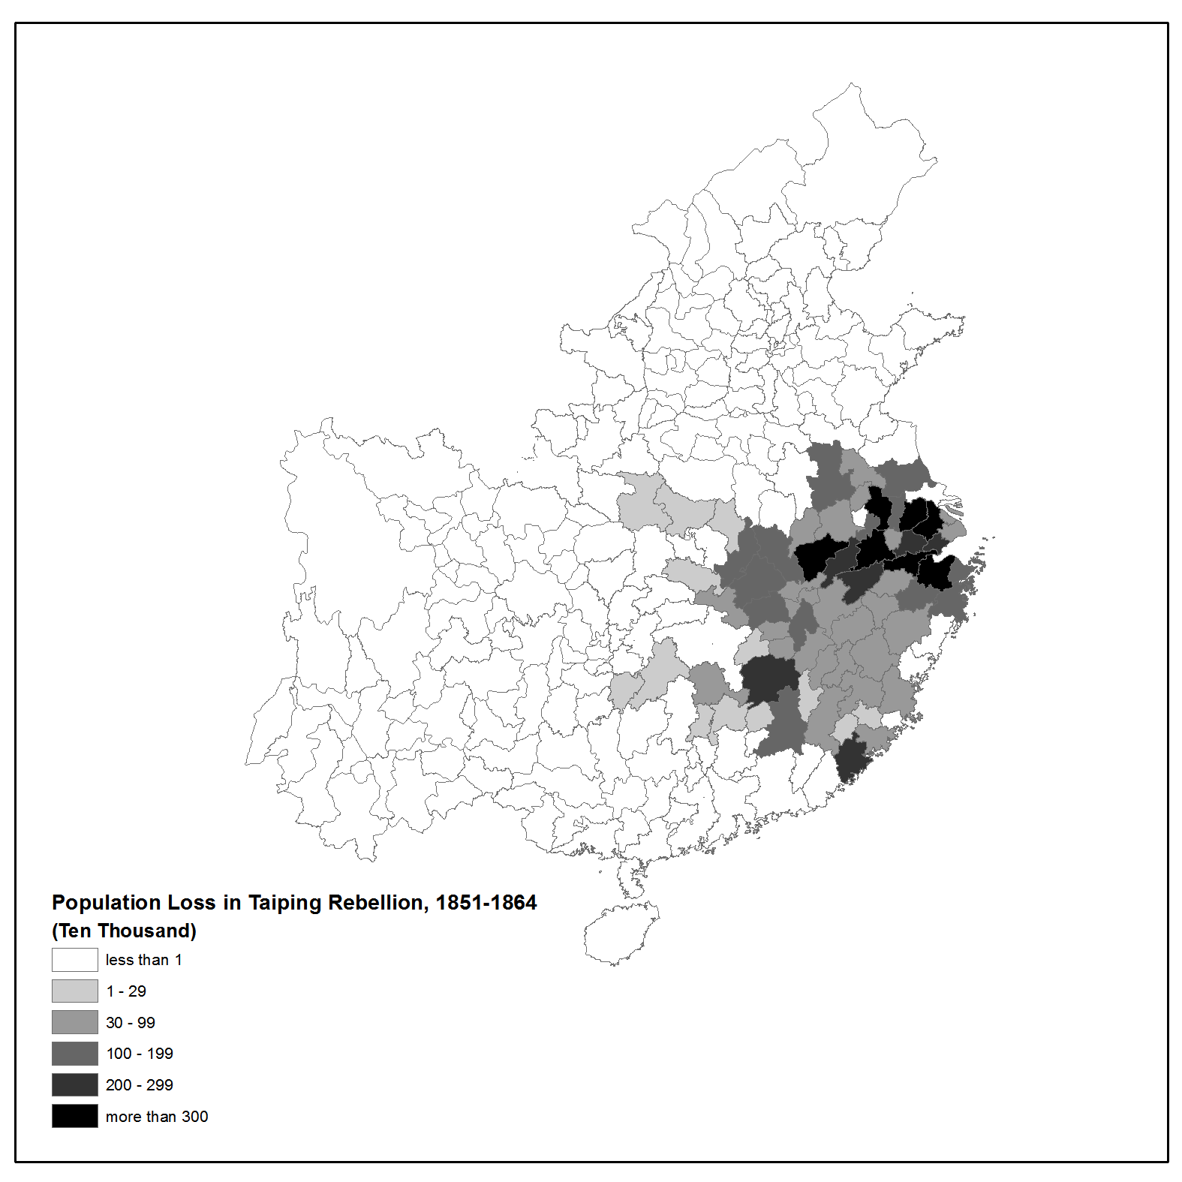

*Source*: Cao (2000)

Figure C2: Number of Steamboats Deployed to the Treaty Ports, 1877-1916



*Source*: Yan (1955)

Figure C3: Steamboat Usage in Domestic and Foreign Trade, 1877 and 1913

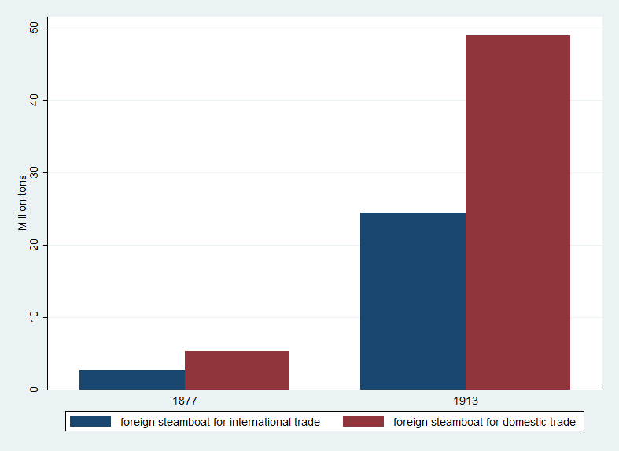

*Source*: Yan (1955)

Appendix C

|  |  |  |  |  |
| --- | --- | --- | --- | --- |
| VARIABLES | (1) | (2) | (3) | (4) |
| Taiping Rebellion (TR) | -0.00113 | -0.00135 |  |  |
|  | (0.00218) | (0.00240) |  |  |
| Period: During TR | -0.01397*** | -0.01887*** | -0.01866*** | -0.01922*** |
|  | (0.00304) | (0.00282) | (0.00284) | (0.00288) |
| Period: Post-TR | -0.01090*** | -0.00443 | -0.00260 | -0.00451 |
|  | (0.00415) | (0.00579) | (0.00601) | (0.00580) |
| Taiping*Period (During TR) | -0.00430 | -0.00058 |  |  |
|  | (0.00328) | (0.00344) |  |  |
| Taiping*Period (Post-TR) | 0.02870*** | 0.03196*** |  |  |
|  | (0.00452) | (0.00526) |  |  |
| Population loss (*ln*) |  |  | -0.00035 | -0.00043 |
|  |  |  | (0.00055) | (0.00055) |
| Population loss (*ln*)*Period (During TR) |  |  | -0.00028 | 0.00004 |
|  |  |  | (0.00076) | (0.00075) |
| Population loss (*ln*)*Period (Post-TR) |  |  | 0.00639*** | 0.00683*** |
|  |  |  | (0.00115) | (0.00116) |
| Total Number of Steamboat | 0.00286*** | 0.00250*** | 0.00265*** | 0.00263*** |
|  | (0.00047) | (0.00050) | (0.00052) | (0.00051) |
| Total Number of Steamboat*Waterway | 0.00088* | 0.00128* | 0.00124* | 0.00115* |
|  | (0.00052) | (0.00065) | (0.00068) | (0.00067) |
| Duration of Railroads | 0.00101 | -0.00005 | -0.00080 | -0.00062 |
|  | (0.00124) | (0.00114) | (0.00116) | (0.00114) |
| Telegraph | 0.00368 | 0.00156 | 0.00031 | 0.00132 |
|  | (0.00695) | (0.00820) | (0.00848) | (0.00844) |
| Treaty Ports | -0.00277 | -0.00278 | -0.00320 | -0.00315 |
|  | (0.00229) | (0.00250) | (0.00260) | (0.00256) |
| Observations | 1,112 | 867 | 867 | 867 |
| R-squared | 0.45487 | 0.47698 | 0.46145 | 0.46873 |

Table C1: Differences-in-differences Estimation of the Determinants of Market Integration in China, 1776-1910

*Notes*: In columns 1 & 2, a prefecture is assigned the value of 1 if the Taiping rebellion occurred in that prefecture. *Multiplelevy* Post1853* is controlled for in column 2 but not in column 1. In columns 3, population loss is measured as ∆PDi as specified in Equation (5), whereas in columns 4 it is measured as ∆i as specified in Equation (6). Control variables include flood, drought, temperature, war, and the interactions of regions with periods *** p < 0.01, **p < 0.05, *p < 0.1; Constant terms are not reported.

*Source*: See in text

Appendix C

Table C2: Robustness check for the Difference-in-differences Estimation of the

Determinants of Market Integration in China, 1776-1910 (dropping provincial capitals)

|  |  |  |  |  |
| --- | --- | --- | --- | --- |
| VARIABLES | (1) | (2) | (3) | (4) |
| Taiping Rebellion (TR) | -0.00221 | -0.00186 |  |  |
|  | (0.00226) | (0.00261) |  |  |
| Period: During TR | -0.01507*** | -0.01966*** | -0.01945*** | -0.02016*** |
|  | (0.00310) | (0.00288) | (0.00292) | (0.00295) |
| Period: Post-TR | -0.01332*** | -0.00653 | -0.00460 | -0.00678 |
|  | (0.00425) | (0.00595) | (0.00619) | (0.00593) |
| Taiping*Period (During TR) | -0.00254 | 0.00023 |  |  |
|  | (0.00330) | (0.00354) |  |  |
| Taiping*Period (Post-TR) | 0.02909*** | 0.03249*** |  |  |
|  | (0.00485) | (0.00566) |  |  |
| Population loss (*ln*) |  |  | -0.00050 | -0.00060 |
|  |  |  | (0.00062) | (0.00062) |
| Population loss (*ln*)*Period (During TR) |  |  | -0.00008 | 0.00029 |
|  |  |  | (0.00081) | (0.00080) |
| Population loss (*ln*)*Period (Post-TR) |  |  | 0.00664*** | 0.00715*** |
|  |  |  | (0.00129) | (0.00130) |
| Total Number of Steamboat | 0.00295*** | 0.00251*** | 0.00264*** | 0.00262*** |
|  | (0.00047) | (0.00051) | (0.00053) | (0.00052) |
| Total Number of Steamboat*Waterway | 0.00102* | 0.00144** | 0.00140* | 0.00131* |
|  | (0.00056) | (0.00069) | (0.00072) | (0.00071) |
| Duration of Railroads | 0.00101 | -0.00038 | -0.00106 | -0.00093 |
|  | (0.00162) | (0.00125) | (0.00130) | (0.00129) |
| Telegraph | 0.00302 | 0.00049 | -0.00065 | 0.00047 |
|  | (0.00725) | (0.00853) | (0.00880) | (0.00879) |
| Treaty Ports | -0.00243 | -0.00329 | -0.00361 | -0.00356 |
|  | (0.00260) | (0.00292) | (0.00305) | (0.00300) |
| Observations | 1,033 | 803 | 803 | 803 |
| R-squared | 0.44932 | 0.46250 | 0.44637 | 0.45441 |

*Notes*: In columns 1 & 2, a prefecture is assigned the value of 1 if the Taiping rebellion occurred in that prefecture. *Multiplelevy* Post1853* is controlled for in column 2 but not in column 1. In columns 3, population loss is measured as ∆PDi as specified in Equation 4, whereas in columns 4 it is measured as ∆ $\hat{PD}$ i as specified in Equation 5. Control variables include flood, drought, temperature, war, and the interactions of regions with periods *** p < 0.01, **p < 0.05, *p < 0.1; Constant terms are not reported.

*Source*: See in text

Appendix D

Figure D1: Grain Price across Regions, 1736-1910

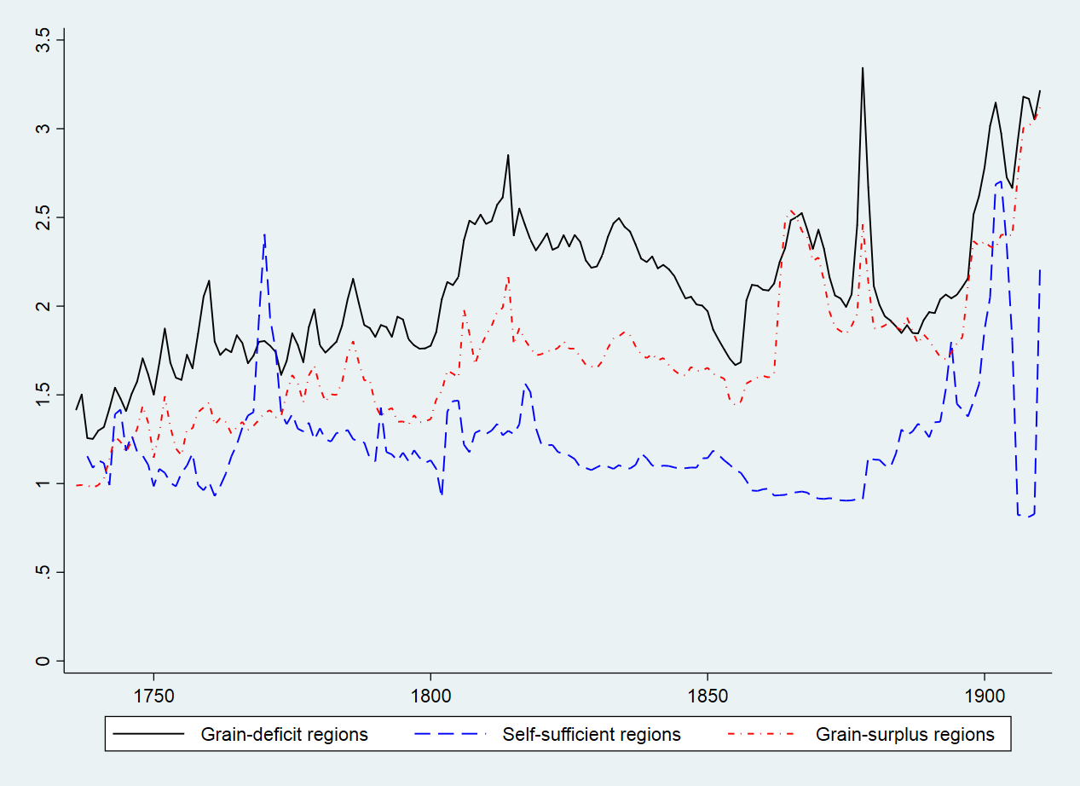

*Sources*: Own construction based on grain price collected by Wang (2009) and the Chinese Academy of Social Science (2010).

|  |  |  |  |  |
| --- | --- | --- | --- | --- |
| Appendix E  Table E1: Effect of Population Growth on Market Integration in the Grain Self-sufficient Regions, 1736-1910 (with Extreme Values Removed) | | | | |
|  | (1) | (2) | (3) | (4) |
| VARIABLES | Column (5) of Table 5  Full sample | Excluding the prefecture with the highest MI | Excluding the prefectures with the highest two MI | Exclude the prefectures with the highest three MI |
| Population density (*ln*) | -0.04487 | -0.03465 | -0.01947 | -0.01622 |
| (Robust standard error) | (0.02893) | (0.02695) | (0.02733) | (0.02580) |
| (Conley spatial errors, 200km) | [0.01819]** | [0.01718]* | [0.01999] | [0.01908] |
| (Conley spatial errors, 500km) | [0.01367]*** | [0.01445]** | [0.01635] | [0.01634] |
| Observations | 154 | 149 | 144 | 139 |
| R-squared | 0.76382 | 0.79205 | 0.75976 | 0.73889 |
| Number of Prefectures | 31 | 30 | 29 | 28 |
| *Notes*: Control variables include the total number of steamboats and its interaction with waterway, duration of railway, likin tax, maize adoption, flood, drought, temperature, war, prefecture and period fixed effects, and prefecture-specific time trend. Robust standard errors in parentheses; *** p < 0.01, ** p < 0.05, *p < 0.1; Constant terms are not reported.  *Source*: See in text | | | | |

Appendix E

Table E2: Gravity Model Estimation of the Effect of Population Growth on the Speed of Grain Price Adjustment, 1776-1910

|  |  |  |  |  |  |  |  |
| --- | --- | --- | --- | --- | --- | --- | --- |
| VARIABLE | 1 | 2 | 3 |  | 4 | 5 | 6 |
|  | Inter-provincial trade | | |  | Intra-provincial trade | | |
|  | From grain-surplus to deficit-region | From grain-surplus to deficit-region (subsample) 1 | From grain-surplus to deficit-region (subsample) 2 |  | Within grain-deficit region | Within grain-surplus region | Within self-sufficient region |
| Population density in importers (*ln*) | -0.22570 | 0.62558 | 0.22803 |  | 1.46080 | 1.81777** | 0.55309 |
|  | (0.669634) | (0.84341) | (0.84218) |  | (0. 96483) | (0. 73612) | (2.53739) |
| Population density in exporters (*ln*) | -1.46490** | -1.53092*** | -1.42935** |  | -0.70731 | -1.68646** | -0.52886 |
|  | (0.01127) | (0.44886) | (0.0.68668) |  | (0.89394) | (0.68170) | (2.02700) |
| Number of observations | 33382 | 6869 | 25074 |  | 5798 | 6136 | 1,756 |
| Number of importers | 91 | 32 | 91 |  | 91 | 107 | 31 |
| Number of exporters | 106 | 57 | 106 |  | 91 | 107 | 31 |
| *Notes*: Dependent variable is the speed of price adjustment from the exporting to the importing prefectures. Control variables include the total number of steamboats and its interaction with waterway, duration of railway, flood, drought, temperature, war, and maize adoption, *Multiplelevy*Post1853*, and period and prefecture-pair fixed effects. 1. The interprovincial trade subsample includes prefecture-pairs of the exporting provinces of Anhui, Hunan, Jiangxi and Sichuan, and prefecture-pairs of the importing provinces of Fujian, Jiangsu and Zhejiang. 2. This subsample includes all interprovincial trade observations except for those in column (2). Two-way clustered standard errors in parentheses; *** p < 0:01, ** p < 0:05, *p < 0:1; Constant terms are not reported.  *Source*: See in text | | | | | | | | |

Appendix E

Table E3: Grain-surplus Provinces in 18th Century China

|  |  |  |  |  |
| --- | --- | --- | --- | --- |
| Provinces | Wang & Huang (1989) | Jiang (1992) | Deng (1994) | Wu (2001) |
| Anhui | Yes | Yes | Yes | Yes |
| Guangxi | Yes | Yes | Yes | Yes |
| Hunan | Yes | Yes | Yes | Yes |
| Jiangxi | Yes | Yes | Yes | Yes |
| Sichuan | Yes | Yes | Yes | Yes |
| Henan | Yes |  | Yes | Yes |
| Shandong | Yes |  | Yes |  |
| Shaanxi | Yes |  | Yes |  |
| Hubei |  |  | Yes | Yes |

*Source*: See the table

Appendix E

Table E4: Different Classifications of Provinces in Early 21st-Century China

|  |  |  |
| --- | --- | --- |
| Provinces | Classification | Source |
| Anhui | Surplus-region | Hou (1996); Zhang (2002) |
| Guangxi | Surplus-region | Zhang (1938, 2002) |
| Hunan | Surplus-region | Tian(2006a); Hou (1996); Zhang (2002) |
| Jiangxi | Surplus-region | Hou (1996); Zhang (2002) |
| Sichuan1 | Surplus-region | Zhang (2002); Perkins (1969) |
| Henan | Self-sufficient | Zhang (2002) |
| Shandong2 | Self-sufficient | Zhang (2002); Perkins (1969) |
| Shaanxi | Self-sufficient | Zhang (2002) |
| Hubei3 | Surplus-region | Tian (2006b); Hou (1996)；Zhang (2002); Perkins (1969) |

*Notes：*

1Perkins (1969) argues that Sichuan was not a grain-exporting province, but Zhang (2002) is of the view that Sichuan did have a small surplus.

2Perkins (1969) maintains that Shandong was able to export a modest surplus, whereas Zhang (2002) assesses this province as primarily self-sufficient.

3Both Tian (2006b) and Zhang (2002) view Hubei as primarily a grain-exporting province, whereas Hou (1996) contends that Hubei served as no more than an intermediary between Hunan and the lower Yangzi Delta in the 1920s. Perkins (1969) classifies Hubei as a grain-deficit province in 1936.

*Source*: See the table

REFERENCE

Cao, Shuji. *Zhongguo Renkou Shi [History of Population in China],* vol. 5, Qing Shiqi (Qing period). Shanghai: Fudan University Press, 2000.

Deng, Yibing. “Qingdai Qianqi Neilu Liangshi Yunshuliang ji Bianhuaqushi [The volume and its trend of grain trade in inland in the ealry qing].” *Zhongguo Jingjishi Yanjiu [China’s Economic History Research Journal]*, no. 3 (1994): 80–92. .

———. “The Grain Transport, Trade and Market in the Early Qing Dynasty (Qingdai Qianqi de Liangshi Yunxiao he Shichang).” *History Research (Lishi Yanjiu)*, no. 4 (1995): 151–161.

Ejrnæs, Mette, and Karl Gunnar Persson. “Market Integration and Transport Costs in France 1825–1903: A Threshold Error Correction Approach to the Law of One Price.” *Explorations in Economic History* 37, no. 2 (2000): 149–73.

Xing, Fang, Shi Qi, Jian Rui, and Wang Shixin. “The Growth of Commodity Circulation and the Rise of Merchant Organisations.” In *Chinese Capitalism, 1522–1840*, edited by Xu Dixin and Wu Chengming, 165–84. New York: St. Martin’s Press, 2000.

Federico, Giovanni. “How Much Do We Know about Market Integration in Europe?” *Economic History Review* 65, no. 2 (2012): 470–97.

Jacks, David S. “Intra- and International Commodity Market Integration in the Atlantic Economy, 1800–1913.” *Explorations in Economic History* 42, no. 3 (2005): 381–413.

———. “What Drove 19th Century Commodity Market Integration?” *Explorations in Economic History* 43, no. 3 (2006): 383–412.

Jiang, Jianping. *Qingdai Qianqi Migumaoyi Yanjiu [Studies on Rice Trade in the Early Qing Dynasty]*. Beijing: Peking University Press, 1992.

Hou, Yangfang. “Changjiang Zhongxiayou Diqu Migu Changtumaoyi [Rice Long-Distance Trade in the Middle and Low Yangtze Region].” *Zhongguo Jingjishi Yanjiu [China’s Economic History Research Journal]* 2 (1996): 70–79.

Perkins, Dwight Heald. *Agricultural Development in China, 1368-1968*, United States: Aldine Publishing Company, 1969.

Tian, Jiongquan. “Qingmomingchu Shiqi Hunan de Migushichang he Shangpingliutong [Hunan’s Rice Market and Commodity Circulation in Late Qing and Republic China].” *Qingshi Yanjiu [Studies in Qing History]* 1 (2006a): 17–28.

———. “Qingmomingchu Shiqi Hubei de Migushichang he Shangpingliutong [Hunan’s Rice Market and Commodity Circulation in Late Qing and Republic China].” *Zhongguo Jingjishi Yanjiu [China’s Economic History Research Journal]* 4 (2006b): 68–76.

Wang, Yeh-chien. “Secular Trends of Rice Prices in the Yangtze Delta, 1638–1935.” In *Chinese History in Economic Perspective*, 35–68. Berkeley: University of California Press, 1992.

———. *Qingdai Liangjia Ziliaoku [Dataset on Grain Price in the Qing Dynasty]*. Taibei: Institute of Modern History, Academia Sinica, 2009.

Wang, Yeh-chien., and Huang, GuoShu. “Shiba Shiji Zhongguo Liangshi Gongxu de Kaocha [An Investigation into the China’s Supply-Demand of Grain in the Eighteenth Century].” In *Collection on Rural Economic History of Modern China,* edited by Institute of Modern History, Academia Sinica. Taipei: Institute of Modern History, Academia Sinica, 1989.

Wu, Chengming. *Zhongguo de Xiandaihua: Shichang yu Shehui [China’s Modernization: Market and Society]*. Beijing: SDX Joint Publishing Company, 2001.

Yan, Zhongping. *Zhongguo Jindai Jingjishi Tongji Ziliao Xuanji [Selection of Statistics on Economic History of Modern China]*. Beijing: Kexue chubanshe, 1955.

Zhang, Peigang. *Guangxi Liangshi Wenti [Grain Issue in Guangxi Province]*. Shanghai: The Commercial Press, 1938.

———. *Ershi Shiji Zhongguo Liangshi Wenti [China’s Grain Economy in the 20th Century]*. Wuhan, China: Huazhong University of Science and Technology Press, 2002.

1. Neither measure, however, is able to capture the effect of migration on population growth, which is a caveat that should be borne in mind.
2. A related question is why the demographic effects of the Taiping on market integration appear to be so long lasting – a question to which we barely have an answer. All we know from the meticulous works of demographic historians is that the recovery from the population loss inflicted by the Taiping had indeed been a lengthy process. In the heavily afflicted provinces such as Anhui, Jiangxi and Zhejiang, the populations had never fully recovered to their pre-Taiping levels even after a hundred years (Cao, 2000).
3. Fig. C2 in Appendix C shows that the usage of steamboats increased over time (between 1877 and 1917), whereas Fig. C3 shows that steamboats were used primarily in domestic trade (Yan, 1955). Together, these historical facts are compatible with the significant finding concerning the steamboat variable.