Online Appendix Material

G.I. Jane Goes to College? Female Educational Attainment, Earnings, and the Servicemen’s Readjustment Act of 1944
Conor Lennon

Appendix 1 - Additional Estimates

High School Completion Status
The National Museum for the U.S. Army states that female enlistees had to be “high school graduates between 21 and 45 years of age.” Despite the stated requirements, my data has a small number of females who report being a WWII veteran and who do not report having a high school diploma. As a robustness check, I present estimates that expand my sample to all females, regardless of high-school completion status, in Table A1. Unsurprisingly, because including those without a high school diploma tends to reduce the overall sample means for educational attainment and earnings, expanding the sample in this manner tends to increase the effect of WWII service on the various outcomes.

Medical Professions
Because one source of problematic selection could be that those in medical occupations may have been more educated prior to enlistment, I present estimates in Table A2 where I again exclude those who do not report having a high school diploma but also exclude any who report being a nurse or doctor in 1980. Reassuringly, when my sample excludes such females, my findings are only very mildly attenuated.

Wider Sample of Birth Years
Another source of problematic selection is that, by 1980, anyone born in 1915 would be 65 years old. For females, as I mention in the main text, those age 62 (= b. 1918) are the first birth year cohort for whom a majority (51 percent) are retired (technically, “not in the labor force”). That means that the oldest birth year cohort for whom a majority are not retired in 1980 are those who were born in 1919, and who therefore turn 21 in 1940. Because those born prior to 1919 are more likely to be retired, and because they would have been 23 or older when the U.S. entered WWII (they may have already married, had kids, and so on), I exclude them from my main estimates. One further reason to restrict the sample this way is to ensure it is more comparable to those born between 1926 and 1930, my alternative comparison group. To formally illustrate, however, that I am not cherry-picking my sample, I present estimates in Table A3 where I once again exclude those who do not report having a high school diploma but expand the sample to include females born as early as 1915. Reassuringly, when my sample includes such females, my findings are essentially the same as when I restrict the sample to those born in 1919 or later.

IV Placebo Estimates
In Table A4 I examine what happens if I use age at the time of the G.I. Bill to instrument for non-veterans’ educational attainment. The IV estimates are seriously inflated (but statistically insignificant) because the instrument is extremely weak (I present first-stage F-statistics in the table), explaining little of the variation in non-veterans’ educational attainment. Such a pattern is consistent with Bound et al. (1995) who examine the bias associated with weak instruments.

Heckman Two Step Earnings Estimates
Because there are differences in the proportion of female and non-female veterans who are employed in 1980, I present estimates of the effect on veteran status on annual earnings for females using a Heckman Selection model in Table A5. In the table, for comparison purposes, the first column reports estimates using OLS where the sample includes all females born between 1919 and 1925, regardless of labor force status and asserts annual earnings of $0 for those who report not working. In the second column, this estimate is restricted only to those who are working (that estimate is the same as the main estimate in Table 2). In the third column, I present estimates using a Heckman Selection approach. In the selection equation, I use other household income as the “additional” variable. For most respondents, this is spouse/partner income, which is a common approach in this literature. The estimates when using a Heckman selection model are negligibly different relative to the OLS estimates. However, I present these estimates only as an appendix item because I cannot easily refute the claim that spousal or other household income is correlated with veteran status.

Estimates Including Education and Occupation as Controls
In Table A6, I progressively add education and occupation controls to the specification in column six of Table 2 in the body of the paper. As I mention in the paper, veterans’ earnings are likely to be greater than non-veterans’ because of increased education and associated occupation choices. The effect of veteran status on earnings is somewhat smaller with these additional controls but remains large and statistically significant.

Testing Conditional Independence Assumption
Table 1 suggests that veterans and non-veterans differ in terms of their observable characteristics. For that reason, in Table A7, I present estimates where I examine the sensitivity of my main estimates (Table 2, Panel A) to sequentially adding controls and fixed effects. This serves as a test of the conditional independence assumptions that underpin my cohort-based approach. In the table, I first present estimates similar to Table 2, Panel A but with no controls. Then, I add race, marital status, state, and year-quarter of birth as controls and fixed effects. Adding controls tends to mildly reduce the effect of veteran status on the outcomes of interest. Note, I do not attempt to control for parental education in my main estimates because, in my 1980 census data, parents’ educational attainment is only available in the data when that parent is living with the respondent.

Table A1: Estimates Including All Females b. 1919-1925

Non-Veterans = All Non-Veteran Females born 1919-1925
 | (1) | (2) | (3) | (4) | (5) | (6)
 | Any College  (OLS) | Completed Degree  (OLS) | Years of College  (Poisson) | In Labor Force  (OLS) | Employed  (OLS) | Annual Earnings  (OLS)
WWII Veteran | 0.236*** | 0.096*** | 0.795*** | 0.039*** | 0.001 | 2,372.37***
 | (0.005) | (0.004) | (0.013) | (0.005) | (0.003) | (111.24)
Observations | 426,163 | 426,163 | 426,163 | 426,163 | 203,649 | 194,883
R-squared | 0.032 | 0.015 | - | 0.073 | 0.003 | 0.04
Source: 1980 PUMS 5 Percent Census Sample. Note: Standard errors, corrected for heteroskedasticity, in parentheses. *** p<0.01, ** p<0.05, * p<0.1. Dollar values are $1980. Here, I restrict the sample to females who turned 21 between 1940 and 1946, regardless of whether they report having a high school diploma or not. Non-veterans are, therefore, all females born between 1919 and 1925 who do not enlist in the armed forces during the WWII period. All specifications include state fixed effects and control for marital status, age (measured in quarters), and race.

Table A2: Estimates Excluding Nurses and Doctors

Non-Veterans = Non-Veteran Female HS Graduates born 1919-1925
 | (1) | (2) | (3) | (4) | (5) | (6)
 | Any College  (OLS) | Completed Degree  (OLS) | Years of College  (Poisson) | In Labor Force  (OLS) | Employed  (OLS) | Annual Earnings  (OLS)
WWII Veteran | 0.166*** | 0.071*** | 0.451*** | 0.017*** | -0.006** | 1,610.11***
 | (0.006) | (0.005) | (0.014) | (0.005) | (0.003) | (133.30)
Observations | 249,677 | 249,677 | 249,677 | 249,677 | 130,470 | 125,890
R-squared | 0.031 | 0.019 | - | 0.070 | 0.003 | 0.05
Source: 1980 PUMS 5 Percent Census Sample. Note: Standard errors, corrected for heteroskedasticity, in parentheses. *** p<0.01, ** p<0.05, * p<0.1. Dollar values are $1980. Here, I restrict the sample to females who turned 21 between 1940 and 1946, who have a high school diploma, and do not report being either a nurse or a doctor. Non-veterans are, therefore, all females with a high-school diploma born between 1919 and 1925 who do not enlist in the armed forces during the WWII period and are not nurses or doctors in 1980. All specifications include state fixed effects and control for marital status, age (measured in quarters), and race.

Table A3: Estimates for Female High-School Graduates b. 1915-1925

Non-Veterans = Non-Veteran Female HS Graduates born 1915-1925
 | (1) | (2) | (3) | (4) | (5) | (6)
 | Any College  (OLS) | Completed Degree  (OLS) | Years of College  (Poisson) | In Labor Force  (OLS) | Employed  (OLS) | Annual Earnings  (OLS)
WWII Veteran | 0.201*** | 0.091*** | 0.526*** | 0.029*** | -0.003 | 1,846.68***
 | (0.005) | (0.004) | (0.010) | (0.005) | (0.002) | (110.59)
Observations | 369,905 | 369,905 | 369,905 | 369,905 | 175,652 | 169,616
R-squared | 0.032 | 0.021 | - | 0.095 | 0.003 | 0.04
Source: 1980 PUMS 5 Percent Census Sample. Note: Standard errors, corrected for heteroskedasticity, in parentheses. *** p<0.01, ** p<0.05, * p<0.1. Dollar values are $1980. Here, I restrict the sample to females who turned 21 between 1936 and 1946, who have a high school diploma. Non-veterans are, therefore, all females with a high-school diploma born between 1915 and 1925 who do not enlist in the armed forces during the WWII period. All specifications include state fixed effects and control for marital status, age (measured in quarters), and race.

Table A4: Two-Stage Least Squares Estimates, Placebo Using Non-Veterans

 | OLS Estimates |  |  |  | IV Estimates
 |  |  |  |  | (IV = Age at time of G.I. Bill Announcement)
 | (1) | (2) | (3) |  | (4) | (5) | (6)
 | Annual Earnings | Annual Earnings | Annual Earnings |  | Annual Earnings | Annual Earnings | Annual Earnings
Any College | 2,594.94*** |  |  |  | 57,039.50
 | (43.61) |  |  |  | (77,039.50)
Bachelor’s Degree (or more) |  | 4,333.27*** |  |  |  | 48,281.92
 |  | (64.89) |  |  |  | (42,830.94)
Years of College |  |  | 1,003.62*** |  |  |  | 6,992.74
 |  |  | (13.63) |  |  |  | (4,292.56)
F-Stat First Stage |  |  |  |  | 0.29 | 0.43 | 1.09
Observations | 126,179 | 126,179 | 126,179 |  | 126,179 | 126,179 | 126,179
R-squared | 0.07 | 0.09 | 0.1
Source: 1980 PUMS 5 Percent Census Sample restricted to female non-veterans born 1919 to 1925. Note: Standard errors, corrected for heteroskedasticity, in parentheses. *** p<0.01, ** p<0.05, * p<0.1. Dollar values are $1980. All specifications include state fixed effects and control for marital status and race. My OLS estimates also control for year-quarter of birth. My IV estimates do not control for year-quarter of birth because I use age as an instrument. “Age at time of G.I. Bill Announcement” refers to an indicator for being born before versus after the second quarter of 1923, making a female 21, and thus eligible to serve, before versus after the announcement of the G.I. Bill.

Table A5: Heckman Selection Model
OLS
Heckman Selection Model
(1) (2) (3)
Annual Earnings Annual Earnings Annual Earnings
WWII Veteran | 1,414.41*** | 1,887.05*** | 1,913.36***
 | (89.44) | (121.77) | (101.08)
Observations | 256,326 | 131,163 | 256,326
Estimation Sample | All | Employed Only | All
Heckman Selection Variable |  |  | Employment Status
Source: 1980 PUMS 5 Percent Census Sample restricted to female non-veterans born 1919 to 1925. Note: Standard errors, corrected for heteroskedasticity, in parentheses. In the model, I use other household income to predict employment status. *** p<0.01, ** p<0.05, * p<0.1. Dollar values are $1980. All specifications include state fixed effects and control for marital status, race, and year-quarter of birth.

Table A6: Earnings Estimates with Additional Controls

 | (1) | (2) | (3) | (4)
 | Annual Earnings | Annual Earnings | Annual Earnings | Annual Earnings
WWII Veteran | 1,887.05*** | 1,336.52*** | 904.53*** | 771.95***
 | (121.77) | (119.55) | (112.65) | (112.29)
Observations | 131,163 | 131,163 | 131,133 | 131,133
State Fixed Effects | Y | Y | Y | Y
Race, Marital Status, and Year-Quarter of Birth Controls | Y | Y | Y | Y
Education |  | Y |  | Y
Occupation |  |  | Y | Y
Source: 1980 PUMS 5 Percent Census Sample restricted to female non-veterans born 1919 to 1925. Note: Standard errors, corrected for heteroskedasticity, in parentheses. *** p<0.01, ** p<0.05, * p<0.1. Dollar values are $1980. All specifications include state fixed effects and control for marital status, race, and year-quarter of birth. The second column adds education, the third, occupation, and the fourth adds both education and occupation as controls. These estimates highlight how much of the gross increase in Annual Earnings is attributable to differences in educational attainment and occupational choices.

Table A7: Adding Covariates Sequentially

 | (1) | (2) | (3) | (4) | (5) | (6)
 | Any College | Completed Degree | Years of College | In Labor Force | Employed | Annual Earnings
Panel A
WWII Vet | 0.203*** | 0.083*** | 0.534*** | 0.047*** | -0.004 | 2,079.60***
 | -0.005 | -0.004 | -0.012 | -0.005 | -0.003 | -123.34
Controls: None

Panel B
WWII Vet | 0.205*** | 0.084*** | 0.544*** | 0.052*** | -0.004 | 2,105.51***
 | -0.005 | -0.004 | -0.012 | -0.005 | -0.003 | -123.39
Controls: Race

Panel C
WWII Vet | 0.199*** | 0.079*** | 0.518*** | 0.035*** | -0.004 | 1,934.27***
 | -0.005 | -0.004 | -0.012 | -0.005 | -0.003 | -121.7
Controls: Race, Marital Status

Panel D
WWII Vet | 0.190*** | 0.077*** | 0.493*** | 0.039*** | -0.004 | 1,873.90***
 | -0.005 | -0.004 | -0.012 | -0.005 | -0.003 | -121.4
Controls: Race, Marital Status, State of Residence

Panel E
WWII Vet | 0.190*** | 0.078*** | 0.498*** | 0.032*** | -0.004 | 1,887.05***
 | -0.005 | -0.004 | -0.012 | -0.005 | -0.003 | -121.77
Controls: Race, Marital Status, State of Residence, Year-Quarter of Birth

Observations | 256,326 | 256,326 | 256,326 | 256,326 | 135,818 | 131,163
Source: 1980 PUMS 5 Percent Census Sample restricted to female non-veterans born 1919 to 1925. Note: Standard errors, corrected for heteroskedasticity, in parentheses. *** p<0.01, ** p<0.05, * p<0.1. Dollar values are $1980. Here, in each set of estimates, I sequentially add controls and fixed effects for race, marital status, state of residence, and year-quarter of birth.

Appendix 2 - Additional Information

Additional Information on Enlistees in 1940s and Veterans in 1980
In Table B1 I provide summary statistics regarding age at enlistment, race, marital status, and dependents for high school graduates, those with some college, and college graduates born between 1915 and 1925 who appear in the Women’s Army Corp Enlistment Records. Notice that there are a small number who do not appear to meet the requirements of enlistment - including individuals who report that they are under age 20. That being said, these records come from digitized enlistment punch cards. Leaving aside human error, the National Archives explains that “[a]bout 35 percent of the electronic WWII Army Enlistment Records have a scanning error. Most of these errors are because of the poor condition of the microfilm and the scanning mechanism could not properly “read” various characters on the punch cards.” It is possible, therefore, that those recorded as teenagers in the enlistment records were actually 27-, 28-, or 29-years-old. Further, enlistees engaged in training prior to service. It is possible that those close to age 21 were able to enlist if they would turn 21 prior to the end of that training. I cannot find any information, however, to either confirm or deny such a conjecture.
Notice that the majority of the sample consists of single females who have no children, are aged 21 to 27, and have only a high school diploma at time of enlistment. In addition, Figure B1 shows the geographic distribution of WAC enlistees. For completeness, Figure B2 shows the geographic distribution of female veterans in 1980. Both figures are what we might expect given population trends in the twentieth century.
Finally, in Table B2, I show the most common occupations for females and non-females born between 1919 and 1925 and who have a high school diploma. Unsurprisingly, there are differences across the two groups that arise from the different education levels of the two groups. The prevalence of registered nurses among veterans highlights how important it is to examine my estimates when excluding nurses from my estimation sample (see Appendix A.2).

Background Information on Service Eligibility Standards
It is worth noting that while women served in various roles, the legislation establishing the Women’s Army Corps only authorized “non-combatant service.” With women’s roles being more like civilian employment – sorting and delivering mail, driving buses, and so on – it is not clear that stringent physical or educational requirements would be necessary. Indeed, the text of the 1942 legislation that established the Women’s Auxiliary Army Corps (WAAC) states only that “The Secretary [of Defense] is authorized to have enrolled in the corps [...] women of excellent character in good physical health, between the ages of twenty-one and forty-five years and citizens of the United States.” The same legislation also states that “The Secretary is authorized to establish and maintain such number of schools as he may consider necessary for the purpose of training candidates for officers of the corps. The Secretary may establish by regulation the qualifications for entry into such schools” (emphasis added). The legislation itself says nothing more about selection procedures but the National Museum of the United States Army reports that the Army ultimately required that “WAACs be high school graduates between 21 and 45 years of age, between five and six feet tall, between 105 and 200 pounds, and of good health and character.”
The Women’s Auxiliary Army Corps (later renamed to Women’s Army Corps) was the largest all-female branch of the military during WWII (about 150,000 served). However, many women joined the nursing corps (estimates suggest the Army Nurse Corps enlisted about 60,000 over the war period) and the navy (the Women Accepted for Volunteer Emergency Service had more than 80,000 enlistees). Note that the Army Nurse Corps enlisted only registered nurses. Registered nurses naturally had to be high school graduates who had also completed the three years of training required for an RN license. For WAVES, it is worth noting that enlistees only had to be 20. There is also evidence to suggest women with small children would not be accepted. That being said, it appears that WAVES sometimes allowed experience or other forms of education to serve as a substitute for having a high school degree.
While all female branches of the military (excepting WASP, see below) were eligible for G.I. benefits, the variations in recruitment eligibility across army branches provide further motivation for the estimates I discuss in Appendix A1, A2, and A3. Those estimates show that my findings are robust to excluding nurses/doctors, adding those without a high-school degree back to the sample, and expanding the sample to include more birth years.

WASP: A Unique Case
The Women Airforce Service Pilots (WASP) was created in 1943 by merging the Women’s Auxiliary Ferrying Squadron (WAFS) and the Women’s Flying Training Detachment (WFTD). The WAFS consisted of a few dozen pilots who typically moved military planes from factories to bases. Only commercially licensed female pilots with at least 500 hours flying-time were eligible for the WAFS. In the WFTD, trainees were between 21 and 35 years old, and had to have at least 200 hours of flying experience. The program consisted of 6+ months of training including 200+ hours of flight time. Enlistment requirements were later reduced to 35 hours of flight time, and it appears that WASP enlisted women aged under 21 who met the other necessary criteria.
Given few people in the 1940s would have the opportunity to obtain even one hour of flight experience, it is not surprising that the National Museum reports that only 1,074 women served as part of WASP. While those WASP veterans are likely to have valuable and unique skills, a 5 percent census sample would be expected to contain around 50 WASP veterans in total, assuming they all lived. Note that I cannot separately identify veterans from the various branches of the military in my data. Of these 50, however, only some would have been born between 1919 and 1925 and, of that group, only a fraction would still be in the labor force in 1980. It is therefore likely that I have very few WASP veterans in my main estimation sample, which limits any effect they could have on my estimates. Note that WASP servicewomen were eventually granted full military recognition and benefits (including G.I. Bill benefits) only in 1977.
Figure B1: Distribution of Women’s Army Corp Enlistees by State in the 1940s

Figure B1: Distribution of Female Enlistees by State in 1940
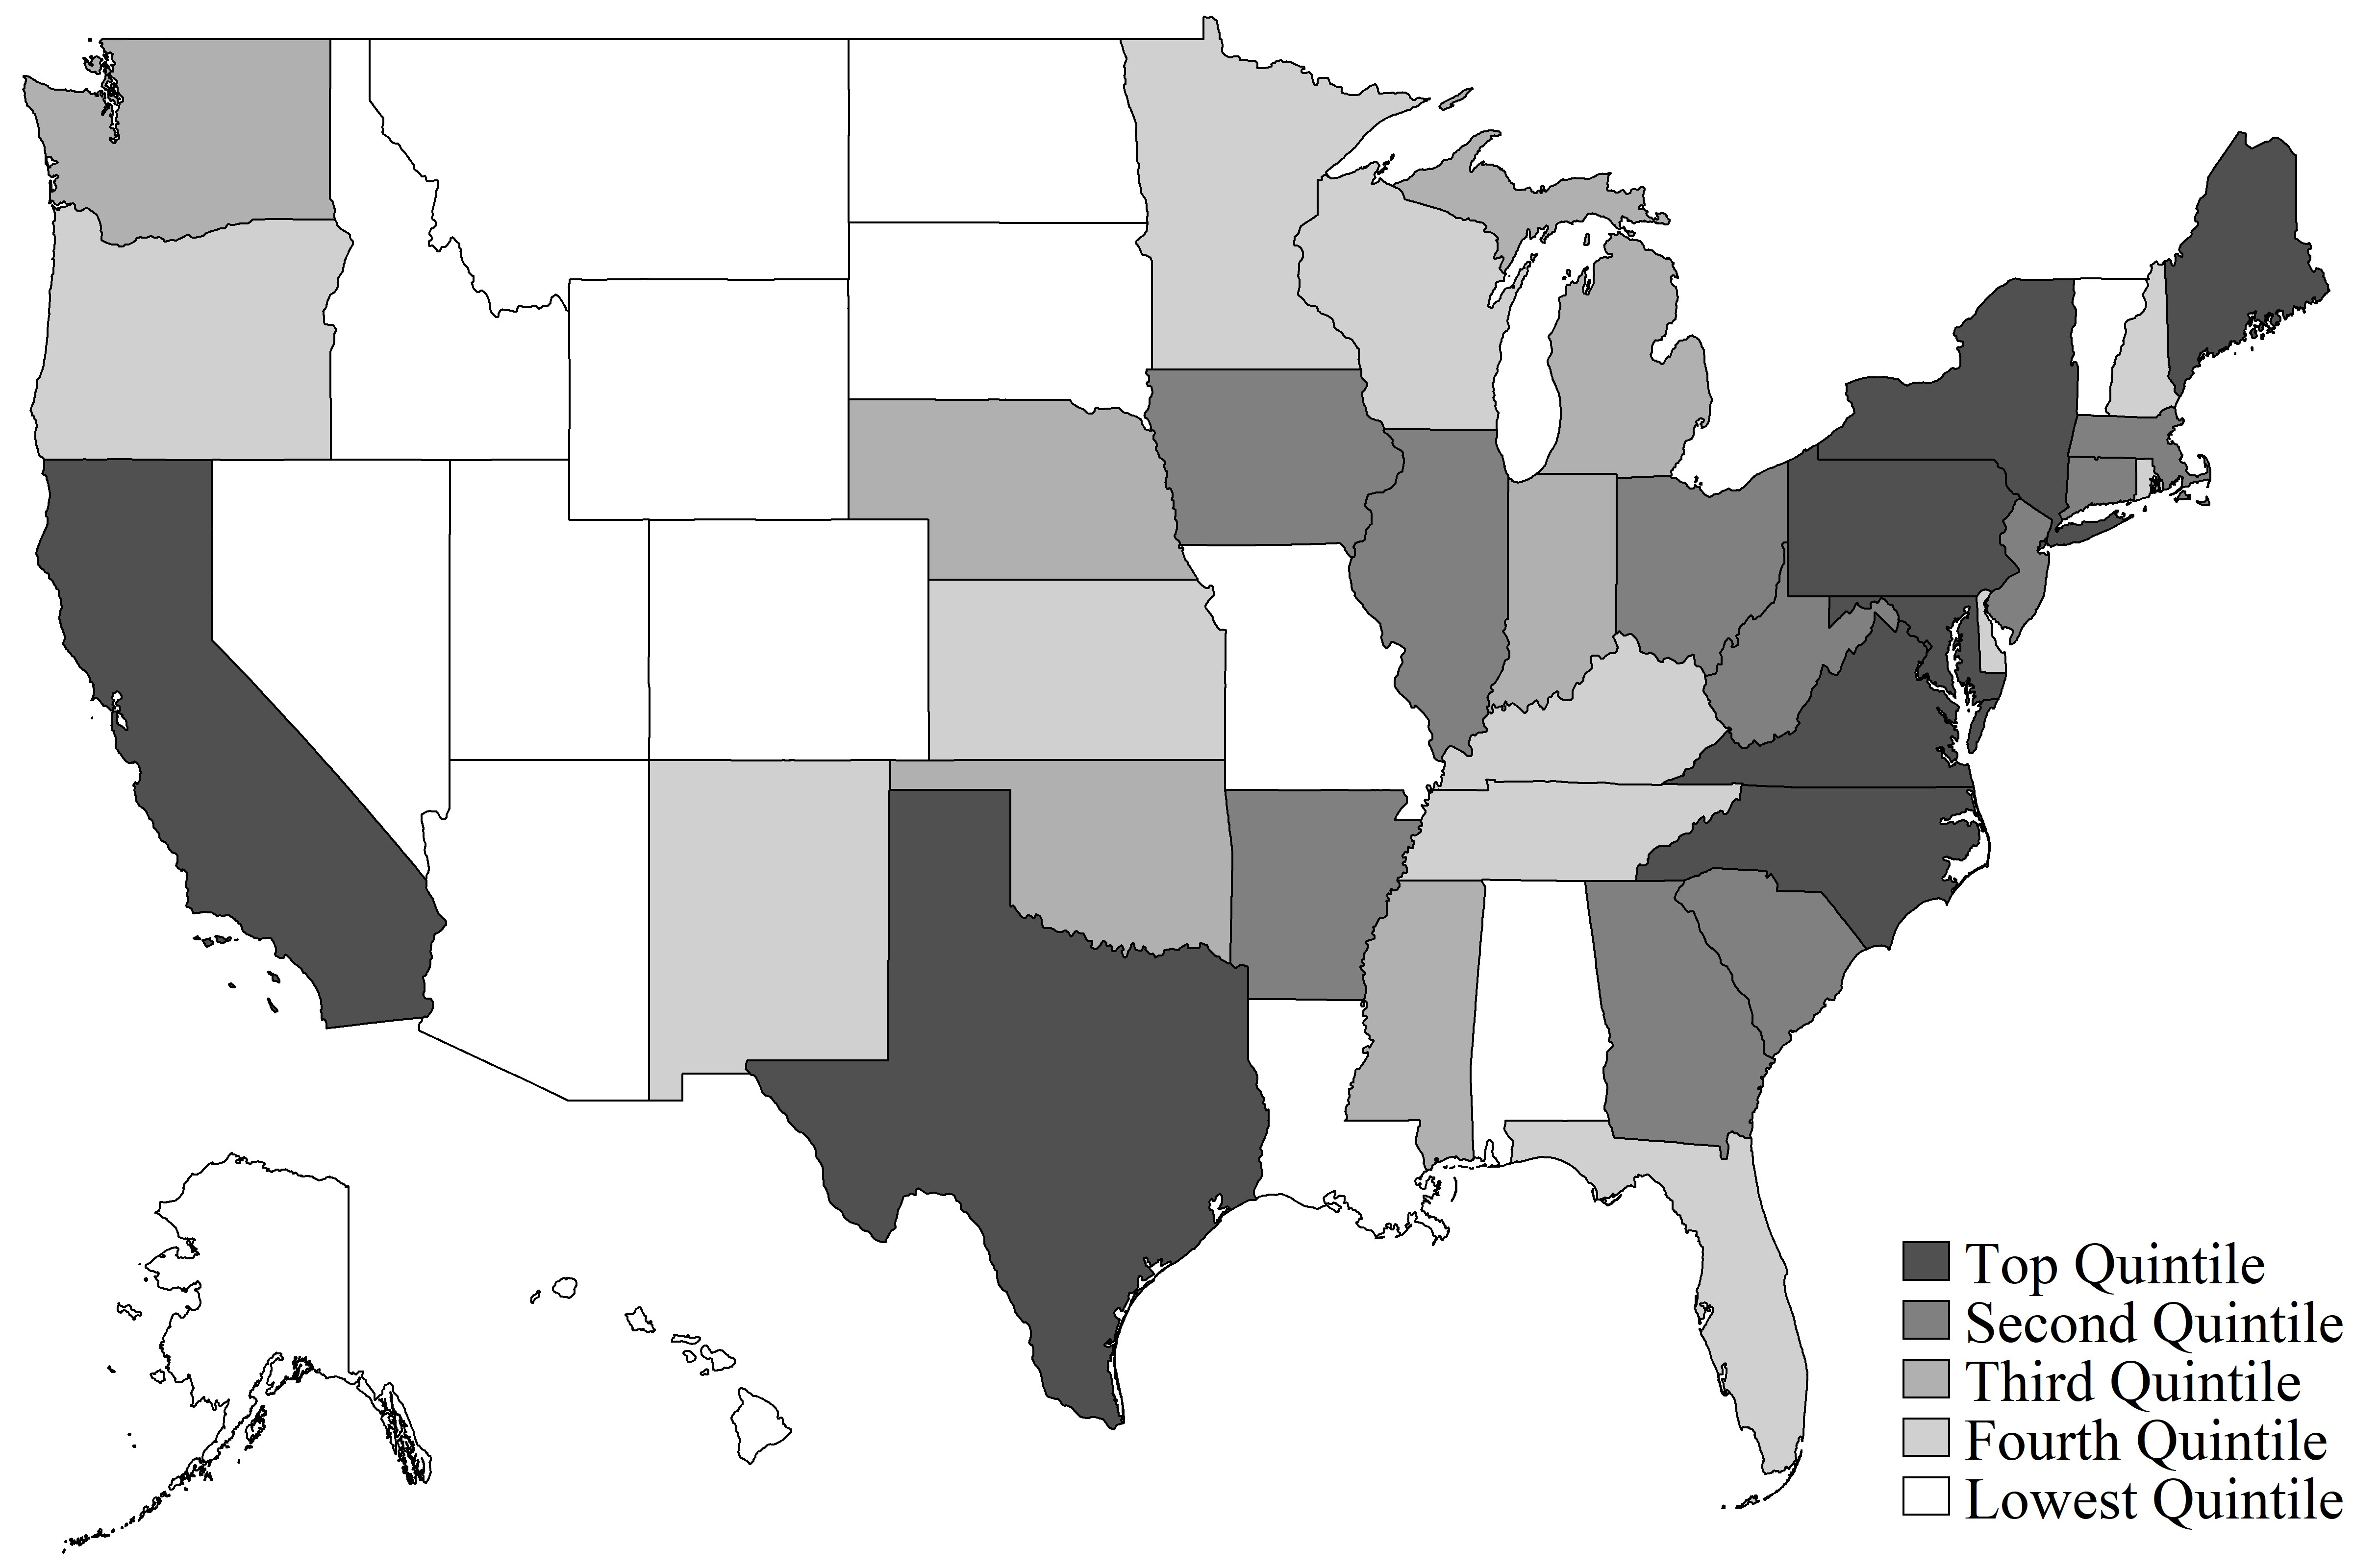

Source: Data from 1940 to 1946 Women’s Army Corp Enlistment Records for individuals born between 1915 and 1925, but excluding records with missing age, race, marital status, education, dependent, or state information. Note: Darker shades indicate that more individuals enlisted from those states.

Figure B2: Distribution of Female Veterans by State in 1980
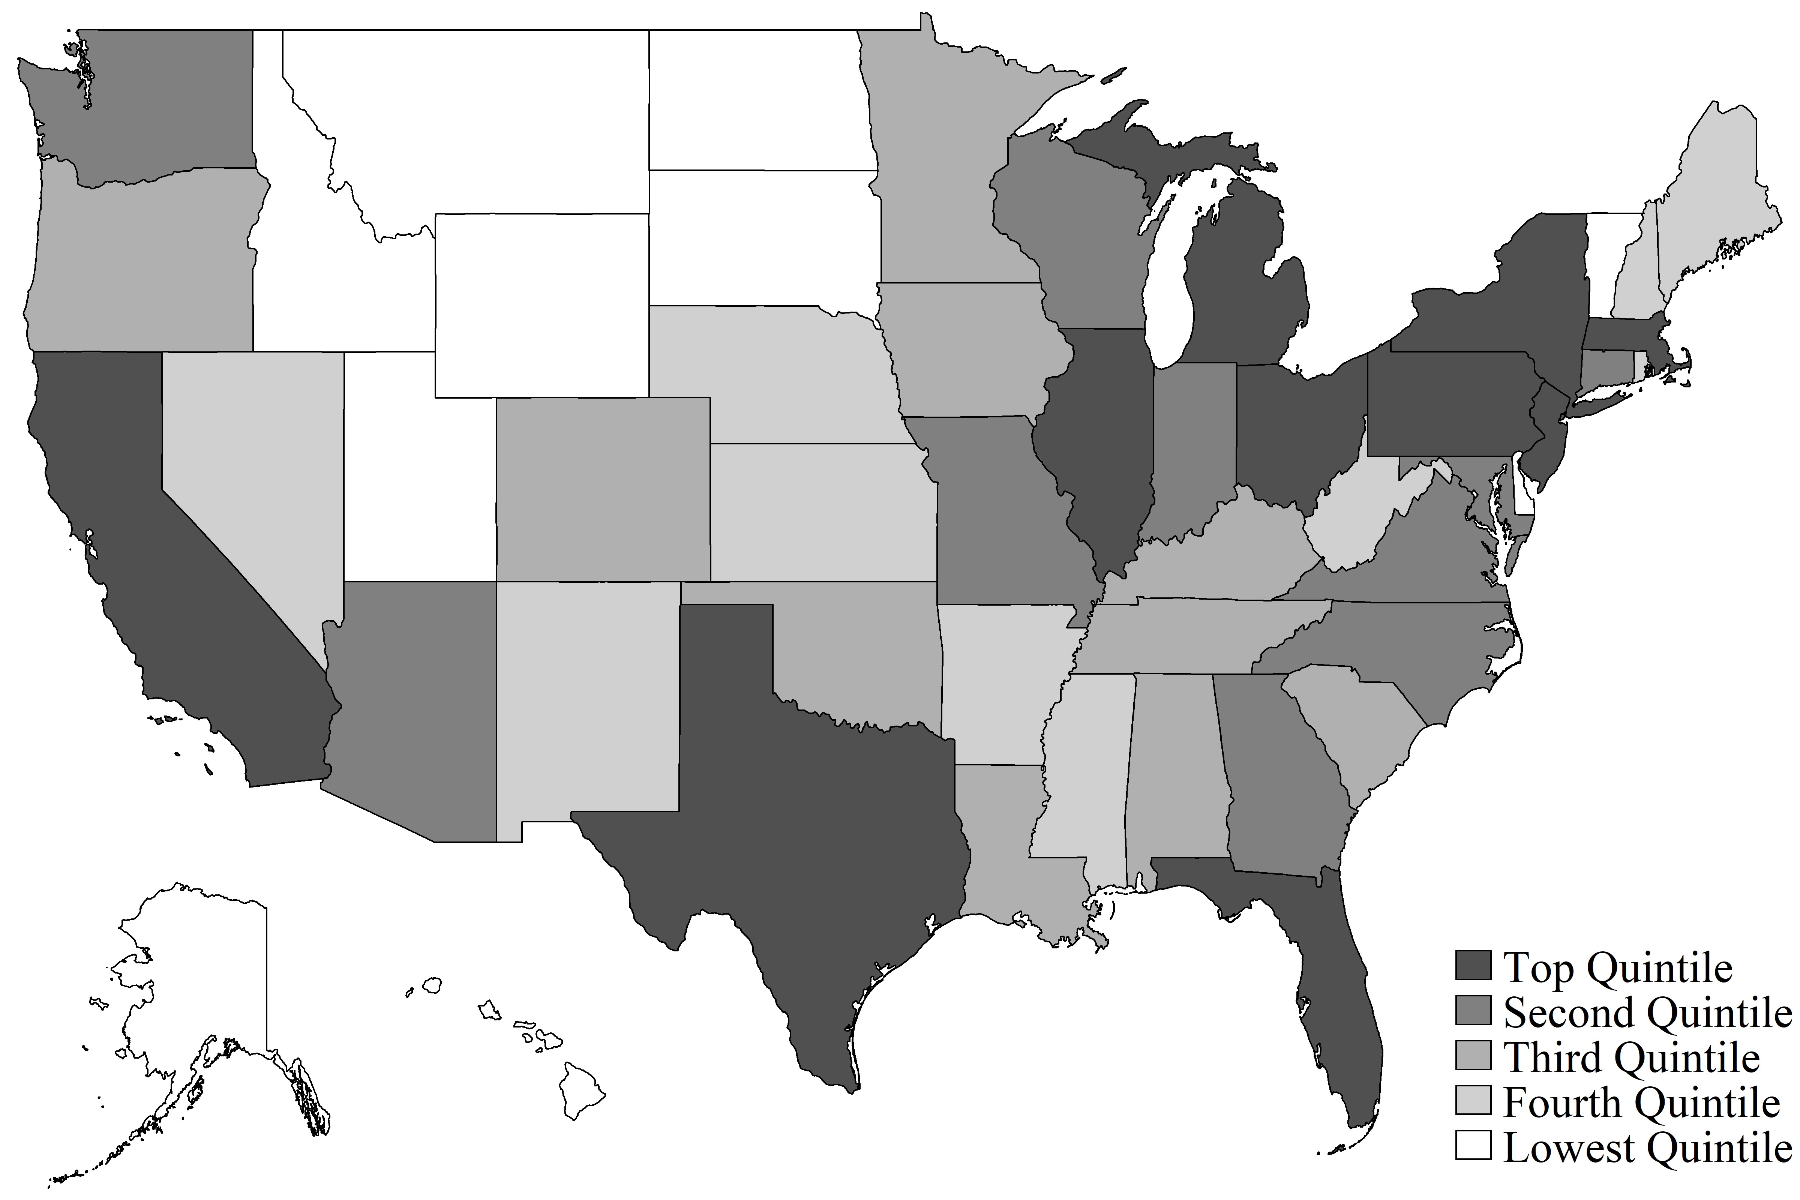

Source: Data from 1980 5% Census Sample. Note: Darker shades indicate that more veterans live in those states.

Table B1: Summary Statistics for Enlistees in 1940s
 |  |  |  | Education Level
 | High School Grad |  |  | Some College |  |  | College Grad |  |  | Total
 | N | % | N |  | % | N |  | % | N |  | %
Age at Enlistment  17 | 2 | 66.7% | 1 |  | 33.3% | 0 |  | 0.0% | 3 |  | 100.0%
18 | 9 | 69.2% | 2 |  | 15.4% | 2 |  | 15.4% | 13 |  | 100.0%
19 | 28 | 77.8% | 8 |  | 22.2% | 0 |  | 0.0% | 36 |  | 100.0%
20 | 4,646 | 83.3% | 891 |  | 16.0% | 38 |  | 0.7% | 5,575 |  | 100.0%
21 | 7,808 | 78.0% | 1,899 |  | 19.0% | 309 |  | 3.1% | 10,016 |  | 100.0%
22 | 8,751 | 73.7% | 2,420 |  | 20.4% | 703 |  | 5.9% | 11,874 |  | 100.0%
23 | 5,797 | 70.8% | 1,634 |  | 20.0% | 757 |  | 9.2% | 8,188 |  | 100.0%
24 | 4,139 | 67.6% | 1,267 |  | 20.7% | 719 |  | 11.7% | 6,125 |  | 100.0%
25 | 3,354 | 66.8% | 1,050 |  | 20.9% | 620 |  | 12.3% | 5,024 |  | 100.0%
26 | 2,623 | 65.3% | 834 |  | 20.8% | 561 |  | 14.0% | 4,018 |  | 100.0%
27 | 2,135 | 64.6% | 686 |  | 20.7% | 486 |  | 14.7% | 3,307 |  | 100.0%
28 | 1,382 | 65.0% | 456 |  | 21.4% | 289 |  | 13.6% | 2,127 |  | 100.0%
29 | 494 | 67.3% | 151 |  | 20.6% | 89 |  | 12.1% | 734 |  | 100.0%
30 | 141 | 70.9% | 39 |  | 19.6% | 19 |  | 9.5% | 199 |  | 100.0%
31 | 21 | 77.8% | 5 |  | 18.5% | 1 |  | 3.7% | 27 |  | 100.0%
Race  White | 38,850 | 72.6% | 10,372 |  | 19.4% | 4,311 |  | 8.1% | 53,533 |  | 100.0%
Other | 2,480 | 66.4% | 971 |  | 26.0% | 282 |  | 7.6% | 3,733 |  | 100.0%
Marital Status  Single | 27,359 | 70.0% | 8,083 |  | 20.7% | 3,665 |  | 9.4% | 39,107 |  | 100.0%
Married | 11,554 | 76.8% | 2,670 |  | 17.7% | 820 |  | 5.5% | 15,044 |  | 100.0%
Divorced/Widowed | 2,417 | 77.6% | 590 |  | 18.9% | 108 |  | 3.5% | 3,115 |  | 100.0%
Has Dependents?  No | 40,515 | 72.1% | 11,154 |  | 19.8% | 4,527 |  | 8.1% | 56,196 |  | 100.0%
Yes | 815 | 76.2% | 189 |  | 17.7% | 66 |  | 6.2% | 1,070 |  | 100.0%
Observations | 41,330 | 72.2% | 11,343 |  | 19.8% | 4,593 |  | 8.0% | 57,266 |  | 100.0%
Source: Enlistees born between 1915 and 1925 in the Women’s Army Corp Enlistment Records excluding records with missing age, race, marital status, education, dependent, or state information.

Table B2: Occupations in 1980
 | Count | % | Cumulative %
Non-Veteran Females  Secretaries | 14,951 | 11.44 | 11.44
Bookkeepers and accounting and auditing | 8,158 | 6.24 | 17.69
Salespersons, n.e.c. | 7,631 | 5.84 | 23.53
Primary school teachers | 6,393 | 4.89 | 28.42
Managers and administrators, n.e.c. | 6,273 | 4.8 | 33.23
General office clerks | 5,769 | 4.42 | 37.64
Registered nurses | 4,381 | 3.35 | 41
Nursing aides, orderlies, and attendant | 2,786 | 2.13 | 43.13
Cashiers | 2,730 | 2.09 | 45.22
Cooks, variously defined | 2,631 | 2.01 | 47.23
Total | 61,703 | 47.21
Veteran Females  Registered nurses | 761 | 14.69 | 14.69
Secretaries | 553 | 10.68 | 25.37
Managers and administrators, n.e.c. | 285 | 5.5 | 30.87
Primary school teachers | 215 | 4.15 | 35.02
Salespersons, n.e.c. | 207 | 4 | 39.02
General office clerks | 205 | 3.96 | 42.97
Bookkeepers and accounting and auditing | 200 | 3.86 | 46.83
Typists | 96 | 1.85 | 48.69
Nursing aides, orderlies, and attendant | 81 | 1.56 | 50.25
Office supervisors | 80 | 1.54 | 51.79
Total | 2,683 | 51.79

Source: 1980 PUMS 5 Percent Census Sample. Note: As in my main estimates, I restrict the sample to females who turned 21 between 1940 and 1946 who have a high school diploma. Non-veterans are, therefore, all females with a high-school diploma born between 1919 and 1925 who do not enlist in the armed forces during the WWII period.

Appendix 3 - Cohort Level Estimates
One alternative to my within-cohort approach is to follow Bound and Turner (2002). Specifically, Bound and Turner “collapse” their data to summary statistics by birth year-quarter cohort. They then regress educational attainment for each cohort on the share of the cohort that is a male veteran. Their OLS estimates suggest that the share of veterans in a cohort is positively related to greater educational attainment. They also present IV estimates where they use an indicator variable for being born prior to 4Q 1927, and thus having turned 18 prior to V-J Day (Victory over Japan Day, August 15, 1945), as an IV to predict the share of a cohort that are veterans. Note that V-J Day works as an IV because Japan’s surrender essentially marked the end of draft requirements. In turn, the share of WWII veterans by cohort declines swiftly for cohorts turning 18 after that day (See Figure 2 in Bound and Turner, 2002, p. 799).
Because so few females served and because there were no draft requirements for females, such a cohort level analysis is immediately limited when applied to females. Moreover, non-veteran female educational attainment and labor supply decisions were also affected by the events of WWII (Acemoglu et al., 2004;
Jaworski, 2014). For completeness, however, I present estimates that mirror Bound and Turner’s approach in Table C1. In the table, I provide OLS estimates along with IV estimates that use an indicator variable for being born prior to 4Q 1924, and thus having turned 21 prior to V-J Day, as an instrument to predict the share of a cohort that are veterans. I present estimates for cohorts of female high school graduates born between 1919 and 1925, 1919 and 1926, and 1919 and 1930. To follow Bound and Turner as closely as possible, I also include a birth year-quarter linear time trend in all specifications. The coefficients in the table refer to the effect on the outcome of interest for a one percentage point increase in the female veteran share in the cohort.
I find mostly null effects on labor force participation, employment, and earnings, regardless of approach to estimation. In contrast, I find negative effects on college attendance, years of college, and degree completion. That is, estimates suggest that a greater share of veterans in a birth year-quarter cohort leads to lower educational attainment. Because we know already that veterans have greater educational attainment and earnings, it must be the case that the war also affected non-veteran females’ outcomes. As I mention in the body of the paper, this is consistent with Acemoglu et al. (2004) and Jaworski (2014) who show large increases in labor force participation among women, at the expense of further education during the war
period.
The main consequence here is that my within-cohort approach is likely to mildly overestimate the effect of veteran status on female veterans’ later life outcomes. I discuss the potential size of any overestimate when discussing my findings in the main body of the paper along with how it compares to Jaworski’s estimate of the reduction in educational attainment due to WWII among females in affected cohorts.

Table C1: Cohort Level Analyses

 | (1) | (2) | (3) | (4) | (5) | (6)
 | Any College | Completed Degree | Years of College | In Labor Force | Employed | Annual Earnings
Panel A: OLS (b. 1919 to 1925)
Share WWII Vet | -0.001 | -0.005*** | -0.016*** | 0.001 | -0.001 | 19.26
 | (0.00) | (0.00) | (0.00) | (0.00) | (0.00) | (26.55)
Panel B: IV (b. 1919 to 1925)
Share WWII Vet | -0.002 | -0.005*** | -0.021*** | -0.000 | -0.001* | 1.18
 | (0.00) | (0.00) | (0.00) | (0.00) | (0.00) | (23.68)
First Stage F-Stat | 29.02 | 29.02 | 29.02 | 29.02 | 29.02 | 29.02
No. of Birth Quarters | 28 | 28 | 28 | 28 | 28 | 28
Panel C: OLS (b. 1919 to 1926)
Share WWII Vet | -0.003** | -0.006*** | -0.023*** | 0.002 | -0.001 | 19.5
 | (0.00) | (0.00) | (0.00) | (0.00) | (0.00) | (22.50)
Panel D: IV (b. 1919 to 1926)
Share WWII Vet | -0.003** | -0.006*** | -0.025*** | 0.000 | -0.001* | 3.76
 | (0.00) | (0.00) | (0.01) | (0.00) | (0.00) | (21.00)
First Stage F-Stat | 35.64 | 35.64 | 35.64 | 35.64 | 35.64 | 35.64
No. of Birth Quarters | 32 | 32 | 32 | 32 | 32 | 32
Panel E: OLS (b. 1919 to 1930)
Share WWII Vet | -0.003*** | -0.006*** | -0.025*** | 0.001 | -0.000 | 18.64
 | (0.00) | (0.00) | (0.00) | (0.00) | (0.00) | (25.52)
Panel F: IV (b. 1919 to 1930)
Share WWII Vet | -0.002 | -0.005*** | -0.020*** | -0.003 | -0.000 | -19.44
 | (0.00) | (0.00) | (0.01) | (0.00) | (0.00) | (23.07)
First Stage F-Stat | 41.67 | 41.67 | 41.67 | 41.67 | 41.67 | 41.67
No. of Birth Quarters | 48 | 48 | 48 | 48 | 48 | 48
Source: 1980 PUMS 5 Percent Census Sample. Note: I restrict the sample to females and study birth quarter level cohort outcomes for varying birth years as indicated in the table. In the IV estimates, I instrument for the share of a birth quarter cohort who are WWII veterans using an indicator that equals one if the birth quarter is strictly before 4Q 1924. Those born before 4Q 1924 would be military-eligible prior to V-J Day (therefore, I am using the same instrument as Bound and Turner, 2002). Following Bound and Turner, I include a birth-quarter linear time trend and standard errors are corrected for heteroskedasticity. All estimates use OLS, event when looking at Years of College.

See https://armyhistory.org/skirted-soldiers-the-womens-army-corps-and-gender-integration-of-the-u-s-army-during-worldwar-ii/. Last accessed 10/13/2020.
See https://aad.archives.gov/aad/content/aad docs/rg64 army serial faq.pdf.
See https://www.loc.gov/law/help/statutes-at-large/77th-congress/session-2/c77s2ch312.pdf.
See https://www.loc.gov/law/help/statutes-at-large/77th-congress/session-2/c77s2ch312.pdf.
See https://armyhistory.org/skirted-soldiers-the-womens-army-corps-and-gender-integration-of-the-u-s-army-during-worldwar-ii/.
See https://www.loc.gov/law/help/statutes-at-large/77th-congress/session-2/c77s2ch538.pdf..
See https://www.history.navy.mil/research/library/online-reading-room/title-list-alphabetically/h/how-to-serve-your-countryin-the-WAVES.html.
See https://www.loc.gov/law/help/statutes-at-large/78th-congress/session-2/c78s2ch268.pdf.
See https://www.nationalmuseum.af.mil/Portals/7/documents/education/teacher resource flying for freedom.pdf.
See https://www.nationalmuseum.af.mil/Portals/7/documents/education/teacher resource flying for freedom.pdf.
See Title IV of Public Law 95-2020, https://www.govinfo.gov/content/pkg/STATUTE-91/pdf/STATUTE-91-Pg1433.pdf.

